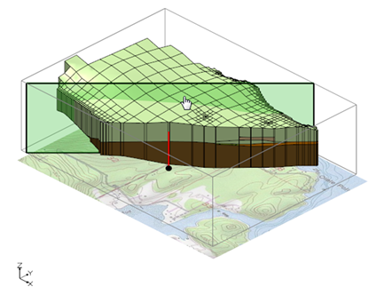

GMS 10.9

GMS 10.9 Tutorial

***UGrid Clipping***

Using the clipping display option to visualize UGrid data

Objectives

This tutorial describes the UGrid clipping tool. The UGrid clipping tool can be used to cut away a portion of a UGrid to visualize the data inside.

Time

* 10–15 minutes

Required Components

* GMS Core

Prerequisite Tutorials

* Getting Started

|  |
| --- |
| 1 Introduction 2  2 Using a Clipping Plane 2  2.1 Opening the UGrid Stratigraphy Project 2  2.2 Manually Setting a Clipping Plane 3  2.3 Using the Clipping Plane Widget 4  3 Clipping to Scalar Values 5  3.1 Opening the UGrid Project 5  3.2 Clipping to UGrid Cells Above a Scalar Value 6  3.3 Clipping to Smoothed UGrid Within a Scalar Range 7  3.4 Removing Additional Cells With Cell Visibility 8  4 Conclusion 10 |

# Introduction

The UGrid clipping display option can be used to cut away a portion of a UGrid and visualize the data inside the grid. It can be used to cut part of the UGrid using a clipping plane or by using scalar dataset values.

# Using a Clipping Plane

For this section of the tutorial, a UGrid with complex stratigraphy will be opened. A clipping plane will then be used to cut away a portion of a UGrid to visualize the inner stratigraphy.

To get started, do the following:

Launch GMS.

If GMS is already running, select *File |* **New** to ensure that the program settings are restored to the default state.

## Opening the UGrid Stratigraphy Project

Next, to open the GMS project containing the UGrid:

1. Click **Open** File:Open Macro.svg to bring up the *Open* dialog.
2. Select “All Files (*.*)” from the *Files of type* drop-down.
3. Browse to the *UGridClip\UGridClip* directory and select “olele.gpr”.
4. Click **Open** to import the project and close the *Open* dialog.

The UGrid should appear in the Graphics Window as shown in Figure 1.

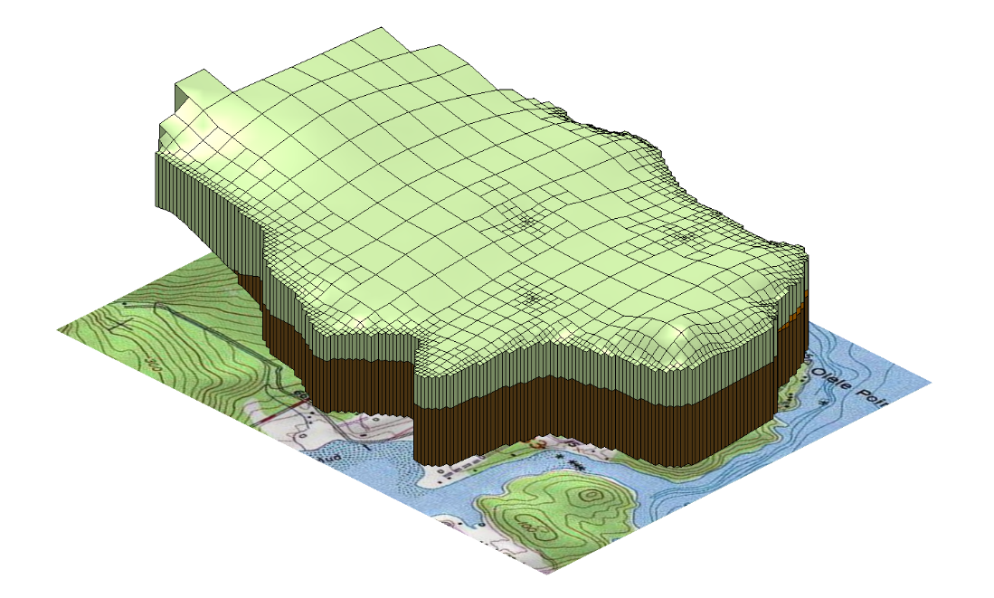

Figure 1 UGrid with outer stratigraphy

## Manually Setting a Clipping Plane

The clipping plane’s location can be manually defined by specifying a point on the plane and its normal vector. This tutorial will display the stratigraphy looking from the southeast with a plane running through cell ID 613. The first step is to determine the location and normal vector for the clipping plane.

1. Make sure the “ quadtree-3d” mesh is selected in the Project Explorer.
2. Select the *Edit |* **Select By ID…** menu item to open the *Select* dialog.
3. Set the *ID* to “613”.
4. Click **OK** to exit the *Select* dialog.

From the status bar at the bottom of the GMS window, notice the centroid of the cell is at approximately (1715229, 17428353, 8.7).

By default, the normal vector points away from the clipped region. To remove the southwest portion of the UGrid, set it to (-1, 1, 0).

1. Select the *Edit |* **Unselect All** menu item to clear the selected cell.

To turn on the clipping display option:

1. Click the **Display Options** File:Display Options Macro.svg macro to bring up the *Display Options* dialog.
2. Select *UGrid: quadtree-3d – [Active]* from the list on the left.
3. Make sure *Define UGrid specific options* is turned on.
4. Turn on the *Clip* option, and click on the **Options...** button to open the *UGrid Clip Settings* dialog.

The *Clip Type* should be set to “Plane”.

Change the *Clip To* setting to “Partial Cells”.

Enter the following values in the rest of the *UGrid Clip Settings* dialog:

|  |  |
| --- | --- |
| ***Item*** | ***Value*** |
| *Plane Point X* | 1715229 |
| *Plane Point Y* | 17428353 |
| *Plane Point Z* | 8.7 |
| *Plane Normal X* | -1.0 |
| *Plane Normal Y* | 1.0 |
| *Plane Normal Z* | 0.0 |

Click **OK** to close the *UGrid Clip Settings* dialog.

1. Click **OK** to close the *Display Options* dialog.

The clipped UGrid should appear in the Graphics Window as shown in Figure 2.

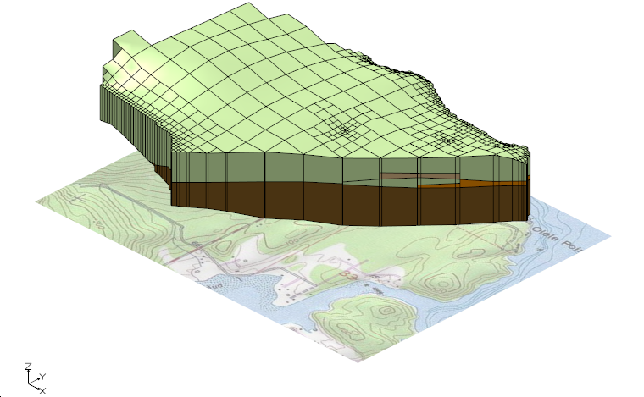

Figure 2 UGrid with clipped stratigraphy

## Using the Clipping Plane Widget

The clipping plane widget provides a much easier way to position the clipping plane.

1. Select the **Edit Clip Plane** File:Edit Clip Plane Tool.svg tool.

The clipping plane widget appears in the Graphics Window as shown in Figure 3. It displays the plane as a translucent rectangle, with the defining point shown on the rectangle and the normal vector represented by an arrow passing through it. A grayed-out bounding box surrounds the UGrid.

The plane, point, and normal can be adjusted by clicking on them and dragging them within the bounding box in the Graphics Window. Dragging the plane moves the point along the normal direction, while dragging the point moves it across the plane’s surface. Adjusting the tail or head of the normal vector changes its orientation around the point.

1. Move the clipping plane by clicking anywhere on the plane and dragging it toward the back corner of the gray bounding box.

Experiment with moving the plane about the UGrid by also adjusting the plane point and normal.

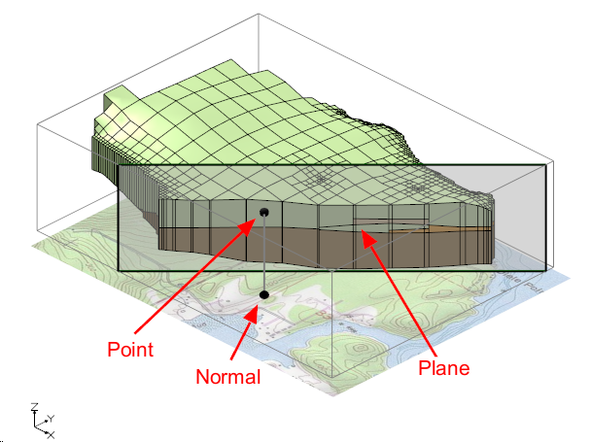

Figure 3 UGrid with clipping plane widget

# Clipping to Scalar Values

This section of the tutorial loads a GMS project containing a UGrid with cell-by-cell contaminate concentration values in parts per million (ppm). The UGrid clip display option is then used to visualize the contaminate plume.

## Opening the UGrid Project

First, open the GMS project containing the UGrid data:

1. Select *File |* **New** to close the “olele.gpr” project and, if desired, save the project to a different location.
2. Click **Open** File:Open Macro.svg to bring up the *Open* dialog.
3. Select “All Files (*.*)” from the *Files of type* drop-down.
4. Browse to the *UGridClip\UGridClip* directory and select “contaminate_plume.gpr”.
5. Click **Open** to import the project and close the *Open* dialog.

The UGrid with the concentration data should appear in the Graphics Window as shown in Figure 4, with contours of the plume visible on the front left face of the grid.

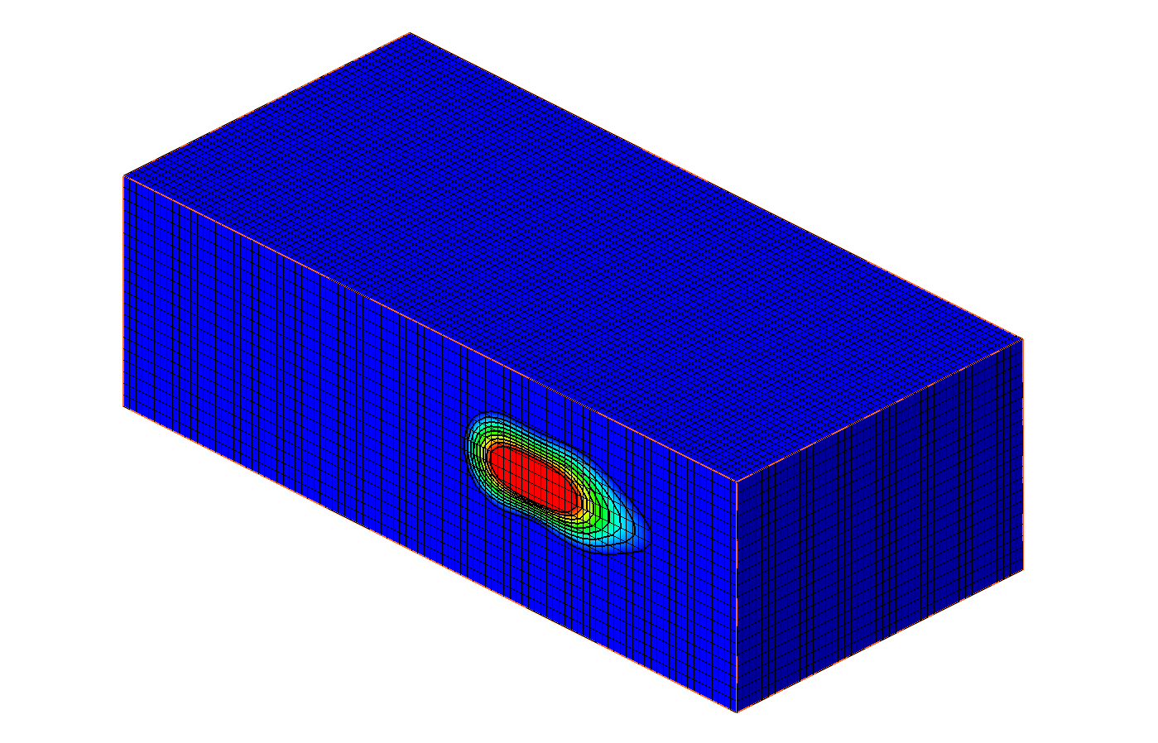

Figure 4 UGrid with contaminate concentration contours

## Clipping to UGrid Cells Above a Scalar Value

To use scalar clipping to display the portion of the UGrid with a contaminant value greater than 2000 ppm:

1. Click the **Display Options** File:Display Options Macro.svg macro to bring up the *Display Options* dialog.
2. Select *UGrid: ugrid – [Active]* in the list on the left.
3. Make sure that *Define UGrid specific options* is checked*.*
4. Turn on the *Clip* option and select the **Options…** button to open the *UGrid Clip Settings* dialog.
5. Change the *Clip Type* to “Scalar”.
6. The *Clip To* option should be set to “Whole Cells”.
7. Enter “2000.0” for the *Scalar Value*.

Click **OK** to close the *UGrid Clip Settings* dialog.

1. Click **OK** to close the *Display Options* dialog.

The Graphics Window should display the plume as shown in Figure 5.

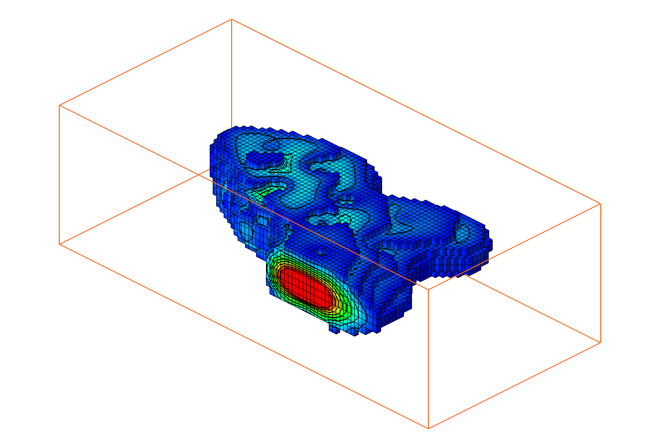

Figure 5 UGrid contaminate plume with scalar and whole cells

## Clipping to Smoothed UGrid Within a Scalar Range

The next step involves using the “Scalar Range” clip option to display the outer portion of the plume, along with the “Partial Cells” option to produce a smoother view of the plume.

The “Partial Cells” option requires scalar values to be defined on UGrid nodes rather than cells. To enable this, the cell-based dataset must be converted to a node-based dataset.

1. Right-click on the “Cell scalar dataset – active contaminant” dataset and select the **Convert to Point Dataset** menu item to bring up the *New Dataset Name* dialog.
2. Click **OK** to use the default dataset name and close the *New Dataset Name* dialog.

Now with the new dataset (“Cell scalar dataset – active contaminant point data”) selected as the active dataset, change the clip display options:

1. Click the **Display Options** File:Display Options Macro.svg macro to bring up the *Display Options* dialog.
2. Select *UGrid: ugrid – [Active]* in the list on the left.
3. Make sure that *Define UGrid specific options* is checked.
4. Click on the **Options…** button next to the *Clip* option to open the *UGrid Clip Settings* dialog.
5. Change the *Clip Type* to “Scalar Range”.
6. Change the *Clip To* option to “Partial Cells”.
7. Enter “2000.0” for the *Minimum Scalar Value*.
8. Enter “9000.0” for the *Maximum Scalar Value*.
9. Click **OK** to close the *UGrid Clip Settings* dialog.
10. Click **OK** to close the *Display Options* dialog.

The Graphics Window should display the plume as shown in Figure 6.

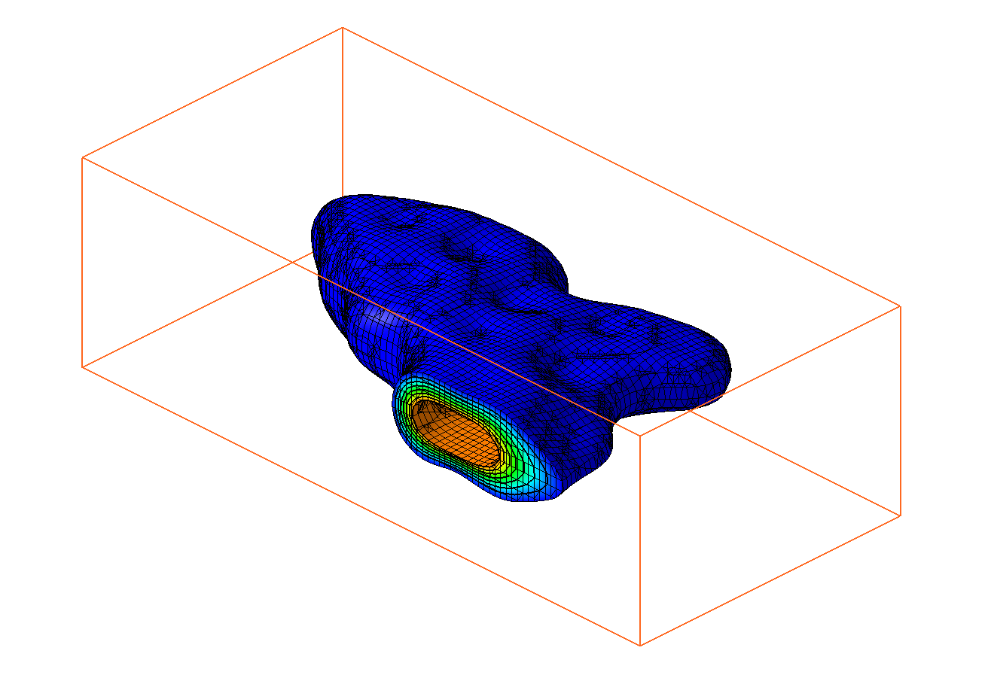

Figure 6 UGrid contaminate plume with scalar range and partial cells

## Removing Additional Cells With Cell Visibility

Cell visibility, in conjunction with the clipping display option, can be used to remove additional portions of the UGrid and view inside the plume. This can be done by hiding the cells near the front-left face of the UGrid.

1. Switch to **Plan View** File:Plan View Macro.svg.
2. Using the **Select Cells** File:Select UGrid Cell Tool.svg tool, drag a rectangle in the Graphics Window to select the cells of the bottom half of the plume (Figure 7).
3. Click on the **Hide Cells** File:GMS Hide Macro.svg macro to hide the selected cells.
4. Switch to **Oblique View** File:Oblique View Macro.svg.

The Graphics Window should appear similar to Figure 8. The hidden cells can be redisplayed using the **Show Cells** File:GMS Show Macro.svg command.

Figure 7 Bottom cells selected to be hidden

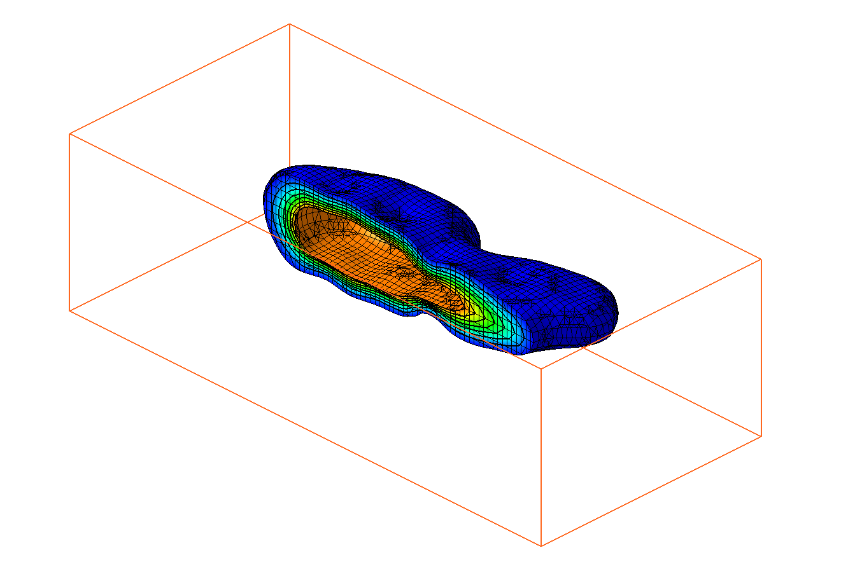

Figure 8 UGrid contaminate plume with hidden cells

# Conclusion

This concludes the “UGrid Clipping” tutorial. Topics covered in the tutorial include:

* Clipping UGrids with a clipping plane
* Clipping above a scalar value
* Clipping to a scalar range
* Using cell visibility to clip additional cells