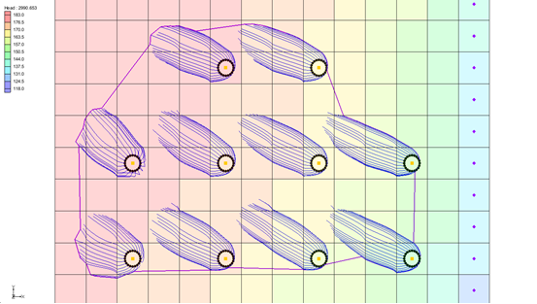

GMS 10.9

GMS 10.9 Tutorial

***Mod-PATH3DU Transient***

A particle tracking with a transient MODFLOW-USG model

Objectives

This tutorial demonstrates more about GMS's mod-PATH3DU interface and how transient simulations are done.

Time

* 15–30 minutes

Required Components

* GMS Core
* MODFLOW Interface
* MODPATH/MP3DU Interface

Prerequisite Tutorials

* Mod-PATH3DU

|  |
| --- |
| [1 Introduction 2](#_Toc201565397)  [1.1 Getting Started 2](#_Toc201565398)  [2 Opening an Existing Model 2](#_Toc201565399)  [3 Saving a Text Copy 3](#_Toc201565400)  [4 Running MODFLOW 3](#_Toc201565401)  [5 Creating a Backward Tracking mod-PATH3DU Model 4](#_Toc201565402)  [5.1 Adding Starting Locations 4](#_Toc201565403)  [5.2 Direction and Release Time 5](#_Toc201565404)  [5.3 IFACE 6](#_Toc201565405)  [6 Running the Model Checker 7](#_Toc201565406)  [6.1 Fixing Unit Numbers 8](#_Toc201565407)  [6.2 Running the Model Checker 9](#_Toc201565408)  [7 Saving and Running mod-PATH3DU 9](#_Toc201565409)  [8 Capture Zones and Well Groups 11](#_Toc201565410)  [8.1 Creating Well Groups 11](#_Toc201565411)  [9 Exporting a Shapefile 12](#_Toc201565412)  [10 Conclusion 13](#_Toc201565413) |

# Introduction

The particle path and time tracking simulation program mod-PATH3DU was developed by Chris Muffles at S.S. Papadopulos & Associates for use with both structured and unstructured grids. It is similar to MODPATH and is compatible with unstructured grids and MODFLOW-USG.

This tutorial starts with opening a transient MODFLOW-USG model. A native text copy of the model is saved, and MODFLOW is run on the native text file. A new backward-tracking mod-PATH3DU model is then created with starting points at the wells. The mod-PATH3DU Model Checker is run, and any identified errors are addressed.

Next, the model is launched, the solution is imported, the wells are renamed to modify the capture zones, and a shapefile containing the pathline points is exported.

## Getting Started

Do the following to get started:

1. If necessary, launch GMS.
2. If GMS is already running, select *File |* **New** to ensure that the program settings are restored to their default state.

# Opening an Existing Model

To open a two-layer transient MODFLOW-USG model:

1. Click **Open** http://www.xmswiki.com/images/thumb/5/5d/Open_Macro.svg/60px-Open_Macro.svg.png to bring up the *Open* dialog.
2. Select “Project Files (\*.gpr)” from the *Files of type* drop-down.
3. Browse to the *\Transient* directory and select “Transient.gpr”.
4. Click **Open** to import the project and exit the *Open* dialog.

The project should appear similar to Figure 1.

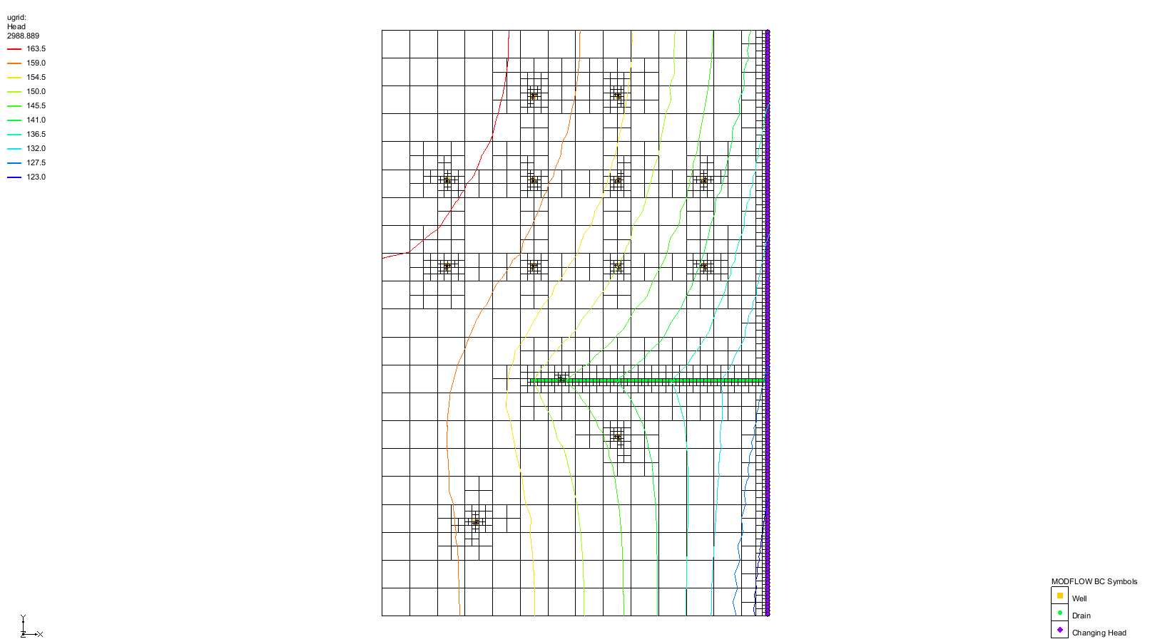

Figure 1 Starting MODFLOW-USG model

Flow is directed from left to right, with the cells on the right side assigned constant head values ranging from “139.0” to “119.0”. Several wells in the model extract water. The simulation includes five stress periods, with the model’s end time set at 1,000,970.1 days. Linear contours displaying head are enabled for visualization.

Before proceeding, it is recommended to save the project under a new name.

1. Select *File* | **Save As…** to open the *Save As* dialog.
2. Select “Project Files (\*.gpr)” from the *Save as type* drop-down.
3. Enter “TransientMp3du.gpr” as the *File name*.
4. Click **Save** to create a new project file and close the *Save As* dialog.

# Saving a Text Copy

MODFLOW files are read by mod-PATH3DU using its internal version of MODFLOW. As a result, mod-PATH3DU cannot read the GMS-formatted MODFLOW files that use HDF5 to store array data. The next step is to save a native text copy of the MODFLOW simulation for mod-PATH3DU to use.

1. In the Project Explorer, double-click on “http://www.xmswiki.com/images/thumb/d/d2/MODFLOW_Package_Icon.svg/60px-MODFLOW_Package_Icon.svg.png Global” to bring up the *MODFLOW Global/Basic Package* dialog.
2. In the *MODFLOW version* section, turn on *Save native text copy*.
3. Click **OK** to close the *MODFLOW Global/Basic Package* dialog.
4. Click **Save** http://www.xmswiki.com/images/thumb/0/00/Save_Macro.svg/53px-Save_Macro.svg.png to save a text copy of MODFLOW to the project directory.

# Running MODFLOW

To generate a solution for the native text copy of the model, MODFLOW must be run. Since the typical method of running MODFLOW involves using the GMS-formatted copy of the model, MODFLOW will need to be run differently for this step.

1. Select *MODFLOW | Advanced* | **Run MODFLOW Dialog…** to bring up the *Run MODFLOW* dialog.
2. In the *MODFLOW version* section, select *USG*.
3. Click **Name file** File:Open Macro.svg to bring up an *Open* dialog.
4. Navigate to the *\TransientMp3du\_MODFLOW-ugrid\_text* folder.
5. Select “TransientMp3du.mfn” and click **Open** to exit the *Open* dialog.
6. Click **OK** to close the *Run MODFLOW* dialog and bring up a command prompt window where MODFLOW will run.
7. When MODFLOW finishes running, close the command prompt window by pressing any key.

# Creating a Backward Tracking mod-PATH3DU Model

The next step is to create the mod-PATH3DU model.

1. In the Project Explorer, right-click on “UGrid item – locked ugrid” and select **New mod-PATH3DU…**.

This adds “File:UGrid Veronoi Icon.svg ugrid”, a new mod-PATH3DU model, to the Project Explorer.

1. Right-click on “File:UGrid Veronoi Icon.svg ugrid” and select **Rename**.
2. Enter “backward” and press *Enter* to set the new name.

## Adding Starting Locations

1. Right-click on “File:UGrid Veronoi Icon.svg backward” and select **Create Particles at Wells…** to bring up the *Generate Particles at Wells* dialog.
2. Click **OK** to accept the defaults and close the *Generate Particles at Wells* dialog.

Notice the ring of starting locations created around the wells (Figure 2).

1. **Zoom** http://www.xmswiki.com/images/thumb/d/df/Zoom_Tool_Icon.svg/56px-Zoom_Tool_Icon.svg.png in to see the particles around the wells.
2. When finished, select the **Frame** File:Frame Macro.svg macro to view the entire grid.

Figure 2 Ring of particle starting locations around wells

## Direction and Release Time

With starting locations at the wells, it is now possible to create a backward tracking simulation.

1. Right-click on “File:UGrid Veronoi Icon.svg backward” and select **Options…** to bring up the *mod-PATH3DU Options* dialog (Figure 3).
2. Select “Options” from the list on the left.
3. From the *DIRECTION* drop-down, select “Backward”.

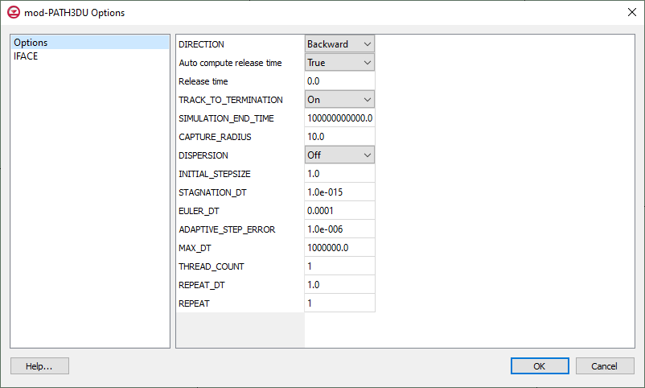

Figure 3 mod-PATH3DU Options dialog

Note that *Release time* is set to “0.0”. Since the MODFLOW model is transient and the mod-PATH3DU *DIRECTION* is set to “Backward”, the *Release time* should not be “0.0”. It is typically set to the end time of the MODFLOW model, which, in this case, is “1000970.1”.

However, note that *Auto compute release time* is set to “True”. When GMS saves the mod-PATH3DU input files, it automatically adjusts the *Release time* based on the tracking direction: it sets the *Release time* to the MODFLOW end time for backward tracking or to “0.0” for forward tracking. Therefore, in this case, the *Release time* does not need to be manually adjusted.

|  |  |
| --- | --- |
| Desc-i_gray 100px | The *Auto compute release time* option will cause the *Release time* to be set at “0.0” or the MODFLOW end time based on the *DIRECTION* option. |

## IFACE

IFACE is an input used by mod-PATH3DU to track particles through cells that contain a source or sink. The flow into or out of a cell due to the source or sink must be assigned to a specific cell face. For example, recharge would be assigned to the top cell face.

IFACE values are integer values ranging from “0” to “6”, where “0” indicates an internal source or sink (e.g. wells); “5” and “6” correspond to the bottom and top faces, respectively; and values between “1” and “4” correspond to the side faces.

1. Select “IFACE” from the list on the left (Figure 4).

Historically, cells were always hexahedrons (six-faced), so the numbering scheme for IFACE made sense. However, with unstructured grids, cells can have any number of side faces. As a result, in mod-PATH3DU, instead of using values from “1” through “4” to indicate side faces, a value of “2” is used to represent any side face, and mod-PATH3DU determines the specific side face internally.

IFACE input can be supplied to mod-PATH3DU in two ways:

* Cell-by-cell input, provided via an auxiliary variable included in the MODFLOW boundary condition package files
* By specifying an IFACE value for each type of boundary condition in the *mod-PATH3DU Options* dialog

Both methods can be used together, with the IFACE values in the options dialog being applied only if the auxiliary variable method is not used.

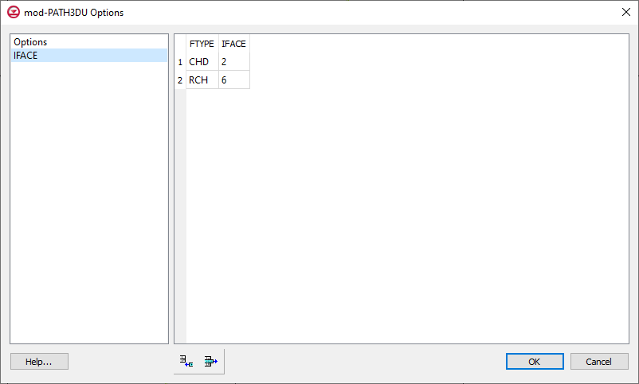

Figure 4 IFACE values

This table (Figure 4) shows how IFACE values are specified. Note that there are two rows listed in the table: one for *CHD* (constant head) and one for *RCH* (recharge). The names correspond to those found in the cell-to-cell flow (CCF) file. GMS automatically adds these two items for all new mod-PATH3DU simulations.

If these types of boundary conditions are not being used in the simulation, mod-PATH3DU will ignore the IFACE values listed in the table. Therefore, there would be no need to delete these values.

|  |  |
| --- | --- |
| Desc-i_gray 100px | Two *IFACE* entries are automatically created by GMS and used by mod-PATH3DU. If these entries are not needed, mod-PATH3DU will simply ignore them. |

Wells are also included in this model; however, IFACE is included by GMS as an auxiliary variable in the well package file, so no IFACE value is required in this table. The CHD package is used for the constant head boundary condition, and GMS does not automatically include IFACE as an auxiliary variable for this package; therefore, the IFACE value listed in the table is necessary.

A value of “2” for *CHD* indicates that flow will be assigned to a side face for cells containing a constant head boundary condition. A value of “6” for *RCH* indicates that flow will be assigned to the top face for cells containing a recharge boundary condition.

The default IFACE values are appropriate for this model, so no changes are necessary.

1. Click **OK** to exit the *mod-PATH3DU Options* dialog.

# Running the Model Checker

GMS includes a model checker for mod-PATH3DU that identifies obvious problems in the model setup and provides warnings about potential errors or issues that could affect the model run.

1. **Save** http://www.xmswiki.com/images/thumb/0/00/Save_Macro.svg/53px-Save_Macro.svg.png the project.
2. Right-click “http://www.xmswiki.com/images/thumb/1/1b/UGrid_Veronoi_Icon.svg/65px-UGrid_Veronoi_Icon.svg.png backward” and select **Check Simulation…** to bring up the *Model Checker* dialog.
3. Click **Run Check** to begin the check.

Note the errors related to unit numbers (Figure 5). For some reason, mod-PATH3DU can only process unit numbers that are 199 or lower. These errors will be addressed in the next section.

1. Click **Done** to close the *Model Checker* dialog.

|  |  |
| --- | --- |
| **Desc-i_gray 100px** | mod-PATH3DU requires that MODFLOW unit numbers be 199 or less. |

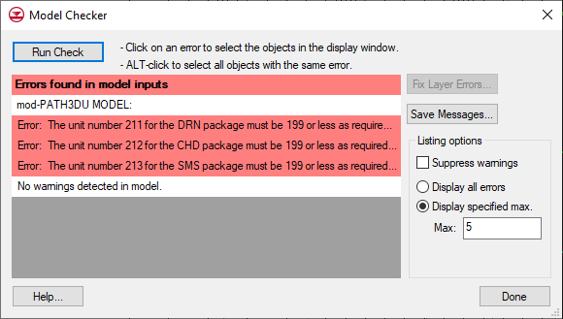

Figure 5 Model Checker dialog showing errors

## Fixing Unit Numbers

To fix the unit numbers, do the following:

1. Select *MODFLOW |* **Name File…** to bring up the *MODFLOW Name File* dialog.
2. Scroll down so that unit numbers greater than “199” are visible (Figure 6).

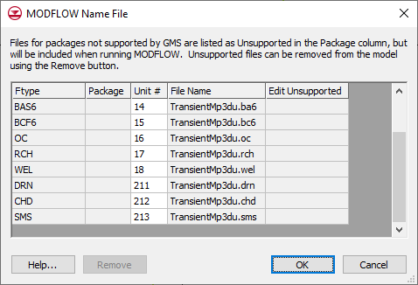

Figure 6 MODFLOW Name File dialog

1. Enter “19”, “20”, and “21” on the *DRN,* *CHD,* and *SMS* rows (respectively) in the *Unit #* column.
2. Click **OK** to exit the *MODFLOW Name File* dialog.

|  |  |
| --- | --- |
| Desc-i_gray 100px | The *MODFLOW Name File* dialog can be used to change unit numbers. |

## Running the Model Checker

To rerun the *Model Checker* to make sure there are no more errors:

1. Right-click “http://www.xmswiki.com/images/thumb/1/1b/UGrid_Veronoi_Icon.svg/65px-UGrid_Veronoi_Icon.svg.png backward” and select **Check Simulation…** to bring up the *Model Checker* dialog.
2. Click **Run Check** to begin the check.

No errors or warnings should be listed (Figure 7).

1. Click **Done** to close the *Model Checker* dialog.

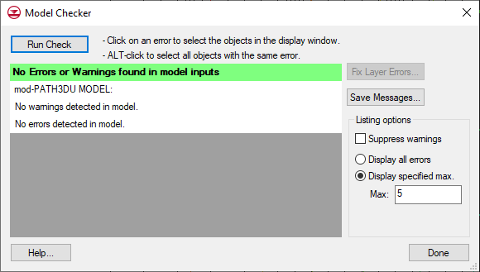

Figure 7 Model Checker dialog with no errors or warnings

|  |  |
| --- | --- |
| Desc-i_gray 100px | The *Model Checker* looks for obvious problems in the model setup. |

# Saving and Running mod-PATH3DU

Before running mod-PATH3DU, it is advised to save the project.

1. **Save** http://www.xmswiki.com/images/thumb/0/00/Save_Macro.svg/53px-Save_Macro.svg.png the project.

This saves the project again, this time including the mod-PATH3DU input files.

1. Right-click “File:UGrid Veronoi Icon.svg backward” and select **Run mod-PATH3DU** to bring up the *MP3DU* model wrapper dialog

The *MP3DU* model wrapper dialog displays the output from the mod-PATH3DU run and typically completes in less than a minute. If the mod-PATH3DU run is successful, the dialog will show “Normal termination of mod-PATH3DU.” near the bottom of the dialog (Figure 8).

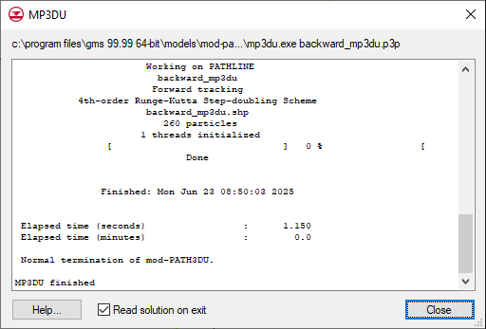

Figure 8 mod-PATH3DU model wrapper dialog

1. When mod-PATH3DU finishes, turn on *Read solution on exit* and click **Close** to exit the *MP3DU* model wrapper dialog.
2. Click the **Redraw Display** http://www.xmswiki.com/images/thumb/c/ce/Refresh_Macro.svg/49px-Refresh_Macro.svg.png macro.

This causes GMS to refresh the display after reading the pathline file. The project should appear similar to Figure 9.

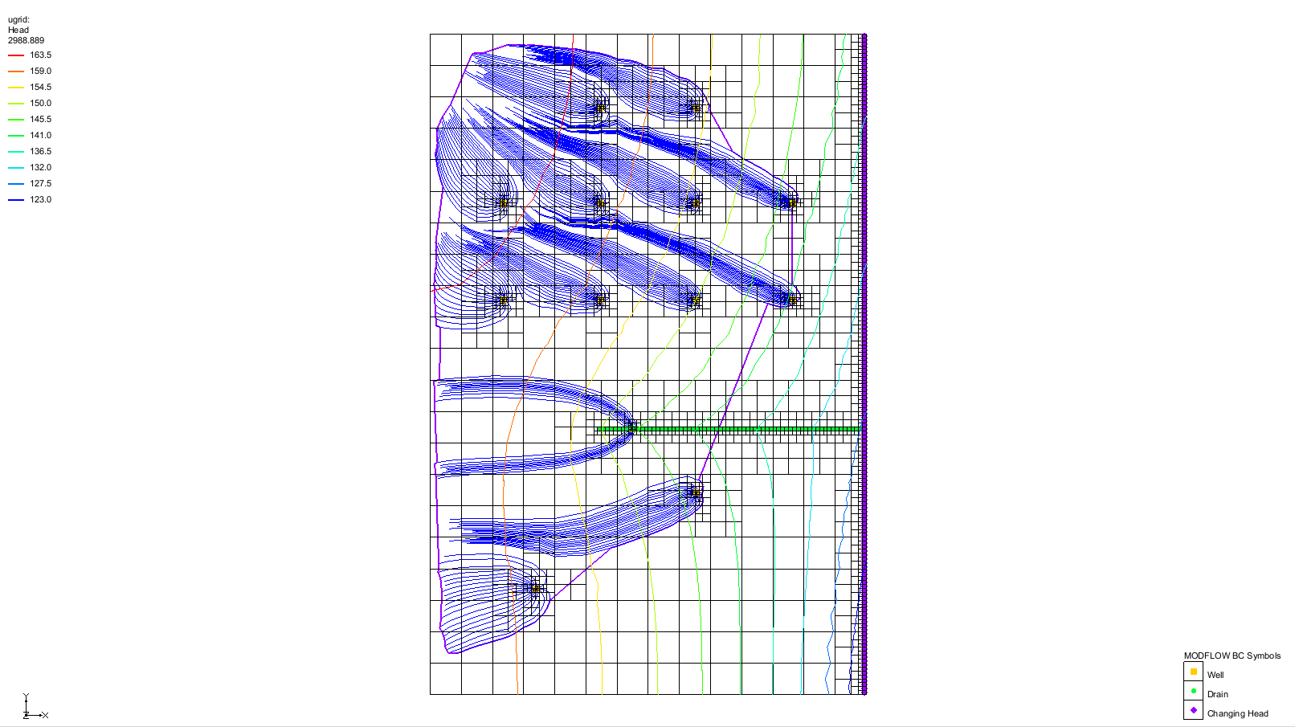

Figure 9 Pathline solution showing pathlines tracking backward from the well

1. If desired, **Zoom** http://www.xmswiki.com/images/thumb/d/df/Zoom_Tool_Icon.svg/56px-Zoom_Tool_Icon.svg.png in and examine the pathlines.
2. **Save** File:Save Macro.svg the project when done reviewing the pathlines, as it now contains the solution.

# Capture Zones and Well Groups

Note the purple line surrounding all the pathlines. This line encloses a capture zone.

1. Click the **Display Options** File:Display Options Macro.svg macro to bring up the *Display Options* dialog.
2. Select “UGrid: ugrid – [Active]” from the list on the left.
3. Turn on *Define UGrid specific options*.
4. In the *Capture zones* section of the *Particles* tab, notice that *Delineate by well* is selected and *Boundary* is turned on.

The *Delineate by well* option groups wells by name and creates a capture zone using the pathlines for each well in the group. Enabling *Boundary* makes the capture zone boundary visible.

1. Click **Cancel** to close the *Display Options* dialog.

## Creating Well Groups

To create different well groups, modify the well names.

1. Select *MODFLOW* | *Optional Packages* | **WEL – Well…** to bring up the *MODFLOW Well Package* dialog.
2. Enter “D” in the *Name* column on row 1.
3. Enter “C” in the *Name* column on row 2.
4. Enter “B” in the *Name* column on row 3.
5. Enter “A” in the *Name* column on rows 4–13.
6. Click **OK** to exit the *MODFLOW Well Package* dialog.
7. Click the **Redraw Display** File:Refresh Macro.svg macro.
8. **Save** File:Save Macro.svg the project.

Note the changes in the capture zone boundary lines (Figure 10). The wells at the top of the model are grouped into a single capture zone, while the remaining wells each have individual capture zones.

|  |  |
| --- | --- |
| Desc-i_gray 100px | Wells can be grouped into the same capture zone by assigning them the same name in the MODFLOW Well package. |

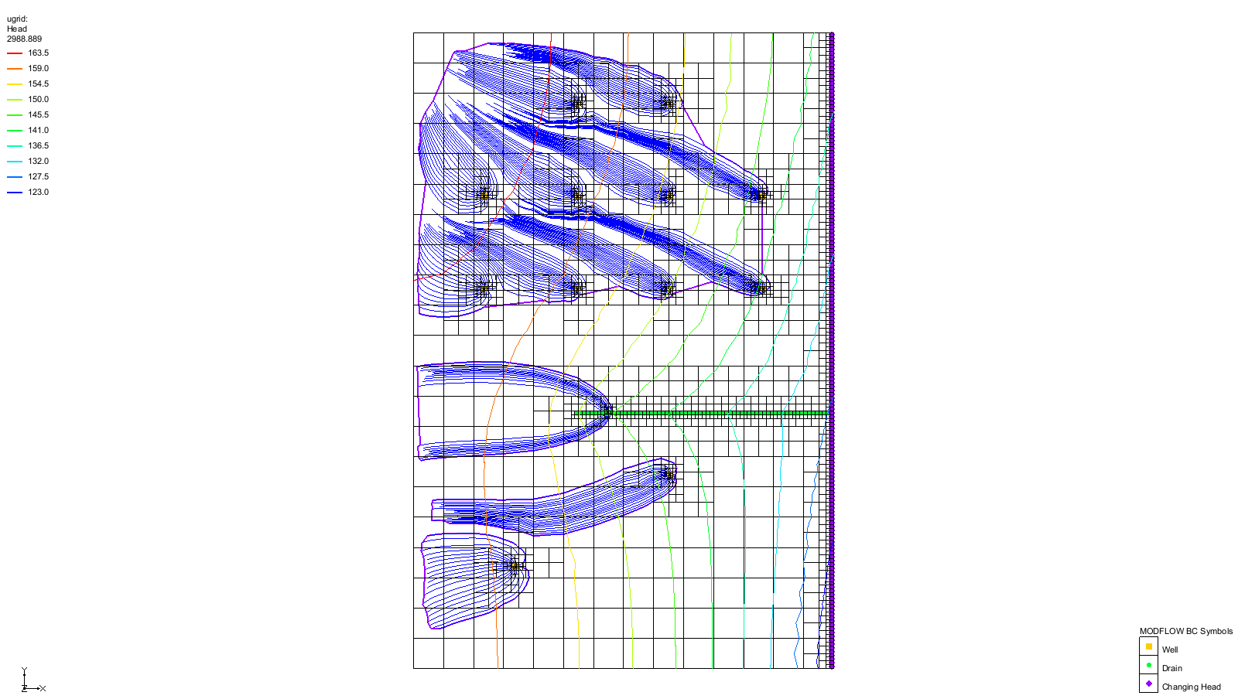

Figure 10 Capture zones for different well groups

# Exporting a Shapefile

The pathline solution can be exported as a shapefile for use in a GIS application. Three types of shapefiles can be exported: a point shapefile containing individual pathline points, a line shapefile representing each pathline, and a polygon shapefile showing the capture zone boundaries.

1. Right-click “http://www.xmswiki.com/images/thumb/1/1b/UGrid_Veronoi_Icon.svg/65px-UGrid_Veronoi_Icon.svg.png backward” and select **Export…** to bring up the *Export mod-PATH3DU* dialog.
2. Select “Pathline Shapefile (\*.shp)” from the *Save as type* drop-down.
3. Enter “backward.shp” as the *File name*.
4. Click **Save** to export the shapefile and close the *Export mod-PATH3DU* dialog.
5. Click **Open** File:Open Macro.svg to bring up the *Open* dialog.
6. Select “Shapefiles (\*.shp)” from the *Files of type* drop-down.
7. Select “backward.shp” and click **Open** to import the shapefile and exit the *Open* dialog.
8. Click the **Display Options** File:Display Options Macro.svg macro to bring up the *Display Options* dialog.
9. Select “UGrid: ugrid – [Active]” from the list on the left.
10. Under the *UGrid: ugrid – [Active]* tab, turn off *Cell edges* and *Face contours*.
11. Turn on *UGrid boundary*.
12. Select “GIS Data” from the list on the left.
13. Select “Blue” from the *Lines* drop-down.
14. Click **OK** to exit the *Display Options* dialog.
15. Turn off “File:UGrid Veronoi Icon.svg backward” in the Project Explorer.
16. Switch to **Oblique View** File:Oblique View Macro.svg.

The project should appear similar to Figure 11.

1. Using the **Rotate** http://www.xmswiki.com/images/thumb/7/7f/Rotate_Tool.svg/60px-Rotate_Tool.svg.png tool, examine the pathlines in 3D.

The lines in the shapefile are 3D lines, just as they are in GMS. The shapefile can be imported into another GIS application, if desired.

|  |  |
| --- | --- |
| Desc-i_gray 100px | Shapefiles of pathlines, path points, or capture zone polygons can all be exported from GMS. |

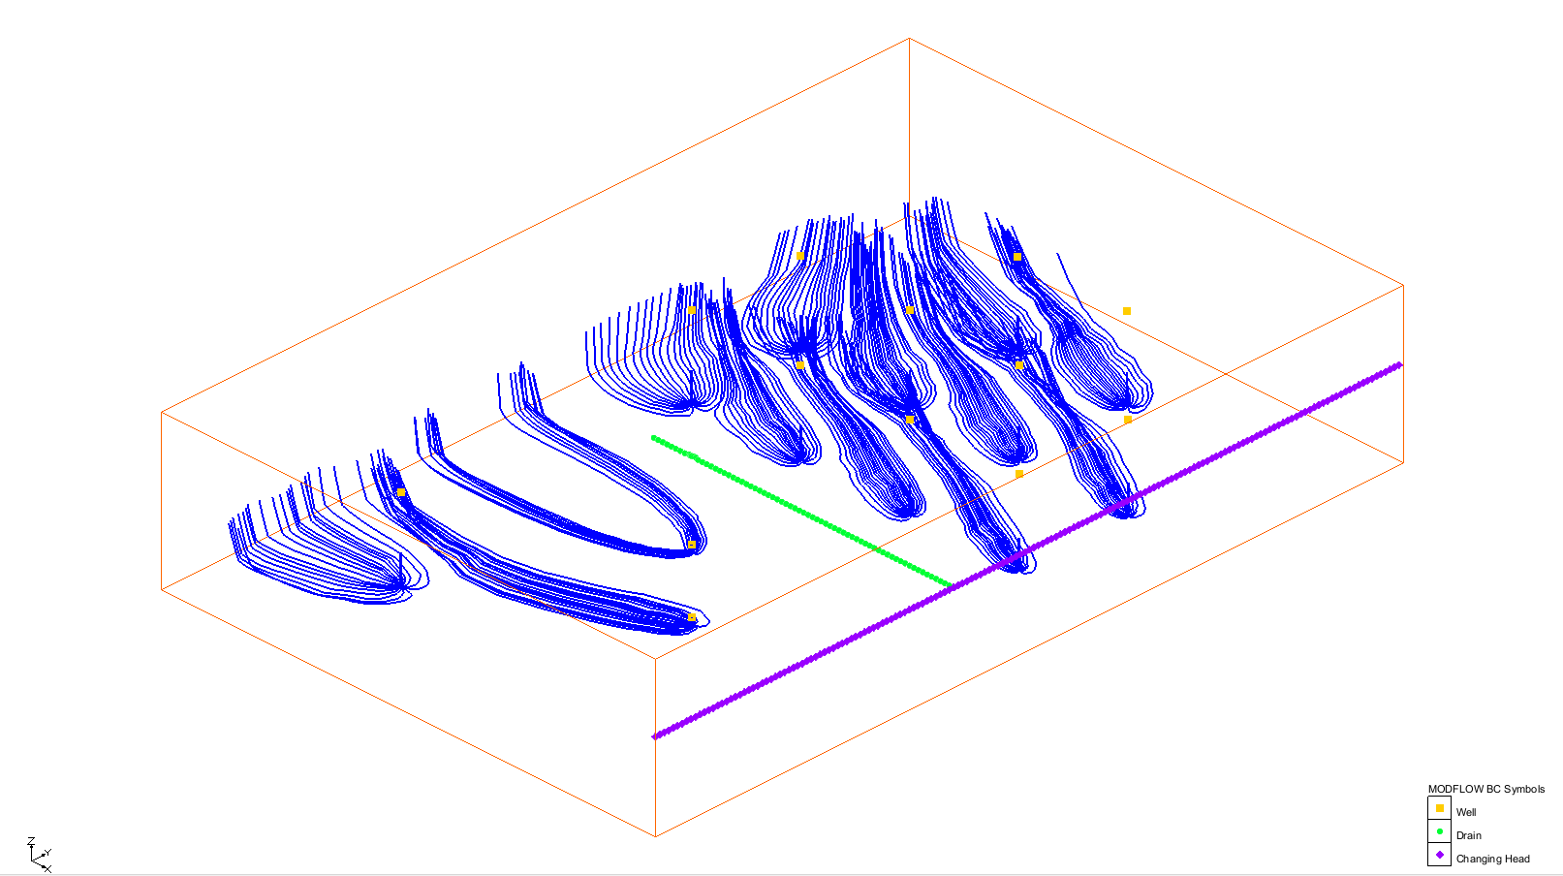

Figure 11 Pathline shapefile in 3D

# Conclusion

This concludes the “mod-PATH3DU Transient” tutorial. The following key concepts were discussed and demonstrated in this tutorial:

* The *Auto Compute Reference Time* option sets the *Reference Time* to either “0.0” or the MODFLOW end time, depending on the *Tracking Direction*
* Two *IFACE* entries are automatically created by GMS and may be used by mod-PATH3DU if needed
* mod-PATH3DU requires MODFLOW unit numbers be 199 or less
* Unit numbers can be modified using the *MODFLOW Name File* dialog
* The mod-PATH3DU model checker identifies obvious problems in the model setup
* Wells can be grouped into the same capture zone by assigning them the same name in the *MODFLOW Well Package* dialog

GMS can export shapefiles for pathlines, path points, or capture zone polygons.