Example Engineering

Johnson Reservoir Dam — Steady Seepage and Stability
  - Slope Stability Analysis Report

Project: | 2026-231
Author: | A. Engineer
Date: | August 30, 2026

Table of Contents
1 Traceability 3
2 Project Definition 3
3 Seepage Analysis 3
3.1 Analysis Inputs 4
3.2 Seepage Mesh 6
3.3 Results 6
4 Limit Equilibrium Analysis 8
4.1 Analysis Inputs 8
4.2 Materials 9
4.3 Loads 9
4.4 Factors of Safety 9
4.5 Bishop's Simplified Method 10
4.5.1 Search for the Critical Surface 10
4.5.2 Results 11
4.5.3 Slice Table 12
4.5.4 Calculations 15
4.6 Spencer's Method 17
4.6.1 Search for the Critical Surface 17
4.6.2 Results 18
4.6.3 Slice Table 19
4.6.4 Calculations 22
5 Deformation and Strength Reduction 24
5.1 Analysis Inputs 25
5.2 Loads 25
5.3 Finite Element Mesh 26
5.4 Results 26

Traceability
The results in this report were computed by xslope from the input file below. Its SHA-256 digest identifies that file exactly.
xslope version | 0.3.0
Input file | xslope_johnson_res_solved.xlsx
Input file SHA-256 | e24c17c9c65d3705c8f7bcacd2c2922e52d102793db88099dddadb9e75ba5c2a
Report generated | 2026-08-30 14:25

Project Definition
The problem cross section is defined by 3 material zones described with profile lines. The zones are named shell, core and foundation. Every analysis in this report is run on this cross section. The problem definition is displayed in Figure 1, including the geometry, the material zones and the maximum depth line the zones are closed at.
All quantities are in US customary units: lengths in ft, stresses and pressures in psf, unit weights in pcf, and forces per unit thickness of section in lb/ft. Angles are in degrees. The analysis is two-dimensional: every force is per unit thickness normal to the section. The unit weight of water is 62.4 pcf.
Each analysis states the materials and loads it reads off this model in its own section: Section 3 for the seepage analysis, Section 4 for the limit equilibrium analysis and Section 5 for the finite element analysis.
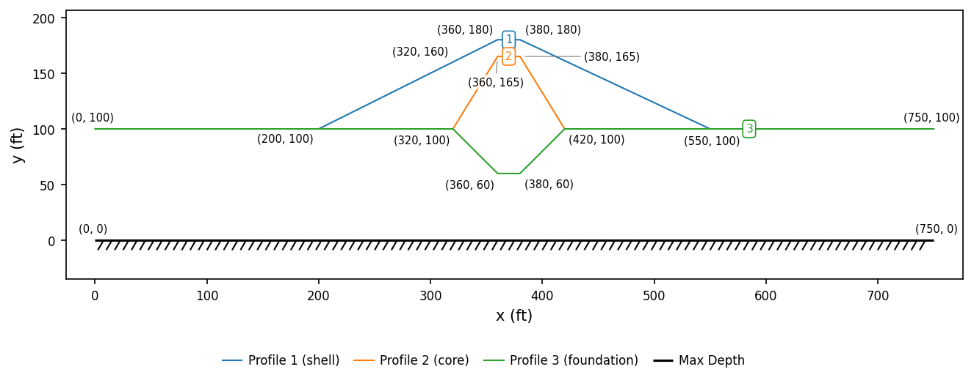
Figure 1. Analysis model, with each geometry point labeled with its coordinates

Seepage Analysis
Flow through the section was solved by the finite element method. The unknown at every node is total head, and the pore pressure at a node is the height of head above it times the unit weight of water. Every material whose pore pressure is taken from seepage reads it from this field.

Analysis Inputs
The problem inputs specific to the seepage model are shown in Figure 2, including the flow domain, its material zones and the water surface set by each specified-head boundary.
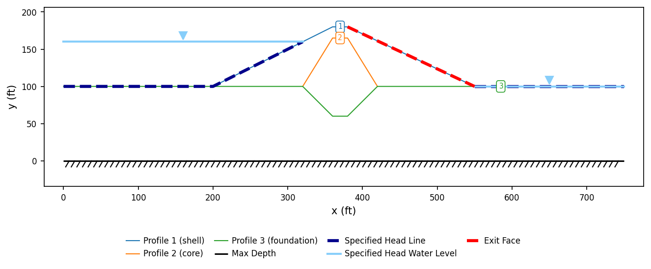
Figure 2. Seepage model
Mesh | 8,082 nodes, 3,923 elements (tri6)
Unit weight of water | 62.4 pcf

The material properties associated with the seepage analysis are shown in Table 1, including the major and minor saturated conductivities of every material in the flow domain and the angle its major axis makes with the horizontal. Above the phreatic surface the conductivity is reduced, so the table also carries, for each material, the unsaturated model it is assigned, the relative conductivity it falls to when dry and the pressure head over which it falls off.
Table 1. Seepage material properties
# | Material | k₁ (ft/day) | k₂ (ft/day) | α (deg) | Unsaturated model | k_{r0} | h₀ (ft)
1 | shell | 1 | 1 | 0.0 | linear front | 0.01 | -1.00
2 | core | 0.001 | 0.001 | 0.0 | linear front | 0.01 | -1.00
3 | foundation | 0.1 | 0.1 | 0.0 | linear front | 0.01 | -1.00

The reduction each material's unsaturated model applies — the factor multiplying its saturated conductivity — is shown in Figure 3 and Figure 4, against matric suction and against the pressure head the solver works in. Both curves are evaluated with the functions the flow solver itself uses.
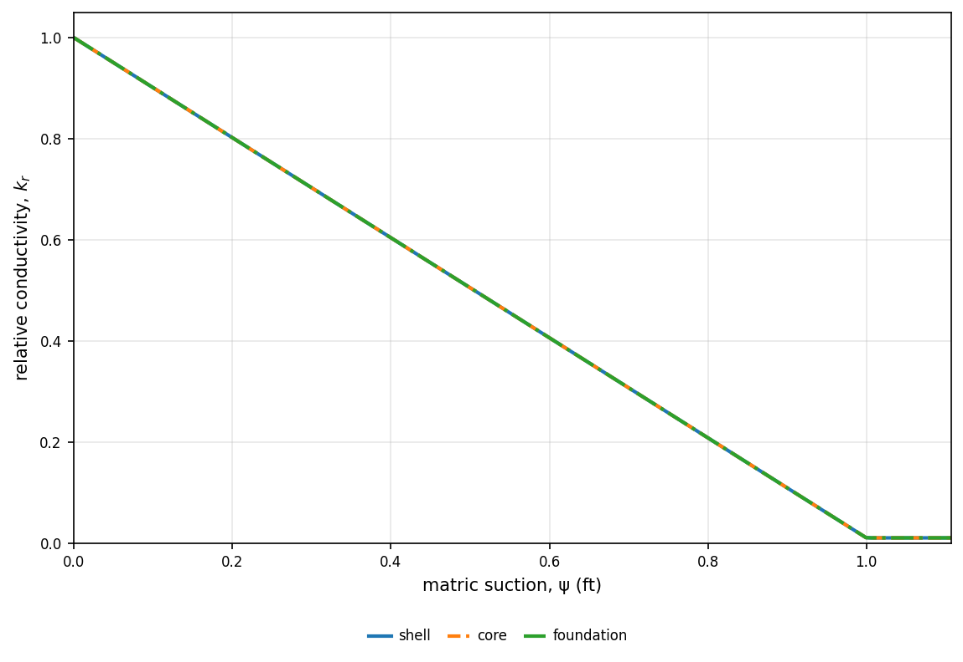
Figure 3. Unsaturated relative conductivity — matric suction
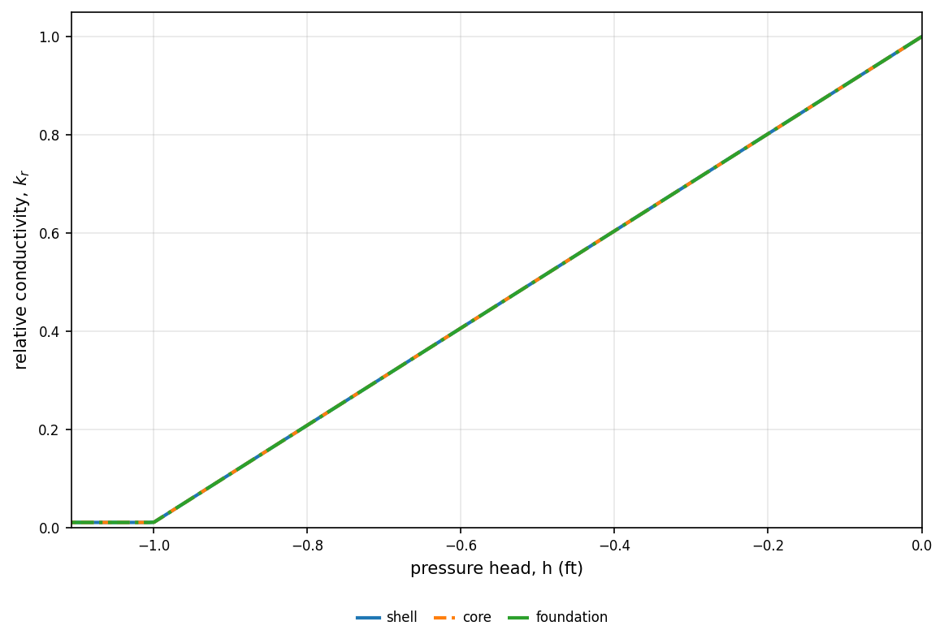
Figure 4. Unsaturated relative conductivity — pressure head

Seepage Mesh
The seepage mesh constructed for the problem is shown in Figure 5, colored by material, with every specified-head and exit-face node marked.
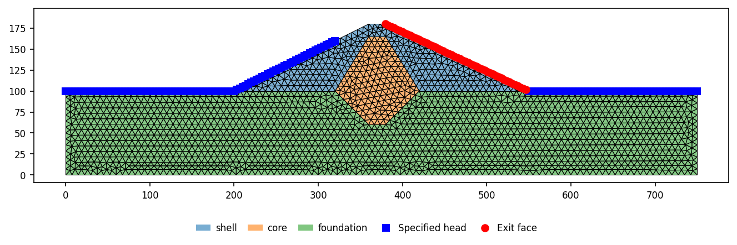
Figure 5. Seepage mesh and boundary conditions

Results
Flow was solved as an unconfined problem: the phreatic surface is located as part of the solution rather than prescribed. 146 nodes carry a specified head and 52 lie on an exit face, where water leaves the section at atmospheric pressure. The position of each of those boundaries is marked in Figure 5. The head contours, the phreatic surface, the flow lines and the water level held by each specified-head boundary are shown in Figure 6.
The flow through the section is 1.925 ft³/day per ft.
The solution converged, closing the boundary inflow against the outflow to within 1.53e-08 ft³/day per ft.
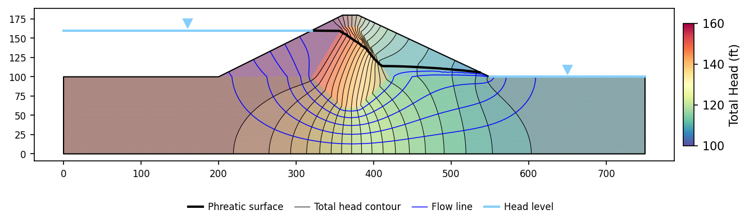
Figure 6. Flow net
The pore pressure field is shown in Figure 7.
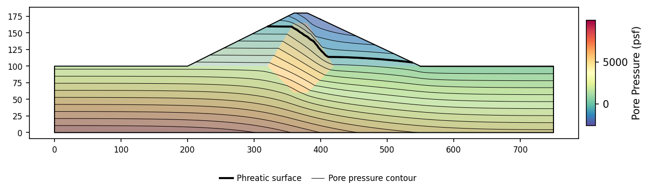
Figure 7. Pore pressure
The magnitude of the seepage velocity is shown in Figure 8, with the velocity vectors drawn over it.
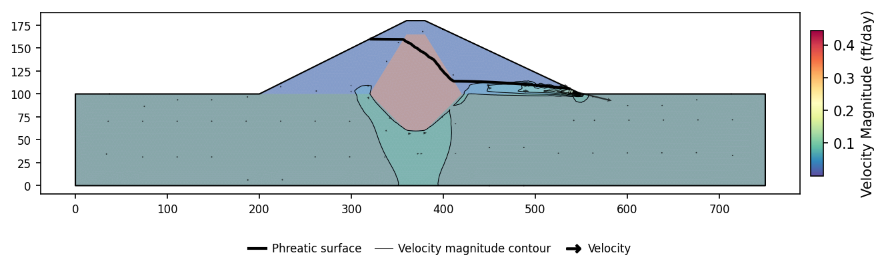
Figure 8. Velocity magnitude
The magnitude of the hydraulic gradient is shown in Figure 9.
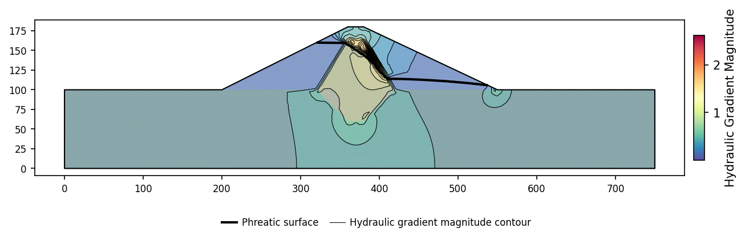
Figure 9. Hydraulic gradient magnitude

Limit Equilibrium Analysis
The stability of the section was evaluated by the method of slices. The factor of safety is the ratio of the shear strength available along the failure surface to the shear required along it to hold the sliding mass in static equilibrium.

Analysis Inputs
The problem inputs specific to the limit equilibrium model are shown in Figure 10, including the section and its materials, the water surface, the distributed loads and the starting circle for the search.
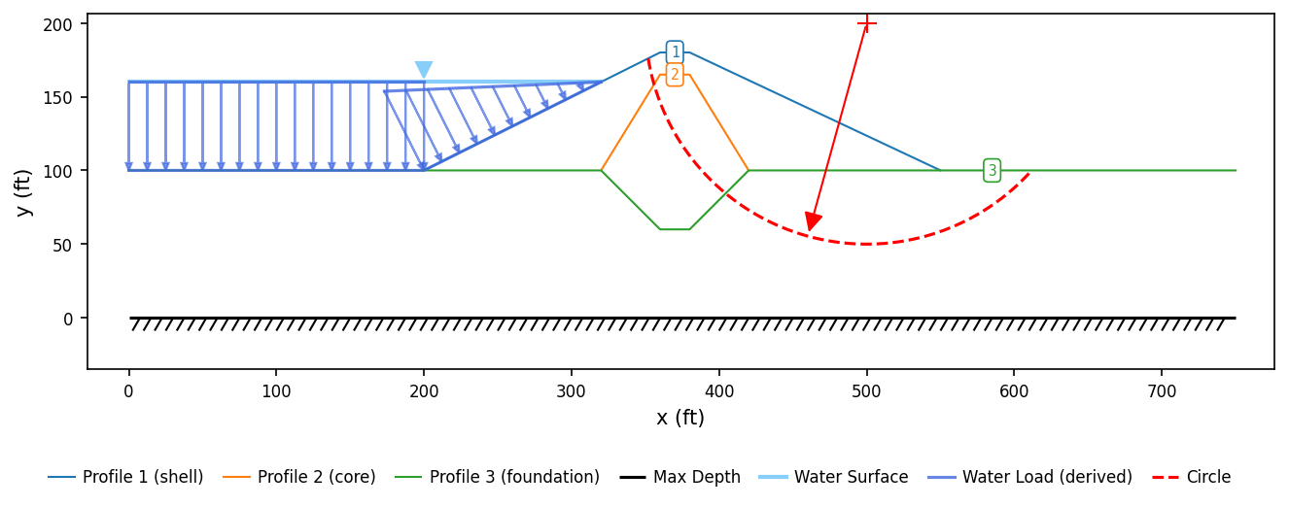
Figure 10. Limit equilibrium model
Methods reported in detail | Bishop's Simplified Method and Spencer's Method
Slices | 40
Surface family | circular
Starting circle | center (500, 200), R = 150
Surface | located by search
Seismic coefficient | none
Maximum surface depth (elevation) | 0

Materials
The material properties associated with the limit equilibrium analysis are shown in Table 2, including the strength option each material is analyzed under, the properties that option uses, and how its pore pressure is taken.
Table 2. Material properties
# | Material | γ (pcf) | Strength | c (psf) | φ (deg) | Pore pressure
1 | shell | 130.0 | MC | 100.0 | 35.0 | seep
2 | core | 125.0 | MC | 400.0 | 18.0 | seep
3 | foundation | 127.0 | MC | 100.0 | 27.0 | seep

Pore pressure on the base of a slice is taken from the computed seepage field, as the table states for each material.
The water surface the section stands under is the one the seepage analysis of Section 3 computes from its head boundaries.
Water loads | derived by the engine from the model's own water surface (automatic)
Water surface | computed by the seepage analysis

Loads
The distributed loads defined for this problem are listed in Table 3, including the polyline each load is defined by, every point with the pressure at it, and the direction that pressure acts in. The pressure varies linearly from point to point. The Source column tells the loads entered for this model from the ones the engine derived from its water surface. Each load is integrated along the ground surface between its end points.
Where the water surface stands above the ground surface, that water is applied to the ground as a distributed load, computed by the engine rather than entered: the pressure at a point is the depth of water above that point times the unit weight of water, and it acts normal to the ground surface. The pressure falls to zero at the shoreline where the two surfaces cross, and each separate stretch of ground standing under water carries its own load block.
Table 3. Distributed loads
Load | Points (x, y) @ pressure (psf) | Direction | Source
1 | (0, 100) @ 3744 → (200, 100) @ 3744 → (320, 160) @ 0 | normal | Derived from the water surface

Factors of Safety
The critical factor of safety reported by each method is listed in Table 4. Each method searched for its own critical surface; the surfaces differ from method to method. Each method is then reported in full below.
Table 4. Computed factors of safety
Method | Factor of safety | Solution parameters
Bishop's Simplified Method | 1.222
Spencer's Method | 1.248 | θ = -16.27 deg

Bishop's Simplified Method
Bishop's Simplified Method satisfies vertical force equilibrium of each slice and moment equilibrium of the sliding mass about the center of the circle. The interslice forces are assumed horizontal, which neglects the interslice shear. The base normal force that follows from vertical equilibrium depends on the factor of safety itself, so the two are solved together by iteration. The method applies to circular and composite surfaces.

Search for the Critical Surface
The critical surface was located by automated search, which refines a grid of trial surfaces until the factor of safety stops improving. The reported surface, highlighted in Figure 11, is the lowest the search reached. Every trial circle evaluated is drawn in gray, and its center marked by a black dot, so the dots map out the grid of centers the search covered; the critical circle and its center are drawn in red. The green arrows run from each refinement stage's best center to the next, and shorten as the grid is refined about the minimum.
Surface family | circular
Method | Bishop's Simplified Method
Trial surfaces evaluated | 583
Grid centers refined | 66
Refinement stages | 9
Factor of safety range | 1.222 to 1.588
Search window | none declared; the search was unconstrained

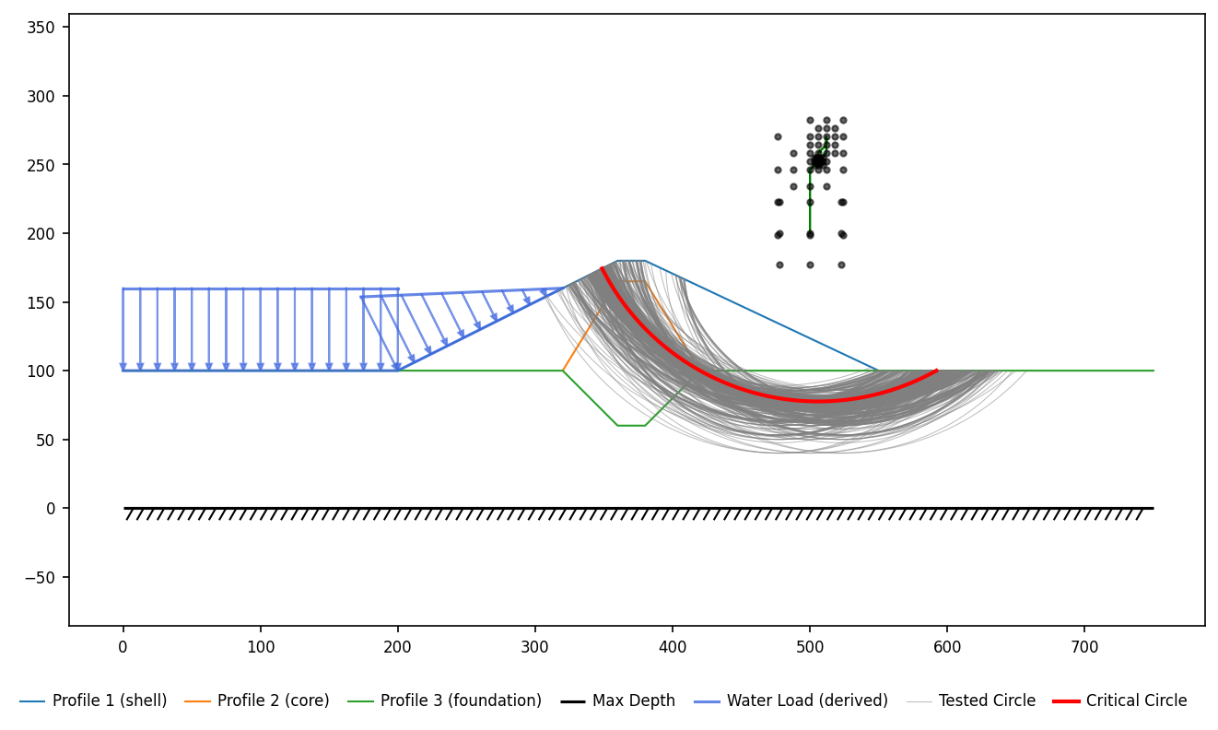
Figure 11. Trial surfaces evaluated by the search, with the critical surface highlighted

Results
Bishop's Simplified Method gives a factor of safety of 1.222 on the critical surface of Figure 12.
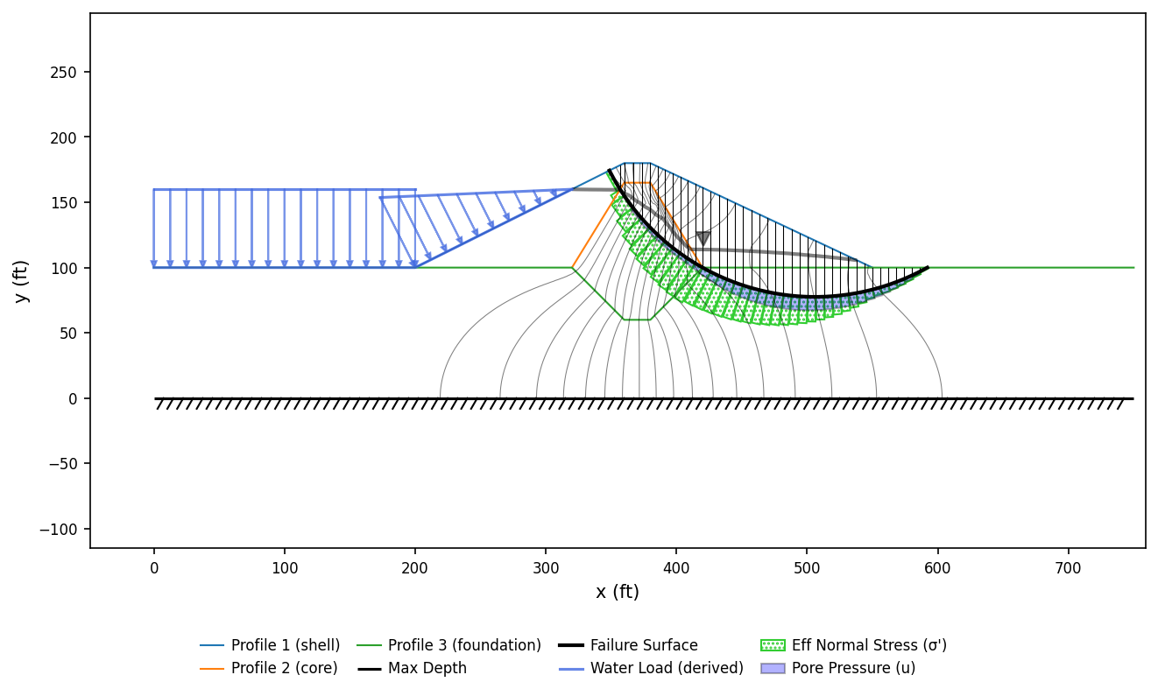
Figure 12. Critical surface and slice forces — Bishop's Simplified Method

Slice Table
The geometry, forces and strengths of every slice on the critical surface as solved by Bishop's Simplified Method are listed in Table 5, numbered as in Figure 13. Forces are per unit thickness of section.
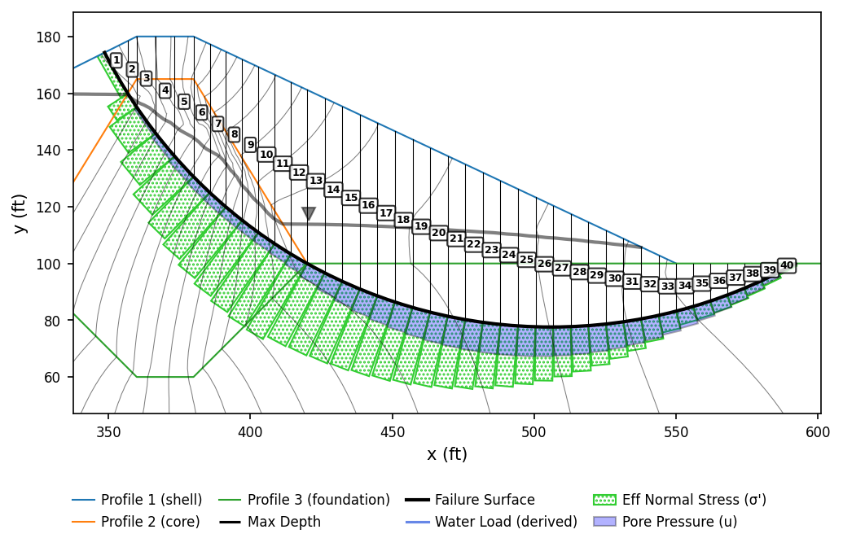
Figure 13. Slice numbering for the table below — Bishop's Simplified Method

Table 5. Slice data — Bishop's Simplified Method
Slice | x_{c} (ft) | y_{b} (ft) | y_{t} (ft) | Δx (ft) | Δl (ft) | α (deg) | W (lb/ft) | u (psf) | Mat | c (psf) | φ (deg) | N' (lb/ft) | M_{R} (lb·ft per ft) | M_{D} (lb·ft per ft)
1 | 352.76 | 166.71 | 176.38 | 8.18 | 16.55 | 60.37 | 10287.8 | 0.0 | 1 | 100.0 | 35.00 | 9179.3 | 1424599.9 | 1576163.1
2 | 358.43 | 157.43 | 179.21 | 3.14 | 5.75 | 56.84 | 8824.3 | 31.5 | 2 | 400.0 | 18.00 | 9290.6 | 937255.2 | 1301957.2
3 | 363.33 | 150.31 | 180.00 | 6.67 | 11.35 | 54.03 | 25239.6 | 216.6 | 2 | 400.0 | 18.00 | 25902.0 | 2283462.4 | 3600106.8
4 | 370.00 | 141.70 | 180.00 | 6.67 | 10.48 | 50.48 | 32416.1 | 403.2 | 2 | 400.0 | 18.00 | 32186.3 | 2581909.2 | 4407637.3
5 | 376.67 | 134.08 | 180.00 | 6.67 | 9.81 | 47.19 | 38770.7 | 538.4 | 2 | 400.0 | 18.00 | 37530.5 | 2840928.8 | 5013212.0
6 | 382.86 | 127.72 | 178.66 | 5.71 | 7.98 | 44.31 | 36897.6 | 613.3 | 2 | 400.0 | 18.00 | 35023.6 | 2568581.7 | 4542615.2
7 | 388.57 | 122.39 | 175.97 | 5.71 | 7.66 | 41.77 | 38975.7 | 644.0 | 2 | 400.0 | 18.00 | 36432.4 | 2626417.0 | 4575777.8
8 | 394.28 | 117.50 | 173.28 | 5.71 | 7.39 | 39.32 | 40734.2 | 649.8 | 2 | 400.0 | 18.00 | 37671.5 | 2678024.5 | 4549512.4
9 | 400.00 | 113.01 | 170.59 | 5.71 | 7.15 | 36.96 | 42206.5 | 644.5 | 2 | 400.0 | 18.00 | 38707.0 | 2720737.6 | 4472820.6
10 | 405.71 | 108.89 | 167.90 | 5.71 | 6.95 | 34.67 | 43419.2 | 656.3 | 2 | 400.0 | 18.00 | 39412.6 | 2746809.3 | 4353272.9
11 | 411.42 | 105.10 | 165.21 | 5.71 | 6.77 | 32.44 | 44393.9 | 711.4 | 2 | 400.0 | 18.00 | 39673.2 | 2749258.5 | 4197361.0
12 | 417.14 | 101.62 | 162.52 | 5.71 | 6.61 | 30.27 | 45148.2 | 812.8 | 2 | 400.0 | 18.00 | 39503.5 | 2728621.7 | 4010744.6
13 | 423.09 | 98.30 | 159.72 | 6.20 | 7.02 | 28.05 | 49462.5 | 1005.6 | 3 | 100.0 | 27.00 | 39828.3 | 3700547.9 | 4099417.5
14 | 429.29 | 95.15 | 156.81 | 6.19 | 6.88 | 25.79 | 49527.9 | 1216.9 | 3 | 100.0 | 27.00 | 38592.7 | 3586984.2 | 3798043.0
15 | 435.48 | 92.31 | 153.89 | 6.19 | 6.75 | 23.58 | 49420.3 | 1394.5 | 3 | 100.0 | 27.00 | 37447.0 | 3481960.5 | 3483857.7
16 | 441.67 | 89.74 | 150.98 | 6.19 | 6.65 | 21.40 | 49090.5 | 1544.9 | 3 | 100.0 | 27.00 | 36307.7 | 3377784.8 | 3156717.1
17 | 447.86 | 87.45 | 148.07 | 6.19 | 6.56 | 19.25 | 48548.8 | 1671.6 | 3 | 100.0 | 27.00 | 35156.2 | 3272766.4 | 2821344.0
18 | 454.05 | 85.42 | 145.15 | 6.19 | 6.48 | 17.13 | 47803.9 | 1777.2 | 3 | 100.0 | 27.00 | 33979.5 | 3165696.4 | 2482123.5
19 | 460.24 | 83.63 | 142.24 | 6.19 | 6.41 | 15.04 | 46862.9 | 1863.4 | 3 | 100.0 | 27.00 | 32768.5 | 3055740.2 | 2143163.7
20 | 466.43 | 82.09 | 139.33 | 6.19 | 6.35 | 12.96 | 45732.1 | 1931.4 | 3 | 100.0 | 27.00 | 31514.6 | 2942122.5 | 1808345.9
21 | 472.62 | 80.78 | 136.41 | 6.19 | 6.30 | 10.91 | 44416.6 | 1982.2 | 3 | 100.0 | 27.00 | 30210.3 | 2824138.1 | 1481365.5
22 | 478.81 | 79.70 | 133.50 | 6.19 | 6.27 | 8.86 | 42920.4 | 2016.6 | 3 | 100.0 | 27.00 | 28848.3 | 2701139.2 | 1165767.5
23 | 485.00 | 78.85 | 130.59 | 6.19 | 6.23 | 6.83 | 41246.9 | 2035.2 | 3 | 100.0 | 27.00 | 27421.7 | 2572482.0 | 864976.1
24 | 491.19 | 78.22 | 127.68 | 6.19 | 6.21 | 4.81 | 39398.7 | 2038.3 | 3 | 100.0 | 27.00 | 25922.7 | 2437471.0 | 582322.0
25 | 497.38 | 77.80 | 124.76 | 6.19 | 6.20 | 2.79 | 37377.7 | 2026.3 | 3 | 100.0 | 27.00 | 24343.2 | 2295370.7 | 321065.4
26 | 503.57 | 77.61 | 121.85 | 6.19 | 6.19 | 0.78 | 35185.1 | 1999.4 | 3 | 100.0 | 27.00 | 22674.6 | 2145406.9 | 84418.8
27 | 509.76 | 77.64 | 118.94 | 6.19 | 6.19 | -1.23 | 32821.5 | 1957.4 | 3 | 100.0 | 27.00 | 20907.8 | 1986755.1 | -124433.0
28 | 515.95 | 77.88 | 116.02 | 6.19 | 6.20 | -3.25 | 30286.8 | 1900.1 | 3 | 100.0 | 27.00 | 19033.0 | 1818538.2 | -302312.9
29 | 522.14 | 78.34 | 113.11 | 6.19 | 6.22 | -5.26 | 27580.2 | 1827.1 | 3 | 100.0 | 27.00 | 17039.8 | 1639828.2 | -446031.7
30 | 528.33 | 79.02 | 110.20 | 6.19 | 6.24 | -7.29 | 24700.5 | 1737.8 | 3 | 100.0 | 27.00 | 14917.0 | 1449616.7 | -552368.1
31 | 534.52 | 79.92 | 107.28 | 6.19 | 6.27 | -9.32 | 21645.6 | 1631.2 | 3 | 100.0 | 27.00 | 12652.6 | 1246833.2 | -618047.8
32 | 540.71 | 81.05 | 104.37 | 6.19 | 6.31 | -11.37 | 18412.6 | 1506.1 | 3 | 100.0 | 27.00 | 10233.2 | 1030277.4 | -639721.3
33 | 546.90 | 82.41 | 101.46 | 6.19 | 6.36 | -13.43 | 14998.3 | 1362.3 | 3 | 100.0 | 27.00 | 7633.7 | 797714.9 | -613939.7
34 | 553.00 | 83.98 | 100.00 | 5.99 | 6.22 | -15.47 | 12193.4 | 1204.9 | 3 | 100.0 | 27.00 | 5989.6 | 647525.1 | -573414.8
35 | 558.99 | 85.76 | 100.00 | 5.99 | 6.29 | -17.51 | 10842.3 | 1040.8 | 3 | 100.0 | 27.00 | 5744.7 | 626689.9 | -574871.8
36 | 564.99 | 87.77 | 100.00 | 5.99 | 6.36 | -19.56 | 9312.1 | 871.7 | 3 | 100.0 | 27.00 | 5308.7 | 588881.2 | -549562.5
37 | 570.98 | 90.02 | 100.00 | 5.99 | 6.45 | -21.64 | 7596.2 | 696.8 | 3 | 100.0 | 27.00 | 4658.9 | 532063.2 | -493838.3
38 | 576.98 | 92.53 | 100.00 | 5.99 | 6.55 | -23.76 | 5687.0 | 513.4 | 3 | 100.0 | 27.00 | 3780.8 | 454974.2 | -403808.1
39 | 582.97 | 95.30 | 100.00 | 5.99 | 6.66 | -25.90 | 3575.1 | 318.7 | 3 | 100.0 | 27.00 | 2653.0 | 355708.6 | -275286.8
40 | 588.97 | 98.36 | 100.00 | 5.99 | 6.80 | -28.09 | 1249.8 | 110.3 | 3 | 100.0 | 27.00 | 1240.4 | 231157.7 | -103730.8
Total |  |  |  | 243.29 | 284.08 |  | 1255209.5 |  |  |  |  | 957320.8 | 83852780.5 | 68622741.0
Slice: Slice number, counted from the left edge of the failure surface. x_{c} (ft): Horizontal coordinate of the slice mid-point. y_{b} (ft): Elevation of the failure surface at the slice mid-point. y_{t} (ft): Elevation of the ground surface at the slice mid-point. Δx (ft): Slice width. Δl (ft): Length of the slice base along the failure surface. α (deg): Inclination of the slice base, positive when the base rises toward the toe. W (lb/ft): Weight of the slice, per unit thickness. u (psf): Pore water pressure on the slice base at its mid-point. Mat: Index of the material the slice base runs through, numbered as on the materials sheet. c (psf): Cohesion of the base material, in the strength formulation the analysis is run under. φ (deg): Friction angle of the base material. N' (lb/ft): Effective normal force on the slice base, per unit thickness, as solved. M_{R} (lb·ft per ft): Resisting moment this slice contributes about the center of rotation, (c·Δl + N'·tan φ)·R. M_{D} (lb·ft per ft): Net driving moment this slice contributes about the center of rotation.

Calculations
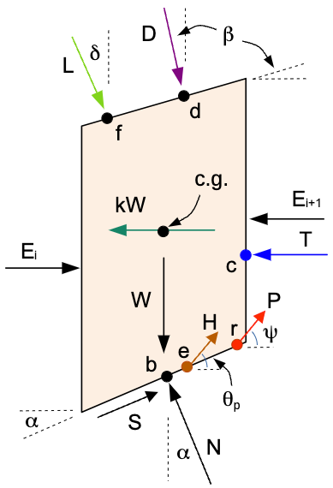
Figure 14. Forces on a slice — Bishop's Simplified Method
The equations below are in the symbols of the derivation published for Bishop's Simplified Method in the XSLOPE documentation; the numbers in them are the converged values.
Every sum below is formed, slice by slice, from the forces on the slice of Figure 14.
Equation (10) of the derivation is the factor of safety this method solves: the strength mobilized on the slice bases over the forces that drive the mass, both sides written as moments about the center of rotation divided by the radius. Its numerator $N_{S}$ and the driving terms below it are one sum per force, and $N_{v}$ is the group of vertical forces that equation (8) forms the base normal from:
$$F = \frac{N_{S}}{D_{W} + D_{D} + D_{k} + D_{T} − D_{P} − D_{H} − D_{L}}$$
$$N_{S} = \sum{\frac{c·Δl·cos α + N_{v}·tan φ}{cos α + \frac{sin α·tan φ}{F}}}$$
$$N_{v} = W + D cos β − P sin ψ − H sin θ_{p} − L sin δ − u·Δl·cos α$$
$$D_{W} = \sum{W·sin α}$$
$$D_{D} = \frac{1}{R}·\sum{D cos β·a_{dx}} − \frac{1}{R}·\sum{D sin β·a_{dy}}$$
$$D_{k} = \frac{k}{R}·\sum{W·a_{k}}$$
$$D_{T} = \frac{1}{R}·T·a_{t}$$
$$D_{P} = \frac{1}{R}·\sum{(P cos ψ·a_{ry} + P sin ψ·a_{rx})}$$
$$D_{H} = \frac{1}{R}·\sum{(H cos θ_{p}·a_{ey} + H sin θ_{p}·a_{ex})}$$
$$D_{L} = \frac{1}{R}·\sum{(L cos δ·a_{fy} + L sin δ·a_{fx})}$$
The model carries no distributed load, seismic load, tension-crack water force, reinforcement crossing the failure surface, pile force and line load, so equation (10) is:
$$F = \frac{N_{S}}{D_{W}}$$
$$N_{S} = \sum{\frac{c·Δl·cos α + N_{v}·tan φ}{cos α + \frac{sin α·tan φ}{F}}}$$
$$N_{v} = W − u·Δl·cos α$$
$$D_{W} = \sum{W·sin α}$$
The symbols used above are defined in Table 6. Those that are columns of Table 5 carry a value for every slice.
Table 6. Nomenclature — Bishop's Simplified Method
Symbol | Meaning
R | radius of the circular failure surface
Δl (ft) | Length of the slice base along the failure surface
α (deg) | Inclination of the slice base, positive when the base rises toward the toe
W (lb/ft) | Weight of the slice, per unit thickness
u (psf) | Pore water pressure on the slice base at its mid-point
c (psf) | Cohesion of the base material, in the strength formulation the analysis is run under
φ (deg) | Friction angle of the base material
F | factor of safety
N_{S} | the strength mobilized on the slice bases, summed over the slices — the numerator of the factor of safety
N_{v} | the vertical forces on the slice other than the base reaction and the mobilized cohesion, which the base normal force is formed from
D_{W} | driving term of the slice weights
D_{D} | driving term of the distributed load, both components
D_{k} | driving term of the seismic force
D_{T} | driving term of the water in the tension crack
D_{P} | resisting term of the reinforcement crossing the failure surface
D_{H} | resisting term of the pile force
D_{L} | term of the line load, whose sign follows its own inclination
k | seismic coefficient, the fraction of the slice weight applied horizontally
β | inclination of the distributed load from vertical (perpendicular to the slope)
ψ | angle of the reinforcement force from horizontal
θ_{p} | angle of the pile force from horizontal (positive counterclockwise, upward)
δ | angle of the line load from horizontal (−90° is straight down)
a_{dx} | horizontal moment arm of the distributed load
a_{dy} | vertical moment arm of the distributed load
a_{k} | moment arm of the seismic force, taken at the slice center of gravity
a_{t} | moment arm of the tension-crack water force
a_{rx} | horizontal moment arm of the reinforcement force
a_{ry} | vertical moment arm of the reinforcement force
a_{ex} | horizontal moment arm of the pile force
a_{ey} | vertical moment arm of the pile force
a_{fx} | horizontal moment arm of the line load
a_{fy} | vertical moment arm of the line load
L | line load applied on top of the slice, per unit thickness
D | resultant of the distributed load acting on the top of the slice, per unit thickness
T | resultant force of the water in a tension crack — column T_{c} of the slice table
P | reinforcement force crossing the failure surface, at the angle ψ from horizontal
H | pile or pier force on the slice at the failure surface — column H_{p} of the slice table

Once the converged factor of safety is known, equation (10) can be evaluated with the solved values. Each named sum below is one force's moment about the center of rotation, divided by the radius and summed over the 40 slices; the per-slice moments are columns $M_{R}$ and $M_{D}$ of Table 5, in lb·ft per ft:
$$N_{S} = 475756$$
$$D_{W} = 389345$$
$$F = \frac{N_{S}}{D_{W}} = \frac{475756}{389345} = 1.222$$

Spencer's Method
Spencer's Method is a complete-equilibrium procedure: it satisfies force equilibrium — both horizontal and vertical — and moment equilibrium of the sliding mass. Its single assumption is that the interslice forces are parallel, at one constant inclination θ, and the factor of safety and θ are solved together from those two conditions. The method applies to circular and non-circular surfaces and is the recommended basis for design.

Search for the Critical Surface
The critical surface was located by automated search, which refines a grid of trial surfaces until the factor of safety stops improving. The reported surface, highlighted in Figure 15, is the lowest the search reached. Every trial circle evaluated is drawn in gray, and its center marked by a black dot, so the dots map out the grid of centers the search covered; the critical circle and its center are drawn in red. The green arrows run from each refinement stage's best center to the next, and shorten as the grid is refined about the minimum.
Surface family | circular
Method | Spencer's Method
Trial surfaces evaluated | 628
Grid centers refined | 71
Refinement stages | 8
Factor of safety range | 1.248 to 1.605
Search window | none declared; the search was unconstrained

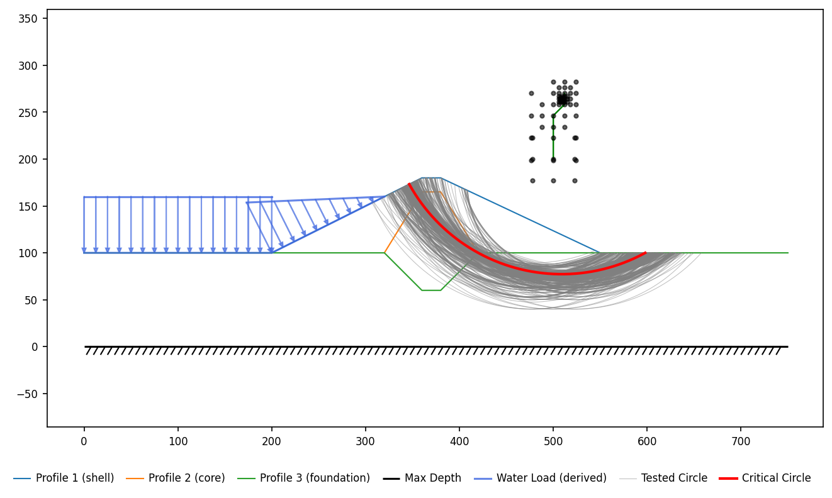
Figure 15. Trial surfaces evaluated by the search, with the critical surface highlighted

Results
Spencer's Method gives a factor of safety of 1.248 on the critical surface of Figure 16.
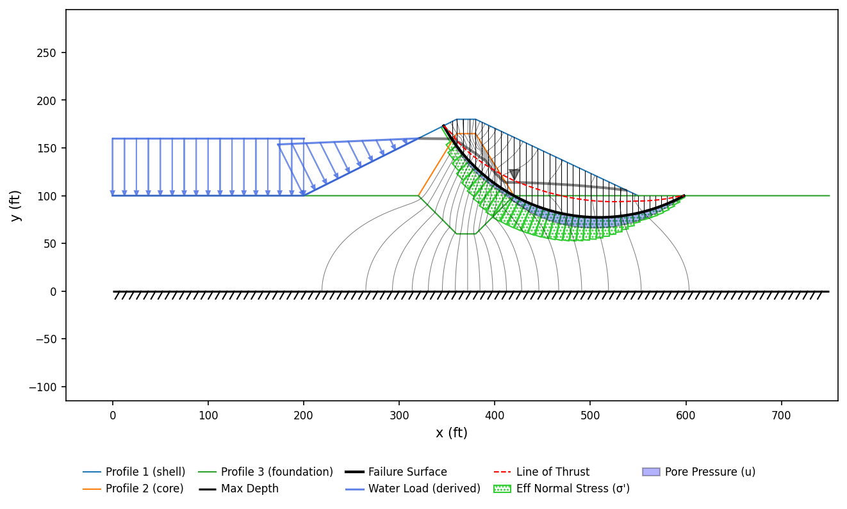
Figure 16. Critical surface and slice forces — Spencer's Method

Slice Table
The geometry, forces and strengths of every slice on the critical surface as solved by Spencer's Method are listed in Table 7, numbered as in Figure 17. Forces are per unit thickness of section.
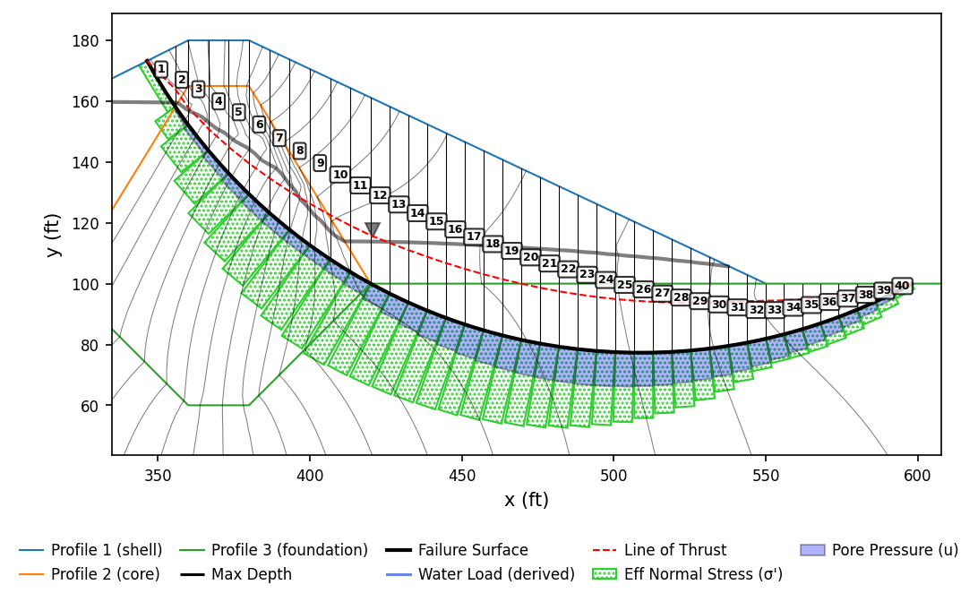
Figure 17. Slice numbering for the table below — Spencer's Method

Table 7. Slice data — Spencer's Method
Slice | x_{c} (ft) | y_{b} (ft) | y_{t} (ft) | Δx (ft) | Δl (ft) | α (deg) | W (lb/ft) | u (psf) | Mat | c (psf) | φ (deg) | N' (lb/ft) | Z (lb/ft) | F_{h} (lb/ft) | F_{v} (lb/ft) | Q_{s} (lb/ft) | y_{Q} (ft)
1 | 351.13 | 165.29 | 175.57 | 9.29 | 17.68 | 58.29 | 12420.7 | 0.0 | 1 | 100.0 | 35.00 | 9812.6 | 0.0 | 0.0 | -12420.7 | -4905.8 | 165.29
2 | 357.89 | 155.11 | 178.94 | 4.22 | 7.27 | 54.52 | 12946.8 | 165.4 | 2 | 400.0 | 18.00 | 10607.7 | 4905.8 | 0.0 | -12946.8 | -6938.7 | 155.11
3 | 363.33 | 147.86 | 180.00 | 6.67 | 10.76 | 51.71 | 27286.7 | 327.8 | 2 | 400.0 | 18.00 | 22078.8 | 11844.5 | 0.0 | -27286.7 | -15002.1 | 147.86
4 | 370.00 | 139.88 | 180.00 | 6.67 | 10.06 | 48.50 | 33933.2 | 485.3 | 2 | 400.0 | 18.00 | 27137.7 | 26846.6 | 0.0 | -33933.2 | -17882.4 | 139.88
5 | 376.67 | 132.73 | 180.00 | 6.67 | 9.51 | 45.48 | 39889.6 | 598.3 | 2 | 400.0 | 18.00 | 31843.9 | 44729.0 | 0.0 | -39889.6 | -19599.4 | 132.73
6 | 383.33 | 126.28 | 178.43 | 6.67 | 9.06 | 42.62 | 44084.2 | 661.3 | 2 | 400.0 | 18.00 | 35251.0 | 64328.4 | 0.0 | -44084.2 | -19830.6 | 126.28
7 | 390.00 | 120.44 | 175.29 | 6.67 | 8.69 | 39.88 | 46598.3 | 680.5 | 2 | 400.0 | 18.00 | 37431.0 | 84159.0 | 0.0 | -46598.3 | -18935.1 | 120.44
8 | 396.67 | 115.12 | 172.16 | 6.67 | 8.37 | 37.25 | 48669.7 | 673.4 | 2 | 400.0 | 18.00 | 39431.9 | 103094.1 | 0.0 | -48669.7 | -17680.4 | 115.12
9 | 403.33 | 110.28 | 169.02 | 6.67 | 8.11 | 34.70 | 50344.5 | 665.9 | 2 | 400.0 | 18.00 | 41108.9 | 120774.4 | 0.0 | -50344.5 | -16192.5 | 110.28
10 | 410.00 | 105.88 | 165.88 | 6.67 | 7.88 | 32.24 | 51659.4 | 703.8 | 2 | 400.0 | 18.00 | 42170.0 | 136967.0 | 0.0 | -51659.4 | -14614.5 | 105.88
11 | 416.67 | 101.86 | 162.75 | 6.67 | 7.68 | 29.83 | 52644.1 | 805.6 | 2 | 400.0 | 18.00 | 42529.3 | 151581.5 | 0.0 | -52644.1 | -13016.7 | 101.86
12 | 423.10 | 98.34 | 159.72 | 6.19 | 6.99 | 27.57 | 49387.0 | 1001.8 | 3 | 100.0 | 27.00 | 38125.0 | 164598.3 | 0.0 | -49387.0 | -6865.5 | 98.34
13 | 429.29 | 95.26 | 156.81 | 6.19 | 6.85 | 25.43 | 49443.6 | 1209.2 | 3 | 100.0 | 27.00 | 37247.5 | 171463.8 | 0.0 | -49443.6 | -5548.0 | 95.26
14 | 435.48 | 92.45 | 153.89 | 6.19 | 6.74 | 23.33 | 49305.1 | 1384.2 | 3 | 100.0 | 27.00 | 36449.9 | 177011.8 | 0.0 | -49305.1 | -4138.6 | 92.45
15 | 441.67 | 89.91 | 150.98 | 6.19 | 6.64 | 21.27 | 48956.6 | 1533.2 | 3 | 100.0 | 27.00 | 35671.3 | 181150.4 | 0.0 | -48956.6 | -2671.6 | 89.91
16 | 447.86 | 87.63 | 148.07 | 6.19 | 6.56 | 19.23 | 48407.4 | 1659.5 | 3 | 100.0 | 27.00 | 34888.1 | 183822.0 | 0.0 | -48407.4 | -1175.3 | 87.63
17 | 454.05 | 85.59 | 145.15 | 6.19 | 6.48 | 17.21 | 47665.2 | 1765.5 | 3 | 100.0 | 27.00 | 34082.9 | 184997.3 | 0.0 | -47665.2 | 326.4 | 85.59
18 | 460.24 | 83.79 | 142.24 | 6.19 | 6.42 | 15.22 | 46736.6 | 1852.8 | 3 | 100.0 | 27.00 | 33243.0 | 184670.9 | 0.0 | -46736.6 | 1812.9 | 83.79
19 | 466.43 | 82.22 | 139.33 | 6.19 | 6.36 | 13.25 | 45627.1 | 1922.7 | 3 | 100.0 | 27.00 | 32356.7 | 182858.0 | 0.0 | -45627.1 | 3264.6 | 82.22
20 | 472.62 | 80.87 | 136.41 | 6.19 | 6.31 | 11.29 | 44341.5 | 1976.0 | 3 | 100.0 | 27.00 | 31413.1 | 179593.4 | 0.0 | -44341.5 | 4662.9 | 80.87
21 | 478.81 | 79.75 | 133.50 | 6.19 | 6.27 | 9.35 | 42883.6 | 2013.7 | 3 | 100.0 | 27.00 | 30401.9 | 174930.5 | 0.0 | -42883.6 | 5989.5 | 79.75
22 | 485.00 | 78.83 | 130.59 | 6.19 | 6.24 | 7.42 | 41256.7 | 2036.1 | 3 | 100.0 | 27.00 | 29312.7 | 168941.0 | 0.0 | -41256.7 | 7225.7 | 78.83
23 | 491.19 | 78.13 | 127.67 | 6.19 | 6.22 | 5.49 | 39463.1 | 2043.7 | 3 | 100.0 | 27.00 | 28133.8 | 161715.3 | 0.0 | -39463.1 | 8352.2 | 78.13
24 | 497.38 | 77.64 | 124.76 | 6.19 | 6.20 | 3.58 | 37504.9 | 2036.8 | 3 | 100.0 | 27.00 | 26852.9 | 153363.2 | 0.0 | -37504.9 | 9348.1 | 77.64
25 | 503.57 | 77.36 | 121.85 | 6.19 | 6.19 | 1.66 | 35383.2 | 2015.5 | 3 | 100.0 | 27.00 | 25456.4 | 144015.1 | 0.0 | -35383.2 | 10191.1 | 77.36
26 | 509.76 | 77.28 | 118.94 | 6.19 | 6.19 | -0.25 | 33099.0 | 1979.9 | 3 | 100.0 | 27.00 | 23929.1 | 133824.0 | 0.0 | -33099.0 | 10856.9 | 77.28
27 | 515.95 | 77.41 | 116.02 | 6.19 | 6.19 | -2.16 | 30652.2 | 1929.8 | 3 | 100.0 | 27.00 | 22254.3 | 122967.1 | 0.0 | -30652.2 | 11318.1 | 77.41
28 | 522.14 | 77.75 | 113.11 | 6.19 | 6.21 | -4.08 | 28042.7 | 1864.7 | 3 | 100.0 | 27.00 | 20413.0 | 111649.0 | 0.0 | -28042.7 | 11544.3 | 77.75
29 | 528.33 | 78.29 | 110.20 | 6.19 | 6.22 | -6.00 | 25269.6 | 1784.2 | 3 | 100.0 | 27.00 | 18383.0 | 100104.7 | 0.0 | -25269.6 | 11500.3 | 78.29
30 | 534.52 | 79.05 | 107.28 | 6.19 | 6.25 | -7.92 | 22331.3 | 1687.5 | 3 | 100.0 | 27.00 | 16138.4 | 88604.4 | 0.0 | -22331.3 | 11145.6 | 79.05
31 | 540.71 | 80.02 | 104.37 | 6.19 | 6.28 | -9.86 | 19225.8 | 1573.9 | 3 | 100.0 | 27.00 | 13646.9 | 77458.8 | 0.0 | -19225.8 | 10431.7 | 80.02
32 | 546.90 | 81.20 | 101.46 | 6.19 | 6.32 | -11.80 | 15950.4 | 1443.4 | 3 | 100.0 | 27.00 | 10860.1 | 67027.1 | 0.0 | -15950.4 | 9296.8 | 81.20
33 | 552.99 | 82.58 | 100.00 | 5.99 | 6.16 | -13.73 | 13247.4 | 1301.3 | 3 | 100.0 | 27.00 | 9089.7 | 57730.4 | 0.0 | -13247.4 | 8486.5 | 82.58
34 | 558.98 | 84.15 | 100.00 | 5.99 | 6.22 | -15.64 | 12053.5 | 1152.8 | 3 | 100.0 | 27.00 | 9081.2 | 49243.9 | 0.0 | -12053.5 | 8783.7 | 84.15
35 | 564.97 | 85.94 | 100.00 | 5.99 | 6.28 | -17.57 | 10694.9 | 999.4 | 3 | 100.0 | 27.00 | 8841.0 | 40460.2 | 0.0 | -10694.9 | 8839.6 | 85.94
36 | 570.96 | 87.95 | 100.00 | 5.99 | 6.35 | -19.52 | 9166.5 | 840.3 | 3 | 100.0 | 27.00 | 8327.6 | 31620.6 | 0.0 | -9166.5 | 8596.1 | 87.95
37 | 576.95 | 90.19 | 100.00 | 5.99 | 6.44 | -21.50 | 7462.4 | 673.8 | 3 | 100.0 | 27.00 | 7496.3 | 23024.6 | 0.0 | -7462.4 | 7983.8 | 90.19
38 | 582.94 | 92.67 | 100.00 | 5.99 | 6.53 | -23.50 | 5575.6 | 497.3 | 3 | 100.0 | 27.00 | 6289.0 | 15040.8 | 0.0 | -5575.6 | 6914.0 | 92.67
39 | 588.93 | 95.40 | 100.00 | 5.99 | 6.64 | -25.53 | 3498.1 | 308.8 | 3 | 100.0 | 27.00 | 4615.8 | 8126.7 | 0.0 | -3498.1 | 5264.2 | 95.40
40 | 594.92 | 98.40 | 100.00 | 5.99 | 6.76 | -27.60 | 1220.3 | 106.8 | 3 | 100.0 | 27.00 | 2343.4 | 2862.6 | 0.0 | -1220.3 | 2862.6 | 98.40
Total |  |  |  | 251.43 | 290.62 |  | 1284328.7 |  |  |  |  | 974746.7 |  |  |  | -0.0
Slice: Slice number, counted from the left edge of the failure surface. x_{c} (ft): Horizontal coordinate of the slice mid-point. y_{b} (ft): Elevation of the failure surface at the slice mid-point. y_{t} (ft): Elevation of the ground surface at the slice mid-point. Δx (ft): Slice width. Δl (ft): Length of the slice base along the failure surface. α (deg): Inclination of the slice base, positive when the base rises toward the toe. W (lb/ft): Weight of the slice, per unit thickness. u (psf): Pore water pressure on the slice base at its mid-point. Mat: Index of the material the slice base runs through, numbered as on the materials sheet. c (psf): Cohesion of the base material, in the strength formulation the analysis is run under. φ (deg): Friction angle of the base material. N' (lb/ft): Effective normal force on the slice base, per unit thickness, as solved. Z (lb/ft): Interslice force on the right-hand side of the slice, per unit thickness. F_{h} (lb/ft): Resultant of all the forces on the slice except the base normal, the base shear and the interslice forces — horizontal component, per unit thickness. F_{v} (lb/ft): Resultant of all the forces on the slice except the base normal, the base shear and the interslice forces — vertical component, per unit thickness. Q_{s} (lb/ft): Resultant of the interslice forces on the slice (Spencer's Q), per unit thickness. y_{Q} (ft): Elevation of the line of action of Q_{s}.

Calculations
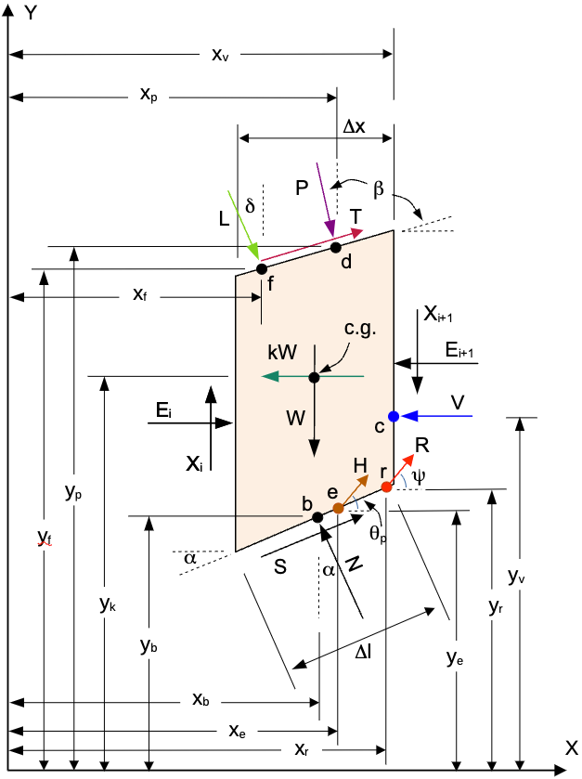
Figure 18. Forces on a slice — Spencer's Method
The equations below are in the symbols of the derivation published for Spencer's Method in the XSLOPE documentation; the numbers in them are the converged values.
Spencer's method lumps the interslice forces on each slice into a single resultant Q acting at the constant inclination θ, so that force and moment equilibrium of the whole sliding mass are two equations in the two unknowns F and θ. $F_{h}$ and $F_{v}$ are the sums of the forces on the slice of Figure 18 other than the base normal, the base shear and the interslice forces, as equations (1) and (2) of the derivation write them:
$$F_{h} = −kW − V + P sin β + T cos β + R cos ψ + H cos θ_{p} + L cos δ$$
$$F_{v} = −W − P cos β + T sin β + R sin ψ + H sin θ_{p} + L sin δ$$
The model carries no distributed load, seismic load, tension-crack water force, reinforcement crossing the failure surface, pile force and line load, and no shear on the top of the slice is simulated, so equations (1) and (2) reduce to:
$$F_{h} = 0$$
$$F_{v} = −W$$
Equations (23) and (24) give Q on each slice from them and from the strength mobilized on its base:
$$Q = [−F_{v}·sin α − F_{h}·cos α − \frac{c·Δl}{F} + (F_{v}·cos α − F_{h}·sin α + u·Δl)·\frac{tan φ}{F}]·m_{α}$$
$$m_{α} = \frac{1}{cos (α − θ) + sin (α − θ)·\frac{tan φ}{F}}$$
There is no equation for F: it appears inside Q, in the mobilized cohesion c·Δl/F and the friction tan φ/F, and again with θ in $m_{α}$. A trial pair (F, θ) fixes Q on every slice.
$F_{h}$, $F_{v}$, Q and $y_{Q}$ are columns $F_{h}$, $F_{v}$, $Q_{s}$ and $y_{Q}$ of the slice table; each row's Q follows from that row through the two equations above, at the converged F and θ.
The derivation is written for a slice of a left-facing slope; this slope faces right and is solved as its mirror image. α, c and tan φ enter the equations above with their signs reversed. $F_{h}$, $F_{v}$, $Q_{s}$ and $y_{Q}$ are the mirrored slice's own values and enter as printed. The factor of safety, a ratio, is unaffected.
Substituting Q and $y_{Q}$ into the equilibrium of the whole sliding mass gives equations (27) and (28) of the derivation, two equations in the two unknowns. $R_{1}$ is the force imbalance and $R_{2}$ the moment imbalance, and the solution is the pair (F, θ) at which both are zero:
$$R_{1} = \sum{Q}$$
$$R_{2} = \sum{Q·(x_{b}·sin θ − y_{Q}·cos θ)}$$
F and θ are iterated together: each trial pair recomputes both sums, and the pair is adjusted until both vanish.
The symbols used above are defined in Table 8. Those that are columns of Table 7 carry a value for every slice.
Table 8. Nomenclature — Spencer's Method
Symbol | Meaning
T | shear force on the top of the slice
P | resultant of the distributed load on the top of the slice, in the symbols of equations (1) and (2) — column D of the slice table, and written D below, where P is instead the reinforcement force
Δl (ft) | Length of the slice base along the failure surface
α (deg) | Inclination of the slice base, positive when the base rises toward the toe
W (lb/ft) | Weight of the slice, per unit thickness
u (psf) | Pore water pressure on the slice base at its mid-point
c (psf) | Cohesion of the base material, in the strength formulation the analysis is run under
φ (deg) | Friction angle of the base material
F_{h} (lb/ft) | Resultant of all the forces on the slice except the base normal, the base shear and the interslice forces — horizontal component, per unit thickness
F_{v} (lb/ft) | Resultant of all the forces on the slice except the base normal, the base shear and the interslice forces — vertical component, per unit thickness
y_{Q} (ft) | Elevation of the line of action of Q_{s}
F | factor of safety
β | inclination of the distributed load from vertical (perpendicular to the slope)
ψ | angle of the reinforcement force from horizontal
θ_{p} | angle of the pile force from horizontal (positive counterclockwise, upward)
δ | angle of the line load from horizontal (−90° is straight down)
θ | inclination of the interslice forces from horizontal
m_{α} | the base-normal denominator, which carries the factor of safety and is what makes the solution iterative
L | line load applied on top of the slice, per unit thickness
kW | horizontal seismic force on the slice, per unit thickness — column kW of the slice table
R | reinforcement force on the slice base, at the angle ψ from horizontal — column P of the slice table, and written P below
V | resultant force of the water in a tension crack — column T_{c} of the slice table, which the other methods' equations write T
H | pile or pier force on the slice at the failure surface — column H_{p} of the slice table
Q | resultant of the interslice forces on the slice, at the inclination θ — column Q_{s} of the slice table
x_{b} | horizontal coordinate of the slice base mid-point
R₁ | force imbalance of the whole sliding mass at a trial (F, θ) — zero at the solution
R₂ | moment imbalance of the whole sliding mass at a trial (F, θ) — zero at the solution

The iteration converged at F = 1.248 with θ = -16.27 degrees. The force equation is the $Q_{s}$ column of Table 7 added up over the 40 slices, printed as the total at the foot of that column:
$$R_{1} = \sum{Q} = -2.728e-11$$
That is one part in 13,560 trillion of the 369995 the magnitudes of Q come to. The moment equation weights the same column by $x_{c}$ — the $x_{b}$ of equation (28) — and by $y_{Q}$, at the θ above:
$$R_{2} = \sum{Q·(x_{b}·sin θ − y_{Q}·cos θ)} = 6.752e-09$$
That is one part in 12,439 trillion of the 83989264 its moment terms come to. Sums re-formed from the printed, rounded columns carry that rounding and close to within a thousandth of these totals.

Deformation and Strength Reduction
The factor of safety was computed by the shear strength reduction method. The shear strength of every material is divided by a trial factor — both the cohesion and the tangent of the friction angle — and the section is solved again at that reduced strength; the factor of safety is the largest reduction the section can withstand. Each trial is solved by the finite element method. Each material is linearly elastic below its Mohr-Coulomb yield surface and perfectly plastic on it, and the viscoplastic algorithm of Griffiths and Lane finds the stresses that satisfy equilibrium under gravity without exceeding that surface. No failure surface is assumed: where the section shears is an outcome of the solution. The critical factor is bracketed between a trial the section stands under and one it does not, and the bracket is halved until it is narrower than 0.01. The factor of safety is the midpoint of the final bracket, which spans 1.227 to 1.234. A trial that cannot reach equilibrium counts as failed unless its computed displacements both stayed at the elastic scale of that same trial and stopped growing. Where they did, the non-convergence is read as a failure to settle rather than a failure of the slope, and the trial is counted as standing.

Analysis Inputs
The problem inputs specific to the finite element model are shown in Figure 19, including the material zones, the water surface and the distributed loads.
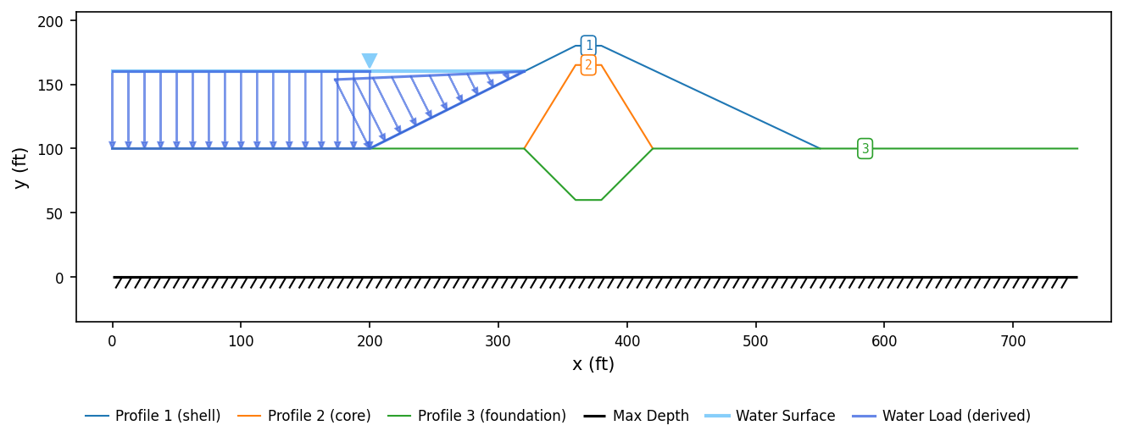
Figure 19. Finite element model
No at-rest coefficient K₀ is specified. The initial stresses are found by applying gravity to the unstressed section; plane-strain elasticity then gives the horizontal stress as $σ_{h}$ = ν/(1−ν)·$σ_{v}$ — about 0.43 $σ_{v}$ at ν = 0.3.
The material properties associated with SSRM finite element analysis are shown in Table 9, including the unit weight, the Mohr-Coulomb strength that sets when an element yields, and the Young's modulus and Poisson's ratio that set how it deforms before yielding.
Table 9. Finite element material properties
# | Material | γ (pcf) | c (psf) | φ (deg) | E (psf) | ν
1 | shell | 130.0 | 100.0 | 35.0 | 2,000,000 | 0.20
2 | core | 125.0 | 400.0 | 18.0 | 200,000 | 0.40
3 | foundation | 127.0 | 100.0 | 27.0 | 1,000,000 | 0.35

Pore pressure at every node is taken from the computed seepage field. That is the field the seepage analysis of Section 3 reports.

Loads
The distributed loads this analysis applies are the ones of Section 4.3, listed in Table 3, carried here as tractions on the boundary of the mesh.

Finite Element Mesh
Both analyses were run on the same mesh, shown in Figure 20 and described in Section 3. The mesh is colored by material. The nodes along the base of the mesh are fixed in both directions, and the nodes on its two sides are on rollers, held horizontally and free to move vertically, so the truncated ground can settle under its own weight.
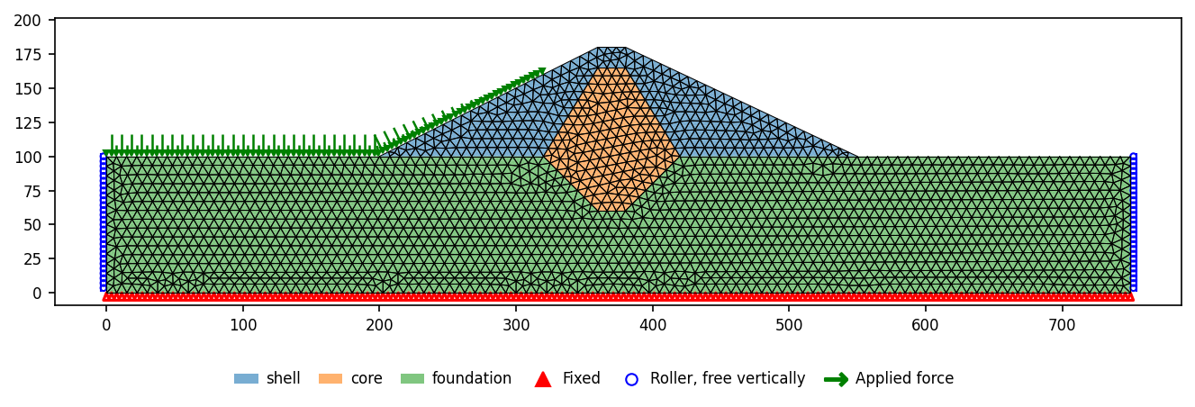
Figure 20. Finite element mesh and boundary conditions

Results
The shear strength reduction method gives a factor of safety of 1.230. The plots below show the mechanism at failure — the trial at which the section could not reach equilibrium. Figure 21 shows the viscoplastic shear strain — where the section is shearing; Figure 22 shows the deformed mesh over the original section; and Figure 23 shows the displacement at every node as an arrow — how the section is moving.
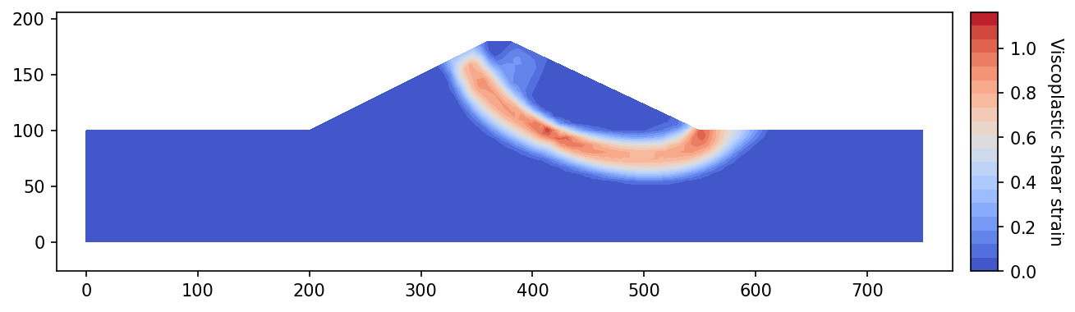
Figure 21. Viscoplastic shear strain — strength reduction analysis
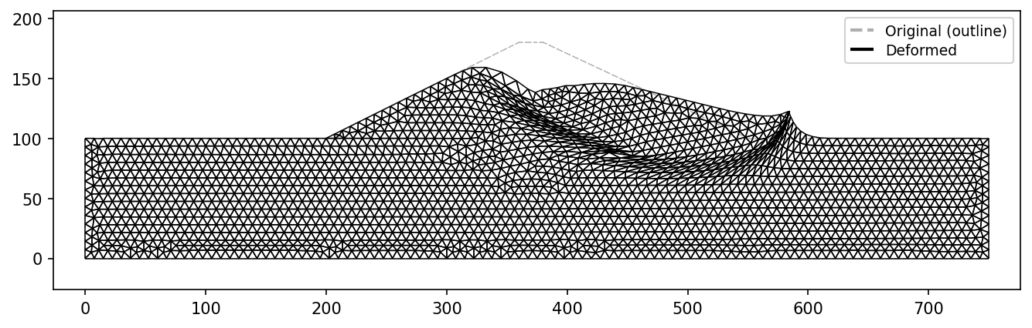
Figure 22. Deformed mesh — strength reduction analysis
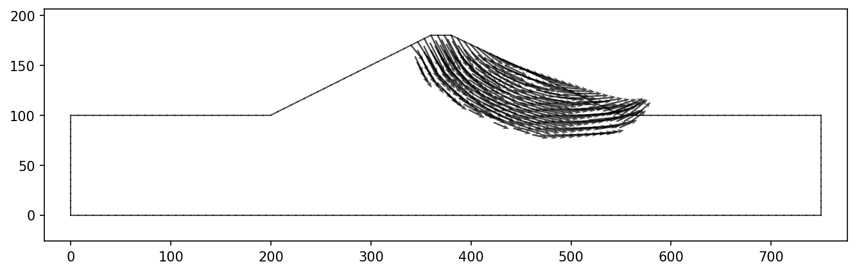
Figure 23. Displacement vectors — strength reduction analysis
The strength reduction search is shown in Figure 24. It plots each of the 9 trials at its own reduction factor, marked by whether the section stood under that factor, with the bracket that remained after each trial.
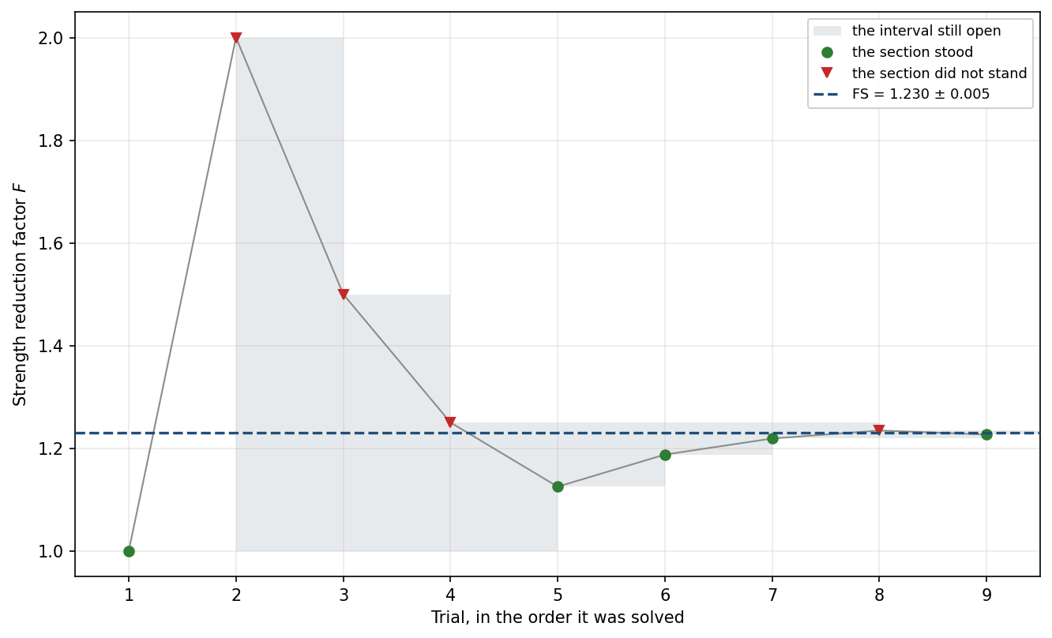
Figure 24. Strength reduction search

