Slope Stability Analysis
  - Slope Stability Analysis Report

Date: | August 29, 2026

Table of Contents
1 Traceability
2 Project Definition
3 Limit Equilibrium Analysis
3.1 Analysis Inputs
3.2 Materials
3.3 Loads
3.4 Spencer's Method
3.4.1 Search for the Critical Surface
3.4.2 Results
3.4.3 Slice Table
3.4.4 Calculations
Page numbers appear when the table is updated in Word (right-click → Update Field, or select all and press F9).

Traceability
The results in this report were computed by xslope from the input file below. Its SHA-256 digest identifies that file exactly.
xslope version | 0.3.0
Input file | xslope_simple_mult_layers.xlsx
Input file SHA-256 | d0307449074ab1094764c075b45ec241a098fbe10731a5cf497b1846581da1bb
Report generated | 2026-08-29 16:09

Project Definition
The problem cross section is defined by 2 material zones described with profile lines. The zones are named embankment and foundation. The problem definition is displayed in Figure 1, including the geometry, the material zones and the maximum depth line the zones are closed at.
All quantities are in US customary units: lengths in ft, stresses and pressures in psf, unit weights in pcf, and forces per unit thickness of section in lb/ft. Angles are in degrees. The analysis is two-dimensional: every force is per unit thickness normal to the section. The unit weight of water is 62.4 pcf.
The materials the analysis reads off this model are stated in Section 3.
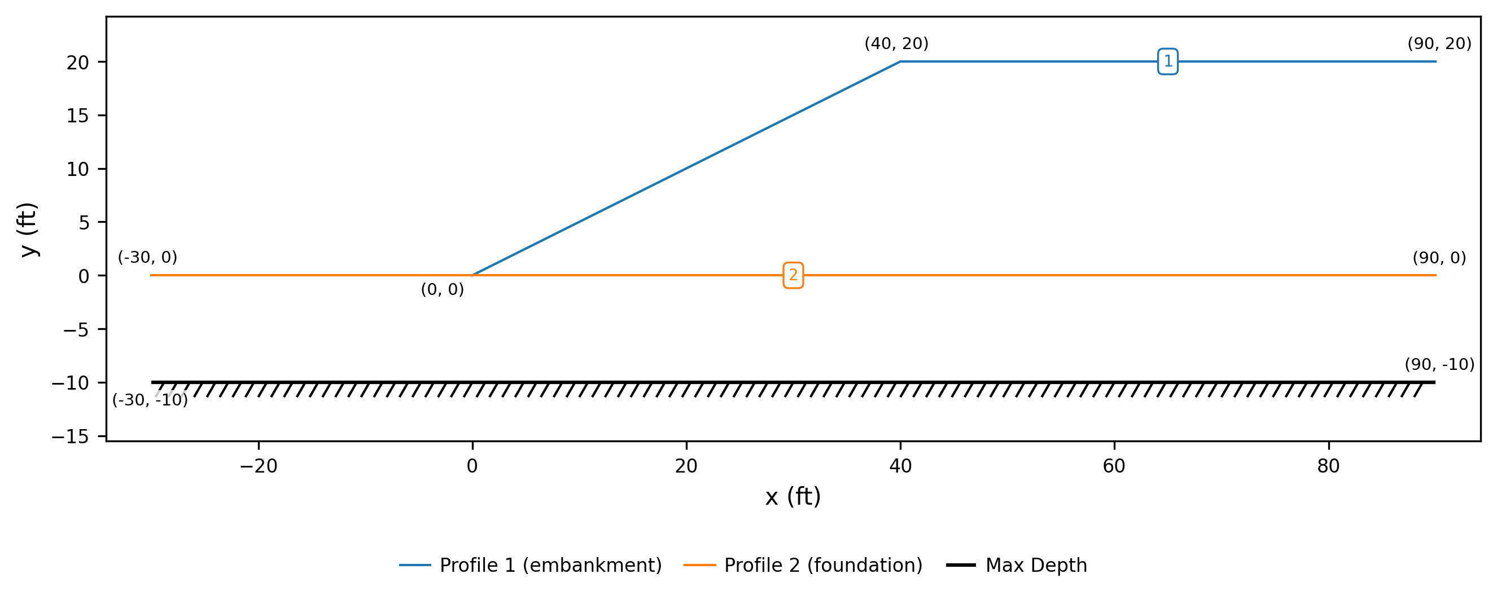
Figure 1. Analysis model, with each geometry point labeled with its coordinates

Limit Equilibrium Analysis
The stability of the section was evaluated by the method of slices. The factor of safety is the ratio of the shear strength available along the failure surface to the shear required along it to hold the sliding mass in static equilibrium.

Analysis Inputs
The problem inputs specific to the limit equilibrium model are shown in Figure 2, including the section and its materials, and the starting circle for the search.
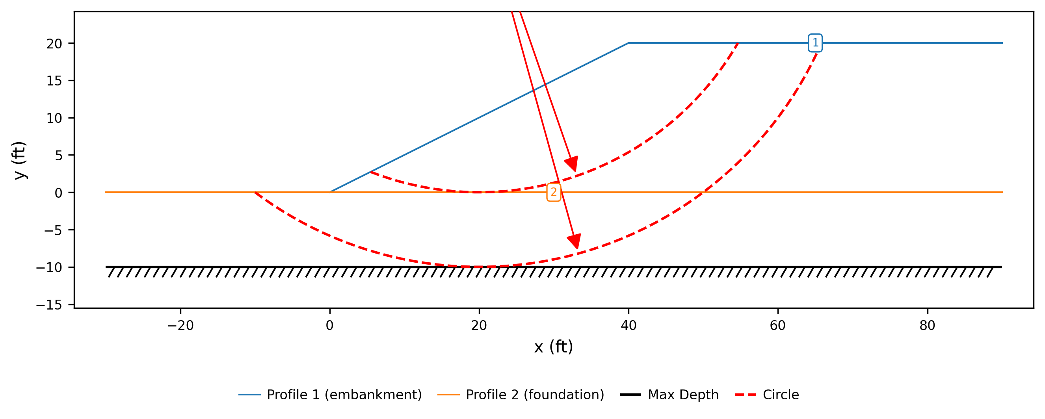
Figure 2. Limit equilibrium model
Method reported in detail | Spencer's Method
Slices | 40
Surface family | circular
Starting circle | center (20, 40), R = 40
Surface | located by search
Seismic coefficient | none
Maximum surface depth (elevation) | -10

Materials
The material properties associated with the limit equilibrium analysis are shown in Table 1, including the strength option each material is analyzed under, the properties that option uses, and how its pore pressure is taken.
Table 1. Material properties
# | Material | γ (pcf) | Strength | c (psf) | φ (deg) | Pore pressure
1 | embankment | 130.0 | MC | 400.0 | 0.0 | none
2 | foundation | 135.0 | MC | 800.0 | 0.0 | none

The model defines no groundwater and no external water; the section is analyzed dry, with zero pore pressure throughout.

Loads
The model carries no distributed loads.

Spencer's Method
Spencer's Method is a complete-equilibrium procedure: it satisfies force equilibrium — both horizontal and vertical — and moment equilibrium of the sliding mass. Its single assumption is that the interslice forces are parallel, at one constant inclination θ, and the factor of safety and θ are solved together from those two conditions. The method applies to circular and non-circular surfaces and is the recommended basis for design.

Search for the Critical Surface
The critical surface was located by automated search, which refines a grid of trial surfaces until the factor of safety stops improving. The reported surface, highlighted in Figure 3, is the lowest the search reached. Every trial circle evaluated is drawn in gray, and its center marked by a black dot, so the dots map out the grid of centers the search covered; the critical circle and its center are drawn in red. The green arrows run from each refinement stage's best center to the next, and shorten as the grid is refined about the minimum.
Surface family | circular
Method | Spencer's Method
Trial surfaces evaluated | 529
Grid centers refined | 62
Refinement stages | 7
Factor of safety range | 1.244 to 1.739
Search window | none declared; the search was unconstrained

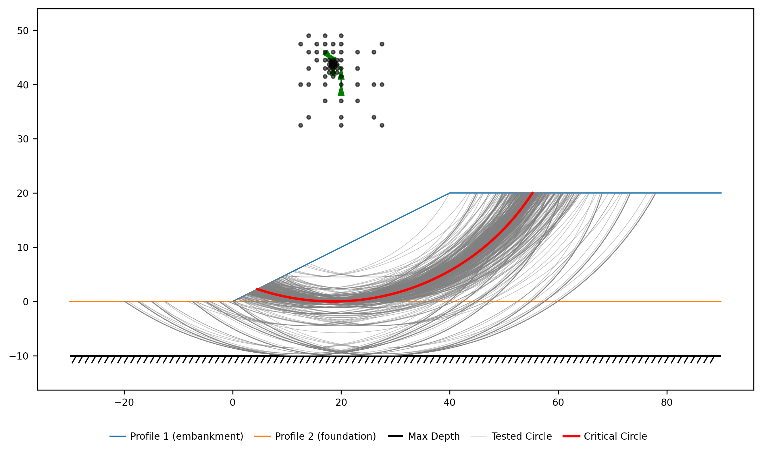
Figure 3. Trial surfaces evaluated by the search, with the critical surface highlighted

Results
Spencer's Method gives a factor of safety of 1.244 on the critical surface of Figure 4.
The solution reported the following admissibility notes, where the computed stresses depart from what the method assumes:
- interslice tension (min Z = -1436.3 vs max compression 7382.1)
- line of thrust outside the slice on 15% of boundaries
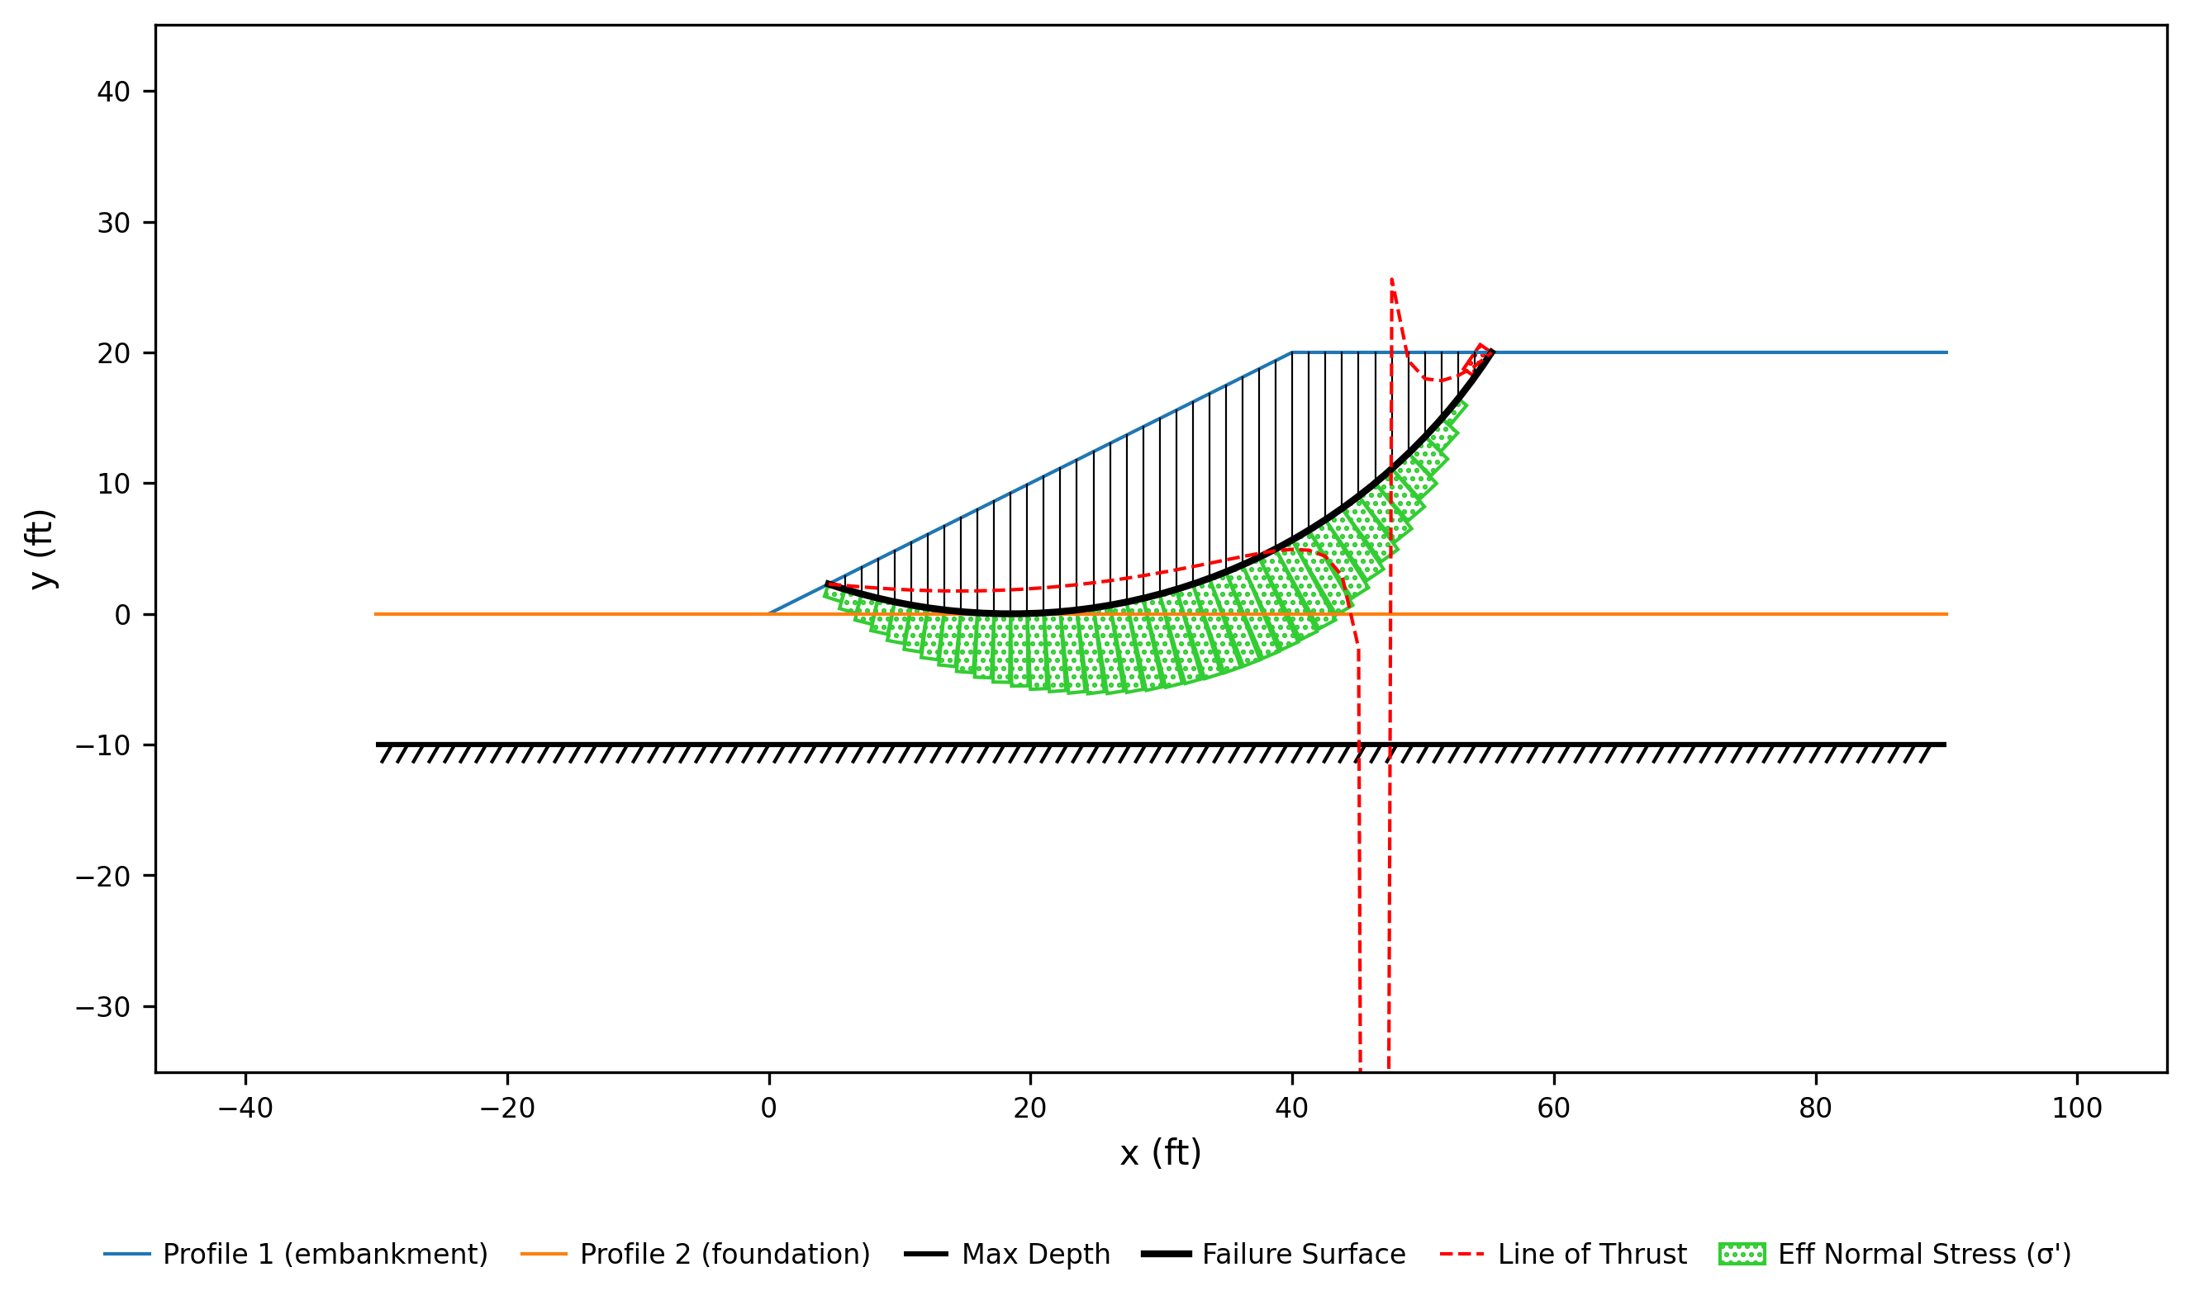
Figure 4. Critical surface and slice forces — Spencer's Method

Slice Table
The geometry, forces and strengths of every slice on the critical surface as solved by Spencer's Method are listed in Table 2, numbered as in Figure 5. Forces are per unit thickness of section.
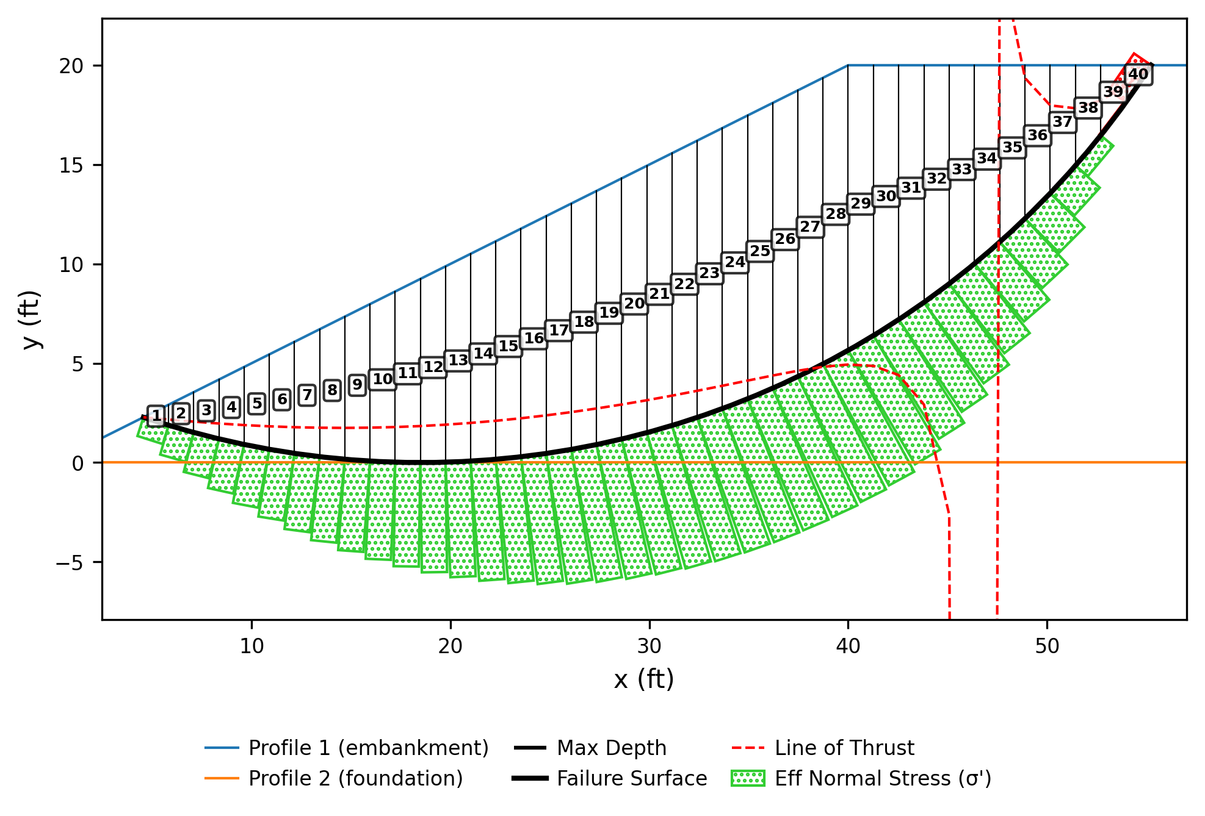
Figure 5. Slice numbering for the table below — Spencer's Method

Table 2. Slice data — Spencer's Method
Slice | x_{c} (ft) | y_{b} (ft) | y_{t} (ft) | Δx (ft) | Δl (ft) | α (deg) | W (lb/ft) | u (psf) | Mat | c (psf) | φ (deg) | N' (lb/ft) | Z (lb/ft) | F_{h} (lb/ft) | F_{v} (lb/ft) | Q_{s} (lb/ft) | y_{Q} (ft)
1 | 5.19 | 2.07 | 2.60 | 1.27 | 1.33 | -17.71 | 86.2 | 0.0 | 1 | 400.0 | 0.00 | 305.2 | 0.0 | 0.0 | -86.2 | -505.4 | 2.07
2 | 6.46 | 1.69 | 3.23 | 1.27 | 1.32 | -15.98 | 253.4 | 0.0 | 1 | 400.0 | 0.00 | 467.9 | 505.4 | 0.0 | -253.4 | -541.6 | 1.69
3 | 7.72 | 1.35 | 3.86 | 1.27 | 1.31 | -14.26 | 413.8 | 0.0 | 1 | 400.0 | 0.00 | 619.7 | 1047.0 | 0.0 | -413.8 | -565.8 | 1.35
4 | 8.99 | 1.05 | 4.50 | 1.27 | 1.30 | -12.55 | 567.5 | 0.0 | 1 | 400.0 | 0.00 | 761.8 | 1612.8 | 0.0 | -567.5 | -578.8 | 1.05
5 | 10.26 | 0.78 | 5.13 | 1.27 | 1.29 | -10.86 | 714.8 | 0.0 | 1 | 400.0 | 0.00 | 894.8 | 2191.6 | 0.0 | -714.8 | -581.9 | 0.78
6 | 11.52 | 0.56 | 5.76 | 1.27 | 1.28 | -9.18 | 855.8 | 0.0 | 1 | 400.0 | 0.00 | 1019.5 | 2773.5 | 0.0 | -855.8 | -575.8 | 0.56
7 | 12.79 | 0.37 | 6.39 | 1.27 | 1.28 | -7.50 | 990.4 | 0.0 | 1 | 400.0 | 0.00 | 1136.6 | 3349.4 | 0.0 | -990.4 | -561.5 | 0.37
8 | 14.05 | 0.23 | 7.03 | 1.27 | 1.27 | -5.83 | 1118.9 | 0.0 | 1 | 400.0 | 0.00 | 1246.5 | 3910.9 | 0.0 | -1118.9 | -539.5 | 0.23
9 | 15.32 | 0.12 | 7.66 | 1.27 | 1.27 | -4.17 | 1241.2 | 0.0 | 1 | 400.0 | 0.00 | 1349.8 | 4450.4 | 0.0 | -1241.2 | -510.7 | 0.12
10 | 16.58 | 0.04 | 8.29 | 1.27 | 1.27 | -2.51 | 1357.5 | 0.0 | 1 | 400.0 | 0.00 | 1446.9 | 4961.1 | 0.0 | -1357.5 | -475.5 | 0.04
11 | 17.85 | 0.00 | 8.93 | 1.27 | 1.27 | -0.85 | 1467.8 | 0.0 | 1 | 400.0 | 0.00 | 1538.1 | 5436.5 | 0.0 | -1467.8 | -434.5 | 0.00
12 | 19.12 | 0.00 | 9.56 | 1.27 | 1.27 | 0.81 | 1572.0 | 0.0 | 1 | 400.0 | 0.00 | 1623.7 | 5871.1 | 0.0 | -1572.0 | -388.3 | 0.00
13 | 20.38 | 0.04 | 10.19 | 1.27 | 1.27 | 2.47 | 1670.1 | 0.0 | 1 | 400.0 | 0.00 | 1704.0 | 6259.4 | 0.0 | -1670.1 | -337.3 | 0.04
14 | 21.65 | 0.11 | 10.82 | 1.27 | 1.27 | 4.13 | 1762.3 | 0.0 | 1 | 400.0 | 0.00 | 1779.1 | 6596.7 | 0.0 | -1762.3 | -282.0 | 0.11
15 | 22.91 | 0.22 | 11.46 | 1.27 | 1.27 | 5.79 | 1848.3 | 0.0 | 1 | 400.0 | 0.00 | 1849.4 | 6878.8 | 0.0 | -1848.3 | -222.8 | 0.22
16 | 24.18 | 0.37 | 12.09 | 1.27 | 1.28 | 7.46 | 1928.3 | 0.0 | 1 | 400.0 | 0.00 | 1914.8 | 7101.6 | 0.0 | -1928.3 | -160.1 | 0.37
17 | 25.44 | 0.55 | 12.72 | 1.27 | 1.28 | 9.13 | 2002.1 | 0.0 | 1 | 400.0 | 0.00 | 1975.6 | 7261.7 | 0.0 | -2002.1 | -94.4 | 0.55
18 | 26.71 | 0.78 | 13.36 | 1.27 | 1.29 | 10.82 | 2069.6 | 0.0 | 1 | 400.0 | 0.00 | 2031.7 | 7356.1 | 0.0 | -2069.6 | -25.9 | 0.78
19 | 27.98 | 1.04 | 13.99 | 1.27 | 1.30 | 12.51 | 2130.7 | 0.0 | 1 | 400.0 | 0.00 | 2083.3 | 7382.1 | 0.0 | -2130.7 | 44.8 | 1.04
20 | 29.24 | 1.34 | 14.62 | 1.27 | 1.31 | 14.21 | 2185.4 | 0.0 | 1 | 400.0 | 0.00 | 2130.2 | 7337.3 | 0.0 | -2185.4 | 117.4 | 1.34
21 | 30.51 | 1.68 | 15.25 | 1.27 | 1.32 | 15.93 | 2233.4 | 0.0 | 1 | 400.0 | 0.00 | 2172.5 | 7219.9 | 0.0 | -2233.4 | 191.4 | 1.68
22 | 31.77 | 2.06 | 15.89 | 1.27 | 1.33 | 17.66 | 2274.7 | 0.0 | 1 | 400.0 | 0.00 | 2210.0 | 7028.6 | 0.0 | -2274.7 | 266.4 | 2.06
23 | 33.04 | 2.49 | 16.52 | 1.27 | 1.34 | 19.41 | 2309.0 | 0.0 | 1 | 400.0 | 0.00 | 2242.6 | 6762.1 | 0.0 | -2309.0 | 342.0 | 2.49
24 | 34.30 | 2.95 | 17.15 | 1.27 | 1.36 | 21.18 | 2336.1 | 0.0 | 1 | 400.0 | 0.00 | 2270.1 | 6420.1 | 0.0 | -2336.1 | 417.7 | 2.95
25 | 35.57 | 3.47 | 17.79 | 1.27 | 1.37 | 22.97 | 2355.8 | 0.0 | 1 | 400.0 | 0.00 | 2292.3 | 6002.4 | 0.0 | -2355.8 | 492.9 | 3.47
26 | 36.84 | 4.03 | 18.42 | 1.27 | 1.39 | 24.78 | 2367.8 | 0.0 | 1 | 400.0 | 0.00 | 2308.9 | 5509.5 | 0.0 | -2367.8 | 566.9 | 4.03
27 | 38.10 | 4.64 | 19.05 | 1.27 | 1.42 | 26.62 | 2371.7 | 0.0 | 1 | 400.0 | 0.00 | 2319.3 | 4942.6 | 0.0 | -2371.7 | 639.2 | 4.64
28 | 39.37 | 5.30 | 19.68 | 1.27 | 1.44 | 28.49 | 2367.2 | 0.0 | 1 | 400.0 | 0.00 | 2323.0 | 4303.4 | 0.0 | -2367.2 | 708.8 | 5.30
29 | 40.64 | 6.01 | 20.00 | 1.27 | 1.47 | 30.39 | 2309.4 | 0.0 | 1 | 400.0 | 0.00 | 2271.6 | 3594.6 | 0.0 | -2309.4 | 749.1 | 6.01
30 | 41.91 | 6.79 | 20.00 | 1.27 | 1.50 | 32.34 | 2181.6 | 0.0 | 1 | 400.0 | 0.00 | 2145.6 | 2845.5 | 0.0 | -2181.6 | 747.7 | 6.79
31 | 43.18 | 7.62 | 20.00 | 1.27 | 1.54 | 34.33 | 2043.6 | 0.0 | 1 | 400.0 | 0.00 | 2006.4 | 2097.8 | 0.0 | -2043.6 | 731.3 | 7.62
32 | 44.45 | 8.52 | 20.00 | 1.27 | 1.58 | 36.37 | 1894.9 | 0.0 | 1 | 400.0 | 0.00 | 1852.0 | 1366.5 | 0.0 | -1894.9 | 697.6 | 8.52
33 | 45.72 | 9.50 | 20.00 | 1.27 | 1.62 | 38.47 | 1734.4 | 0.0 | 1 | 400.0 | 0.00 | 1679.6 | 668.9 | 0.0 | -1734.4 | 643.5 | 9.50
34 | 46.99 | 10.54 | 20.00 | 1.27 | 1.67 | 40.62 | 1561.3 | 0.0 | 1 | 400.0 | 0.00 | 1485.7 | 25.4 | 0.0 | -1561.3 | 565.2 | 10.54
35 | 48.26 | 11.68 | 20.00 | 1.27 | 1.73 | 42.85 | 1374.2 | 0.0 | 1 | 400.0 | 0.00 | 1265.7 | -539.8 | 0.0 | -1374.2 | 457.5 | 11.68
36 | 49.53 | 12.90 | 20.00 | 1.27 | 1.80 | 45.17 | 1171.6 | 0.0 | 1 | 400.0 | 0.00 | 1013.5 | -997.3 | 0.0 | -1171.6 | 313.8 | 12.90
37 | 50.80 | 14.24 | 20.00 | 1.27 | 1.88 | 47.58 | 951.6 | 0.0 | 1 | 400.0 | 0.00 | 720.9 | -1311.1 | 0.0 | -951.6 | 125.2 | 14.24
38 | 52.07 | 15.69 | 20.00 | 1.27 | 1.98 | 50.10 | 711.7 | 0.0 | 1 | 400.0 | 0.00 | 376.0 | -1436.3 | 0.0 | -711.7 | -121.2 | 15.69
39 | 53.34 | 17.28 | 20.00 | 1.27 | 2.10 | 52.77 | 448.7 | 0.0 | 1 | 400.0 | 0.00 | -38.5 | -1315.1 | 0.0 | -448.7 | -443.9 | 17.28
40 | 54.61 | 19.04 | 20.00 | 1.27 | 2.25 | 55.62 | 158.0 | 0.0 | 1 | 400.0 | 0.00 | -549.4 | -871.2 | 0.0 | -158.0 | -871.2 | 19.04
Total |  |  |  | 50.68 | 57.79 |  | 61392.8 |  |  |  |  | 60246.4 |  |  |  | -0.0
Slice: Slice number, counted from the left edge of the failure surface. x_{c} (ft): Horizontal coordinate of the slice mid-point. y_{b} (ft): Elevation of the failure surface at the slice mid-point. y_{t} (ft): Elevation of the ground surface at the slice mid-point. Δx (ft): Slice width. Δl (ft): Length of the slice base along the failure surface. α (deg): Inclination of the slice base, positive when the base rises toward the toe. W (lb/ft): Weight of the slice, per unit thickness. u (psf): Pore water pressure on the slice base at its mid-point. Mat: Index of the material the slice base runs through, numbered as on the materials sheet. c (psf): Cohesion of the base material, in the strength formulation the analysis is run under. φ (deg): Friction angle of the base material. N' (lb/ft): Effective normal force on the slice base, per unit thickness, as solved. Z (lb/ft): Interslice force on the right-hand side of the slice, per unit thickness. F_{h} (lb/ft): Resultant of all the forces on the slice except the base normal, the base shear and the interslice forces — horizontal component, per unit thickness. F_{v} (lb/ft): Resultant of all the forces on the slice except the base normal, the base shear and the interslice forces — vertical component, per unit thickness. Q_{s} (lb/ft): Resultant of the interslice forces on the slice (Spencer's Q), per unit thickness. y_{Q} (ft): Elevation of the line of action of Q_{s}.

Calculations
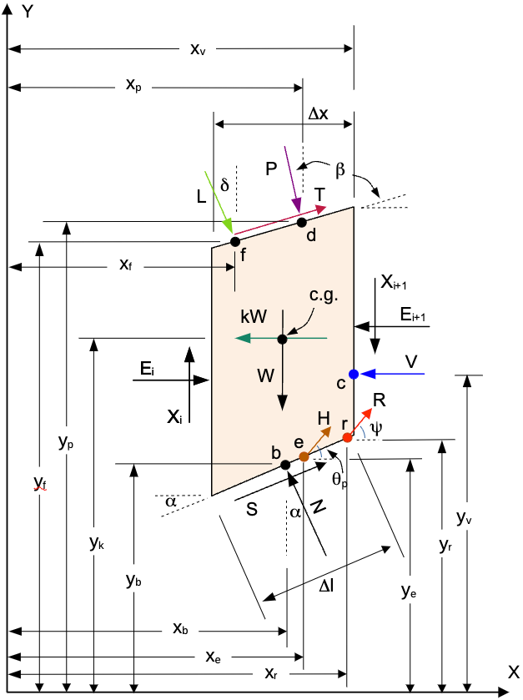
Figure 6. Forces on a slice — Spencer's Method
The equations below are in the symbols of the derivation published for Spencer's Method in the XSLOPE documentation; the numbers in them are the converged values.
Spencer's method lumps the interslice forces on each slice into a single resultant Q acting at the constant inclination θ, so that force and moment equilibrium of the whole sliding mass are two equations in the two unknowns F and θ. $F_{h}$ and $F_{v}$ are the sums of the forces on the slice of Figure 6 other than the base normal, the base shear and the interslice forces, as equations (1) and (2) of the derivation write them:
$$F_{h} = −kW − V + P sin β + T cos β + R cos ψ + H cos θ_{p} + L cos δ$$
$$F_{v} = −W − P cos β + T sin β + R sin ψ + H sin θ_{p} + L sin δ$$
The model carries no distributed load, seismic load, tension-crack water force, reinforcement crossing the failure surface, pile force and line load, and no shear on the top of the slice is simulated, so equations (1) and (2) reduce to:
$$F_{h} = 0$$
$$F_{v} = −W$$
Equations (23) and (24) give Q on each slice from them and from the strength mobilized on its base:
$$Q = [−F_{v}·sin α − F_{h}·cos α − \frac{c·Δl}{F} + (F_{v}·cos α − F_{h}·sin α + u·Δl)·\frac{tan φ}{F}]·m_{α}$$
$$m_{α} = \frac{1}{cos (α − θ) + sin (α − θ)·\frac{tan φ}{F}}$$
There is no equation for F: it appears inside Q, in the mobilized cohesion c·Δl/F and the friction tan φ/F, and again with θ in $m_{α}$. A trial pair (F, θ) fixes Q on every slice.
$F_{h}$, $F_{v}$, Q and $y_{Q}$ are columns $F_{h}$, $F_{v}$, $Q_{s}$ and $y_{Q}$ of the slice table; each row's Q follows from that row through the two equations above, at the converged F and θ.
Substituting Q and $y_{Q}$ into the equilibrium of the whole sliding mass gives equations (27) and (28) of the derivation, two equations in the two unknowns. $R_{1}$ is the force imbalance and $R_{2}$ the moment imbalance, and the solution is the pair (F, θ) at which both are zero:
$$R_{1} = \sum{Q}$$
$$R_{2} = \sum{Q·(x_{b}·sin θ − y_{Q}·cos θ)}$$
F and θ are iterated together: each trial pair recomputes both sums, and the pair is adjusted until both vanish.
The symbols used above are defined in Table 3. Those that are columns of Table 2 carry a value for every slice.
Table 3. Nomenclature — Spencer's Method
Symbol | Meaning
T | shear force on the top of the slice
P | resultant of the distributed load on the top of the slice, in the symbols of equations (1) and (2) — column D of the slice table, and written D below, where P is instead the reinforcement force
Δl (ft) | Length of the slice base along the failure surface
α (deg) | Inclination of the slice base, positive when the base rises toward the toe
W (lb/ft) | Weight of the slice, per unit thickness
u (psf) | Pore water pressure on the slice base at its mid-point
c (psf) | Cohesion of the base material, in the strength formulation the analysis is run under
φ (deg) | Friction angle of the base material
F_{h} (lb/ft) | Resultant of all the forces on the slice except the base normal, the base shear and the interslice forces — horizontal component, per unit thickness
F_{v} (lb/ft) | Resultant of all the forces on the slice except the base normal, the base shear and the interslice forces — vertical component, per unit thickness
y_{Q} (ft) | Elevation of the line of action of Q_{s}
F | factor of safety
β | inclination of the distributed load from vertical (perpendicular to the slope)
ψ | angle of the reinforcement force from horizontal
θ_{p} | angle of the pile force from horizontal (positive counterclockwise, upward)
δ | angle of the line load from horizontal (−90° is straight down)
θ | inclination of the interslice forces from horizontal
m_{α} | the base-normal denominator, which carries the factor of safety and is what makes the solution iterative
L | line load applied on top of the slice, per unit thickness
kW | horizontal seismic force on the slice, per unit thickness — column kW of the slice table
R | reinforcement force on the slice base, at the angle ψ from horizontal — column P of the slice table, and written P below
V | resultant force of the water in a tension crack — column T_{c} of the slice table, which the other methods' equations write T
H | pile or pier force on the slice at the failure surface — column H_{p} of the slice table
Q | resultant of the interslice forces on the slice, at the inclination θ — column Q_{s} of the slice table
x_{b} | horizontal coordinate of the slice base mid-point
R₁ | force imbalance of the whole sliding mass at a trial (F, θ) — zero at the solution
R₂ | moment imbalance of the whole sliding mass at a trial (F, θ) — zero at the solution

The iteration converged at F = 1.244 with θ = 8.48 degrees. The force equation is the $Q_{s}$ column of Table 2 added up over the 40 slices, printed as the total at the foot of that column:
$$R_{1} = \sum{Q} = -5.097e-07$$
That is one part in 35 billion of the 17636.7 the magnitudes of Q come to. The moment equation weights the same column by $x_{c}$ — the $x_{b}$ of equation (28) — and by $y_{Q}$, at the θ above:
$$R_{2} = \sum{Q·(x_{b}·sin θ − y_{Q}·cos θ)} = 1.641e-05$$
That is one part in three billion of the 43715.5 its moment terms come to. Sums re-formed from the printed, rounded columns carry that rounding and close to within a thousandth of these totals.

