Josiah Nelson
DSA 412 (601)
Dr. Paul
4/25/2026

Transaction Classification via Numerical and Text-based Data

Introduction
Many algorithms currently exist to accurately categorize transactions for the purpose of organization, budgeting, and to allow for a better understanding overall of one’s finances. Personal experience with money management applications that utilize a transaction categorization model has shown that while these models are extremely useful, they often struggle with categorizing transactions that have less clear indicators towards a specific category. To effectively classify these unclear transactions, a combination of numerical metadata and text-based data is used. This approach allows for a broader view of the data compared to only using numerical or text data. Effectively classifying transactions is beneficial for both firms and individuals looking to organize their finances.
Due to limitations with finding data, two models were created with two different data sources. The first model was created to show the effectiveness of TF-IDF vectorization for this problem and provide a foundation for the other model to follow. The other model serves as more of a conceptual model, putting into practice this combination of both text-based and numeric data, and the following report will primarily focus on this model. Due to real transactional data being extremely difficult to find, the datasets used for the models use synthetic data (combined with real data in the case of the text-based dataset) aimed to provide an accurate representation of real-world transaction and merchant information.

Datasets
https://huggingface.co/datasets/mitulshah/transaction-categorization
Shah, Mitul. “Financial Transaction Categorization Dataset.” Hugging Face, 2025, Accessed 24 Apr. 2026.
https://datafactory.gomask.ai/dashboard/community/banking-transaction-categorization-dataset
GoMask. “Banking Transaction Categorization Dataset.” 29 July 2025, Accessed 24 Apr. 2026.
Data Explanation/Exploration
The dataset for the conceptual model contains 200 records (hence why it is the conceptual model) with 17 columns, providing information regarding the transaction itself (time, date, transaction type, amount, balance amount after) as well as contextual information (category, subcategory, description, merchant name, location). Key features of interest in this dataset are category (as that is our target variable), subcategory, transaction_description, amount, and transaction_date (potential to identify seasonality).
The preprocessing stage included dropping features to prevent potential leakage/extremely high dimensionality (various ID features, specific location features) and a lot of data standardization. One hot encoding was used on the non-description textual features. This includes merchant_name, however this was only done due to the small size of the dataset and likely would not be feasible for a dataset that has thousands of different merchants. The data was filtered to only include USA transactions, and missing values for transaction time were filled with the median of transaction time converted to seconds in order to preserve as many observations as possible.
Text data in the transaction_description feature was standardized by removing special characters/punctuation, converting text to lowercase, removing numerical digits, and removing words that likely serve little to no importance. This cleaned description column was then fitted with the TF-IDF vectorizer to convert the text data into numerical features with values corresponding to a word’s contextual importance. Since this dataset is so small, a standard 70/30 train-test split was used to prevent underfitting caused by a small training set.

Algorithms and Techniques Analysis
The machine learning technique used for the conceptual model was a Random Forest model. Three models were used on the larger text-based dataset (XGBoost, Naive Bayes, and Random Forest) and the performance of these models was then compared. Random Forest performed the best with this dataset, showing recall and accuracy values of ~.99. Such a high accuracy and recall was alarming, so results were cross validated to determine if there was extreme overfitting within that split. Through cross validation, the model remained robust, consistently showing high accuracy and recall values. Random Forest models perform very well with both textual and numerical data, and so it was determined that this would be the technique used for the conceptual model (Sandeep & Alisha, 2026).
200 decision trees were used in the Random Forest (n_estimators) to balance generalization ability and runtime length. n_jobs = -1 was used to help with fitting the model by using all CPU cores available. To test the performance of the model, a classification report was created to display precision, recall, and f-1 score. The classification report shows the performance for each category (the numbers in the first column) and the overall model performance. The weighted average metrics are used due to an imbalance in sample size (support) for the different categories. The precision value shows an accuracy of positive predictions of around 93%, with the recall value showing around 92% of all actual transactions across the different categories were identified correctly by the model. The F-1 score provides a more balanced look at the model’s performance, combining both precision and recall, and shows the model performs well at both avoiding false positives and minimizing false negatives. A confusion matrix was created to provide a visual representation of the model’s predictions, with correct predictions being in the middle diagonal line.

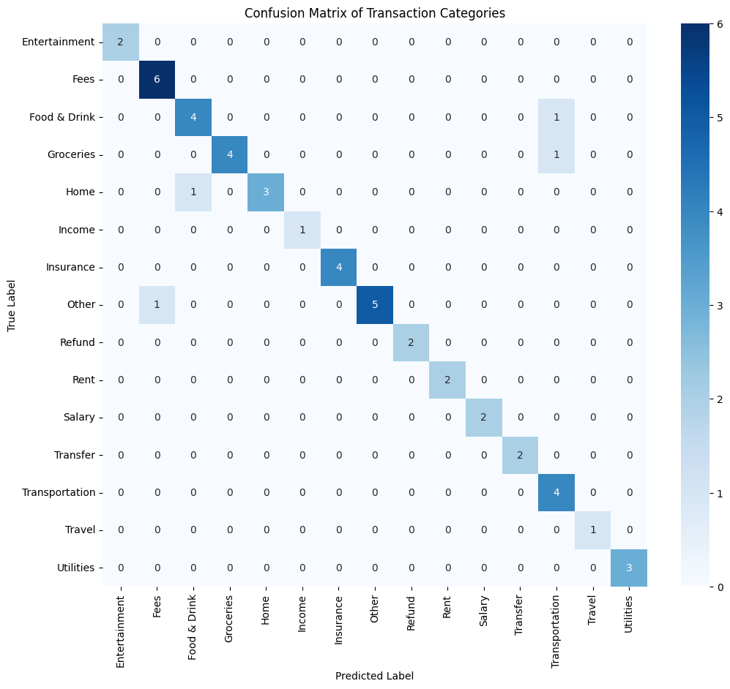
precision recall f1-score support
0 1.00 1.00 1.00 2
1 0.86 1.00 0.92 6
2 0.80 0.80 0.80 5
3 1.00 0.80 0.89 5
4 1.00 0.75 0.86 4
5 1.00 1.00 1.00 1
6 1.00 1.00 1.00 4
7 1.00 0.83 0.91 6
8 1.00 1.00 1.00 2
9 1.00 1.00 1.00 2
10 1.00 1.00 1.00 2
11 1.00 1.00 1.00 2
12 0.67 1.00 0.80 4
13 1.00 1.00 1.00 1
14 1.00 1.00 1.00 3
accuracy 0.92 49
macro avg 0.95 0.95 0.95 49
weighted avg 0.93 0.92 0.92 49
The model’s strong performance is reinforced by the following ROC curve, displaying how the model performs when compared to a random classifier (50/50), showing the trade off between false positive rate and true positive rate. The model performs much better than a random classifier, and is able to get high true positive rates with low false positive rates.
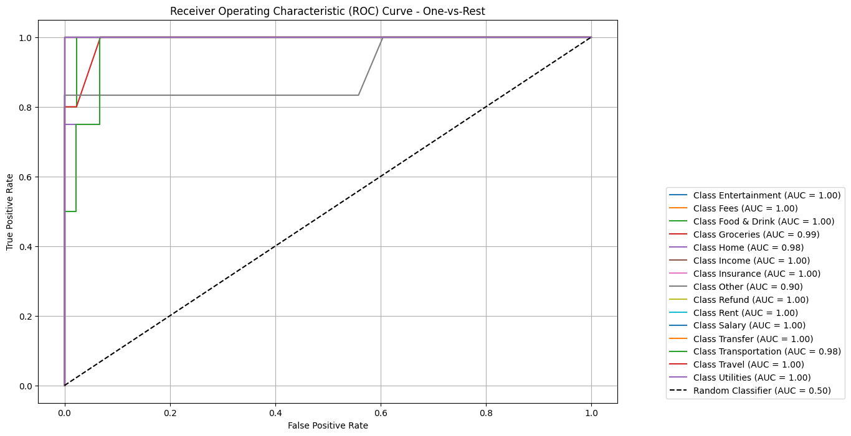

Conclusion
The model was able to produce results that aligned with expectations. While the performance metrics did not score quite as high as the solely text-data based Random Forest model, I believe that this is more so due to the very limited size of the dataset compared to the very large transaction dataset. It would be very interesting to see this model being used on a much larger dataset with more information available, and see if the model remains robust and is able to generalize on new transactions. By expanding on this model and implementing new strategies/techniques (potentially BERTopic instead of just TF-IDF Vectorization), the problem of transaction misclassification may be minimized or even solved.

References
Sandeep, B. S. S., & Alisha, S. K. A. (2026). RESEARCH OF TEXT CLASSIFICATION BASED ON RANDOM FOREST ALGORITHM. International Journal of Engineering Research and Science & Technology, 22(2), 2040–2046. https://ijerst.org/index.php/ijerst/article/view/2597

