* The cities that have latitude close to zero (equator) the temperature is higher. As it goes away from both direction the temperature is declines.

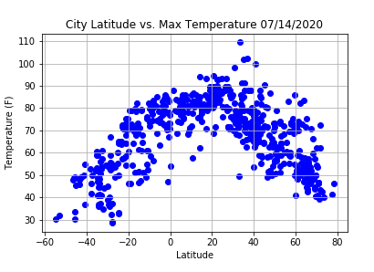

* There isn’t any direct correlation between latitude and humidity. For the most cities, Humidity is above 40%

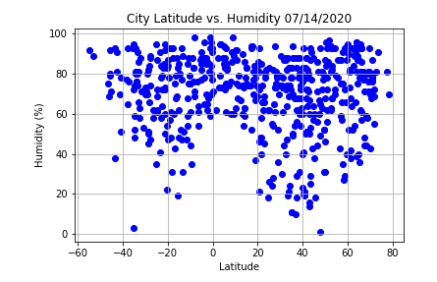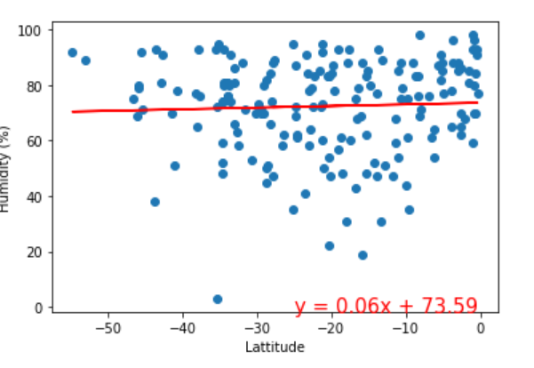

* Wind speeds tends to be lower and mainly below 15mph for the cities close to equator.

