Classroom Assignment

App Manual

Table of Contents

1. Setup Pg. 3
2. Project Creation Pg. 4
3. Resolving Ambiguities Pg. 6
4. Course Assignment Overview Pg. 7
5. Assigning Rooms to Courses Pg. 9
6. Editing a Course Pg. 11
7. Set Course to No Assignment Needed Pg. 13
8. Cross Listing Courses Pg. 14

Setup

The application can be downloaded at the following url: <https://github.com/OscarMo10/ClassroomAssignmentWpf/releases>. As of writing this document the latest version is v1.1. The installer is named “ClassroomAssignmentSetup.msi”.

Project Creation

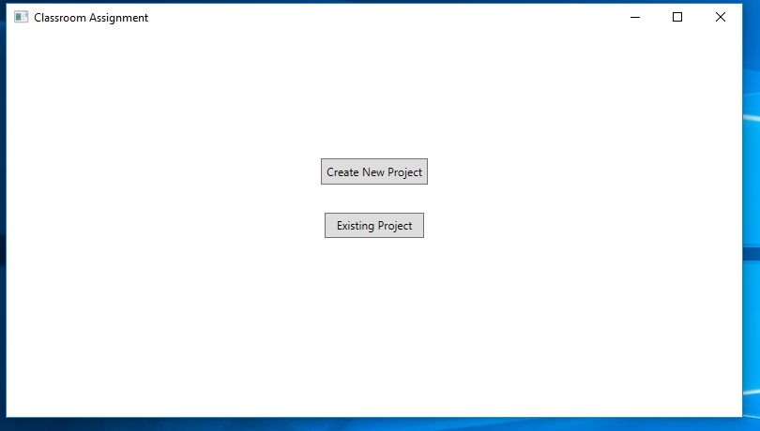

Figure Project Creation Screen

New Project

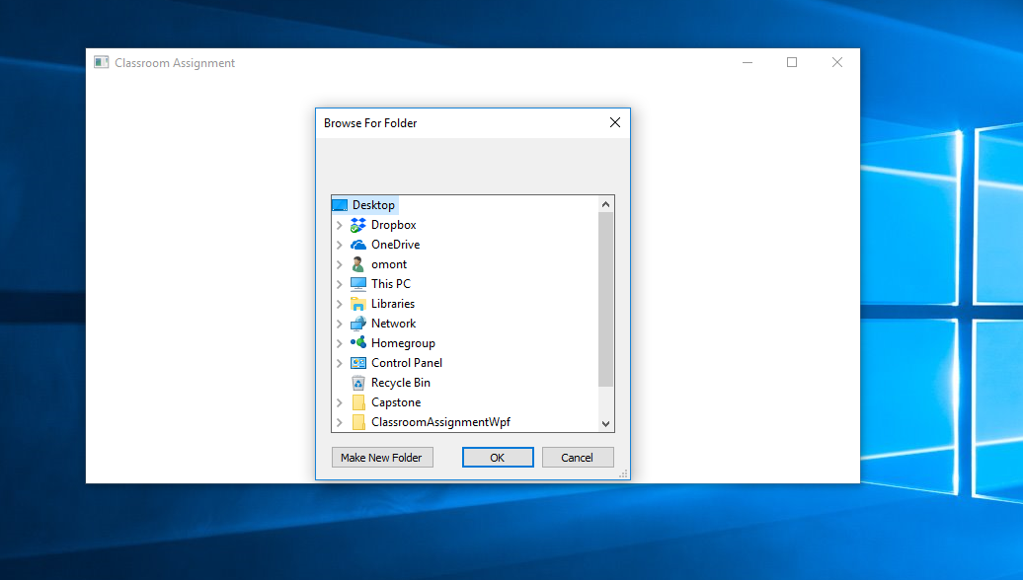

Figure Dialog window prompting for folder containing spreadsheets.

To create a new project, first place all csv files with the course information into a folder. Make sure this folder contains nothing but the valid csv files. Click the Create New Project button, and a dialog will prompt you for the location of the folder. Choose the folder and click OK.

Open Saved Project

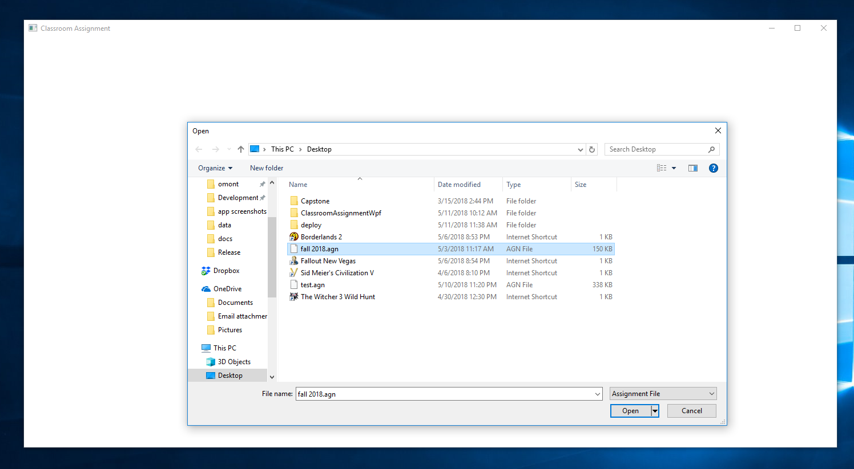

Figure File section dialog box.

To open a saved project, click the “Existing Project” button. You will be prompted for the save file created when you saved your project. This file should have a .agn file extension. Choose the file and click the OK button.

Resolving Assignment Ambiguities

What is an assignment ambiguity?

If a course entry in a spreadsheet has multiple fields containing “PKI\Peter Kiewit Institute ###”, it is considered to have an ambiguous assignment.

The ambiguity page gives you the opportunity to resolve these assignment ambiguities.

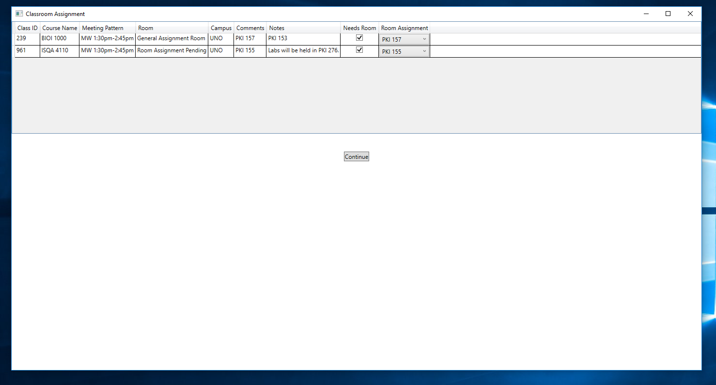

Figure Ambiguity Resolver page

Each course entry will have two fields that will be editable by you. The “Needs Room” checkbox and the “Room Assignment” options box.

For each course you can:

1. If the course doesn’t need a room, Uncheck Needs Room.
2. If course needs room and you know the room, selection an option from drop down;
3. If course needs room and you don’t know the room, select None in the room options box.

Course Assignment Overview

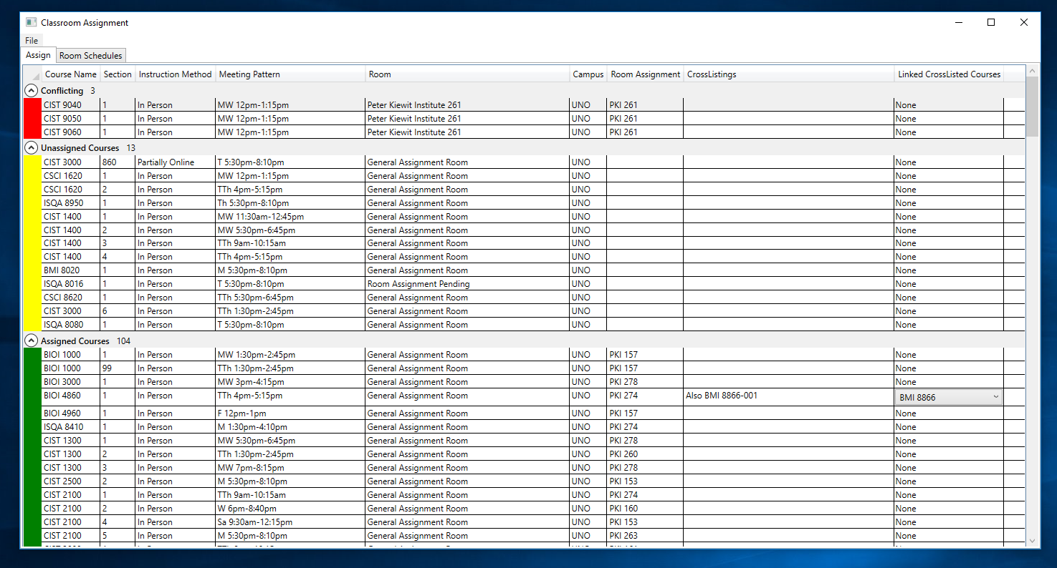

Figure Course Assignment Overview Screen

Purpose

The course assignment overview screen provides you the ability to quickly ascertain the current assignment status of the courses in your project. All courses are grouped into four groups: Conflicting, Unassigned Courses, Assigned Courses, and No Assignment Required. The No Assignment Required courses either do not require a room or have been cross-listed with another course that is being assigned.

Assign Tab

The first tab on the overview page is the Assign tab. This contains all the courses in the project, grouped as described above.

Four operations may be performed on a course entry:

1. If course is not in the “No Assignment Required” group, it may be assigned.
2. Any course may be edited.
3. Multiple courses can be cross listed.
4. If course is not in the “No Assignment Required” group, it may be set as “No Assignment Required.

Room Schedules Tab

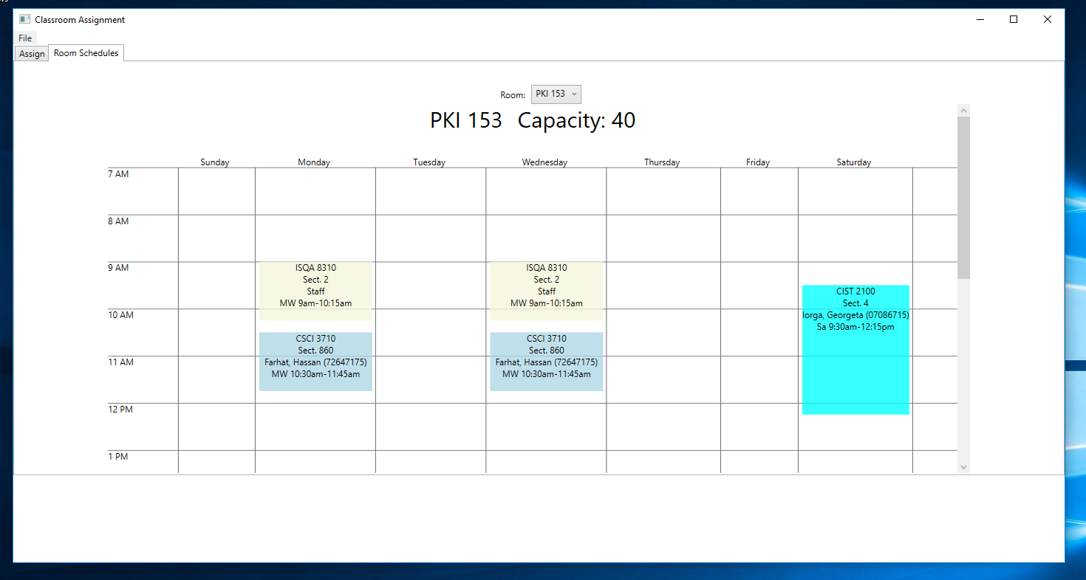

Figure Room Schedules Tab

This tab shows the room schedules for the rooms PKI. Simply select the room from the room options box and the view should be updated to reflect the selection. \*Note: If you have conflicts in your project you will have overlapping entries in the view. Resolving those conflicts should resolve the issue.

Assigning Rooms To Courses

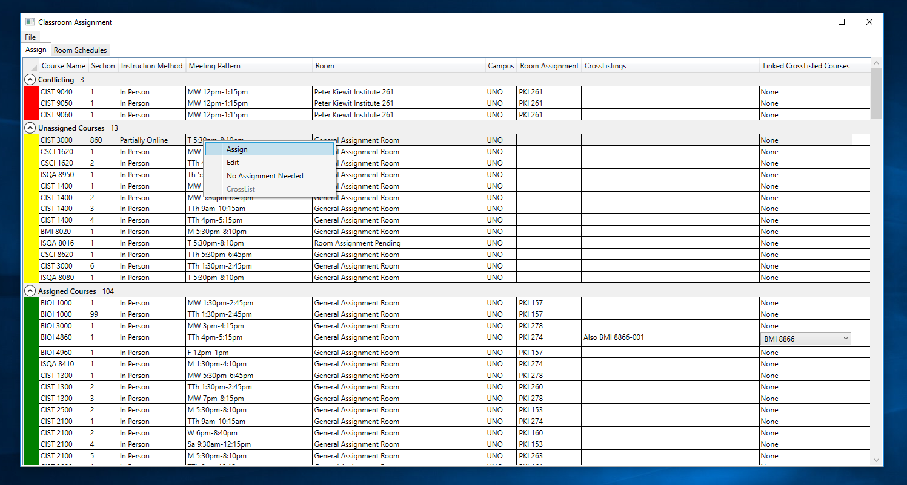

Figure Menu after right-clicking on course in the overview page

A course can be assigned if it is not in the “No Assignment Needed” group. Right clicking on the course entry show a menu with the option “Assign”. \*Note: You can select multiple courses for assignment.

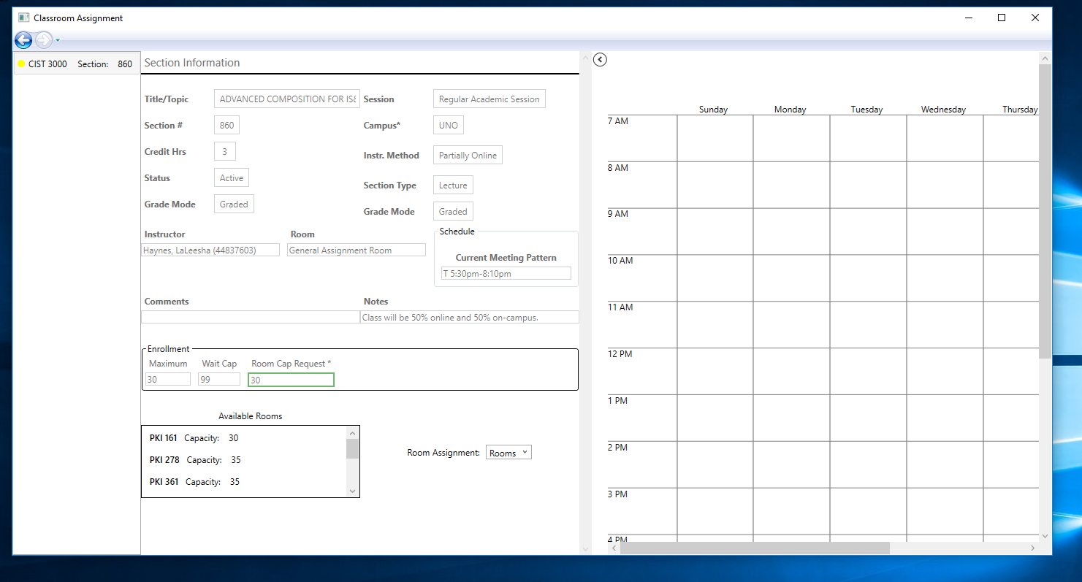

Figure Assignment Page

After choosing a course/courses for assignment, you will be taken to the assignment page. This page is made up of three sections.

The left-most section is the list of courses chosen for assignment, and courses that conflict with any chosen courses. This list will be updated on room assignment.

The middle section displays information for the current course being assigned. This information is not editable on this page. At the bottom of this section is a list of available room. Click on any option in this list will display the schedule for the room on the right-most section of the page. To the left of the room options list is a dropdown box with all the rooms in PKI. You may choose any room, but if that assignment causes a conflict, those conflicting courses will be added to the current courses being assigned.

Any room assignment is saved automatically. To go back to the overview page, click the back arrow at the top-left corner of the screen.

Editing a Course

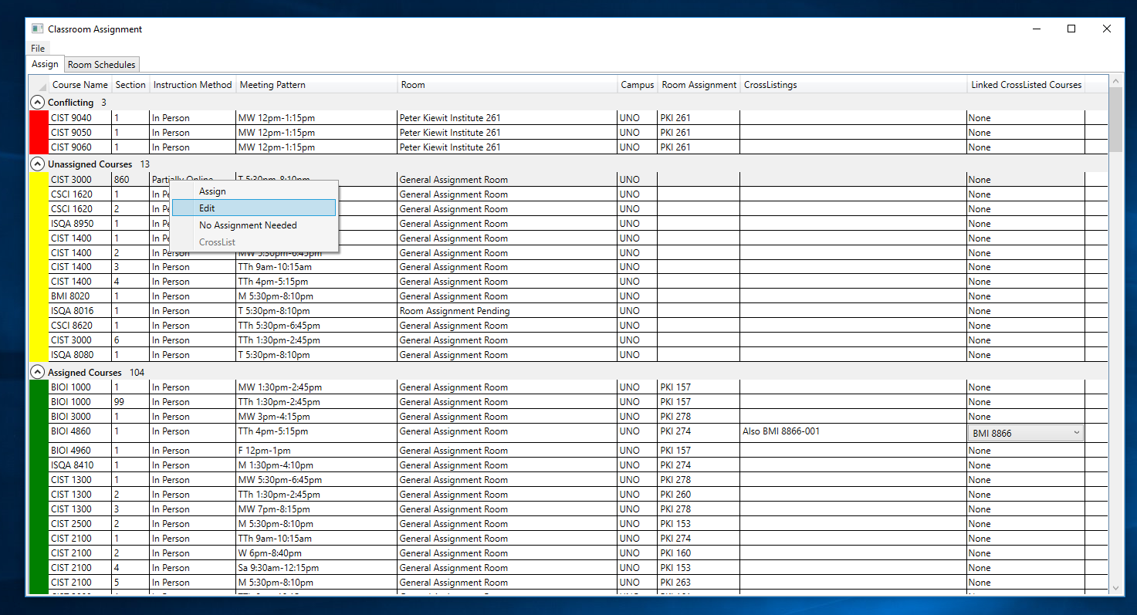

Figure Edit Menu after right-clicking on course.

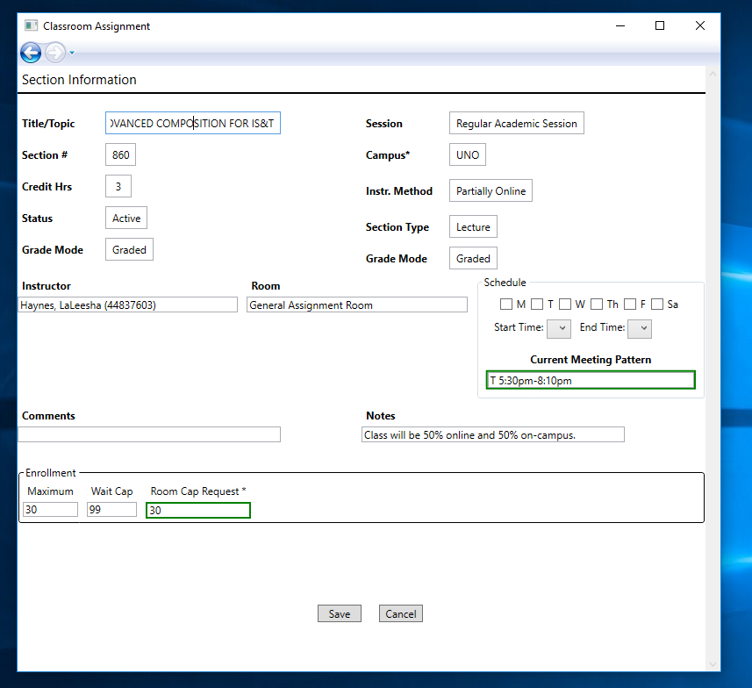

Figure Edit Page

All fields in on the Edit Page may changed except the Current Meeting Pattern. You must use the options grouped in “Schedule” to change the meeting pattern. The “Current Meeting Pattern” and the “Room Cap Request” are both used for assignment, and thus must be valid before allowing to save the changes. The other fields will not affect assignment, but you will be able to view those changes in the Changes Page.

Set Course to No Assignment Needed

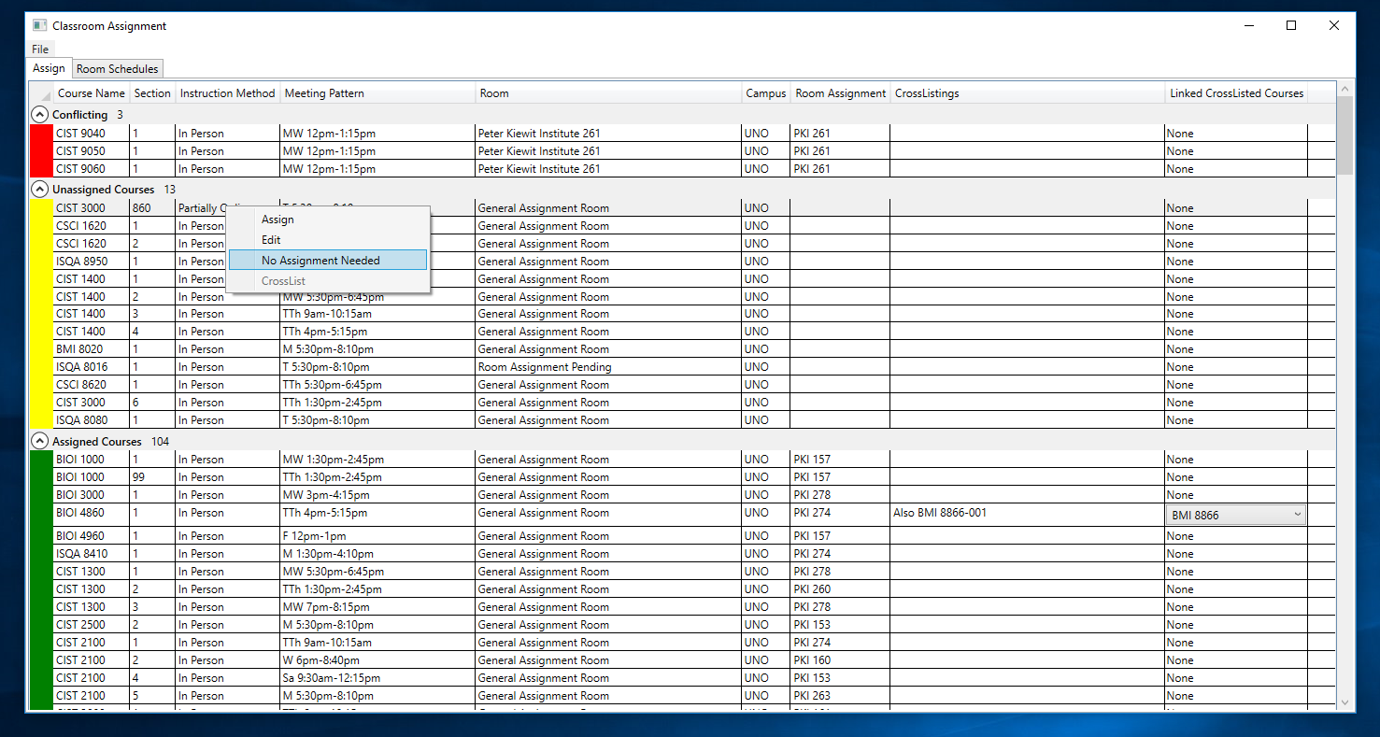

Figure No Assignment Needed Menu Item after right-clicking on course.

A “No Assignment Course” is course that either does not need a room or is assigned to indirectly because it is cross listed with a course that is assigned.

Right-clicking on a course in the overview page will bring up the option “No Assignment Needed”. Click on that option will move the course the “No Assignment Needed” group. To undo this, right-click on the course now in the “No Assignment Needed” group, and select “Needs Assignment”.

Cross Listing Courses

Cross Listing in action: https://oscarmo10.github.io/ClassroomAssignmentWpf/Crosslisting.mov.

To cross list courses, select multiple courses, right-click, and select the “CrossList” option. One course will be marked as assignable and the rest will be marked as “No Assignment Needed”. Any room assignment made to the assignable course reflected on the cross listed courses. \*Note: Editing any property of course will not be reflected on the cross listed courses.