**Cabo Ibbetson**



**Quantiles**

|  |  |  |
| --- | --- | --- |
| 100.0% | maximum | 25.768 |
| 99.5% |  | 25.3876 |
| 97.5% |  | 24.847 |
| 90.0% |  | 24.315 |
| 75.0% | quartile | 23.761 |
| 50.0% | median | 23.016 |
| 25.0% | quartile | 22.298 |
| 10.0% |  | 21.7168 |
| 2.5% |  | 20.603 |
| 0.5% |  | 19.436 |
| 0.0% | minimum | 18.271 |

**Summary Statistics**

|  |  |
| --- | --- |
| Mean | 22.989842 |
| Std Dev | 1.0689381 |
| Std Err Mean | 0.013429 |
| Upper 95% Mean | 23.016167 |
| Lower 95% Mean | 22.963516 |
| N | 6336 |

**Punta Cormoran**



**Quantiles**

|  |  |  |
| --- | --- | --- |
| 100.0% | maximum | 26.012 |
| 99.5% |  | 25.671 |
| 97.5% |  | 25.1514 |
| 90.0% |  | 24.388 |
| 75.0% | quartile | 23.521 |
| 50.0% | median | 22.705 |
| 25.0% | quartile | 21.867 |
| 10.0% |  | 20.77 |
| 2.5% |  | 19.151 |
| 0.5% |  | 17.679 |
| 0.0% | minimum | 15.891 |

**Summary Statistics**

|  |  |
| --- | --- |
| Mean | 22.593508 |
| Std Dev | 1.4417903 |
| Std Err Mean | 0.0174637 |
| Upper 95% Mean | 22.627742 |
| Lower 95% Mean | 22.559273 |
| N | 6816 |

**La Botella**



**Quantiles**

|  |  |  |
| --- | --- | --- |
| 100.0% | maximum | 25.307 |
| 99.5% |  | 24.966 |
| 97.5% |  | 24.6428 |
| 90.0% |  | 23.785 |
| 75.0% | quartile | 22.753 |
| 50.0% | median | 22.034 |
| 25.0% | quartile | 20.984 |
| 10.0% |  | 19.532 |
| 2.5% |  | 17.962 |
| 0.5% |  | 17.013 |
| 0.0% | minimum | 16.106 |

**Summary Statistics**

|  |  |
| --- | --- |
| Mean | 21.793512 |
| Std Dev | 1.6009017 |
| Std Err Mean | 0.019391 |
| Upper 95% Mean | 21.831525 |
| Lower 95% Mean | 21.7555 |
| N | 6816 |

**Punta Espinosa**



**Quantiles**

|  |  |  |
| --- | --- | --- |
| 100.0% | maximum | 25.04 |
| 99.5% |  | 24.75 |
| 97.5% |  | 24.291 |
| 90.0% |  | 22.776 |
| 75.0% | quartile | 21.628 |
| 50.0% | median | 20.579 |
| 25.0% | quartile | 19.365 |
| 10.0% |  | 18.057 |
| 2.5% |  | 16.4492 |
| 0.5% |  | 16.034 |
| 0.0% | minimum | 15.796 |

**Summary Statistics**

|  |  |
| --- | --- |
| Mean | 20.481326 |
| Std Dev | 1.8511697 |
| Std Err Mean | 0.0228279 |
| Upper 95% Mean | 20.526076 |
| Lower 95% Mean | 20.436576 |
| N | 6576 |

**Bartolomé**

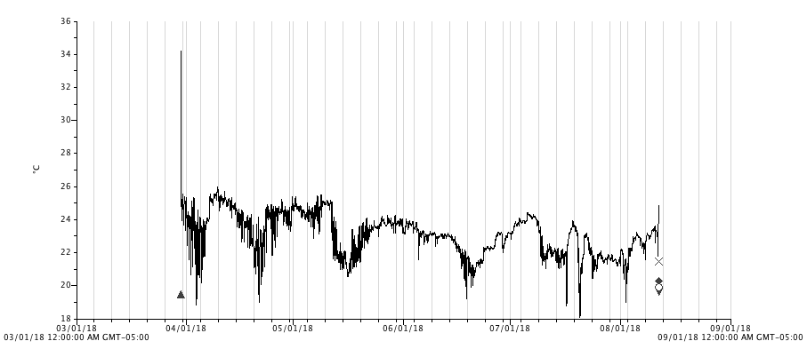

**Temp**

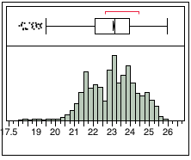

**Quantiles**

|  |  |  |
| --- | --- | --- |
| 100.0% | maximum | 25.963 |
| 99.5% |  | 25.55 |
| 97.5% |  | 25.283 |
| 90.0% |  | 24.75 |
| 75.0% | quartile | 23.954 |
| 50.0% | median | 23.136 |
| 25.0% | quartile | 22.106 |
| 10.0% |  | 21.485 |
| 2.5% |  | 20.865 |
| 0.5% |  | 19.7194 |
| 0.0% | minimum | 18.081 |

**Summary Statistics**

|  |  |
| --- | --- |
| Mean | 23.080957 |
| Std Dev | 1.2397504 |
| Std Err Mean | 0.0156343 |
| Upper 95% Mean | 23.111605 |
| Lower 95% Mean | 23.050308 |
| N | 6288 |