TheKidsBiostatsTemplate

A biostatistics report template

J Smith, Biostatistician

2024-12-12

Contents

## Introduction

### Project Summary

A blurb describing the project, which team or individual is conducting the research

### Research Question

A succinct, specific research question to be answered in this report.

|  |
| --- |
| Important |
| This must be confirmed with the researcher |

## Data Summary

Tables, explanatory plots, etc to examine the data prior to analysis.

mtcars %>%  
 ggplot(aes(x = mpg,   
 y = wt,   
 col = factor(cyl))) +  
 geom_point() +  
 labs(title = "Test Plot") +  
 thekids_theme(base_size = 20, base_family = "Orbitron")

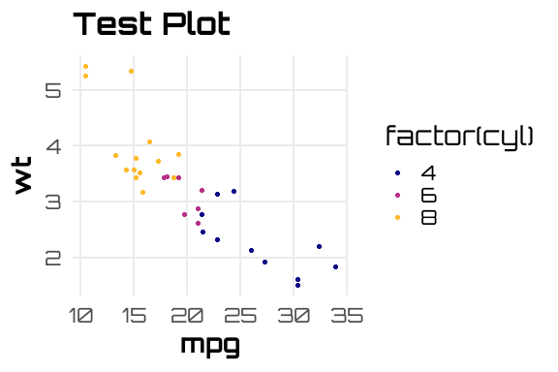

## Analysis

## Supplementary Material