***Group name : Science  
Group members:   
Fabrice Irazi( F17040123)  
Elizabeth Lisa mondol( F17040114)  
Ridita Islam (F17040106)  
Naa koshie Wallace bruce(F17040122)  
Mukhriddin ziyodullaev(F17040110)   
  
LOTTERY MACHINE***  
  
**Introduction:** A lottery is a game of chance in which people pay for the opportunity to win prizes . Part of the money taken in by a lottery is used to award the winners and to pay the costs of administering the lottery. The money left over is profit. Lotteries are extremely popular and legal in more than a hundred countries.

Our goal is to make a software lottery machine which is very faithful and reliable.

The players just need to get a number by scanning the QR code through we chat .The players can take part of the lottery by scanning the QR code.

BRIEFING ABOUT OUR SOFTWARE

Our software lottery machine will be such a software which is easy to use so that an institution can be able to use it.it must be also built with some fun action inside for making the activity of lottery not boring and interesting.

The major features of our software are given below:

-There will be some buttons as in START, STOP, RESET to make it clear and easy for the user.  
- Some moving pictures and colorful background will be added to the software.   
- There will be emoticons with message as in THE WINNER IS or CONGRATULATIONS etc.  
- There will be some interesting music during the lottery time  
- QR code scanning will be the most interesting and updated feature to make it more accessible.  
  
 **WORKS WE HAVE DONE TILL NOW:**To build our software, we made sure each member get chance to share their ideas and research about it before executing. So we researched about how to make the lottery machine more attractive. We did the assignments altogether started to working on coding part.  
  
**OUR PLANS** :   
We have a plan to make an updated and well developed lottery machine. To make it attractive and fun in order to be used in some events. For example, we need to add some music, animations to make it look more interesting. We are also planning to add QR code but we are still working on researching more about it and will finish the whole project before deadline.  
  
**TIME WE NEED TO DO THE TASK:**   
We don’t know exactly when we going to finish as we started to working on the coding already , we will finish this project before the deadline .  
  
   
 **DIFFICULTIES WE MIGHT FACE :**

During building this software about lottery machine we might face some obstacles such as time scheduling. Secondly as a group, each member has different ideas to implement but we are unsure about putting it all together as some parts are a bit difficult. As some parts of our project it’s a bit complicated it is hard to do it according to the time we planned for example when we were preparing the diagrams it took us the whole night as it was our first time. Sometimes we postpone the meeting time as we are unable to match the schedule with everyone.  
  
  
**SYSTEM ARCHITECTURE**  
OUR SYSTEM ARCHITECTURE HAS SOME MODULES SUCH AS WECHAT AND JAVA EDITOR.   
WeChat is used for providing some information. The player scan the QR code and get his id through WeChat. The administrator collect the information as in player's name through wechat.java editor is used for database. We store the name, the id, the information of the player in java editor.

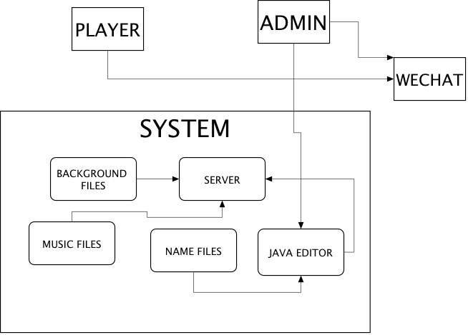  
  
**Class DIAGRAM**Our class diagram is focused on some classes such as Lotto Client, Lotto Server and LottoInfo.those classes have relationships between them. For example a client will be the one and only one to have a particular info. As well a particular info is for only one client. By the way the server can store many info.

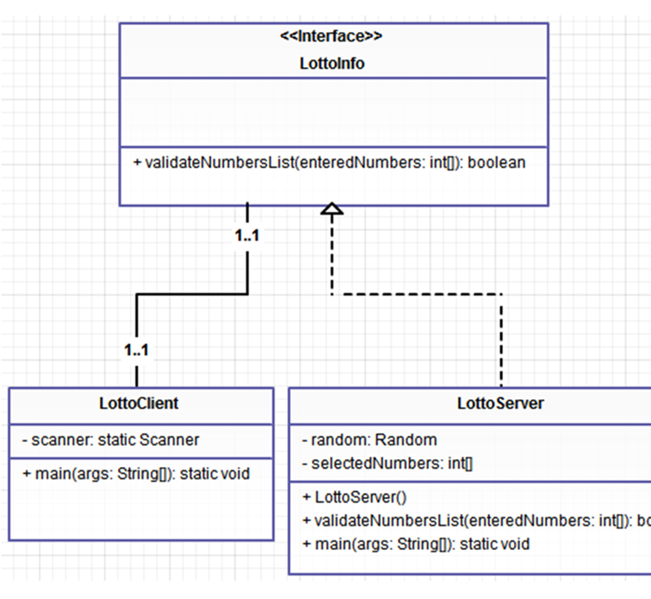

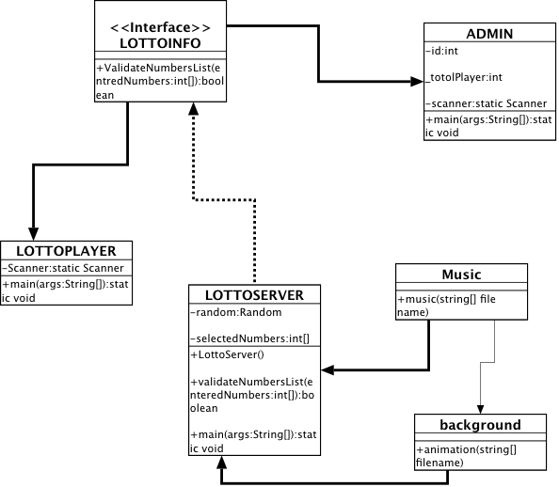

**First sequence diagram**Our first UML sequence diagram shows the interaction between the administrator and the system. Here the administrator is the one to start the procedure of lottery. First of all, he need to get a random list of. players. Then proceed to do verifications 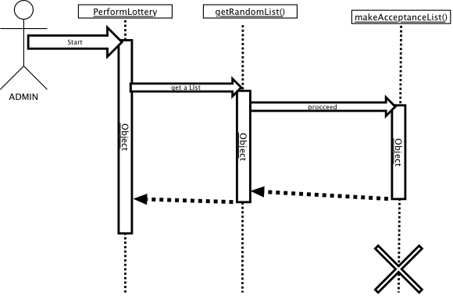

**Second sequence diagram**

for the second UML sequence diagram, it shows the interaction between the player and the system. The player has to scan a QR code and by scanning it he will get some information about lottery as a message to provide his name etc. then after inputting his name he’ll get an id. Second sequence diagram

for the second UML sequence diagram, it shows the interaction between the player and the system. The player has to scan a QR code and by scanning it he will get some information about lottery as a message to provide his name etc. then after inputting his name he’ll get an id

