
《机器学习（双语）》

期末大作业

题 目 Discussion Topics
Strategy-Designing Report

专 业 网络工程
学 号 B22080228
姓 名 徐基恒
任 课 教 师 宋旭琳
日 期 2025.01.17

Catalogue
期末大作业 1
Chapter 1 Discussion Topics 1
1.1 Topic 1 1
1.1.1 Features: Representing the Domain 1
1.1.2 Model: Learning Patterns 1
1.1.3 Task: Solving the Problem 2
1.1.4 Relationships Between Features, Model, and Task 2
1.1.5 Conclusion 3
1.2 Topic 2 3
1.2.1 Major Types of Machine Learning Models 3
1.2.2 Supervised Learning: Predicting Labeled Outputs 3
1.2.3 Unsupervised Learning: Finding Hidden Patterns 4
1.2.4 Reinforcement Learning: Learning Through Interaction 4
1.2.5 Conclusion 5
Chapter 2 Strategy-Designing Report 6
2.1 Background 6
2.2 The Designed System 6
2.2.1 Data Collection 7
2.2.2 Data Processing 7
2.2.3 Model Training 8
2.3 Experimental Design 11
2.3.1 Deployment Testing 11
2.4 Analysis and Discussion 12
2.5 Conclusion 12
2.6 Code Example 12
References 14

Chapter 1 Discussion Topics

1.1 Topic 1
Topic 1: Please discuss the basic components and their relationships included for a typical machine-learning system, strictly according to the architecture of this course.
A machine learning (ML) system is built on several interconnected components that solve a specific problem or task collaboratively. According to the architecture outlined in this course, the three fundamental components of a typical ML system are Features, Models, and Tasks. These components have distinct roles and form a pipeline to translate input data into meaningful outputs. Below, we'll go into each of these components and their relationships.

1.1.1 Features: Representing the Domain
Features are the foundation of any ML system. They are the representation of domain objects or raw data in a structured format that the model can process. For example, in image recognition, features might include pixel values, color histograms, or edge detection outputs. In text processing, features could be word embeddings, token frequencies, or part-of-speech tags.
The quality and relevance of features are crucial for the success of an ML model. This process, known as feature engineering, involves selecting, extracting, and transforming raw data into meaningful representations. Poorly chosen features can lead to underperforming models, regardless of their complexity. Conversely, well-crafted features enable even simple models to perform well.
In the context of this architecture: Features act as the interface between raw domain objects and the model. They must encode sufficient information to allow the model to discern patterns and make predictions.

1.1.2 Model: Learning Patterns
The model is the core computational component of an ML system. Its purpose is to map input features to desired outputs using mathematical and statistical principles. The model learns this mapping through a training process, where it adjusts its internal parameters (such as weights in a neural network) to minimize the error between predictions and actual outputs.
There are different types of models depending on the task at hand. For instance: For regression tasks, linear regression or support vector regression might be used. For classification tasks, decision trees, random forests, or neural networks are common choices.
In the learning phase, the model relies on the features as input and uses training data to optimize itself. The learning algorithm facilitates this process, updating the model's parameters to improve performance iteratively. Once trained, the model can make predictions on unseen data, effectively bridging the gap between features and task requirements.

1.1.3 Task: Solving the Problem
The task defines the ultimate goal of the ML system, translating model outputs into actionable insights or solutions. Tasks can vary widely, from image classification and object detection to sentiment analysis and predictive maintenance. In essence, the task is the "problem definition" that drives the selection of features and models.
The task dictates the type of output: For a classification task, the output might be discrete labels. For a regression task, the output is continuous numerical values. For clustering, the output could be group assignments.
The task also determines the evaluation metrics used to assess model performance. Accuracy, precision, recall, and F1-score are common metrics for classification tasks, while mean squared error and R-squared are typical for regression.

1.1.4 Relationships Between Features, Model, and Task
The relationships among these components form the operational flow of an ML system:
Features feed the model: Features act as input to the model, providing the structured data necessary for learning patterns.
The model solves the task: The trained model uses its learned parameters to generate outputs that align with the task requirements.
The task evaluates the model: The task provides a framework for evaluating the model's predictions, and guiding improvements in feature engineering or model optimization.
These components are tightly coupled. Improving features often enhances model performance, while redefining the task can alter the choice of features and models. For instance, if the task changes from binary to multi-class classification, feature selection and model architecture may need adjustments.

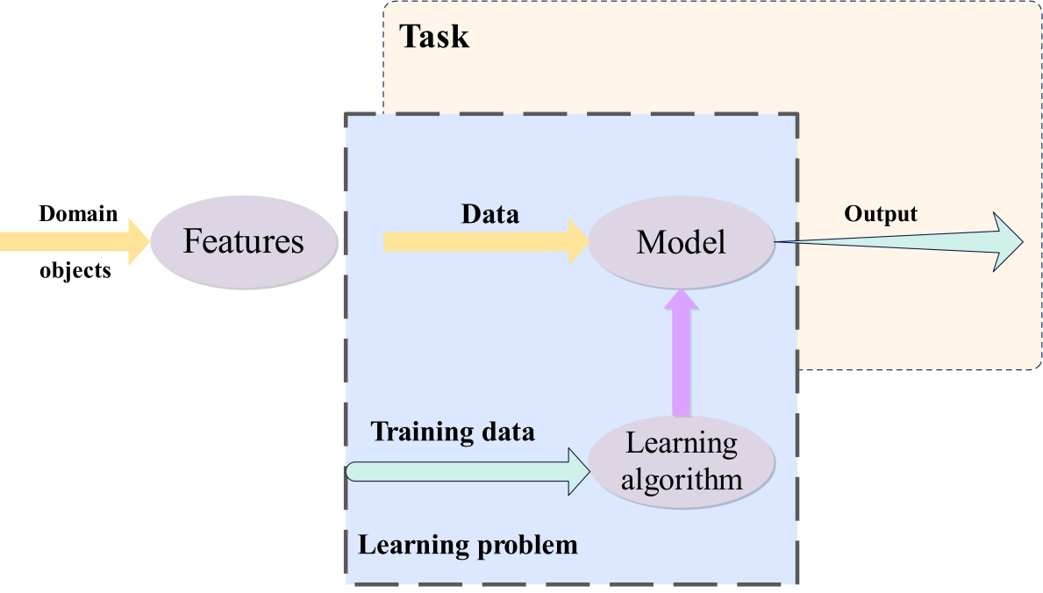
Figure 1.1 Component of Machine Learning

1.1.5 Conclusion
A machine learning system is a symbiotic ecosystem of features, models, and tasks. Features capture the essence of raw data, the model learns patterns within these features, and the task provides the framework for applying the model's predictions. The relationships among these components underscore the importance of a holistic approach to ML system design. By carefully considering each element and their interplay, practitioners can build effective ML systems that address diverse real-world challenges.

1.2 Topic 2
Topic 2: Please discuss the major types of basic learning models and their characteristics, strictly according to the knowledge learned in this course.

1.2.1 Major Types of Machine Learning Models
Machine learning encompasses a variety of learning models, each tailored to address specific types of problems and datasets. Broadly, these models are categorized into supervised learning, unsupervised learning, and reinforcement learning, each characterized by unique methodologies, objectives, and applications. Understanding these models is crucial to selecting the right approach for a given problem and leveraging the strengths of machine learning effectively.

1.2.2 Supervised Learning: Predicting Labeled Outputs
Supervised learning is the most widely used category of machine learning, where the model learns from a labeled dataset. This means that for every input in the training data, there is a corresponding output or label provided. The goal is to map input features to the correct output by identifying patterns within the data. Tasks commonly addressed using supervised learning include classification (e.g., identifying spam emails) and regression (e.g., predicting house prices). Algorithms like linear regression, logistic regression, decision trees, support vector machines, and neural networks are prominent examples of supervised learning models. These models rely heavily on the quality and quantity of labeled data, as their performance is contingent upon how well the training data represents the real-world scenario they aim to model. Supervised learning is highly interpretable in cases like linear regression but can become complex and opaque with deep neural networks. One of its key advantages is its ability to generalize to unseen data, provided the model is not overfitted to the training dataset. Evaluation metrics like accuracy, F1-score, mean squared error, and R-squared are often employed to measure performance, depending on whether the task is classification or regression. Despite its effectiveness, supervised learning is resource-intensive, requiring substantial labeled data, which is often costly and time-consuming to acquire.

1.2.3 Unsupervised Learning: Finding Hidden Patterns
Unsupervised learning differs fundamentally from supervised learning in that it deals with unlabeled data. Here, the objective is not to predict an output but to discover hidden structures, patterns, or relationships within the data. This approach is particularly useful in tasks such as clustering, dimensionality reduction, and anomaly detection. Algorithms like k-means clustering, hierarchical clustering, Gaussian mixture models, principal component analysis (PCA), and autoencoders are central to unsupervised learning. For example, clustering techniques can group customers based on purchasing behavior, aiding targeted marketing, while dimensionality reduction techniques like PCA are used to simplify complex datasets by reducing the number of variables, thereby facilitating visualization and computational efficiency. The primary strength of unsupervised learning lies in its ability to handle vast, unstructured datasets, making it indispensable in fields like big data analytics, biology, and network analysis. However, its limitations include the lack of clear evaluation metrics and the difficulty of interpreting the discovered patterns, as there is no "ground truth" to validate the results. Moreover, the success of these models often hinges on the careful selection of hyperparameters, such as the number of clusters in k-means or the number of principal components in PCA.

1.2.4 Reinforcement Learning: Learning Through Interaction
Reinforcement learning represents a distinct paradigm within machine learning, focusing on decision-making and sequential actions. In this approach, an agent interacts with an environment, learning to make optimal decisions by maximizing cumulative rewards. Unlike supervised or unsupervised learning, reinforcement learning incorporates a feedback loop, where the agent's actions influence the state of the environment, and the environment, in turn, provides rewards or penalties. This makes reinforcement learning particularly well-suited for tasks involving dynamic and uncertain environments, such as robotics, game playing, autonomous driving, and financial portfolio management. Popular reinforcement learning algorithms include Q-learning, deep Q-networks (DQNs), policy gradients, and actor-critic methods. One of the defining characteristics of reinforcement learning is its ability to learn through trial and error, adapting dynamically to new scenarios. However, this flexibility comes at a cost; reinforcement learning often requires substantial computational resources and time to train, as well as a well-defined reward structure to guide learning. Moreover, it can be challenging to ensure stability and convergence, especially in complex environments with high-dimensional state and action spaces.

1.2.5 Conclusion
While these three categories represent the foundational models of machine learning, many real-world problems require hybrid approaches that combine elements from each. For instance, semi-supervised learning bridges supervised and unsupervised learning by utilizing a small amount of labeled data alongside a larger pool of unlabeled data. Similarly, self-supervised learning, an emerging paradigm, leverages the structure of unlabeled data to create pseudo-labels for training, and it has been instrumental in advancing deep learning applications like natural language processing and computer vision.
Ultimately, the choice of a learning model depends on the problem at hand, the nature of the data, and the desired outcome. Supervised learning excels in scenarios where labeled data is abundant, and accurate predictions are required, such as medical diagnosis or fraud detection. Unsupervised learning is invaluable for exploratory data analysis and preprocessing tasks, where the goal is to uncover hidden patterns or reduce data complexity. Reinforcement learning shines in decision-making applications requiring adaptability and interaction with dynamic environments, though its computational demands and complexity make it less suitable for routine tasks. By understanding the strengths, limitations, and appropriate use cases of these models, practitioners can design robust and efficient machine learning systems to address a wide range of challenges.
This comprehensive understanding of the major learning models not only highlights their characteristics but also emphasizes their interconnectedness and the importance of choosing the right approach for specific scenarios. Each model contributes uniquely to the field of machine learning, and together, they form the foundation for solving the diverse and complex problems encountered in real-world applications.

Chapter 2 Strategy-Designing Report

2.1 Background
Mental health has emerged as a crucial area of concern for college students, particularly in the context of China's rapidly evolving educational landscape.[1] The increasing academic pressure, social anxieties, and lifestyle shifts have heightened the vulnerability of students to mental health issues, including anxiety, depression, and stress-related disorders. Universities often lack efficient mechanisms to identify and address mental health concerns proactively, leading to delayed interventions and worsening conditions. This report proposes a machine-learning-based solution to tackle this problem by automating the estimation and potential improvement of mental health conditions among college students. The proposed system will employ a data-driven approach to analyze diverse data types, derive actionable insights, and recommend personalized interventions. This chapter details the design, implementation, and evaluation of this system, emphasizing feasibility, scalability, and ethical considerations.[2]

Figure 2.1 Increasing psychological problems

2.2 The Designed System
The proposed system integrates three essential components: data collection, data processing, and model evaluation. These components work together to ensure accurate estimation of mental health conditions and effective intervention strategies. Figure 2.2 provides an overview of the system architecture.
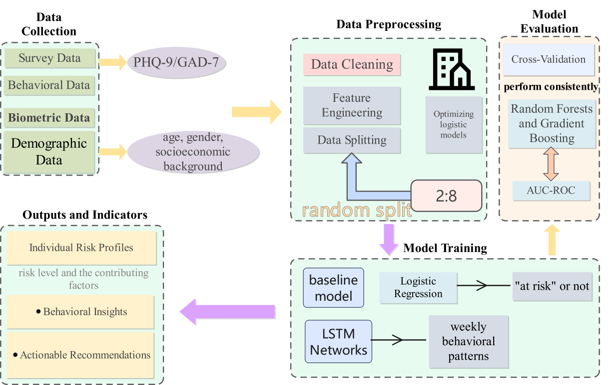
Figure 2.2 System Framework

2.2.1 Data Collection
The first step involves collecting diverse datasets to capture the multifaceted nature of mental health.
Data types include: Survey Data[17], Standardized tools like PHQ-9 and GAD-7 provide self-reported insights into depression and anxiety; Behavioral Data: Digital activity logs from online learning platforms, including login frequency, assignment submissions, and study duration; Biometric Data: Wearable devices monitor metrics such as heart rate, sleep quality, and physical activity[5]; Demographic Data: Information on age, gender, academic discipline, and socioeconomic background.[3]

2.2.2 Data Processing
After collection, the data undergoes rigorous preprocessing to ensure quality and compatibility with machine learning algorithms. This includes:
- Data Cleaning: Handling missing values and removing outliers using statistical and algorithmic methods.
- For missing values:
$x_{i,imputed}=\frac{1}{n}\sum_{j=1}^{n}{x_{j}}(mean imputation)$ (2-1)
- For outlier detection:
$z=\frac{x-μ}{σ}(Z-score analysis)$ (2-2)
- Feature Engineering: Extracting relevant features[15], such as sentiment analysis from text data, and deriving new metrics like sleep consistency.[4]
$Sleep Consistency=σ(Sleep Times)$ (2-3)
- Data Splitting: Dividing the dataset into training, validation, and testing subsets to prevent overfitting and ensure unbiased evaluation.
$X=x_{1},x_{2},…,x_{n},y=y_{1},y_{2},…,y_{n}$ (2-4)

2.2.3 Model Training
The system employs a range of machine learning models, starting with baseline algorithms such as logistic regression for binary classification. Advanced models, including Random Forests and Gradient Boosting, are implemented for their robustness and interpretability. For sequential or time-series data, Long Short-Term Memory (LSTM) networks capture temporal dependencies. Hyperparameter tuning and iterative optimization ensure the models achieve high performance across metrics like accuracy, F1-score, and AUC-ROC.
- Model Introduction
- Logistic Regression: Expand on how logistic regression[7] models the probability of mental health conditions. You could complete the sentence as follows:
$P(y=1∣x)=\frac{1}{1+e^{-(β_{0}+β_{1}x_{1}+⋯+β_{n}x_{n})}}$ (2-5)
Here, $β_{0}$is the intercept, and $β_{i}$ are the coefficients of the features $x_{i}$. This model outputs probabilities, which can then be thresholded (e.g., at 0.5) to make binary classifications.
This probability can then be thresholded to classify students as "at risk" or "not at risk."
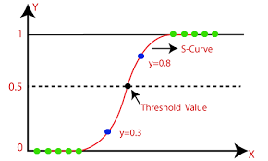
Figure 2.3 Logistic curve
- Random Forests: Provide an explanation and a formalization.[8] For example:
$F(x)=\frac{1}{T}\sum_{t=1}^{T}{f_{t}}(x)$ (2-6)
Where T is the total number of decision trees, and$f_{t}(x)$is the prediction from the t-th tree. Random Forests aggregate predictions from multiple trees to improve robustness and reduce overfitting.
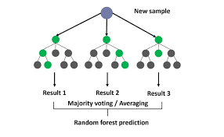
Figure 2.4 Random forest
- Gradient Boosting: Complete the explanation with details on how Gradient Boosting iteratively adds models to minimize the loss function.[9] For example:
$F_{m}(x)=F_{m-1}(x)+η⋅h_{m}(x)$ (2-7)
Here, $F_{m-1}(x)$is the previous ensemble, and$η$is the learning rate, and $h_{m}(x)$is the new weak learner trained to approximate the negative gradient of the loss function:
$h_{m}(x)≈-∇L(y,F_{m-1}(x))$ (2-8)
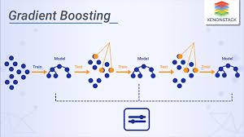
Figure 2.5 Gradient Boosting
- LSTM: For sequential data, LSTMs capture temporal patterns by maintaining a memory state over time steps.[10] The hidden state at the time is calculated as:
$h_{t}=f(W_{xh}x_{t}+W_{hh}h_{t-1}+b_{h})$ (2-9)
Where is an activation function, and are learned parameters?

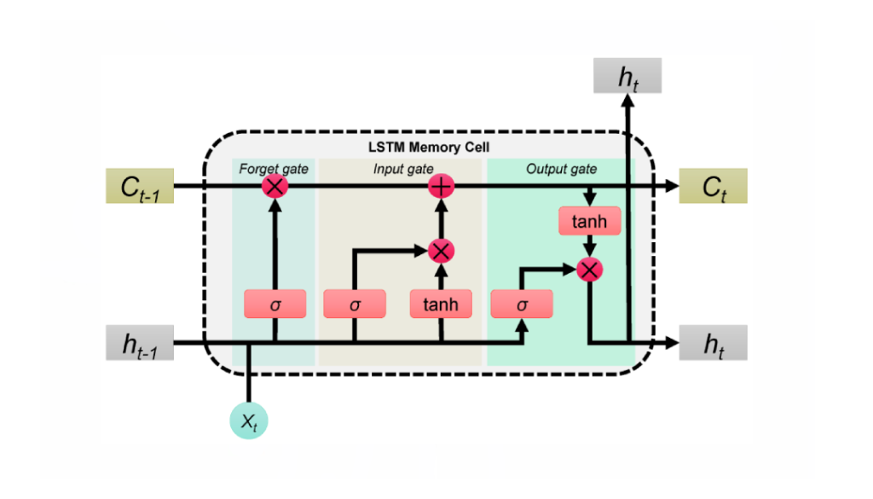
Figure 2.6 LSTM structure
- Solution for Assessing Factors of Psychological Problems
The system analyzes the factors contributing to students’ mental health by combining model outputs with domain knowledge. The process involves: Feature Importance Analysis, Psychological Risk Scoring[11], Clustering for Behavioral Patterns[6], and Interpretable Decision Rules.[14]
First, Feature Importance Analysis. Models like Random Forests and Gradient Boosting provide feature importance scores to identify critical factors influencing mental health.
$Feature Importance=\frac{\sum_{t=1}^{T}{I}(f_{t},feature)}{T}$ (2-10)
These scores highlight key features such as sleep consistency, academic workload, and social interaction frequency.
Second, Psychological Risk Scoring. For each student, a composite risk score is calculated based on model outputs:
$Risk Score=\sum_{i=1}^{n}{w_{i}}⋅x_{i}$ (2-11)
Where are weights derived from feature importance, and are the normalized feature values?
Then, Clustering for Behavioral Patterns. Using unsupervised learning (e.g., k-means clustering), students are grouped based on behavioral data:
$Cluster Assignment=argmink∑i∈C_{k}{|}x_{i}-μ_{k}{|}$ (2-12)
Where is the centroid of the cluster? This helps identify common behavioral patterns linked to mental health conditions.
Finally, Interpretable Decision Rules. Decision tree models generate interpretable rules for counselors to understand high-risk profiles. For instance: Rule Example: If (Sleep Consistency < 0.5) AND (High Academic Load), THEN Risk = High.[20]

- Outputs and Indicators
The final outputs of the system are below.
Individual Risk Scores: Quantitative scores for each student indicate the likelihood of mental health issues. Feature Contribution Analysis: Insights into which features (e.g., low sleep quality, high stress) contribute most to a student’s risk profile. Behavioral Clusters: Groups of students with similar behavioral patterns for targeted interventions. Decision Rules: Human-readable rules for counselors and mental health professionals to act upon.

2.3 Experimental Design
To validate the system’s effectiveness, an experimental evaluation framework is established. The design incorporates:
- Baseline Comparison: Models are compared against baseline approaches to evaluate improvement.
- Cross-Validation[12]: K-fold cross-validation ensures robustness and generalizability across datasets. Cross-validation formula:
$CV Error=\frac{1}{k}\sum_{i=1}^{k}{{Error}_{i}}$ (2-13)
- Evaluation Metrics[13]: Metrics such as precision, recall, and mean squared error are used to assess classification and regression tasks. AUC-ROC is employed for binary classification tasks to measure the ability to distinguish between risk levels.[19]
- Precision
$Precision=\frac{True Positives}{True Positives+False Positives}$ (2-14)
- Recall
$Recall=\frac{True Positives}{True Positives+False Negatives}$ (2-15)
- AUC-ROC:
$AUC=∫_{0}^{1}TPR(FPR)d(FPR)$ (2-16)
User Feedback: A post-experiment survey gauges students’ satisfaction and perceived benefits from the system.

2.3.1 Deployment Testing
The deployment phase involves integrating the system with university platforms, followed by A/B testing. One group of students receives interventions based on system recommendations, while another group continues with existing mental health practices. Comparative analysis highlights the system’s impact on mental health indicators.

2.4 Analysis and Discussion
The results from experimental evaluations are analyzed to assess the system’s accuracy, efficiency, and practical utility. Key findings include:
Improved Detection: The system consistently identifies at-risk students with high precision and recall, outperforming traditional methods.
Scalability: Cloud-based deployment ensures the system can handle increasing student populations without compromising performance.
Ethical Concerns: Data privacy and ethical considerations are integral to system design, with all data anonymized and securely stored[18].
The discussion highlights areas for improvement, such as expanding datasets to include diverse student populations and refining feature selection methods. Feedback from students and counselors provides actionable insights for system enhancement. Table 1.1 summarizes the performance metrics of the best-performing models during the experimental phase.

2.5 Conclusion
The proposed machine learning strategy provides a scalable, data-driven approach to estimating and improving college students’ mental health. By leveraging diverse data sources and advanced machine-learning techniques, the system achieves high accuracy and practical relevance. The inclusion of ethical considerations and user feedback ensures the system is both effective and well-received. Future work will focus on integrating additional data types, refining algorithms, and expanding deployment to a broader range of educational institutions.

2.6 Code Example
import pandas as PD
import numpy as np
from sklearn.model_selection import train_test_split, GridSearchCV
from sklearn.ensemble import RandomForestClassifier
from sklearn.metrics import accuracy_score, classification_report, roc_auc_score
# Step 1: Data Loading and Cleaning
data = pd.read_csv('student_mental_health.CSV)
# Handle missing values
data.fillna(data.median(), inplace=True)
# Step 2: Feature Engineering
# Example feature: Sentiment analysis (placeholder for actual implementation)
data['sentiment_score'] = np.random.uniform(0, 1, len(data))
# Step 3: Train-Test Split
X = data.drop(columns=['mental_health_label'])
y = data['mental_health_label']
X_train, X_test, y_train, y_test = train_test_split(X, y, test_size=0.2, random_state=42)
# Step 4: Model Training
model = RandomForestClassifier(random_state=42)
param_grid = {'n_estimators': [50, 100, 200], 'max_depth': [5, 10, 20]}
grid_search = GridSearchCV(model, param_grid, cv=5, scoring='roc_auc')
grid_search.fit(X_train, y_train)
# Step 5: Evaluation
best_model = grid_search.best_estimator_
y_pred = best_model.predict(X_test)
print("Accuracy:", accuracy_score(y_test, y_pred))
print("Classification Report:\n", classification_report(y_test, y_pred))
print("AUC-ROC:", roc_auc_score(y_test, best_model.predict_proba(X_test)[:, 1]))

References
[1] Sheldon E, Simmonds-Buckley M, Bone C, et al. Prevalence and risk factors for mental health problems in university undergraduate students: A systematic review with meta-analysis[J]. Journal of Affective Disorders, 2021, 287: 282-292.
[2] Orrù G, Monaro M, Conversano C, et al. Machine learning in psychometrics and psychological research[J]. Frontiers in Psychology, 2020, 10: 2970.
[3] Chung J, Teo J. Mental health prediction using machine learning: taxonomy, applications, and challenges[J]. Applied Computational Intelligence and Soft Computing, 2022, 2022(1): 9970363.
[4] Yadav G, Bokhari M U. Hybrid Classifier for Optimizing Mental Health Prediction: Feature Engineering and Fusion Technique[J]. International Journal of Mental Health and Addiction, 2024: 1-41.
[5] Gaggioli A, Pioggia G, Tartarisco G, et al. A mobile data collection platform for mental health research[J]. Personal and Ubiquitous Computing, 2013, 17: 241-251.
[6] Li X, Zhang Y, Cheng H, et al. An unsupervised ensemble clustering approach for the analysis of student behavioral patterns[J]. Ieee Access, 2021, 9: 7076-7091.
[7] Alishiri G H, Bayat N, Fathi Ashtiani A, et al. Logistic regression models for predicting physical and mental health-related quality of life in rheumatoid arthritis patients[J]. Modern Rheumatology, 2008, 18(6): 601-608.
[8] Mohamed E S, Naqishbandi T A, Bukhari S A C, et al. A hybrid mental health prediction model using Support Vector Machine, Multilayer Perceptron, and Random Forest algorithms[J]. Healthcare Analytics, 2023, 3: 100185.
[9] Tian Z, Xiao J, Feng H, et al. Credit risk assessment based on gradient boosting decision tree[J]. Procedia Computer Science, 2020, 174: 150-160.
[10] Uematsu T, Sano A, Taylor S, et al. Improving students' daily life stress forecasting using LSTM neural networks[C]//2019 IEEE EMBS international conference on biomedical & health informatics (BHI). IEEE, 2019: 1-4.
[11] Boersma K, Linton S J. Screening to identify patients at risk: profiles of psychological risk factors for early intervention[J]. The Clinical journal of pain, 2005, 21(1): 38-43.
[12] De Rooij M, Weeda W. Cross-validation: A method every psychologist should know[J]. Advances in Methods and Practices in Psychological Science, 2020, 3(2): 248-263.
[13] Carrington A M, Manuel D G, Fieguth P W, et al. Deep ROC analysis and AUC as balanced average accuracy to improve model selection, understanding, and interpretation[J]. arXiv preprint arXiv:2103.11357, 2021.
[14] Aneja A. Artificial Intelligence-Based Customer Behavioral Analysis: Techniques, Applications, and Business Insights[C]//2023 International Conference on Innovative Computing, Intelligent Communication and Smart Electrical Systems (ICSES). IEEE, 2023: 1-5.
[15] Barber L K, Munz D C, Bagsby P G, et al. Sleep consistency and sufficiency: Are both necessary for less psychological strain?[J]. Stress and Health, 2010, 26(3): 186-193.
[16] Carr S. ‘AI gone mental’: engagement and ethics in data-driven technology for mental health[J]. Journal of Mental Health, 2020, 29(2): 125-130.
[17] Bertocci D, Hirsch E, Sommer W, et al. Student mental health needs: Survey results and implications for service[J]. Journal of American College Health, 1992, 41(1): 3-10.
[18] Nicholas J, Onie S, Larsen M E. Ethics and privacy in social media research for mental health[J]. Current Psychiatry Reports, 2020, 22: 1-7.
[19] Salvador-Carulla L, González-Caballero J L. Assessment instruments in mental health: description and metric properties[J]. Mental health outcome measures, 2010, 3: 28-62.
[20] Ganai U J, Sachdev S, Bhushan B. Predictive modeling of stress, anxiety, and depression: A network analysis and machine learning study[J]. British Journal of Clinical Psychology, 2024, 63(4): 522-542.

