2017141093001 刘天畅
1、
#include <iostream>

using namespace std;

class Complex {
public:
Complex() {
real = 0;
imag = 0;
}

Complex(double r, double i) {
real = r;
imag = i;
}

void display();

double real;
double imag;
private:
};
Complex operator +(Complex& c1,Complex& c2)
{Complex c;
c.real=c1.real+c2.real;
c.imag=c1.imag+c2.imag;
return c;
}
void Complex::display()
{cout<<"("<<real<<","<<imag<<"i)"<<endl;}

int main()
{Complex c1(3,4),c2(5,-10),c3;
c3=c1+c2;
cout<<"c1=";c1.display();
cout<<"c2=";c2.display();
cout<<"c1+c2=";c3.display();
return 0;
}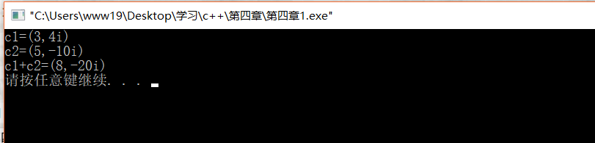

2、
#include <iostream>

using namespace std;

class Complex {
public:
Complex() {
real = 0;
imag = 0;
}

Complex (double r, double i) {
real = r;
imag = i;
}
Complex operator+(Complex &c2);
Complex operator-(Complex &c2);
Complex operator*(Complex &c2);
Complex operator/(Complex &c2);
void display();

private:
double real;
double imag;
};

Complex Complex::operator +(Complex& c2)
{Complex c;
c.real=real+c2.real;
c.imag=imag+c2.imag;
return c;
}

Complex Complex::operator -(Complex& c2)
{Complex c;
c.real=real-c2.real;
c.imag=imag-c2.imag;
return c;
}

Complex Complex::operator *(Complex& c2)
{Complex c;
c.real=real*c2.real-imag*c2.imag;
c.imag=real*c2.imag+imag*c2.real;
return c;
}

Complex Complex::operator /(Complex& c2)
{Complex c;
c.real=(real*c2.real+imag*c2.imag)/(c2.imag*c2.imag+c2.real*c2.real);
c.imag=(imag*c2.real-real*c2.imag)/(c2.imag*c2.imag+c2.real*c2.real);
return c;
}
void Complex::display()
{cout<<"("<<real<<","<<imag<<"i)"<<endl;}

int main()
{
Complex c1(3,4),c2(5,-10),c3,c4,c5,c6;
c3=c1+c2;
c4=c1-c2;
c5=c1*c2;
c6=c1/c2;
cout<<"c1=";c1.display();
cout<<"c2=";c2.display();
cout<<"c1+c2=";c3.display();
cout<<"c1-c2=";c4.display();
cout<<"c1*c2=";c5.display();
cout<<"c1/c2=";c6.display();
return 0;

}
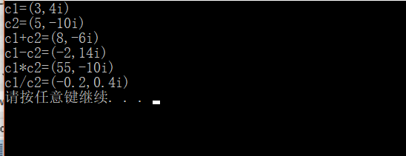

3、

#include <iostream>

using namespace std;

class Complex {
public:
Complex() {
real = 0;
imag = 0;
}

Complex (double r, double i) {
real = r;
imag = i;
}
Complex operator+(Complex &c2);
friend Complex operator+(int i,Complex &c);
friend Complex operator+(Complex &c,int i);
void display();
private:
double real;
double imag;
};

Complex Complex::operator +(Complex& c2)
{Complex c;
c.real=real+c2.real;
c.imag=imag+c2.imag;
return c;
}

Complex operator +(Complex &c,int i){
return Complex(i+c.real,c.imag);
}
Complex operator +(int i,Complex &c){
return Complex(i+c.real,c.imag);
}

void Complex::display()
{cout<<"("<<real<<","<<imag<<"i)"<<endl;}

int main()
{
Complex c1(3,4),c2(5,-10),c3,c4,c5;
int i=10;
c3=c1+c2;
c4=c1+i;
c5=i+c1;
cout<<"c1=";c1.display();
cout<<"c2=";c2.display();
cout<<"c1+c2=";c3.display();
cout<<"c1+i=";c4.display();
cout<<"i+c1=";c5.display();
return 0;

}
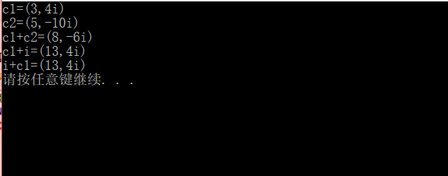

4、
#include <iostream>
using namespace std;
class Matrix{
public:
Matrix();
Matrix operator+(Matrix &c2);
void display();
void input();
private:
int a[2][3],i,j;
};

Matrix::Matrix()
{
for( i=0;i<2;i++)
for( j=0;j<3;j++)
a[i][j]=0;
}

Matrix Matrix::operator +(Matrix& c2)
{Matrix c;
for(i=0;i<2;i++)
for(j=0;j<3;j++)
c.a[i][j]=a[i][j]+c2.a[i][j];
return c;
}

void Matrix::display()
{for(i=0;i<2;i++){

for(j=0;j<3;j++)
{
cout<<a[i][j]<<'|';
}
cout<<'\n';}
}

void Matrix::input()
{
for(i=0;i<2;i++)
for(j=0;j<3;j++)
cin>>a[i][j];
}

int main()
{
Matrix t1,t2,t3;
t1.input();
t2.input();
t3=t2+t1;
cout<<"t1=";t1.display();
cout<<"t2=";t2.display();
cout<<"t1+t2=";t3.display();
return 0;
}

