# Requirement

(Additional to Orders_Simulation_-_Homework.pdf)

## Courier

* The number of couriers should be configurable.
* The courier will cancel the picking job if he is not possible to arrive at kitchen on time.
* The courier will cancel the picking job if the food is discarded when he is on the way.

## Shelf

* Once need to discard an order on the overflow shelf, kitchen will estimate the value of each order when it’s picked. And choose the minimal one to discard.

## Shelf Life

* If an order used to resident on both overflow shelf and single temp shelf. Its value is

value = (shelfLife - decayRate * (ageOnOverFlow * 2 + ageOnSigleTemp * 1)) / shelfLife

Code architecture  
Overall

Use core package to hold all global shared information including config, log and global data structures. Common package includes the common used utilities independent to business logic.

Use Mediator pattern to de-couple each component.

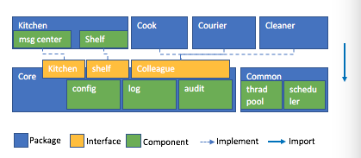

## Kitchen MSG center

Kitchen msg center implements a FIFO msg queue for order events. Once kitchen msg center receiving an event, it notifies colleagues who are interested in this event. And once a colleague completes his job, he sends a message to kitchen msg center.

* Event type
  + Accepted
  + Cooked
  + Moved (food is moved from overflow shelf to single temp shelf)
  + Picked
  + Discarded
  + Delivered

## Shelf

Shelf implement data structure of a set of shelves and provides ‘Pick()’ and ‘Put()’ method as interface.

## Cook

Cook receives Accepted event and produces Cooked event after finish cooking job.

## Courier

Courier receives Accepted event. And get a thread from thread pool to execute the picking job. Produce Picked and Delivered event once the job is done. And if the order is discarded during picking, the picking job will terminate immediately.

## Cleaner

Once receiving Cooked or Moved event. Cleaner calculate the remain shelf life of related food and schedules/reschedules a clean job for it. It sends Discarded event after then clean job done.

And once receiving Discarded, Delivered event, cleaner removes related clean job.