Veneracion, Nelson Jay S.

BSIT 4-E

**LEARNING MANAGEMENT SYSTEM FOR PHILIPPINE ACADEMY OF TECHNICAL STUDIES INC.**

One of the key requirements for being a BSIT student is to create a capstone project that develops a system aimed at solving real-world problems and helping people. Initially, our first capstone project didn’t align with the needs of our target community, as it didn’t address any actual problem. As a result, we had to start over. Instead of discarding the original idea, we searched for ways to refine it. One suggestion was to collaborate with TESDA-accredited institutions. Since there are many such institutions in Nueva Ecija, we thought it would be relatively easy to partner with one.

We first approached a nearby institution and met with a staff member. However, our attempt didn’t progress because the person in charge wasn’t available. Undeterred, we moved on to another institution. This time, after a bit of waiting, we had the opportunity to present our proposal to the head of the institution. We explained that we wanted to develop a learning system tailored to their needs. They expressed interest but mentioned they already had an LMS in place. However, they identified specific issues: currently, only the admin could enrol students, certificates weren’t automatically generated, and students who were inactive for more than a week remained in the system. These challenges were crucial, and addressing them became the foundation for enhancing our project.

The main stakeholders for this project include several key groups. First, the students, who will need easy access to course materials and downloadable certificates upon course completion, verified by instructors. Second, the instructors, who will require tools to upload and manage various content types, as well as assessment tools for student evaluation. Third, the administrators, who oversee the system’s operations, manage user accounts, and need the ability to track user activities and manage enrolments. Finally, the institutions themselves will play a significant role in implementing and funding the LMS. By understanding the needs of these different stakeholders, we were able to identify the essential requirements for developing our project.

As we gathered these requirements, it became clear that the process wasn’t without challenges. We had to engage in meaningful conversations, ensuring that we fully understood the problems the users faced. These conversations often involved interviews, where we collected feedback and brainstormed solutions to the issues that were raised. We also observed common scenarios in the institution to better visualize the problems and how they could be solved.

In the process of gathering requirements, visual diagrams played an essential role in clarifying and communicating the stakeholders' needs. One of the key tools we used were Use Case Diagrams, which visually represented the interactions between users, such as students, instructors, and administrators, and the system. These diagrams illustrated specific scenarios like student enrolments and course management, helping us understand how different users interact with the system. We also utilized Data Flow Diagrams (DFD) to track how data moves through the system, showing how it is processed, stored, and outputted. DFD’s were especially useful in understanding how various modules within the system interacted and managed data flow. Lastly, Wireframes and Mock-ups were created to visualize the system’s user interface, allowing stakeholders to provide early feedback on the design. This approach enabled us to make necessary adjustments and ensure the system met user expectations.

These tools and methods helped us significantly in building our capstone project. By combining careful requirements gathering, stakeholder engagement, and visual aids, we are on our way to developing a system that will truly address the needs of TESDA-accredited institutions and their students.

Draft

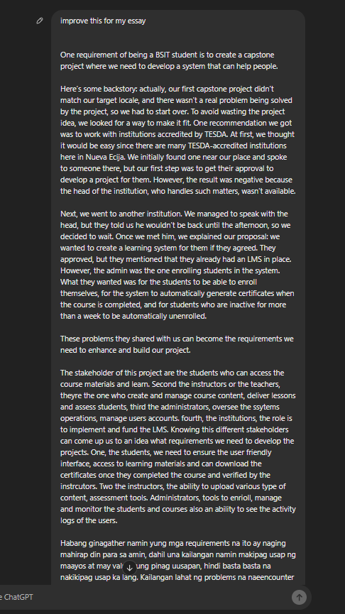

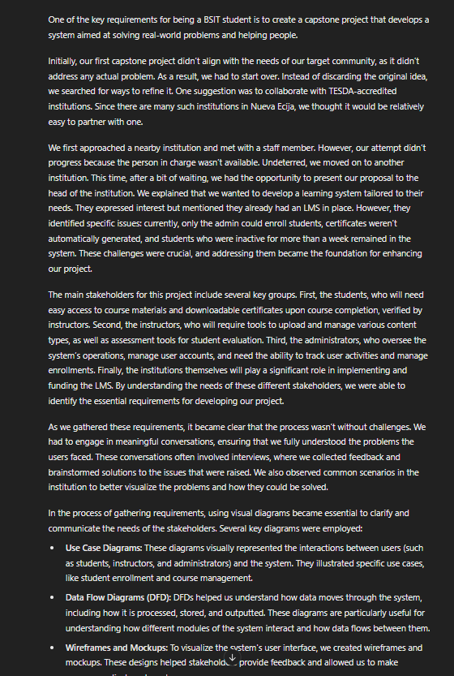ChatGPT Improved Version