Mini Project 1: Mining text from the web

Jong Woo Nam

1. Project Overview:

For this project, I was going to do a similarity comparison among Harry Potter fan fictions that exists on the web. Using pattern, I was able to cluster fan ficitons into similar categories and graph them using the graph tool provided by pattern.

2. Implementation:
I decided to divide my code into two python files. One is “jong_miniproject.py”, which defines all the functions I will be using, and the other is “test.py”, which is just made to test whatever functions are defined in the other python file, and also to see the actual output.
The “jong_miniproject.py” is divided into two parts. The first part is the actual mining of the texts from “www.fanfiction.net”, and the second part is processing the text into a more meaningful data by clustering them into categories.
To explain more in detail about what each of the defined functions does, “save_url(pages)” function takes in the number of pages from the user, and mines a list of urls from the website pages. It returns list of urls in dictionary form, where the key is the title of the book and the item is the actual url.
Then, “save_text(urldict,chapnum)” takes the dictionary of urls from “save_url” and chapnum, which is just a integer from user input to tell the program how many chapters of each book you want to download from the web, and returns a dictionary where key is title and the item is the mined text. Within this process, “save_necessary” and “delete_empty_list” functions are used, which are just functions that saves only the necessary parts of the downloaded text, which includes some unnecessary stuff such as html and menu bar from the website.
“print_text” function was created for testing. This fucntion takes in dictionary or list of fan fiction texts, and prints them into more readable format. “count_word” function serves similar purpose, where it takes in list or dictionary of mined texts and returns nested dictionary that looks like this: {title: {word: #of occurance, word:#..},title: {..}}.
Functions “covert2doc” and “create_cluster” uses pattern.vector. All it is doing is just taking the text and converting into the “Document” and “Cluster” objects, which are the objects pattern generates while processing the data. In the final form, “create_cluster” takes in a list of “Document” objects, and clusters similar “Document” objects into 10 categories.
Finally, “make_graph” funciton takes the “Cluster”object and graphs them using javascript. It exports the graph to the “graph” folder. You can check out my results by opening index.html in graph folder.

3. Example output:

Example output for running “save_text”:
new book
adding next chapter
adding next chapter
adding next chapter
adding next chapter
adding next chapter
adding next chapter
adding next chapter
adding next chapter
end of the book
new book
adding next chapter
adding next chapter
adding next chapter
end of the book
…

Example output for running “print_text” of “save_text” output:

Bitten
This is the story on how I died; but don't worry it is actually a pretty interesting story. But it all started with another person, with a chance of fate, and the birth of a prince...
The Kingdom of Primus Lune ruled peacefully with its people of all magical origin; being them wizards, muggles, or magical creature. When the new king was set on the throne though things changed.
A small collection of werewolves rose up against him; for their actions the pack was sent out of the kingdom and into the hills to live out the rest of their days. Since the day of the attack werewolves that had not been involved were shunned from the kingdom. Seen as second rate.
The king passed laws that set the life for werewolves at such a low standard most fled to the hills to join this mercenary's pack.
…

Example output of “make_graph”:
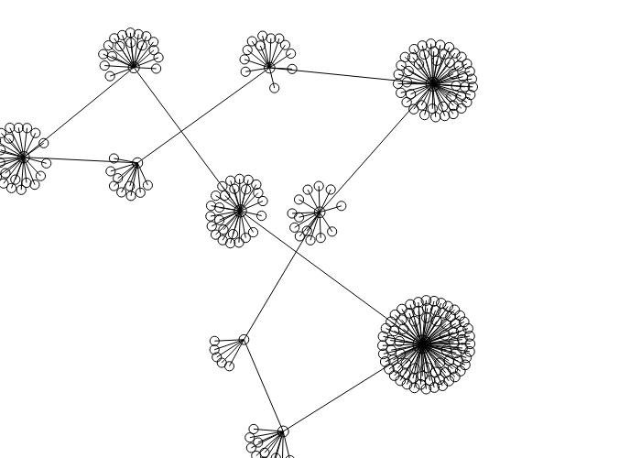
This is the graph output of the result. 10 pages of book urls were used. Typically in a page, I can
get 25 different fan fictions. The central nodes are made just to categorize, and the nodes that connect to the central nodes represent each individual fan fictions.

4. Reflection:

I think I did a good job of mining the texts from the internet. I actually got my program to mine a lot of texts within short amount of time.
However, there were some limitations to accomplishing my intentions. First, the graph tool for the pattern was not as sophisticated to express cosine similarity as the distance between nodes (fictions). This means I can cluster them into different categories and also get the distance between the categories, but cannot express the distances in the graph.
In addition, I think it would have been better if I tried this with crossover fan fictions along with just Harry Potter fan fictions, since I can try to validate the robustness of the pattern code by seeing if it actually clustered the crossovers into the ones more similar to Harry Potter and ones that are more similar to whatever the fan fiction is combining.

