**Question: What do the arguments of the emulator command mean?**

*Actual command executed (note avd lab1 was defined): Emulator –avd Lab1 –scale 0.85 –no-boot-anim*

Based on observation of the boot up of the emulator, this command allows starting a specific AVD with the dimension of the emulator window and indicating not to show the animation of the bootup by the emulator

**Question: How long did the emulator take to boot? Why? Will HAXM help? What is the benefit of HAXM?**

Approximately less than a minute. HAXM helps in making the Android emulator run faster and be more responsive

**Question: Android has an emulator and iOS has a simulator. What’s the difference between an emulator and a simulator?**

An emulator mimics the behavior of the target system. The internal mechanism behind the emulator does not accurately reflect the actual system internal state

A simulator however emulates the actual system state

As such a simulator is a better test environment for code deployment as it will accurately reflect the internal state of the targeted system while an emulator may be prone to bugs as the testing may not be comprehensive in covering all targeted systems internal state of systems especially Android which has a wide variety of internal specifications

**Question: What does the ps command do ?**

The ps command is a linux command of yielding current process running in the system

**Question: What does the df command do ?**

The df command is a linux command displays te amount of disk space available on the file system

# Lab Assignment

## Question 1

**Get the results of the ps command into a text file. Whats a UID and GID? What are the difference between UID and GID of system owned process and user applications?**

Step 1: Run ls-la to discover folders that enables write access by public.



In this case I used /etc/sdcard and saved the result of the command “ps” into the result file by entering the command “ps > q1_proc_result.txt.

Step 2: exit the shell. Run the command “adb pull /sdcard/q1_ps_result.txt”

See attached for results:



## **Question 2**

Step 1: Run the command “top –m 15 > q2_top_result.txt” to print the result into the text file. Let the process run for a minute or two.

Step 2: exit the shell. Run the command “adb pull /sdcard/q2_top_result.txt”.



The top 10 Android processes observed to be running on my device were:

1. Top
2. system_server
3. com.android.phone
4. kworker/u16:8
5. com.android.systemui
6. /system/bin/surfaceflinger
7. cfinteractive0
8. /system/bin/argosd
9. com.facebook.orca
10. com.whatsapp

## Question 3

The “top –m 10” command monitors current running process sorted by resource usage and limited to the top 10 processes

See attached for the results:



## Question 4

The actual process that runs the music is /system/bin/mediaserver. The application that host the process running the music is com.sec.android.app.music.

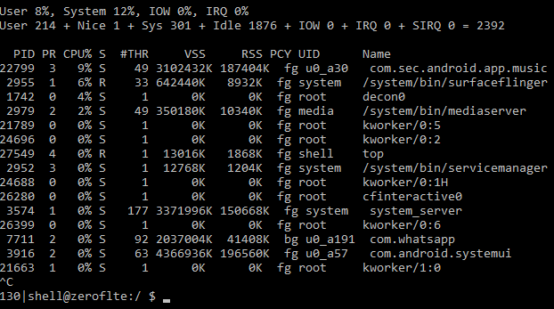

## Question 5

**To install the application**

Src: <http://www.appsapk.com/es-file-explorer/>

Step 1: Launch the emulator

Step 2: adb install com.estrongs.android.pop.apk

**To list all installed packages**

Step 1: adb shell pm list packages (-f option lists the full installation path of each installed packages)

**To uninstall**

Step 1: adb shell

Step 2: pm uninstall com.estrongs.android.pop

Note: The above steps works but when attempting “adb shell pm uninstall com.estrongs.android.pop” fails.

## Question 6

Src : <http://www.apk20.com/apk/952395/>

**To activate logging:**

Step 1: adb logcat (-c option clears the log buffer)

Upon changing the game difficulty, I observed the following entry in the log capture :



Based on this observation , I would deduce the application is trying to focus on the current activity window based on the input entered by me when I tried to change the difficulty of the game.