**IAM**

1. Create IAM user attach user to a group with create a policy with just s3 read access. Attach the policy to the group

**Step 1**: created a user **dg_intern_naveen.**

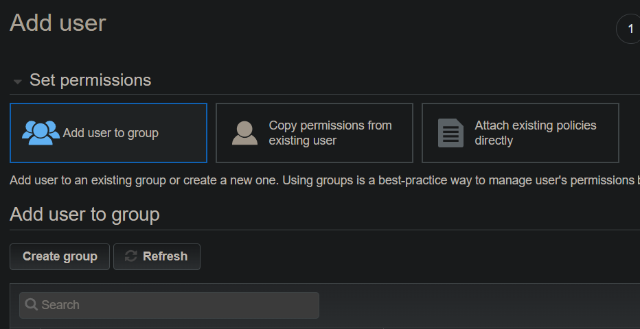

**Step 2**: created a group **s3_access_group** with administrator permissions.

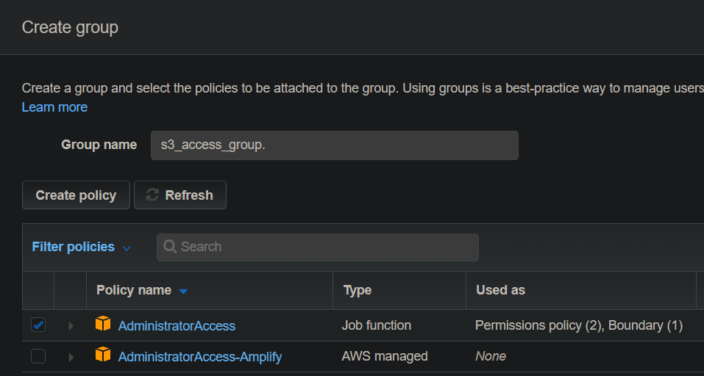

**Step 3**: added **dg_intern_naveen** user to **s3_access_group.**

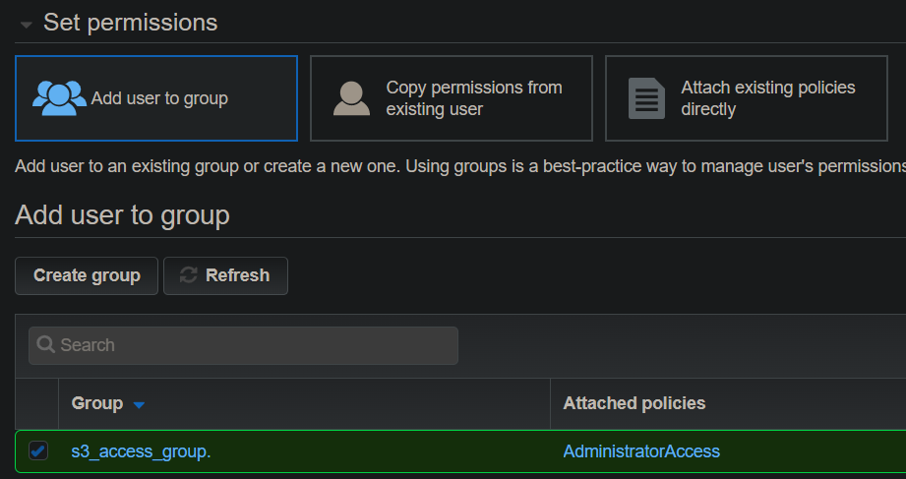

**Step 4:** created a policy **s3_read_access** with **s3 read access permissions.**

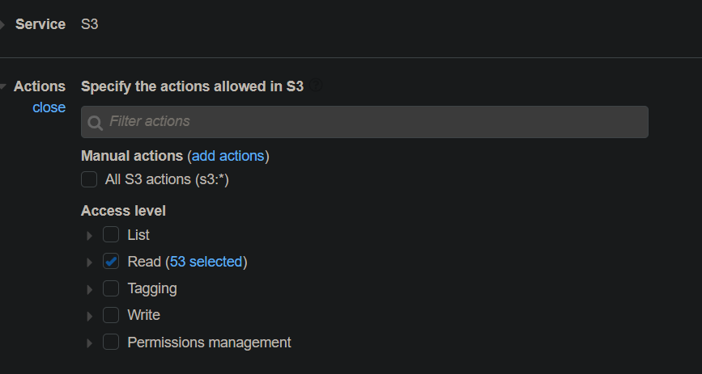

**Step 5:** Attached the **s3_read_access** policy to the group **s3_access_group.**

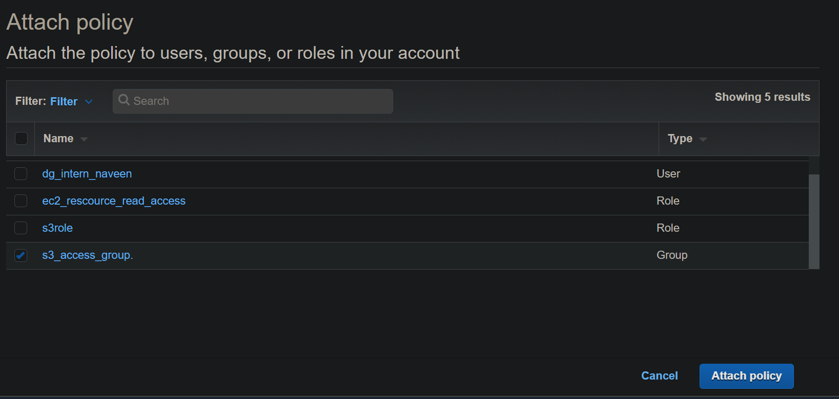

1. Create a role which has read access to ec2 resources. Using aws cli assume the role and list out the ec2 instances

**Step 1**: created a role **ec2_rescource_read_access** which has read access to ec2 resource

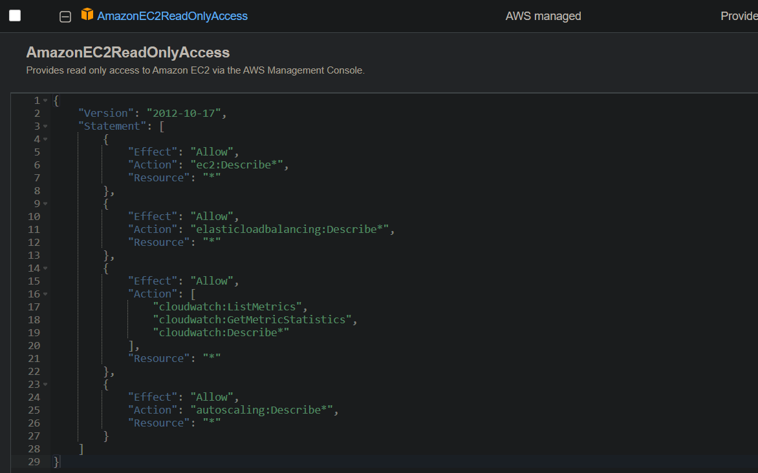

**Step 2:** Using aws cli assume the role and list out the ec2 instances

Aws configuration:

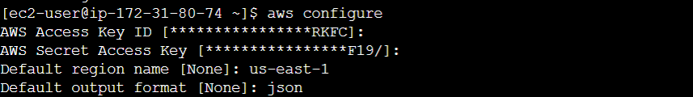

Listing Instances:

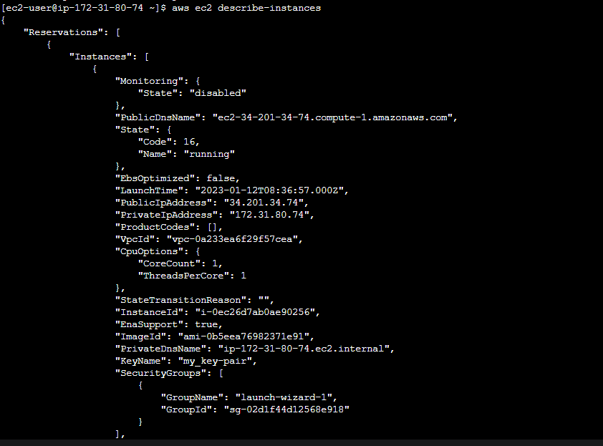

Ec2 instances:

