**MOBILE APPLICATIONS DEVELOPMENT**

**LAB RECORD**

**NAME : SHRUTI SUBRAMANIYAM**

**ROLL NO: 106114090**

1. **AIM: To design a bluetooth application.**

CODE:

activitymain.xml

<?xml version="1.0" encoding="utf-8"?>

<RelativeLayout xmlns:android[="http://schemas.android.com/apk/res/androi](http://schemas.android.com/apk/res/android)d" xmlns:tools=["http://schemas.android.com/tool](http://schemas.android.com/tools)s" android:layout_width="match_parent" android:layout_height="match_parent" android:paddingLeft=["@dime](mailto:@dimen)n/activity_horizontal_margin" android:paddingRight=["@dimen](mailto:@dimen)/activity_horizontal_margin" android:paddingTop=["@dime](mailto:@dimen)n/activity_vertical_margin" android:paddingBottom[="@dime](mailto:@dimen)n/activity_vertical_margin" tools:context=".MainActivity"

android:transitionGroup="true">

<TextView android:text="Bluetooth Example" android:layout_width="wrap_content" android:layout_height="wrap_content" android:id="@+id/textview" android:textSize="35dp" android:layout_alignParentTop="true"

android:layout_centerHorizontal="true" />

<TextView android:layout_width="wrap_content" android:layout_height="wrap_content" android:text="one" android:id="@+id/textView" android:layout_below="@+id/textview" android:layout_centerHorizontal="true" android:textColor="#ff7aff24" android:textSize="35dp" />

<Button android:layout_width="wrap_content" android:layout_height="wrap_content" android:text="Turn On" android:id="@+id/button"

android:clickable="true" android:onClick="on" />

<Button android:layout_width="wrap_content" android:layout_height="wrap_content" android:text="Get visible"

android:onClick="visible" android:id="@+id/button2" android:layout_alignBottom="@+id/button" android:layout_centerHorizontal="true" />

<Button android:layout_width="wrap_content" android:layout_height="wrap_content" android:text="List devices" android:onClick="list" android:id="@+id/button3"/>

<Button android:layout_width="wrap_content" android:layout_height="wrap_content" android:text="turn off" android:onClick="off" android:id="@+id/button4" android:layout_below="@+id/button" android:layout_alignParentLeft="true" android:layout_alignParentStart="true" />

<ListView android:layout_width="wrap_content" android:layout_height="wrap_content"

android:id="@+id/listView" android:layout_alignParentBottom="true" android:layout_alignLeft[="@+i](mailto:@+id)d/button" android:layout_align[Start="@+id/button" android:layout_below="@+i](mailto:@+id)d/textView2" />

<TextView android:layout_width="wrap_content" android:layout_height="wrap_content" android:text="Paired devices:" android:id="@+id/textView2" android:textColor="#ff34ff06" android:textSize="25dp" android:layout_below="@+id/button4" android:layout_alignLeft[="@+i](mailto:@+id)d/listView" android:layout_align[Start="@+id/listView" />](mailto:@+id)

</RelativeLayout>

Mainactivity.java

package com.example.smile.bluetooth;

import android.app.Activity;

import android.bluetooth.BluetoothAdapter;

import android.bluetooth.BluetoothDevice;

import android.content.Intent; import android.os.Bundle; import android.view.View;

import android.widget.ArrayAdapter;

import android.widget.Button; import android.widget.ListView; import android.widget.Toast; import java.util.ArrayList;

import java.util.Set;

public class MainActivity extends Activity { Button b1,b2,b3,b4;

private BluetoothAdapter BA;

private Set<BluetoothDevice>pairedDevices; ListView lv;

[@Override](mailto:@Override)

protected void onCreate(Bundle savedInstanceState) { super.onCreate(savedInstanceState); setContentView(R.layout.activity_main);

b1 = (Button) findViewById(R.id.button); b2=(Button)findViewById(R.id.button2); b3=(Button)findViewById(R.id.button3); b4=(Button)findViewById(R.id.button4);

BA = BluetoothAdapter.getDefaultAdapter();

lv = (ListView)findViewById(R.id.listView);

}

public void on(View v){

if (!BA.isEnabled()) {

Intent turnOn = new Intent(BluetoothAdapter.ACTION_REQUEST_ENABLE);

startActivityForResult(turnOn, 0);

Toast.makeText(getApplicationContext(), "Turned on",Toast.LENGTH_LONG).show();

} else {

Toast.makeText(getApplicationContext(), "Already on", Toast.LENGTH_LONG).show();

}

}

public void off(View v){ BA.disable();

Toast.makeText(getApplicationContext(), "Turned off" ,Toast.LENGTH_LONG).show();

}

public void visible(View v){

Intent getVisible = new Intent(BluetoothAdapter.ACTION_REQUEST_DISCOVERABLE);

startActivityForResult(getVisible, 0);

}

public void list(View v){

pairedDevices = BA.getBondedDevices(); ArrayList list = new ArrayList();

for(BluetoothDevice bt : pairedDevices) list.add(bt.getName());

Toast.makeText(getApplicationContext(), "Showing Paired

Devices",Toast.LENGTH_SHORT).show();

list);

final ArrayAdapter adapter = new ArrayAdapter(this,android.R.layout.simple_list_item_1,

lv.setAdapter(adapter);

}

}

manifestfile.xml

<?xml version="1.0" encoding="utf-8"?>

<manifest xmlns:android[="http://schemas.android.com/apk/res/androi](http://schemas.android.com/apk/res/android)d" package="com.example.smile.bluetooth" >

<uses-permission android:name="android.permission.BLUETOOTH"/>

<uses-permission android:name="android.permission.BLUETOOTH_ADMIN"/>

<application android:allowBackup="true" android:icon[="@mipma](mailto:@mipmap)p/ic_launcher" android:label=["@string/app_name" android:theme](mailto:@string)[="@style](mailto:@style)/AppTheme" >

<activity android:name=".MainActivity" android:lab[el="@stri](mailto:@string)ng/app_name" >

<intent-filter>

<action android:name="android.intent.action.MAIN" />

<category android:name="android.intent.category.LAUNCHER" />

</intent-filter>

</activity>

</application>

</manifest> OUTPUT:

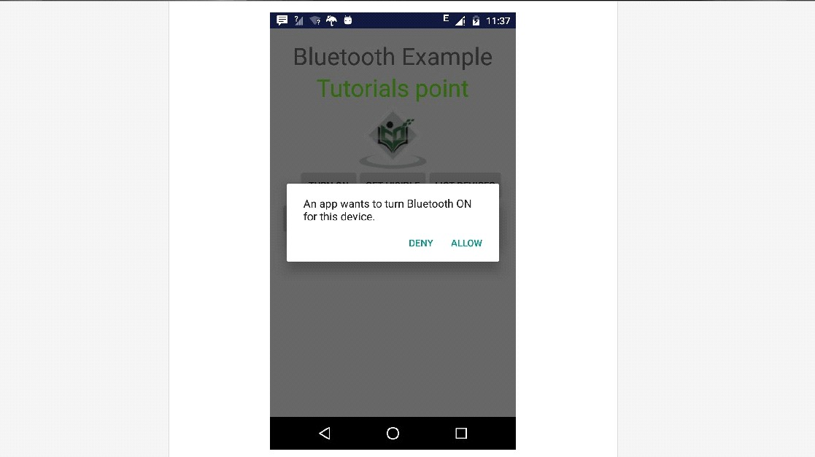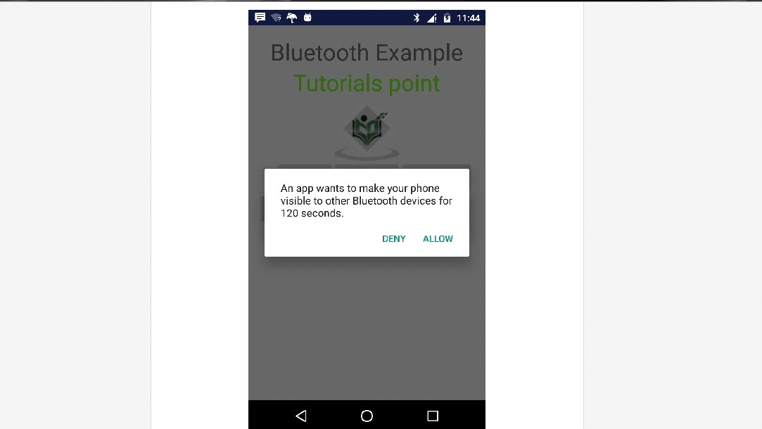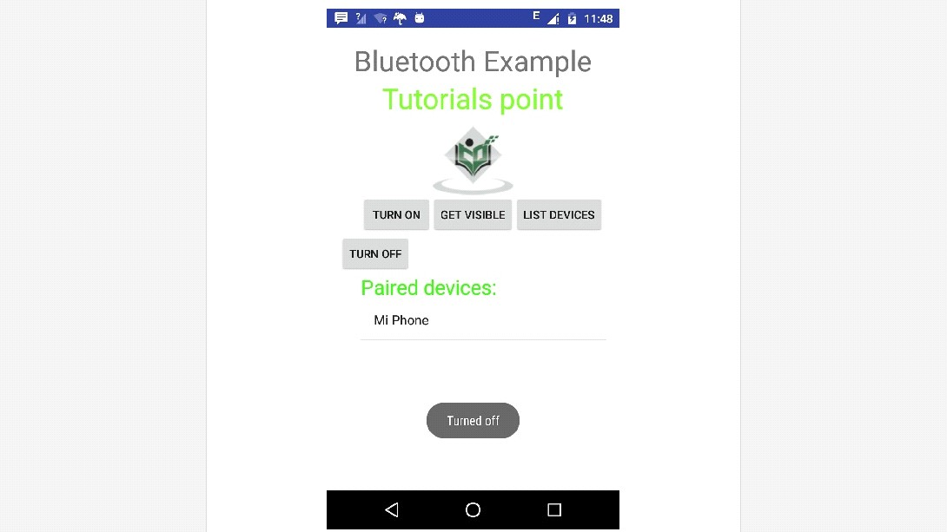

1. **AIM: To design a wifi application.**

CODE:

activitymain.xml

<?xml version="1.0" encoding="utf-8"?>

<RelativeLayout xmlns:android[="http://schemas.android.com/apk/res/androi](http://schemas.android.com/apk/res/android)d" xmlns:tools=["http://schemas.android.com/tool](http://schemas.android.com/tools)s" android:layout_width="match_parent" android:layout_height="match_parent" android:paddingLeft=["@dime](mailto:@dimen)n/activity_horizontal_margin" android:paddingRight=["@dimen](mailto:@dimen)/activity_horizontal_margin" android:paddingTop=["@dime](mailto:@dimen)n/activity_vertical_margin" android:paddingBottom[="@dime](mailto:@dimen)n/activity_vertical_margin" tools:context=".MainActivity">

<ImageView android:layout_width="wrap_content" android:layout_height="wrap_content" android:id="@+id/imageView" android:layout_alignParentTop="true" android:layout_centerHorizontal="true" />

<Button android:id="@+id/button1" android:layout_width="wrap_content" android:layout_height="wrap_content" android:layout_marginLeft="76dp" android:text="Enable Wifi" android:layout_centerVertical="true" android:layout_alignEnd="@+id/imageView" />

<Button android:id="@+id/button2" android:layout_width="wrap_content" android:layout_height="wrap_content" android:text="Disable Wifi" android:layout_marginBottom="93dp" android:layout_alignParentBottom="true" android:layout_align[Start="@+id/imageView" />](mailto:@+id)

</RelativeLayout>

manifest.xml

<?xml version="1.0" encoding="utf-8"?>

<RelativeLayout xmlns:android[="http://schemas.android.com/apk/res/androi](http://schemas.android.com/apk/res/android)d" xmlns:tools=["http://schemas.android.com/tool](http://schemas.android.com/tools)s" android:layout_width="match_parent" android:layout_height="match_parent" android:paddingLeft=["@dime](mailto:@dimen)n/activity_horizontal_margin" android:paddingRight=["@dimen](mailto:@dimen)/activity_horizontal_margin" android:paddingTop=["@dime](mailto:@dimen)n/activity_vertical_margin" android:paddingBottom[="@dime](mailto:@dimen)n/activity_vertical_margin" tools:context=".MainActivity">

<ImageView android:layout_width="wrap_content" android:layout_height="wrap_content" android:id="@+id/imageView" android:layout_alignParentTop="true" android:layout_centerHorizontal="true" />

<Button android:id="@+id/button1" android:layout_width="wrap_content" android:layout_height="wrap_content" android:layout_marginLeft="76dp" android:text="Enable Wifi" android:layout_centerVertical="true"

android:layout_alignEnd="@+id/imageView" />

<Button android:id="@+id/button2" android:layout_width="wrap_content" android:layout_height="wrap_content" android:text="Disable Wifi" android:layout_marginBottom="93dp" android:layout_alignParentBottom="true" android:layout_align[Start="@+id/imageView" />](mailto:@+id)

</RelativeLayout>

Mainactivity.java

package com.example.smile.wifi; import android.net.wifi.WifiManager; import android.os.Bundle;

import android.app.Activity; import android.content.Context; import android.view.View;

import android.view.View.OnClickListener;

import android.widget.Button;

public class MainActivity extends Activity { Button enableButton,disableButton;

[@Override](mailto:@Override)

protected void onCreate(Bundle savedInstanceState) { super.onCreate(savedInstanceState); setContentView(R.layout.activity_main);

enableButton=(Button)findViewById(R.id.button1);

disableButton=(Button)findViewById(R.id.button2);

enableButton.setOnClickListener(new OnClickListener(){

public void onClick(View v){

WifiManager wifi = (WifiManager) getSystemService(Context.WIFI_SERVICE);

wifi.setWifiEnabled(true);

}

});

disableButton.setOnClickListener(new OnClickListener(){

public void onClick(View v){

WifiManager wifi = (WifiManager) getSystemService(Context.WIFI_SERVICE);

wifi.setWifiEnabled(false);

}

});

}

} OUTPUT:

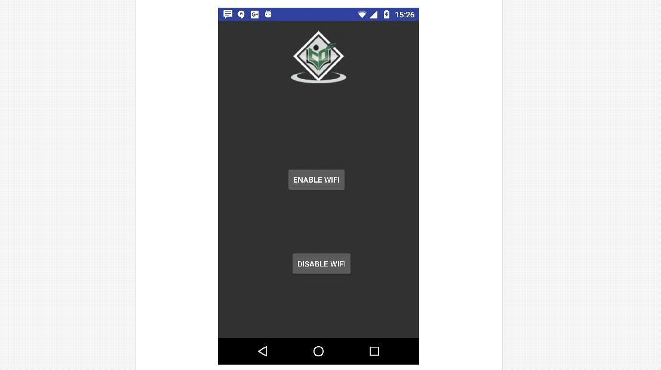

1. **AIM: To design a sms application.**

CODE:

**MainActivity.java :**

package com.example.user.sms;

import android.app.Activity;

import android.app.PendingIntent;

import android.content.BroadcastReceiver;

import android.content.Context;

import android.content.Intent;

import android.content.IntentFilter;

import android.os.Bundle;

import android.telephony.SmsManager;

import android.view.View;

import android.widget.Button;

import android.widget.EditText;

import android.widget.Toast;

public class SMS extends Activity {

        Button btnSendSMS;

   EditText txtPhoneNo;

   EditText txtMessage;

   /** Called when the activity is first created. */

   @Override

   public void onCreate(Bundle savedInstanceState)

   {

    super.onCreate(savedInstanceState);

    setContentView(R.layout.main);

    btnSendSMS = (Button) findViewById(R.id.btnSendSMS);

    txtPhoneNo = (EditText) findViewById(R.id.txtPhoneNo);

    txtMessage = (EditText) findViewById(R.id.txtMessage);

    btnSendSMS.setOnClickListener(new View.OnClickListener()

    {

        public void onClick(View v)

        {

            String phoneNo = txtPhoneNo.getText().toString();

            String message = txtMessage.getText().toString();

            if (phoneNo.length()>0 && message.length()>0)

                sendSMS(phoneNo, message);

            else

                   Toast.makeText(getBaseContext(),

                    "Please enter both phone number and message.",

                       Toast.LENGTH_SHORT).show();

        }

    });

   }

   private void sendSMS(String phoneNumber, String message)

   {

        String SENT = "SMS_SENT";

    String DELIVERED = "SMS_DELIVERED";

    PendingIntent sentPI = PendingIntent.getBroadcast(this, 0,

        new Intent(SENT), 0);

    PendingIntent deliveredPI = PendingIntent.getBroadcast(this, 0,

        new Intent(DELIVERED), 0);

    //---when the SMS has been sent---

    registerReceiver(new BroadcastReceiver(){

        @Override

        public void onReceive(Context arg0, Intent arg1) {

            switch (getResultCode())

            {

                case Activity.RESULT_OK:

                       Toast.makeText(getBaseContext(), "SMS sent",

                               Toast.LENGTH_SHORT).show();

                    break;

                case SmsManager.RESULT_ERROR_GENERIC_FAILURE:

                    Toast.makeText(getBaseContext(), "Generic failure",

                               Toast.LENGTH_SHORT).show();

                    break;

                case SmsManager.RESULT_ERROR_NO_SERVICE:

                       Toast.makeText(getBaseContext(), "No service",

                            Toast.LENGTH_SHORT).show();

                    break;

                case SmsManager.RESULT_ERROR_NULL_PDU:

                       Toast.makeText(getBaseContext(), "Null PDU",

                           Toast.LENGTH_SHORT).show();

                    break;

                case SmsManager.RESULT_ERROR_RADIO_OFF:

                       Toast.makeText(getBaseContext(), "Radio off",

                               Toast.LENGTH_SHORT).show();

                    break;

            }

        }

    }, new IntentFilter(SENT));

    //---when the SMS has been delivered---

    registerReceiver(new BroadcastReceiver(){

        public void onReceive(Context arg0, Intent arg1) {

            switch (getResultCode())

            {

                case Activity.RESULT_OK:

                       Toast.makeText(getBaseContext(), "SMS delivered",

                           Toast.LENGTH_SHORT).show();

                    break;

                case Activity.RESULT_CANCELED:

                       Toast.makeText(getBaseContext(), "SMS not delivered",

                               Toast.LENGTH_SHORT).show();

                    break;

            }

        }

    }, new IntentFilter(DELIVERED));

    SmsManager sms = SmsManager.getDefault();

    sms.sendTextMessage(phoneNumber, null, message, sentPI, deliveredPI);

   }

}

**activity_main.xml :**

<?xml version="1.0" encoding="utf-8"?>

<LinearLayout xmlns:android="http://schemas.android.com/apk/res/android"

   android:orientation="vertical"

   android:layout_width="fill_parent"

   android:layout_height="fill_parent"

   >

   <TextView

       android:layout_width="fill_parent"

       android:layout_height="wrap_content"

    android:text="Enter the phone number of recipient"

    />

   <EditText

       android:id="@+id/txtPhoneNo"

       android:layout_width="fill_parent"

       android:layout_height="wrap_content"

    />

   <TextView

       android:layout_width="fill_parent"

       android:layout_height="wrap_content"

    android:text="Message"

       />

   <EditText

       android:id="@+id/txtMessage"

       android:layout_width="fill_parent"

    android:layout_height="150px"

    android:gravity="top"

    />

   <Button

    android:id="@+id/btnSendSMS"

       android:layout_width="fill_parent"

       android:layout_height="wrap_content"

    android:text="Send SMS"

    />

</LinearLayout>

**AndroidManifest.xml:**

*<?*xml version="1.0" encoding="utf-8"*?>*<manifest xmlns:android="http://schemas.android.com/apk/res/android"  
 package="com.example.user.sms">  
<uses-permission android:name="android.permission.SEND_SMS" />  
<uses-permission android:name="android.permission.RECEIVE_SMS">  
</uses-permission>  
<application  
 android:allowBackup="true"  
 android:icon="@mipmap/ic_launcher"  
 android:label="@string/app_name"  
 android:roundIcon="@mipmap/ic_launcher_round"  
 android:supportsRtl="true"  
 android:theme="@style/AppTheme">  
<activity android:name=".MainActivity">  
<intent-filter>  
<action android:name="android.intent.action.MAIN" />  
  
<category android:name="android.intent.category.LAUNCHER" />  
</intent-filter>  
</activity>  
</application>  
  
</manifest>

**OUTPUT:**

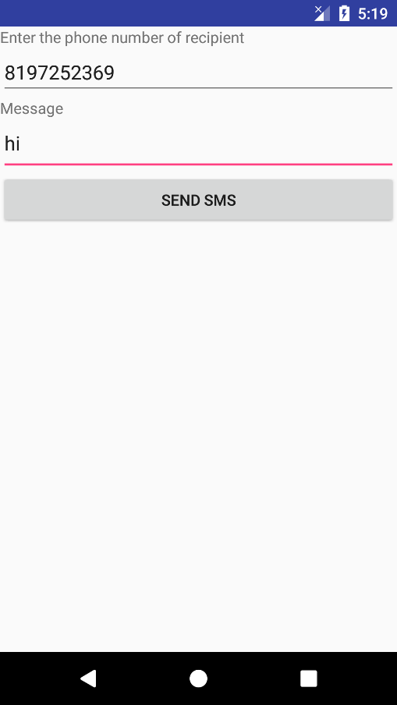

1. **AIM: To design a search application**.

CODE:

activitymain.xml

<RelativeLayout xmlns:android[="http://schemas.android.com/apk/res/androi](http://schemas.android.com/apk/res/android)d" android:layout_width="fill_parent"

android:layout_height="fill_parent">

<SearchView android:id="@+id/search" android:layout_width="fill_parent" android:layout_height="wrap_content" android:iconifiedByDefault="false">

<requestFocus />

</SearchView>

<ListView android:id="@+id/listview" android:layout_width="fill_parent" android:layout_height="fill_parent" android:layout_below="@+id/search" />

</RelativeLayout> Mainactivity.java

package example.smile.searchviewexample;

import android.os.Bundle;

import android.support.v7.app.AppCompatActivity;

import android.widget.ListView;

import android.widget.SearchView;

import java.util.ArrayList;

public class MainActivity extends AppCompatActivity implements SearchView.OnQueryTextListener {

// Declare Variables

ListView list; ListViewAdapter adapter; SearchView editsearch; String[] animalNameList;

ArrayList<AnimalNames> arraylist = new ArrayList<AnimalNames>();

[@Override](mailto:@Override)

public void onCreate(Bundle savedInstanceState) { super.onCreate(savedInstanceState); setContentView(R.layout.activity_main);

// Generate sample data

animalNameList = new String[]{"Lion", "Tiger", "Dog", "Cat", "Tortoise", "Rat", "Elephant", "Fox", "Cow","Donkey","Monkey"};

// Locate the ListView in listview_main.xml list = (ListView) findViewById(R.id.listview);

for (int i = 0; i < animalNameList.length; i++) {

AnimalNames animalNames = new AnimalNames(animalNameList[i]);

// Binds all strings into an array arraylist.add(animalNames);

}

// Pass results to ListViewAdapter Class adapter = new ListViewAdapter(this, arraylist);

// Binds the Adapter to the ListView list.setAdapter(adapter);

// Locate the EditText in listview_main.xml

editsearch = (SearchView) findViewById(R.id.search);

editsearch.setOnQueryTextListener(this);

}

[@Override](mailto:@Override)

public boolean onQueryTextSubmit(String query) {

return false;

}

[@Override](mailto:@Override)

public boolean onQueryTextChange(String newText) { String text = newText;

adapter.filter(text);

return false;

}

}

Animalnames.java

package example.smile.searchviewexample;

public class AnimalNames {

private String animalName;

public AnimalNames(String animalName) {

this.animalName = animalName;

}

public String getAnimalName() {

return this.animalName;

}

}

list_view_items.xml

<RelativeLayout xmlns:android[="http://schemas.android.com/apk/res/androi](http://schemas.android.com/apk/res/android)d" android:layout_width="fill_parent"

android:layout_height="fill_parent" android:padding="10dp">

<TextView android:id="@+id/nameLabel" android:layout_width="wrap_content" android:layout_height="wrap_content" android:text="Animal : " />

<TextView android:id="@+id/name" android:layout_width="wrap_content" android:layout_height="wrap_content" android:layout_toRightOf=["@+id/nameLabel" />](mailto:@+id)

</RelativeLayout>

listviewadapter.java

package example.smile.searchviewexample;

import android.content.Context; import android.view.LayoutInflater; import android.view.View;

import android.view.ViewGroup;

import android.widget.BaseAdapter; import android.widget.TextView; import java.util.ArrayList;

import java.util.List;

import java.util.Locale;

public class ListViewAdapter extends BaseAdapter {

// Declare Variables

Context mContext; LayoutInflater inflater;

private List<AnimalNames> animalNamesList = null;

private ArrayList<AnimalNames> arraylist;

public ListViewAdapter(Context context, List<AnimalNames> animalNamesList) {

mContext = context;

this.animalNamesList = animalNamesList; inflater = LayoutInflater.from(mContext); this.arraylist = new ArrayList<AnimalNames>(); this.arraylist.addAll(animalNamesList);

}

public class ViewHolder { TextView name;

}

[@Override](mailto:@Override)

public int getCount() {

return animalNamesList.size();

}

[@Override](mailto:@Override)

public AnimalNames getItem(int position) {

return animalNamesList.get(position);

}

[@Override](mailto:@Override)

public long getItemId(int position) {

return position;

}

public View getView(final int position, View view, ViewGroup parent) {

final ViewHolder holder;

if (view == null) {

holder = new ViewHolder();

view = inflater.inflate(R.layout.listview_item, null);

// Locate the TextViews in listview_item.xml

holder.name = (TextView) view.findViewById(R.id.name);

view.setTag(holder);

} else {

holder = (ViewHolder) view.getTag();

}

// Set the results into TextViews holder.name.setText(animalNamesList.get(position).getAnimalName()); return view;

}

// Filter Class

public void filter(String charText) {

charText = charText.toLowerCase(Locale.getDefault());

animalNamesList.clear();

if (charText.length() == 0) {

animalNamesList.addAll(arraylist);

} else {

for (AnimalNames wp : arraylist) {

if (wp.getAnimalName().toLowerCase(Locale.getDefault()).contains(charText)) {

animalNamesList.add(wp);

}

}

}

notifyDataSetChanged();

}

} OUTPUT:

