Untitled

STAT613_HW5

2/26/2021

#An investor sued his broker for lack of diversification. Below are the rates of return (in percent) for the investor’s portfolio over 39 months (data from Moore, McCabe, and Craig (2017)). The average of the S&P 500 stock index for the same period was 0.95%. Does the broker perform worse than average?.

library(tidyverse)

## -- Attaching packages --------------------------------------- tidyverse 1.3.0 --

## v ggplot2 3.3.2 v purrr 0.3.4  
## v tibble 3.0.1 v dplyr 1.0.0  
## v tidyr 1.1.2 v stringr 1.4.0  
## v readr 1.4.0 v forcats 0.5.0

## -- Conflicts ------------------------------------------ tidyverse_conflicts() --  
## x dplyr::filter() masks stats::filter()  
## x dplyr::lag() masks stats::lag()

library(dplyr)  
library(purrr)

Stockreturns <- c(-8.36, 1.63, -2.27, -2.93, -2.70,   
 -2.93, -9.14, -2.64, 6.82, -2.35,   
 -3.58, 6.13, 7.00, -15.25, -8.66,  
 -1.03, -9.16, -1.25, -1.22, -10.27,  
 -5.11, -0.80, -1.44, 1.28, -0.65,  
 4.34, 12.22, -7.21, -0.09, 7.34,   
 5.04, -7.24, -2.14, -1.01, -1.41,   
 12.03, -2.53, 4.33, 1.35)  
 Stockreturns

## [1] -8.36 1.63 -2.27 -2.93 -2.70 -2.93 -9.14 -2.64 6.82 -2.35  
## [11] -3.58 6.13 7.00 -15.25 -8.66 -1.03 -9.16 -1.25 -1.22 -10.27  
## [21] -5.11 -0.80 -1.44 1.28 -0.65 4.34 12.22 -7.21 -0.09 7.34  
## [31] 5.04 -7.24 -2.14 -1.01 -1.41 12.03 -2.53 4.33 1.35

#1) Use and show R code to find the mean of the sample data.

mean(Stockreturns)

## [1] -1.124615

#Mean can also be generated using summary

summary(Stockreturns)

## Min. 1st Qu. Median Mean 3rd Qu. Max.   
## -15.250 -3.255 -1.410 -1.125 1.490 12.220

#2) Use and show R code to find the standard deviation of the sample data

sd(Stockreturns)

## [1] 5.977673

#3) Assuming a normal distribution, use and show R code to find the proportion of returns that are less than -1.5. #Assuming standard normal distribution: Mean=0, SD=1

pnorm(q = -1.5, mean = 0, sd = 1)

## [1] 0.0668072

#4) Assuming a normal distribution, use and show R code to find return value that is above 70% of the returns

qnorm(p = 0.30, mean = 0, sd = 1)

## [1] -0.5244005

#5) Use and show R code to find Q1 for the data. # Q1 = -3.255

quantile(Stockreturns, 0.25)

## 25%   
## -3.255

#About 25% of the data falls below Q1 and 75% above Q1.

quantile(Stockreturns, probs = c(0.25))

## 25%   
## -3.255

#6) Explore the data by producing and examining a boxplot and checking for normality.

boxplot(Stockreturns)

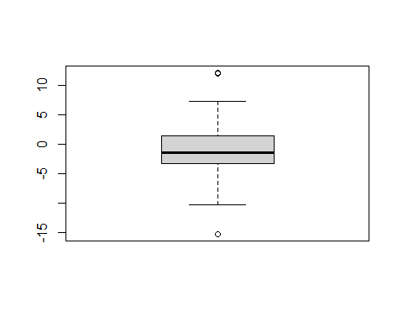 #Analysis of Boxplot: #There seem obvious outliers at the top and one at the bottom.

#Analysis of a Histogram: #The graph is unimodal with approximate normal distribution.

hist(Stockreturns)

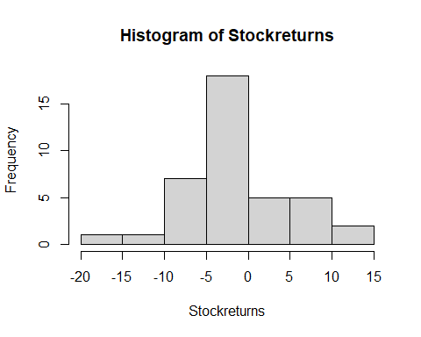

#Analysis of qqplot: #The data seems to fall close to the line in the center. However, #it begins to deviate and move away from the line especially #towards and at the ends (top and bottom) indicating overall #somewhat approximate normality.

qqnorm(Stockreturns)  
qqline(Stockreturns)

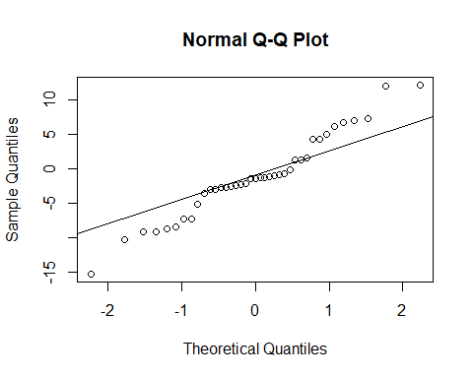

#7) State the appropriate null and alternative hypothesis required for the appropriate t test. #ANSWER): #Null is average score is 0.0095, Alternative is > 0.0095 # H(0) : mu = 0.0095 (Null Hypothesis) # H(A) : mu > 0.0095 (Alternative Hypothesis)

#We will reject the Null Hypothesis if a calculated #p-value is less than a pre-set alpha value (normally .05)

#8) Use and show R code that will output the needed p value and confidence interval to determine if the null hypothesis should be rejected.

t.test(Stockreturns,mu=0.0095, alternative = "greater", conf.level = .95)

##   
## One Sample t-test  
##   
## data: Stockreturns  
## t = -1.1848, df = 38, p-value = 0.8783  
## alternative hypothesis: true mean is greater than 0.0095  
## 95 percent confidence interval:  
## -2.738401 Inf  
## sample estimates:  
## mean of x   
## -1.124615

#summary and conclusion (P-value): #since p = 0.8783> .05, we fail to reject the null hypothesis #i.e. it is concluded that the average score for the portfolio #is 0.95%.

#(Confidence Interval): #since 0.0095 (the null hypothesized vale) is between the confidence interval, i.e. -2.738401 and Infinity, it also concludes that #we fail to reject to null hypothesis

#9) Now answer the question originally stated. Does the broker perform worse than average? (Explain or justify in two or three sentences). #ANSWER): #The above calculations/results of p-vales and confidence interval, #both lead to the conclusion of failure to reject Null and #confirming that the broker performs the same as the average #of the S&P500 stock(neither below or above it).