**ZenSafe**

AI-Driven Quantum-Enhanced CCTV System for Women’s Safety

Team details:

Team name: Matrix

|  |  |  |  |  |
| --- | --- | --- | --- | --- |
| S.No | Name | Role | E-Mail | Contact |
| 1. | Pavan K | AI/ML (Leader) | pavanbindhu54@gmail.com | 8925116261 |
| 2. | Divakar E | MERN/Flutter | ejilandivakar@gmail.com | 6385585685 |
| 3. | Sachin G.P | DevOps/Quantum | sachin2gita@gmail.com | 9787484004 |
| 4. | Nidhin S | UI/UX | nidhins1807@gmail.com | 7418571367 |

Mentor details:

|  |  |  |  |  |
| --- | --- | --- | --- | --- |
| S.No | Name | Role | E-Mail | Contact |
| 1. | Suresh R | Guide | sureshramanujam@smvec.ac.in | 9655228850 |

Name of the institution:

Sri Manakula Vinayagar Engineering College - Puducherry 605007

Contents:

|  |  |  |
| --- | --- | --- |
| S.No | Topic | Page No |
| 1. | Abstract | 3 |
| 2. | Introduction | 4 |
| 3. | Problem statement | 5 |
| 4. | Existing system | 6 |
| 5. | Proposed solution | 7 |
| 6. | Market analysis | 8 |
| 7. | Architecture | 9 |
| 8. | Technical stack | 10 |
| 9. | Conclusion | 11 |
| 10. | References | 11 |

1. Abstract:

In the rapidly evolving digital era, women's safety remains a critical concern, with crimes against women increasing alarmingly. According to the **National Crime Records Bureau**, incidents of crime against women surged by **87%** between **2011 and 2021**, from **228,650 to 428,278** cases. This highlights the urgent need for a robust, technologically advanced system to ensure women's safety.

**ZenSafe**, an innovative **AI and Quantum powered system**, addresses this challenge by detecting crimes in real-time through **deep learning video classification** on **live CCTV feeds**. Upon identifying a potential crime, ZenSafe immediately **alerts** the nearest **police station**, sharing incident footage for cross-validation and retrieving footage from six nearby CCTV cameras to provide critical contextual information. These capabilities enhance response times, increasing the chances of **victim survival** and enabling swift action to **mitigate crimes**.

ZenSafe also tackles **post-incident investigation** challenges, where analyzing vast amounts of CCTV footage for evidence is labor-intensive and time-consuming. By integrating **Generative AI**, the system enables users to query video data using natural language, such as, "Was there a white sedan passing between 1:30 PM -3:00 PM?" This is achieved through a **Vision Language Model (VLM)** based on **BLIP (Bootstrapping Language-Image Pretraining)**, which extracts textual descriptions from video frames with timestamps. These descriptions are processed by **a Retrieval-Augmented Generation (RAG)** model for rapid and efficient querying, significantly reducing the time required for evidence collection.

The system employs the **Multiple Instance Self Training (MIST) model**, achieving an **Area Under Curve (AUC) of 82%** on the **UCF Crime Dataset**. To safeguard sensitive video data, ZenSafe uses **AES encryption and BB84 quantum key distribution algorithm**, ensuring **privacy and confidentiality**. A **quantum-based** security backbone improves data integrity, enabling seamless expansion across vulnerable metropolitan areas.

ZenSafe is a transformative tool for women's safety, delivering real-time crime detection, rapid police response, and intelligent video analysis to redefine **urban security standards**. By empowering law enforcement with swift, **data-driven insights**, it fosters **safer communities** and strengthens trust in **public safety systems**.

2. Introduction:

2.1 Background:

**Women's safety** is a critical **global concern**, particularly in **urban areas** where rising crime rates highlight the urgent need for effective solutions. Reported crimes against women have increased by **87% from 2011 to 2021**, according to the **National Crime Records Bureau**. This alarming trend emphasizes the need for advanced safety measures that go beyond traditional approaches. Technology, especially **Artificial Intelligence (AI)** and **Quantum Computing**, offers **transformative potential** through **real-time insights, rapid responses**, and **data-driven solutions**. Integrating these technologies with existing infrastructure like **CCTV** can address key gaps in **crime prevention, detection, and investigation**.

2.2 Motivation:

This project is motivated by the pressing need to enhance women's safety through advanced technological interventions. Traditional safety measures often lack immediacy and actionable insights, leaving victims vulnerable and law enforcement under-equipped. Additionally, the manual analysis of extensive surveillance footage is time-intensive and inefficient. By harnessing AI's ability to process visual data and Elevating security standard using Quantum, this project aims to develop a comprehensive system for real-time crime detection and evidence collection, ultimately reducing crime rates and fostering trust in public safety systems.

2.3 Scope:

**ZenSafe** is an **AI and Quantum powered system** designed to detect crimes in real-time using live CCTV feeds. It provides **immediate alerts** to law enforcement with **incident footage** and contextual data from nearby cameras. Post-incident, it enables **natural language querying** of video data for efficient evidence collection. The project integrates **deep learning models**, **generative AI** for video analysis, and **quantum computing** for security. Its goal is to create a scalable, efficient, and secure solution that addresses women's safety comprehensively, from **prevention to investigation**.

3. Problem statement:

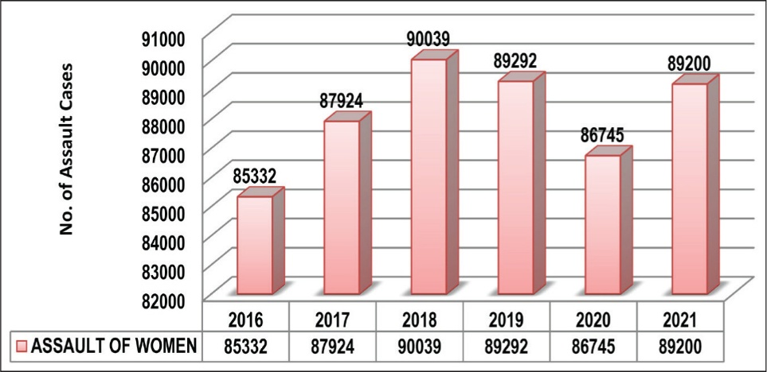Women's safety remains a pressing issue worldwide, particularly in urban areas, where the increasing rates of crimes against women highlight the need for immediate action. Traditional safety measures have proven insufficient in the face of growing challenges. Delayed police response, underutilized surveillance systems, and slow investigative processes are key barriers to ensuring safety for women. These gaps leave women vulnerable to crimes, with few resources for immediate intervention.

3.1 Challenges in current system:

* **Delayed Responses:** Traditional safety protocols like emergency calls often result in slow responses from law enforcement, leaving women vulnerable.
* **Inefficient Video Analysis:** Manual review of extensive CCTV footage is time-consuming and delays investigations, preventing timely action.
* **Lack of Advanced Technology:** Existing systems do not fully utilize AI and quantum computing, which could significantly enhance crime detection, speed up responses, and improve data analysis.
* **Privacy Concerns:** Managing vast amounts of video data while ensuring privacy and security remains a significant challenge.

3.2 Impacts on society:

These issues have far-reaching consequences for women’s safety and society as a whole.

* **Increased Vulnerability:** Delayed responses and inadequate systems make women more vulnerable to crime, eroding their sense of security in public spaces.
* **Delayed Justice:** Slow investigations prolong justice, leaving victims without immediate support.
* **Loss of Trust:** Ineffective safety systems reduce public trust in law enforcement and urban safety, negatively affecting communities.
* **Emotional and Economic Toll:** Victims and their families endure emotional, physical, and financial hardships, adding to the social burden of crime.

4. Existing Solutions:

4.1 Existing solutions:

Several technologies have been developed to improve women’s safety, but they still face significant challenges that limit their effectiveness.

* **Mobile Safety Apps:** Apps like “I’m Safe” provide real-time alerts to emergency contacts, but they require manual user input, causing delays during critical moments.
* **CCTV Surveillance:** Cameras in public areas monitor potential crimes but often lack real-time crime detection and require human analysis for actionable insights.
* **Wearable Devices:** Personal alarms and smart wearables can send distress signals, but their effectiveness depends on the victim's ability to activate them in a dangerous situation.
* **Emergency Hotlines:** These services offer a quick connection to authorities, but they are reactive rather than proactive, often missing early intervention opportunities.

4.2 Limitations:

Despite their utility, these solutions have key shortcomings:

* **Delays in Response:** Many technologies rely on human intervention, leading to slower response times.
* **Reactive Nature:** Current systems often only detect incidents after they occur, missing the chance for prevention.
* **Fragmented Systems:** Most technologies operate in isolation, limiting their coordination with emergency services and law enforcement.
* **Vulnerability in Emergencies:** Many solutions depend on the user’s ability to manually activate them during critical moments, which isn’t always possible.

These gaps in existing safety solutions highlight the need for a more integrated, real-time, and proactive approach to women's safety.

5. Proposed Solutions:

ZenSafe is a groundbreaking public safety solution that enhances women’s safety by integrating deep learning, quantum computing, and generative AI. This innovative system ensures real-time crime detection, efficient evidence collection, and timely law enforcement interventions, creating a safer environment for women in urban spaces.

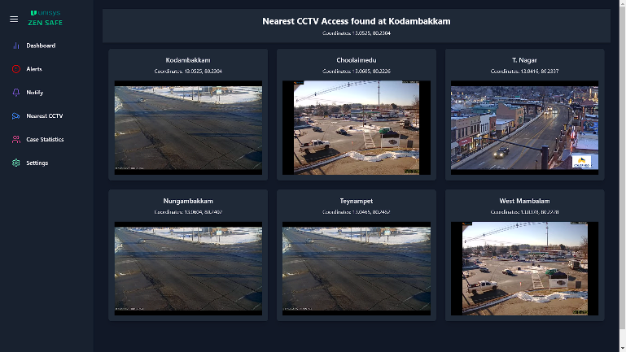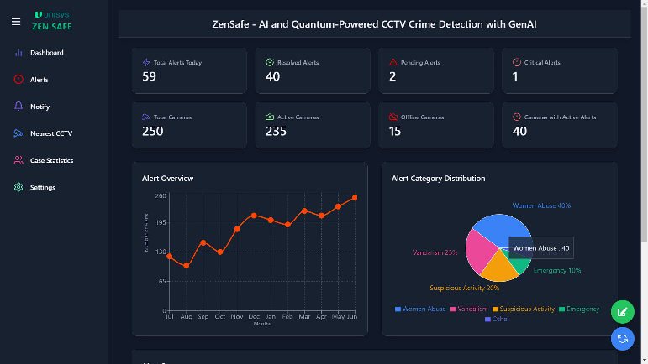

5.1 Features:

* **Real-Time Crime Detection:** Uses deep learning algorithms to analyze CCTV footage and identify criminal activities with high accuracy.
* **Contextual Crime Analysis:** Retrieves and integrates footage from nearby cameras for a comprehensive view of crime scenes.
* **GenAI Query System:** Enables law enforcement to interact with video data via natural language, streamlining evidence and lead extraction from large CCTV footage.
* **Data Security:** A hybrid cryptographic system combines AES encryption and quantum key distribution to protect sensitive data.

5.2 Benefits:

* **Enhanced Public Safety:** Provides early detection and swift intervention, increasing the chances of victim survival.
* **Efficient Evidence Collection:** Speeds up evidence retrieval, saving time and resources for law enforcement.
* **Improved Law Enforcement Effectiveness**: Immediate alerts, contextual information, and quick responses ensure a coordinated and effective response.
* **Increased Arrest and Conviction Rates:** Accurate crime detection and efficient evidence collection lead to higher rates of arrest and conviction.
* **Heightened Sense of Security:** Improves public confidence particularly among women safety.

6. Market Analysis:

6.1 Industry Overview:

**Global Public Safety Market Growth Projection (2024-2030)**

**Market Contributions by Country (2024)**

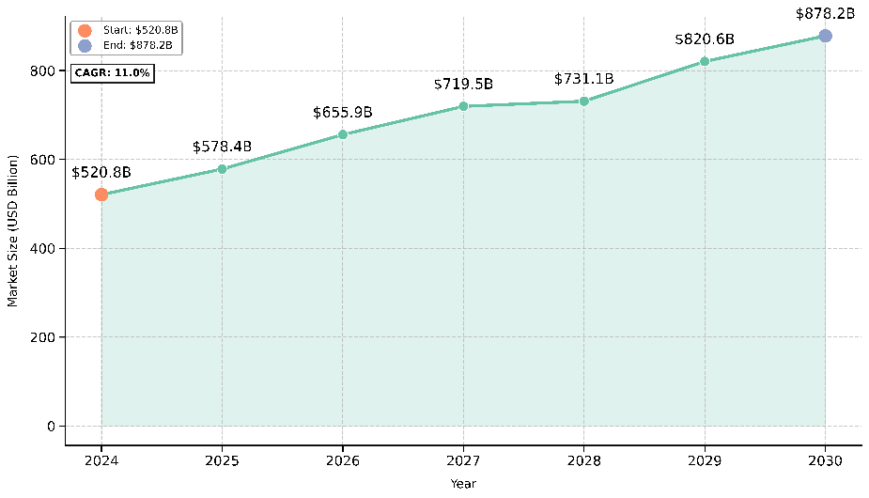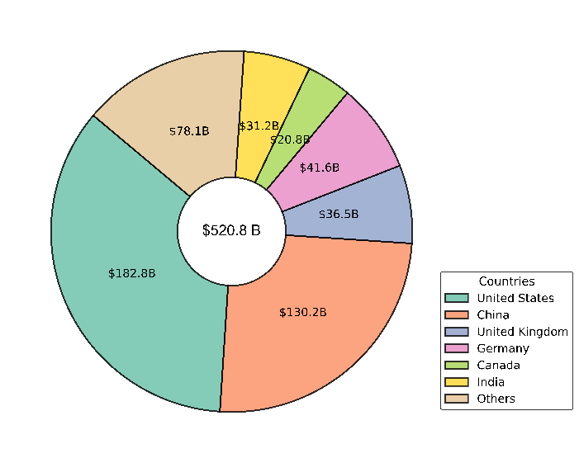

* **Market Size:** In 2024, the global public safety market was valued at $520.8 billion and is expected to grow to $878.2 billion by 2030 at a CAGR of 11.0%.

6.2 Target Audience:

* **Governments and Municipalities:** Seeking scalable and efficient systems to enhance public safety.
* **Law Enforcement Agencies:** Requiring tools for real-time crime detection and faster investigations.
* **Private Institutions and Corporations:** Focused on ensuring employee and community safety within campuses.

6.3 Market Drivers:

* **Crime Statistics:** Alarming increase in crimes, particularly against women, necessitates innovative safety solutions.
* **Smart City Initiatives:** Global investments in smart city projects fuel demand for integrated safety systems.
* **Advances in AI and Quantum Technology:** Enhancing the capability and scalability of surveillance systems.

7. Architecture:

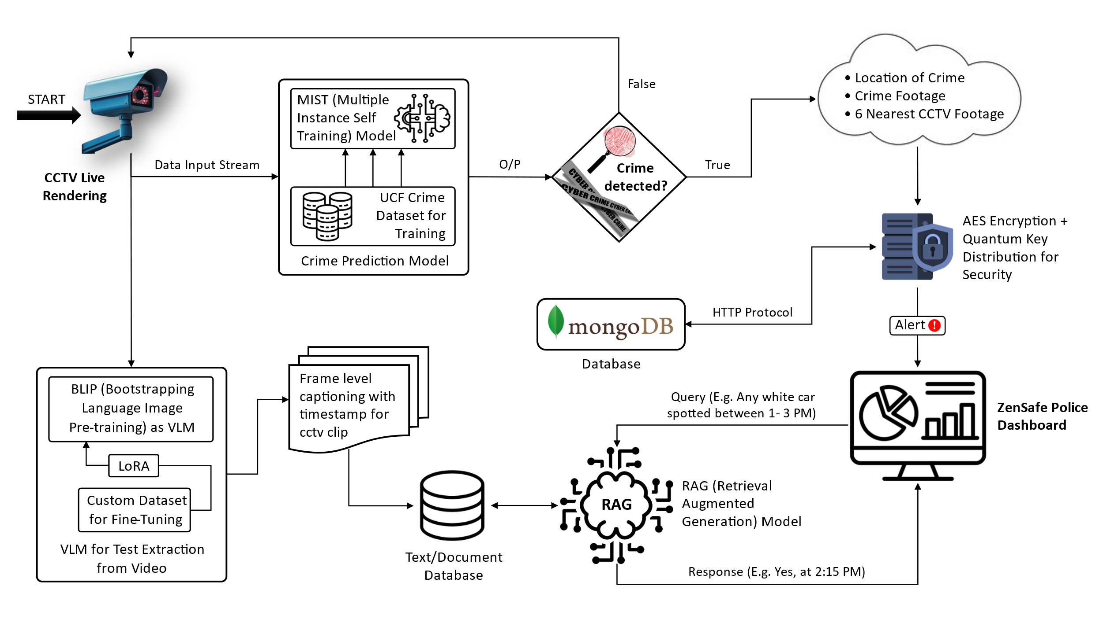7.1 ZenSafe:

7.2 Bootstrapping Language-Image Pre-training (BLIP):

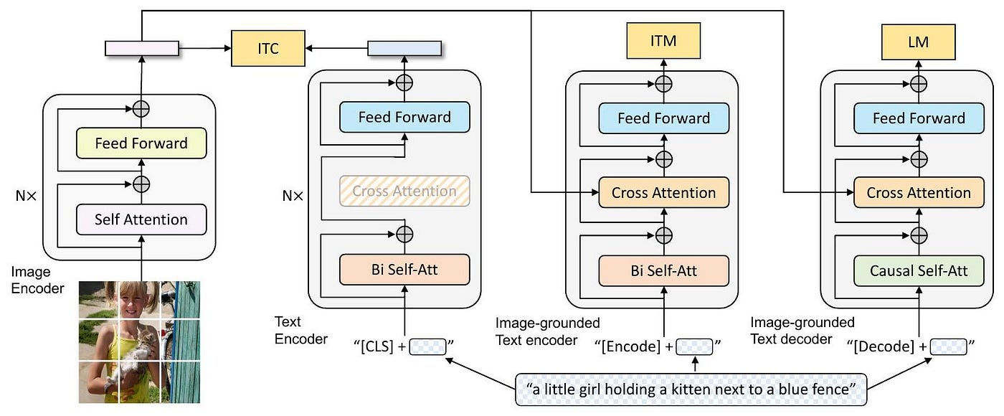

8. Technical stack:



Python



Dart



Javascript



PyTorch



Qiskit



Flutter



React JS



Flask



Hugging Face



Llama Index

Langchain



Mongo DB



Express JS



Node JS



Dockers



Jenkins



Prometheus

SonarQube



Ubuntu OS



Grafana



|  |  |
| --- | --- |
| Features | Tech Stack |
| Crime Detection | PyTorch, Flask [Python] |
| Video Analysis | PyTorch, Langchain, HugginFace, Llama Index, Flask [Python] |
| Front-End | MERN, Flutter [Javascript, Dart] |
| Security | Qiskit [Python] |
| DevOps | Dockers, Jenkins, Grafana, Prometheus, SonarQube [Ubuntu] |

9. Conclusion:

In conclusion, ZenSafe represents a transformative leap in public safety technology, combining deep learning, quantum computing, and generative AI to enhance women’s safety and empower law enforcement with cutting-edge tools. Its ability to detect crimes in real time, provide contextual insights, and facilitate efficient evidence retrieval ensures faster, more effective responses to criminal activities. With robust data security measures and a user-friendly query system, ZenSafe not only improves law enforcement efficiency but also fosters a heightened sense of security in communities. By integrating advanced technologies into public safety solutions, ZenSafe paves the way for a safer, more connected urban environment.

10. References:

* Deep learning for Anomaly Detection: <https://arxiv.org/pdf/2007.02500>
* Woman Violence Report: <https://www.ojp.gov/pdffiles1/nij/grants/199577.pdf>
* Vision Language Modelling: <https://arxiv.org/pdf/2405.17247>
* Quantum Cryptography: <https://arxiv.org/pdf/quant-ph/0307049>
* Parameter Efficient Fine Tuning: <https://arxiv.org/pdf/2211.15583>