Supplement to: Acidithiobacillus ferrooxidans’s comprehensive model driven analysis of the electron transfer metabolism and synthetic strain design for biomining applications

Miguel A. Campodonico1, Daniela Vaisman1, Jean F. Castro1, Valeria Razmilic1, Francesca Mercado1, Barbara A. Andrews1, Adam M. Feist2, Juan A. Asenjo1
1 Centre for Biotechnology and Bioengineering, CeBiB, University of Chile, Beauchef 850, Santiago, Chile.
2 Department of Bioengineering, University of California, 9500 Gilman Drive # 0412, San Diego, La Jolla, CA, 92093, USA.

Table of Contents
Supplementary Notes 2
Supplementary Note 1. Thermodynamic analysis of A. ferrooxidans transmembrane enzyme’s proton translocation metabolism 2
Supplementary Note 2. Energy Metabolism Characterization and Analysis 4
Supplementary Note 3. Genetic algorithm specification and results analysis 6
Supplementary Note 4. iMC507 model-driven analysis of central carbon metabolism 7
Supplementary Note 5. EPS growth coupled production through FUM/MDH reaction knock-outs 10
Supplementary Figures 11
Supplementary Figure 1. Schematic representation of the main metabolic pathways of Acidithiobacillus ferrooxidans ATCC 23270 metabolism. 11
Supplementary Figure 2. Properties of iMC507 12
Supplementary Figure 3. Comprehensive categorization of current available information for A. ferrooxidans. 13
Supplementary Figure 4. Thermodynamic base estimation of proton translocation bounds in transmembrane reactions. 14
Supplementary Figure 5. Genetic algorithm based analysis output summary. 15
Supplementary Figure 6. Reaction essentiality analysis. 16
Supplementary Figure 7. Effect of proton exchange on predicted growth rate. 17
Supplementary Figure 8. EPS growth coupled production pathways/reactions and flux distribution comparison. 18
Supplementary Figure 9. Carbon fixation and EPS flux distribution predicted for ferrous ion metabolism 19
Supplementary Figure 10.Carbon fixation and electron transfer metabolism Flux Variability Analysis (FVA) results. 20
Supplementary Figure 11.Carbon fixation and electron transfer metabolism under oxygen limitations. 21
References 22

Supplementary Notes

Supplementary Note 1. Thermodynamic analysis of A. ferrooxidans transmembrane enzyme’s proton translocation metabolism

In order to set the upper and lower bounds of A. ferrooxidans’s transmembrane enzymes proton translocation stoichiometry, a detailed thermodynamic analysis of each enzyme in the ferrous ion metabolism (FIM) and reduce inorganic sulfur compound (RISCs) metabolism was performed.
Initially, based on previous reports, each enzyme reaction stoichiometry and reaction directionality for the FIM and RISCs metabolism were defined (Chi et al., 2007; Feist et al., 2014; Ferguson and Ingledew, 2008; Quatrini et al., 2009; Quatrini et al., 2006; Rawlings and Johnson, 2007; Valdes et al., 2008). The aim of setting the reaction directionality was to accurately describe and modeled the actual cell behavior, by not allowing reverse flux during the simulations. From a biological perspective, this model approach sets the way and direction on how transmembrane enzymes will work during cell growth, under the simulated conditions.
Then, an enzyme specific thermodynamic analysis was performed as described elsewhere (Feist et al., 2014; Kroger et al., 2002). The ATP synthase reaction (ATPS5rpp) thermodynamic analysis was discarded from this analysis, since it has been extensively studied. For ATPS5rpp the upper and lower proton translocation stoichiometry bounds were set to 3.3 and 5 according to (Ferguson and Ingledew, 2008). In order to proceed with the thermodynamic analysis for the rest of the enzyme reactions, first, the change in reduction potential (ΔE°’ [mV]) of each enzyme reaction was calculated. Reactions were split in half reactions, and depending on the directionality, standard half-reaction reduction potentials were added or subtracted. Since the Gibbs free energy change (ΔG°’ [kJ]) of a particular reaction is related to ΔE°’ as follow:

$$ΔG°’= -nF\left(ΔE°’\right)$$

where n is the number of electrons transferred in the reaction (in mol), and F id the Faraday’s constant (96.5 [kJ/V/mol]), is it possible to determine whether a particular reaction might be feasible or not, and the corresponding condition at which it will be feasible. Based on these calculations, two reactions (CYTBC1 and NADHI) where found to be not thermodynamically feasible. Nevertheless, from the chemiosmotic theory is it possible to make certain predictions, and set the stoichiometric bounds in which these reactions can be feasible according to the next formula:
$$x_{min}= ΔE°’/Δp$$

where xmin is the proton translocation stoichiometry lower bound ( in H+/2e-), and Δp is the proton motive force (in mV). For this calculations Δp was set to 256 [mV], which is the proton motive force at pH 2 in A. ferrooxidans(Ferguson and Ingledew, 2008). For the proton translocation stoichiometry’s upper limit, no reference regarding A. ferrooxidans was found. Thus, in these cases the proton translocation stoichiometry upper limit was set arbitrarily to 5 H+/2e-, which is the maximum proton translocation for the ATPS5rpp reaction. Next, for the reactions with a negative ΔG°’ (CYTAA31, CYTRED, CYTAA32, CYTBO3, CYTBD and TSQOC), the proton translocation stoichiometry upper bound was calculated according to the next equation:
$$x_{max}= ΔE°’/Δp$$
where xmax is the proton translocation stoichiometry upper bound ( in H+/2e-). In these cases, the proton stoichiometry’s lower bound was set to 0, meaning that the reactions can’t invert the fluxes and work backwards.
The specific calculations for each enzyme reaction can be found in Supplementary Figure 4. It is worthwhile to notice that reaction TSQOC was discarded from the analysis since the thermodynamically calculated upper limit was very close to 0. Furthermore, all bounds and further calculations were performed by treating the reactions proton translocation stoichiometry as a continuous variable. This assumption appears to be reasonable, since it has been reported that in vacuolar membranes that a non-integer value of proton translocation stoichiometry could be generated by an enzyme which operates an incomplete coupling mechanism. In this event, the reaction cycle could proceed without full occupancy of all the available binding sites and the coupling ratio would effectively be less than the stoichiometry(Davies, 1997). Moreover, this behavior can be also explain as an average over an ensemble of enzymes, where a certain percentage of which pump a particular amount of protons per stroke and the rest of the enzymes a completely different amount of protons(Davies, 1997). More examples on the use of non-integer values of proton translocation stoichiometry can be found elsewhere (Blankenship, 2013; Brzezinski and Johansson, 2010; Hinkle, 2005; Palsson, 2015). Since, there is no evidence on the proton translocation efficiency for each studied enzymes in A. ferrooxidans, in this study the proton translocation stoichiometry as a non-integer variable.

Supplementary Note 2. Energy Metabolism Characterization and Analysis

For FIM, the reconstruction includes the flow of electrons from the oxidation of fe2 by Cyc2 (CYT) to reduce o2 via the aa3 complex (CYTAA31, downhill pathways), and to reduce nad via the bc1/quinone/nadh complex working in reverse (CYTBC1 and NADHI, uphill pathway). The switch point between the downhill and the uphill flow was represented at the level of the rusticyanin complex, where CyA1(CYTA2) and Cyc1(CYT1) diverge the electron flux through the uphill and downhill pathways, respectively (Quatrini et al., 2009). For the uphill pathway, individual reactions for the rusticyanin complex (CYT1, CYT2, and CYTA2), cytochrome oxidase bc1 (CYTBC1), cytochrome c oxidase (CYTAA31) and a ubiquinone nadh dehydrogenase (NADHI). Reactions CYTBC1 and NADHI, in the uphill pathway, were modeled as being energetically driven by the proton motive force (Bruscella et al., 2007; Levican et al., 2002). Nevertheless, no specific proton translocation stoichiometry was found. For reaction CYTAA31, in the downhill pathway, discrepancies arise when trying to determine whether this reaction translocates , protons from the cytoplasm into the periplasmic space (Ferguson and Ingledew, 2008). For this, CYAA31 was modeled as if it were actually translocating protons through the membrane. In order to computationally estimate the missing proton translocation stoichiometry, a genetic algorithm was implemented (see Methods). Reduced inorganic sulfur compound (RISC) metabolism is of great importance for biohydrometallurgical reactions. Biologically relevant RISCs are sulfide, polysulfides, elemental sulfur, sulfite, thiosulfate and polythionates, such as tri-, tertra-, and pentathionate. All of these species are finally oxidized to sulfate, being responsible for lowering the pH value in their habitats (Rohwerder and Sand, 2007). Since RICSs exist in multiple oxidation steps, from -2 to +6, many relevant enzymes, reactions steps and intermediates remain undiscovered and unconnected (Quatrini et al., 2009). With the aim of characterizing already identified RISC oxidation pathways, individual reactions for elemental sulfur, tetrathionate and thiosulfate metabolism were incorporated into the model. Additionally, computational model validation for TTM and TSM was performed. RISC oxidation was modeled by incorporating the so-called Sox system. Reaction compartmentalization was based on previously reported work (Chi et al., 2007; Quatrini et al., 2009). Elemental sulfur was proposed to be oxidized by a dioxygenase (SULDO) (Rohwerder and Sand, 2003). The product of SULDO is sulfite, which is further oxidized to sulfate by a sulfite cytochrome c reductase (SCCR). Sulfate can be exported outside the cell by SO4tex.
The reduced cytochrome c (CycA2) is further oxidized by the cytochrome oxidase CYTAA32 (Chi et al., 2007), which is different from the ferrous ion metabolism oxidase. Thiosulfate and tetrathionate metabolism were proposed to work as a cycle (Beard et al., 2011), where tetrathionate hydrolase converts tetrathionate to thiosulfate (4THASE1 or 4THASE2) (Kanao et al., 2007; Kikumoto et al., 2013). Then, by using a thiosulfate quinone oxidoreduxtase (TSQOC), thiosulfate is regenerated to tetrathionate and contributes to the quinone pool (Quatrini et al., 2009). TSQOC represents a switch point where electrons are diverged i) in the form of reduced ubiquinone (q8h2) to NADHI for nadh generation, described as the “RISC uphill pathway”, and ii) for o2 reduction and generation of proton motif force via two different electron transfer systems through the “RISC downhill pathway”. The first system is formed by a quinone dependent bc1 complex (CYTRED) catalyzing cytochrome c (CycA2) reduction. Further, CycA2 is oxidized by the cytochrome oxidase CYTAA32 which catalyzes direct o2 reduction into water. The second system able to directly reduce o2 into water might be accomplished by two different cytochrome oxidases, CYTBD or CYTBO2 (Quatrini et al., 2009). Using the implemented genetic algorithm, proton translocation reaction stoichiometry for CYTAA32, CYTRED and CYTBO3 was determined.
The first step of co2 consumption in A. ferrooxidans was modeled according to co2 aqueous equilibrium. When atmospheric co2 is dissolved in water, three different major molecular species are formed: carbonic acid (h2co3), bicarbonate (hco3) and carbonate (co3) (Valdés et al., 2010). Below pH 4 the only specie is h2co3, and at pH 6.5 the predominant specie is hco3. Since A. ferrooxidans periplasmic pH is equal to 2 and cytoplasmic pH equal to 6.5, the transport reaction (HCO3tpp) that moves dissolved co2 through the periplasmic membrane was modeled by simulating the chemical h2co3 conversion to hco3 due to the pH aqueous equilibrium. Once hco3 enters the cell, a carbonic anhydrase (HCO3E) is used to generate co2 which is fixed via the Calvin Cycle (Gale and Beck, 1967; Valdes et al., 2003) using energy and reducing power derived from the oxidation of RISCs and ferrous ions. A key reaction in the Calvin Cycle was the ribulose-bisphosphate carboxylase/oxygenase (abbreviated RUBISCO in the reconstruction), which enables co2 incorporation into the chemolithoautotrophic metabolism (Esparza et al., 2010), connecting the Calvin Cycle with the Glycolysis/Gluconeogenesis pathway. In order to feed RUBISCO and ensure rapid conversion of cytosolic hco3 to co2 at concentrations that support optimal RUBISCO activity, a carbonic anhydrase (HCO3E in the model) that catalyzes the reversible hydration of co2 was added to the model. Fixed carbon through RUBISCO can be channeled for glycogen biosynthesis and provide precursors for the anabolic reaction. In total 90 % of all reactions in the central carbon metabolism (TCA, Calvin Cycle, Pentose Phosphate, Glycolysis/Gluconeogenesis, pyruvate, glyoxylate and anaplerotic metabolism) were associated with at least one GPR association. The TCA cycle was modeled as incomplete(Valdes et al., 2008), as has been previously described in a number of obligate autotrophic bacteria and archaea(Wood et al., 2004). Nevertheless, these pathways were incorporated based only on genome annotation (i.e. confidence score equal to 2), meaning that further biochemical characterization is needed. EPS production, for mediating bacterial attachment, was modeled in the same way the as BOF reaction. The EPS reaction is a linear equation consisting of the fractional molar amounts of metabolites that constitute the EPS, which have been proposed to be formed via the Leloir pathway (Barreto et al., 2005; Harneit et al., 2006). Specifically, eight out of ten reactions labeled as EPS biosynthesis, were linked with at least one GPR association. A detailed description specifying the total amount of reactions and reactions with GPRs associations organized by subsystems can be found in Supplementary Table 6.

Supplementary Note 3. Genetic algorithm specification and results analysis

Genome-scale reconstructions need to be validated by assessing their ability to compute physiological states(Thiele and Palsson, 2010). iMC507 was validated by comparing growth predictions with experimental values (see Supplementary Table 5). A genetic algorithm able to estimate several model parameters (such as proton translocation for 8 different periplasmic proteins and GAM stoichiometry), which minimizes the error between growth predictions and experimental values was implemented (see Methods). The genetic algorithm simultaneously fitted FBA predictions with experimental results for chemolithoautotrophic aerobic FIM, TTM and TSM conditions. Proton translocation stoichiometry for ATPS5rpp, CYTAA31, NADHI, CYTBC1, CYTAA32, CYTRED, CYTBO3 and CYTBD and, GAM stoichiometry, were determined by performing three different genetic algorithm based simulations. Since CYTBO3 and CYTBD are the same reaction (but with different GPR associations), and in order to decrease prediction uncertainties, only CYTBO3 was used for all analysis and the results were extrapolated to CYTBD. First, for all studied reactions proton translocation stoichiometry variables were fed into the genetic algorithm for parameter estimation. A total of 100 simulations were performed and statistical results showing each parameter mean, standard deviation and violin plots are shown in Supplementary Fig. 5. According to the results, for reactions ATPS5rpp, CYTAA31, NADHI and CYTBC1, the smallest proton translocation stoichiometry standard deviation from the set was determined (approximately in the order of hundredths). A particular characteristic of this subset of reactions is that all reactions are involved in FIM. While for reactions involved in the RISC’s, such as, CYTAA32, CYTRED and CYTBO3/CYTBD, standard deviations were in the order of tenths. An R2m equal to 0.92 was calculated, meaning that each simulation was run until an acceptable numerical completion. A detailed analysis on the RISCs electron transfer metabolism showed that reactions CYTAA32 and CYTRED in conjunction performed the same function as CYTBO3. This network characteristic generates higher variability on the predictions when trying to estimate the parameters during the genetic algorithm procedure, by adding more degrees of freedom to the minimization problem. In order to accurately determine these proton translocation reaction stoichiometry, each system (i.e. CYTRED/CYTAA32 and CYTBO3) was independently studied. Based on the latter, the second genetic algorithm based simulation was performed similarly to the first one, excluding CYTBO3 and CYTBD from the analysis. Similarly, the third genetic algorithm based simulation was performed excluding CYTRED and CYTAA32 from the analysis and reincorporating the CYTBO3/CYTBD function. From these results, more accurate predictions for CYTRED, CYTAA32 and CYTBO3 were determined, by considerably decreasing the proton translocation stoichiometry standard deviation on the predictions. Furthermore, for the second and third simulations, no considerable changes in the parameters mean and standard deviation for reactions ATPS5rpp, CYTAA31, NADHI and CYTBC1 were observed.

Supplementary Note 4. iMC507 model-driven analysis of central carbon metabolism
In order to study the central carbon metabolism in A. ferrooxidans, two different types of model-driven analysis were performed. First, in order to decipher the internal flux distribution under different conditions, three different simulations were performed. For the first simulation the carbon uptake rate in the form of h2co3 was set to -2 mmol/gDW/h, oxygen and ferrous ion uptake rate were left unconstrained, and FBA was run to maximize the flux through BOF. Flux distributions are shown in Supplementary Fig. 9A. It is well known that A. ferrooxidans fixes co2 through the Calvin cycle. In order to feed RUBISCO and ensure rapid conversion of cytosolic hco3 to co2 at concentrations that support optimal RUBISCO activity, a carbonic anhydrase (HCO3E in the model) that catalyzes the reversible hydration of co2 converts almost all incoming hco3 to co2. Approximately 95 % of all hco3 goes through HCO3E to the RUBISCO reaction in the form of co2. The rest goes directly to fatty acid, arginine and proline metabolism. RUBISCO catalyzes the formation of two molecules of 3-phosphoglyceric acid (3pg) from ribulose biphosphate (rb15bp) and co2. 3pg represents the junction point between the Calvin cycle and glycolysis. Specifically, 83 % of all 3pg produced is taken by the phosphoglycerate kinase (PGK) to continue the Calvin cycle, whereas the rest goes to glycolysis via phosphoglycerate mutase (PGM1), demonstrating that most of the activity is concentrated in the Calvin cycle. Through an ATP driven reaction, PGK phosphorylates 3pg to produce 13dpg. 98 % of all ATP is produced by ATP synthases and from all ATP produced approximately 16 % is used by PGK and 19 % and 33% is used by BOF and nitrogen fixation through NITF correspondingly. Next, using a nad dependent glyceraldehyde-3-phosphate dehydrogenase (GAPD1), electrons are incorporated to the metabolism by converting 13dpg to g3p. Approximately 93 % of all nadh is generated from NADHI, and GAPD1 uses 67% of all nadh. This reaction could be replaced by a nad dependent glyceraldehyde-3-phosphate dehydrogenase (GADP2), which might work as well as GAPD1, through the conversion of nadh to nadph by a nad transhydrogenase (NADTRHD). This alternate use can be observed from the FVA analysis (see Supplementary Fig. 10), where the GAPD1 range of performance without acting against biomass productions starts at 0. This means that, when GAPD1 flux is 0, GAPD2 takes over its function and allows the Calvin cycle to work. From this perspective, almost all of the reactions in the Calvin cycle need to be actively working in order to sustain growth, with the exception of FBA, FBA3, FBP, SBPASE and TALA, which can be taken over by other specific reactions or pathways. A similar trend can be found throughout glycolysis and the TCA cycle, where only MDH and FUM can be taken over by other specific reactions or pathways. In order to determine the effect on constraining the ferrous ion uptake rate, a second simulation was performed. In this case the same constraints as in the previous simulation were applied, but instead of leaving the ferrous ion uptake rate unconstrained, it was constrained to -140 mmol/gDW/h (only lower bound). Solutions from the second FBA simulation were divided by the solutions obtained in the first simulation. The corresponding ratio is outlined in Supplementary Fig. 9B. By constraining ferrous ion uptake rate, it was not possible for the system to generate the needed reducing power in the form of nadh, nor the sufficient ATP to use all the available h2co3, 83 % of the available carbon was used to generate biomass. This is shown in Supplementary Fig. 9B, where almost all reactions showed a decrease of approximately in 83 % compared to the first analysis. Discrepancies arose from alternate optima, where reactions FBA and FBP are replaced by a cycle generated by the TALA reaction in conjunction with FBA3 and SBPASE. In order to analyze the carbon flux through the network, when forcing the system to use all carbon under ferrous ion restriction, a third simulation was performed. In this simulation, the same constraints as in the second simulation were applied, but instead of setting only the lower bound for the h2co3 uptake rate, the upper bound was also constrained to -2 mmol/gDW/h. Solutions from the third FBA simulation were divided by the solutions obtained in the first FBA simulation. The corresponding ratio is shown in Supplementary Fig. 9C. For this simulation the system was not able to generate the needed reducing power in the form of nadh, nor the sufficient ATP for generating the optimum amount of biomass, instead, just like the previous result only 83 % of the available carbon was used to generate biomass. The rest of the carbon was used to generate EPS. All the changes observed are related to the production of EPS. In the case of PDH and SUCOAS, both reactions showed an increase compared to the first solution. This is due to the need of the system to generate precursors for fatty acid biosynthesis which enables the EPS production. Furthermore, a considerable increase was observed in the Calvin cycle, specifically in the TALA, FBA3 and SBAPSE loop. This is due to the need to produce f6p-B, which is also needed for producing the EPS precursor. This result shows how rigid the network is in terms of the carbon metabolism. Although evidence based on genome annotation indicates the presence of genes coding for the production of organic acids in A. ferrooxidans, specifically for a lactate/malate dehydrogenase (MDH), an acetyl-CoA synthetase (ACS) and a alcohol dehydrogenase (AFE_0697, not included in the model), no convincing experimental evidence regarding their production was found. Despite this, and in order to study the effect of carbon leaking throughout the cell due to metabolic co2 production, transport reactions allowing metabolic co2 transport through the periplasmic (CO2tpp) and extracellular (CO2tex) membrane were added.
As mentioned previously, the second analysis was performed in order to study the system evolution in terms of carbon uptake, biomass, EPS and co2 production due to ferrous ion restriction. To study and compare different metabolic scenarios, three different simulations were performed (Supplementary Fig. 9D-E). The first simulation was performed by setting the carbon uptake rate in the form of h2co3 to -2 mmol/gDW/h (only lower bound), the co2 production rate was constraint to 0 (lower and upper bounds), oxygen uptake rate was left unconstraint, ferrous ion was varied between 0 and -200 mmol/gDW/h, and FBA was run to maximize the flux through BOF. The second simulation was performed in the same manner, but constraining the h2co3 uptake rate in both bounds, forcing the system to metabolize all of the carbon. The third simulation was performed identical to the second one, but this time metabolic co2 was allowed to leave the cell. Results from these simulations are shown in Supplementary Fig. 9D-E. For the first simulation, results are specifically plotted in Supplementary Fig. 9D. Since only the h2co3 lower bound was set, the cell was freely allowed to metabolize the necessary amount of h2co3 to produce biomass, and not diverge fluxes towards EPS production. The specific amount of h2co3 consumed was highly constrained by the ferrous ion uptake rate, which delivers the electrons necessary for proton motive force, ATP and nadh generation. This is shown in Supplementary Fig. 9D, where the h2co3 uptake rate increases along the permissible ferrous ion uptake rate (x-axis). All carbon goes directly to biomass, reaching the optimum at approximately a ferrous ion uptake rate of -170 mmol/gDW/h (optimality line 2). This point represents the FBA flux distribution result used to plot Supplementary Fig. 9A, and the point described by the optimality line 2 (ferrous ion uptake rate constraint to -140 mmol/gDW/h) represents the flux distribution ratio plot in Supplementary Fig. 8B. Oxygen uptake rate continues to increase after reaching the optimum growth. This was to neutralize the incoming proton from ferrous ion and produce water from oxygen and protons by CYTAA31. When constraining lower and upper bounds in h2co3 uptake rate, the minimum ferrous ion flux necessary to sustain growth was approximately -120 mmol/gDW/h. Furthermore, EPS production associated to growth was determined. While ferrous ion uptake rate increases, EPS production decreases and biomass increases reaching its optimum when no EPS production was observed (optimality line 2 in Supplementary Fig. 9E). The point described by the optimality line 2 (ferrous ion uptake rate constraint to -140 mmol/gDW/h) represents the flux distribution ratio plot in Supplementary Fig. 9C. According to the third simulation, by not constraining metabolic co2 transport outside the cell, the same results are obtained as in the first simulation. Discrepancies arose in h2co3 consumption and metabolic co2 evolution (purple line in Supplementary Fig. 9D). In this case h2co3 uptake was always to -2 mmol/gDW/h, and co2 decreases until reaching the optimum growth, where the cell uses all h2co3 for biomass production. No EPS production was observed, since from an energetic point of view, EPS precursors are harder or energetically more expensive to produce compared to metabolic co2. This suggests that there might be some carbon losses due to metabolic co2 production during cell growth, depending the ferrous ion availability.

Supplementary Note 5. EPS growth coupled production through FUM/MDH reaction knock-outs
The independent FUM/MDH reaction deletion disturbs A. ferrooxidans’s metabolic network in a way that EPS production is coupled to growth. First, in order to understand the EPS growth coupled, it’s necessary to mention that (Purine and Pyrimidine Biosynthesis) and ARGSL(Arginine and Proline Metabolism) reactions are essential for growth, and both generates fum as a byproduct. Thus, under normal conditions, A. ferrooxidans recycles fum by incorporating it into the Incomplete TCA cycle. By, deleting FUM or MDH reactions, A. ferrooxidans network loses its natural ability for recycling fum, thus redirecting the fluxes towards the production of EPS. In order to determine the metabolites that determine the growth coupled design, each substrate in the EPS reaction was eliminated independently and then the model was optimized for growth. Based on these calculations, the metabolites in the EPS reaction that determine and explain the growth coupled behavior are hpdcaACP and nodcaACP. As shown in Supplementary Fig. 8 , both metabolites are being produce in the Lower Fatty Acid Biosynthesis branch, which is being fed by the Incomplete TCA cycle through succ, which at the same time is being produced from fum, and closing the EPS growth coupled production. In order to outline such behavior, Supplementary Fig. 8 was generated, where the normalized flux distribution ratio between the growth coupled design solution over the wild type solution was plotted against the major pathways involved in the EPS growth coupled design.

Supplementary Figures
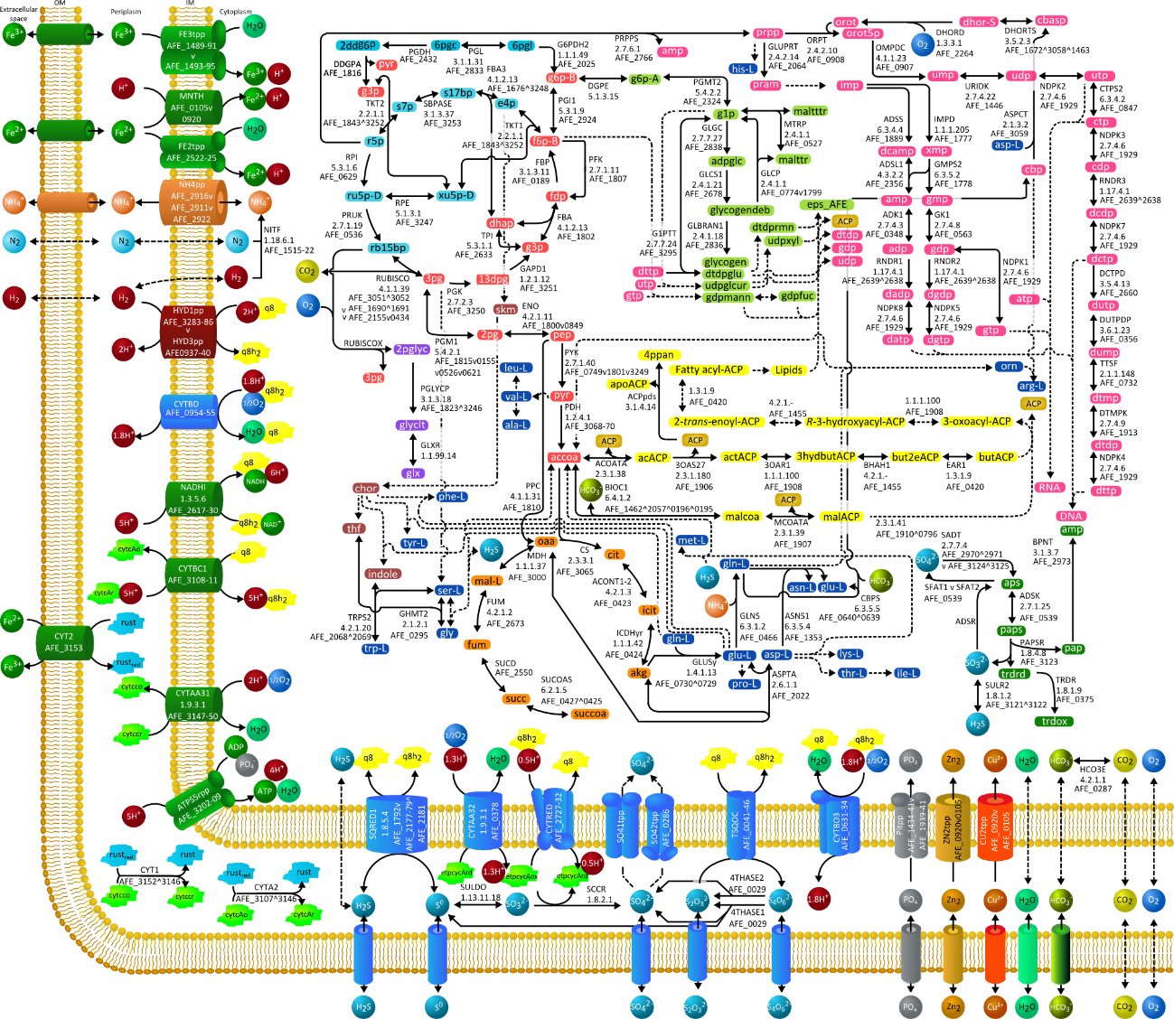

Supplementary Figure 1. Schematic representation of the main metabolic pathways of Acidithiobacillus ferrooxidans ATCC 23270 metabolism.
Full pathways details are listed in Supplementary Table 1. Continuous lines show one reaction, which is associated with relevant information such as enzyme name abbreviation, gene ID and E. C. number; dashed lines indicate that more than one reaction is involved in the pathway. Hyphen (-) indicates a consecutive series of genes (e.g. AFE_0001-3 means AFE_0001 and AFE_0002 and AFE_0003). Logical operators were used: ^ indicates "AND"; v indicates "OR". Each color represents one pathway. In the cytoplasm: Red = Glycolisis/Gluconeogenesis; ligth blue = Pentose Phosphate Pathway; orange = incomplete Citric Acid Cycle; blue = Aminoacid Biosynthesis; brown = Chorismate Biosynthesis; purple = Alternate Carbon Metabolism; yellow = Membrane Lipid Metabolism/Fatty acid biosynthesis; pink = Nucleotide Salvage Pathway/Purine and Pyrimidine Biosynthesis; light green = Glycogen Metabolism; green = Cysteine Metabolism/Sulfur Metabolism. In the membranes/periplasm: green = Oxidative Phosphorylation; dark red = Hydrogen and Formate Utilization; ligth blue = Sulfur Metabolism. Top-left cycle = Calvin-Benson-Bassham Cycle. OM = Outer membrane; IM = Internal membrane. Compounds 3-oxoacyl-ACP, R-3-hydroxyacyl-ACP, 2-trans-enoyl-ACP, Fatty acyl-ACP and Lipids are generic intermediates in the fatty acids biosynthesis pathway and they are not listed in Supplementary Table 3.

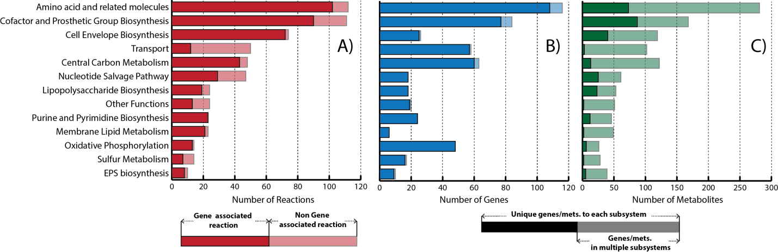

Supplementary Figure 2. Properties of iMC507
(A) The number of reactions in each functional category. Non gene associated reactions are shown by the shaded portion of each bar. (B) The number of independent genes with associated reactions in each category are indicated by the lighter portion at each bar. The solid portion corresponds to the number of genes unique to each category (i.e. associated only with reactions in one category). (C) The number of independent metabolites with associated reactions in each category are indicated by the lighter portion at each bar. The solid portion corresponds to the number of metabolites unique to each category (i.e. associated only with reactions in one category).

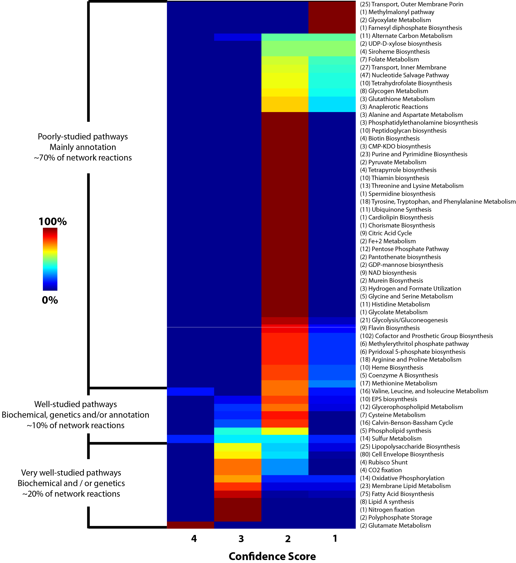

Supplementary Figure 3. Comprehensive categorization of current available information for A. ferrooxidans.
Subsystems and the number of reaction in each one of them are listed. Colors represent the percentage of reactions in the corresponding subsystem, organized by confidence score. The confidence score was assigned to each reaction in the model on a scale from 1 to 4. A score of 4 was assigned when experimental, gene product function and biochemical reaction evidence are available; 3 represents physiological, genetic or proteomic evidence; 2 corresponds only to genome annotation evidence for a gene product and its reaction(s) association; and a score of 1 shows that no evidence is available, but the reaction is required for modeling purposes.

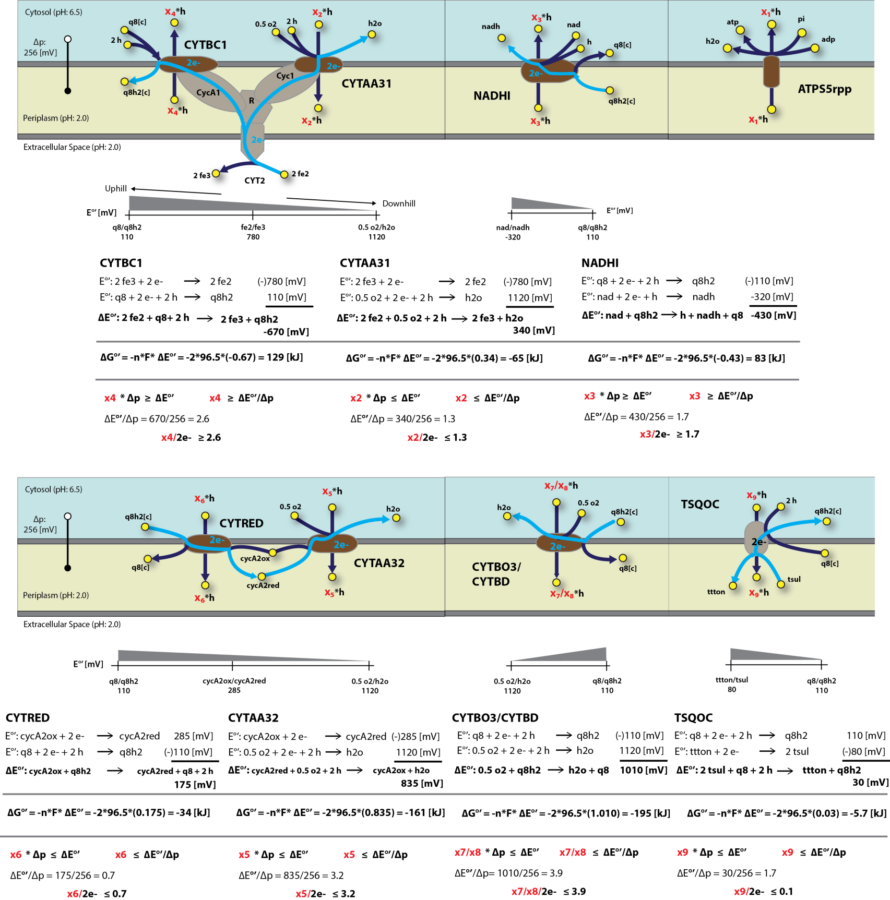

Supplementary Figure 4. Thermodynamic base estimation of proton translocation bounds in transmembrane reactions.
Key enzymes in A. ferrooxidans’s fe2, ttton and tsul metabolism where identify and further thermodynamic based estimation of proton translocation bounds were estimated. First, Based on each enzyme/reaction redox balance, the ΔG°’ was calculated. Then, according to the chemiosmotic theory and taking into account experimental information on Δp, lower and upper bound were determine.
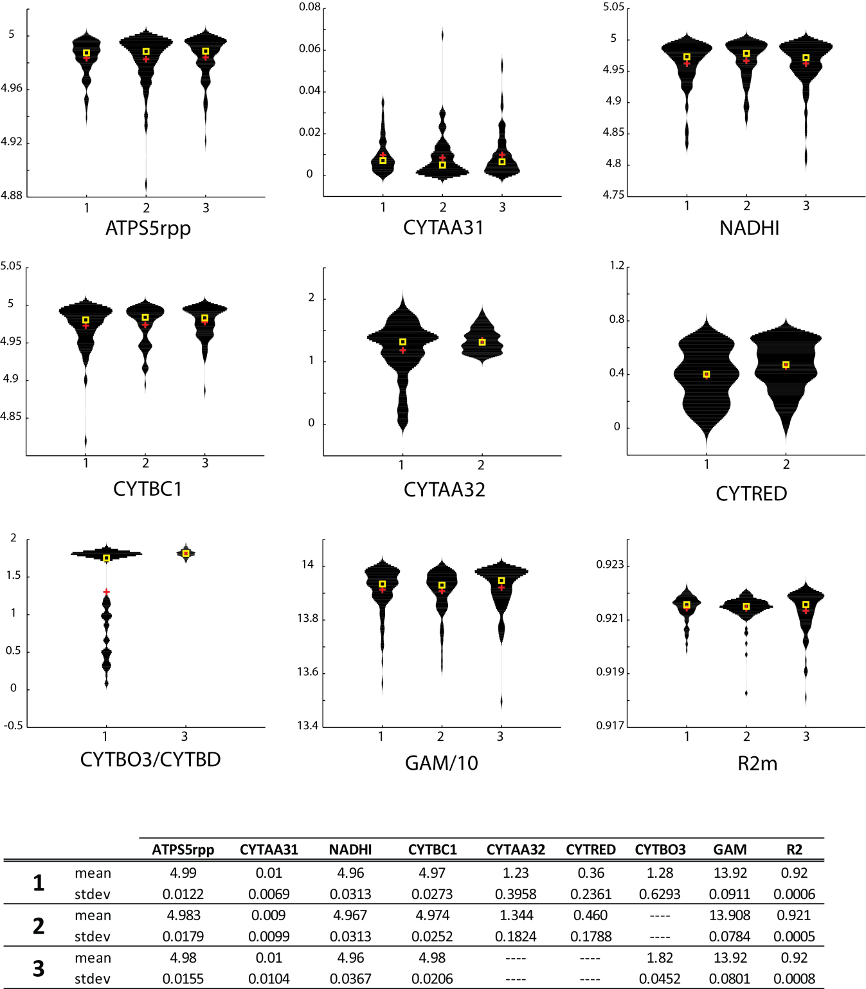

Supplementary Figure 5. Genetic algorithm based analysis output summary.
Proton translocation and GAM stoichiometry violin plots, mean (red cross), median (yellow square) and standard deviation for each fitted parameter in the corresponding reaction were plotted and tabulated. Furthermore, R2m calculations were incorporated. Results were given for three different genetic algorithm based simulations. 1) All parameters were fed into the model for computational estimation according to methods. Then 2) and 3) were executed similar to 1), but in these cases CYTBO3 and CYRED/CYTAA32 were excluded from the genetic algorithm based estimation, respectively. In total each simulation was run 100 times. Initial values for lower and upper bounds proton translocation and GAM reactions stoichiometry were set randomly in-between the corresponding minimum lower and maximum upper allowable bound space.
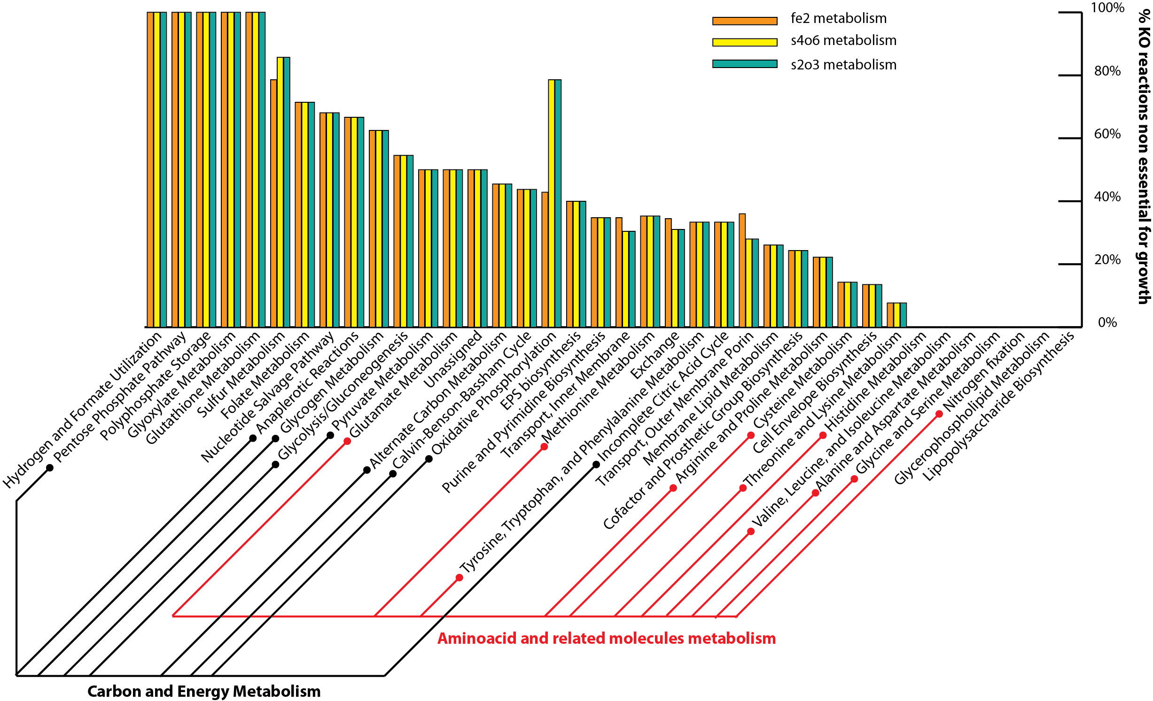

Supplementary Figure 6. Reaction essentiality analysis.
For each studied metabolism, ferrous ion (orange), tetrathionate (yellow), and thiosulfate (green) the percentage of knock-out reactions non-essential for growth in various subsystems were plotted. Specific associations with carbon and energy (black lines), and amino acid related molecules (red lines) metabolism were specified.

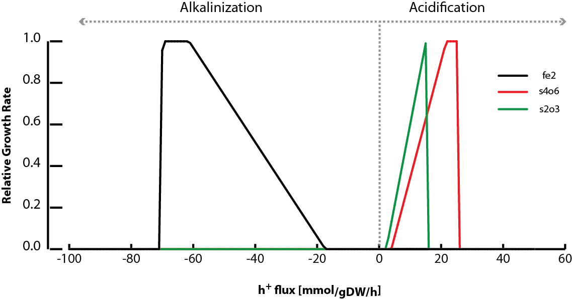

Supplementary Figure 7. Effect of proton exchange on predicted growth rate.
The proton exchange between the cell and the medium was varied from -100 to 60 mmol/gDW/h and the relative growth rate was computed under autotrophic conditions for ferrous ion (black line), tetrathionate (green line), and thiosulfate (red line) metabolism.

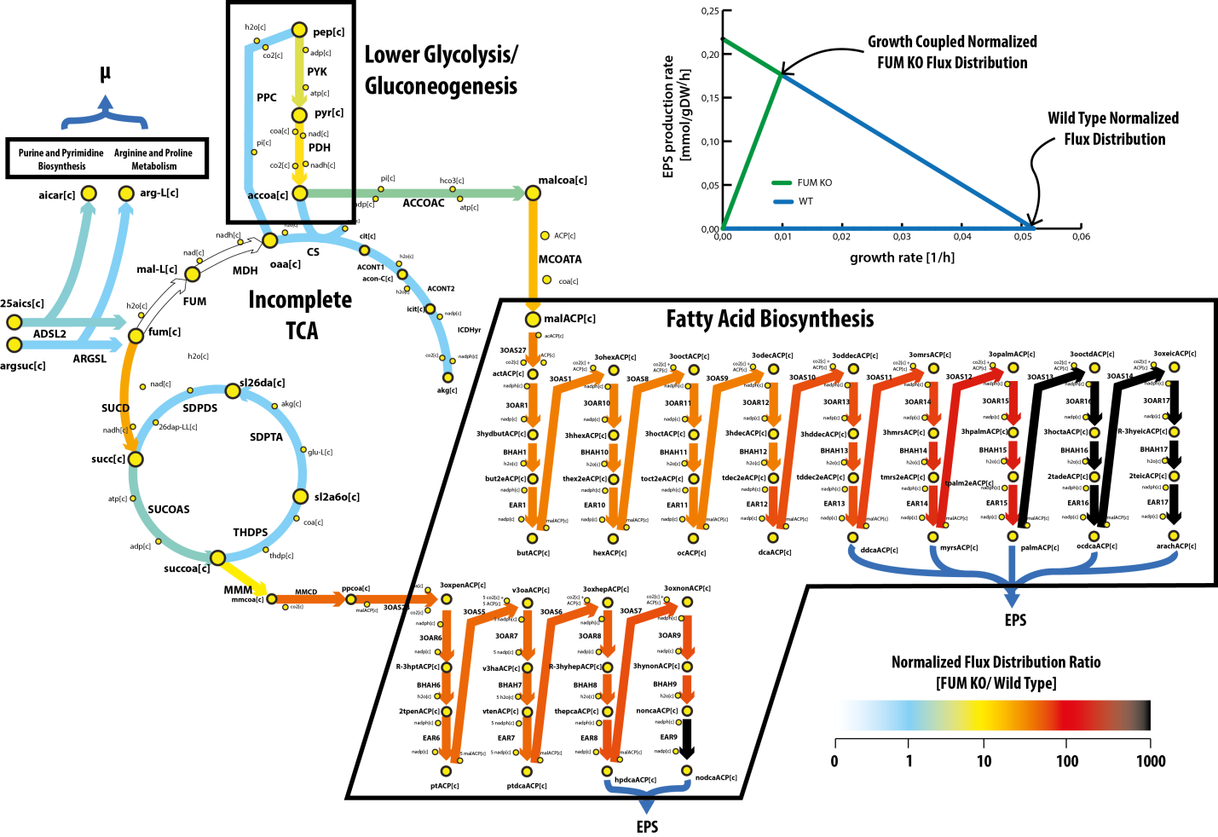

Supplementary Figure 8. EPS growth coupled production pathways/reactions and flux distribution comparison.
The major pathways and reactions involved in the EPS growth coupled design through FUM reaction deletion were outline. Reactions are represented by arrows and metabolites in circles. The normalized flux distribution ratio between the growth coupled and wild type flux distribution is represented by the color fill in the arrows. The production envelope for both, the wild type (blue line) and growth coupled (green line) strains is plotted in the upper right corner. No matter with reaction deletion is preformed (i.e. MDH or FUM) same flux distributions were obtained. For solutions presented in the figure, FUM was deleted.

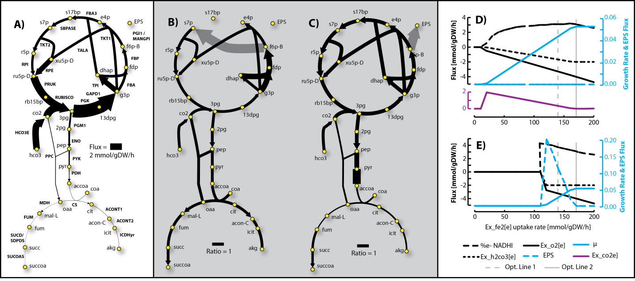

Supplementary Figure 9. Carbon fixation and EPS flux distribution predicted for ferrous ion metabolism
A) This analysis was executed by setting the carbon uptake rate (lower bound) in the form of h2co3 to 2 mmol/gDW/h, ferrous ion was left unconstrained, and FBA was run to maximize the flux through BOF. Reactions are specified in capital letters, while metabolites in lowercase letters. Arrows indicate the direction of reaction activity and the arrow thicknesses are proportional to the flux through each reaction (a thicker arrow has a larger flux). B) A FBA flux comparison between flux distributions obtained in A and simulations ran when constraining the ferrous ion uptake rate (lower and upper bounds) to -140 mmol/gDW/h. Arrows indicate the direction of enzymatic activity and the arrow thicknesses are proportional to the ratio between predictions (a thicker arrow shows that flux obtained in A is lower than the one predicted when constraining ferrous ion uptake rate). C) A FBA flux comparison between flux distributions obtained in A and simulations ran when constraining the ferrous ion uptake rate (lower and upper bounds) to -140 mmol/gDW/h and carbon uptake rate (lower and upper bound) in the form of h2co3 to 2 mmol/gDW/h. Arrows indicate the direction of enzymatic activity and the arrow thicknesses are proportional to the ratio between predictions (a thicker arrow shows that flux obtained in A is lower than the one predicted when constraining ferrous ion and h2co3 uptake rate). D) The results of two different analyses were plotted. i) carbon uptake rate in the form of h2co3 was set to 2 mmol/gDW/h (lower bound), ferrous ion was varied between 0 and -140 mmol/gDW/h, and FBA was ran to maximize the flux through BOF. And ii), a metabolic co2 transport reaction was added, carbon uptake rate in the form of h2co3 was set to 2 mmol/gDW/h (lower and upper bound), ferrous ion was varied between 0 and -140 mmol/gDW/h, and FBA was ran to maximize the flux through BOF. Results for specific reactions were outlined. Lines in light blue represent reaction flux predictions for growth rate and EPS production. Reactions in black, represent the predicted flux in the oxygen and h2co3 uptake reactions. And the reaction in purple, represents the discrepancy between prediction i) and ii) (external metabolic co2 transport reaction flux). Optimality lines for predictions outlined in A, B and C were plotted in gray. E) A flux distribution for simulations obtained by setting the carbon uptake rate in the form of h2co3 to 2 mmol/gDW/h (lower and upper bound), varying the ferrous ion uptake rate between 0 and -140 mmol/gDW/h, and running FBA to maximize the flux through BOF were outlined.

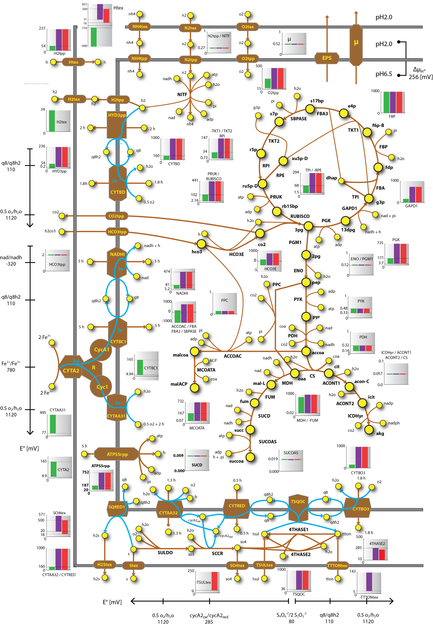

Supplementary Figure 10.Carbon fixation and electron transfer metabolism Flux Variability Analysis (FVA) results.
FVA was performed under autotrophic conditions using as electron donors ferrous ion (green), tetrathionate (purple), and thiosulfate (red). Carbon fixation and electron transfer metabolism were outlined. Reactions in light blue represent the flow of electrons through the membrane. Each reaction in the figure was associated with a specific graph, in which is represented the calculated FVA range for the three different conditions studied.

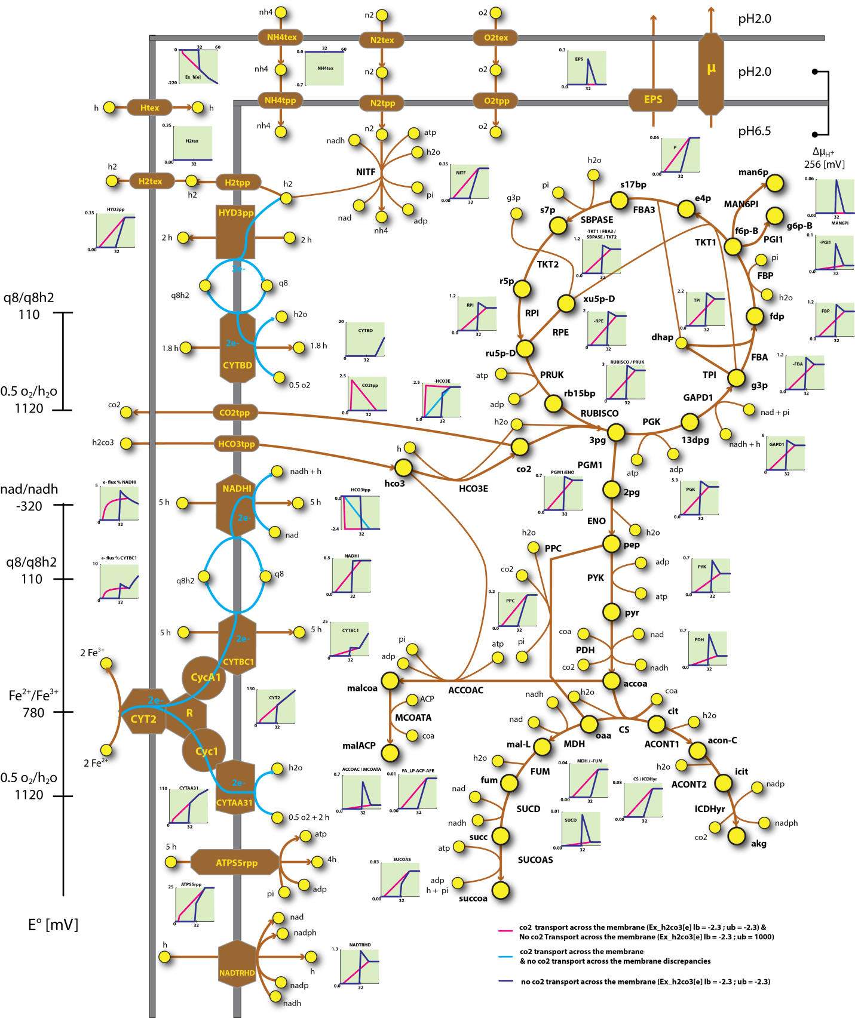

Supplementary Figure 11.Carbon fixation and electron transfer metabolism under oxygen limitations.
FBA was performed under autotrophic conditions using as electron donors ferrous ion (green). This analysis was executed by setting the carbon uptake rate in the form of h2co3 to 2.34 mmol/gDW/h, oxygen was varied between 0 and 60 mmol/gDW/h, and running FBA to maximize the flux through BOF. Carbon fixation and electron transfer pathways are outlined. Reactions in light blue represent the flow of electrons through the membrane. Each reaction in the figure was associated with a specific graph, in which the FBA prediction range is represented for the three different condition studied. Lines in red represents two different kinds of simulations: i) simulations were a metabolic co2 transport outside the cell was incorporated into the model and setting h2co3 uptake rate upper and lower bound to -2.34, and ii) where no metabolic co2 transport was incorporated but setting the h2co3 uptake rate lower bound to -2.34 and upper bound to 1000. Lines in purple shows the results without metabolic co2 transport incorporation, and setting the h2co3 uptake rate upper and lower bound to -2.34. Lines in light blue shows the discrepancies obtained between i) and ii).

References
Barreto, M., Jedlicki, E., Holmes, D. S., 2005. Identification of a gene cluster for the formation of extracellular polysaccharide precursors in the chemolithoautotroph Acidithiobacillus ferrooxidans. Appl Environ Microbiol. 71, 2902-9.
Beard, S., Paradela, A., Albar, J. P., Jerez, C. A., 2011. Growth of Acidithiobacillus Ferrooxidans ATCC 23270 in Thiosulfate Under Oxygen-Limiting Conditions Generates Extracellular Sulfur Globules by Means of a Secreted Tetrathionate Hydrolase. Front Microbiol. 2, 79.
Blankenship, R. E., 2013. Molecular mechanisms of photosynthesis. John Wiley & Sons.
Bruscella, P., Appia-Ayme, C., Levican, G., Ratouchniak, J., Jedlicki, E., Holmes, D. S., Bonnefoy, V., 2007. Differential expression of two bc1 complexes in the strict acidophilic chemolithoautotrophic bacterium Acidithiobacillus ferrooxidans suggests a model for their respective roles in iron or sulfur oxidation. Microbiology. 153, 102-10.
Brzezinski, P., Johansson, A. L., 2010. Variable proton-pumping stoichiometry in structural variants of cytochrome c oxidase. Biochim Biophys Acta. 1797, 710-23.
Chi, A., Valenzuela, L., Beard, S., Mackey, A. J., Shabanowitz, J., Hunt, D. F., Jerez, C. A., 2007. Periplasmic proteins of the extremophile Acidithiobacillus ferrooxidans: a high throughput proteomics analysis. Mol Cell Proteomics. 6, 2239-51.
Davies, J. M., 1997. Vacuolar energization: Pumps, shunts and stress. J Exp Bot. 48, 633-641.
Esparza, M., Cardenas, J. P., Bowien, B., Jedlicki, E., Holmes, D. S., 2010. Genes and pathways for CO2 fixation in the obligate, chemolithoautotrophic acidophile, Acidithiobacillus ferrooxidans, carbon fixation in A. ferrooxidans. BMC Microbiol. 10, 229.
Feist, A. M., Nagarajan, H., Rotaru, A. E., Tremblay, P. L., Zhang, T., Nevin, K. P., Lovley, D. R., Zengler, K., 2014. Constraint-based modeling of carbon fixation and the energetics of electron transfer in Geobacter metallireducens. PLoS Comput Biol. 10, e1003575.
Ferguson, S. J., Ingledew, W. J., 2008. Energetic problems faced by micro-organisms growing or surviving on parsimonious energy sources and at acidic pH: I. Acidithiobacillus ferrooxidans as a paradigm. Biochim Biophys Acta. 1777, 1471-9.
Gale, N. L., Beck, J. V., 1967. Evidence for the Calvin cycle and hexose monophosphate pathway in Thiobacillus ferrooxidans. J Bacteriol. 94, 1052-9.
Harneit, K., Göksel, A., Kock, D., Klock, J.-H., Gehrke, T., Sand, W., 2006. Adhesion to metal sulfide surfaces by cells of Acidithiobacillus ferrooxidans, Acidithiobacillus thiooxidans and Leptospirillum ferrooxidans. Hydrometallurgy. 83, 245-254.
Hinkle, P. C., 2005. P/O ratios of mitochondrial oxidative phosphorylation. Biochim Biophys Acta. 1706, 1-11.
Kanao, T., Kamimura, K., Sugio, T., 2007. Identification of a gene encoding a tetrathionate hydrolase in Acidithiobacillus ferrooxidans. J Biotechnol. 132, 16-22.
Kikumoto, M., Nogami, S., Kanao, T., Takada, J., Kamimura, K., 2013. Tetrathionate-forming thiosulfate dehydrogenase from the acidophilic, chemolithoautotrophic bacterium Acidithiobacillus ferrooxidans. Appl Environ Microbiol. 79, 113-20.
Kroger, A., Biel, S., Simon, J., Gross, R., Unden, G., Lancaster, C. R., 2002. Fumarate respiration of Wolinella succinogenes: enzymology, energetics and coupling mechanism. Biochim Biophys Acta. 1553, 23-38.
Levican, G., Bruscella, P., Guacunano, M., Inostroza, C., Bonnefoy, V., Holmes, D. S., Jedlicki, E., 2002. Characterization of the petI and res operons of Acidithiobacillus ferrooxidans. J Bacteriol. 184, 1498-501.
Palsson, B. O., 2015. Systems biology. Cambridge university press.
Quatrini, R., Appia-Ayme, C., Denis, Y., Jedlicki, E., Holmes, D. S., Bonnefoy, V., 2009. Extending the models for iron and sulfur oxidation in the extreme acidophile Acidithiobacillus ferrooxidans. BMC Genomics. 10, 394.
Quatrini, R., Appia-Ayme, C., Denis, Y., Ratouchniak, J., Veloso, F., Valdes, J., Lefimil, C., Silver, S., Roberto, F., Orellana, O., 2006. Insights into the iron and sulfur energetic metabolism of< i> Acidithiobacillus ferrooxidans</i> by microarray transcriptome profiling. Hydrometallurgy. 83, 263-272.
Rawlings, D. E., Johnson, D. B., 2007. Biomining. Springer.
Rohwerder, T., Sand, W., 2003. The sulfane sulfur of persulfides is the actual substrate of the sulfur-oxidizing enzymes from Acidithiobacillus and Acidiphilium spp. Microbiology. 149, 1699-710.
Rohwerder, T., Sand, W., 2007. Oxidation of inorganic sulfur compounds in acidophilic prokaryotes. Engineering in Life Sciences. 7, 301-309.
Thiele, I., Palsson, B. O., 2010. A protocol for generating a high-quality genome-scale metabolic reconstruction. Nat Protoc. 5, 93-121.
Valdés, J., Cárdenas, J., Quatrini, R., Esparza, M., Osorio, H., Duarte, F., Lefimil, C., Sepulveda, R., Jedlicki, E., Holmes, D., 2010. Comparative genomics begins to unravel the ecophysiology of bioleaching. Hydrometallurgy. 104, 471-476.
Valdes, J., Pedroso, I., Quatrini, R., Dodson, R. J., Tettelin, H., Blake, R., 2nd, Eisen, J. A., Holmes, D. S., 2008. Acidithiobacillus ferrooxidans metabolism: from genome sequence to industrial applications. BMC Genomics. 9, 597.
Valdes, J., Veloso, F., Jedlicki, E., Holmes, D., 2003. Metabolic reconstruction of sulfur assimilation in the extremophile Acidithiobacillus ferrooxidans based on genome analysis. BMC Genomics. 4, 51.
Wood, A. P., Aurikko, J. P., Kelly, D. P., 2004. A challenge for 21st century molecular biology and biochemistry: what are the causes of obligate autotrophy and methanotrophy? FEMS Microbiol Rev. 28, 335-52.

