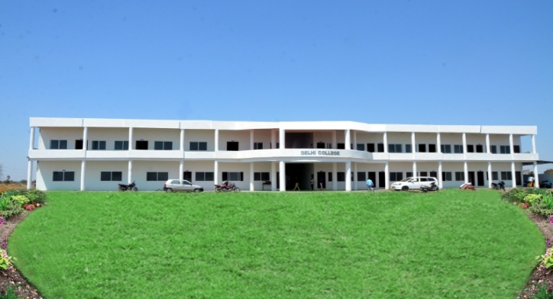

THE SOCIETY

COMIENZO EDUCATIONAL SAMAJIK LOK KALYAN SAMITI

Comienzo Educational Samajik Lok Kalyan Samiti Society is a Registered Society under the Societies Registration Act 1973 and is a non profit organization. The Society is managed by learned people drawn from academics, industry and business. The Chairman of the Society, Mr. Sunil Shivhare has done MBA from IMS, Indore. The Secretary, Mr. Anand Shivare, has done his B.E (CS) form SGSITS, Indore and M.Tech from the well known Indian Institute of Technology, Roorki. Likewise, the Treasurer of the Society Mr. Ashish Jaiswal holds a masters degree in Commerce. The Society is keenly devoted to the cause of professional education.

## C:\Users\Admin\Desktop\DSC_2873.jpgTHE INSTITUTE

The Delhi College is one of the few Institutions approved by AICTE, New Delhi to run world class PGDM course at par with IIMs. The DC at Ashta, Sehore has a curriculum design for PGDM developed by global experts that offers world class quality management education to budding professionals, to create managers for this era of digital world. The course which is designed with a global focus will generate confident, creative and proactive young professionals who will have the ability to meet the global challenges of the time. The Institute is credited with world class faculty specialized in different streams of business management. The institute will provide 100% placement assistance to its students in various National & International corporate sector.

DC is a place of learning for knowledge-driven learners. It has been built with an aim to impart education that surpasses the benchmarks of excellence. To achieve the motto it has a comprehensive pedagogical structure which provides paramount academic skills, curriculum with the ever-evolving dynamics of global business environment, esteemed faculty members with their vast experience and expertise and world class facilities.

## Infrastructure

#### Location

The institute is located in a spacious area in Gram Richadiya, Behind Maa Dayaluware House, Dewankhedi Road, Kannod Road, Ashta Dist – Sehore (M.P)

#### Classroom

Our classroom atmosphere has been a significant factor in creating harmony in the teacher-student relationship. It has been designed to propel an inquiry-based learning that fosters liberation of mind, thereby creating an eagerness to learn.

#### Library

The institute subscribes to a large number of national and international magazines, periodicals, journals and research paper of repute. The libraries also have reputed software packages of several journals. Audio and multimedia versions of some course modules are also available.

Cafeteria

Our cafeteria not only provides a vibrant atmosphere and unleaded fuel for the day but also is an effective way to put forth a new method called the "Cafeteria approach".

Vision & Mission of the Institute

OUR VISION

To be an Institute of Academic Excellence with total commitment to quality education in Management.

OUR MISSION

To serve the society and improve the quality of life by imparting high quality education in management.

CHAIRMAN'S MESSAGE

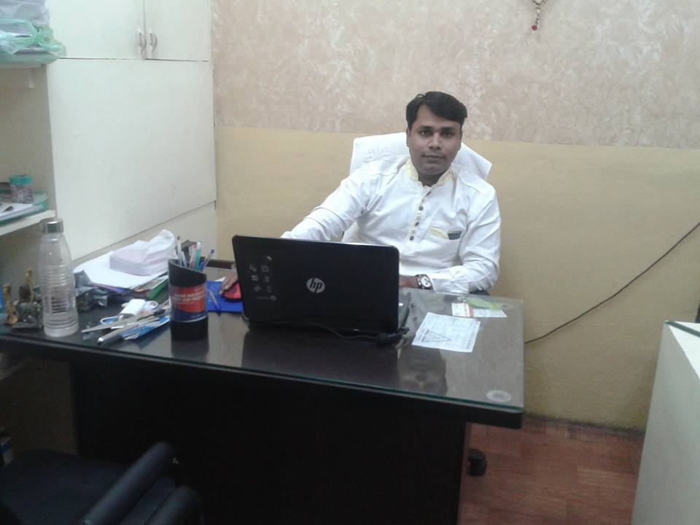DC has been working for the attainment of a mission i.e. to develop highly skilled and professional human resource for industry and business

We understand that management education is ever-changing and ever-evolving. On these lines we focus and frequently interact with the industry to know our employer expectations. This has enabled repeated arrival of companies for campus recruitments year after year. The feedback received from the industry is regularly incorporated to update and upgrade our academic deliverables which has made our students highly competent.

SUNIL SHIVHARE

(CHAIRMAN)

DIRECTOR'S MESSAGE

Delhi College, Ashta is one of the top Management Institute in the Sehore. As an institute of excellence we aim to provide high-quality management education, action-centric research and value-added consulting.

Our vision is to create future leaders who manage and create powerful organizations in the emerging corporate landscape. The curricula of all over long term programmes are industry oriented based on best global practices. Academic rigour is reflected in the course design and delivery of these programmes. Various pedagogic tools help our students develop not only a holistic business perspective but an ability to seize opportunities in a competitive business environment. At the same time they remain committed towards the betterment of the society.

Management involves decision making. We all know that in order to make best possible utilization of available resources, we come across various alternative solutions. We have to pick some and forego others. These decision making skills are sometimes god-gifted, but more often than not, these skills could be acquired. One way of acquiring them is through the process of trial and error. That could be very costly and sometimes, prove fatal for the organization. There is an increasing realization that managerial skills should be acquired. There is greater emphasis on building the human capital. According to some recent demographic studies, India will have a comparative advantage over U.S. and Europe in terms of 'young' population. India is being seen as a major supplier of workforce in the next decade, since the developed world shall have a large component of aging population. This would be possible only when our workforce undergoes appropriate training and acquires requisite skills. This is not an era of the ‘generalist’; it is an age of the 'specialist'.

Executive Board

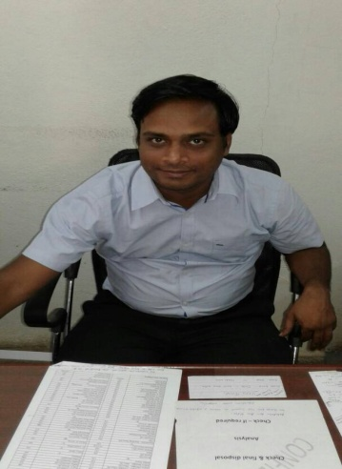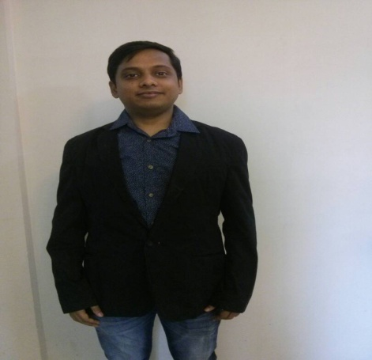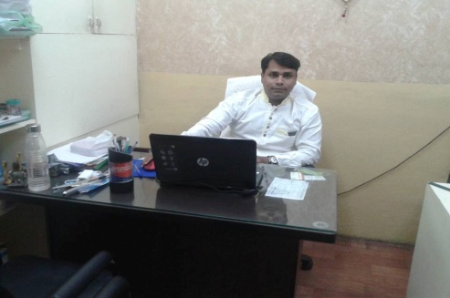

Sunil Shivhare Anand Shivhare Ashish Jaiswal

Chairman Secretary Treasurer



Ishwar Nayak

Joint Secretary

Faculty

The employability quotient of an institute is highly dependent on dedicated and experienced teaching members. They form the base of an institute on which lays the building stones of a successful institute. Industry requirements and demands play a significant role where these members share their experiences and opportunities with the students. Using smart-boards and competitive teaching approach they guide students to excel in consultancy assignments. The professional values are inculcated with a relentless quest for gaining knowledge which gets accredited with the corporate.

Their expert areas lie in constant learning and reciprocating in the form of

* Regular curriculum reviews based on academic and corporate inputs.
* Rigorous student evaluations based on case-studies, assignments, presentations etc.
* Research work on current trends in business environment.
* Attending faculty development programs, seminars, conferences and workshops on contemporary issues in management.

PGDM Faculty:-

|  |  |  |  |
| --- | --- | --- | --- |
| S.NO | FACULTY NAME | QUALIFICATION | EXPERIENCE |
| 1. | BRIJESH SHIVHARE | B.COM,MBA | 5 YR |
| 2. | RANI JAISWAL | BCA,MCA | 5 YR |
| 3. | SHAKTI SINGH | BBA, MBA | 5 YR |
| 4. | KAMAL MULE | BBA, MBA | 5 YR |
| 5. | SATISH VERMA | B.A,PGDM | 3 YR |
| 6. | MANISHA GAIN | BCOM, PGDM | 2 YR |
| 7. | RUCHI NAYAK | B.COM, PGDM | 2 YR |
| 8. | PRITI MAHESHWARI | B.COM, PGDM | 1 YR |
| 9. | DIPESH CHAUDHARY | B.COM, PGDM | 2 YR |
| 10. | ANKIT SAHU | B.COM, MBA | 5 YR |
| 11. | NARENDRA VERMA | BBA, MBA | 3 YR |
| 12. | NAVED KHAN | B.COM, MBA | 5 YR |

VISITING FACULTY: -

|  |  |  |  |
| --- | --- | --- | --- |
| S.NO | FACULTY NAME | QUALIFICATION | EXPERIENCE |
| 1. | POONAM KUKREJA | FCA (CA) | 3 YR |
| 2. | KRISHNA RAI | FCA (CA) | 3 YR |
| 3. | ISHWAR NAYAK | BBA, MBA | 5 YR |
| 4. | NARENDRA SONI | BE, PGDM | 2 YR |
| 5. | KAMAL MULE | B.COM, MBA | 5 YR |

**programsoffers**

POST GRADUATE DIPLOMA IN MANAGEMENT (PGDM)

TWO - YEAR (FULL-TIME)

Delhi College, Ashta is one of the top Management Institute in the Sehore. As an institute of excellence we aim to provide high-quality management education, action-centric research and value-added consulting

The institute from the very outset focused on professional studies at the Post- Graduate level with a view to tap, direct and channelize the enormous talent pool in the country. We offer Post Graduate Diploma in Management (PGDM) (two year - Full Time and three year - Part Time).

PGDM PROGRAMME

PGDM Programme is renowned for its extensive and in depth coverage of core and specialized courses, creating innovation and entrepreneurial qualities. The Programme is approved by the All India Council for Technical Education (AICTE), Ministry of HRD, Government of India . PGDM has also been granted equivalence to MBA degree by Association of Indian Universities (AIU).

In our PGDM programme, we offer following specializations, spanning over two years; It is designed to provide students with first-hand experience of corporate culture

HR | FINANCE | MARKETING | PRODUCTION |IT | BANKING | RETAIL MANAGEMENT

SUMMER INTERNSHIP

Internship programs are one of the best ways to bring the academic and business community together. It is a win-win situation for both the students of the institute as well as the company providing internship.

Student benefits include:

* Chance to apply theoretical learning into practice
* Gaining corporate experience
* Building network

Employer benefits include:

* Accessing ready talent pool
* Spotting future employees
* Decreasing recruitment cost significantly

Admission Procedure

* 1. **Post Graduate Diploma in Management (PGDM)**
* Eligibility Criteria (Batch 2017-2019)

|  |  |  |
| --- | --- | --- |
| **Nomenclature** | **Duration** | **Eligibility Requirements** |
| **PGDM** | **2 Years (4 Semester)** | **Recognized Bachelor’s Degree of minimum 3 Yrs duration, Obtained at least 50% (45% in case of candidate belonging to reserved category) at the qualifying Examination.** |

Institutes offering Post Graduate Diploma in Management shall admits students who have valid score of CAT, MAT,XAT, ATMA, JMET and common entrance CMAT & Institute entrance test of AICTE

Selection procedure and the merit list of the students who have applied for the program. The selection of students shall be strictly on the basis of merit\Weightages for Common entrance tests, Group discussion, Interview, Work experience and academic performance as suggested below shall be used for preparing merit list.

**For more details, contact**

**Helpline No:**9584112000, 8263648180

**Email:**delhicollegeashta@gmail.com

FEE STRUCTURE

PGDM

|  |  |  |  |  |  |  |  |  |  |  |  |  |  |  |  |
| --- | --- | --- | --- | --- | --- | --- | --- | --- | --- | --- | --- | --- | --- | --- | --- |
| |  |  |  | | --- | --- | --- | |  | Total Fee | Rs.2,55,000 + Rs. 5000 (security refundable) | |  | Ist Installment (Payable at the time of admission) | Rs. 50,000/- + Rs. 5,000/- Refundable security | |  | IInd Installment | Rs. 70,000/- 23rd January, 2018 | |  | IIIrd Installment | Rs. 50,000/- Payable by 11th July, 2018 | |  | IVth Installment | Rs. 80,000/- Payable by 22nd November, 2018 | |