YUVAINTERN – WEEK 1 PROJECT
Data Acquisition, Cleaning and
Exploratory Data Analysis

Dataset: Titanic Passenger Dataset
Prepared for YuvaIntern Week 1

1. Introduction
This project demonstrates the basic data science workflow using the publicly available Titanic passenger dataset. The work covers data acquisition, data understanding, data cleaning, preprocessing, exploratory data analysis (EDA), visualization, and interpretation of findings. Python libraries including Pandas, NumPy, Matplotlib, and Seaborn are used to perform the analysis.

2. Project Objective
- Acquire a publicly available dataset from the internet.
- Understand the structure, columns, data types, and statistical characteristics of the dataset.
- Identify missing values and duplicate records.
- Apply appropriate data-cleaning and preprocessing techniques.
- Perform exploratory data analysis using summary statistics.
- Create at least three meaningful visualizations.
- Identify patterns and relationships in the data.
- Document the methodology, code, visualizations, and findings in a structured report.

3. Dataset Description
The Titanic dataset contains passenger-level information from the Titanic voyage. It includes demographic, ticket, fare, family, class, and survival information.
Column | Description
PassengerId | Unique passenger identifier
Survived | Survival status: 0 = did not survive, 1 = survived
Pclass | Passenger class: 1, 2, or 3
Name | Passenger name
Sex | Passenger sex
Age | Passenger age
SibSp | Number of siblings/spouses aboard
Parch | Number of parents/children aboard
Ticket | Ticket number
Fare | Passenger fare
Cabin | Cabin information
Embarked | Port of embarkation

4. Tools and Technologies
- Python – primary programming language
- Google Colab – development and execution environment
- Pandas – data loading, cleaning, transformation, and analysis
- NumPy – numerical operations
- Matplotlib – visualization
- Seaborn – statistical visualization
- Microsoft Word / DOCX – final project documentation

5. Data Acquisition
The dataset was loaded into Python using Pandas. The public CSV source can be accessed from the Data Science Dojo datasets repository on GitHub.
import pandas as pd
import numpy as np
import matplotlib.pyplot as plt
import seaborn as sns
url = "https://raw.githubusercontent.com/datasciencedojo/datasets/master/titanic.csv"
df = pd.read_csv(url)
print("Dataset loaded successfully!")

6. Data Understanding
The following commands were used to inspect the dataset before cleaning:
df.head()
df.shape
df.info()
df.describe()
df.isnull().sum()
df.duplicated().sum()
The dataset contains 891 passenger records and 12 original columns. The inspection step identified missing values in Age, Cabin, and Embarked and provided the basis for selecting appropriate cleaning methods.

7. Data Cleaning and Preprocessing

7.1 Missing Values
Missing values were checked using df.isnull().sum(). The original dataset contains 177 missing Age values, 687 missing Cabin values, and 2 missing Embarked values.
print(df.isnull().sum())
Age – Median Imputation
df["Age"] = df["Age"].fillna(df["Age"].median())
Age is numerical data. Median imputation was selected because the median is less sensitive to extreme values than the mean and retains passenger records instead of deleting them.
Embarked – Mode Imputation
df["Embarked"] = df["Embarked"].fillna(df["Embarked"].mode()[0])
Embarked is categorical data, so the mode (most frequent category) was used to replace the small number of missing values.
Cabin – Column Removal
df = df.drop(columns=["Cabin"])
Cabin has a very high proportion of missing values. Reliable row-by-row imputation would be difficult, so the column was removed for this analysis.

7.2 Duplicate Records
print("Duplicate rows:", df.duplicated().sum())
df = df.drop_duplicates()
print("Duplicate rows after cleaning:", df.duplicated().sum())
Duplicate rows were checked and removed where present so that repeated records would not distort summary statistics or visualizations.

7.3 Data Validation
print(df.isnull().sum())
df.info()
df.describe()
The cleaned dataset was checked again to confirm that the selected missing values had been handled and that the remaining columns had appropriate data types.

8. Exploratory Data Analysis
EDA was used to understand the distribution of passenger characteristics and to investigate patterns related to survival. Summary statistics and grouped survival rates were calculated.
print("Overall survival rate:",
df["Survived"].mean() * 100)
print("Survival by gender:")
print(df.groupby("Sex")["Survived"].mean() * 100)
print("Survival by passenger class:")
print(df.groupby("Pclass")["Survived"].mean() * 100)

9. Visualizations

9.1 Missing Values Before Cleaning
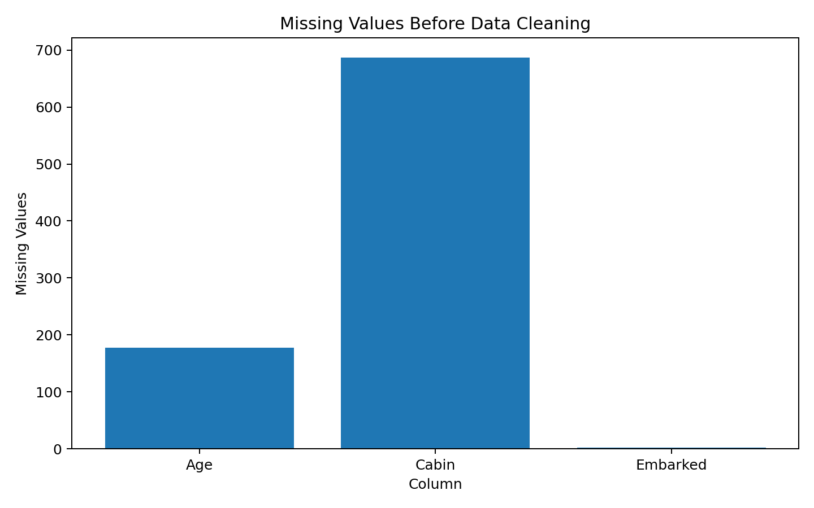
Figure 1. Missing-value counts in the original Titanic dataset.

9.2 Survival Rate by Gender
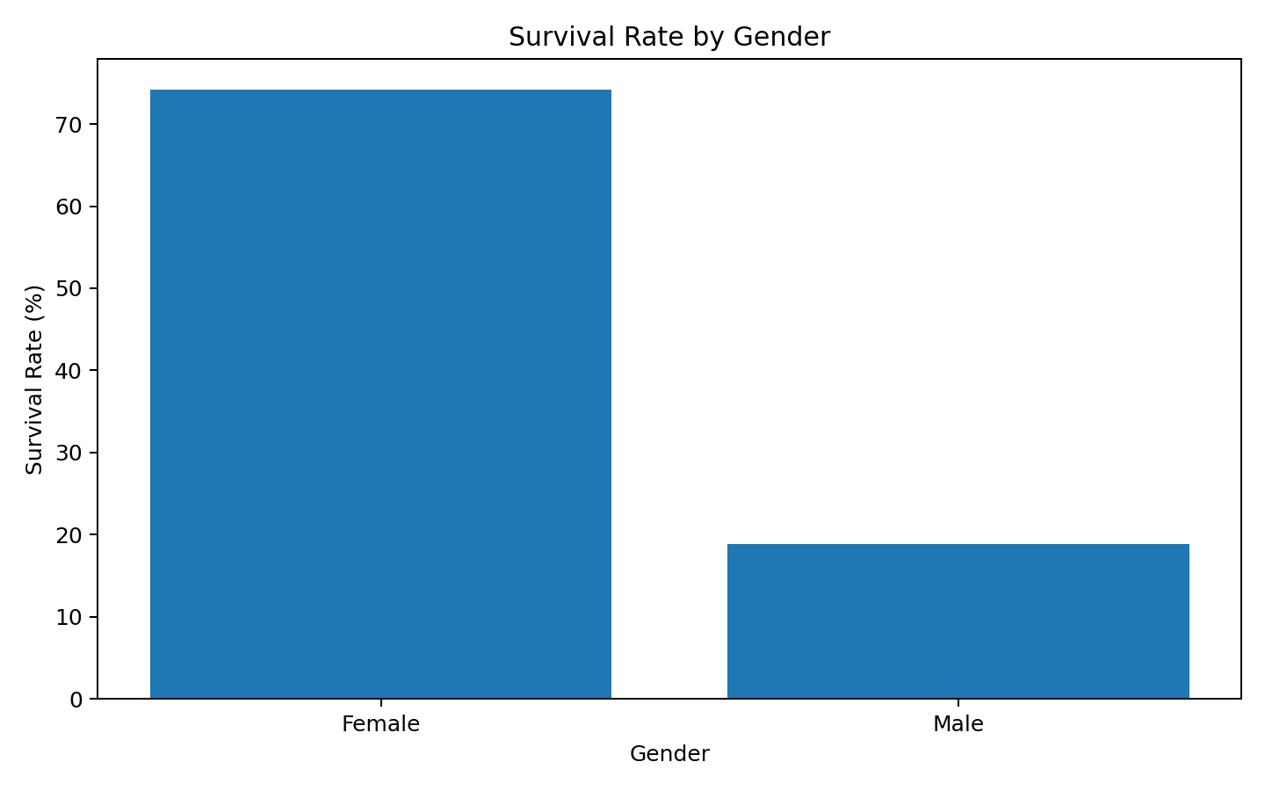
Figure 2. Survival percentage by recorded sex category.

9.3 Survival Rate by Passenger Class
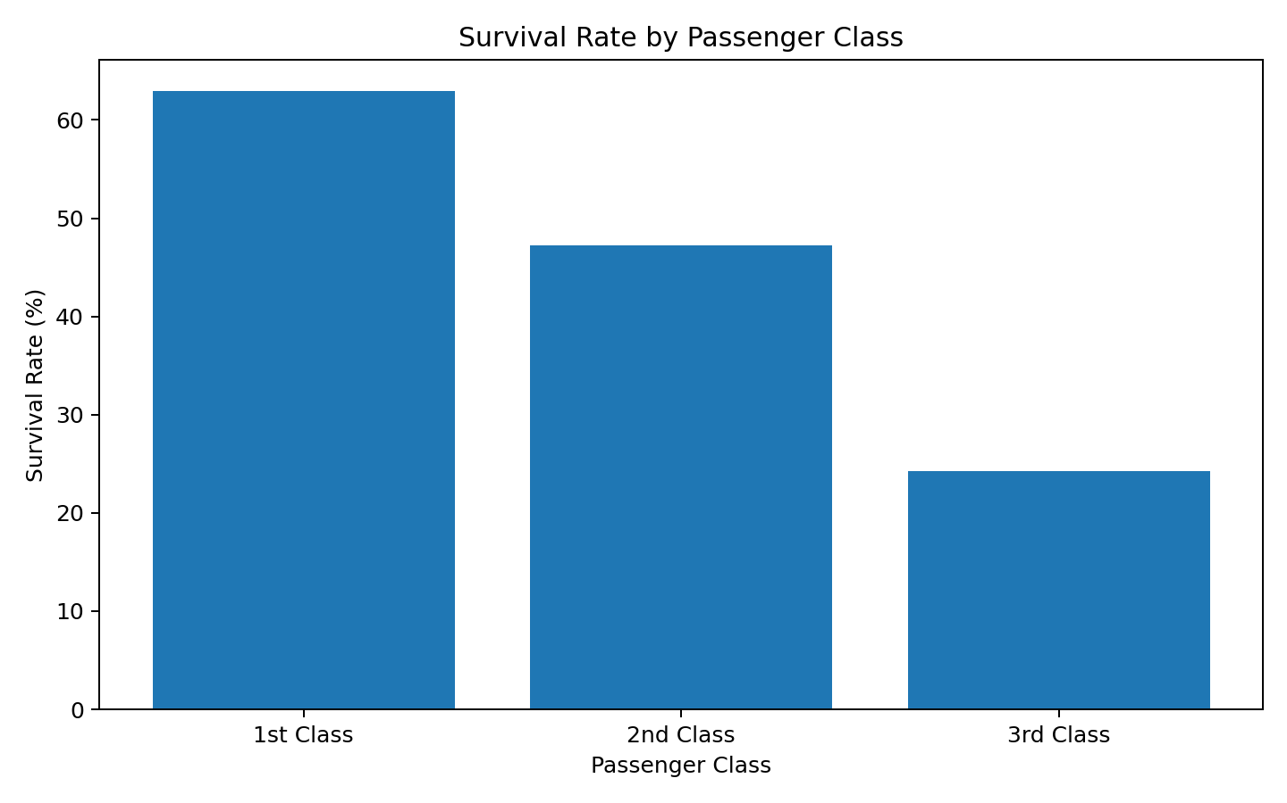
Figure 3. Survival percentage across passenger classes.

9.4 Correlation with Survival
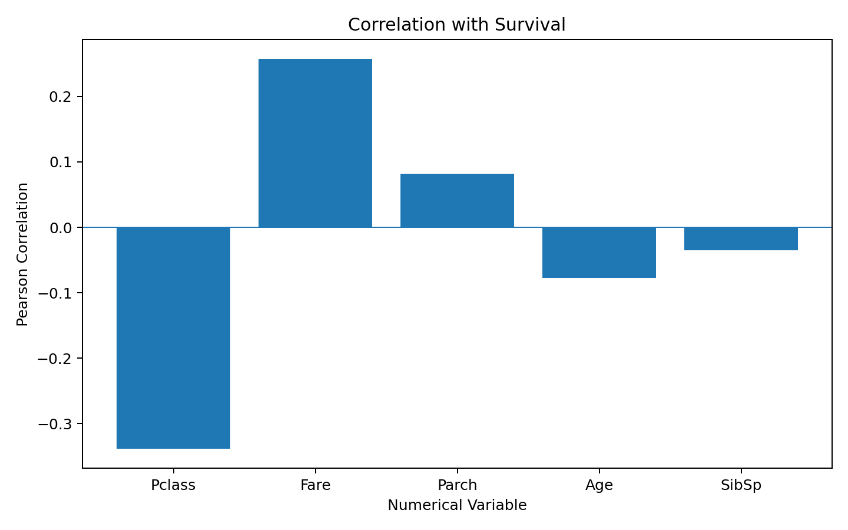
Figure 4. Pearson correlation of numerical variables with Survived.

10. Key Insights
The following insights were obtained from the exploratory analysis of the canonical 891-row Titanic dataset:
- The original dataset contains substantial missingness in Cabin (687 values), while Age has 177 missing values and Embarked has 2 missing values.
- The overall survival count is 342 survivors and 549 non-survivors, corresponding to an overall survival rate of approximately 38.38%.
- The recorded female passenger group had a survival rate of approximately 74.20%, while the recorded male passenger group had a survival rate of approximately 18.89%.
- Survival varied substantially by passenger class: approximately 62.96% for 1st class, 47.28% for 2nd class, and 24.24% for 3rd class.
- Among the numerical variables, Pclass has a moderate negative correlation with Survived (approximately -0.34), while Fare has a positive correlation (approximately 0.26). Correlation indicates association, not causation.
- The analysis demonstrates why missing-value handling and exploratory visualization are important before applying further statistical or machine-learning techniques.

11. Cleaning Decisions and Rationale
Issue | Action | Rationale
Age missing values | Median imputation | Numerical variable; median is less sensitive to extreme values.
Embarked missing values | Mode imputation | Categorical variable with only a small number of missing records.
Cabin missing values | Remove column | Very high missingness makes reliable imputation difficult.
Duplicate rows | Check and remove | Prevents repeated records from affecting analysis.
Data types | Inspect and validate | Ensures variables are suitable for analysis.

12. Challenges and Limitations
- The Cabin variable has substantial missing information, limiting its usefulness without additional external data.
- Correlation measures linear association and does not establish causation.
- The analysis is descriptive and does not attempt to establish causal explanations for survival outcomes.
- The results depend on the selected dataset and preprocessing choices.

13. Conclusion
This project provided practical experience with the core data preparation workflow used in data science. The Titanic dataset was acquired using Python, inspected using Pandas, cleaned using appropriate methods, and explored using summary statistics and visualizations. Missing values, duplicate records, and data-quality issues were addressed before analysis. The EDA highlighted clear differences in survival rates across gender and passenger class and showed relationships between survival and numerical variables. The project demonstrates that careful data cleaning and exploratory analysis are essential foundations for reliable downstream analytics and machine-learning work.

14. References
1. Titanic dataset: Data Science Dojo public datasets repository – https://raw.githubusercontent.com/datasciencedojo/datasets/master/titanic.csv
2. Pandas documentation – https://pandas.pydata.org/docs/
3. NumPy documentation – https://numpy.org/doc/
4. Matplotlib documentation – https://matplotlib.org/stable/
5. Seaborn documentation – https://seaborn.pydata.org/

End of Week 1 Report

