Pharmacy Management System

  - Database class project, academic year 2025 /2026

Student Name in English | Student Name in Arabic | Student ID | Section time as shown in zajel | Work percentage
Anas Alshame | أنس الشامي | 12323975 | Sunday / Tuesday  9:30-11 | 33%
Amr Fadda | عمرو فضة | 12323605 | Sunday / Tuesday  9:30-11 | 33%
Kareem Hadi | كريم حمد | 12324485 | Sunday / Tuesday  9:30-11 | 34%

  - Date/time

---------------------------------------------This section is intended for the Instructor---------------------------------------
Topic | Mark
Project Requirements and Modeling
Correctness of Database mapping
Functional Dependency and Normalization
Project Tools
Project Discussion
Project Completeness
Project Output Results or reporting (JasperReport, charts, graphs, etc.)
Project Administration and Management
Project Report
Project Idea
Project Complexity
Team work
Abstract :
This project presents a Pharmacy Management System implemented using Java, organized into a structured architecture that separates the database layer from the user interface layer. The system’s backend, shown in the com.pharmacy.db package, contains classes responsible for database connectivity and operations on core entities such as medicines, suppliers, customers, invoices, categories, and users. Each class handles specific CRUD functionalities through a dedicated DB handler, supported by a centralized database connection class. This organization ensures clean data management, reduces redundancy, and allows efficient interaction with stored information.
The com.pharmacy.ui package represents the graphical interface of the application, containing interactive components such as dashboards for managers, pharmacists, and cashiers, as well as editors for medicines, suppliers, customers, and categories. Additional interface elements such as login forms, registration screens, sales pages, and invoice viewers provide a complete workflow for daily pharmacy operations. By combining structured database modules with intuitive UI components, the system supports tasks such as inventory management, sales processing, user authentication, and supplier tracking. Overall, the project demonstrates the integration of Java GUI design with database management to create a functional, organized, and user-friendly pharmacy management solution.
Table Of Contents :
- introduction
- Project requirement
- All the Functional Dependency of your project
- Project EER or UML
- Check that all your tables are in BCNF , and you must show the normalization process.
- Tools used in the project
- discussion about your project GUI work
- conclusion
- references

Introduction :
This project presents a Pharmacy Management System designed using Java and structured into two main components: a database layer and a graphical user interface (GUI) layer. The system aims to organize, automate, and simplify the daily operations of a pharmacy by managing medicines, suppliers, customers, invoices, categories, and users in an efficient and structured manner. The two package folders shown in the project—com.pharmacy.db and com.pharmacy.ui—form the basis of the system’s architecture and highlight the separation between data handling and user interaction.
The database layer (com.pharmacy.db) is responsible for all data-related operations. It contains classes that interact directly with the database, such as MedicinesDB, SuppliersDB, CustomersDB, InvoicesDB, CategoriesDB, and UsersDB. Each of these classes handles CRUD operations for its corresponding entity, ensuring that data is inserted, updated, retrieved, and deleted correctly. The presence of a central DBConnection class guarantees secure and consistent connectivity with the database, while the SharedInformation class provides a convenient way to share common data across the application. This design keeps the database logic organized, reduces redundancy, and helps maintain data integrity.
The user interface layer (com.pharmacy.ui) forms the visual and interactive portion of the system. It includes dashboards for managers, pharmacists, and cashiers, each providing a set of tools appropriate to their role. The package also contains editor windows such as MedicinesEditor, CategoriesEditor, SuppliersEditor, and CustomersEditor, which allow users to manage the pharmacy’s data through intuitive forms and tables. Interfaces like LoginFrame and RegisterFrame handle authentication, while SalesPage, PurchasePrompt, and InvoicesEditor support the sales workflow and invoice management. Additional helper interfaces, such as GradientPanel, ProductTemplate, and ViewAllWindow, enhance the system’s usability and visual consistency.
By combining structured database classes with well-organized GUI components, the Pharmacy Management System provides a complete solution for managing pharmacy operations. The architecture not only improves workflow efficiency but also demonstrates how Java, JDBC, and GUI development principles can be integrated to build a functional, scalable, and user-friendly software application.

Project Requirements :

1. System Users
The system includes three types of users:
- Manager
- Pharmacist
- Cashier

General User Information
Each user has:
- Full name
- Username
- Password
- Phone number
- Email
- Role (Manager / Pharmacist / Cashier)

2. Managers
- A manager has full system access and control.
- Manager data includes: name, phone number, email, and salary.
- The manager can manage:
  - Users
  - Medicines
  - Categories
  - Customers
  - Suppliers
  - Invoices
  - General system reports

3. Pharmacists
- A pharmacist is responsible for medicine-related operations.
- A pharmacist has the ability to:
  - Add new medicines
  - Edit medicine information
  - Update stock quantities
  - View medicines by category
  - Handle sales invoices together with cashiers

4. Cashiers
- The cashier is responsible for selling operations.
- A cashier can:
  - Create new invoices
  - Add medicines to an invoice
  - Search for medicines
  - Add new customers during the sale
  - Print invoices for customers

5. Customers
Each customer has:
- Name
- Phone number
- Address
- Email (optional)
Functions:
- Customers are linked to invoices.
- Their purchase history can be viewed inside the system.

6. Medicines
Each medicine contains:
- Medicine ID
- Name
- Category
- Production date
- Expiration date
- Manufacturer company
- Price
- Quantity in stock
- Description
Relationships:
- Each medicine belongs to a category.
- Each sale reduces the stock quantity.

7. Categories
Each category includes:
- Category ID
- Category name
- Description
Purpose:
- Categories are used to classify and organize medicines in the system.

8. Suppliers
Each supplier has:
- Supplier name
- Phone number
- Email
- Address
- Company name
Relationships:
- Each supplier provides medicines to the pharmacy.

9. Invoices
Each invoice contains:
- Invoice ID
- Date
- Time
- Customer name
- Employee responsible for the invoice
- Total amount
- List of medicines sold (medicine + quantity + price)
Relationships:
- An invoice is linked to one customer.
- An invoice is created by one employee.
- Each invoice contains multiple medicines.

10. Purchases (Buying Medicines From Suppliers)
Through PurchasePrompt.java, the system supports:
- Adding new stock quantities
- Recording purchases from suppliers
- Updating medicine inventory
- Generating purchase reports

11. Dashboards

Manager Dashboard
- View system statistics
- Manage users
- Manage medicines
- Manage categories
- Manage suppliers
- View overall sales

Pharmacist Dashboard
- Manage medicines
- Edit stock
- Search and view medicine details

Cashier Dashboard
- Fast selling interface
- Create invoices
- Search medicines
- Register payments

12. Database Layer (com.pharmacy.db)
This package includes:
- UsersDB
- MedicinesDB
- SuppliersDB
- CategoriesDB
- CustomersDB
- InvoicesDB
- DBConnection
Each database class is responsible for:
- CRUD operations
- Executing SQL queries
- Returning data to UI components

13. SharedInformation
A special class used to store:
- Logged-in user information
- Session data
- User permissions

14. Additional System Features
- Global search functionality
- Secure login system (LoginFrame)
- Role-based access control
- Invoice printing
- “View All” pages for all data entries

Functional Dependencies :

Users
UserID → Full Name
UserID → Phone
UserID → Email
UserID → Username
UserID → Password
UserID → Role
(Manager / Cashier / Pharmacist)

Managers
ManagerID → Name (first, last)
ManagerID → Phone
ManagerID → Email
ManagerID → Salary
ManagerID → Employment Date

Pharmacists
PharmacistID → Name
PharmacistID → Phone
PharmacistID → Email
PharmacistID → Salary

Cashiers
CashierID → Name
CashierID → Phone
CashierID → Email
CashierID → Salary

Customers
CustomerID → Name
CustomerID → Phone
CustomerID → Email
CustomerID → Address

Medicines
MedicineID → Name
MedicineID → CategoryID
MedicineID → Production Date
MedicineID → Expiration Date
MedicineID → Manufacturer
MedicineID → Price
MedicineID → Quantity
MedicineID → Description

Categories
CategoryID → Category Name
CategoryID → Category Description

Suppliers
SupplierID → Name
SupplierID → Phone
SupplierID → Email
SupplierID → Address
SupplierID → Company

Invoices
InvoiceID → Invoice Date
InvoiceID → Invoice Time
InvoiceID → CustomerID
InvoiceID → EmployeeID
InvoiceID → Total Amount

Invoice Items (Medicine inside invoice)
(InvoiceID, MedicineID) → Quantity
(InvoiceID, MedicineID) → Unit Price

Purchases (Buying From Suppliers)
PurchaseID → SupplierID
PurchaseID → MedicineID
PurchaseID → Quantity Added
PurchaseID → Purchase Date

Stock Updates
StockUpdateID → MedicineID
StockUpdateID → Quantity Before
StockUpdateID → Quantity After
StockUpdateID → Update Date

Login Session
SessionID → CurrentUserID
SessionID → UserRole

UML :
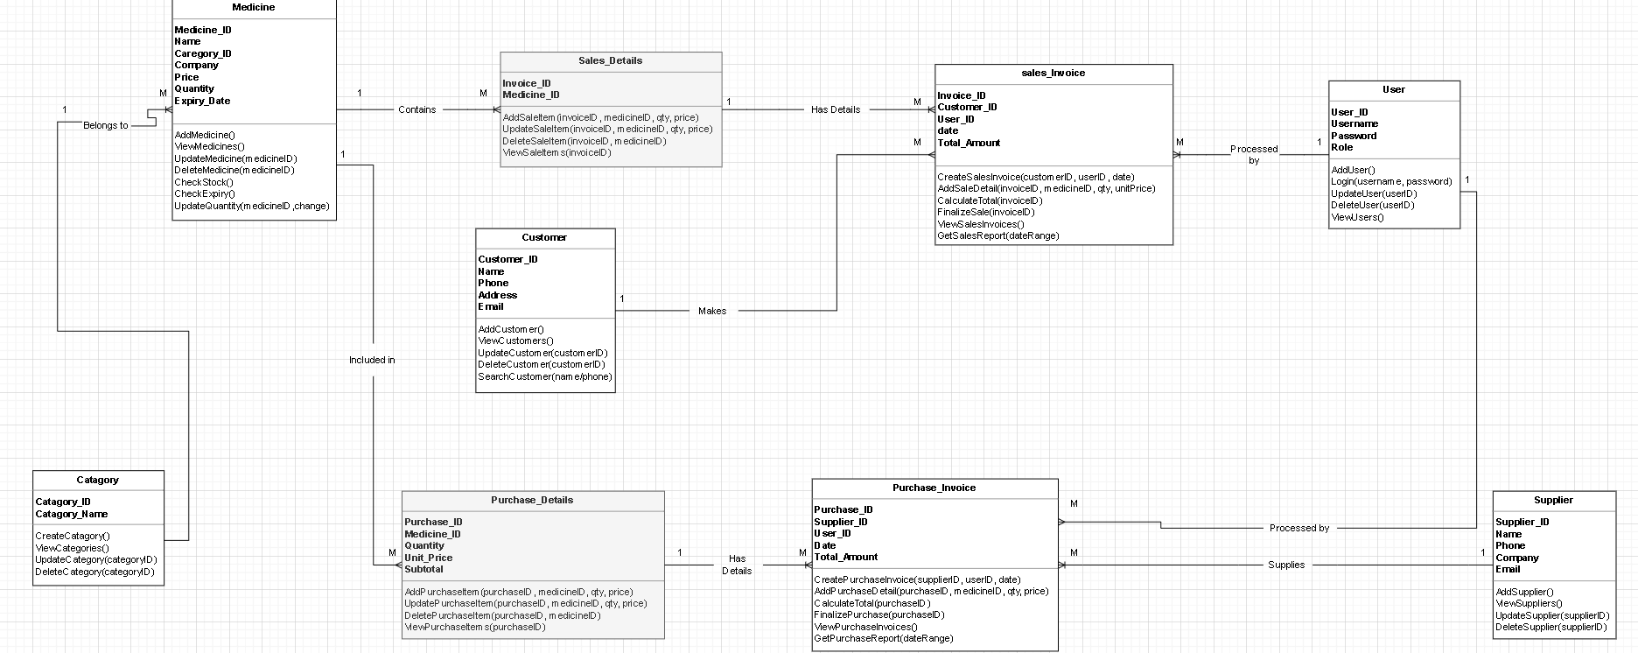

Normalization :

1NF:
- Invoice has multivalued medicines → split into InvoiceItems(InvoiceID, MedicineID, Quantity, UnitPrice)
- Purchase has multivalued medicines → split into PurchaseItems(PurchaseID, MedicineID, Quantity, Price)
- All other tables contain only atomic attributes.

2NF:
- Only tables with composite keys: InvoiceItems and PurchaseItems
- No partial dependencies exist.

3NF:
- No transitive dependencies in any table.

BCNF:
- Every determinant in the database is a candidate key.

Tools used :
1- Netbeans
2-PostgressSql(Pg4Admin for build database)

3-JasperSoft Studio (verison 6.20.6) to build the reports

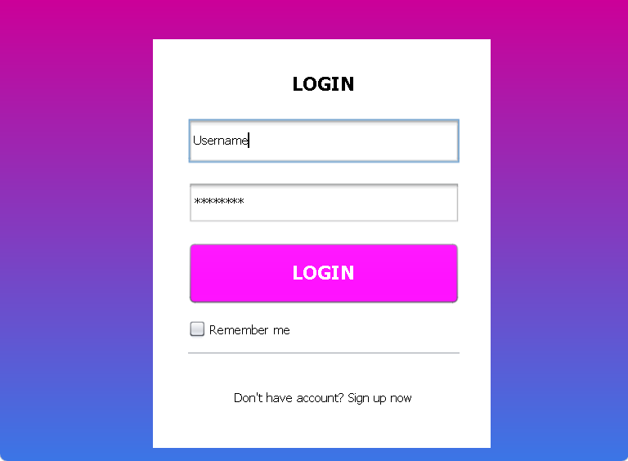

This interface represents a simple and modern login screen designed for user authentication. It features a clean white login card centered on a colorful gradient background, which helps draw the user’s attention. At the top, a clear “LOGIN” title indicates the purpose of the page. Below it, there are input fields for username and password, with the password masked for security. A prominent Login button is placed beneath the fields, styled with a bright color to make it easily noticeable. The interface also includes a “Remember me” checkbox to allow users to stay signed in, and a sign-up link at the bottom for new users who do not yet have an account. Overall, the design is simple, user-friendly, and focused on usability and clarity.

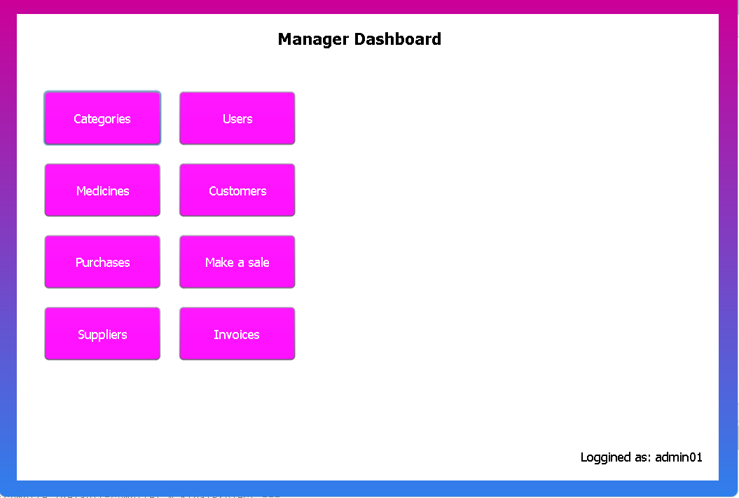

This interface represents a Manager Dashboard designed to give administrators quick and organized access to the main system functions. The dashboard has a clean layout with clearly labeled buttons arranged in a grid, making navigation simple and efficient. Each button opens a separate interface (screen) dedicated to a specific task. The Categories button opens the category management interface, Users allows managing system users and their roles, Medicines opens the medicine inventory interface, and Customers provides access to customer information. The Purchases button leads to the purchase management screen, Make a Sale opens the sales interface, Suppliers allows managing supplier data, and Invoices opens the invoice viewing and management interface. At the bottom, the system displays the currently logged-in user, which helps with accountability and security. Overall, this dashboard improves workflow by centralizing all management operations in one place and providing quick access to each functional module.

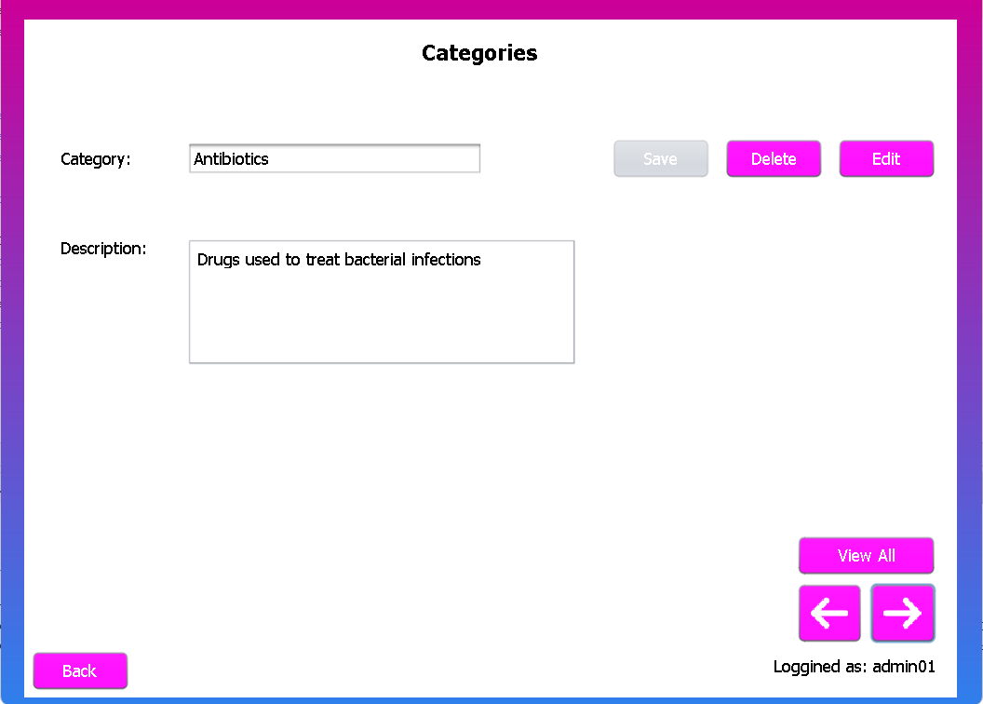

This interface represents the Categories Management screen, which is used to manage product or medicine categories within the system. It allows the manager to add, view, update, and delete categories in an organized way. The interface includes an input field for the category name and a larger text area for the category description, enabling clear documentation of each category’s purpose. Action buttons such as Save, Edit, and Delete are provided to manage category records efficiently. The View All button opens a separate interface that displays all available categories in a list or table. The arrow buttons are used to navigate between categories, allowing the user to move to the previous or next category easily. A Back button is included to return to the main dashboard, and the logged-in username is displayed at the bottom to ensure clarity and accountability.
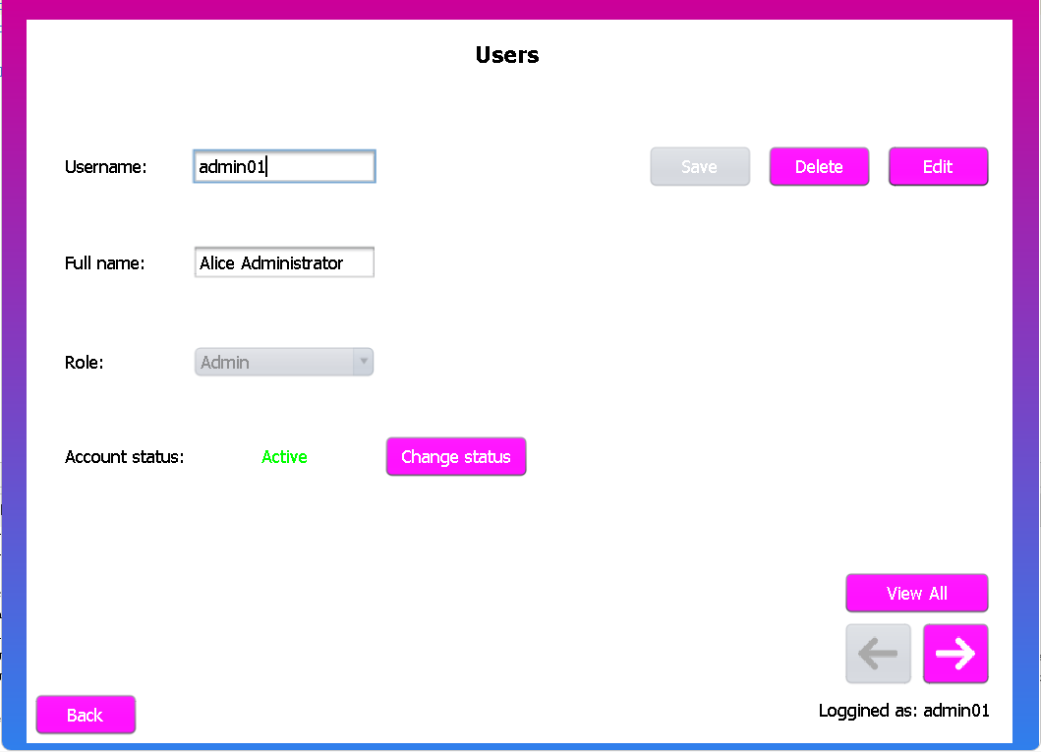

The Users Page is designed to manage system users and their roles. It includes fields for username, full name, role, and account status. Administrators can add new users using Save, modify user details with Edit, or remove users using Delete. The Change status button controls whether a user account is active or inactive, and the View All option displays all users. This page ensures secure and organized user management.

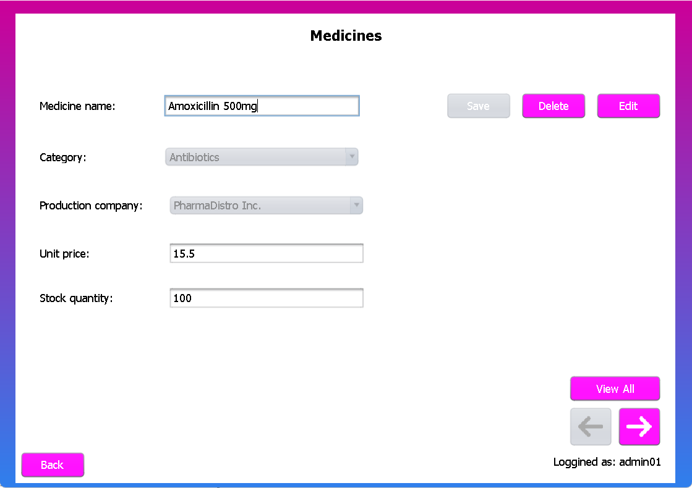

The Medicines Page is responsible for managing medicines available in the pharmacy. It includes fields for the medicine name, category, production company, unit price, and stock quantity. Users can add new medicines using the Save button, update information with Edit, or remove medicines using Delete. The View All option displays all medicines, while navigation buttons allow browsing through records. This page helps ensure accurate medicine inventory management.

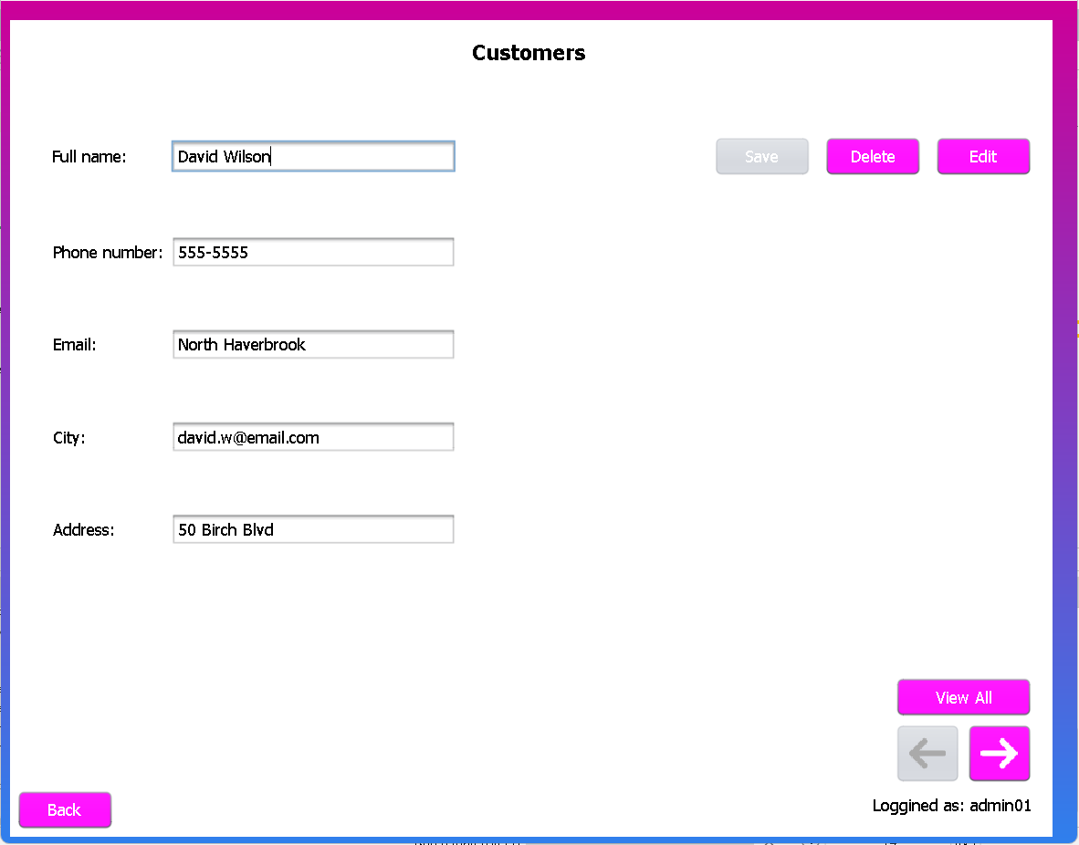

The Customers Page is used to manage customer information within the system. It allows the user to enter and view customer details such as full name, phone number, email, city, and address. The Save button is used to add new customers, while the Edit button allows updating existing records and the Delete button removes customers from the database. Navigation buttons enable moving between records, and the View All option displays all customers in a list. The page is designed to be simple and efficient for managing customer data.

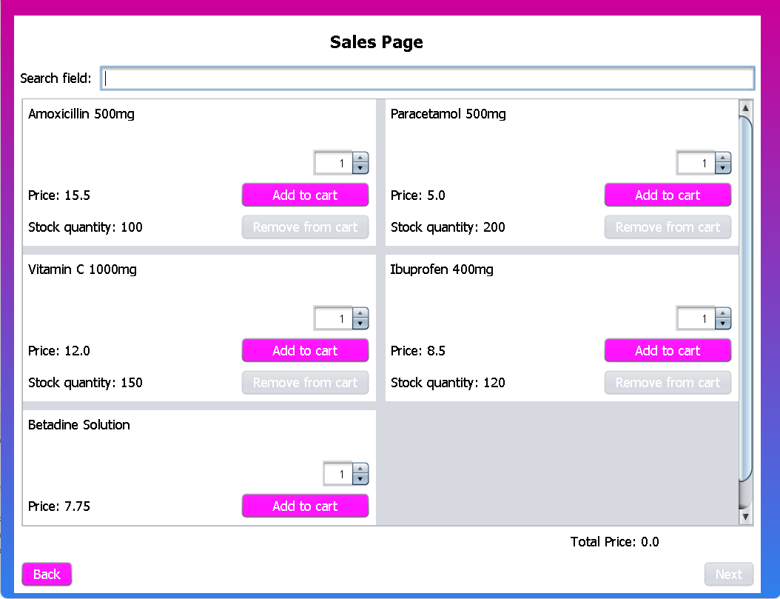

The Sales Page is used to process medicine sales and manage the shopping cart. It provides a search field to find medicines quickly and displays available medicines with their prices and stock quantities. Users can select quantities and add items to the cart or remove them if needed. The total price is calculated automatically, and the Next button proceeds to invoice creation, while the Back button returns to the previous page. This page is optimized for fast and accurate sales operations.

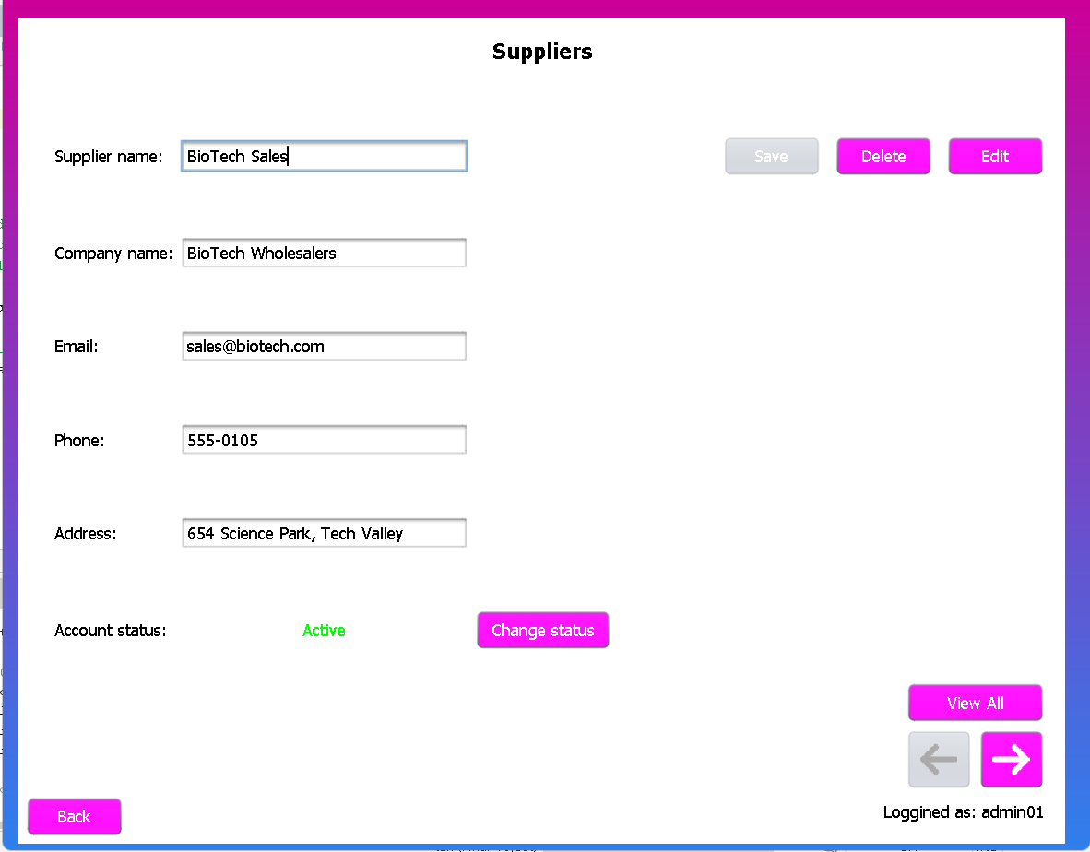

The Suppliers Page is used to manage supplier information and monitor their status. It contains details such as supplier name, company name, email, phone number, and address. The Save button stores supplier data, Edit updates existing information, and Delete removes suppliers from the system. The Change status button allows activating or deactivating supplier accounts, while View All and navigation buttons help browse records. This page supports effective supplier management.

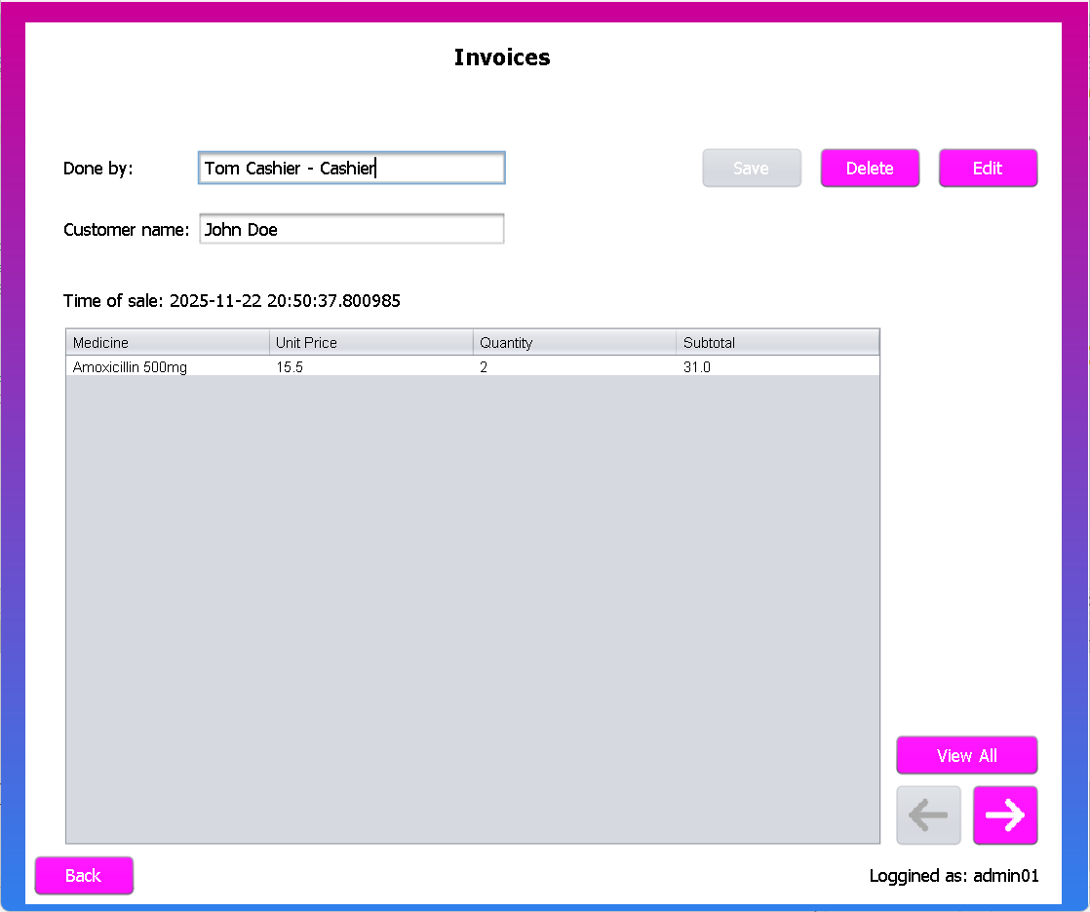

The Invoices Page displays detailed information about completed sales. It shows the employee who processed the sale, the customer name, and the time of the transaction. A table lists the medicines sold along with their unit prices, quantities, and subtotals. Users can save, edit, or delete invoices, navigate between them, or view all invoices at once. This page ensures clear documentation and tracking of sales transactions.

Conclusion :
The Pharmacy Management System successfully integrates user management, medicine inventory control, supplier handling, customer tracking, and invoice processing into one coherent database-driven application. The system structure is divided into UI components and database access layers, allowing clear separation of responsibilities and easier maintenance. Each main entity—Users, Medicines, Categories, Customers, Suppliers, Invoices, and Purchases—was analyzed to identify accurate functional dependencies, ensuring that every attribute is fully and correctly determined by its key.
Through the normalization process, all tables were checked and confirmed to satisfy 1NF, 2NF, 3NF, and BCNF. Multi-valued attributes were decomposed into separate relationship tables, and no partial or transitive dependencies remain. As a result, the database eliminates redundancy, prevents update anomalies, and maintains referential integrity across all operations.
Overall, the project provides a complete, efficient, and well-structured system that supports the essential workflows of a pharmacy, ensures data consistency, and follows proper database design principles.
References :
1-Our Course Slides and projects
2-PostgressSql
Documntation(https://www.postgresql.org/docs/?fbclid=IwY2xjawE2l75leHRuA2FlbQIxMA
ABHe3Y1TdtmlVClPft_gxiXhp97kbRynhcXP25es1f6o6CJBHFMM1Np0TEkQ_aem_nE5xoCJfU
NKjasfyVNjhjA)

