ABSTRACT
This technical documentation for the software product “Square Root Calculator” is intended to provide an overview of the program’s functionality, input and output data requirements, operating algorithm, testing procedure, instructions, source code, program structure, and technical requirements.
The calculator is designed to speed up and simplify the extraction of complex, analytical, and arithmetic square roots with a specified precision. It was created for non-commercial purposes. The product is cross-platform and multilingual.

Table of Contents
ABSTRACT 1
Table of Contents 2
How to start using the calculator? 3
System and browser requirements 3
Launching the software product 3
Configuration 3
User Manual 4
List of functions for interaction: 4
Functionality 5
Software product functions: 5
Technical aspects of the product 6
Programming languages and technologies used: 6
Software product flowchart 6
Testing 8
Software product source files 8

How to start using the calculator?

System and browser requirements
The software product can be run on OS Windows, Linux, macOS, Android, IOS, using the browsers Google Chrome, Yandex, Microsoft Edge, Opera, Mozilla Firefox. An internet connection is required.

Launching the software product
To use the software product, go to the link: https://hse-calculator-cyan.vercel.app
in any of the browsers listed above.

Configuration
No configuration of the software product is required. The project code is available for anyone to view in the documentation.

User Manual

List of functions for interaction:
- Go to the home page
- Go to the calculator page
- Input field
- Field for entering calculation precision
- Result output button
- Root output field
- Field for displaying the root in analytical form
- Download technical documentation
- Go to VKontakte technical support
- Go to technical support on Telegram
- Switch language
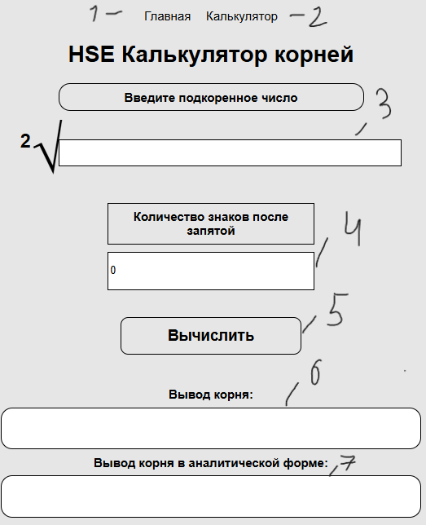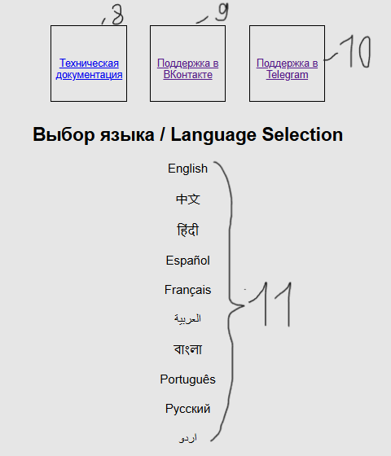

Functionality

Software product functions:
- The user can enter the radicand expression manually
- Languages can be switched
- A custom language can be added
- Calculation precision can be set
- Error handling
- Calculates arithmetic, complex, and analytical square roots

Technical aspects of the product

Programming languages and technologies used:
- HTML
- CSS
- JavaScript
- Vercel
- GitHab

Software product flowchart
Start
Launch the website
Home page display:
Navigation display
Project information display
Authors display
User instructions
Documentation
Support: VK, Telegram
Language selection
Home page
Calculator page
Go to the calculator page
User input of number and precision
Continuation 1
Continuation 2
Loading the home page

Continuation 1
Checking input validity
Displaying an error message
Is the expression valid?
Displaying an error message
Displaying the result
End
Continuation 2
No
Yes
Expression check:
- Parentheses
- Invalid characters
- Empty parentheses
- Operators
- Division by zero
Calculation
Complex numbers
Arithmetic expression
Square root extraction
Square root extraction
No
Yes

Testing
The test results were satisfactory. The test table can be viewed at the link: https://github.com/nk6357/HSE_Root_Calculator

Software product source files
The software product source files can be viewed at the link: https://github.com/nk6357/HSE_Root_Calculator

