Question1

Ans

pip install awsebcli --upgrade –user

eb init
eb create
eb open

Deployed website link -- http://nikhibootstrap-work-dev.us-east-1.elasticbeanstalk.com/

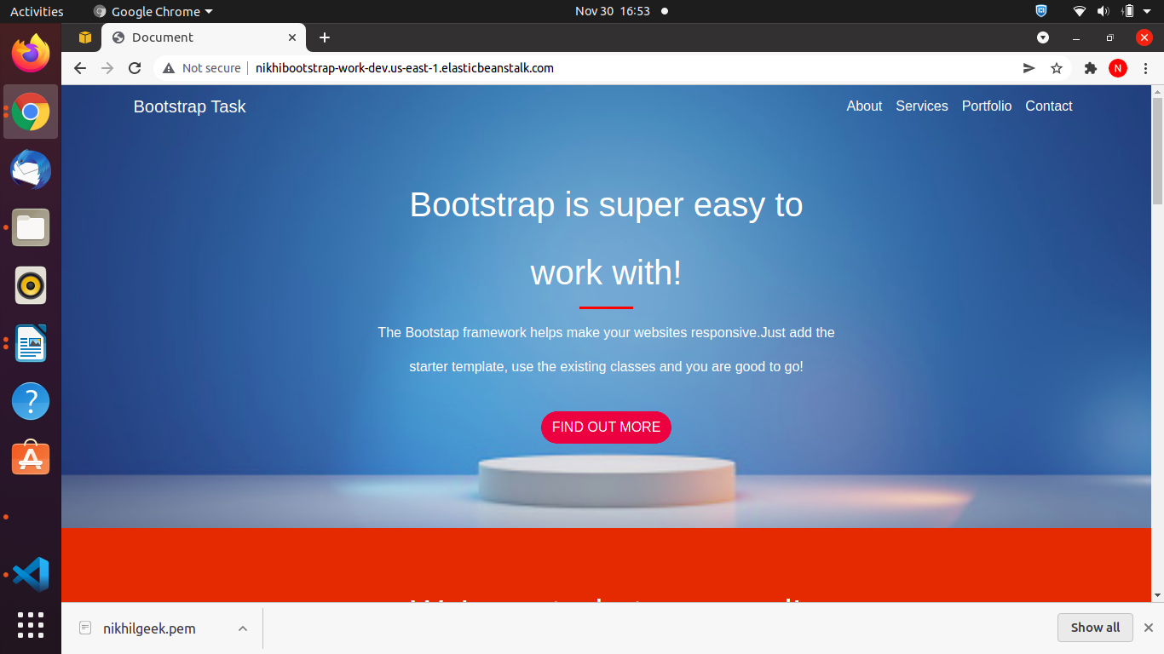

Question 2

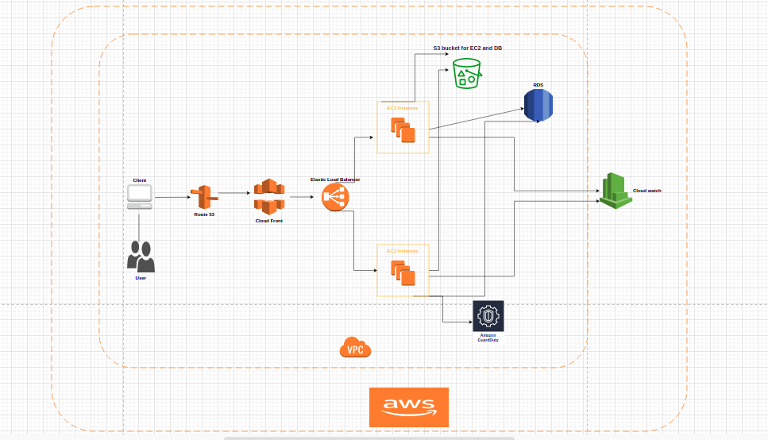

Route 53 - It is intended for managing DNS for services and machines deployed on Amazon’s public cloud. The AWS Route 53 DNS service connects user requests to ELB load balancers, Amazon EC2 instances, Amazon S3 buckets, and other infrastructure running on AWS.

Amazon CloudFront - It is a content delivery network (CDN) operated by Amazon Web Services. Content delivery networks provide a globally-distributed network of proxy servers that cache content, such as web videos or other bulky media, more locally to consumers, thus improving access speed for downloading the content.

Elastic load balancer - Elastic Load Balancing automatically distributes your incoming traffic across multiple targets, such as EC2 instances, containers, and IP addresses, in one or more Availability Zones. ... Elastic Load Balancing scales your load balancer as your incoming traffic changes over time.

EC2 Instance - An EC2 instance is nothing but a virtual server in Amazon Web services terminology. It stands for Elastic Compute Cloud. It is a web service where an AWS subscriber can request and provision a compute server in AWS cloud.

S3 bucket - S3 stands for simple storage service, and it is AWS’s cloud storage service. S3 provides the ability to store, retrieve, access, and back up any amount of data at any time and place.
As S3 is object-based storage, this means that all data is stored as objects.

Amazon GuardDuty - Amazon GuardDuty is a service that detects the threats by continuously analyzing and monitoring the unusual and unexpected behavior to protect your AWS account, workloads, and your data which is stored in amazon s3.

RDS - Amazon GuardDuty is a service that detects the threats by continuously analyzing and monitoring the unusual and unexpected behavior to protect your AWS account, workloads, and your data which is stored in amazon s3.

Cloudwatch - Amazon CloudWatch is a monitoring and management service that provides data and actionable insights for AWS, hybrid, and on-premises applications and infrastructure resources. With CloudWatch, you can collect and access all your performance and operational data in form of logs and metrics from a single platform.

VPC - A virtual private cloud (VPC) is the logical division of a service provider's public cloud multi-tenant architecture to support private cloud computing. ... With a VPC, a public cloud provider acts as the service provider and the cloud's subscribers are the tenants.

