Question 1

Ans:

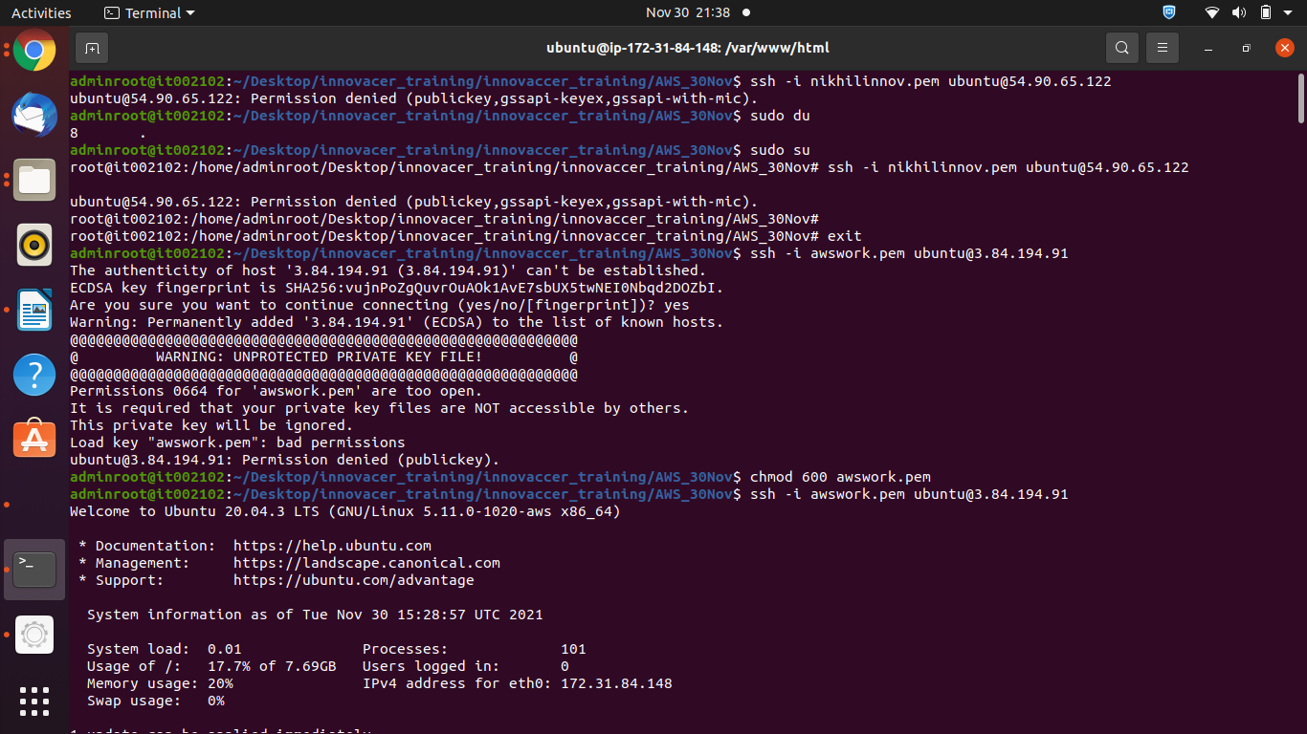

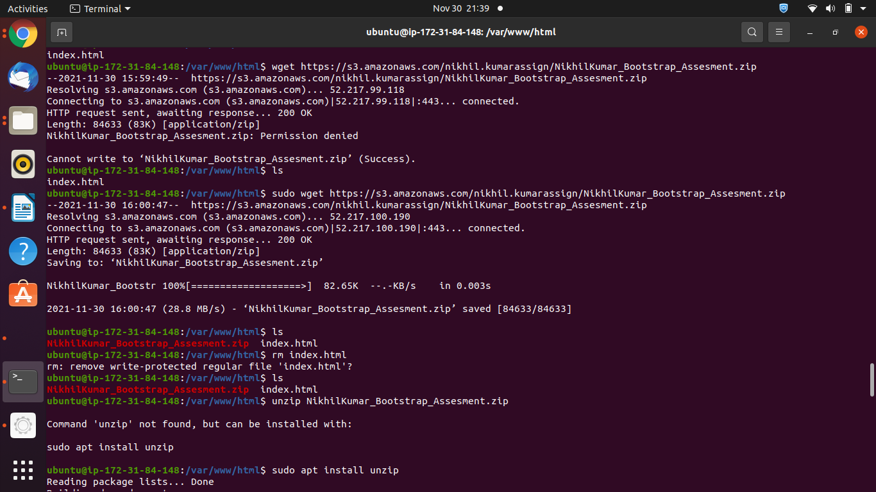

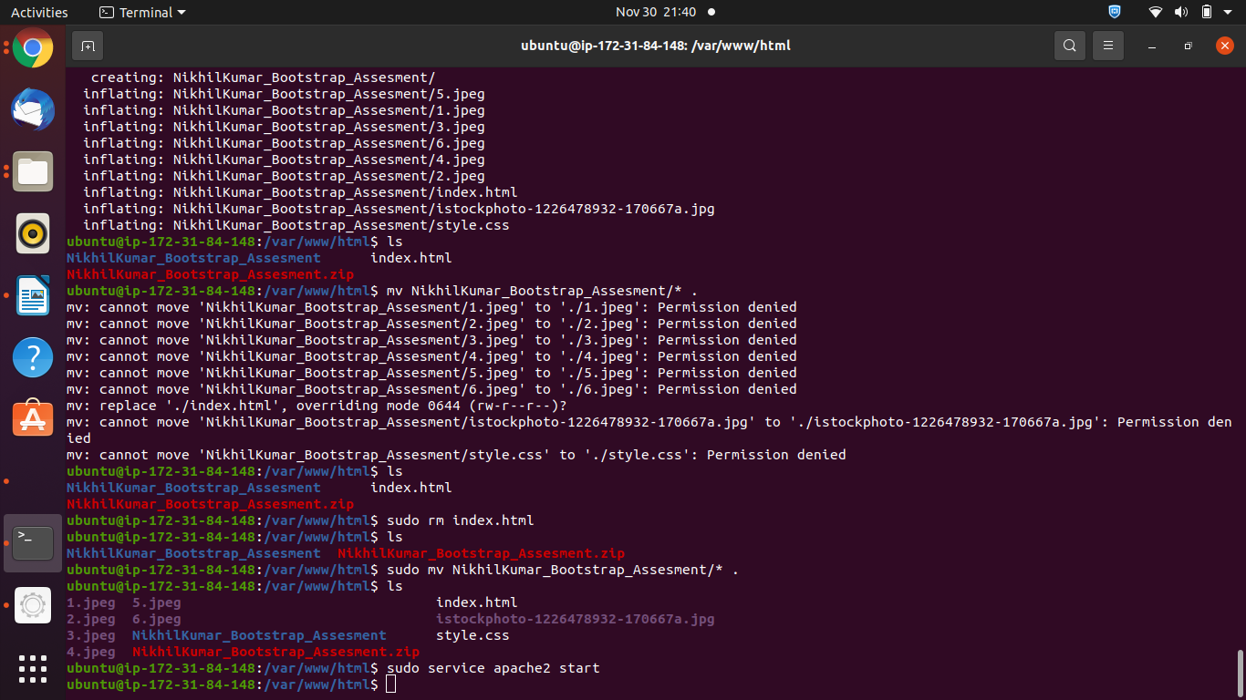

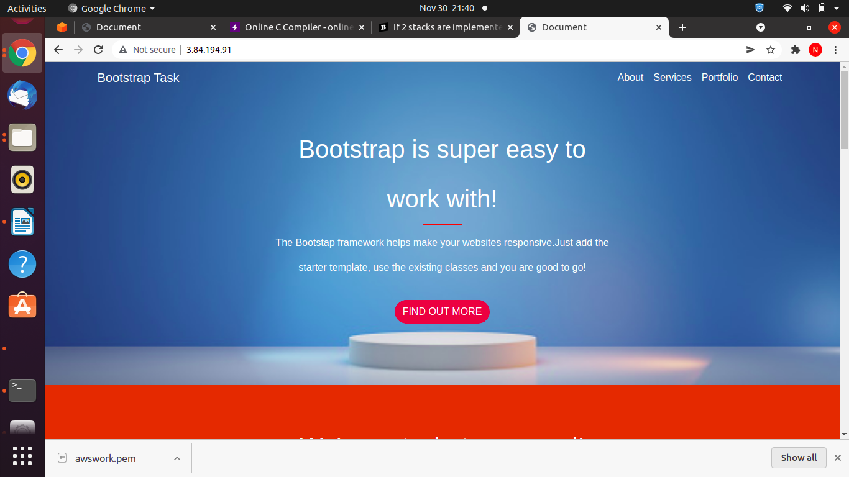

Question2

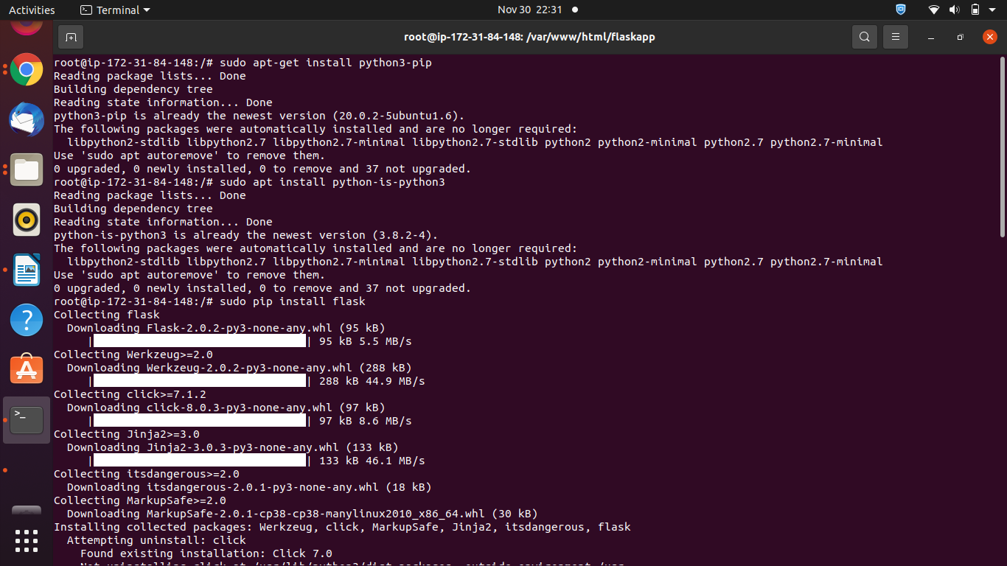

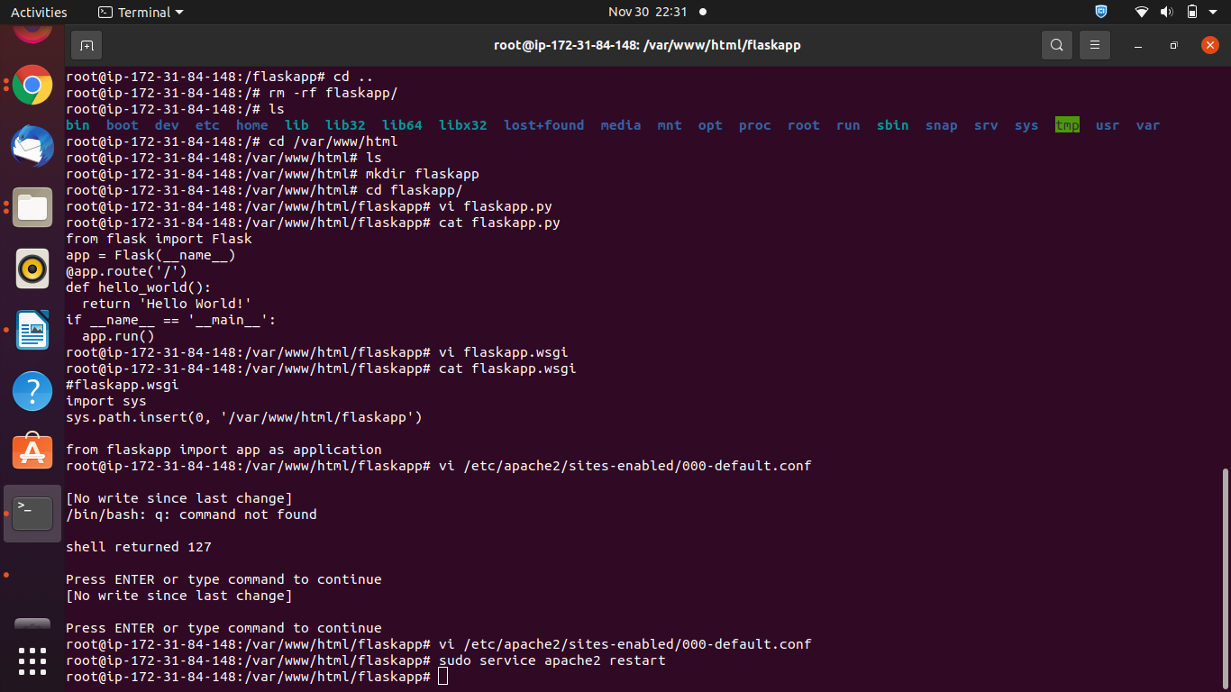

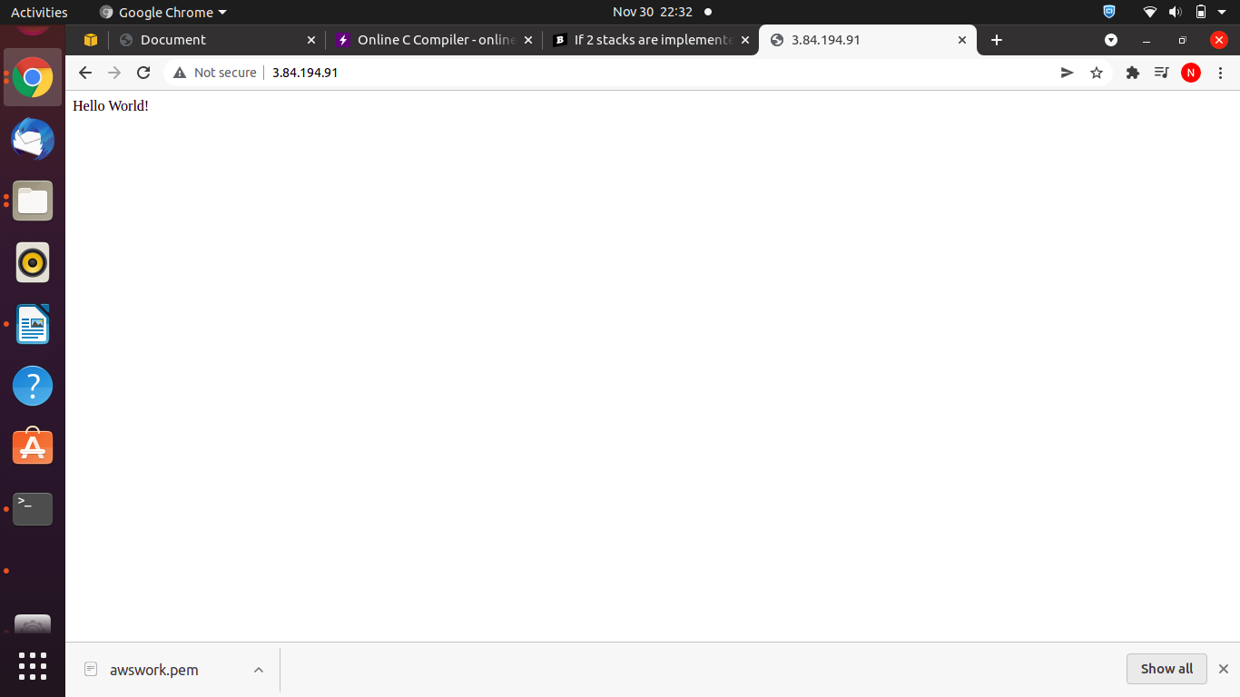

Question3

Ans Created using EC2 instance

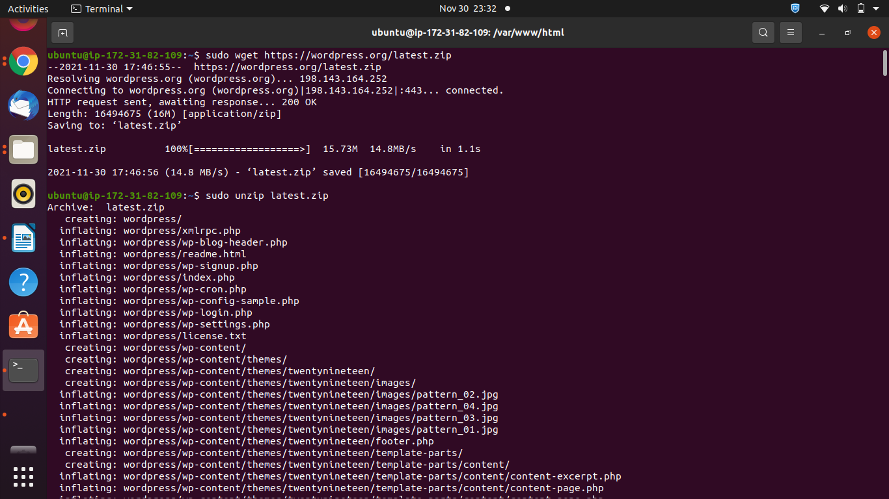

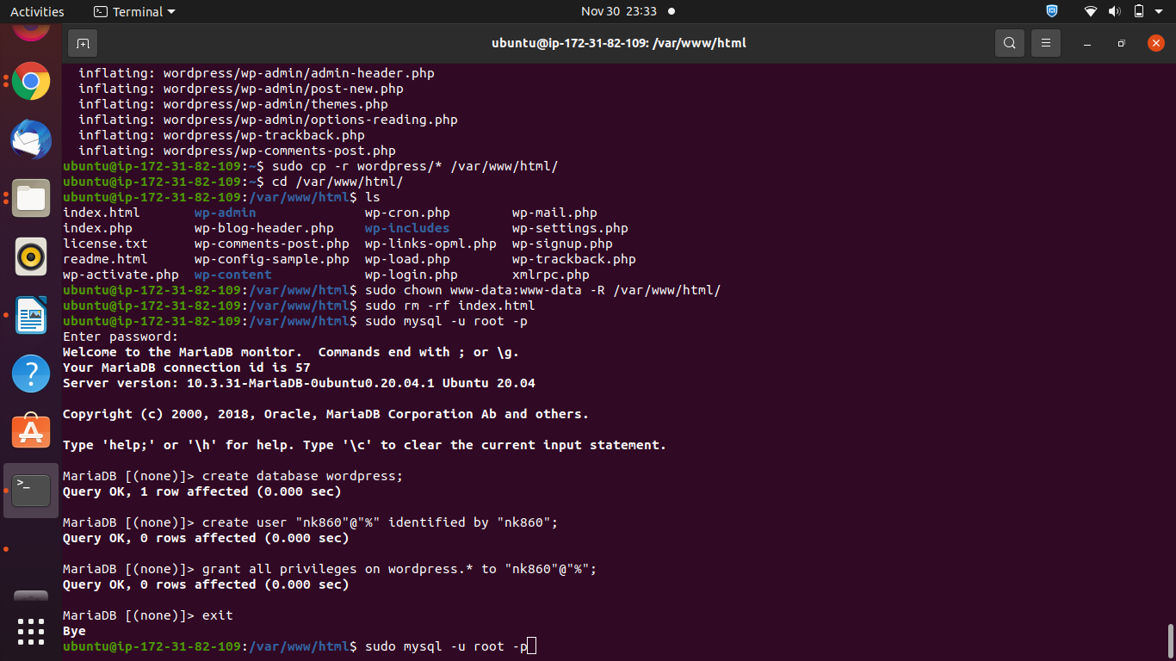

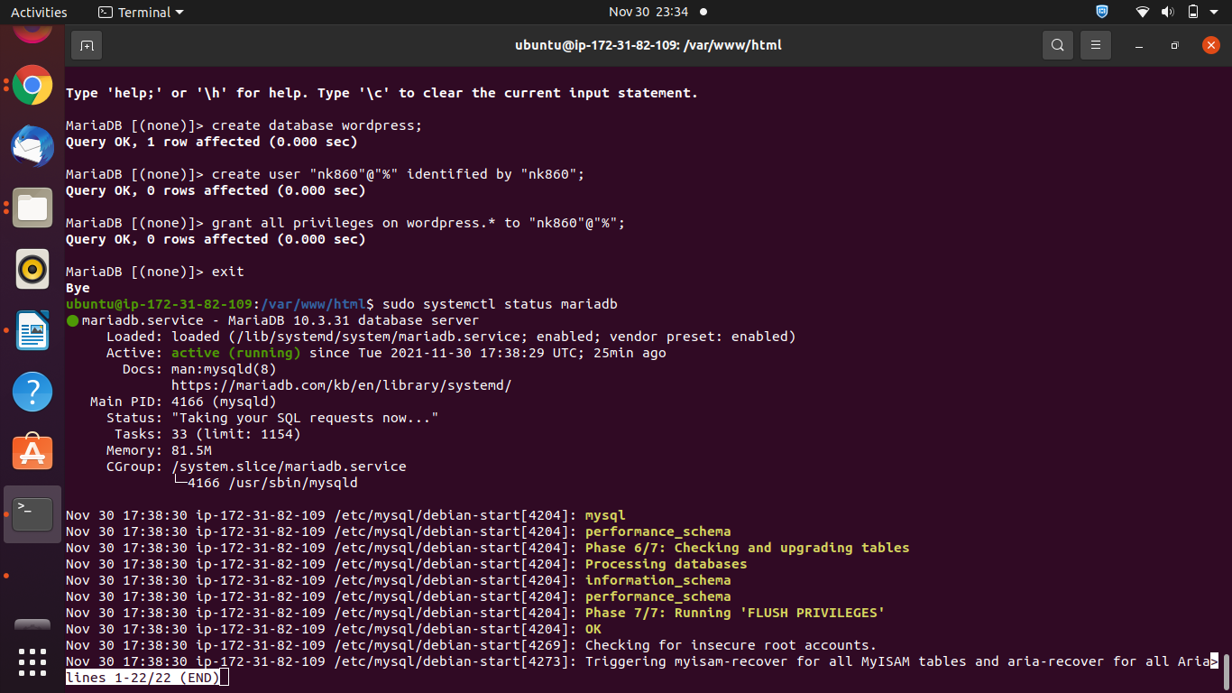

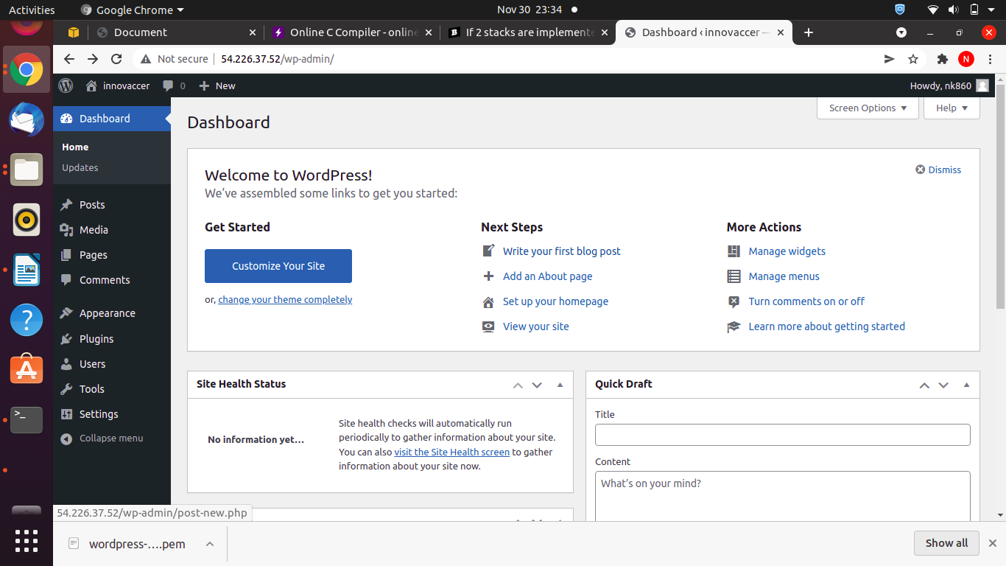

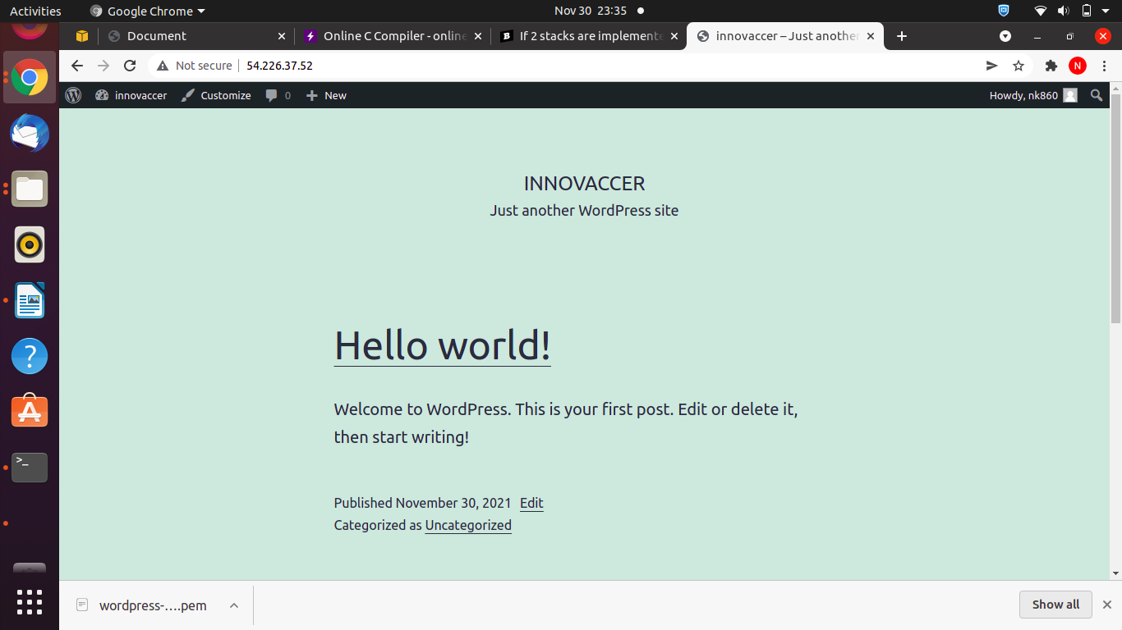
s

Created using Lightsail

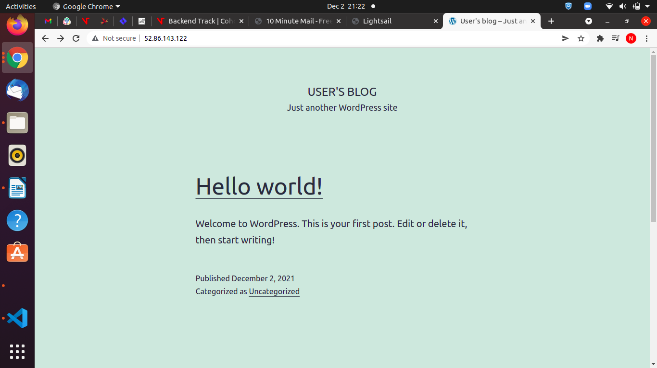

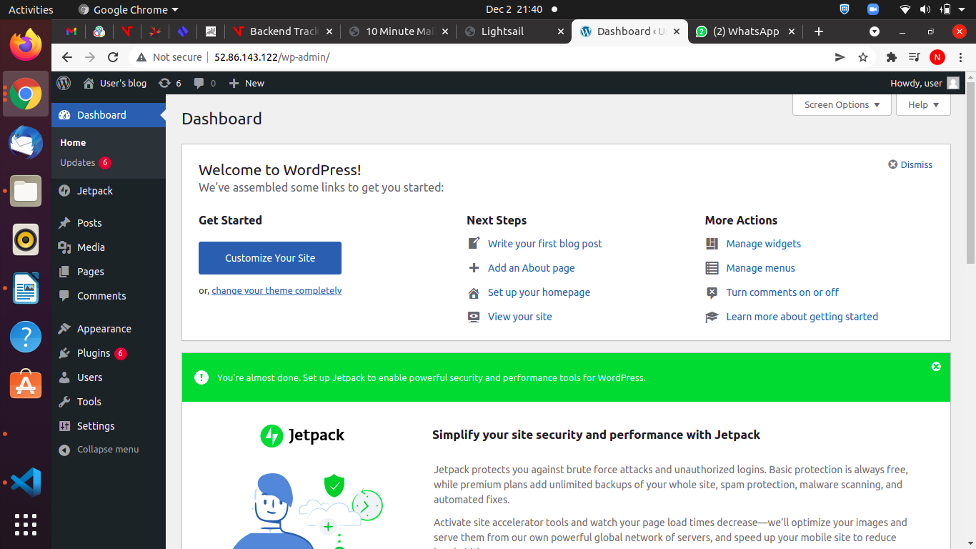

http://52.86.143.122/wp-admin/

Steps
1. Login to AWS console
2. Select Lightsail service
3. Click on create instance
4. Select Wordpress and select region provide all the details and click on create instance
5. After the wordpress instance is created , go to networks section of wordpress instance and click on create static ip to generate static ip.
6. Now copy the ip address in the url bar and your website will be displayed
7. To get the password for wordpress dashboard, go to wordpress intance then click on connect to open terminal using terminal find the file named bitnami_application_password which contains the password.
Using this password you can login to wordpress console.

