1.

https://github.com/nk8601370/deploying-a-static-site-with-netlify-sample.git

2.

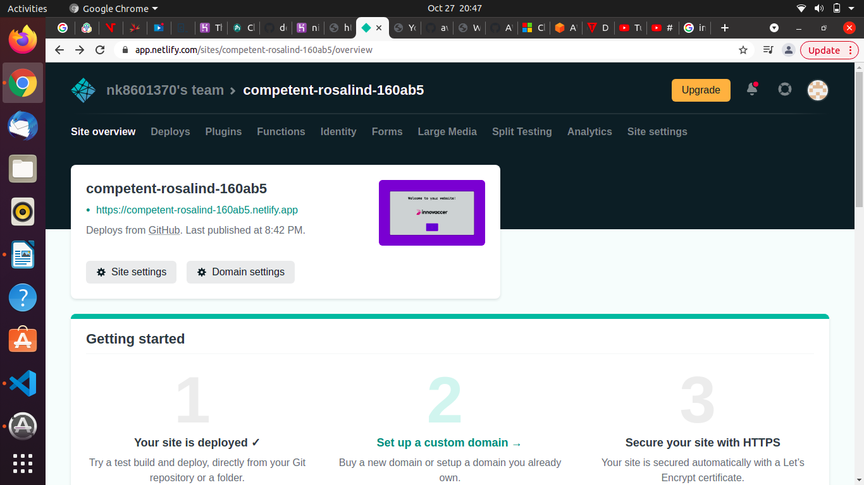

Netlify self paced reading link -

https://docs.netlify.com/site-deploys/notifications/

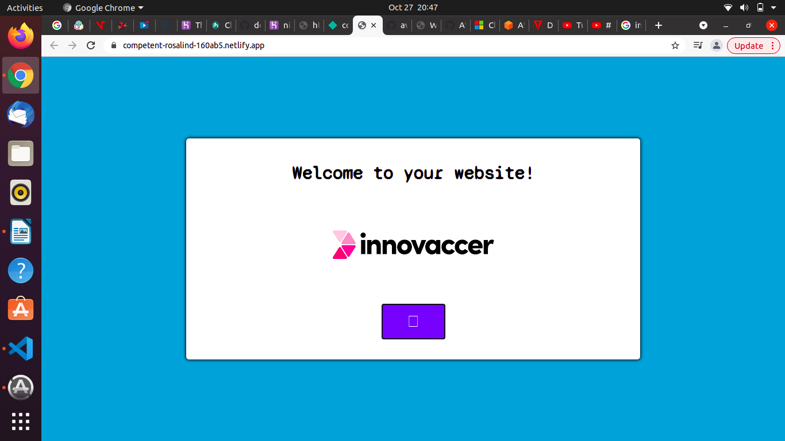

3.

https://github.com/nk8601370/deploying-backend-with-heroku-sample.git

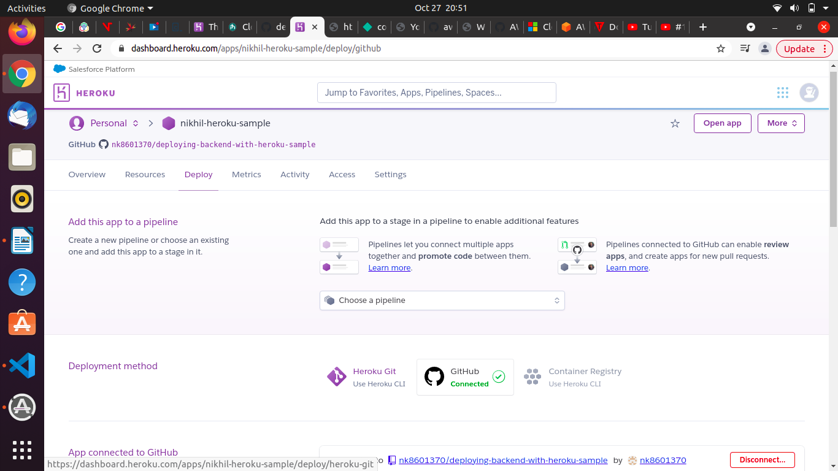
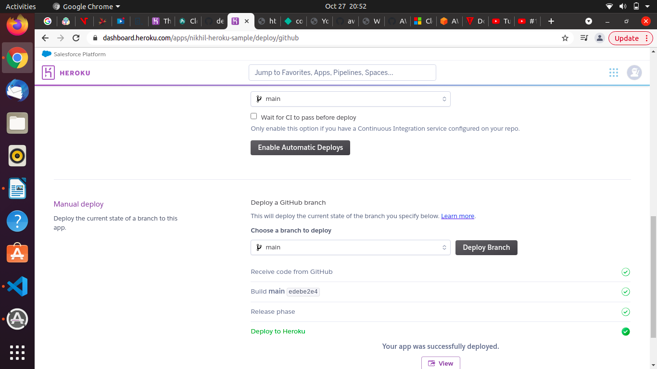

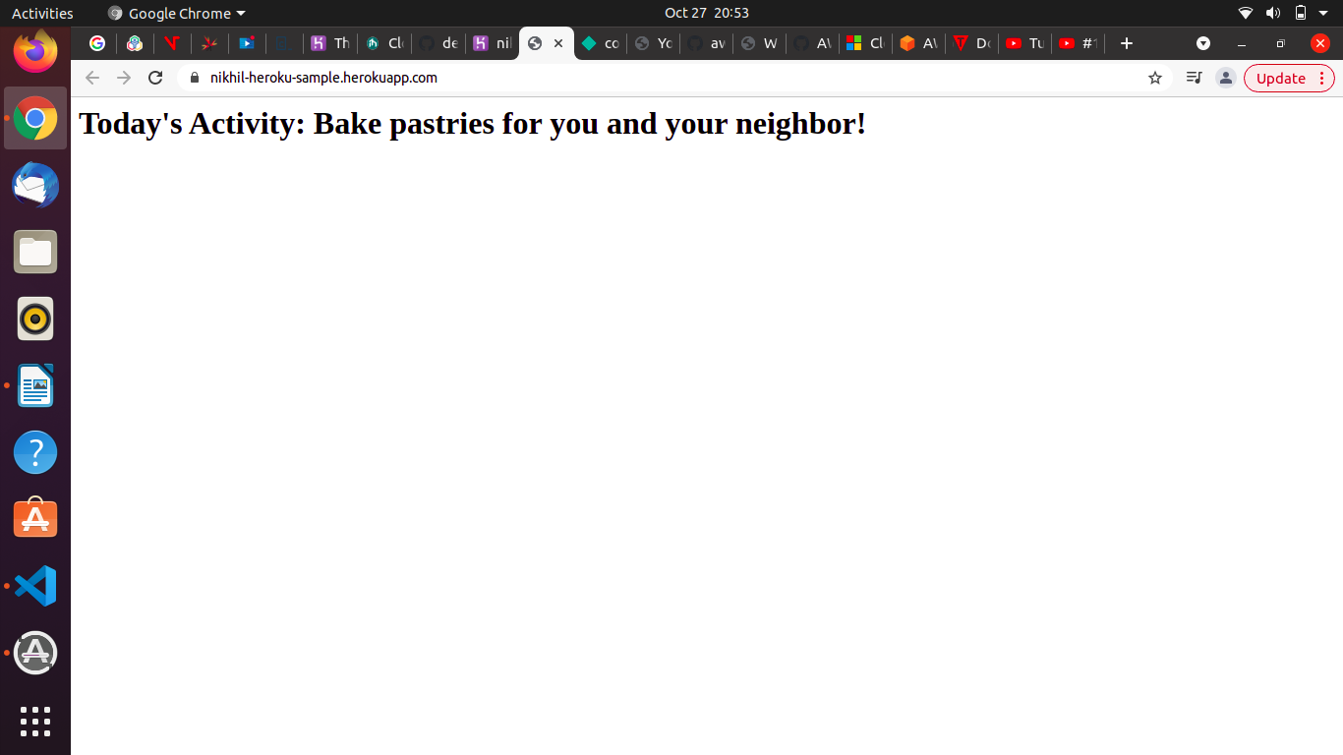

Heroku self paced reading link - https://devcenter.heroku.com/categories/reference

Q4. What is a Cloud Technology?

Ans. Cloud computing is the on-demand delivery of IT resources over the Internet with pay-as-you-go pricing. Instead of buying, owning, and maintaining physical data centers and servers, you can access technology services, such as computing power, storage, and databases, on an as-needed basis from a cloud provider like Amazon Web Services (AWS).

Benefits of cloud technology :-

Agility
Elasticity
Cost saving
Deploy globally in minutes

Types of cloud technology
1. IAAS - IaaS contains the basic building blocks for cloud IT. It typically provides access to networking features, computers (virtual or on dedicated hardware), and data storage space. IaaS gives you the highest level of flexibility and management control over your IT resources. It is most similar to the existing IT resources with which many IT departments and developers are familiar.
2. PAAS - PaaS removes the need for you to manage underlying infrastructure (usually hardware and operating systems), and allows you to focus on the deployment and management of your applications. This helps you be more efficient as you don’t need to worry about resource procurement, capacity planning, software maintenance, patching, or any of the other undifferentiated heavy lifting involved in running your application.
3. SAAS - SaaS provides you with a complete product that is run and managed by the service provider. In most cases, people referring to SaaS are referring to end-user applications (such as web-based email). With a SaaS offering, you don’t have to think about how the service is maintained or how the underlying infrastructure is managed. You only need to think about how you will use that particular software.

Q5. What are some of the key features of Cloud Computing?

Ans.
1. Resources Pooling - It means that the Cloud provider pulled the computing resources to provide services to multiple customers with the help of a multi-tenant model. There are different physical and virtual resources assigned and reassigned which depends on the demand of the customer.
2. On-Demand Self_service - It is one of the important and valuable features of Cloud Computing as the user can continuously monitor the server uptime, capabilities, and allotted network storage. With this feature, the user can also monitor the computing capabilities.

3. Easy Maintenance
The servers are easily maintained and the downtime is very low and even in some cases, there is no downtime. Cloud Computing comes up with an update every time by gradually making it better.

4. Large Network Access
The user can access the data of the cloud or upload the data to the cloud from anywhere just with the help of a device and an internet connection. These capabilities are available all over the network and accessed with the help of internet.

5. Availability
The capabilities of the Cloud can be modified as per the use and can be extended a lot. It analyzes the storage usage and allows the user to buy extra Cloud storage if needed for a very small amount.

Q6- What do you mean by cloud delivery models?
Ans. A cloud delivery model represents a specific, pre-packaged combination of IT resources offered by a cloud provider. Three common cloud delivery models have become widely established and formalized: Infrastructure-as-a-Service (IaaS) Platform-as-a-Service (PaaS) Software-as-a-Service (SaaS)
1. IAAS - IaaS contains the basic building blocks for cloud IT. It typically provides access to networking features, computers (virtual or on dedicated hardware), and data storage space. IaaS gives you the highest level of flexibility and management control over your IT resources. It is most similar to the existing IT resources with which many IT departments and developers are familiar.
2. PAAS - PaaS removes the need for you to manage underlying infrastructure (usually hardware and operating systems), and allows you to focus on the deployment and management of your applications. This helps you be more efficient as you don’t need to worry about resource procurement, capacity planning, software maintenance, patching, or any of the other undifferentiated heavy lifting involved in running your application.
3. SAAS - SaaS provides you with a complete product that is run and managed by the service provider. In most cases, people referring to SaaS are referring to end-user applications (such as web-based email). With a SaaS offering, you don’t have to think about how the service is maintained or how the underlying infrastructure is managed. You only need to think about how you will use that particular software.

Q7. What are the different versions of the cloud?
Ans.
Public cloud - Some public cloud examples include those offered by Amazon, Microsoft, or Google. These companies provide both services and infrastructure, which are shared by all customers. Public clouds typically have massive amounts of available space, which translates into easy scalability. A public cloud is often recommended for software development and collaborative projects.

Private cloud - Private clouds usually reside behind a firewall and are utilized by a single organization. A completely on-premises cloud may be the preferred solution for businesses with very tight regulatory requirements, though private clouds implemented through a colocation provider are gaining in popularity. Authorized users can access, utilize, and store data in the private cloud from anywhere, just like they could with a public cloud. The difference is that no one else can access or utilize those computing resources.

Hybrid cloud - Hybrid clouds combine public clouds with private clouds. They are designed to allow the two platforms to interact seamlessly, with data and applications moving smoothly from one to the other. It’s the perfect solution for a business or organization who needs a little bit of both options, usually dependent upon industry and size.

Community cloud - Although not as commonly used as the other three models, community clouds are a collaborative, multi-tenant platform used by several distinct organizations to share the same applications. The users are typically operating within the same industry or field and share common concerns in terms of security, compliance, and performance.

Q8. What are the main constituents that are part of the cloud ecosystem?
Ans. A cloud ecosystem is a dynamic system of interdependent elements, all of which work together to make cloud services possible. In nature, an ecosystem consists of objects that are linked and work together that are living and non-living. The ecosystem consists of hardware and software in cloud computing, as well as cloud clients, cloud developers, consultants, integrators, and collaborators.
The main constituents that are part of the cloud ecosystem are:
Cloud Service User
- Cloud service user (CSU) is an individual or company who uses cloud services that are distributed.
- End-users may be individuals, machines, or apps.
Cloud service Provider
- A company that provides and manages the cloud services provided.

Cloud Service Partner
- An entity or organization which supports the creation of the service offer by a partner.

Q9. Who are the Cloud Consumers in a cloud ecosystem?
Ans. A cloud consumer represents a person or organization that maintains a business relationship with, and uses the service from a cloud provider. A cloud consumer browses the service catalog from a cloud provider, requests the appropriate service, sets up service contracts with the cloud provider, and uses the service.
The cloud consumer may be billed for the service provisioned, and needs to arrange payments accordingly. Cloud consumers need SLAs to specify the technical performance requirements fulfilled by a cloud provider. SLAs can cover terms regarding the quality of service, security, remedies for performance failures.

Q10. Who are the Direct customers in a cloud ecosystem?
Ans. Users who often take advantage of services that your business has created within a cloud environment.
Example, small and large enterprises , individuals like us are direct customers of cloud ecosystem.

Q11. Who are the Cloud service providers in a cloud ecosystem?
Ans.
- Microsoft Azure
- Google Cloud
- Alibaba Cloud
- IBM Cloud
- Oracle
- Salesforce
- SAP
- Rackspace Cloud
- VMWare
- Amazon Web Services (AWS)

PrivateThe cloThe cloud gives you easy access to a broad range of technologies so tate faster and build nearly anything that you can imagine. You can quickly spin up resources as you need them–from infrastructure services, such as compute, storage, and databases, to Internet of Things, machine learning, data lakes and analytics, and much more.ud gives you easy access to a broad range of technologies so that you can innovate faster and build nearly anything that you can imagine. You can quickly spin up resources as you need them–from infrastructure services, such as compute, storage, and databases, to Internet of Things, machine learning, data lakes and analytics, and much more.

