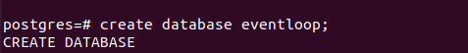
Question 1. Create a new database called “eventloop”. This is the name of the company.

postgres=# create database eventloop;
CREATE DATABASE

Question 2. Add a “userdetails” table which contains the registered user data - user id(primary key),
user name, user mobile number, user email, user city, user date of birth

eventloop=# create table userdetails(user_id integer primary key, user_name varchar(100), user_mobile_number varchar(10), user_email varchar(100), user_city varchar(100), user_date_of_birth date);
CREATE TABLE

Question 3. Add an “events” table which contains the data of all events - event id(primary), event
name, event type(birthday, wedding, corporate, training, other), event date (could be a past or a
future date), event organiser (connect this to user id as a foreign key), event venue, event city, event
budget

eventloop=# create table events(event_id integer primary key, event_name varchar(100), event_type varchar(100), event_date date, event_organiser integer references userdetails(user_id), event_venue varchar(100), event_city varchar(100), event_budget integer);
CREATE TABLE

Question 4. Add a “logistics” table which contains data of all logistics required for an event - logistics
id(primary), event id(connect this to event id as a foreign key), logistics supplier, logistics cost,
logistics status (pending, ordered, delivered), logistics description

eventloop=# create table logistics(logistics_id integer primary key, event_id integer references events(event_id), logistics_supplier varchar(100),logistics_cost integer, logistics_status varchar(100), logistics_description varchar(100));
CREATE TABLE

Question 5. Edit the “logistics” table to include one more column “logistics order date”

eventloop=# alter table logistics add column logistics_order_date date;
ALTER TABLE

Question 6. Import data from the 3 CSV files attached with the assessments into the 3
corresponding tables

eventloop=# copy userdetails(user_id, user_name, user_mobile_number,user_email,user_city,user_date_of_birth)
from '/home/adminroot/Downloads/userdetails.csv' with (DELIMITER ',',FORMAT CSV);
COPY 10

eventloop=# copy events(event_id, event_name, event_type, event_date, event_organiser, event_venue, event_city, event_budget)
from '/home/adminroot/Downloads/events.csv' with (DELIMITER ',',FORMAT CSV);
COPY 10

eventloop=# copy logistics(logistics_id, event_id, logistics_supplier, logistics_cost, logistics_status, logistics_description)
from '/home/adminroot/Downloads/logistics.csv' with (DELIMITER ',',FORMAT CSV);
COPY 7

Question 7. Display the details of all events scheduled for the month of December 2021

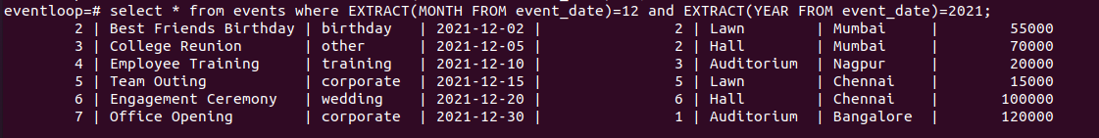
eventloop=# select * from events where EXTRACT(MONTH FROM event_date)=12 and EXTRACT(YEAR FROM event_date)=2021;
2 | Best Friends Birthday | birthday | 2021-12-02 | 2 | Lawn | Mumbai | 55000
3 | College Reunion | other | 2021-12-05 | 2 | Hall | Mumbai | 70000
4 | Employee Training | training | 2021-12-10 | 3 | Auditorium | Nagpur | 20000
5 | Team Outing | corporate | 2021-12-15 | 5 | Lawn | Chennai | 15000
6 | Engagement Ceremony | wedding | 2021-12-20 | 6 | Hall | Chennai | 100000
7 | Office Opening | corporate | 2021-12-30 | 1 | Auditorium | Bangalore | 120000

Question 8. Display the details of all pending logistics where the cost is more than Rs. 5,000

eventloop=# select * from logistics where logistics_status='pending' and logistics_cost>5000;
6 | 7 | Tabdeel Logistics | 10000 | pending | NA |

Question 9. Display the count of all users who are based in Mumbai and have birthdays in the next
30 days

select * from userdetails where (to_char(user_date_of_birth,'MM-DD') between to_char(CURRENT_DATE,'MM-DD') and to_char((CURRENT_DATE + INTERVAL '30 day'),'MM-DD')) and user_city='Mumbai';

Question 10. Edit the details of the user with id 5 and modify their city to Bangalore

eventloop=# update userdetails set user_city='Bangalore' where user_id=5;
UPDATE 1

Question 11. Display the details of logistics which are ordered but not yet delivered for all events
with type corporate. Use the concept of Joins.

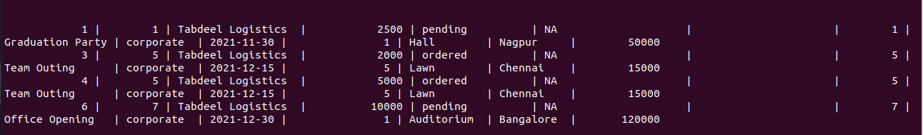
select * from logistics left join events on logistics.event_id=events.event_id where (logistics.logistics_status='ordered' or logistics.logistics_status='pending') and event_type='corporate';

1 | 1 | Tabdeel Logistics | 2500 | pending | NA | | 1 | Graduation Party | corporate | 2021-11-30 | 1 | Hall | Nagpur | 50000
3 | 5 | Tabdeel Logistics | 2000 | ordered | NA | | 5 | Team Outing | corporate | 2021-12-15 | 5 | Lawn | Chennai | 15000
4 | 5 | Tabdeel Logistics | 5000 | ordered | NA | | 5 | Team Outing | corporate | 2021-12-15 | 5 | Lawn | Chennai | 15000
6 | 7 | Tabdeel Logistics | 10000 | pending | NA | | 7 | Office Opening | corporate | 2021-12-30 | 1 | Auditorium | Bangalore | 120000

Question 12. Display the details of all users who are the event organisers for all events with budget
more than Rs. 50,000. Use the concept of joins.

select * from userdetails left join events on userdetails.user_id=events.event_organiser where event_budget>50000;

1 | John | 9999999999 | john@eventloop.com | Nagpur | 1990-03-13 | 7 | Office Opening | corporate | 2021-12-30 | 1 | Auditorium | Bangalore | 120000
2 | Sana | 9999999988 | sana@eventloop.com | Nagpur | 1987-04-12 | 3 | College Reunion | other | 2021-12-05 | 2 | Hall | Mumbai | 70000
2 | Sana | 9999999988 | sana@eventloop.com | Nagpur | 1987-04-12 | 2 | Best Friends Birthday | birthday | 2021-12-02 | 2 | Lawn | Mumbai | 55000
6 | Aston | 9999999944 | aston@eventloop.com | Bangalore | 2001-07-28 | 6 | Engagement Ceremony | wedding | 2021-12-20 | 6 | Hall | Chennai | 100000

Question 13. Display the details of all events happening in “Nagpur” where the event type is either
“corporate” or “training”. Use the concept of sub queries.

select * from events where event_city='Nagpur' and (event_type='corporate' or event_type='training');

1 | Graduation Party | corporate | 2021-11-30 | 1 | Hall | Nagpur | 50000
4 | Employee Training | training | 2021-12-10 | 3 | Auditorium | Nagpur | 20000

Question 14. Show the list of all tables in the database.

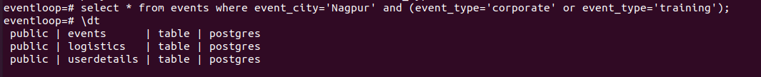
eventloop=# \dt
public | events | table | postgres
public | logistics | table | postgres
public | userdetails | table | postgres

Question 15. Delete all tables from the database.

