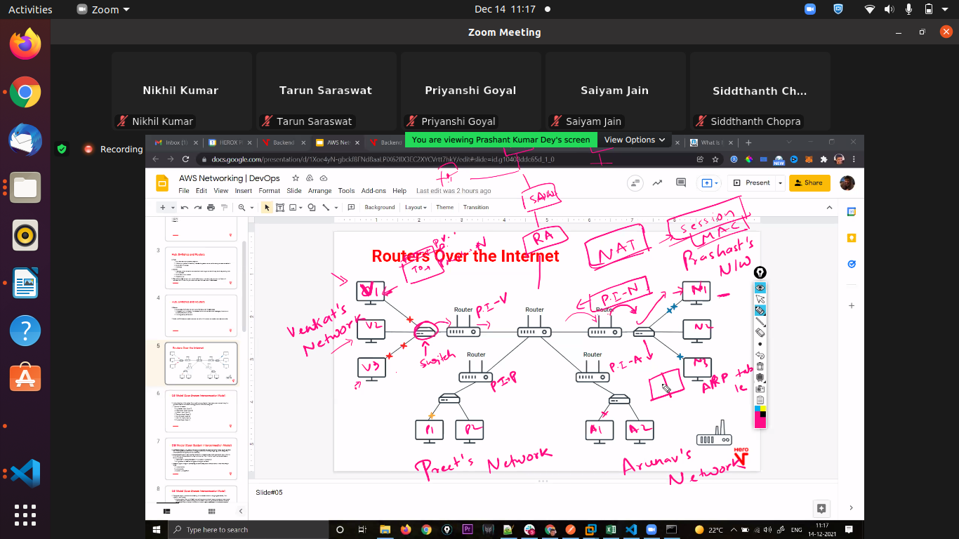
Ws

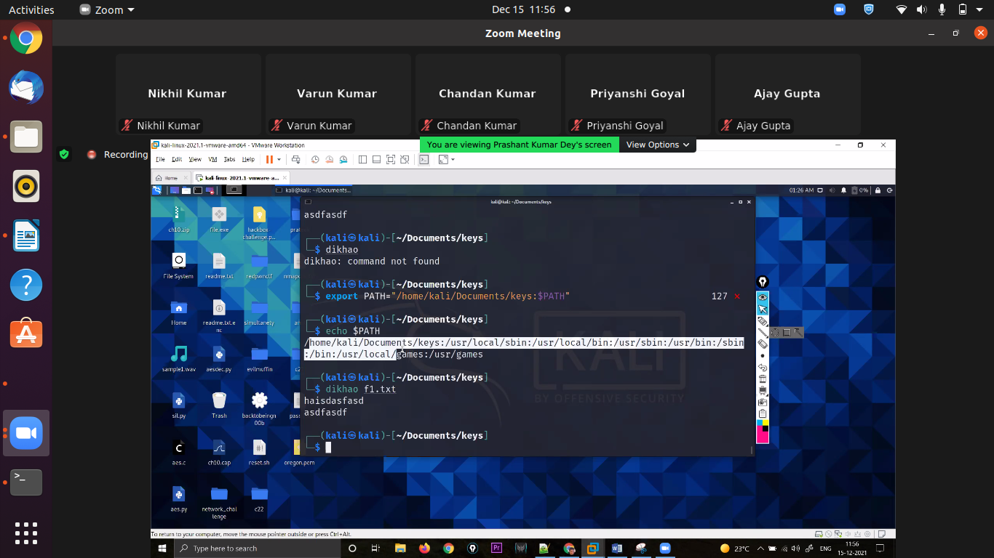
a

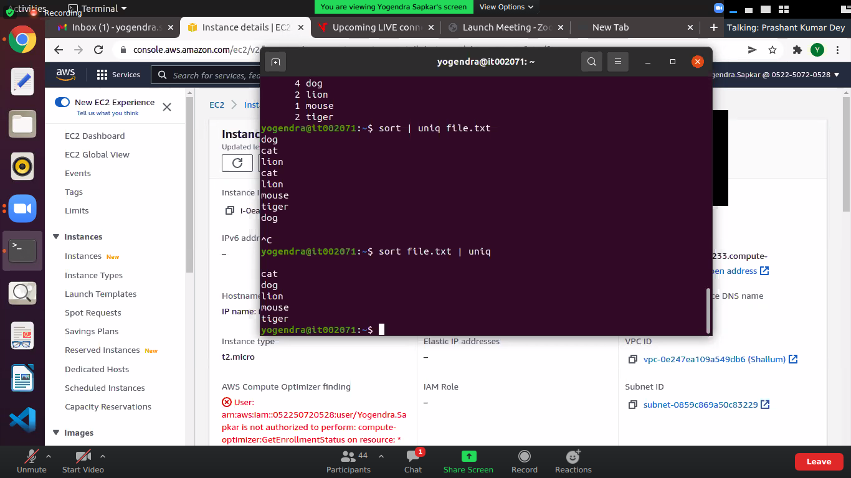
w

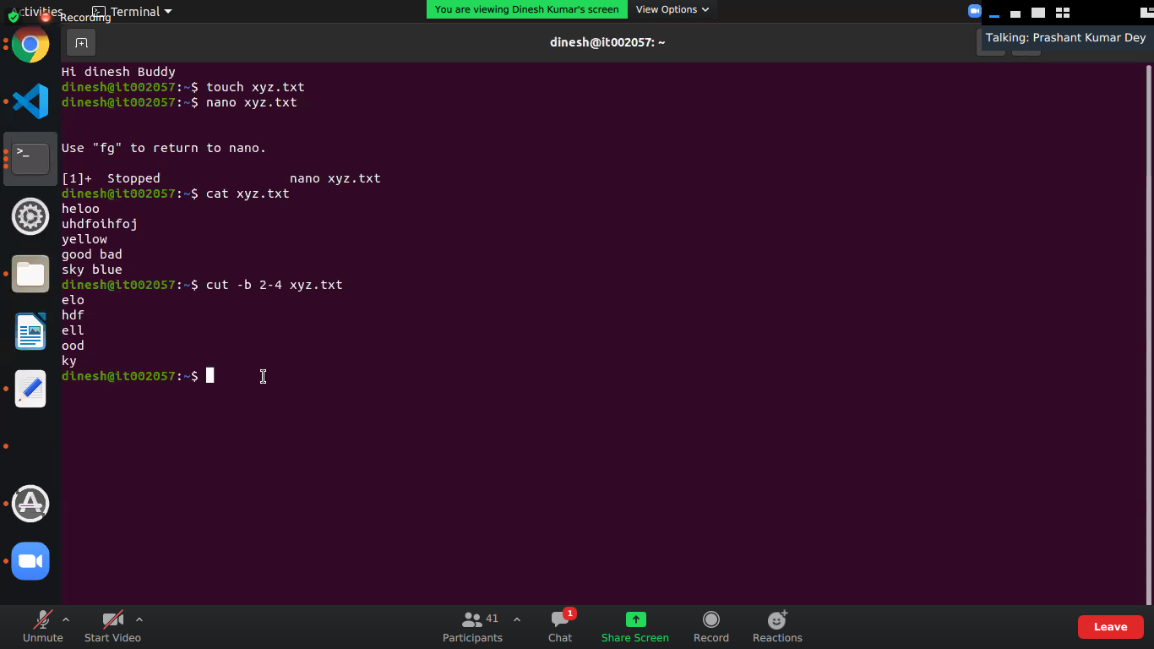
jh

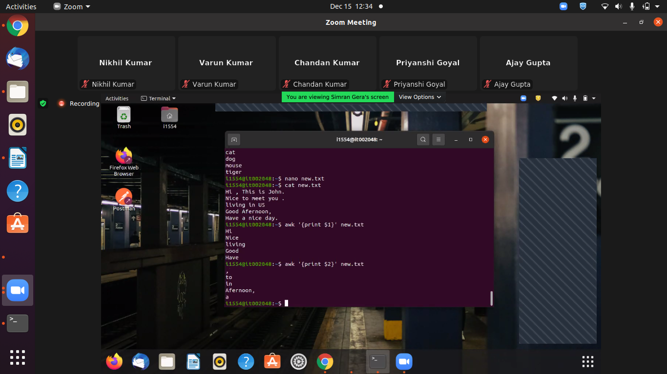
qws

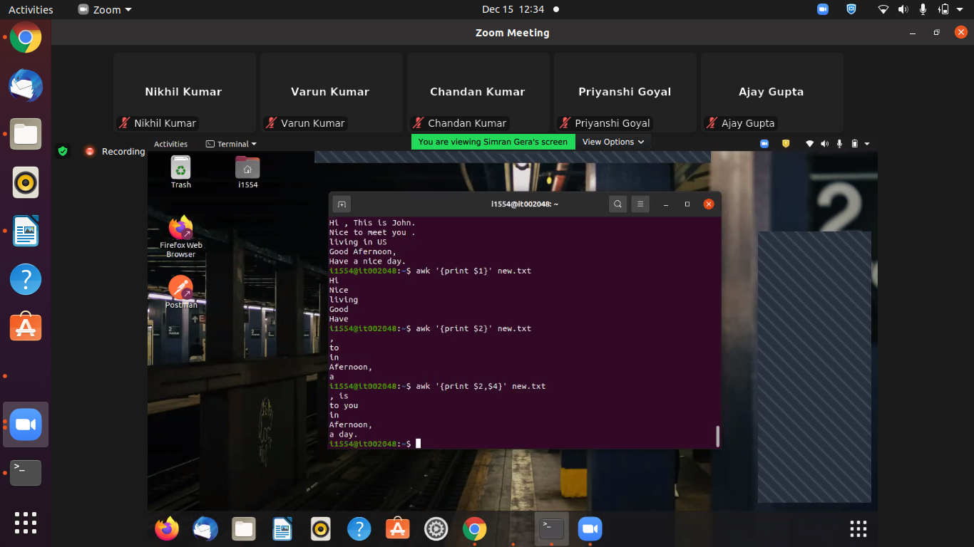
jj

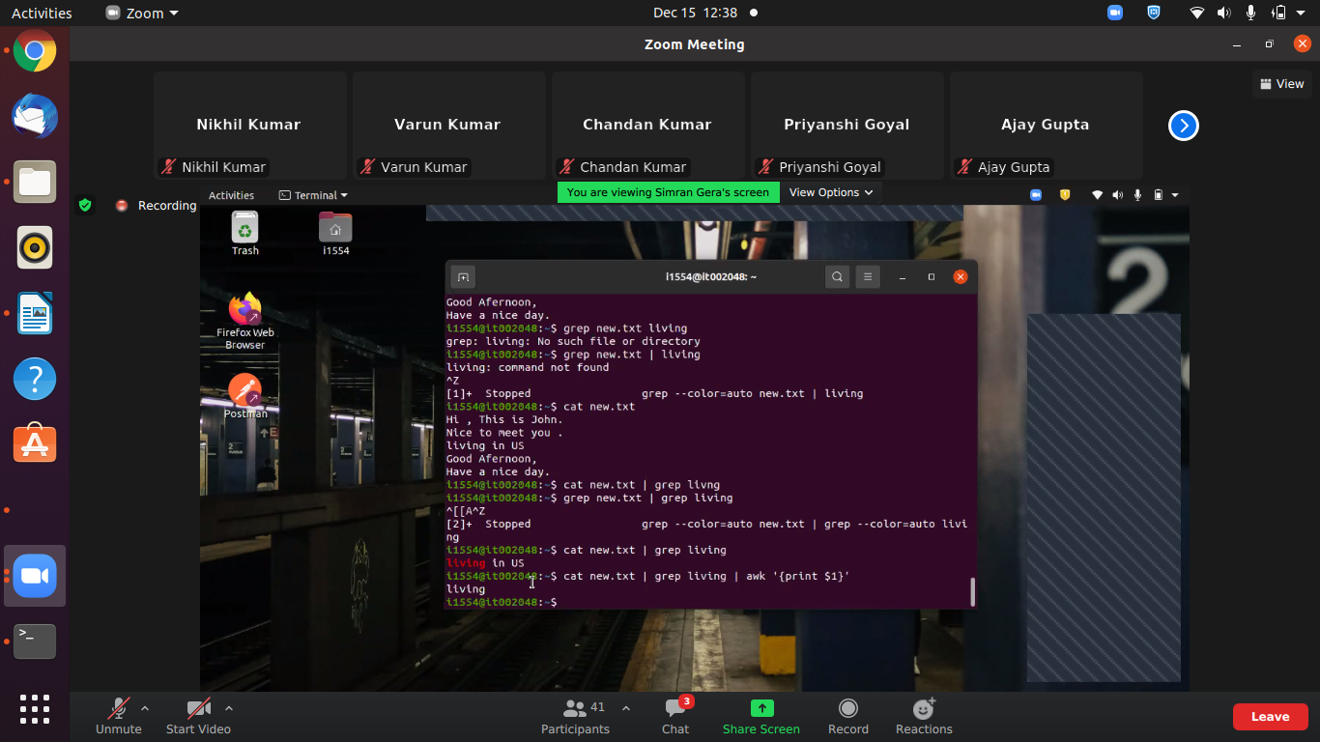
qqs
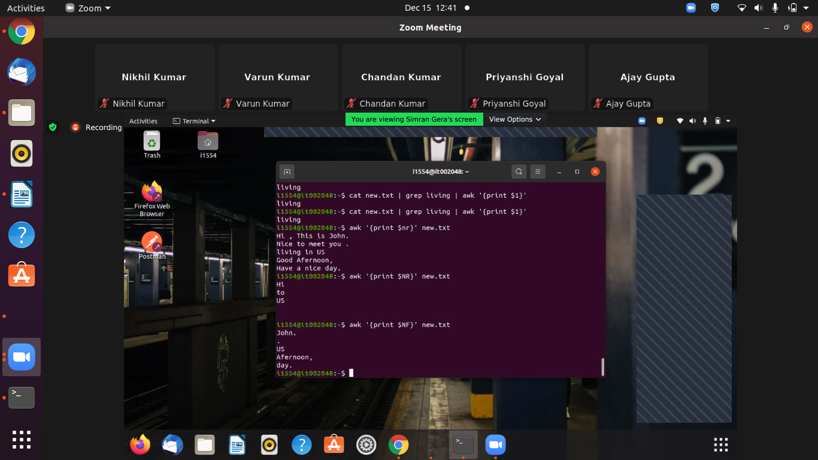
sq

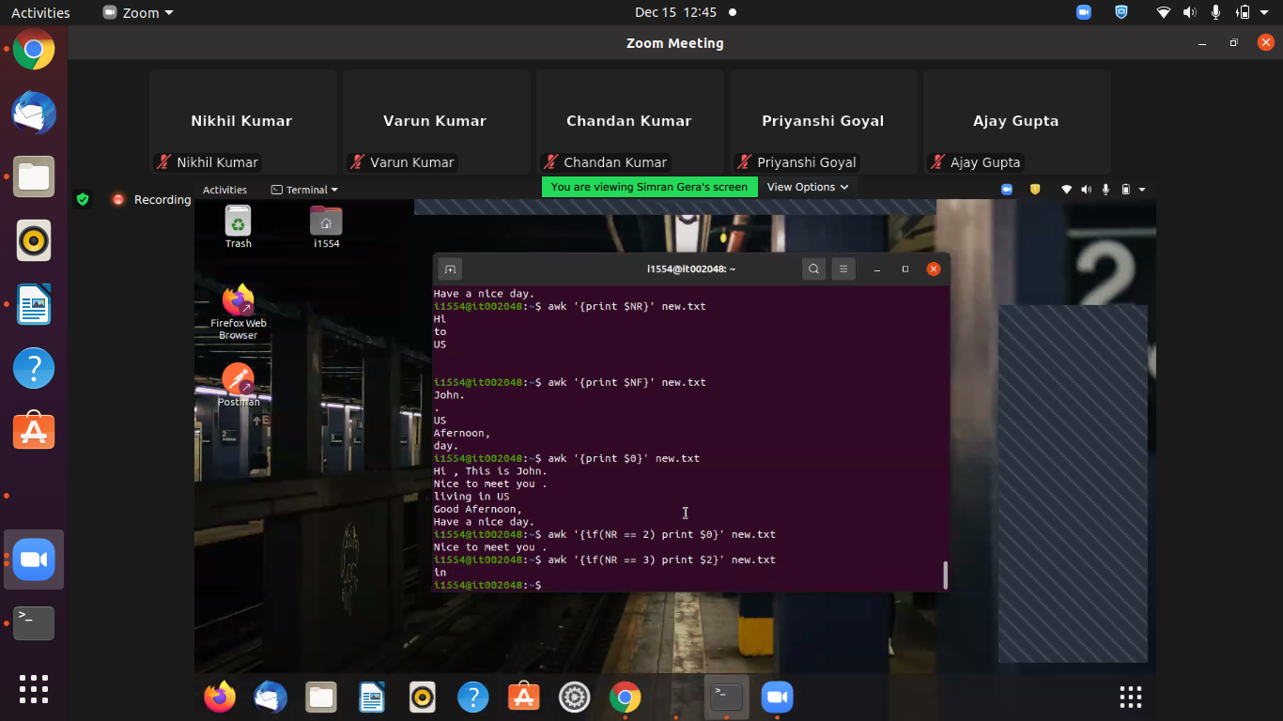
qs

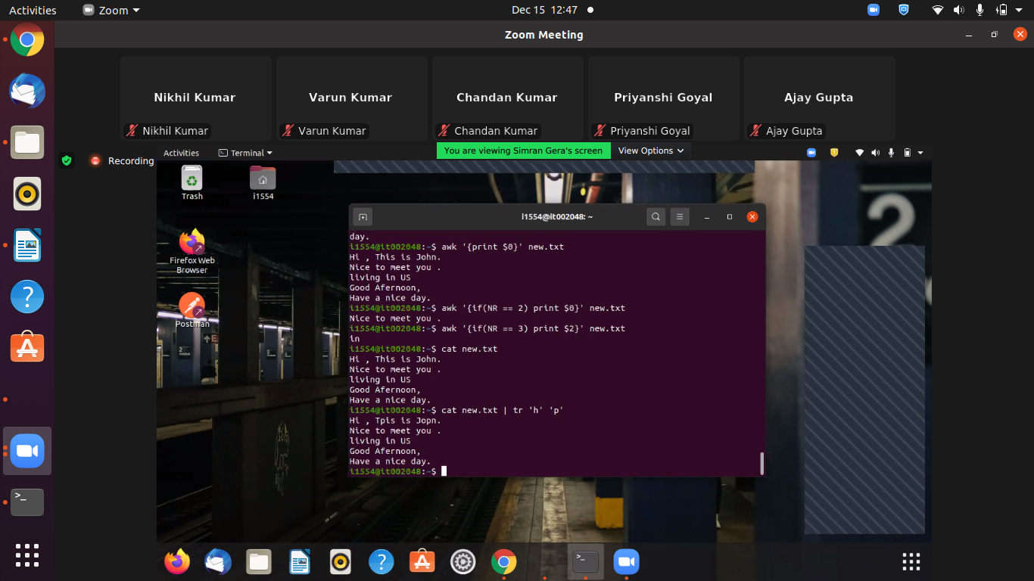
f

sudo tcpdump -r sampleNetworkLog.pcap | grep .com | awk '{print $(NF -1)}' | sort | uniq | grep .com | awk '{print substr($1,1,length($1)-1)}' | tr '.' ' ' | awk '{print $(NF-1),$NF}' | tr ' ' '.' | sort | uniq

tcpdump -r sampleNetworkLog.pcap | grep .com | awk '{print $(8)}' | sort | uniq | grep .com | awk '{print substr($1,1,length($1)-1)}'

