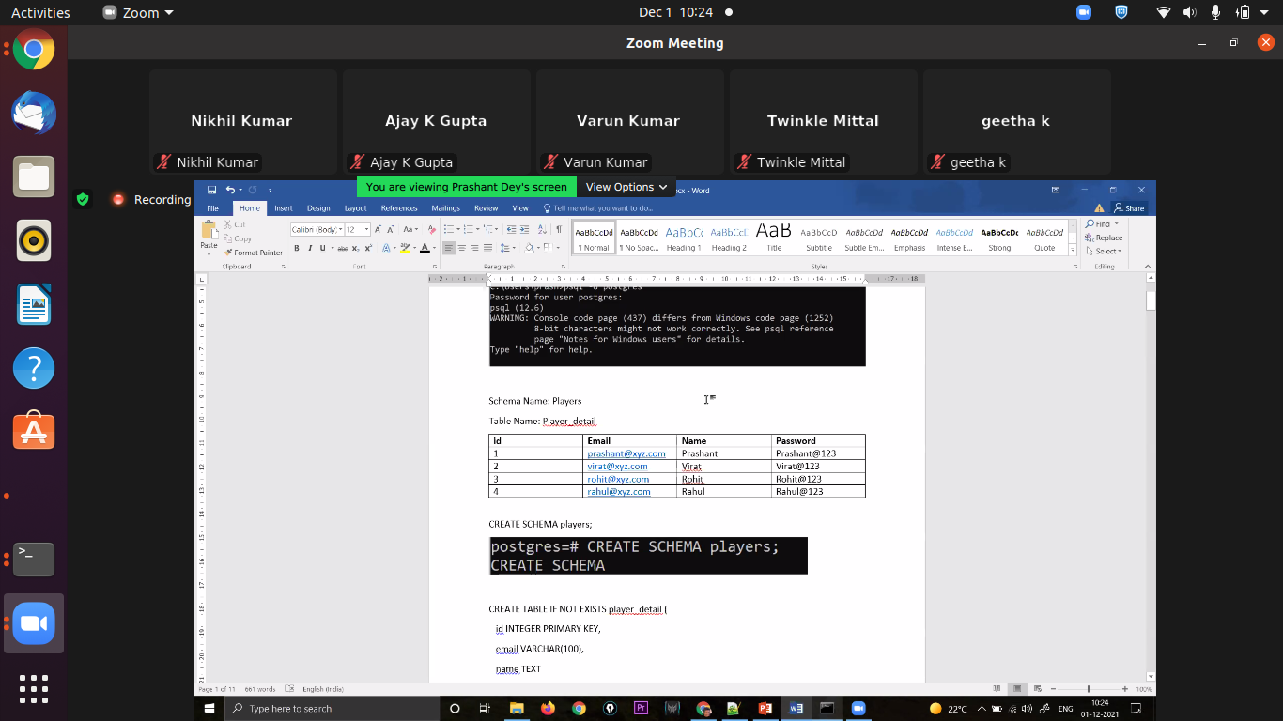
Sd

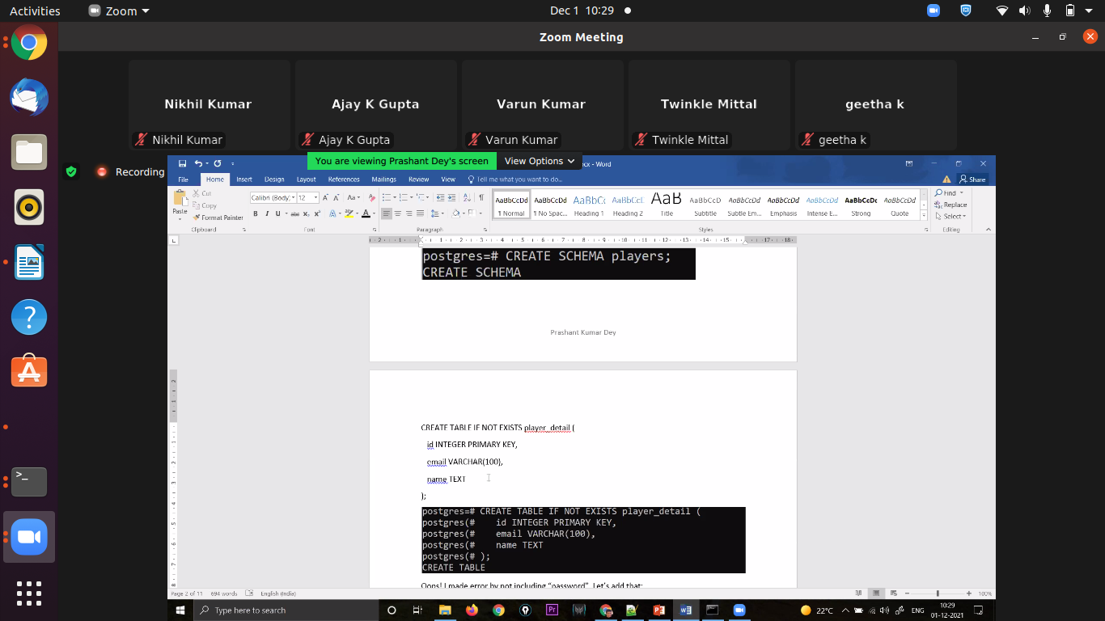
ed

to create virtual environment

s
udo apt install python3.8-venv
[sudo] password for adminroot:
Reading package lists... Done
Building dependency tree
Reading state information... Done
python3.8-venv is already the newest version (3.8.10-0ubuntu1~20.04.1).
The following packages were automatically installed and are no longer required:
apt-clone archdetect-deb augeas-lenses debugedit
dmraid gir1.2-timezonemap-1.0 gir1.2-xkl-1.0
kpartx kpartx-boot libaugeas0
libboost-system1.67.0 libboost-thread1.67.0
libdebian-installer4 libdmraid1.0.0.rc16
libllvm10 libllvm11 librpmbuild8 librpmsign8
libsolv-tools libsolv0 libsolvext0
libtimezonemap-data libtimezonemap1 libzypp-bin
libzypp-common libzypp-config libzypp1702
python3-icu python3-pam rdate rpm shim
zypper-common
Use 'sudo apt autoremove' to remove them.
0 upgraded, 0 newly installed, 0 to remove and 4 not upgraded.
adminroot@it002102:~/Desktop/innovacer_training/flaskapp$ python3 -m venv venv
adminroot@it002102:~/Desktop/innovacer_training/flaskapp$ source venv/bin/activate
(venv) adminroot@it002102:~/Desktop/innovacer_training/flaskapp$

All the commands for today

pip install virtualenv
1769 pip --version
1770 .\env\Scripts\acivate.ps1
1771 sudo pip install virtualenv
1772 pip install flask
1773 sudo apt update
1774 sudo apt install mysql-server
1775 sudo systemctl status mysql
1776 sudo mysql_secure_installation
1777 mysql
1778 sudo mysql
1779 git clone git@github.com:nk8601370/LearningFlask.git
1780 code .
1781 sudo apt install python3.8-venv
1782 python3 -m venv venv
1783 source venv/bin/activate
1784 pip install psycopg2-binary
1785 pip install requirements.txt
1786 sudo apt install flask
1787 sudo apt install Flask-SQLalchemy
1788 python3 app.py
1789 cd LearningFlask/
1790 python3 app.py
1791 sudo apt install mysql-server
1792 sudo apt-get update
1793 mysql --version
1794 sudo mysql_secure_installation
1795 sudo systemctl start mysql
1796 sudo mysql -u root -p
1797 python3 app.py
1798 sudo apt-get install flask
1799 pip install -r requirements.txt
1800 sudo apt-get install libmysqlclient-dev
1801 sudo apt-get install python-dev
1802 pip install -r requirements.txt
1803 python3 app.py

