Observed Output

LEVEL-1: ROOT OF THE DECISION TREE

|  |  |
| --- | --- |
| **Features** | **Churn Contribution in %** |
| Female | 50.24 |
| Youth | 74.53 |
| Independent | 82.55 |
| Multiple Lines | 45.47 |
| Fibre Optic | 69.39 |
| No Online Security | 78.17 |
| No Backup | 65.97 |
| No Device Protection | 64.79 |
| No Technical Support | 77.36 |
| No Streaming TV | 50.4 |
| No Streaming Movie | 50.4 |
| Paperless Billing | 74.9 |
| Electronic Transfer | 57.3 |
| Phone Service | 90 |

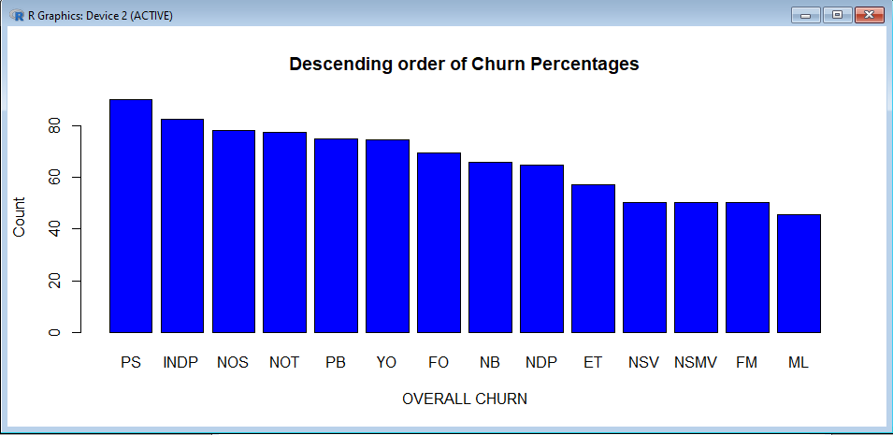

LEVEL-2: NEXT ROOT OF THE DECISION TREE

PHONE SERVICE IS “YES” AND CAUSING MAXIMUM CHURN.

NEXT ROOT SELECTION :

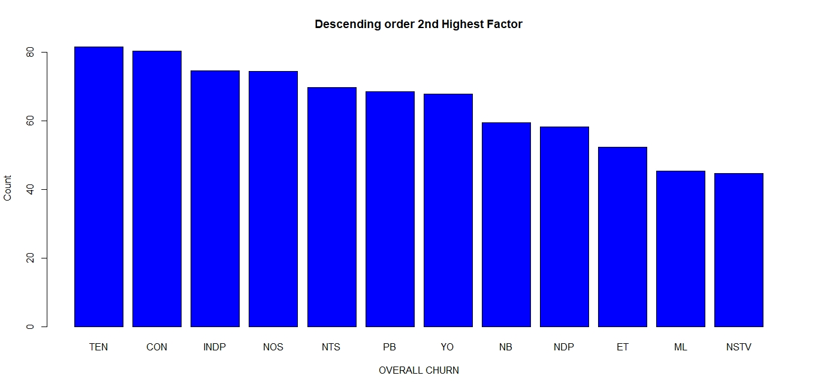

|  |  |
| --- | --- |
| **Features** | **Churn Contribution in %** |
| Female | 45.96 |
| Youth | 67.79 |
| Independent | 74.69 |
| Multiple Lines | 45.47 |
| Fibre Optic | 69.39 |
| No Online Security | 70.49 |
| No Backup | 59.60 |
| No Device Protection | 58.31 |
| No Technical Support | 69.76 |
| No Streaming TV | 44.72 |
| No Streaming Movie | 44.94 |
| Paperless Billing | 68.59 |
| Electronic Transfer | 52.40 |
| Contract | 80.36 |
| No Partner | 58.37 |
| Tenure | 81.59 |
| Monthly Charges | 77.36 |

LEVEL-3: NEXT ROOT OF THE DECISION TREE

PHONE SERVICE IS “YES” AND TENURE <=50 CAUSING MAXIMUM CHURN.

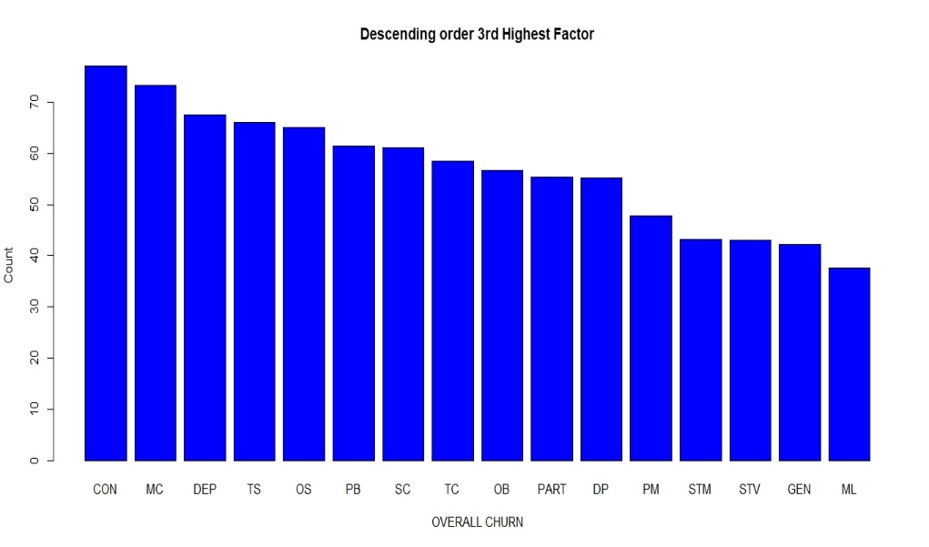NEXT ROOT SELECTION:

|  |  |
| --- | --- |
| **Features** | **Churn Contribution in %** |
| Female | 42.16 |
| Youth | 61.04 |
| Independent | 67.46 |
| Multiple Lines | 37.66 |
| No Online Security | 65 |
| No Backup | 56.66 |
| No Device Protection | 55.21 |
| No Technical Support | 63.99 |
| No Streaming TV | 43.07 |
| No Streaming Movie | 43.23 |
| Paperless Billing | 61.36 |
| Electronic Transfer | 47.83 |
| Contract | 76.99 |
| No Partner | 55.37 |
| Monthly Charges | 73.19 |

LEVEL-4: NEXT ROOT OF THE DECISION TREE

PHONE SERVICE IS “YES” AND TENURE <=50 AND CONTRACT M2M CAUSING MAXIMUM CHURN.

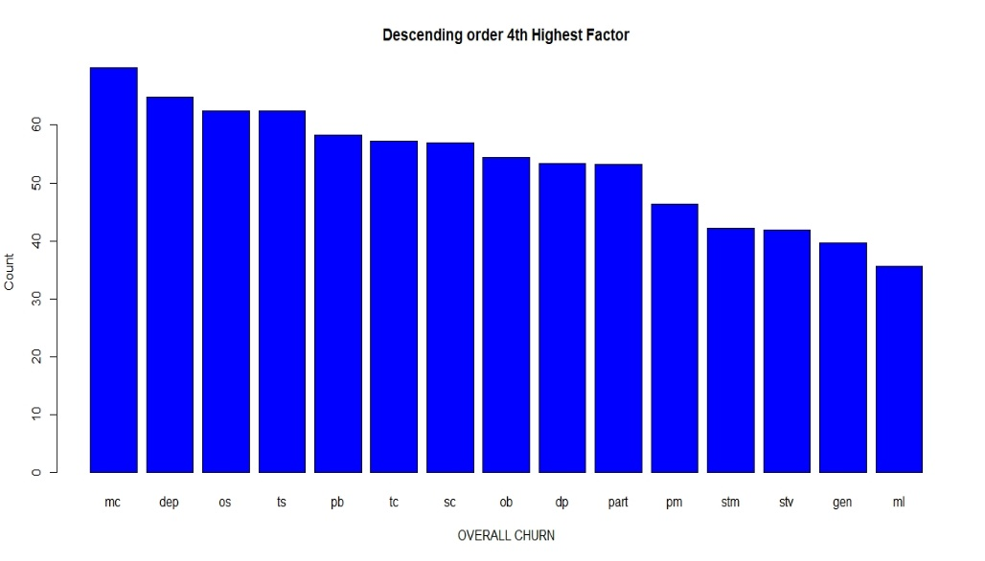NEXT ROOT SELECTION:

|  |  |
| --- | --- |
| **Features** | **Churn Contribution in %** |
| Female | 39.07 |
| Youth | 56.98 |
| Independent | 64.84 |
| Multiple Lines | 35.58 |
| No Online Security | 62.38 |
| No Backup | 54.36 |
| No Device Protection | 53.39 |
| No Technical Support | 62.38 |
| No Streaming TV | 41.94 |
| No Streaming Movie | 42.16 |
| Paperless Billing | 58.21 |
| Electronic Transfer | 46.33 |
| No Partner | 53.18 |
| Monthly Charges | 69.87 |

LEVEL-5: NEXT ROOT OF THE DECISION TREE

PHONE SERVICE IS “YES”, TENURE <=50, ,MONTHLY CHARGES AND CONTRACT M2M CAUSING MAXIMUM CHURN.

NEXT ROOT SELECTION:

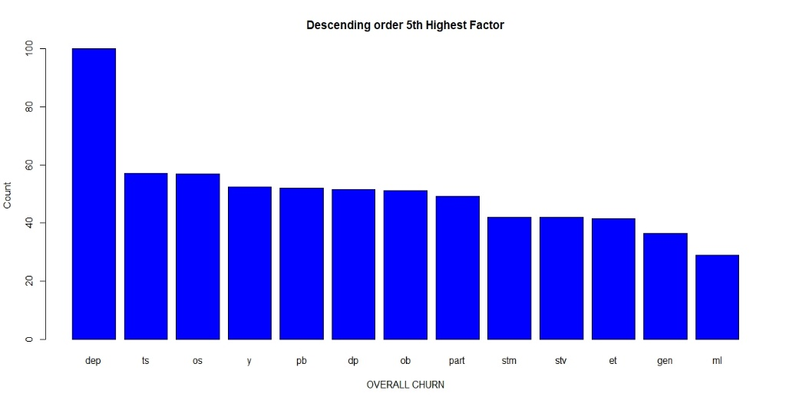

|  |  |
| --- | --- |
| **Features** | **Churn Contribution in %** |
| Female | 36.43 |
| Youth | 52.38 |
| Independent | 100 |
| Multiple Lines | 29.10 |
| No Online Security | 56.92 |
| No Backup | 51.25 |
| No Device Protection | 51.63 |
| No Technical Support | 57.24 |
| No Streaming TV | 41.94 |
| No Streaming Movie | 42.05 |
| Paperless Billing | 52.05 |
| Electronic Transfer | 41.51 |
| No Partner | 49.33 |