**Output**

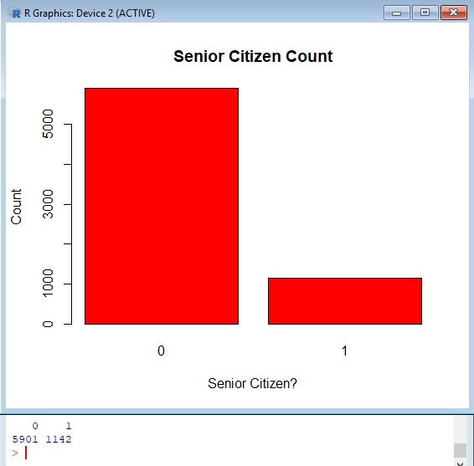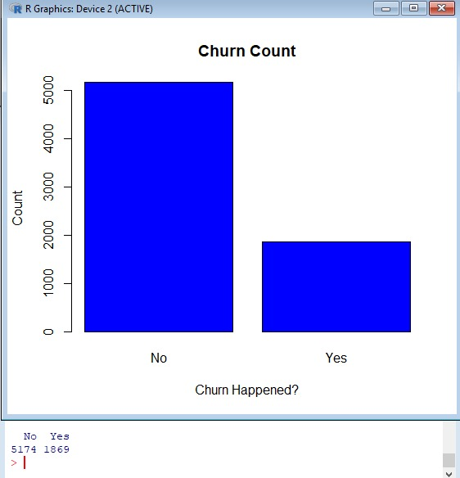Q1-> HOW MANY CHRUN HAPPENED? Q3-> TOTAL SENIOR CITIZEN CUSTOMERS?

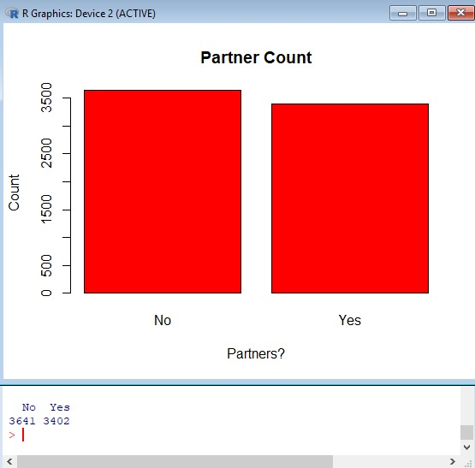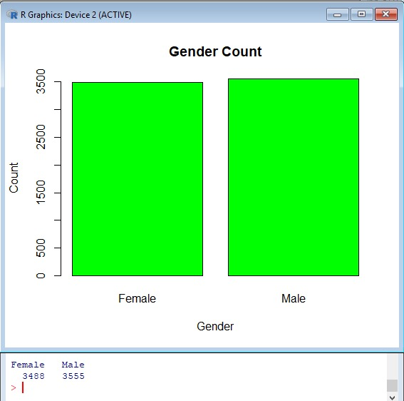Q2-> HOW MANY TOTAL MALE AND Q4-> HOW MANY OF THEM ARE FEMALE CUSOMERS ARE THERE? PARTNERS?

Q5-> HOW MANY OF THEM ARE Q7-> HOW MANY OF THEM ARE DEPENDENT? USING MULTIPLE CONNECTIONS ?

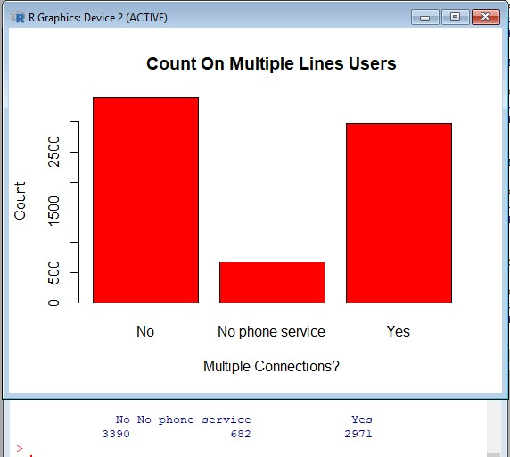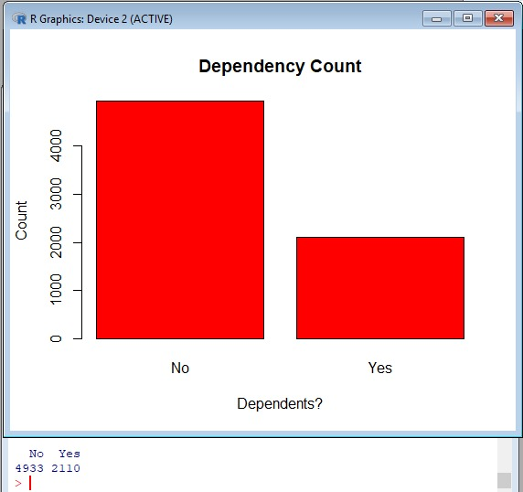

Q6-> HOW MANY ARE USING Q8-> COUNT OF DIFFERENT TYPES TELECOM SERVICE FOR MOBILE OF INTERNET SERVICES THEY PHONES? HAVE USED?

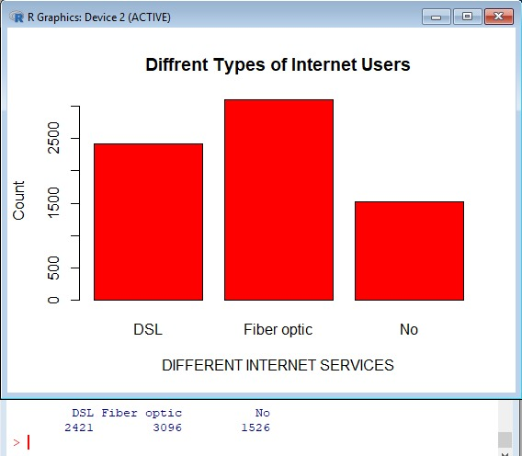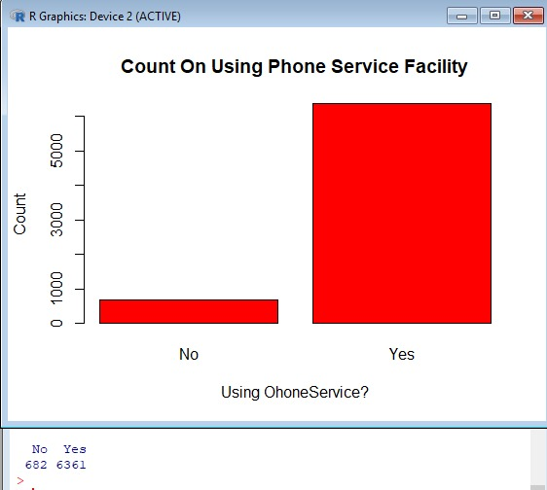

Q9-> HOW MANY ARE HAVING Q11-> HOW MANY ARE HAVING ONLINE SECURITY? DEVICE PROTECTION?

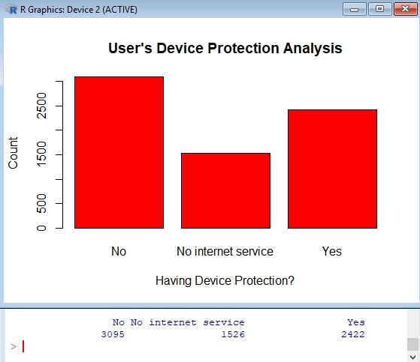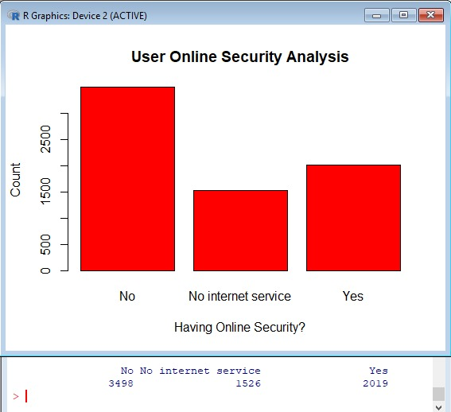

Q10-> HOW MANY ARE HAVING Q12-> HOW MANY ARE HAVING ONLINE BACKUP? TECHNICAL SUUPORT ?

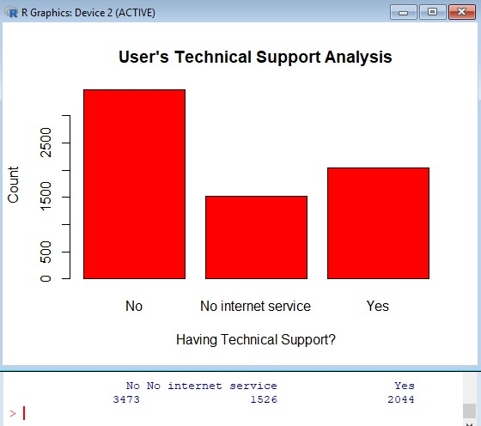 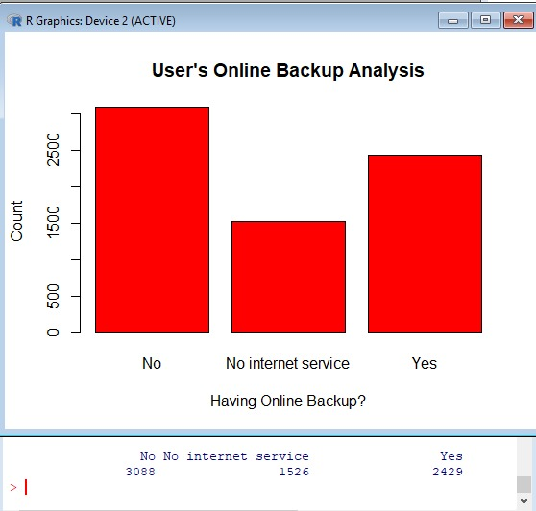

Q13-> HOW MANY ARE STREAMING Q15-> WHAT ARE DIFFERENT TELEVISION? CONTRACT PERIODS?

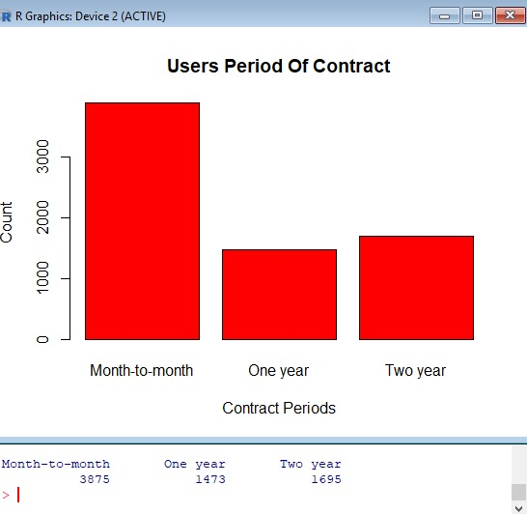 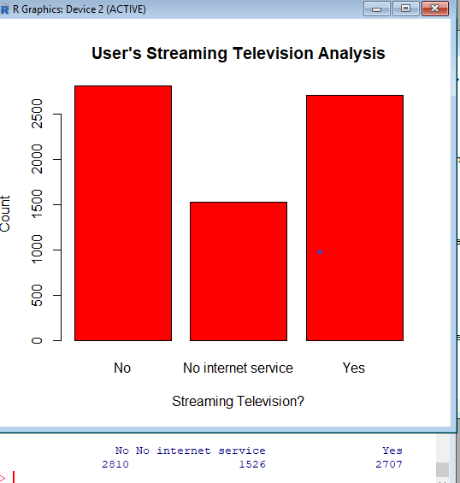

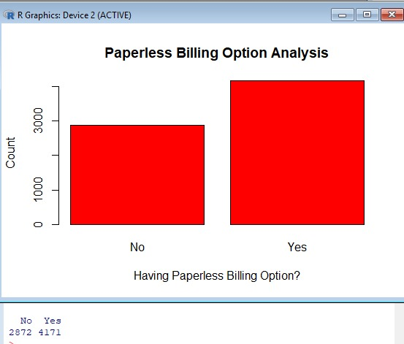Q14-> HOW MANY ARE STREAMING Q16-> HOW MANY ARE USING MOVIES? PAPERLESS BILLING SCHEMES?

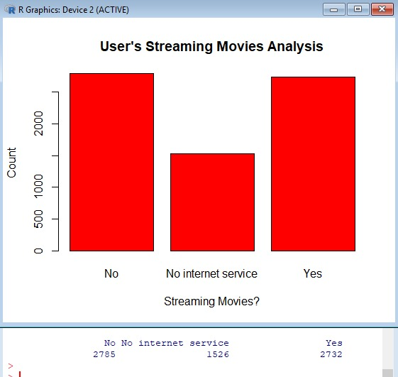

Q17-> COUNT ON THE DIFFERENT Q19-> [MEAN,MEDIAN,MODE]

BILLING MODES USED BY THEM ANALYSIS MONTHLY CHARGING

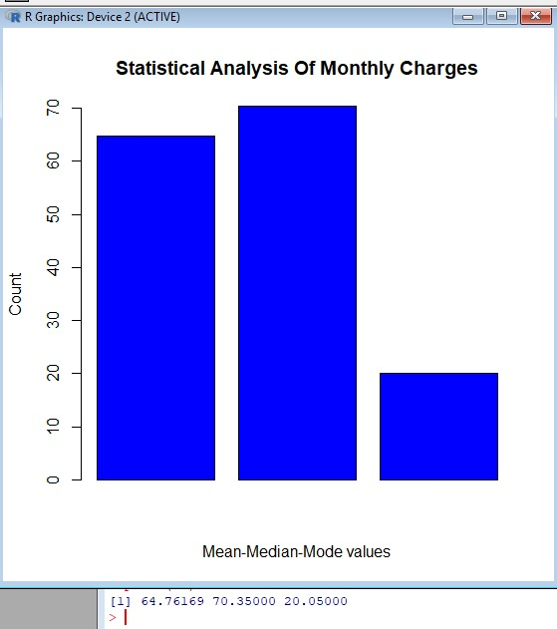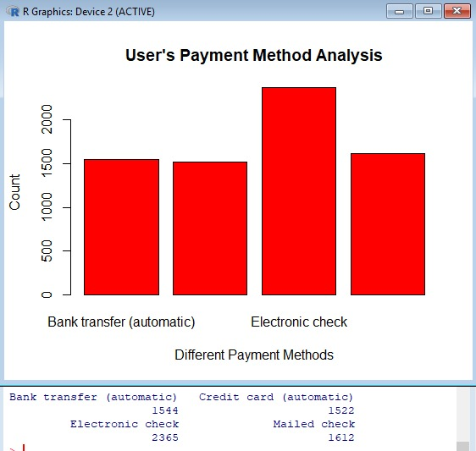

Q18->[MEAN,MEDIAN,MODE]ANALYSIS Q20-> [MEAN,MEDIAN,MODE]

OF TENURES ANALYSIS OF TOTAL CHARGING

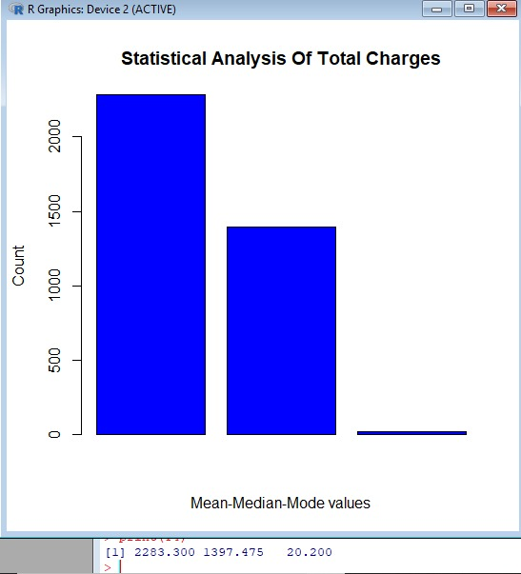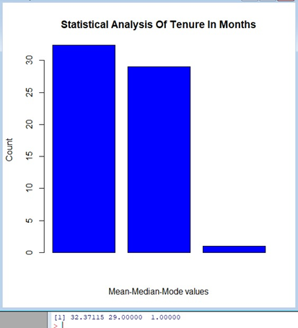

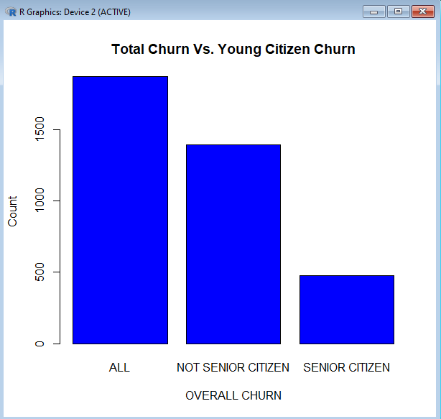Percentage of Female churn: 50.24% 74.53% OF THEM ARE NOT SENIOR CITIZENS

