Physical design PA3 Report
EE3 B05901172 黃禹靖
- Algorithm Flow
- It follows the fast simulated annealing progress in the essay “Modern Floorplanning Based on Fast Simulated Annealing”.
- Knowing that all the inputs are able to be put inside the outline, it reduces the iteration time in one annealing progress, and repeat the whole progress until a feasible solution is find. However, it would usually find a feasible solution in the first annealing.
- Data Structure:
- Class B*Tree with operation insert, deletion, rotate, and swap. All operations are nondeterministic.
- Three B*Tree. One is for all operation. One is a backup for recover previous tree after perturb. And one is the best solution overall.
- Class Module and inheritance class Block for terminal and block respectively.
- Class Contour is a double linked list of Class Segment to implement horizontal contour for packing of a floorplan.
- Discussion
- The constant c and k follow which in the essay.
- By experiment in given 5 testcases,
number of iteration in each temperature = 40 * numBlock +40,
number of different temperature = 500, and
Initial uphill accepting probability = 0.95.
- For every B*Tree, after packing, I would also examine whether the transpose of the floorplan is a good solution. That is, invert x y coordinate of every block. The check is very easy to do. But it would significantly increase exploring space of solutions. Since a transpose of the whole floorplan is not able to be packed by any B*Tree. So the simple check would double exploring space.
- I implemented visualizing. gnuplot_i.h is included.
Add a flag -v or -visualize at the end of command would invoke visualizing.

Here are visualizing for each testcase with:

Xerox:
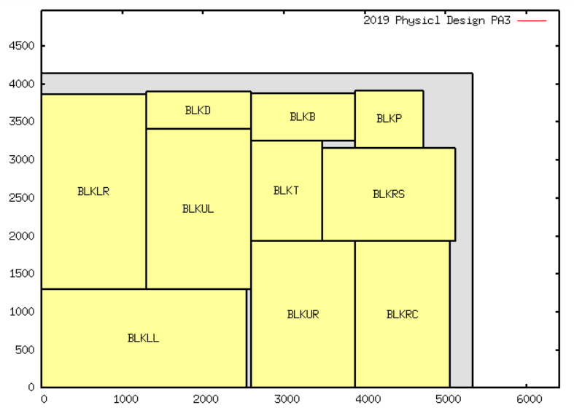
Hp:
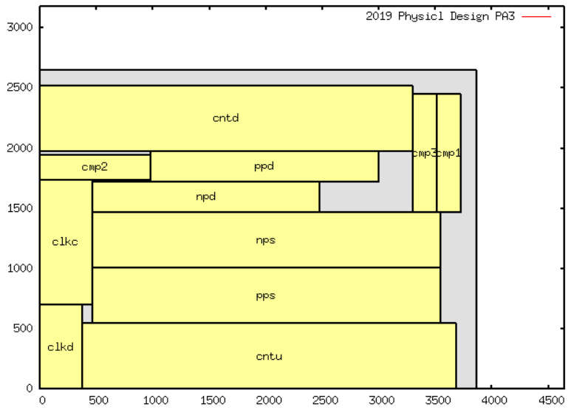
Apte:
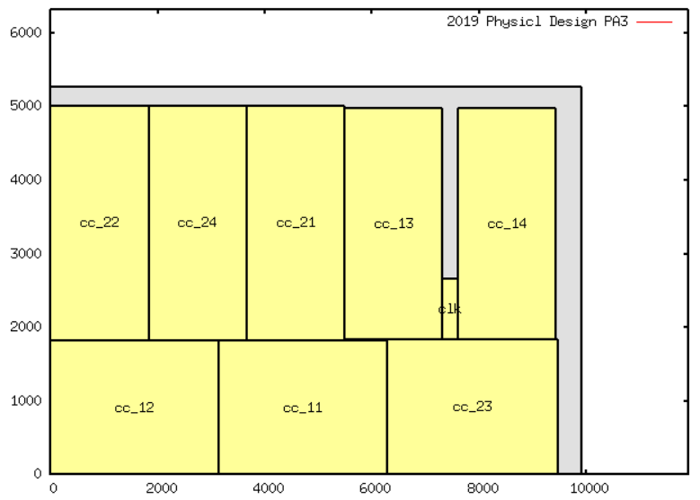
Ami33:
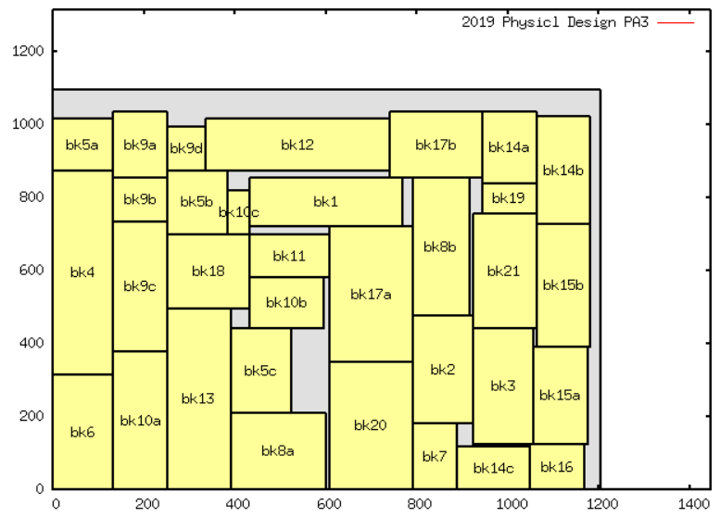
Ami49:
