Physical design PA3 Report

EE3 B05901172 黃禹靖

* Algorithm Flow

1. It follows the fast simulated annealing progress in the essay “Modern Floorplanning Based on Fast Simulated Annealing”.
2. Knowing that all the inputs are able to be put inside the outline, it reduces the iteration time in one annealing progress, and repeat the whole progress until a feasible solution is find. However, it would usually find a feasible solution in the first annealing.

* Data Structure:

1. Class B*Tree with operation insert, deletion, rotate, and swap. All operations are nondeterministic.
2. Three B*Tree. One is for all operation. One is a backup for recover previous tree after perturb. And one is the best solution overall.
3. Class Module and inheritance class Block for terminal and block respectively.
4. Class Contour is a double linked list of Class Segment to implement horizontal contour for packing of a floorplan.

* Discussion

1. The constant c and k follow which in the essay.
2. By experiment in given 5 testcases,

number of iteration in each temperature = 40 * numBlock +40,

number of different temperature = 500, and

Initial uphill accepting probability = 0.95.

1. For every B*Tree, after packing, I would also examine whether the transpose of the floorplan is a good solution. That is, invert x y coordinate of every block. The check is very easy to do. But it would significantly increase exploring space of solutions. Since a transpose of the whole floorplan is not able to be packed by any B*Tree. So the simple check would double exploring space.
2. I implemented visualizing. gnuplot_i.h is included.

Add a flag -v or -visualize at the end of command would invoke visualizing.

Here are visualizing for each testcase with:

Xerox:

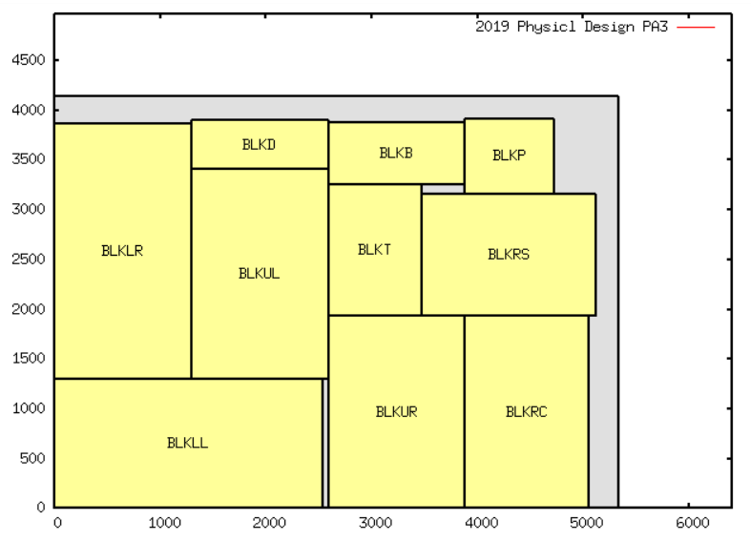

Hp:

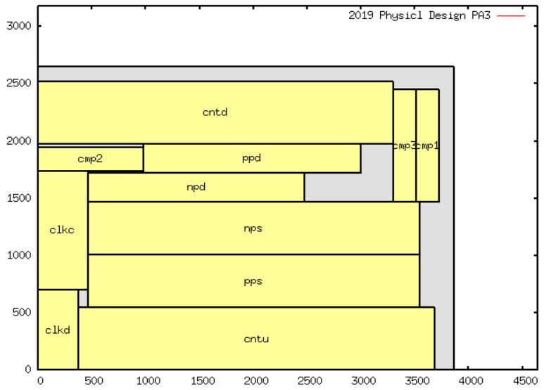

Apte:

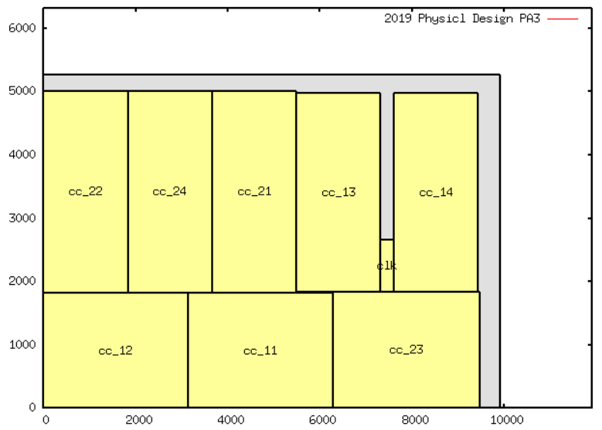

Ami33:

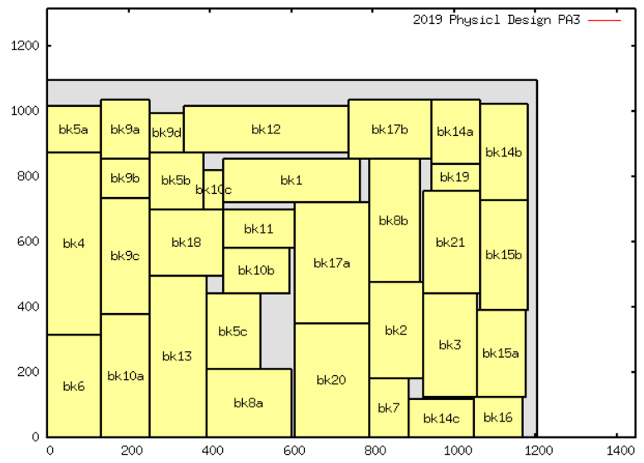

Ami49:

