Algorithm pa2 maximum planar subset

EE2 b05901172 黃禹靖

1. Algorithm
2. The algorithm is like which mentioned in the appendix of lecture notes of unit 4.
3. The algorithm is top down dynamic programming.
4. MIS means the chords amount in the maximum independent subset.

k is the other endpoint of the chord connect with j.

* Case1:

MIS(i,j) = MIS(i,j-1), k>j or k<i

* Case2 and case 3 is actually the same case:

MIS(i,j) = max( MIS(i,k-1)+1+MIS(k+1,j-1) , MIS(I,j-1) ), i<=k<j.

If the chord (k,j) is in maximum independent subset, then MIS(i,j) = MIS(i,k-1) +1 +MIS(k+1,j-1), shown in picture below.

If the chord (k,j) is not in maximum independent subset, then MIS(I,j) = MIS(i,j-1).

* Note that MIS(i,j)=0, where j<=i.

1. To access chords in MIS(i,j), construct another table to record if MIS(i,j) = MIS(i,j-1) or MIS(i,j) = MIS(i,k-1) +1 +MIS(k+1,j-1). If the case is the later, the chord (k,j) is in MIS(i,j).

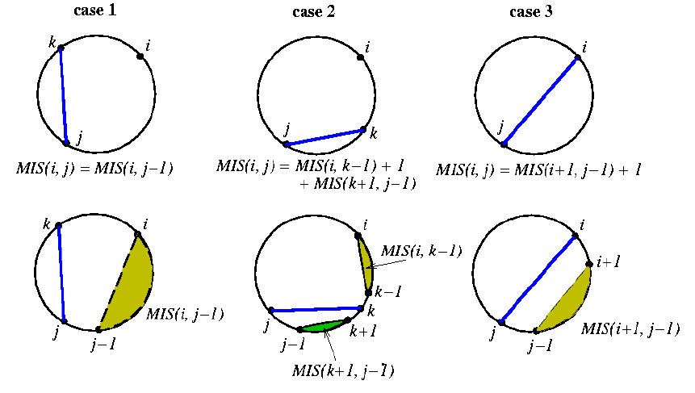

1. Data structure

N : total chords amount

* A table recording MIS(i,j) for DP.

2D size_t array of size (2N)*(2N-1)/2.

* A table recording if MIS(i,j) = MIS(i,k-1) +1 + MIS(k+1,j-1) or MIS(i,j) = MIS(i,j-1).

2D bool array of size (2N)*(2N-1)/2.

1. Discussion

It seems that there are more than one optimal solutions. So it is not so easy to check whether the program is correct. I discuss with 王鈺能 B05901025, and he wrote a program to check whether the output is really correct ,that is if there are some chords intersect.

My MPS solving program pass the test of our own debug program. So I guess it is correct.