DSP HW2 report

EE3 B05901172 黃禹靖

1. Base line

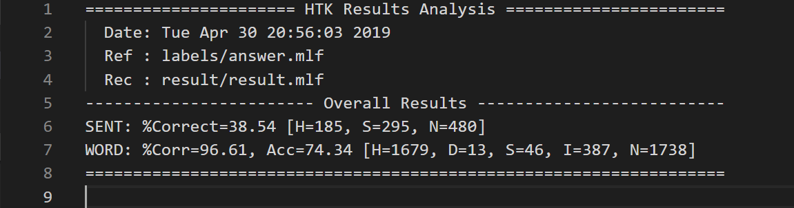

I sequentially modified iteration number of re-estimate, state number, HTK state changing range, and number of Gaussian mixture.

1. Change the iteration in 03_training.sh

Double every iteration number of re-estimate.

First re-estimate: 3 -> 6

Second re-estimate: 3 -> 6

Third re-estimate: 6 -> 12

Result in slight gain in accuracy to 77.62%.

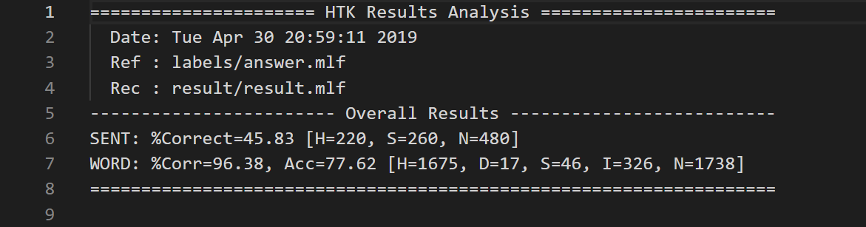

1. Change the state number to 15.

Initial model:

Mean and variance of all states are set to 0 and 1 respectively.

Transition probability is set that each state has probability 0.5 remaining in the same state, and has probability 0.5 going to the next state.

Result in great improvement in accuracy to 95.91%.

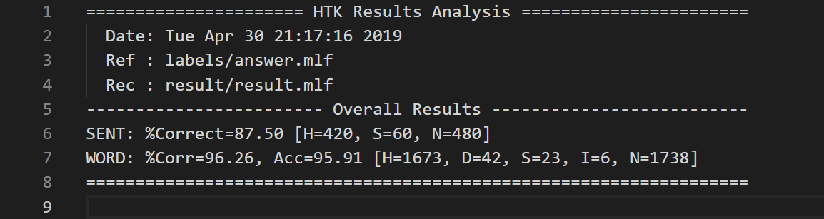

1. Modify that HTK change state from 2 to 14 for every word models.

Result in slightly improvement in accuracy to 96.61

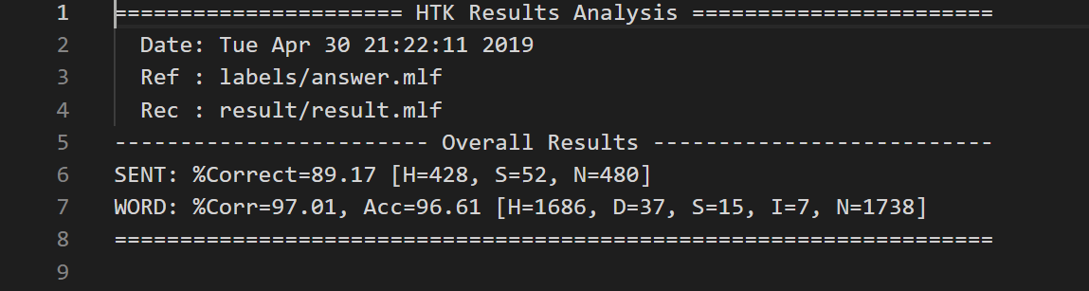

1. Modify the number of Gaussian mixture to 4 for every word models.

Result in slightly improvement in accuracy to 97.35%.

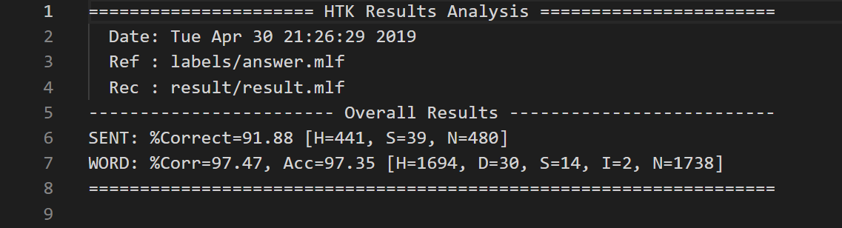

Conclusion:

Originally it used too few state to model a word, so it could not distinguish each word accurately. After increasing state number, the accuracy improved significantly. Other factors have less impact.