Comparison of Manual and Automated Data Collection for the NestWatch Community Science Project using Observations of Chickadee Nest Boxes in Washington State

Natasha Kacoroski and Doug Bonham

October 10, 2019

I. Abstract

Automated data collection of nest boxes for community science projects could decrease observer impact on the nest, improve data quality, and increase participation by decreasing the time commitment for volunteers. The eNest system is a newly available, low cost, automated data collection device for nest bird boxes that could address these issues and expand the scope of data collected. Comparing manual and eNest data collection for NestWatch, a volunteer-based nest monitoring program will provide initial evidence on the suitability of eNest in nest boxes and its compatibility with community science projects.

II. Introduction

NestWatch is a volunteer bird nest monitoring program in the United States run by the Cornell Lab of Ornithology (Cornell Lab of Ornithology, 2019). Community science projects like NestWatch expand the capability of researchers to collect large amounts of data while connecting the general public to the natural world through science. They also face challenges such as observer impact, poor data quality, and volunteer limitations. For NestWatch, manual monitoring of nest sites might disturb nests, produce imprecise data, or limit volunteer participation.

Although volunteers are trained to limit negative impacts (Cornell Lab of Ornithology, 2019), visiting a nest repeatedly could cause the parent birds to abandon the nest or alert predators and parasitic bird species to the nest location. In the NestWatch protocol, nests are visited every 3 to 4 days ideally, and not more than every 7 days (Cornell Lab of Ornithology, 2019). When the nesting cycle of most songbird chicks is only 14 to 21 days (Cornell Lab of Ornithology, 2019), many important observations may be missed and need to be estimated. These estimated observations are imprecise and lower data quality, limiting the scope of inferences that can be made. And even visiting a nest site every 7 days, or other aspects of manual data collection, might limit volunteer participation because the commitment threshold is too high.

Automating data collection to assist nest site monitoring is a viable solution to decrease nest disturbance, increase data precision, and lower the volunteer time commitment threshold. It also enriches understanding of bird nest box behavior by collecting additional environmental data. Automated monitoring with eNest, a data collection system for bird nest boxes, gathers information continuously throughout the nesting season. Designed to be non-invasive, it uses passive infrared to collect environmental metrics (humidity, air pressure, light, temperature), and movement in seconds of motion per minute. It also uses active infrared to take up to 5 images per day, which can be set to a motion trigger, and collects location coordinates. The device lasts for 10 days on a charge, but may be hooked up to a battery pack or solar panel to last for the entire nesting season. After the nesting season, the data can be uploaded to the eNest data visualization dashboard and interpreted for important nest observations. By automatically collecting data, eNest improves data precision and eliminates nest visits during the active nesting season, lowering the volunteer time commitment and possibly reducing nest disturbance.

The eNest system has the potential to benefit volunteer nest site monitoring programs, but carries potential drawbacks. In 2019, eNest was field tested in approximately 50 nest boxes with no discernable negative effects, however, it is possible that design aspects of the device may increase nest disturbance such as predation and parasitic events. And although eNest removes the need for regular nest site visits, it requires technical literacy to upload the data and interact with it through the online dashboard. We believe that these skills may be easily taught with training and support but acknowledge that computer access and technical literacy may cause barriers to volunteer participation. Device cost is also a potential hurdle to community science projects. The manufacturer’s goal is to price eNest under $100 by 2021, but it is currently at $200 to cover material costs. Finally, there is an experiential cost to consider. The eNest system collects all the data, making site visits redundant. These repeated site visits might be an integral part of connecting a volunteer to the natural world, and key to the NestWatch community science experience.

III. Hypothesis

The purpose of this study is to compare manual and eNest assisted monitoring of nest sites in a community science environment by analyzing important nest observations collected for NestWatch from chickadee nest boxes. We would like to know: (1) Is there a significant difference between nest site observations collected from manual and eNest assisted monitoring? (2) If so, which nest observations? And (3), how are they different? By answering these questions, we hope to show that eNest is a suitable alternative to manually collecting data from bird nest boxes for community science projects. Nest observations that we will examine include: dates of nesting attempts, number of nesting attempts, nesting species, number of eggs, dates of first egg laid, hatch dates, number of nest parasitism events, dates of nest parasitism events, number of nest predation events, dates of nest predation events, final nest fate, fledge dates, and host species count total.

We hypothesize that there is a difference between manual and eNest assisted monitoring of chickadee nest boxes. We predict that the temporal nest cycle observations (dates of nesting attempts, dates of first egg laid, hatch dates, and fledge dates) will be different. Observations collected by eNest will have earlier dates and be more varied because the device gathers data continuously. We also predict that the number of nesting events and host species count total will be greater, and final nest fate more positive (chicks successfully fledge) in nest boxes equipped with eNest because the device is less disturbing than repeated nest visits. We predict all other nest observations will not be significantly different. Both repeated nest visits or design features of the eNest system may alert predators or parasitic species to the nest, and, for the purpose of this study, we think these events occur randomly enough to leave out of the temporal nest cycle. Variation is expected in nesting species and number of eggs, but we think these will be comparable.

IV. Methodology

Site Area: This study will take place in outdoor urban and suburban environments in the Greater Seattle Area of Washington State. For experimental control, it will focus on chickadee (*Poecile sp.*) nest sites. Nest boxes will be designed for chickadees (Cornell Lab of Ornithology, 2019), and installed in areas where they are known to frequent. Boxes will be attached to a building, pole, post or tree 5 to 15 feet off the ground with the entrance hole facing away from prevailing winds. Nest boxes will be a minimum of 650 feet apart.

Materials: All equipment will be supplied by the eNest manufacturer, Animal Data Science, including: nest boxes, nest hanging materials, eNest data collection system, solar panels, battery packs, and micro SD cords. Equipment costs will be funded by partnership between Animal Data Science and the Eastside Audubon Society. Computer access assistance will be provided by Animal Data Science. Equipment requests for nest access will be evaluated on a case by case basis. At the end of the study period, volunteers may choose to keep the nest box or receive assistance from Animal Data Science to remove it. All eNest monitoring equipment will be donated to the Eastside Audubon Society.

Budget:

|  |  |  |  |
| --- | --- | --- | --- |
| Item | Cost Per Unit | Quantity | Total |
| eNest system | $200 | 52 - 100 | $10,400 - $20,000 |
| chickadee nest box |  | 52 - 100 |  |

Volunteer Recruitment: 26 to 100 volunteers will be recruited from the Eastside Audubon Society and local birding community through booths at birding events, newsletters, and social media. Nest boxes will be distributed as randomly and independently as possible, depending upon volunteer recruitment results. The goal is to have a total sample size of 52 to 100 nest boxes (see data analysis below). We suspect more volunteers will be able to commit to the eNest method, and will limit volunteer participation to maintain equal sample sizes. If there are enough volunteers, each volunteer will be given one nest box. If not, we will give multiple nest boxes to a volunteer as long as nest boxes will be 650 feet apart. Ideally, a volunteer will have no more than 2 nest boxes. We are also considering, giving each volunteer 2 nest boxes, one for each monitoring type, depending on volunteer availability. To limit nest site bias, all nest sites will be accessible for manual monitoring, and eNest monitors will be placed as randomly as possible after nest boxes are installed. All volunteers will complete NestWatch training for monitoring nest sites and using the eNest app. Trainings will be held before and after the nesting season in group sessions. For those who can’t attend, individualized trainings will be provided by Animal Data Science during nest box installment. Support and resources will be provided to volunteers throughout the study period.

Data Collection: Manual monitoring will follow the NestWatch protocol, and consists of visiting the nest box every 3-7 days to collect data on nest attempts. At the end of each nest attempt, the volunteer records a nest summary. For more information see the Understanding NestWatch Data (https://nestwatch.org/learn/how-to-nestwatch/understanding-nestwatch-data/) on the NestWatch website. For eNest assisted monitoring, volunteers will set up the eNest device, and then stay away from the nest. At the end of the nesting season, volunteers will collect the eNest device, transfer data to a computer using a micro SD cord, and upload it to the eNest app. There will be a feature built into the eNest app for submitting nest site reports to NestWatch. Using the eNest app, volunteers will visualize their data, identify important nest site observations, and submit information to NestWatch.

Analysis: After all data has been submitted, Animal Data Science will retrieve the data from NestWatch for analysis. Exploratory data analysis will be conducted on the following nest site data: location, site description, dates of nesting attempts, number of nesting attempts, nesting species, number of eggs, dates of first egg laid, hatch dates, number of nest parasitism events, dates of nest parisitism events, number of nest predation events, dates of nest predation events, final nest fate, fledge dates, host species count total, and number of completed nest reports. From *a priori* power analyses (Figure 1) using G*Power (Faul, Erdfelder, Lang, & Buchner, 2007), a total sample size between 30 and 100 is too small with 14 dependent variables for a multivariate analysis of variance (MANOVA). Instead, it is possible to do a series of independent t-tests corrected for multiple comparisons with a total sample size of 52 (26 nest boxes per group).

Figure 1

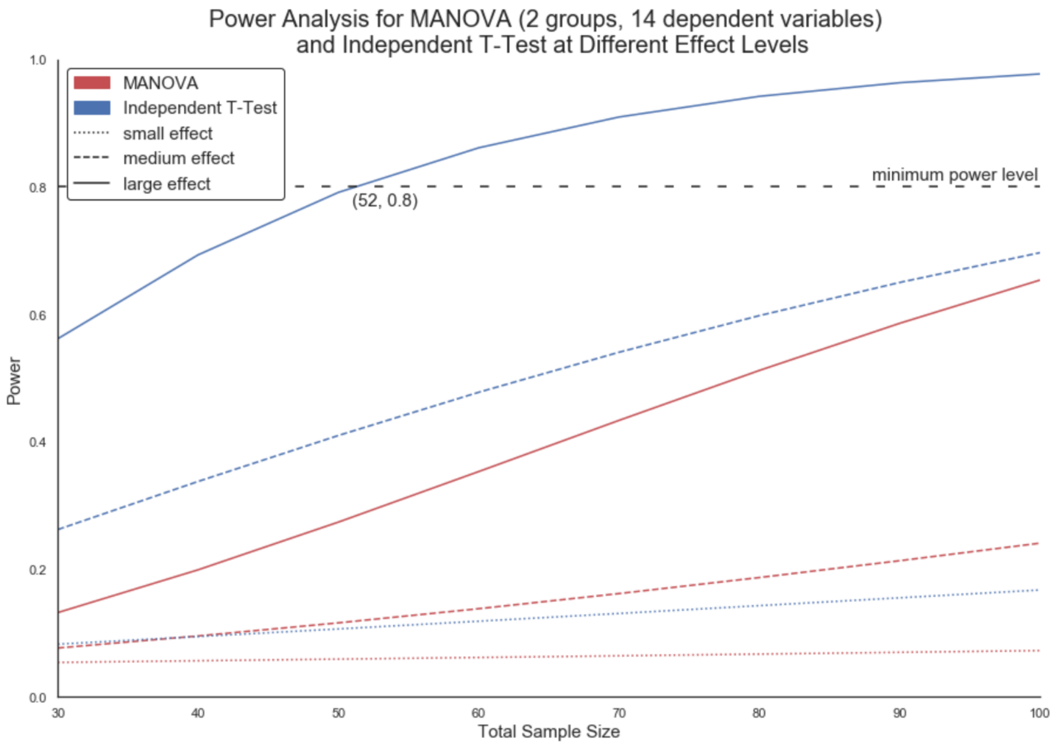

This means that the scope of the study is limited to comparing the two monitoring methods at each specific dependent variable, and cannot compare the two methods in aggregate. To determine if there is a difference between manual and eNest assisted monitoring of chickadee nest boxes in aggregate, it may be possible to use Bayesian inference and computational statistics, but these techniques need further investigation. Results will be shared with the public, and if possible, submitted for publication in a scientific journal.

Timeline:

|  |  |
| --- | --- |
| Date | Event |
| October – December 2019 | volunteer recruitment, nest box and eNest construction |
| January 2020 | nest box installation |
| February 2020 | eNest placement, volunteer training |
| March – August 2020 | data collection |
| September 2020 | volunteer training, data submission |
| October 2020 | study completion, data analysis, study publication |

V. Conclusion and Justification

Automated data collection is a growing technique in the scientific community. It is a less time-intensive method to gather high quality data over a continuous observation window. The eNest data collection system is a device that has many potential benefits, but is relatively untested as a monitoring method for bird nest boxes. And community science programs are limited by the quality of data they can collect from the number of volunteers who can make a commitment. Comparing eNest assisted to manual monitoring of nest sites in the NestWatch program will provide evidence on the suitability of eNest in bird nest boxes, and its compatibility with community science projects like NestWatch. If eNest is an acceptable monitoring method, it could dramatically change the quality and scope of data collected by volunteers, leading to a more intimate look at animal behavior and higher engagement in community science programs.

# VI. References

Cornell Lab of Ornithology. (2019, 10 11). *All About Birdhouses Black-capped Chickadee Nest Box Plan and Information*. Retrieved from NestWatch: https://nestwatch.org/learn/all-about-birdhouses/birds/black-capped-chickadee/

Cornell Lab of Ornithology. (2019, 10 11). *Black-capped Chickadee Life History*. Retrieved from All About Birds: https://www.allaboutbirds.org/guide/Black-capped_Chickadee/lifehistory

Cornell Lab of Ornithology. (2019, 10 11). *General Bird & Nest Info*. Retrieved from NestWatch: https://nestwatch.org/learn/general-bird-nest-info/nesting-cycle/

Cornell Lab of Ornithology. (2019, 10 11). *How to Nest Watch Code of Conduct*. Retrieved from NestWatch: https://nestwatch.org/learn/how-to-nestwatch/code-of-conduct/

Cornell Lab of Ornithology. (2019, 10 11). *Overview*. Retrieved from NestWatch: https://nestwatch.org/about/overview/

Cornell Lab of Ornithology. (2019, 10 11). *Understanding NestWatch Data*. Retrieved from NestWatch: https://nestwatch.org/learn/how-to-nestwatch/understanding-nestwatch-data/

Faul, F., Erdfelder, E., Lang, A.-G., & Buchner, A. (2007). G*Power 3: A Flexible Statistical Power Analysis Program for the Social, Behavioral, and Biomedical Sciences. *Behavior Research Methods*, 175-191.