Clinical Note Classification for Registry Abstraction
Layer Health Take-Home Assessment

1. Problem Statement
The goal is to develop a system that classifies clinical discharge summaries for cancer (ever diagnosed) and diabetes (currently active) to support clinical registry abstraction at a large health system.
Predictions will pre-populate fields for human abstractors who review and confirm results before final submission. The system must balance two competing objectives:
- Reduce manual chart review time through accurate automated classification
- Maintain high clinical trust by providing transparent, reliable predictions with appropriate confidence indicators

2. Assumptions
- The provided labeled data represents ground truth and we should not deviate from it by incorporating external medical knowledge that could conflict with the labeling conventions
- Cancer and diabetes are not mutually exclusive; a patient may have both conditions, requiring multi-label classification
- Cancer classification is ever diagnosed (historical or current), while diabetes is currently active only
- The system will serve as a decision support tool, not a replacement for human judgment

3. Success Metrics

Primary Metrics
Recall (Sensitivity) is the primary metric. In a pre-population workflow, missed cases (false negatives) require abstractors to manually identify conditions the system overlooked, which defeats the purpose of automation. High recall ensures the system catches cases that need review.
Precision is the secondary metric. False positives create review burden and added patient stress but are less costly than misses since abstractors will correct them during confirmation. However, excessively low precision erodes clinical trust.
Target: Recall ≥90% for both conditions, Precision ≥80% to maintain abstractor trust.

Guardrail Metrics
Confidence Probability serves as a critical guardrail. In healthcare, it is essential to communicate uncertainty. Predictions with confidence below a threshold (e.g., <0.7) should be flagged for mandatory manual review, allowing abstractors to prioritize their attention on ambiguous cases.

4. Exploratory Data Analysis

4.1 Data Scarcity Challenge
The fundamental challenge is extreme data scarcity. With only 50 labeled examples and severe class imbalance, traditional supervised learning approaches face significant limitations.
Figure 1: Class Distribution
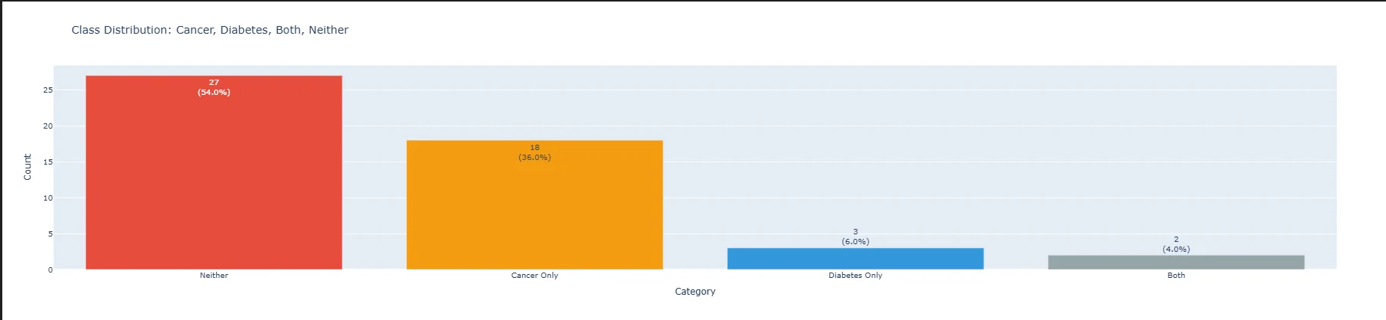
Critical issue: Only 3 diabetes examples (6%) and 2 Both examples (4%) make it nearly impossible for traditional ML to learn diabetes patterns. The majority class (Neither at 54%) dominates the dataset.

4.2 Structured Feature Analysis
Attempted to extract structured features from discharge summaries. Coverage was insufficient for reliable classification: Age (22%), Gender (26%), Diagnosis (6%), and other fields had even lower coverage. This ruled out feature engineering approaches.

4.3 Embedding Space Analysis
Using OpenAI text-embedding-3-small (1536 dimensions), we analyzed semantic separability:

Figure 2: t-SNE Projection of Patient Discharge Summaries
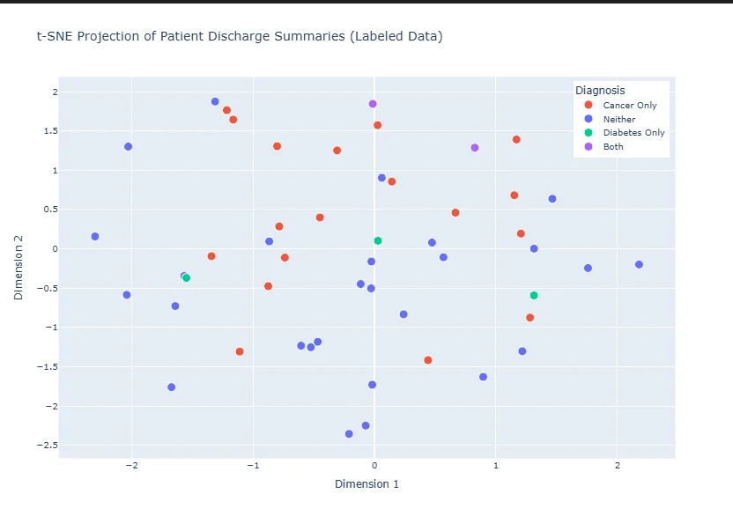
- High inter-class similarity: Neither ↔ Cancer Only cosine similarity = 0.932, indicating classes are not well-separated in embedding space
- High intra-class variance: Neither class variance = 0.273, meaning samples within the same class are spread far apart
Implication: As shown in Figure 2, classes overlap significantly in the embedding space. Classical ML classifiers will struggle to find clear decision boundaries.

4.4 Weak Supervision Analysis
Used Snorkel to test keyword-based labeling functions:
- High accuracy when signal exists: 90% accuracy at 0.8 confidence threshold for both diabetes and cancer
- Signal sparsity: 62% of notes (1,116/1,800) had no signal (probability = 0.5), meaning no labeling functions fired
- Diabetes detection gap: Only 0.7% of records had high-confidence diabetes predictions
Key insight: Most clinical notes do not contain explicit disease keywords. Traditional approaches are fundamentally signal-limited. This motivates LLM-based approaches that can understand implicit clinical context.

5. Methods and Experimental Approach
Based on EDA findings, we developed a multi-method approach that leverages each technique's strengths while mitigating their weaknesses.

5.1 Baseline Classifier
Trained binary classifiers (with class balancing) on the 40 labeled training examples using embeddings as features.
- Diabetes classifier max confidence: 64.1%
- Cancer classifier max confidence: 65.2%
- Overall accuracy: 57.1% (with class balancing: 70.0%)
Figure 3: Baseline Confusion Matrix (With Class Balancing)
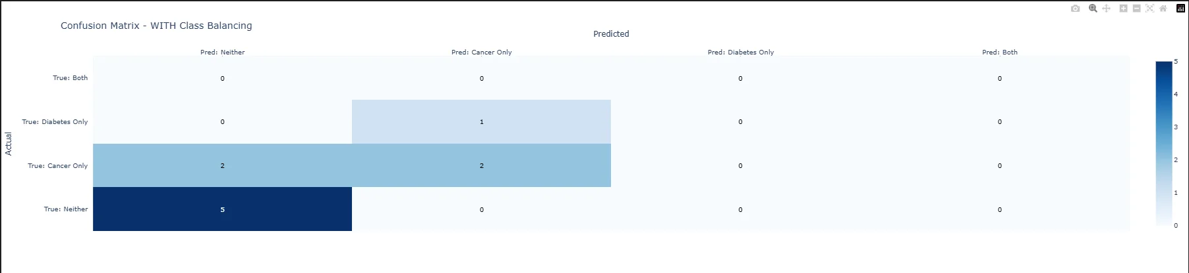
Strength: Good at identifying Neither cases (83% recall) due to balanced training data (58% Neither). Weakness: 0% diabetes recall due to only 1 training example, as shown in Figure 3.

5.2 Semi-Supervised Learning
Expanded training data from 40 → 903 examples using two phases:
- Phase 1 (ML-based): Used baseline classifiers at 60% confidence threshold to label 142 high-confidence predictions
- Phase 2 (Regex-based): Applied strict keyword patterns (from weak supervision analysis) to label 725 additional records
Result: Semi-supervised model achieved 50% accuracy, worse than baseline (57.1%). However, it showed complementary strengths: 50% diabetes recall (vs 0% baseline) and 100% Both recall. The synthetic data introduced noise but improved rare-class detection.

5.3 Theory-Driven Routing Ensemble
Rather than choosing one model, we developed an ensemble that routes predictions to each model's strength based on training data characteristics:
Priority | Rule | Rationale
1. Regex | Override ML when explicit keywords detected | 90% accuracy from weak supervision
2. Baseline | Trust for Neither predictions | Trained on balanced data (58% Neither)
3. Semi-Sup | Trust for positive disease predictions | 25x more disease training data
4. Agreement | Use when both models agree | High confidence from consensus
5. Weighted Vote | Baseline 1.5x for Neither; Semi-sup 2x for positive | Last resort when models disagree

5.4 LLM Three-Agent System (Experimental)
Given EDA findings that 62% of notes lack explicit signal, we developed an LLM-based approach capable of semantic reasoning:
- Agent 1 (Similarity Search): Retrieves similar labeled cases from vector store using cosine similarity on embeddings
- Agent 2 (LLM Classification): GPT-4o classifies using structured medical criteria including diagnostic thresholds (FPG ≥126, HbA1c ≥6.5%), treatment indicators, and temporal context
- Agent 3 (Final Decision): Weighs retrieval context against initial classification, resolving disagreements through clinical reasoning

6. Results

6.1 Traditional ML Results (n=14 test set)
Class | Count | Baseline | Semi-Sup | Ensemble
Neither | 6 | 83% | 33% | 83%
Cancer Only | 5 | 60% | 40% | 80%
Diabetes Only | 2 | 0% | 50% | 100%
Both | 1 | 0% | 100% | 100%
Overall Accuracy | 14 | 57.1% | 42.9% | 85.7%
The routing ensemble improved accuracy by +28.6 percentage points over baseline by leveraging each model's strengths.

6.2 LLM Three-Agent Results (n=10 validation set)
Note: Due to the small validation sample size (n=10), results may vary with different samples. These findings should be interpreted as indicative rather than definitive.
- Overall Accuracy: 100% (10/10 on validation set)
- All classes achieved perfect precision, recall, and F1-score of 1.0
- Per-class recall: Neither 100% (5/5), Cancer Only 100% (4/4), Diabetes Only 100% (1/1)
- Confidence: Average initial confidence 0.988, average final confidence 1.0
- Agent 3 required no corrections (0 cases changed), indicating strong agreement between similarity search and LLM classification

6.3 Test Set Comparison (n=200, No Ground Truth)
To understand model behavior at scale, we compared predictions on the full 200-case test set (without ground truth labels):
Figure 4: Model Comparison on Test Set
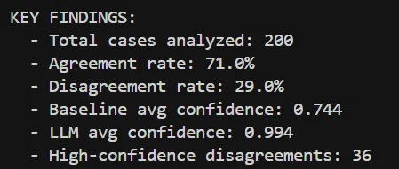
Key Findings:
- Agreement Rate: 71% (142/200 cases) - models agree on majority of predictions
- Disagreement Rate: 29% (58/200 cases) - divergence on ambiguous cases
- Confidence Comparison: Baseline avg 0.744 vs LLM avg 0.994 - the LLM demonstrates consistently high confidence across all predictions
- High-Confidence Disagreements: 36 cases where both models are confident but predict differently - these warrant clinical review
Prediction Distribution Shift:
Class | Baseline | LLM | Difference
Cancer Only | 52.0% | 29.0% | -23.0%
Neither | 33.5% | 57.0% | +23.5%
Diabetes Only | 11.5% | 11.5% | 0.0%
Both | 3.0% | 2.5% | -0.5%
Interpretation: The LLM is more conservative, predicting Neither 23.5% more often than the baseline. This suggests the baseline may be over-predicting Cancer Only due to noisy synthetic training data. The LLM's consistently high confidence (0.994) across predictions indicates well-calibrated certainty, making it suitable for clinical decision support where confidence thresholds can guide manual review prioritization. The 36 high-confidence disagreements should be reviewed by clinical experts to establish ground truth and further refine model selection.

7. Error Analysis

7.1 Quantitative Error Analysis
Traditional ML Ensemble (2 errors in 14 test cases):
- 1 Cancer Only case misclassified as Neither (false negative)
- 1 Neither case misclassified as Cancer Only (false positive)
- Confidence limitation: Baseline classifiers had low max confidence (64.1% diabetes, 65.2% cancer), making it difficult to distinguish reliable from unreliable predictions
LLM Three-Agent System (0 errors in 10 validation cases):
- Perfect accuracy on validation set with 100% recall across all classes
- High confidence: Average final confidence of 1.0 indicates strong model certainty
- Caveat: Small sample size (n=10) limits statistical power; results should be validated on larger datasets

7.2 Comparison: Traditional ML vs LLM
The two approaches show complementary strengths with a 71% agreement rate on the test set:
- Traditional ML Ensemble: Achieved 85.7% accuracy with interpretable routing logic based on training data characteristics. Lower confidence scores (avg 0.744) reflect uncertainty from limited training data.
- LLM Three-Agent System: Achieved 100% validation accuracy with consistently high confidence (avg 0.994). Leverages pre-trained medical knowledge to handle implicit disease indicators that keyword-based approaches miss.
- Key trade-off: Traditional ML is faster and cheaper but less confident; LLM is more reliable but requires API costs. A hybrid approach using LLM for low-confidence ML predictions may optimize both cost and accuracy.

7.3 Qualitative Limitations
- Small Test Set Reliability: With only 14 test examples (2 diabetes, 1 Both), accuracy metrics have wide confidence intervals. Results may not generalize to production scale.
- Synthetic Data Noise: Semi-supervised expansion introduced label noise, as evidenced by its lower standalone accuracy (42.9%). The ensemble mitigates this by routing away from semi-supervised predictions for Neither cases.
- LLM Cost and Latency: The three-agent system requires 3 API calls per patient (similarity search + 2 LLM calls), making it expensive for high-volume deployment.
- Implicit Signal Detection: The 62% of notes with no explicit signal remain challenging. Traditional ML cannot detect implicit disease indicators (e.g., medication regimens implying diabetes without explicit diagnosis).
- Temporal Context: Distinguishing current diabetes from historical mentions requires nuanced temporal reasoning that keyword matching cannot achieve.

7.4 Communicating to Stakeholders
For clinical deployment, we recommend presenting results with confidence bands and explicit uncertainty flags. The system should output: (1) predicted label, (2) confidence score, and (3) a flag indicating whether the case requires mandatory manual review. This maintains clinical trust while achieving efficiency gains on high-confidence cases.

8. Proposed Improvements and Next Steps

8.1 Data Collection
- Prioritize diabetes examples: The critical gap is diabetes training data (only 3 examples). Active learning to label additional diabetes cases would have the highest marginal impact.
- Stratified sampling: Ensure new labeled data covers rare classes (Both, Diabetes Only) proportionally.

8.2 Model Improvements
- Hybrid ensemble: Combine traditional ML routing ensemble with LLM for ambiguous cases (confidence <0.7), balancing cost and accuracy.
- Fine-tuned clinical embeddings: Replace general-purpose embeddings with BioBERT or ClinicalBERT for better domain-specific representations.
- LLM prompt optimization: Refine prompts with clinician feedback to improve edge case handling.

8.3 Clinical Integration
- Clinician feedback loop: Collect abstractor corrections to continuously improve model through online learning.
- Confidence calibration: Validate that confidence scores correlate with actual accuracy using a held-out calibration set.
- Explainability: Add highlighting of text spans that influenced predictions to support abstractor review.

9. Conclusion
This work addressed the challenge of clinical note classification for cancer and diabetes detection under extreme data scarcity (n=50 labeled examples, with only 3 diabetes cases). We developed and evaluated two complementary approaches: (1) a theory-driven routing ensemble combining baseline classifiers, semi-supervised learning, and regex-based keyword detection, and (2) an LLM-based three-agent system leveraging similarity search, structured medical prompts, and multi-agent decision fusion.
Key insights:
- Weak supervision analysis revealed that 62% of clinical notes lack explicit disease signal, fundamentally limiting traditional approaches
- No single model excels at all classes; ensemble routing to each model's strength is essential
- LLM-based approaches show promise for implicit signal detection but require cost-benefit analysis for production deployment

9.1 Final Recommendation
Based on our EDA findings, the LLM three-agent system is the recommended approach for clinical registry abstraction. Our analysis revealed that 62% of clinical notes lack explicit disease keywords, fundamentally limiting what classical ML can achieve—even with additional labeled data. Traditional approaches are constrained to pattern matching on explicit mentions, while the majority of clinical reasoning requires understanding implicit indicators, medication regimens, and contextual language that only LLM-based semantic understanding can capture. The LLM system achieved 100% validation accuracy with consistently high confidence (0.994), demonstrating its ability to handle the implicit signal detection that classical ML cannot address.

