Introduction

¡Insignifigante! Is my rendition of a trivia game. The game is very simple. The user must input an answer to each question. At the end of the game the user is given a score as well as an assessment of their intelligence.

Summary

Project size: 260 lines

The number of variables: 15

I believe that this project can also be used as a template for the second project. For example, I can include all of the trivia questions, including their if/else statements in files.

My project contains many concepts that we've learned during the first 4 weeks of class. The project took me the better part of two weeks. I feel like the project was moderately difficult, but made very difficult by the coinciding mid-term. I was able to limit the game to concepts we’ve learned during the first four weeks. I originally had a different idea for my game; but upon learning that my idea would require concepts from the from the course that we were yet to be introduced to, I decided to design a game that still challenged my understanding of the lessons thus far, but that I would be able to complete with little extra help from you or the SI's.

Description

The main point of the program is to utilize the 7 constructs, primitive data types, formatting, and file I/O.

Variables

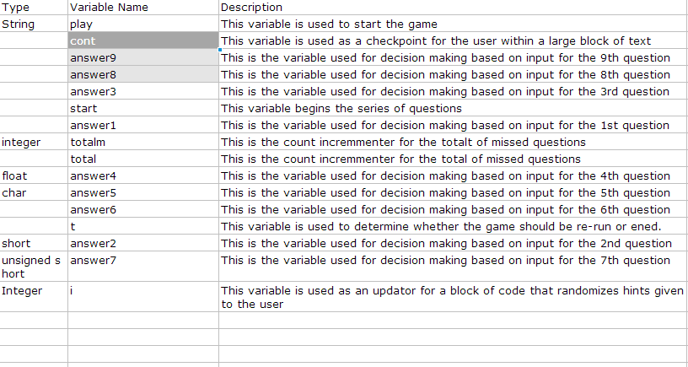

C++ Construct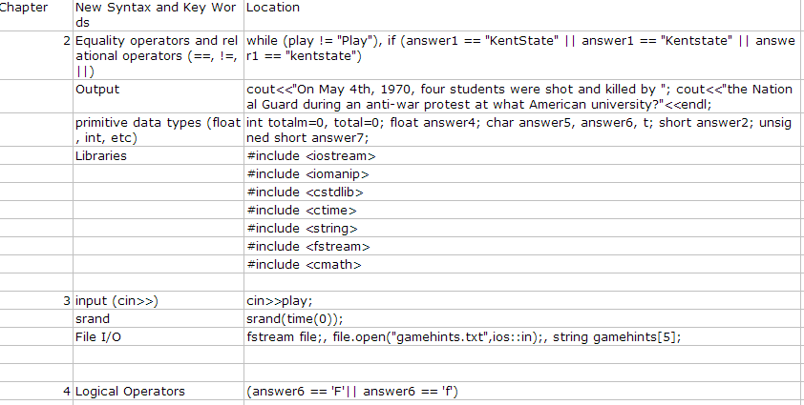

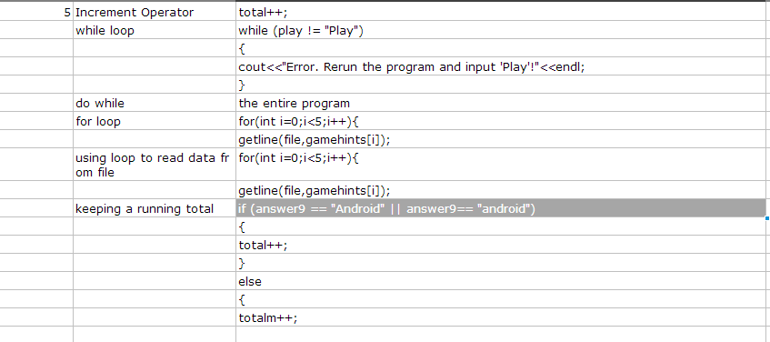

Pseudo Code

initialize

while “Play” is entered

do

Display Instructions

Prompt user to input “Continue”

Prompt user to input “start” or “help”

Display questions

Keep running total

Output assessment Output results from switch statement

Else if star t= hint

Print random hint from file

While (play !=”Play”) execute infinite loop to prompt user to input “Play”

While player inputs ‘Y’ for t variable

Flo-Chart

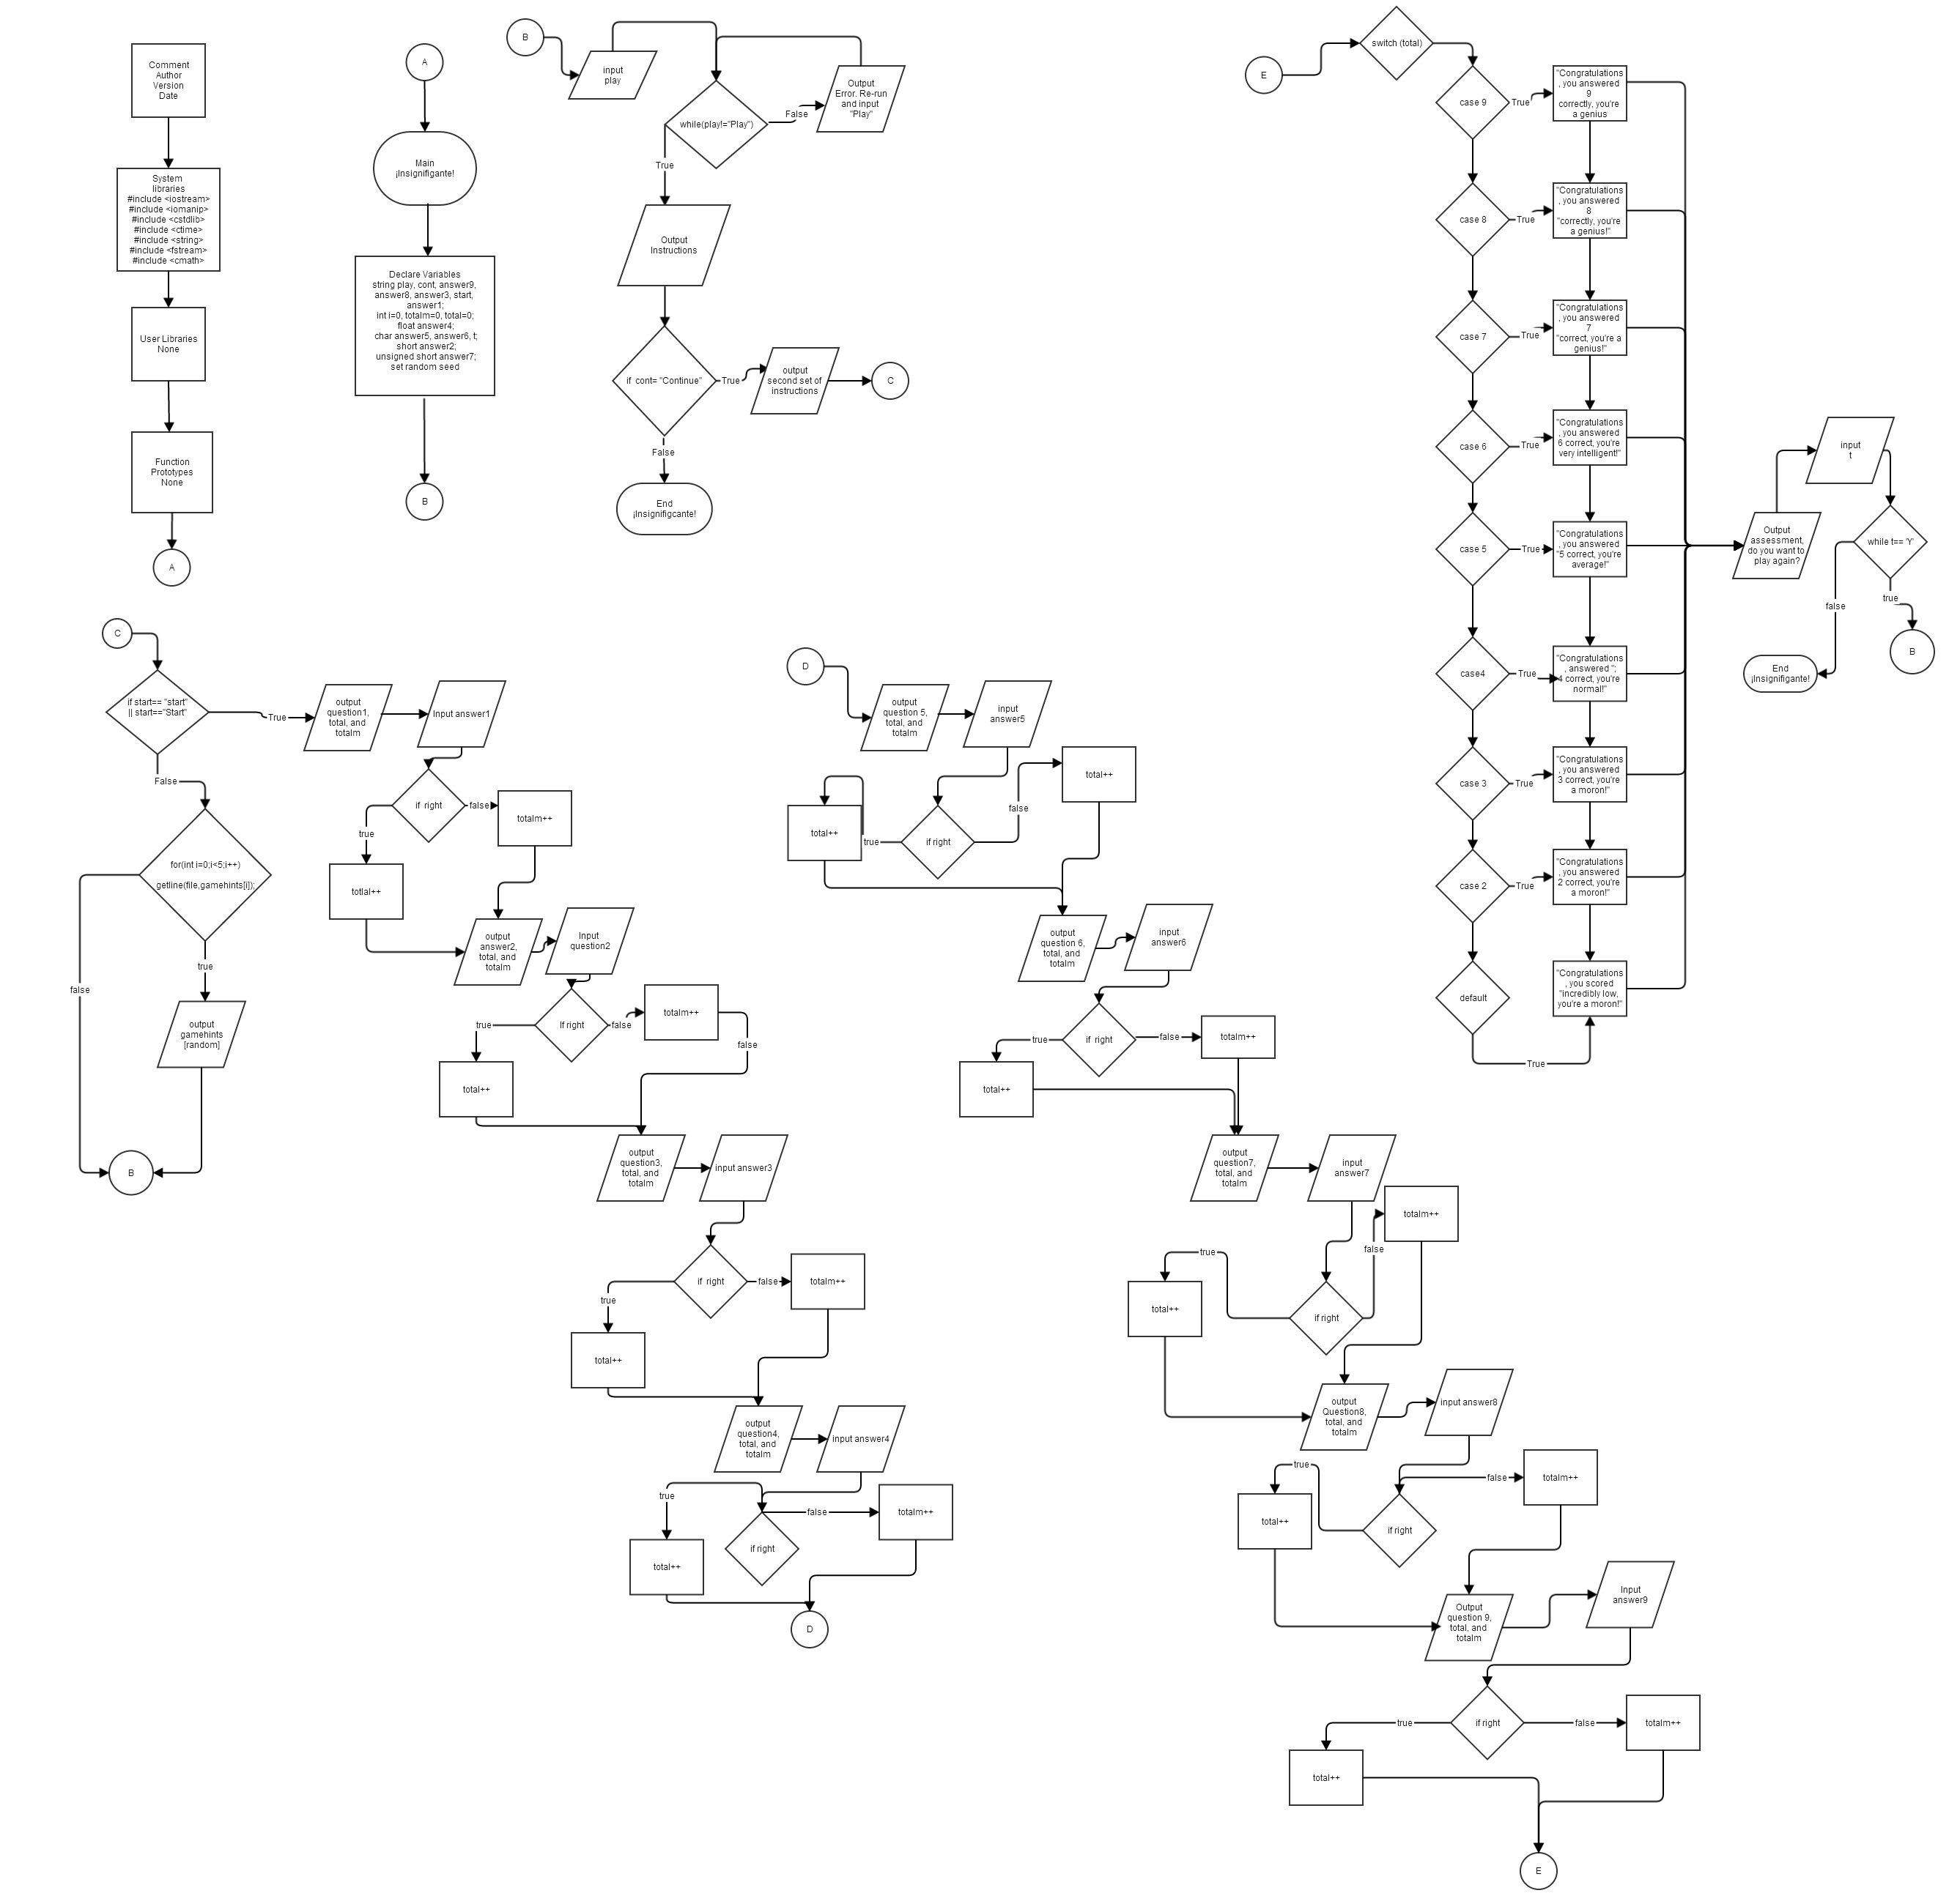

Code

#include <iostream>

#include <iomanip>

#include <cstdlib>

#include <ctime>

#include <string>

#include <fstream>

#include <cmath>

using namespace std;

//User Libraries

//Global Constant

//Function Prototypes

//Execution Begins Here

int main(int argc, char\*\* argv) {

//Declare variables

string play, cont, answer9, answer8, answer3, start, answer1;

int totalm=0, total=0;

float answer4;

char answer5, answer6, t;

short answer2;

unsigned short answer7;

srand(time(0));

fstream file;

file.open("gamehints.txt",ios::in);

string gamehints[5];

cout<<"Welcome to ¡Insignifigante!"<<endl;

cout<<"Input 'Play' to play."<<endl;

cin>>play;

while (play != "Play")

{

cout<<"Error. Rerun the program and input 'Play'!"<<endl;

}

do

{

cout<<"¡Insignifigante! trivia game!"<<endl;

cout<<"Its topics span the globe."<<endl;

cout<<"The game will ask you for "<<endl;

cout<<"specific dates, as well as the names"<<endl;

cout<<"of powerful figures from our worlds history."<<endl;

cout<<"If you do not know the answer to a question"<<endl;

cout<<" just guess. There are nine questions in this game"<<endl;

cout<<" so each question is very important."<<endl;

cout<<"Because the game is so hard, at the beginning "<<endl;

cout<<"of each game you can input 'Hint' instead,";

cout<<" of 'Start' to receive a randomly drawn hint."<<endl;

cout<<"Do NOT input spaces. If you feel a question warrants"<<endl;

cout<<"a two word response, input both words without a space in between."<<endl;

cout<<"Remember to capitalize the first letter of";

cout<<" each word you input."<<endl;

cout<<"If you're still paying attention input 'Continue'."<<endl;

cin>>cont;

if (cont== "Continue")

{

cout<<"At the end of each game you will be given an"<<endl;

cout<<" assessment based of your performance."<<endl;

cout<<"The assessment may hurt, but remember this:"<<endl;

cout<<"What doesn't kill you makes you STRONGER!"<<endl;

cout<<"NOW GO AHEAD AND INPUT 'Start' or 'Hint'!"<<endl;

cout<<"Goodluck!"<<endl;

cin>>start;

}

if (start == "start" ||start == "Start")

{

cout<<"On May 4th, 1970, four students were shot and killed by ";

cout<<"the National Guard during an anti-war protest at what American university?"<<endl;

cin>>answer1;

if (answer1 == "KentState" || answer1 == "Kentstate" || answer1 == "kentstate")

{

total++;

}

else

{

totalm++;

cout<<"Wrong!!"<<endl;

}

cout<<"Correct: "<<total<<" Missed: "<<totalm<<endl;

cout<<"In what year did the first European";

cout<<" ship land in NORTH America??"<<endl;

cin>>answer2;

if (answer2 == 1497)

{

total++;

}

else

{

totalm++;

cout<<"Wrong!!"<<endl;

}

cout<<"Correct: "<<total<<" Missed: "<<totalm<<endl;

cout<<"Which African country gained its independence";

cout<<" from Britain in the year 1960?"<<endl;

cin>>answer3;

if (answer3 == "Nigeria" || answer1 == "nigeria")

{

total++;

}

else

{

totalm++;

cout<<"Wrong!!"<<endl;

}

cout<<"Correct: "<<total<<" Missed: "<<totalm<<endl;

cout<<"Input the 4th significant figure of PI."<<endl;

cin>>answer4;

if (answer4 == 1)

{

total++;

}

else

{

totalm++;

cout<<"Wrong!!"<<endl;

}

cout<<"Correct: "<<total<<" Missed: "<<totalm<<endl;

cout<<"The Black Mamba is the most poisonous land snake. ";

cout<<"Input 'T', or 'F'?(True or False)."<<endl;

cin>>answer6;

if (answer6 == 'F'|| answer6 == 'f')

{

total++;

}

else

{

totalm++;

cout<<"Wrong!!"<<endl;

}

cout<<"Correct: "<<total<<" Missed: "<<totalm<<endl;

cout<<"Human blood is blue before being oxygenated. ";

cout<<"Input 'T', or 'F'?(True or False)."<<endl;

cin>>answer6;

if (answer6 == 'F'|| answer6 == 'f')

{

total++;

}

else

{

totalm++;

cout<<"Wrong!!"<<endl;

}

cout<<"Correct: "<<total<<" Missed: "<<totalm<<endl;

cout<<"The first atomic bomb dropped on Japan was";

cout<<" equal to approximately how many tons of TNT?"<<endl;

cin>>answer7;

if (answer7 == 20000)

{

total++;

}

else

{

totalm++;

cout<<"Wrong!!"<<endl;

}

cout<<"Correct: "<<total<<" Missed: "<<totalm<<endl;

cout<<"What is the first name of the president ";

cout<<"who served the longest term in American history?"<<endl;

cin>>answer8;

if (answer8 == "Franklin" || answer8 == "franklin")

{

total++;

}

else

{

totalm++;

cout<<"Wrong!!"<<endl;

}

cout<<"Correct: "<<total<<" Missed: "<<totalm<<endl;

cout<<"Which Mobile operating system featured ";

cout<<"home screen folders and multitasking first?"<<endl;

cout<<"IOS or Android?"<<endl;

cin>>answer9;

if (answer9 == "Android" || answer9== "android")

{

total++;

}

else

{

totalm++;

cout<<"Wrong!!"<<endl;

}

cout<<"Correct: "<<total<<" Missed: "<<totalm<<endl;

switch (total){

case 9:cout<<"Congratulations, answered 9 ";

cout<<"correctly, you're a genius!"<<endl;

break;

case 8:cout<<"Congratulations, answered ";

cout<<"8 correct, you're a genius!"<<endl;

break;

case 7:cout<<"Congratulations, you answered 7 ";

cout<<"correct, you're a genius!"<<endl;

break;

case 6:cout<<"Congratulations, you answered ";

cout<<"6 correct, you're very intelligent!"<<endl;

break;

case 5:cout<<"Congratulations, you answered ";

cout<<"5 correct, you're average!"<<endl;

break;

case 4:cout<<"Congratulations, answered ";

cout<<"4 correct, you're normal!"<<endl;

break;

case 3:cout<<"Congratulations, answered ";

cout<<"3 correct, you're a moron!"<<endl;

break;

case 2:cout<<"Congratulations, answered ";

cout<<"2 correct, you're a moron!"<<endl;

break;

default:cout<<"Congratulations, you scored ";

cout<<"incredibly low, you're a moron!"<<endl;

}}

else if (start== "hint" || start == "Hint")

{

for(int i=0;i<5;i++){

getline(file,gamehints[i]);

}

int random = rand()%5;

cout<<gamehints[random]<<endl;

}

cout<<"Do you want to play again?";

cout<<" If yes input 'Y', if not input 'N'."<<endl;

cin>>t;

}

while(t == 'Y' || t == 'y');

return 0;

}