Accuracy and Precision of Continuous Non-Invasive Arterial Pressure Monitoring in Critical Care

A systematic review and meta-analysis

Navpreet Kamboj MScN1, Kristina Chang MScN2, Kelly Metcalfe PhD1,5, Charlene H. Chu PhD1,4, and Aaron Conway PhD1,2,3

1 Lawrence S. Bloomberg Faculty of Nursing, University of Toronto, Toronto, Canada

2 Peter Munk Cardiac Centre, University Health Network, Toronto, Canada  
3 School of Nursing, Queensland University of Technology (QUT), Brisbane, Australia

4 KITE-Toronto Rehabilitation Institute, University Health Network, Toronto, Canada

5 Women’s College Research Institute, Toronto, Canada

## 

## Declarations

Availability of data and material (data transparency): All data used in the meta-analyses is available [here](https://github.com/nkamboj06/cnap-review).

Code availability: All data used in the meta-analyses is available [here](https://github.com/nkamboj06/cnap-review).

Abbreviated title: CNAP Monitoring in Critical Care

Funding statement: This research did not receive any specific grant from funding agencies in the public, commercial, or not-for-profit sectors.

Conflict of interest: none

**Author contributions:** NK: Study design, analysis, Writing- Original draft preparation;

AC: Study design, Supervision, Writing- Reviewing and Editing; KC: Study design, Writing- Reviewing and Editing; KM: Study design, Writing- Reviewing and Editing; CC: Study design, Writing- Reviewing and Editing.

### Abstract

**Objective**

To summarize the evidence regarding the agreement between continuous non-invasive and invasive arterial pressure measurements in adult critical care patients.

**Research Methodology**

Medline and EMBASE were searched for studies that included adult critical care patients reporting the agreement between continuous non-invasive and invasive arterial pressure measurements. Two reviewers independently selected studies and assessed risk of bias using the Revised Quality Assessment of Diagnostic Accuracy Studies tool (QUADAS-2). The Grading of Recommendations, Assessment, Development and Evaluations approach was used. Pooled estimates of the mean bias and limits of agreement with outer 95% confidence intervals (termed population limits of agreement) were calculated.

**Results**

Population limits of agreement for systolic blood pressure were wide, spanning from -36.13 mmHg to 28.28 mmHg (18 studies; 785 participants). Accuracy of diastolic blood pressure measurements was highly inconsistent across studies, resulting in imprecise estimates for the population limits of agreement. Population limits of agreement for mean arterial pressure spanned from -39.96 mmHg to 44.36 mmHg (17 studies; 765 participants). The evidence was rated as very low-quality due to very serious concerns about heterogeneity and imprecision.

**Conclusion**

Substantial differences in blood pressure were identified between measurements taken from continuous non-invasive and invasive monitoring devices. Clinicians should consider this broad range of uncertainty if using these devices to inform clinical decision-making in critical care.

Keywords: arterial pressure, arterial pressure monitoring, continuous non-invasive monitoring, critical care

Clinical Implications:

* Continuous non-invasive arterial pressure monitoring is not sufficiently accurate to substitute for invasive monitoring for adult patients in intensive care as large difference in blood pressure measurements between continuous non-invasive and invasive monitoring were identified.
* The arterial applanation tonometry technique is more accurate than volume clamp for diastolic blood pressure measurement.
* The T-line device produces more accurate systolic, diastolic, and mean arterial pressure measurements than ClearSight.

**Glossary of terms:**

GRADE = Grading of Recommendations, Assessment, Development and Evaluations

QUADAS-2 = Revised Quality Assessment of Diagnostic Accuracy Studies tool

LoA = Limits of Agreement

CI = Confidence intervals

SD2 = Variance

τ2 = Tau-squared

## Introduction

Invasive arterial pressure monitoring is the standard of care for patients requiring continuous blood pressure monitoring (Kim et al., 2014). Arterial cannulation is painful, time-consuming, needs to be done by a trained clinician, and is associated with complications such as infections, embolism, tissue and nerve damage (Brzezinski et al., 2009; Haddad et al., 2008). For these reasons, intermittent non-invasive blood pressure monitoring is a frequently used alternative (Kim et al., 2014). However, monitoring blood pressure intermittently increases risk of late recognition and delayed correction of hemodynamic compromise (Chen et al., 2012; Benes et al., 2015). Continuous non-invasive arterial pressure monitoring allows for continuous blood pressure measurements without the risk of vascular complications and inconvenience associated with arterial cannulation. These monitoring devices display real-time, continuous arterial pressure waveforms and provide non-invasive beat-to-beat arterial pressure measurement (Meidert & Saugel, 2018).

Continuous non-invasive monitoring of blood pressure can be achieved through the arterial applanation tonometry and volume clamp techniques (also called vascular unloading technique or finger cuff technologies) (Meidert & Saugel, 2018; Saugel et al., 2014; Teboul et al., 2016). Arterial applanation tonometry is based on the work of Pressman and Newgard, who discovered that a transducer strapped to an artery with a bone underneath, can obtain the arterial pulse wave (Meidert & Saugel, 2018). A device that is automated and commercially available that uses this method is the T-line system (Tensys Medical, San Diego, CA, USA). The volume clamp technique is based on the work by Penaz et al. (1976). Blood pressure is measured at the finger using an inflatable cuff combined with a photodiode (Meidert & Saugel, 2018). Devices using this technique include ClearSight system (Edwards Life-sciences, Irvine, CA, USA (formerly known as Nexfin; BMEye, Amsterdam, The Netherlands); and continuous non-invasive arterial pressure® monitor (CNSystems, Graz, Austria). Numerous validation studies have investigated the concordance between continuous non-invasive and invasive arterial pressure measurement in critical care with contradicting results. The purpose of this study is to summarize the evidence from these studies regarding the agreement between invasive and continuous non-invasive arterial pressure measurements among patients admitted to an adult intensive care unit. Critical appraisal of the quality of evidence from these studies followed by synthesis of results in a meta-analysis would aid clinical decision-making regarding the appropriateness of substituting continuous non-invasive for invasive blood pressure monitoring in the intensive care unit.

## Methods

A systematic review and meta-analysis was conducted. The primary comparison for this review was blood pressure measured using a continuous non-invasive versus invasive arterial pressure device in the critical care setting.

### Inclusion criteria

Studies that reported blood pressure from a continuous non-invasive arterial pressure device with a concurrent invasive measurement obtained from an arterial cannula were included. Due to the potential of overestimation of the intervention performance, case control designs were excluded. Studies were limited to human subjects who were 18 years of age or older and received care in a critical care setting (e.g., Intensive Care Unit, Cardiothoracic Intensive Care Unit, Surgical Intensive Care Unit). No publication date or language restrictions were applied. Published conference abstracts were included if there was enough information reported to appraise the quality of the study.

### Data sources and searches

A comprehensive search of EMBASE and Medline was conducted. The last update of the systematic search was January 28th, 2020. The search strategies used for each database in presented in the appendix one.

### Data extraction and quality assessment

Information on the study characteristics (author, year of publication, country, design, sample size, clinical setting, numbers studied, and analyses for each outcome), population characteristics (inclusion and exclusion criteria) and blood pressure measurement characteristics (type of continuous non-invasive arterial pressure device and site of invasive measurements) was extracted. Outcomes were the mean bias (e.g., accuracy) and variance (e.g., SD, precision) for systolic blood pressure, diastolic blood pressure, and mean arterial pressure. We also extracted information about how repeated measurements were handled. In particular we assessed whether studies: (1) analysed each pair of data separately; (2) treated each pair of data as independent; or (3) used either analysis of variance or a random effects model as a way to control for the dependent nature of the repeated measures data (Myles & Cui, 2007).

Two reviewers independently completed risk of bias assessments using the revised Quality Assessment of Diagnostic Accuracy Studies (QUADAS-2) (Hadian & Pinsky, 2006). Risk of bias for patient selection, conduct of the continuous non-invasive arterial pressure measurements, conduct of the comparator invasive measurements, and timing and flow (eg, timing of continuous non-invasive and established invasive blood pressure measurements, dropouts) was rated as ‘high’, ‘low’ or ‘unclear’. The QUADAS-2 template is presented in the appendix two.

The Grading Quality of Evidence and Strength of Recommendation methodology was applied to rate the quality of evidence across studies (Schünemann et al., 2008). Evidence was downgraded in accordance with study limitations, inconsistency, and imprecision. There were no circumstances in which evidence was downgraded for indirectness as this systematic review only included relevant studies. Although the possibility of publication bias was not excluded, this bias was not formally assessed as it was not considered sufficient enough to reason downgrading the quality of evidence.

### Data synthesis and analysis

A framework for meta-analysis of Bland-Altman method comparison studies based on limits of agreement approach was used (Tipton & Shuster, 2017). One advantage of this method is that it incorporates sampling error into the estimate of the pooled limits of agreement (LoA). This ‘population LoA’ is wider than those typically reported in meta-analyses of Bland-Altman studies (Tipton & Shuster, 2017).

Pooled limits of agreement were calculated using the formula , where is the average bias across studies, $σ2$ is the average within-study variation in differences and $τ2$ is the variation in bias between studies. We estimated and using a weighted least-squares model, which is similar to a random-effects approach. The associated estimations of their standard errors were made using robust variance estimation. As some studies used repeated-measures designs without accommodating for the correlation between measurements from the same participants, robust variance estimation was used instead of model-based standard errors (Hedges et al., 2010; Tanner-Smith et al., 2016; Tipton, 2015). The method-of-moments estimator from DerSimonian and Laird (1986) was used for parameter.

Outer 95% confidence intervals for pooled limits of agreement were calculated to determine the measures of uncertainty. If the individual studies did not account for repeated measurements, we calculated weights proportional to the number of participants and not the total number of measurements for use in the meta-analysis.

At present there are no minimal standards set for the accuracy of continuous non-invasive arterial pressure monitoring systems. Criteria developed by the Association for the Advancement of Medical Instrumentation (AAMI, 2009) for evaluating automatic sphygmanometers has been cited in other research to evaluate continuous non-invasive arterial pressure measurement accuracy (Fischer et al., 2012; Hahn et al., 2012; Hohn et al., 2013; Ilies et al., 2012; Ilies et al., 2015; Martina et al., 2012). The AAMI defines acceptable limits for accuracy of an automatic sphygmanometer as no greater than 5 mmHg and precision not greater than 8 mmHg for systolic and diastolic blood pressure (AAMI, 2009).

Prior to conducting the meta-analyses, results from each study were converted into a standard format, with bias meaning continuous non-invasive minus the comparator invasive blood pressure monitoring system. A sensitivity analysis for the primary comparison (continuous non-invasive versus invasive arterial pressure monitoring systems) was performed based on risk of bias. Studies rated as ‘unclear risk of bias’ was treated as ‘high risk’ and ‘high risk of bias’ studies were excluded from analyses. We conducted subgroup analyses for the primary comparison according to the method of continuous non-invasive arterial pressure monitoring (volume clamp vs. arterial applanation tonometry), and arterial catheter site for invasive arterial pressure measurement (radial vs. femoral). As clinicians would be interested in the accuracy of specific continuous non-invasive arterial pressure devices, we conducted a subgroup analyses for the type of continuous non-invasive arterial pressure monitoring device, where more than five studies were available. Due to the lack of validated methods on statistical approaches for detecting reporting bias, this assessment was not performed (Begg, 2005). Simulations have revealed that tests for detecting funnel plot asymmetry will result in publication bias often being identified incorrectly (Deeks et al., 2005). All the analyses were conducted using the R statistical program (R Core Team, 2018). All data and R code used in the meta-analyses is available [here](https://github.com/nkamboj06/cnap-review).

## Results

### Study selection and description

Eighteen studies were included (Figure 1). A summary of the characteristics of included studies is displayed in Table 1. Twenty-nine studies were excluded after full-text review for failure to meet the inclusion criteria or insufficient data for meta-analysis (see appendix three). The primary meta-analysis for systolic blood pressure consisted of 262,352 measurements, 785 participants, and 19 comparisons from 18 individual studies. The primary meta-analysis for diastolic blood pressure consisted of 262,235 measurements, 760 participants, and 18 comparisons from 17 individual studies. There were 162,029 measurements from 765 participants included in the primary meta-analysis for mean arterial pressure (18 comparisons; 17 studies). One study reported results for two groups of participants (atrial fibrillation and sinus rhythm) and each of these groups was treated as a separate ‘comparison’ in the meta-analysis (Berkelmans et al., 2018).

The sensitivity analysis including only studies that were rated as having low risk of bias across all domains included 8 comparisons from 7 studies that enrolled 234 participants with 155,459 paired measurements for the systolic blood pressure outcome. Primary diastolic blood pressure comparison of low risk of bias studies included 8 comparisons from 7 studies that enrolled 234 participants with 155,459 paired measurements. Primary mean arterial pressure comparison for low risk of bias studies included 7 comparisons from 6 individual studies of 214 participants with 155,459 paired measurements.

The modified QUADAS-2 was used to conduct the quality assessment (presented in Figure 2). In the patient selection domain, risk of bias was assessed as low in 16 studies, unclear in 1, and high in 1. In the index test domain, 13 studies were assessed as low risk, 3 as unclear risk, and 2 as high risk. In the reference standard domain, 12 studies were assessed as low risk, 2 as unclear risk, and 4 as high risk. In the flow and timing domains, 11 studies were low risk, 3 unclear risk, and 4 high risk. Overall, 7 studies were assessed as low risk and 11 as high risk. In 7 (39%) studies, the authors declared a receipt of funding from manufacturers, institutional, departmental, or an infrastructure grant.

### Primary meta-analysis

Table 2 presents the results of the primary, sensitivity, and all subgroup analyses. The pooled estimate for the mean bias between the continuous non-invasive and invasive arterial pressure measurements was -3.93 mmHg, 4.61 mmHg, and 2.2 mmHg for systolic, diastolic, and mean arterial pressure, respectively. Population limits of agreement, which take into consideration the between-study heterogeneity and sampling error, were wide, spanning from -36.13 mmHg to 28.28 mmHg for systolic blood pressure, -92.6 mmHg to 101.82 mmHg for diastolic blood pressure, and -39.96 mmHg to 44.36 mmHg for mean arterial pressure. The amount of between-study heterogeneity is displayed graphically in the density plots in Figure 3. The quality of evidence for the primary meta-analysis was downgraded to very low quality due to concerns about imprecision, inconsistency, and study limitations.

### Sensitivity Analyses

Population limits of agreement for the sensitivity analysis restricted to studies rated as low risk across all domains of the QUADAS-2 were wider than the primary meta-analysis for all outcomes. The mean bias for systolic blood pressure was -3.87 mmHg with population limits of agreement spanning from -53.40 mmHg to 45.65 mmHg. The mean bias for diastolic blood pressure was 4.73 mmHg with population limits of agreement of -192.17 mmHg to 201.64 mmHg. The mean bias for mean arterial pressure was 1.54 mmHg, with population limits of agreement between -86.05 mmHg and 89.13 mmHg. The quality of evidence for this sensitivity analysis was downgraded to very low quality due to concerns about imprecision and inconsistency. A sensitivity analysis excluding studies that received any source of funding revealed population limits of agreement that were wider than the primary analysis (-38.62 mmHg to 29.54 mmHg for systolic blood pressure, -219.52 mmHg to 227.01 mmHg for diastolic blood pressure, and -74.59 mmHg to 79.43 mmHg for mean arterial pressure). The evidence rating for this sensitivity analysis was downgraded to very low, again, due to concerns about imprecision, inconsistency, and study limitations.

### Subgroup Analyses

We conducted three subgroup analyses based on the method of continuous non-invasive arterial pressure monitoring, types of monitoring device, and the anatomical site (femoral or radial artery) where the arterial catheter was placed for invasive blood pressure measurement. In the subset of studies conducted using a device based on the arterial applanation tonometry, the pooled mean bias (population limits of agreement) for systolic blood pressure was -3.12 mmHg (-39.23 mmHg to 32.99 mmHg). For diastolic blood pressure, mean bias was 5.54 mmHg (-31.22 mmHg to 25.89 mmHg). The pooled mean bias for mean arterial pressure was 2.15 mmHg (-21.59 mmHg to 25.89 mmHg). In the subset of studies conducted using a device based on the volume clamp method, the pooled mean bias (population limits of agreement) for systolic blood pressure was -4.34 mmHg (-39.1 mmHg to 30.42 mmHg). Pooled mean bias for diastolic blood pressure was 3.8 mmHg (-184.81 mmHg to 192.41 mmHg), and 1.94 mmHg (-66.09 mmHg to 69.96 mmHg) for mean arterial pressure. The GRADE rating for quality of evidence was downgraded to very low quality due to concerns about imprecision, inconsistency, and study limitations.

In the subset of studies conducted based on the type of monitoring device, the pooled mean bias (population limits of agreement) for the ClearSight system was -3.96 mmHg (-61.19 mmHg to 53.27 mmHg) for systolic blood pressure, 3.52 mmHg (-440.22 mmHg to 447.27 mmHg) for diastolic blood pressure, and 0.21 (-101.96 mmHg to 102.39 mmHg) for mean arterial pressure. In the subset of studies conducted based on the type of T-line monitoring device, the mean bias (population limits of agreement) was -3.47 mmHg (-45.58 mmHg to 38.64 mmHg) for systolic blood pressure, 6.31 mmHg (-30.88 mmHg to 43.51 mmHg) for diastolic blood pressure, and 2.55 (-25.43 mmHg to 30.53 mmHg) for mean arterial pressure. The GRADE rating for quality of evidence was downgraded to very low due to study limitations, imprecision, and inconsistency.

In the subset of studies conducted using the femoral site for invasive systolic blood pressure measurement, the pooled mean bias (population limits of agreement) was -6.21 mmHg (-64.75 mmHg to 52.32 mmHg), for diastolic blood pressure 6.31 mmHg   
(-15.93 mmHg to 19.90 mmHg), and for mean arterial pressure 1.21 mmHg (-17.48 mmHg to 19.90 mmHg). For the radial site, the estimates for pooled mean bias (population limits of agreement) were -3.38 mmHg (-35.13 mmHg to 28.37 mmHg) for systolic blood pressure, 5.13 mmHg (-105.63 mmHg to 70.27 mmHg) for diastolic blood pressure, and 3.30 mmHg (-63.67 mmHg to 70.27 mmHg) for mean arterial pressure. We downgraded the quality of evidence to very low quality due to concerns about imprecision, inconsistency, and study limitations.

One study used the femoral artery as the comparator for all 45 participants and completed an additional analysis on 17 of the 45 participants using the radial artery for invasive MAP measurement (Ameloot et al., 2014). The results from the radial artery were included in the measurement site sub-group analysis, whereas the results from the femoral artery were reported in the primary analysis. Two studies used a mixture of radial and femoral artery for comparator measurements (Hohn et al., 2013; Lakhal et al., 2016). The authors of these studies reported the combined results therefore these two studies were not included in the arterial catheter site sub-group analysis.

## Discussion

We found that systolic and mean arterial blood pressure measurements from continuous non-invasive arterial pressure monitoring devices could be as much as about 30-45 mmHg lower or higher than an invasive measurement recorded at the same time. Results for the diastolic blood pressure outcome suggest continuous non-invasive arterial pressure devices produce highly inaccurate measurements for this parameter. Based on these results, it is not appropriate to substitute blood pressure measurements from continuous non-invasive devices in place of those obtained from invasive arterial pressure monitoring in critical care settings when close hemodynamic monitoring is required. The evidence was downgraded to very low quality due to concerns about imprecision, inconsistency and risk of bias.

Pooled estimates for the accuracy of continuous non-invasive arterial pressure devices have been reported in previous meta-analyses (Kim et al., 2014; Saugel et al., 2020). Our estimates for the population limits of agreement should be considered a better representation of the magnitude of discrepancy which should be expected between continuous non-invasive and invasive blood pressure measurements if these devices were to be used in critical care settings for a number of reasons. First, in our review, we used the framework for meta-analysis of Bland-Altman method comparison studies based on limits of agreement approach (Tipton & Shuster, 2017). This approach incorporates the magnitude of heterogeneity in results between studies as well as sampling error. Second, we applied repeated measures adjustments for several of the included studies, which did not account for the correlation between measurements taken from the same participants over time in their primary analyses. This adjustment was not undertaken in the prior meta-analyses, which may lead to more favourable estimates for pooled limits of agreement. Third, by restricting the systematic review to the specific population of critical care patients, this systematic review provides direct evidence for this context. Another distinction is that we included both methods of continuous non-invasive arterial pressure monitoring (volume clamp and arterial applanation tonometry) in our meta-analyses and performed a sub-group analysis. A previous meta-analysis did not conduct a subgroup analysis on these two methods of continuous non-invasive blood pressure monitoring (Kim et al., 2014). A recent meta-analysis only focused on the volume clamp method (Saugel et al., 2020). Our subgroup meta-analyses revealed important insights into the accuracy of specific types of continuous non-invasive arterial pressure devices in critical care.

The certainty of evidence was downgraded due to imprecision arising from the fact that many included studies analysed a large number of blood pressure measurements from only a small number of participants. For example, one study analysed 8700 measurements from just 29 participants (Martina et al., 2014). We used robust variance estimation to ensure that the pooled estimates were proportional to the number of patients, not the total number of measurements (Tipton & Shuster, 2017). Therefore, studies with much larger sample sizes are required to increase confidence in the accuracy and precision of continuous non-invasive arterial pressure devices.

One obvious feature of the primary and sensitivity meta-analyses that requires discussion is that population limits of agreement for diastolic blood pressure were far wider than the systolic and mean arterial pressure outcomes. In many cases, the population limits of agreement even exceeded physiologically plausible ranges, suggesting the non-invasive device was highly inaccurate for diastolic blood pressure measurements. The major cause of the extremely wide population limits of agreement was the considerably large amount of heterogeneity across the studies, which can be evidenced by high values for the τ2 parameter (reported in Table 2). The more pronounced variation in limits of agreement for diastolic blood pressure compared with systolic and mean arterial pressure is also clearly visible in the density plots presented in Figure 3. Close inspection of the subgroup analyses based on the type of continuous non-invasive device used, does provide some important additional insight. Population limits of agreement for the diastolic blood pressure outcome in the subgroup meta-analysis of studies that used the arterial applanation tonometry approach were not wider than systolic and mean arterial pressure and did not have high values for the τ2 parameter, meaning results between studies were not inconsistent. Based on these results, continuous non-invasive blood pressure devices based on arterial applanation technology should be considered more reliable for use in clinical practice and, in particular, they should be given preference over volume clamp devices for any situation where continuous non-invasive monitoring of diastolic blood pressure is required. It is important to note that technical challenges for measuring blood pressure with arterial applanation tonometry have been reported. For instance, optimal positioning of the sensor is key to obtaining reliable measurements and devices based on this method are very sensitive to muscle contraction and movements of the limb where the device is applied (Abreu et al., 2020; Kizilova, 2018).

The sub-group analysis restricted to studies that used devices based on the arterial applanation tonometry technique was comprised primarily of studies that used only one specific device (T-line). From the seven included studies, six used the T-line and one used the NCAT. In contrast, the subgroup meta-analysis of devices based on the volume clamp approach included three different types of devices (Finapres, CNAP® monitor, ClearSight) across the 11 studies. Moreover, different models for the Finapres, ClearSight and CNAP® devices were used across the studies. It seems, though, that variation in the type of volume clamp device does not explain the large variation in estimates for the accuracy of diastolic blood pressure population limits of agreement. Population limits of agreement for diastolic blood pressure were wide in further subgroup meta-analyses restricted to studies that used the ClearSight device.

### Limitations

Data on adverse events due to blood pressure monitoring with continuous non-invasive arterial pressure devices were not extracted. This meta-analysis focused on calculating population limits of agreement, which incorporate the variation in bias between studies into the estimates. Therefore, it was not appropriate to use meta-regression or tests for interaction between subgroups to investigate sources of heterogeneity. The possibility of publication bias cannot be ruled out, although the evidence suggests this may not be as serious of a problem for studies that are not randomized controlled trials (Begg, 2005).

Several different types of continuous non-invasive arterial pressure monitoring devices were combined in our primary meta-analysis. These devices are based on different technologies, namely the arterial applanation tonometry and volume-clamp methods. We performed a sub-group analysis of the different methods (arterial applanation tonometry and volume clamp), and of the different devices (ClearSight system and T-line). Different models of each device were not assessed individually. We did not undertake subgroup meta-analysis for specific continuous non-invasive arterial pressure devices where there was less than five number of studies. For example, there was only one study each exploring the Finapres and NCAT device (Novak et al., 1994; Searle et al., 1993).

This systematic review focused on estimating the absolute agreement between the continuous non-invasive and invasive arterial pressure methods. As arterial pressure continuously changes overtime in response to a variety of factors, an alternative way that continuous non-invasive devices could potentially be useful in clinical practice is if the blood pressure trends over time were accurate (Saugel et al., 2020; Smolle et al., 2015). We did not evaluate the trending ability continuous non-invasive arterial pressure devices because methods to meta-analyses results from individual studies are not available.

## Conclusion

Substantial differences between blood pressure measurements from continuous non-invasive and invasive monitoring for blood pressure measurements were identified in this meta-analysis. Systolic and mean arterial blood pressure measurements from continuous non-invasive arterial pressure monitoring devices could be as much as about 30-45 mmHg lower or higher than an invasive measurement recorded at the same time. Overall, continuous non-invasive arterial pressure devices produced highly inaccurate measurements for diastolic blood pressure. However, non-invasive devices that use arterial applanation tonometry technology to measure blood pressure differ from invasive measurements by 30 mmHg lower to 45 mmHg higher range. Population limits of agreement were wide, spanning from -36.13 mmHg to 28.28 mmHg for systolic blood pressure, -92.60 mmHg to 101.82 mmHg for diastolic blood pressure, and -39.96 mmHg to 44.36 mmHg for mean arterial pressure. Clinicians should consider this broad range of uncertainty of continuous noninvasive blood pressure monitoring if using these devices to inform clinical decision-making in critical care.

# References

Abreu, P., Carneiro, F., & Restivo, M. T. (2020). Screening System for Cardiac Problems through Non-Invasive Identification of Blood Pressure Waveform. Information. 11, 150.

Ameloot, K., Van De Vijver, K., Van Regenmortel, N., Delaet, I., Schoonheydt, K., Dits, H., … & Malbrain, M. (2014). Validation study of Nexfin® continuous non-invasive blood pressure monitoring in critically ill adult patients. Minerva Anestesiol. 80, 1294-1301.

Association for the Advancement of Medical Instrumentation. (2009). Non-invasive sphygmomanometers-part 2: clinical validation of automated measurement type. Arlington, American National Standard. ANSI/AAMI/ISO 81060–2, 1–21.

Begg, C. B. (2005). Systematic reviews of diagnostic accuracy studies require study by study examination: first for heterogeneity, and then for sources of heterogeneity. J. Clin. Epidemiol. 58, 865.

Benes, J., Simanova, A., Tovarnicka, T., Sevcikova, S., Kletecka, J., Zatloukal, J., ... & Kasal, E. (2015). Continuous non-invasive monitoring improves blood pressure stability in upright position: randomized controlled trial. J Clin Monit Comput. 29, 11-17.

Berkelmans, G. F. N., Kuipers, S., Westerhof, B. E., Spoelstra-de Man, A. M. E., & Smulders, Y. M. (2018). Comparing volume-clamp method and intra-arterial blood pressure measurements in patients with atrial fibrillation admitted to the intensive or medium care unit. J Clin Monit Comput. 32, 439-446.

Brzezinski, M., Luisetti, T., & London, M. J. (2009). Radial artery cannulation: a comprehensive review of recent anatomic and physiologic investigations. Anesth. Analg.109, 1763-1781.

Chen, G., Chung, E., Meng, L., Alexander, B., Vu, T., Rinehart, J., & Cannesson, M. (2012). Impact of non invasive and beat-to-beat arterial pressure monitoring on intraoperative hemodynamic management. J Clin Monit Comput. 26, 133-140.

Deeks, J. J., Macaskill, P., & Irwig, L. (2005). The performance of tests of publication bias and other sample size effects in systematic reviews of diagnostic test accuracy was assessed. J. Clin. Epidemiol. 58, 882-893.

DerSimonian, R., & Laird, N. (1986). Meta-analysis in clinical trials. Control. Clin. Trials. 7,177-188.

Fischer, M. O., Avram, R., Cârjaliu, I., Massetti, M., Gérard, J. L., Hanouz, J. L., & Fellahi, J. L. (2012). Non-invasive continuous arterial pressure and cardiac index monitoring with Nexfin after cardiac surgery. Br. J. Anaesth. 109, 514-521.

Greiwe, G., Hoffmann, S., Herich, L., Winkler, M. S., Trepte, C. J., Behem, C. R., ... & Haas, S. A. (2018). Comparison of blood pressure monitoring by applanation tonometry and invasively assessed blood pressure in cardiological patients. *J Clin Monit Comput*. 32, 817-823.

Haddad, F., Zeeni, C., El Rassi, I., Yazigi, A., Madi-Jebara, S., Hayeck, G., ... & Yazbeck, P. (2008). Can femoral artery pressure monitoring be used routinely in cardiac surgery?. J. Cardiothorac. Vasc. Anesth. 22, 418-422.

Hadian, M., & Pinsky, M. R. (2006). Evidence-based review of the use of the pulmonary artery catheter: impact data and complications. Crit. Care. 10, S8.

Hahn, R., Rinösl, H., Neuner, M., & Kettner, S. C. (2012). Clinical validation of a continuous non-invasive haemodynamic monitor (CNAP™ 500) during general anaesthesia. Br. J. Anaesth. 108, 581-585.

Hedges, L. V., Tipton, E., & Johnson, M. C. (2010). Robust variance estimation in meta‐regression with dependent effect size estimates. Res. Synth. Methods. 1, 39-65.

Hofhuizen, C., Lansdorp, B., van der Hoeven, J. G., Scheffer, G. J., & Lemson, J. (2014). Validation of noninvasive pulse contour cardiac output using finger arterial pressure in cardiac surgery patients requiring fluid therapy. J. Crit. Care. 29, 161-165.

Hohn, A., Defosse, J. M., Becker, S., Steffen, C., Wappler, F., & Sakka, S. G. (2013). Non-invasive continuous arterial pressure monitoring with Nexfin® does not sufficiently replace invasive measurements in critically ill patients. Br. J. Anaesth. 111, 178-184.

Ilies, C., Bauer, M., Berg, P., Rosenberg, J., Hedderich, J., Bein, B., ... & Hanss, R. (2012). Investigation of the agreement of a continuous non-invasive arterial pressure device in comparison with invasive radial artery measurement. Br. J. Anaesth. 108, 202-210.

Ilies, C., Grudev, G., Hedderich, J., Renner, J., Steinfath, M., Bein, B., ... & Hanss, R. (2015). Comparison of a continuous noninvasive arterial pressure device with invasive measurements in cardiovascular postsurgical intensive care patients: a prospective observational study. Eur. J. Anaesthesiol. 32, 20-28.

Kim, S. H., Lilot, M., Sidhu, K. S., Rinehart, J., Yu, Z., Canales, C., & Cannesson, M. (2014). Accuracy and precision of continuous noninvasive arterial pressure monitoring compared with invasive arterial pressure: a systematic review and meta-analysis. Anesthesiology, 120, 1080-1097.

Kizilova, N. (2018). Review of emerging methods and techniques for arterial pressure and flow waves acquisition and analyses. Int. J. Biosens. Bioelectron.4, 179-187.

Lakhal, K., Martin, M., Faiz, S., Ehrmann, S., Blanloeil, Y., Asehnoune, K., ... & Boulain, T. (2016). The CNAP™ finger cuff for noninvasive beat-to-beat monitoring of arterial blood pressure: an evaluation in intensive care unit patients and a comparison with 2 intermittent devices. Anesth. Analg. 123, 1126-1135.

Langwieser, N., Prechtl, L., Meidert, A. S., Hapfelmeier, A., Bradaric, C., Ibrahim, T., ... & Saugel, B. (2015). Radial artery applanation tonometry for continuous noninvasive arterial blood pressure monitoring in the cardiac intensive care unit. Cli. Res. Cardiol. 104, 518-524.

Martina, J. R., Westerhof, B. E., de Jonge, N., van Goudoever, J., Westers, P., Chamuleau, S., ... & Lahpor, J. R. (2014). Noninvasive arterial blood pressure waveforms in patients with continuous-flow left ventricular assist devices. Asaio J. 60, 154-161.

Martina, J. R., Westerhof, B. E., van Goudoever, J., de Beaumont, E. M. H., Truijen, J., Kim, Y. S., ... & Bas, A. J. (2012). Noninvasive continuous arterial blood pressure monitoring with Nexfin®. Anesthesiology, 116, 1092-1103.

Meidert, A. S., Huber, W., Hapfelmeier, A., Schöfthaler, M., Müller, J. N., Langwieser, N., ... & Saugel, B. (2013). Evaluation of the radial artery applanation tonometry technology for continuous noninvasive blood pressure monitoring compared with central aortic blood pressure measurements in patients with multiple organ dysfunction syndrome. J. Crit. Care. 28, 908-912.

Meidert, A. S., Huber, W., Müller, J. N., Schöfthaler, M., Hapfelmeier, A., Langwieser, N., ... & Saugel, B. (2014). Radial artery applanation tonometry for continuous non-invasive arterial pressure monitoring in intensive care unit patients: comparison with invasively assessed radial arterial pressure. Br. J. Anaesth. 112, 521-528.

Meidert, A. S., & Saugel, B. (2018). Techniques for non-invasive monitoring of arterial blood pressure. Front. Med. 4, 231.

Myles, P. S., & Cui, J. (2007). I. Using the Bland–Altman method to measure agreement with repeated measures. Br. J. Anaesth. 99, 309-311.

Novak, V., Novak, P., & Schondorf, R. (1994). Accuracy of beat-to-beat noninvasive measurement of finger arterial pressure using the Finapres: a spectral analysis approach. J Clin Monit Comput. 10, 118-126.

Penaz, J., Voigt, A., & Teichmann, W. (1976). Contribution to the continuous indirect blood pressure measurement. Z Gesamte Inn Med. 31, 1030-1033.

R Core Team (2018) R: A language and environment for statistical computing. R Foundation for Statistical Computing, Vienna, Austria.

Saugel, B., Dueck, R., & Wagner, J. Y. (2014). Measurement of blood pressure. Best Pract. Res. Clin. Anaesthesiol. 28, 309-322.

Saugel, B., Fassio, F., Hapfelmeier, A., Meidert, A. S., Schmid, R. M., & Huber, W. (2012). The T-Line TL-200 system for continuous non-invasive blood pressure measurement in medical intensive care unit patients. Intensive Care Med. 38, 1471-1477.

Saugel, B., Hoppe, P., Nicklas, J. Y., Kouz, K., Körner, A., Hempel, J. C., ... & Scheeren, T. W. (2020). Continuous noninvasive pulse wave analysis using finger cuff technologies for arterial blood pressure and cardiac output monitoring in perioperative and intensive care medicine: a systematic review and meta-analysis. Br. J. Anaesth. 125, 25-37.

Saugel, B., Meidert, A. S., Hapfelmeier, A., Eyer, F., Schmid, R. M., & Huber, W. (2013). Non-invasive continuous arterial pressure measurement based on radial artery tonometry in the intensive care unit: a method comparison study using the T-Line TL-200pro device. Br. J. Anaesth. 111, 185-190.

Schünemann, H. J., Oxman, A. D., Brozek, J., Glasziou, P., Jaeschke, R., Vist, G. E., ... & Bossuyt, P. (2008). Grading quality of evidence and strength of recommendations for diagnostic tests and strategies. BMJ. 336, 1106-1110.

Searle, N. R., Perrault, J., Ste-Marie, H., & Dupont, C. (1993). Assessment of the arterial tonometer (N-CAT) for the continuous blood pressure measurement in rapid atrial fibrillation. Can J Anaesth. 40, 388-393.

Smolle, K. H., Schmid, M., Prettenthaler, H., & Weger, C. (2015). The accuracy of the CNAP® device compared with invasive radial artery measurements for providing continuous noninvasive arterial blood pressure readings at a medical intensive care unit: a method-comparison study. Anesth. Analg. 121, 1508-1516.

Tanner-Smith, E. E., Tipton, E., & Polanin, J. R. (2016). Handling complex meta-analytic data structures using robust variance estimates: A tutorial in R. J. Dev. Life Course Criminol. 2, 85-112.

Teboul, J. L., Saugel, B., Cecconi, M., De Backer, D., Hofer, C. K., Monnet, X., ... & Squara, P. (2016). Less invasive hemodynamic monitoring in critically ill patients. Intensive Care Med. 42, 1350-1359.

Tipton, E. (2015). Small sample adjustments for robust variance estimation with meta-regression. Psychol. Methods, 20, 375.

Tipton, E., & Shuster, J. (2017). A framework for the meta‐analysis of Bland–Altman studies based on a limits of agreement approach. Stat Med. 36, 3621-3635.

Wagner, J. Y., Negulescu, I., Schöfthaler, M., Hapfelmeier, A., Meidert, A. S., Huber, W., ... & Saugel, B. (2015). Continuous noninvasive arterial pressure measurement using the volume clamp method: an evaluation of the CNAP device in intensive care unit patients. J Clin Monit Comput. 29, 807-813.

# Figure legend

Fig. 1 PRISMA Flow Diagram.

Fig. 2 Risk of bias assessments for included studies.

Fig. 3 Comparisons between continuous non-invasive and invasive blood pressure measurement within and across studies. Blue curves are distributions of the differences between measurements from continuous non-invasive and invasive arterial blood pressure measurements in individual studies. The red curve is the distribution of the pooled estimate.

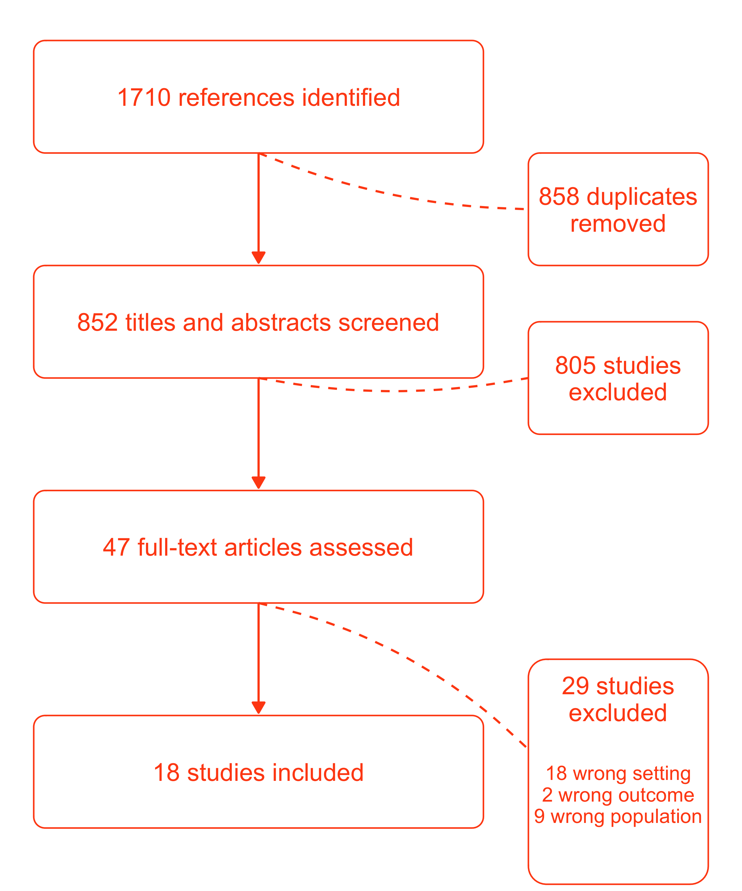

Figure 1: PRISMA Flow Diagram

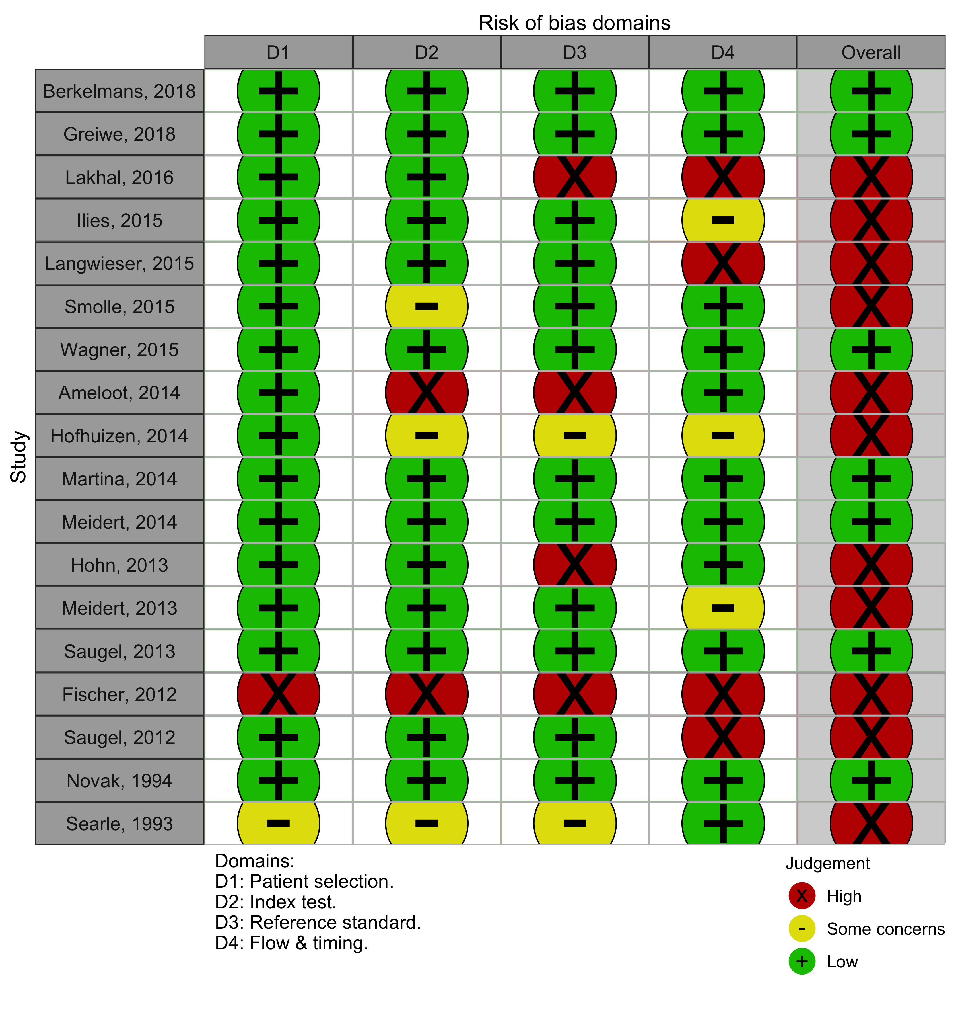

Figure 2: Risk of bias assessments for included studies

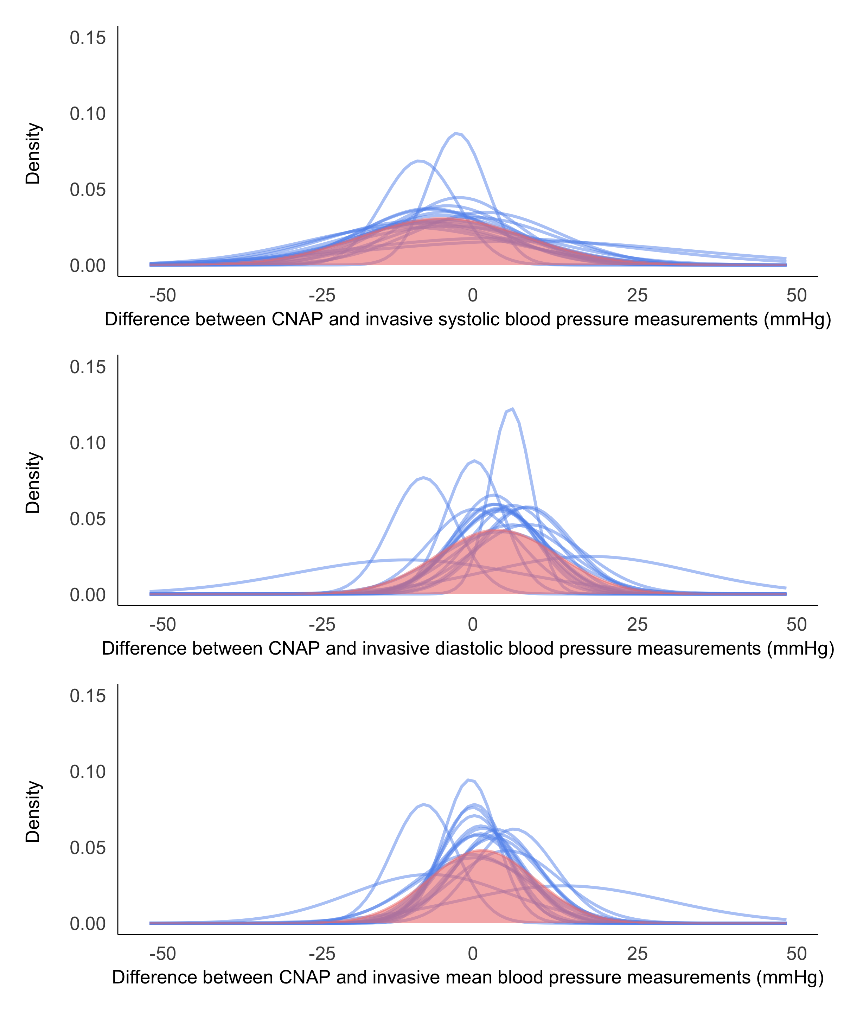

Figure 3: Comparisons between continuous non-invasive and invasive blood pressure measurement within and across studies. Blue curves are distributions of the differences between measurements from continuous non-invasive and invasive arterial blood pressure measurements in individual studies. The red curve is the distribution of the pooled estimate.

## Table 1: Study Characteristics

| Study | | | Participants | | | | Blood pressure measurements | | | | | | |
| --- | --- | --- | --- | --- | --- | --- | --- | --- | --- | --- | --- | --- | --- |
|  |  |  |  | Age (years)a |  |  | Device |  |  | Participants |  | Measurements |
| 2018 | Berkelmans |  |  | 74 (9) | Atrial fibrillation | ICU/CCU | ClearSight | Radial | 31 |  | 4650 |  |
|  | 64 (17) | Sinus Rhythm | 10 |  | 1500 |  |
| Greiwe |  |  | 71 [59, 76] |  | Cardiac Surgery ICU | T-line | Radial | 31 |  | 27900 |  |
| 2016 | Lakhal |  |  | 64 (13) |  | Surgical ICU | CNAP® | Radial/Femoral | 182 |  | 546 |  |
| 2015 | Ilies |  |  | 68.8 (9.4) |  | Cardiac ICU | CNAP® | Radial | 104 |  | 11222 |  |
| Langwieser |  |  | 69 [60, 77) |  | Cardiac ICU | T-line | Radial | 30 |  | 7304 |  |
| Smolle |  |  | 66 [56, 72] |  | Medical ICU | CNAP® | Radial | 40 |  | 7200 |  |
| Wagner |  |  | 60 [52, 71] |  | ICU | CNAP® | Femoral | 55 |  | 4891 |  |
| 2014 | Ameloot |  |  | 57.6 (19.4) |  | Medical Surgical Burns ICU | ClearSight | Femoral | 45 |  | 225 |  |
| Radial | 17 |  | 85 |  |
| Hofhuizen |  |  | 67 (50 to 81)* |  | ICU | ClearSight | Radial | 20 |  | 54 |  |
| Martina |  |  | 50 (11) |  | ICU | ClearSight | Radial | 29 |  | 8700 |  |
| Meidert |  |  | 67 [54 to 77]* |  | ICU | T-line | Radial | 24 |  | 2993 |  |
| 2013 | Hohn |  |  | 63 (18 to 82)* |  | ICU | ClearSight | Radial/Femoral | 25 |  | 117 |  |
| Meidert |  |  | 60 [55, 65] |  | ICU | T-line | Femoral | 23 |  | 2879 |  |
| Saugel |  |  | 63 [51, 74] |  | Medical ICU | T-line | Femoral | 34 |  | 4502 |  |
| 2012 | Fischer |  |  | 68 [22 to 85]* |  | Cardiac Surgery ICU | ClearSight | Radial | 44 |  | 220 |  |
| Saugel |  |  | 68 [61.5, 73.5] |  | Medical ICU | T-line | Femoral | 28 |  | 76826 |  |
| 1994 | Novak |  |  | [20 to 78] |  | ICU | Finapres | Radial | 20 |  | 100323 |  |
| 1993 | Searle |  |  | 60.8 (11.7) |  | Cardiac ICU | NCAT | Radial | 10 |  | 300 |  |
| amean(standard deviation), mean(range)*, mean(interquartile range), median[range]*, or median[interquartile range] | | | | | | | | | | | | | |

### Table 2: Results of meta-analyses

|  |  |  |  |  |  |  |  |  |  |  | Population LoA | | |
| --- | --- | --- | --- | --- | --- | --- | --- | --- | --- | --- | --- | --- | --- |
| Analysis | Outcome | Studies | Comparisons | Participants | Measurements | Mean biasa | SD2ab | τ2ac | Lower 95% LoAad | Upper 95% LoAad | Outer CI for lower 95% LoAade | Outer CI for upper 95% LoAade |
| Primary | SBP | 18 | 19 | 785 | 262,352 | -3.93 | 161.39 | 7.01 | -29.88 | 22.03 | -36.13 | 28.28 |
| DBP | 17 | 18 | 760 | 262,235 | 4.61 | 57.54 | 31.42 | -14.26 | 23.47 | -92.60 | 101.82 |
| MAP | 17 | 18 | 765 | 162,029 | 2.20 | 52.62 | 16.42 | -14.42 | 18.82 | -39.96 | 44.36 |
| Low Risk Studies | SBP | 7 | 8 | 234 | 155,459 | -3.87 | 156.56 | 12.79 | -29.90 | 22.16 | -53.40 | 45.65 |
| DBP | 7 | 8 | 234 | 155,459 | 4.73 | 50.56 | 36.33 | -13.91 | 23.38 | -192.17 | 201.64 |
| MAP | 6 | 7 | 214 | 55,136 | 1.54 | 54.47 | 20.43 | -15.77 | 18.85 | -86.05 | 89.13 |
| Studies Not Funded | SBP | 11 | 12 | 504 | 135,671 | -4.54 | 142.94 | 7.99 | -29.11 | 20.03 | -38.62 | 29.54 |
| DBP | 11 | 12 | 504 | 135,671 | 3.74 | 67.06 | 47.87 | -17.70 | 25.18 | -219.52 | 227.01 |
| MAP | 11 | 12 | 504 | 135,671 | 2.42 | 51.49 | 22.97 | -14.84 | 19.68 | -74.59 | 79.43 |
| Arterial Applanation Tonometry | SBP | 7 | 7 | 180 | 122,704 | -3.12 | 145.51 | 4.84 | -27.64 | 21.40 | -39.23 | 32.99 |
| DBP | 7 | 7 | 180 | 122,704 | 5.54 | 65.27 | 9.78 | -11.79 | 22.87 | -31.22 | 42.30 |
| MAP | 7 | 7 | 180 | 122,704 | 2.15 | 51.28 | 5.05 | -12.86 | 17.16 | -21.59 | 25.89 |
| Volume Clamp | SBP | 11 | 12 | 605 | 139,648 | -4.34 | 168.54 | 7.47 | -30.87 | 22.19 | -39.10 | 30.42 |
| DBP | 10 | 11 | 580 | 139,531 | 3.80 | 53.41 | 40.84 | -15.62 | 23.21 | -184.81 | 192.41 |
| MAP | 10 | 11 | 585 | 39,325 | 1.94 | 52.87 | 20.61 | -15.21 | 19.08 | -66.09 | 69.96 |
| ClearSight | SBP | 6 | 7 | 204 | 15,466 | -3.96 | 161.42 | 14.32 | -30.47 | 22.55 | -61.19 | 53.27 |
| DBP | 5 | 6 | 179 | 15,349 | 3.52 | 45.88 | 52.30 | -16.29 | 23.34 | -440.22 | 447.27 |
| MAP | 6 | 7 | 204 | 15,466 | 0.21 | 48.70 | 22.42 | -16.65 | 17.08 | -101.96 | 102.39 |
| T-line | SBP | 6 | 6 | 170 | 122,404 | -3.47 | 186.54 | 7.19 | -31.31 | 24.37 | -45.58 | 38.64 |
| DBP | 6 | 6 | 170 | 122,404 | 6.31 | 74.82 | 9.10 | -12.01 | 24.64 | -30.88 | 43.51 |
| MAP | 6 | 6 | 170 | 122,404 | 2.55 | 58.54 | 6.13 | -13.53 | 18.64 | -25.43 | 30.53 |
| Femoral Site | SBP | 5 | 5 | 185 | 89,323 | -6.21 | 170.01 | 13.09 | -33.28 | 20.85 | -64.75 | 52.32 |
| DBP | 5 | 5 | 185 | 89,323 | 6.31 | 62.53 | 3.71 | -9.96 | 22.59 | -15.93 | 28.56 |
| MAP | 5 | 5 | 185 | 89,323 | 1.21 | 49.36 | -0.68 | -12.74 | 15.16 | -17.48 | 19.90 |
| Radial Site | SBP | 11 | 12 | 393 | 172,366 | -3.38 | 136.50 | 6.27 | -27.28 | 20.52 | -35.13 | 28.37 |
| DBP | 11 | 12 | 393 | 172,366 | 5.13 | 48.17 | 29.18 | -12.45 | 22.72 | -105.63 | 115.90 |
| MAP | 11 | 12 | 390 | 72,128 | 3.30 | 48.49 | 20.60 | -13.32 | 19.93 | -63.67 | 70.27 |
| aUnits are mmHg | | | | | | | | | | | | | | |
| bVariance | | | | | | | | | | | | | | |
| cMeasure of heterogeneity | | | | | | | | | | | | | | |
| dLoA = Limits of Agreement | | | | | | | | | | | | | | |
| eCI = Confidence Intervals | | | | | | | | | | | | | | |

# Appendix 1: Search Strategy

## Medline search strategy

1. Blood pressure OR arterial pressure
2. ‘non invasive’ OR Noninvasive or non-invasive
3. 1 AND 2
4. Nexfin or ClearSight OR CNAP OR CNAPTM OR Finapres OR Tensys OR T-line OR TL-200 OR TL-300 OR Vasotrac
5. Penaz OR (Pressman and Newgard) OR Volume Clamp OR Arterial applanation tonometry OR Finger Cuff OR ‘vascular unloading’ OR ‘pulse transit time’
6. (Continuous OR continued OR continual OR continually OR continuing)
7. (Beat-to-beat OR real time OR real-time OR simultaneous OR simultaneously)
8. (Accuracy OR precision OR reliability OR validity OR validation OR standard deviation)
9. (Bias OR (mean adj1 difference) OR (limi* adj2 agreement) OR (Bland adj1 Altman))
10. blood pressure monitors.sh.
11. 6 OR 7
12. 10 OR 11
13. 3 AND 11
14. 5 AND 13
15. 4 OR 12 OR 13 OR 14
16. 8 OR 9
17. 15 AND 16

## EMBASE search strategy

1. Blood pressure OR arterial pressure
2. ‘non invasive’ OR Noninvasive or non-invasive
3. 1 AND 2
4. Nexfin or ClearSight OR CNAP OR CNAPTM OR Finapres OR Tensys OR T-line OR TL-200 OR TL-300 OR Vasotrac
5. Penaz OR (Pressman and Newgard) OR Volume Clamp OR Arterial applanation tonometry OR Finger Cuff OR ‘vascular unloading’ OR ‘pulse transit time’
6. (Continuous OR continued OR continual OR continually OR continuing)
7. (Beat-to-beat OR real time OR real-time OR simultaneous OR simultaneously)
8. (Accuracy OR precision OR reliability OR validity OR validation OR standard deviation)
9. (Bias OR (mean adj1 difference) OR (limi* adj2 agreement) OR (Bland adj1 Altman))
10. exp blood pressure monitor/
11. 6 OR 7
12. 10 OR 11
13. 3 AND 11
14. 5 AND 13
15. 4 OR 12 OR 13 OR 14
16. 8 OR 9
17. 15 AND 16

# Appendix 2: Quality Assessment by Using Revised Quality Assessment of Diagnostic Accuracy Studies Tool (QUADAS-2)

|  |  |  |
| --- | --- | --- |
| **Domain** | **Quality Assessment Question** | **Rating** |
| Patient selection | Was a consecutive or random sample of patients enrolled? | High/ Low / Unclear |
| Was a case-control design avoided? | High/ Low / Unclear |
| Did the study avoid inappropriate exclusions? | High/ Low / Unclear |
| What was the overall risk of bias associated with the selection of participants? | High/ Low / Unclear |
| Index test | Were the continuous non-invasive arterial pressure results interpreted without knowledge of the results of the comparator? | High/ Low / Unclear |
| Were the continuous non-invasive arterial pressure device measurements performed accurately? | High/ Low / Unclear |
| What was the overall risk of bias associated with the conduct or interpretation of continuous non-invasive arterial pressure results? | High/ Low / Unclear |
| Reference standard | Were comparator blood pressure results interpreted without knowledge of continuous non-invasive arterial pressure measurements? | High/ Low / Unclear |
| Was the comparator blood pressure device used the same way for all patients? | High/ Low / Unclear |
| Were the comparator measures performed accurately? | High/ Low / Unclear |
| What was the overall risk of bias associated with the conduct or interpretation of comparator blood pressure measurements? | High/ Low / Unclear |
| Flow and Timing | Was the interval between continuous non-invasive arterial pressure and comparator blood pressure measurement device the same for all patients and repeated measurements? | High/ Low / Unclear |
| Were all patients included in the analysis? | High/ Low / Unclear |
| Were repeated measurements taken into account in the Bland-Altman analysis? | High/ Low / Unclear |
| What was the overall risk of bias associated with the participant flow? | High/ Low / Unclear |

# Appendix 3: List of 29 Excluded Studies

Hansen, S., & Staber, M. (2006). Oscillometric blood pressure measurement used for calibration of the arterial tonometry method contributes significantly to error. *Eur J Anaesthesiol, 23*(9), 781-7.

**Reason:** Insufficient or lack of data (only reported the worst and lowest range in SBP error).

Steiner, L. A, Johnston, A. J, Salvador, R., Czosnyka, M., & Menon, D. K. (2003). Validation of a tonometric noninvasive arterial blood pressure monitor in the intensive care setting. *Anaesthesia, 58*, 448–54

**Reason:** Insufficient or lack of data (data were expressed as bias and 10th and 90th percentile.

No standard deviation could be calculated. There was no extractable age and sex information).

Jagadeesh, A. M., Singh, N. G., & Mahankali, S. (2012). A comparison of a continuous noninvasive arterial pressure (CNAP) monitor with an invasive arterial blood pressure monitor in the cardiac surgical ICU. *Annals of Cardiac Anaesthesia, 15*(3), 180–4

**Reason:** Patients under 18 years of age (inclusion criteria for their study is age >16 years).

Brittain, J. M., Busk, T. M., & Møller, S. (2018). Validation of non-invasive haemodynamic methods in patients with liver disease: the Finometer and the Task Force Monitor. *Clin Physiol Funct Imaging, 38*(3), 384-389.

**Reason:** Wrong setting (not critical care)

Gomez-Angelats, E., Sierra, C., Coca, A., Pare, J. C., & de la Sierra, A. (2004). Lack of association between blood pressure variability and left ventricular hypertrophy in essential hypertension. *Medicina Clinica, 123*(19), 731-734.

**Reason:** Wrong setting (not critical care)

Kawahara, M. (1990). Evaluation of the accuracy of non-invasive automatic blood pressure monitors. *Anesthesia progress, 37*(5), 244-247.

**Reason:** Wrong setting (operative room- patients having oral surgery under general anesthesia)

Kugler, J., Rollnik, J., & Schmitz, N. (1997). Retest-reliability and convergent validity of noninvasive blood pressure determination: arm sphygmomanometry vs. Penaz-method. *International journal of clinical monitoring and computing, 14*(4), 251-254.

**Reason:** Wrong setting (not critical care)

Lal, S. K., Mihailidou, A. S., Cejnar, M., Henderson, R. J., Jones, M., & Hunyor, S. N. (1993). Continuous, non-invasive volume-clamp blood pressure: determinants of performance. *Journal of hypertension, 11*(12), 1413-1422.

**Reason:** Wrong setting (did not specify critical care and sample included 60 volunteers)

Tanaka, S. Nogawa, M. Yamakoshi, T. & Yamakoshi, K. (2007). Accuracy assessment of a noninvasive device for monitoring beat-by-beat blood pressure in the radial artery using the volume-compensation method. *IEEE transactions on bio-medical engineering, 54*(10), 1892-5.

**Reason:** Wrong population (sample consisted of nine healthy adult subjects aged from 22 to 48 years)

Nelesen, R. A., & Dimsdale, J. E. (2002). Use of radial arterial tonometric continuous blood pressure measurement in cardiovascular reactivity studies. *Blood pressure monitoring, 7*(5), 259-63.

**Reason:** Wrong setting (did not specify critical care, recruited participants in hypertension and sleep apnea studies conducted at the University of California, San Diego)

Jagomagi, K., Raamat, R., & Talts, J. (2001). Effect of altering vasoactivity on the measurement of finger blood pressure. *Blood pressure monitoring, 6*(1), 33-40

**Reason:** Wrong population (participants were healthy volunteers).

Imholz, B. P., van Montfrans, G. A., Settels, J. J., van der Hoeven, G. M., Karemaker, J. M. & Wieling, W. (1988). Continuous non-invasive blood pressure monitoring: reliability of Finapres device during the Valsalva manoeuvre. *Cardiovascular research, 22*(6), 390-7.

**Reason:** Wrong setting (not in critical care)

Hehenkamp, W. J. K., Rang, S., van Goudoever, J., Bos, W. J. W., Wolf, H., & van der Post, J. A. M. (2002). Comparison of Portapres with standard sphygmomanometry in pregnancy. *Hypertension in pregnancy, 21*(1), 65-76.

**Reason:** Patients under 18 years of age (age range in this study is 15-43 years).

Gizdulich, P., Prentza, A., & Wesseling, K. H. (1997). Models of brachial to finger pulse wave distortion and pressure decrement. *Cardiovascular research, 33*(3), 698-705.

**Reason:** Wrong population (included healthy volunteer)

Eeftinck Schattenkerk, D. W., van Lieshout, J. J., van den Meiracker, A. H., Wesseling, K. R., Blanc, S., Wieling, W., van Montfrans, G. A., Settels, J. J., Wesseling, K. H., & Westerhof, B. E. (2009). Nexfin noninvasive continuous blood pressure validated against Riva-Rocci/Korotkoff. *American journal of hypertension, 22*(4), 378-83

**Reason:** Wrong patient population (volunteers)

Belani, K. G., Buckley, J. J., & Poliac, M. O. (1999). Accuracy of radial artery blood pressure determination with the Vasotrac. *Canadian journal of anaesthesia = Journal canadien d'anesthesie, 46*(1), 488-96.

**Reason:** Wrong patient population (healthy volunteers)

Wagner, J. Y., Prantner, J. S., Meidert, A. S., Hapfelmeier, A., Schmid, R. M., & Saugel, B. (2014). Noninvasive continuous versus intermittent arterial pressure monitoring: evaluation of the vascular unloading technique (CNAP device) in the emergency department. *Scandinavian journal of trauma, resuscitation and emergency medicine, 22*(101477511), 8

**Reason:** Wrong setting (Emergency department)

van Egmond, J., Hasenbos, M., & Crul, J. F. (1985). Invasive v. non-invasive measurement of arterial pressure. Comparison of two automatic methods and simultaneously measured direct intra-arterial pressure. *British journal of anaesthesia,* *57*(4), 434-44.

**Reason:** Wrong setting (included ICU and operative room)

van der Does, Y., van Loon, L. M., Alsma, J., Govers, A., Lansdorp, B., Rood, P. P. M., & Schuit, S. C. E. (2013). Non-invasive blood pressure and cardiac index measurements using the Finapres Portapres in an emergency department triage setting. *The American journal of emergency medicine, 31*(7), 1012-6.

**Reason:** Wrong setting (Emergency department)

Schutte, A. E., Huisman, H. W., van Rooyen, J. M., Malan, N. T., & Schutte, R. (2004). Validation of the Finometer device for measurement of blood pressure in black women. *Journal of human hypertension, 18*(2), 79-84.

**Reason:** Wrong setting (not in critical care)

Pouwels, S., Lascaris, B., Nienhuijs, S. W., Arthur Bouwman, R., & Buise, M. P. (2017). Validation of the Nexfin non-invasive continuous blood pressure monitoring validated against Riva-Rocci/Korotkoff in a bariatric patient population. *Journal of clinical anesthesia, 39*(an9, 8812166), 89-95.

**Reason:** Wrong setting (Outpatient clinic)

Parati, G., Casadei, R., Groppelli, A., Di Rienzo, M., & Mancia, G. (1989). Comparison of finger and intra-arterial blood pressure monitoring at rest and during laboratory testing. *Hypertension, 13*(6), 647-55.

**Reason:** Wrong setting (not in critical care)

Nowak, R. M., Sen, A., Garcia, A. J., Wilkie, H., Yang, J. J., Nowak, M. R., & Moyer, M. L. (2011). Noninvasive continuous or intermittent blood pressure and heart rate patient monitoring in the ED. The American journal of emergency medicine, 29(7), 782-9.

**Reason:** Wrong setting (Emergency department)

Idzenga, T., Reesink, K. D., van Swelm, Y., Hansen, H. H. G., Holewijn, S., & de Korte, C. L. (2012). Noninvasive estimation of the blood pressure waveform in the carotid artery using continuous finger blood pressure monitoring. *Ultrasound in medicine & biology, 38*(11), 1998-2006.

**Reason:** Wrong population (included healthy volunteers)

Epstein, R. H., Huffnagle, S., & Bartkowski, R. R. (1991). Comparative accuracies of a finger blood pressure monitor and an oscillometric blood pressure monitor. *Journal of clinical monitoring, 7*(2), 161-7.

**Reason:** Wrong setting (operative room- patients with back pain undergoing spinal fusion with metal plates under general anesthesia)

Broch, O., Bein, B., Gruenewald, M., Carstens, A., Illies, C., Schoneich, F., Steinfath, M., & Renner, J. (2013). A comparison of continuous non-invasive arterial pressure with invasive radial and femoral pressure in patients undergoing cardiac surgery. *Minerva anestesiologica, 79*(3), 248-56.

**Reason:** Wrong setting (operative room)

Arfeen, Z. U., Maran, N. J., Simon, E. J., & McClure, J. H. (1996). A comparison of non-invasive methods of blood pressure measurement in normotensive and hypertensive pregnant women. *International journal of obstetric anesthesia, 5*(3), 168-71.

**Reason:** Wrong setting (not in critical care; outpatient clinics)

Allan, P. D., O'Donnell, T., & Tzeng, Y. (2018). Agreement between finger plethysmography- and brachial oscillometry-derived blood pressure measurements. *Clinical physiology and functional imaging, 38*(3), 439-446.

**Reason:** Wrong population (included healthy volunteers; data obtained from the Wellington

Cerebral Hemodynamics Database)

Akkermans, J., Diepeveen, M., Ganzevoort, W., van Montfrans, G. A., Westerhof, B. E., & Wolf, H. (2009). Continuous non-invasive blood pressure monitoring, a validation study of Nexfin in a pregnant population. *Hypertension in pregnancy, 28*(2), 230-42.

**Reason:** Wrong setting (outpatient clinic)