Predicting Treatment Outcome in Depression using Multi-Omics Immunophenotyping and Machine Learning

Nils Kappelmann^{1,2}, Lee Jollans¹, Nicolas Rost^{1,2}, Jonas Hagenberg^{1,2}, Johannes Kopf-Beck³, Susanne Lucae³, CHARGE inflammation working group, OPTIMA study team*, Janine Arloth^{1,4}
¹Department of Translational Research in Psychiatry, Max-Planck-Institute of Psychiatry, Munich, Germany
²International Max Planck Research School for Translational Psychiatry (IMPRS-TP), Munich, Germany
³Max-Planck-Institute of Psychiatry, Munich, Germany
⁴Institute of Computational Biology, Helmholtz Zentrum Munich, Neuherberg, Germany

*The OPTIMA study team includes Johannes Kopf-Beck, Samy Egli, Martin Rein, Nils Kappelmann, Julia Fietz, Jeanette Tamm, Katharina Rek, and Martin Keck.

Corresponding author:
Nils Kappelmann
Department of Translational Research in Psychiatry
Max-Planck-Institute of Psychiatry
Kraepelinstraße 2-10
80804 Munich, Germany

Email: nils_kappelmann@psych.mpg.de; n.kappelmann@gmail.com

Abstract word count: X
Manuscript word count: X
Tables and Figures: X
Online Supplementary Tables and Figures: X Tables and X Figure

Abstract
tbc
Keywords: Major Depressive Disorder; inflammation; cytokine; inpatient

Introduction
Immune system alterations have been reliably associated with Major Depressive Disorder (MDD). Low-grade inflammation, as commonly indexed by C-reactive protein (CRP) levels >3mg/L, has been estimated to affect every fourth patient with MDD (Dantzer et al., 2008; Osimo et al., 2019). This could be clinically relevant as pro-inflammatory protein levels prior to treatment have been associated with worse treatment outcome following standard monoaminergic and psychotherapeutic treatments (Goldsmith et al., 2016; Liu et al., 2020; Lopresti, 2017). Studies predicting treatment response from inflammatory protein levels have been heterogeneous, however, with mixed evidence for individual cytokines (Liu et al., 2020), so it remains unclear which immune markers may have greatest utility for treatment prediction.
One reason for heterogeneity of findings could be the complexity inherent to immune system functioning. Innate immune function, for instance, depends on a complex network of gene-regulatory and protein-protein interactions, which is further complicated by cytokine family complexity and receptor redundancy (Ozaki and Leonard, 2002; Subramanian et al., 2015). On the meta-analytic level, this is evident from diverging patient-control and pre-post cytokine profile differences (Goldsmith et al., 2016). Individual studies have rarely assessed many cytokines concurrently with the largest panel including up to 16 different cytokines (Gadad et al., 2017). Analyses have also been restricted to univariate predictions, thus neglecting potential protein-protein interactions (CHECK)[REFS]. ADD INFORMATION ON RECENT CATTANEO STUDY (Cattaneo et al., 2020). Therefore, studies need to combine large-scale immunophenotyping with methodological techniques that are ideally suited for multivariate predictions including non-linear association testing.
In the present study, we aimed to predict 8-week inpatient treatment response for moderate-to-severely depressed patients using multi-omics immunophenotyping data including protein, transcriptomics, and genetic information. To accommodate such multi-level data, we applied a machine learning analysis pipeline that was compared against predictions from sociodemographic and baseline clinical variables and against chance predictions. We hypothesised that a prediction algorithm from multi-omics immunophenotyping data can explain treatment response as indexed by depressive symptom severity, dropout, and general functioning.

OLD TEXT:
Inflammation predicts worse treatment response (Liu et al., 2020; Strawbridge et al., 2015) (and TNF-a changes with anti-depressant treatment (Hannestad et al., 2011)).

Studies to date have only investigated single, few or a maximum of 16 (Gadad et al., 2017) different cytokines concurrently (Liu et al., 2020). Cytokine signalling is a complex interrelated process, however, so methods are needed that disentangle complex cytokine interactions to develop algorithms indexing treatment response. Lynall and colleagues have recently XY (Lynall et al., 2020).

Chekroud and colleagues have used machine learning to predict treatment outcome in two antidepressant medication clinical trials (Chekroud et al., 2016).
Procedures were informed by two prior reports predicting response to antidepressant medication and predicting differential response to psychotherapies in depression (Chekroud et al., 2016; Cohen et al., 2020).

Methods

Study Population
We used data from the OPTIMA study, a single-centre, naturalistic randomised controlled trial (RCT) evaluating comparative effectiveness of schema therapy, cognitive behavioural therapy, and individual supportive therapy as treatment for moderate-to-severe depression (Kopf-Beck et al., 2020). The study was conducted at the clinic of the Max-Planck-Institute of Psychiatry in Munich, Germany, and patients were recruited from inpatient and day clinic wards. Study duration was 8 weeks, which included a baseline week with various assessments followed by 7-week psychotherapeutic treatment. Antidepressant medication (ADM) was given throughout the stay at the clinic as were additional therapies such as sports and/or occupational therapy. Further study details such as inclusion and exclusion criteria were reported previously (Kopf-Beck et al., 2020), but are summarised in the supplementary material.
In the current report, we included 115 patients who provided blood samples for a combined immunophenotyping project including participants from OPTIMA and BeCOME studies (Brückl et al., 2020; Kopf-Beck et al., 2020), the latter of which was also conducted at the Max Planck Institute. We only report data from the OPTIMA study, which included prospective assessments of treatment outcome. From an initial sample of 115 patients, one patient was excluded due to non-compliance with assessments and 9 further patients were excluded who dropped out of the study in the first week, leaving a final analysis sample of 105 patients.
The OPTIMA study received approval from the ethics committee of the Ludwig-Maximilians-University (LMU) in Munich under project number 17-395 and all patients gave their informed consent prior to participation.

Immunophenotyping

Cytokine Panel
As

Transcriptomics
As

Genomics
Genetic data were based on a combination of candidate single-nucleotide polymorphisms (SNPs) with known biological function and polygenic risk scores (PRSs) for different inflammatory markers.
Genotyping for study participants was conducted with XY. Quality control was based on INFO >= 0.6, MAF >= 0.01, HWE > e-05.
Candidate SNPs included rs2228145, located in the IL-6R gene, which explains 51% of soluble IL-6Rs and has been associated with depressive and psychotic symptoms (Khandaker et al., 2018; Van Dongen et al., 2014). Add other candidate SNPs?
PRS were based on two genome-wide association studies (GWAS) on (i) circulating CRP levels based on 204,402 European individuals (Ligthart et al., 2018) and (ii) 41 circulating cytokines and growth factors based on 8,293 Fynns (Ahola-Olli et al., 2017). PRS were calculated using Bayesian regression with continuous shrinkage priors (Ge et al., 2019) and scores were corrected for age, sex, and first two principal genotyping components.

Clinical Measures

Primary Outcome
As primary outcome, we used the German version of the self-report Beck Depression Inventory (2nd version) to create a sum-score of 21 depressive symptom items (Beck et al., 1996; Kühner et al., 2007).

Secondary Outcome
As secondary outcome measures to assess generalisability, we also an additional measure of depressive symptom severity, a measure of general functioning, and assessments of dropout.
Depressive symptom severity was based on the expert-rated Montgomery-Åsberg Depression Rating Scale (MADRS) (Montgomery and Asberg, 1979). MADRS expert raters were subject to recurrent training sessions to assure high interrater reliability. To assess general functioning, the WHO XY (WHODAS) 2.0 was applied by the same expert raters who applied the MADRS.
Dropout was defined as patients leaving the study for any reasons other than successful treatment (i.e., discharge from inpatient wards or day-clinic). This included X, Y, and Z.

Handling of Missing Data
Missing BDI data at study endpoint were present for 26 patients. These were imputed using a last-observation-carried-forward approach. This was also conducted for the MADRS and the WHODAS.
For the BDI, we also used a best-worst case sensitivity analysis to see if results from our analysis pipeline were dependent on the type of imputation (Jakobsen et al., 2017). To this end, we imputed endpoint BDI using participants’ best and worst BDI scores throughout treatment, respectively.

Machine Learning Analysis Pipeline
All analyses were conducted in R under the umbrella of the caret package, which collates different ML functionalities and models (Kuhn, 2008; R Core Team, 2017). The analysis pipeline has been set up using a repeated, k-fold nested cross-validation (CV) design using k=5 folds each in inner and outer CV cycles based on 100 repetitions (see Figure 1). Nested cross-validation is considered the gold-standard as the model is trained in the inner CV cycle, thus leaving an independent outer test set (Dwyer et al., 2018).

Figure 1: Nested Cross-Validation (CV) Analysis Pipeline.
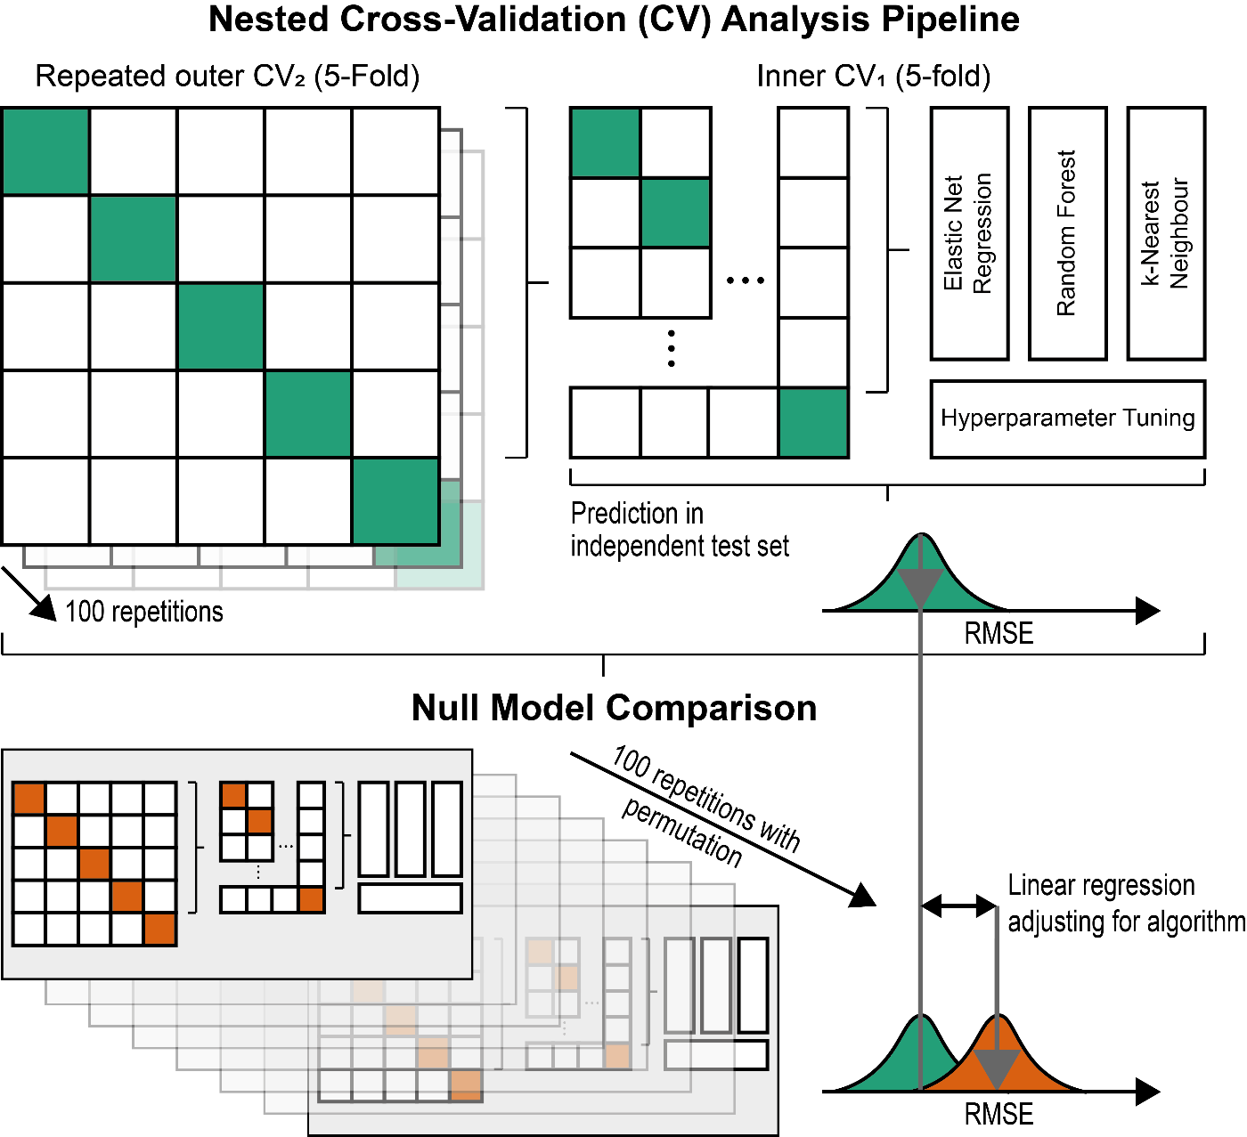

Model Training
Model training in the inner CV cycle was performed using elastic net regression, random forest and k-nearest neighbour with the goal of minimising the Root Mean Squared Error (RMSE) between predicted and observed values; see details below. These algorithms were chosen as they differ quite substantially in underlying computations (see details below), which facilitates generalisability of findings across individual algorithms. Relevant hyperparameters for these algorithms were fine-tuned in the inner CV cycle using a grid search and the best hyperparameters were taken forward for independent prediction in the held-out outer CV test set.
Elastic net regression was performed using the glmnet package (Engebretsen and Bohlin, 2019). Elastic net regression is an extension of least squares regression including two hyperparameters, a penalisation parameter λ and a tuning parameter α. The tuning parameter α can take values between 0-1 and determines the type of penalisation, where 0 equals ridge regression, 1 equals LASSO regression, and values in between 0-1 indicate the relative balance of ridge vs. LASSO penalisation. The penalisation parameter λ can also take values between 0-1 with higher values reflecting a greater amount of penalisation.
Random forest was performed using the randomForest package (Liaw and Wiener, 2002). Random forests are an ensemble learning methods that construct multiple decision trees and average across tree-based predictions in a regression setting. There is one tuning parameter mtry which specifies the number of available variables at nodes for splitting.
K-nearest neighbour (KNN) is implemented in caret. KNN calculates the distance between individuals in the feature space. Based on the distance to the k individuals that are closest to the to-be-predicted individual, a prediction is made that constitutes the average value of these nearest neighbours. The tuning parameter k thus defines the number of nearest neighbours used for prediction.
Finally, we used the package caretEnsemble to learn from these three models.
Variable Importance
Variable importance is estimated using caret, which provides normalised values between 0-100, with higher values reflecting greater variable importance (Kuhn, 2008). Estimation of variable importance depends on the model algorithm, so differs for selected algorithms of elastic net regression, random forest, and k-nearest neighbour. For elastic net regression, variable importance is based on variable t-statistics. For random forest, variable importance is estimated by comparing mean squared error (MSE) of out-of-bag predictions with out-of-bag predictions with the variable permuted. For k-nearest neighbour, no specific variable importance calculation exists, so variable importance is based on linear regression t-statistics of variables on the outcome.

Permutation-based Null Model Comparison
To statistically test the advantage of the prediction models against chance predictions, the complete nested CV analysis pipeline was repeated with random permutations of the 7-week depressive symptom outcome in each outer CV repetition (see Figure 1). This created a permutation-based RMSE distribution that allowed comparisons with actual model predictions. To minimise the multiple testing burden, we used linear regression of RMSE values across nested CV repetitions and outer folds on a dummy variable coding model- vs permutation-based prediction and a variable coding for the algorithm used. Significance of model- vs permutation-based prediction could then be interpreted to reflect significant predictive value of the model averaged across the three prediction algorithms.

Assessment of Generalisability
As

Data Availability
All scripts for statistical analyses are openly available under XY. Data from the OPTIMA study are confidential and cannot be freely shared with researchers under the ethics agreement.

Results

Baseline characteristics
Baseline characteristics of participants of the OPTIMA study are highlighted in Table 1.

Table 1
Baseline Characteristics
 | Inflammation Status
Variable | Non-Inflamed | Inflamed | Pª | Total
N | 74 (64.9%) | 40 (35.1%) |  | 114 (100%)
Sex
Female | 35 (47.3%) | 25 (62.5%) |  | 60 (52.63%)
Male | 39 (52.7%) | 15 (37.5%) | 0.175 | 54 (47.37%)
Missing (%) | 0 (0%) | 0 (0%) |  | 0 (0%)
Age
Mean (SD) | 41.3 (13.92) | 45.4 (12.77) |  | 42.74 (13.62)
Median (IQR) | 42.5 (29-52) | 48.5 (35.25-55) | 0.125 | 44 (30-53)
Missing (%) | 0 (0%) | 0 (0%) |  | 0 (0%)
Social class
lower-class | 11 (14.86%) | 7 (17.5%) |  | 5 (4.39%)
lower middle-class | 21 (28.38%) | 13 (32.5%) |  | 21 (18.42%)
middle middle-class | 40 (54.05%) | 27 (67.5%) |  | 54 (47.37%)
upper middle-class | 26 (35.14%) | 8 (20%) | 0.179 | 21 (18.42%)
Missing (%) | 8 (10.81%) | 5 (12.5%) |  | 13 (11.4%)
Country of Origin
Germany | 69 (93.24%) | 35 (87.5%) |  | 92 (80.7%)
Other | 13 (17.57%) | 9 (22.5%) | 0.499 | 10 (8.77%)
Missing (%) | 8 (10.81%) | 4 (10%) |  | 12 (10.53%)
Ethnicity
German | 67 (90.54%) | 36 (90%) |  | 91 (79.82%)
Other | 15 (20.27%) | 8 (20%) | 1 | 11 (9.65%)
Missing (%) | 8 (10.81%) | 4 (10%) |  | 12 (10.53%)
Employment status
Employed | 49 (66.22%) | 26 (65%) |  | 58 (50.88%)
Retired | 13 (17.57%) | 8 (20%) |  | 4 (3.51%)
Unemployed | 32 (43.24%) | 20 (50%) | 0.844 | 35 (30.7%)
Missing (%) | 10 (13.51%) | 7 (17.5%) |  | 17 (14.91%)
BDI
Mean (SD) | 32.15 (7.87) | 32.8 (7.83) |  | 32.38 (7.82)
Median (IQR) | 32 (27-37.75) | 32.5 (27-38.25) | 0.673 | 32 (27-38)
Missing (%) | 0 (0%) | 0 (0%) |  | 0 (0%)
MADRS
Mean (SD) | 26.85 (5.01) | 24.92 (6.09) |  | 26.21 (5.44)
Median (IQR) | 27 (23-30) | 24 (22-27) | 0.078 | 26 (22.5-30)
Missing (%) | 0 (0%) | 3 (7.5%) |  | 3 (2.63%)
BSI: Depression
Mean (SD) | 2.68 (0.91) | 2.89 (0.8) |  | 2.76 (0.88)
Median (IQR) | 2.75 (1.83-3.33) | 3 (2.29-3.38) | 0.23 | 2.83 (2.04-3.33)
Missing (%) | 0 (0%) | 0 (0%) |  | 0 (0%)
Hospitalisation in
Day-clinic | 15 (20.27%) | 14 (35%) |  | 29 (25.44%)
Ward | 59 (79.73%) | 26 (65%) | 0.134 | 85 (74.56%)
Missing (%) | 0 (0%) | 0 (0%) |  | 0 (0%)
Number of psychiatric diagnoses
Mean (SD) | 5.21 (3.12) | 5.11 (2.46) |  | 5.17 (2.9)
Median (IQR) | 5 (3-8) | 5 (3-7) | 0.864 | 5 (3-7)
Missing (%) | 1 (1.35%) | 2 (5%) |  | 3 (2.63%)
Note: ªP-values are based on T-tests and χ²-tests for continuous and categorical variables, respectively.

Treatment Prediction
Tbc

Figure 2: Model Prediction Performance
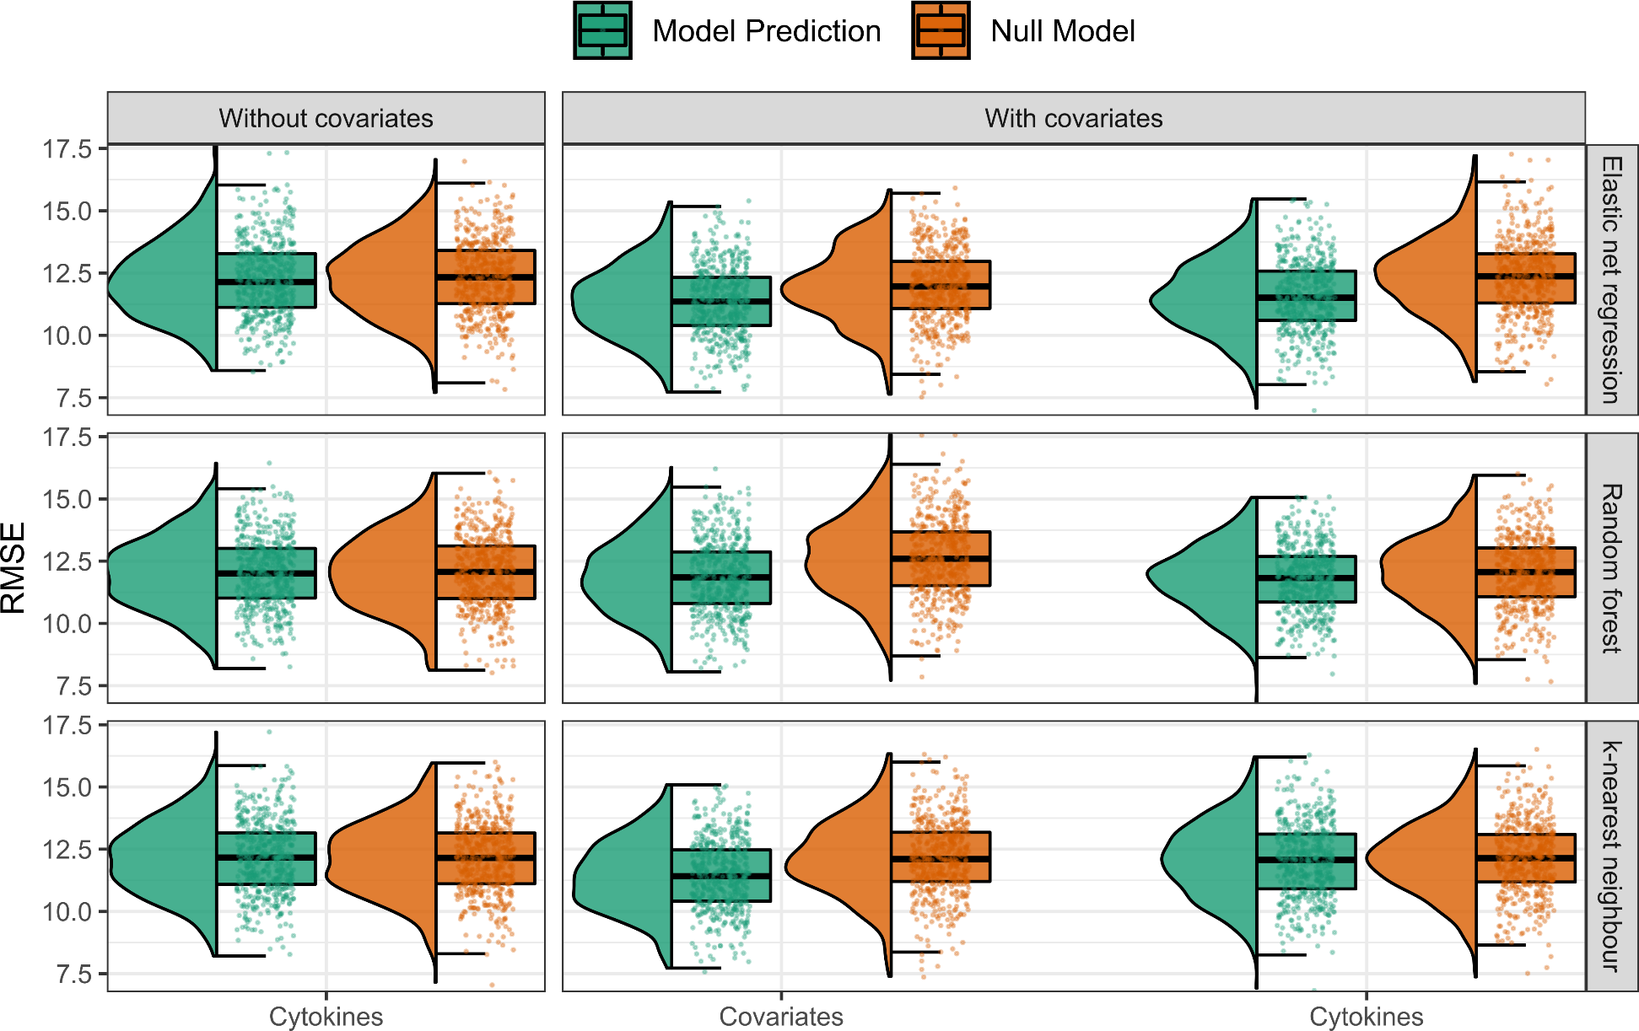

Table 2: Treatment Prediction Results
 | Baseline feature set |  |  | Feature set including age, sex, baseline symptom severity, and BMI
Feature set | RMSE  (Mean, SD) | R²  (Median, IQR) | Permutation testª | RMSE  (Mean, SD) | R²  (Median, IQR) | Permutation testª
Age, sex, baseline symptom severity, & BMI
Elastic net regression |  |  |  | - | - | -
Random forest |  |  |  | - | - | -
k-nearest neighbour |  |  |  | - | - | -
Cytokines
Elastic net regression
Random forest
k-nearest neighbour
Transcriptomics
Elastic net regression
Random forest
k-nearest neighbour
Genomics
Elastic net regression
Random forest
k-nearest neighbour
Combined immunophenotyping
Elastic net regression
Random forest
k-nearest neighbour
Note: ªP-value obtained from t-tests comparing the distribution of actual predictions against prediction based on permutations of 7-week BDI.

Figure 3: Variable Importance
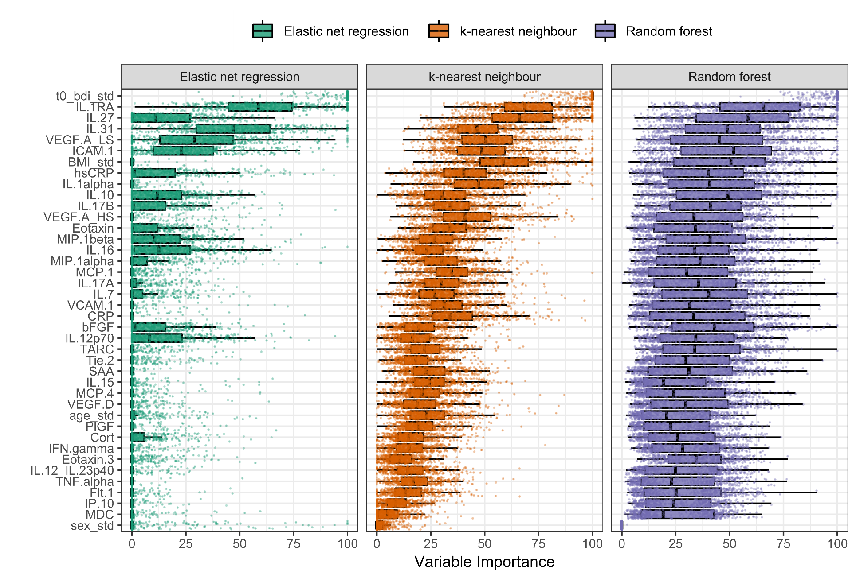

Content Validity Analyses
as

Discussion
Tbc

Conclusion
Tbc

Competing interests
The authors do not have any competing interests.

Funding
This study is funded by the Max Planck Institute of Psychiatry. NK is supported by the International Max Planck Research School of Translational Psychiatry (IMPRS-TP).

Authors’ contributions
tbc

Acknowledgements
tbc

References
Ahola-Olli, A. V, Würtz, P., Havulinna, A.S., Aalto, K., Pitkänen, N., Lehtimäki, T., Kähönen, M., Lyytikäinen, L.-P., Raitoharju, E., Seppälä, I., Sarin, A.-P., Ripatti, S., Jalkanen, S., Maksimow, M., Salomaa, V., Salmi, M., Kettunen, J., Raitakari, O.T., 2017. Genome-wide Association Study Identifies 27 Loci Influencing Concentrations of Circulating Cytokines and Growth Factors. Am. J. Hum. Genet. 100, 40–50. https://doi.org/10.1016/j.ajhg.2016.11.007
Beck, A.T., Steer, R.A., Brown, G., 1996. Beck depression inventory–II. Psychol. Assess. https://doi.org/10.1037/t00742-000
Brückl, T.M., Spoormaker, V.I., Sämann, P.G., Brem, A., Henco, L., Czamara, D., Elbau, I., Grandi, N.C., Jollans, L., Kühnel, A., Leuchs, L., Pöhlchen, D., Schneider, M., Tontsch, A., Keck, M.E., Schilbach, L., Czisch, M., Lucae, S., Erhardt, A., Binder, E.B., 2020. The biological classification of mental disorders (BeCOME) study: a protocol for an observational deep-phenotyping study for the identification of biological subtypes. BMC Psychiatry 1–25. https://doi.org/10.1186/s12888-020-02541-z
Cattaneo, A., Ferrari, C., Turner, L., Mariani, N., Enache, D., Hastings, C., Kose, M., Lombardo, G., McLaughlin, A.P., Nettis, M.A., Nikkheslat, N., Sforzini, L., Worrell, C., Zajkowska, Z., Cattane, N., Lopizzo, N., Mazzelli, M., Pointon, L., Cowen, P.J., Cavanagh, J., Harrison, N.A., de Boer, P., Jones, D., Drevets, W.C., Mondelli, V., Bullmore, E.T., Pariante, C.M., 2020. Whole-blood expression of inflammasome- and glucocorticoid-related mRNAs correctly separates treatment-resistant depressed patients from drug-free and responsive patients in the BIODEP study. Transl. Psychiatry 10, 232. https://doi.org/10.1038/s41398-020-00874-7
Chekroud, A.M., Zotti, R.J., Shehzad, Z., Gueorguieva, R., Johnson, M.K., Trivedi, M.H., Cannon, T.D., Krystal, J.H., Corlett, P.R., 2016. Cross-trial prediction of treatment outcome in depression: a machine learning approach. The Lancet Psychiatry 3, 243–250. https://doi.org/10.1016/S2215-0366(15)00471-X
Cohen, Z.D., Kim, T.T., Van, H.L., Dekker, J.J.M., Driessen, E., 2020. A demonstration of a multi-method variable selection approach for treatment selection: Recommending cognitive–behavioral versus psychodynamic therapy for mild to moderate adult depression. Psychother. Res. 30, 137–150. https://doi.org/10.1080/10503307.2018.1563312
Dantzer, R., O’Connor, J.C., Freund, G.G., Johnson, R.W., Kelley, K.W., 2008. From inflammation to sickness and depression: when the immune system subjugates the brain. Nat. Rev. Neurosci. 9, 46–56. https://doi.org/10.1038/nrn2297
Dwyer, D.B., Falkai, P., Koutsouleris, N., 2018. Machine Learning Approaches for Clinical Psychology and Psychiatry. Annu. Rev. Clin. Psychol. 14, 91–118. https://doi.org/10.1146/annurev-clinpsy-032816-045037
Engebretsen, S., Bohlin, J., 2019. Statistical predictions with glmnet. Clin. Epigenetics 11, 123. https://doi.org/10.1186/s13148-019-0730-1
Gadad, B.S., Jha, M.K., Grannemann, B.D., Mayes, T.L., Trivedi, M.H., 2017. Proteomics profiling reveals inflammatory biomarkers of antidepressant treatment response: Findings from the CO-MED trial. J. Psychiatr. Res. 94, 1–6. https://doi.org/10.1016/j.jpsychires.2017.05.012
Ge, T., Chen, C.-Y., Ni, Y., Feng, Y.-C.A., Smoller, J.W., 2019. Polygenic prediction via Bayesian regression and continuous shrinkage priors. Nat. Commun. 10, 1776. https://doi.org/10.1038/s41467-019-09718-5
Goldsmith, D.R., Rapaport, M.H., Miller, B.J., 2016. A meta-analysis of blood cytokine network alterations in psychiatric patients: comparisons between schizophrenia, bipolar disorder and depression. Mol. Psychiatry 21, 1696–1709. https://doi.org/10.1038/mp.2016.3
Hannestad, J., DellaGioia, N., Bloch, M., 2011. The effect of antidepressant medication treatment on serum levels of inflammatory cytokines: a meta-analysis. Neuropsychopharmacology 36, 2452–2459. https://doi.org/10.1038/npp.2011.132
Jakobsen, J.C., Gluud, C., Wetterslev, J., Winkel, P., 2017. When and how should multiple imputation be used for handling missing data in randomised clinical trials – a practical guide with flowcharts. BMC Med. Res. Methodol. 17, 162. https://doi.org/10.1186/s12874-017-0442-1
Khandaker, G.M., Zammit, S., Burgess, S., Lewis, G., Jones, P.B., 2018. Association between a functional interleukin 6 receptor genetic variant and risk of depression and psychosis in a population-based birth cohort. Brain. Behav. Immun. 69, 264–272. https://doi.org/10.1016/j.bbi.2017.11.020
Kopf-Beck, J., Zimmermann, P., Egli, S., Rein, M., Kappelmann, N., Fietz, J., Tamm, J., Rek, K., Lucae, S., Brem, A., Sämann, P., Schilbach, L., Keck, M.E., 2020. Schema therapy versus cognitive behavioral therapy versus individual supportive therapy for depression in an inpatient and day clinic setting: study protocol of the OPTIMA-RCT. BMC Psychiatry 20, 506. https://doi.org/10.1186/s12888-020-02880-x
Kuhn, M., 2008. Building Predictive Models in R Using the caret Package. J. Stat. Softw. 28. https://doi.org/10.18637/jss.v028.i05
Kühner, C., Bürger, C., Keller, F., Hautzinger, M., 2007. Reliabilität und Validität des revidierten Beck-Depressionsinventars (BDI-II). Nervenarzt 78, 651–656. https://doi.org/10.1007/s00115-006-2098-7
Liaw, A., Wiener, M., 2002. Classification and Regression by randomForest. R News 2, 18–22.
Ligthart, S., Vaez, A., Võsa, U., Stathopoulou, M.G., de Vries, P.S., Prins, B.P., Van der Most, P.J., Tanaka, T., Naderi, E., Rose, L.M., Wu, Y., Karlsson, R., Barbalic, M., Lin, H., Pool, R., Zhu, G., Macé, A., Sidore, C., Trompet, S., Mangino, M., Sabater-Lleal, M., Kemp, J.P., Abbasi, A., Kacprowski, T., Verweij, N., Smith, A. V, Huang, T., Marzi, C., Feitosa, M.F., Lohman, K.K., Kleber, M.E., Milaneschi, Y., Mueller, C., Huq, M., Vlachopoulou, E., Lyytikäinen, L.-P., Oldmeadow, C., Deelen, J., Perola, M., Zhao, J.H., Feenstra, B., Amini, M., Lahti, J., Schraut, K.E., Fornage, M., Suktitipat, B., Chen, W.-M., Li, X., Nutile, T., Malerba, G., Luan, J., Bak, T., Schork, N., Del Greco M., F., Thiering, E., Mahajan, A., Marioni, R.E., Mihailov, E., Eriksson, Joel, Ozel, A.B., Zhang, W., Nethander, M., Cheng, Y.-C., Aslibekyan, S., Ang, W., Gandin, I., Yengo, L., Portas, L., Kooperberg, C., Hofer, E., Rajan, K.B., Schurmann, C., den Hollander, W., Ahluwalia, Tarunveer S., Zhao, J., Draisma, H.H.M., Ford, I., Timpson, N., Teumer, A., Huang, H., Wahl, S., Liu, Y., Huang, J., Uh, H.-W., Geller, F., Joshi, P.K., Yanek, L.R., Trabetti, E., Lehne, B., Vozzi, D., Verbanck, M., Biino, G., Saba, Y., Meulenbelt, I., O’Connell, J.R., Laakso, M., Giulianini, F., Magnusson, P.K.E., Ballantyne, C.M., Hottenga, J.J., Montgomery, G.W., Rivadineira, F., Rueedi, R., Steri, M., Herzig, K.-H., Stott, D.J., Menni, C., Frånberg, M., St. Pourcain, B., Felix, S.B., Pers, T.H., Bakker, S.J.L., Kraft, P., Peters, A., Vaidya, D., Delgado, G., Smit, J.H., Großmann, V., Sinisalo, J., Seppälä, I., Williams, S.R., Holliday, E.G., Moed, M., Langenberg, C., Räikkönen, K., Ding, J., Campbell, H., Sale, M.M., Chen, Y.-D.I., James, A.L., Ruggiero, D., Soranzo, N., Hartman, C.A., Smith, E.N., Berenson, G.S., Fuchsberger, C., Hernandez, D., Tiesler, C.M.T., Giedraitis, V., Liewald, D., Fischer, K., Mellström, D., Larsson, A., Wang, Y., Scott, W.R., Lorentzon, M., Beilby, J., Ryan, K.A., Pennell, C.E., Vuckovic, D., Balkau, B., Concas, M.P., Schmidt, R., Mendes de Leon, C.F., Bottinger, E.P., Kloppenburg, M., Paternoster, L., Boehnke, M., Musk, A.W., Willemsen, G., Evans, D.M., Madden, P.A.F., Kähönen, M., Kutalik, Z., Zoledziewska, M., Karhunen, V., Kritchevsky, S.B., Sattar, N., Lachance, G., Clarke, R., Harris, T.B., Raitakari, O.T., Attia, J.R., van Heemst, D., Kajantie, E., Sorice, R., Gambaro, G., Scott, R.A., Hicks, A.A., Ferrucci, L., Standl, M., Lindgren, C.M., Starr, J.M., Karlsson, M., Lind, L., Li, J.Z., Chambers, J.C., Mori, T.A., de Geus, E.J.C.N., Heath, A.C., Martin, N.G., Auvinen, J., Buckley, B.M., de Craen, A.J.M., Waldenberger, M., Strauch, K., Meitinger, T., Scott, R.J., McEvoy, M., Beekman, M., Bombieri, C., Ridker, P.M., Mohlke, K.L., Pedersen, N.L., Morrison, A.C., Boomsma, D.I., Whitfield, J.B., Strachan, D.P., Hofman, A., Vollenweider, P., Cucca, F., Jarvelin, M.-R., Jukema, J.W., Spector, T.D., Hamsten, A., Zeller, T., Uitterlinden, André G., Nauck, M., Gudnason, V., Qi, L., Grallert, H., Borecki, I.B., Rotter, J.I., März, W., Wild, P.S., Lokki, M.-L., Boyle, M., Salomaa, V., Melbye, M., Eriksson, J.G., Wilson, J.F., Penninx, B.W.J.H., Becker, D.M., Worrall, B.B., Gibson, G., Krauss, R.M., Ciullo, M., Zaza, G., Wareham, N.J., Oldehinkel, A.J., Palmer, L.J., Murray, S.S., Pramstaller, P.P., Bandinelli, S., Heinrich, J., Ingelsson, E., Deary, I.J., Mägi, R., Vandenput, L., van der Harst, P., Desch, K.C., Kooner, J.S., Ohlsson, C., Hayward, C., Lehtimäki, T., Shuldiner, A.R., Arnett, D.K., Beilin, L.J., Robino, A., Froguel, P., Pirastu, M., Jess, T., Koenig, W., Loos, R.J.F., Evans, D.A., Schmidt, H., Smith, G.D., Slagboom, P.E., Eiriksdottir, G., Morris, A.P., Psaty, B.M., Tracy, R.P., Nolte, I.M., Boerwinkle, E., Visvikis-Siest, S., Reiner, A.P., Gross, M., Bis, J.C., Franke, L., Franco, O.H., Benjamin, E.J., Chasman, D.I., Dupuis, Josée, Snieder, H., Dehghan, A., Alizadeh, B.Z., Alizadeh, B.Z., Boezen, H.M., Franke, L., van der Harst, P., Navis, G., Rots, M., Snieder, H., Swertz, M., Wolffenbuttel, B.H.R., Wijmenga, C., Benjamin, E., Chasman, D.I., Dehghan, A., Ahluwalia, Tarunveer Singh, Meigs, J., Tracy, R., Alizadeh, B.Z., Ligthart, S., Bis, J., Eiriksdottir, G., Pankratz, N., Gross, M., Rainer, A., Snieder, H., Wilson, J.G., Psaty, B.M., Dupuis, Josee, Prins, B., Vaso, U., Stathopoulou, M., Franke, L., Lehtimaki, T., Koenig, W., Jamshidi, Y., Siest, S., Abbasi, A., Uitterlinden, Andre G., Abdollahi, M., Schnabel, R., Schick, U.M., Nolte, I.M., Kraja, A., Hsu, Y.-H., Tylee, D.S., Zwicker, A., Uher, R., Davey-Smith, G., Morrison, A.C., Hicks, A., van Duijn, C.M., Ward-Caviness, C., Boerwinkle, E., Rotter, J., Rice, K., Lange, L., Perola, M., de Geus, E., Morris, A.P., Makela, K.M., Stacey, D., Eriksson, Johan, Frayling, T.M., Slagboom, E.P., 2018. Genome Analyses of >200,000 Individuals Identify 58 Loci for Chronic Inflammation and Highlight Pathways that Link Inflammation and Complex Disorders. Am. J. Hum. Genet. 103, 691–706. https://doi.org/10.1016/j.ajhg.2018.09.009
Liu, J.J., Wei, Y. Bin, Strawbridge, R., Bao, Y., Chang, S., Shi, L., Que, J., Gadad, B.S., Trivedi, M.H., Kelsoe, J.R., Lu, L., 2020. Peripheral cytokine levels and response to antidepressant treatment in depression: a systematic review and meta-analysis. Mol. Psychiatry 25, 339–350. https://doi.org/10.1038/s41380-019-0474-5
Lopresti, A.L., 2017. Cognitive behaviour therapy and inflammation: A systematic review of its relationship and the potential implications for the treatment of depression. Aust. New Zeal. J. Psychiatry 51, 565–582. https://doi.org/10.1177/0004867417701996
Lynall, M.-E., Turner, L., Bhatti, J., Cavanagh, J., de Boer, P., Mondelli, V., Jones, D., Drevets, W.C., Cowen, P., Harrison, N.A., Pariante, C.M., Pointon, L., Clatworthy, M.R., Bullmore, E., 2020. Peripheral Blood Cell–Stratified Subgroups of Inflamed Depression. Biol. Psychiatry 88, 185–196. https://doi.org/10.1016/j.biopsych.2019.11.017
Montgomery, S.A., Asberg, M., 1979. A new depression scale designed to be sensitive to change. Br. J. psychiatry 134, 382–389. https://doi.org/10.1192/bjp.134.4.382
Osimo, E.F., Baxter, L.J., Lewis, G., Jones, P.B., Khandaker, G.M., 2019. Prevalence of low-grade inflammation in depression: a systematic review and meta-analysis of CRP levels. Psychol. Med. 49, 1958–1970. https://doi.org/10.1017/S0033291719001454
Ozaki, K., Leonard, W.J., 2002. Cytokine and Cytokine Receptor Pleiotropy and Redundancy. J. Biol. Chem. 277, 29355–29358. https://doi.org/10.1074/jbc.R200003200
R Core Team, 2017. R: A language and environment for statistical computing.
Strawbridge, R., Arnone, D., Danese, A., Papadopoulos, A., Herane Vives, A., Cleare, A.J., 2015. Inflammation and clinical response to treatment in depression: A meta-analysis. Eur. Neuropsychopharmacol. 25, 1532–1543. https://doi.org/10.1016/j.euroneuro.2015.06.007
Subramanian, N., Torabi-Parizi, P., Gottschalk, R.A., Germain, R.N., Dutta, B., 2015. Network representations of immune system complexity. Wiley Interdiscip. Rev. Syst. Biol. Med. 7, 13–38. https://doi.org/10.1002/wsbm.1288
Van Dongen, J., Jansen, R., Smit, D., Hottenga, J.J., Mbarek, H., Willemsen, G., Kluft, C., Penninx, B.W.J., Ferreira, M.A., Boomsma, D.I., de Geus, E.J.C., 2014. The contribution of the functional IL6R polymorphism rs2228145, eQTLs and other genome-wide SNPs to the heritability of plasma sIL-6R levels. Behav. Genet. 44, 368–382. https://doi.org/10.1007/s10519-014-9656-8

