Predicting Treatment Outcome in Depression using Multi-Omics Immunophenotyping and Machine Learning

Nils Kappelmann^{1,2}, Nicolas Rost^{1,2}, Jonas Hagenberg^{1,2}, Lee Jollans¹, Johannes Kopf-Beck³, Susanne Lucae³, CHARGE inflammation working group, OPTIMA study team*, Janine Arloth^{1,4}
¹Department of Translational Research in Psychiatry, Max-Planck-Institute of Psychiatry, Munich, Germany
²International Max Planck Research School for Translational Psychiatry (IMPRS-TP), Munich, Germany
³Max-Planck-Institute of Psychiatry, Munich, Germany
⁴Institute of Computational Biology, Helmholtz Zentrum Munich, Neuherberg, Germany

*The OPTIMA study team includes Johannes Kopf-Beck, Samy Egli, Martin Rein, Nils Kappelmann, Julia Fietz, Jeanette Tamm, Katharina Rek, and Martin Keck.

Corresponding author:
Nils Kappelmann
Department of Translational Research in Psychiatry
Max-Planck-Institute of Psychiatry
Kraepelinstraße 2-10
80804 Munich, Germany

Email: n.kappelmann@gmail.com

Abstract word count: X
Manuscript word count: X
Tables and Figures: X
Online Supplementary Tables and Figures: X Tables and X Figure

ABSTRACT
tbc
Keywords: Major Depressive Disorder; inflammation; cytokine; inpatient ; treatment prediction

INTRODUCTION
Major Depressive Disorder (MDD) has been consistently associated with several immune system alterations (Dantzer et al., 2008). Meta-analyses of cross-sectional case-control studies indicate that patients with MDD have elevated serum concentrations of C-reactive protein and system-level alterations across a range of pro- and anti-inflammatory markers in serum and cerebrospinal fluid (Goldsmith et al., 2016; Köhler et al., 2017; Orlovska-Waast et al., 2019; Osimo et al., 2019). Prospective population-based studies further show that inflammatory markers are longitudinally associated with depressive symptoms (Khandaker et al., 2014; Mac Giollabhui et al., 2020) and studies in patients suggest elevated pro-inflammatory markers prior to treatment are associated with worse treatment outcome following standard monoaminergic and psychotherapeutic treatments (Goldsmith et al., 2016; Liu et al., 2020; Lopresti and Schmidt, 2018). These findings are clinically relevant as pro-inflammatory markers may constitute biomarkers that are predictive of outcome with current treatments. So far, however, studies predicting treatment response from individual cytokine concentrations have been heterogeneous (Liu et al., 2020), so it remains unclear if immune markers are useful biomarkers for treatment prediction and which markers have greatest utility.
One reason for heterogeneity of findings could be the complexity inherent to immune system functioning. Innate immune function, for instance, depends on a complex network of gene-regulatory and protein-protein interactions, which is further complicated by cytokine family complexity and receptor redundancy (Ozaki and Leonard, 2002; Subramanian et al., 2015). In MDD, multiple immunological cells, systems, and pathways have been implicated including, for instance, the interleukin (IL)-6 pathway, the kynurenine pathway, microglia activation, inflammasomes, T cell dysregulation (Dantzer et al., 2008; Grosse et al., 2016; Haapakoski et al., 2016; Himmerich et al., 2019; Marx et al., 2020). This heterogeneity is also evident from recent studies suggesting differential gene expression for inflammasome and glucocorticoid-related genes as well as altered balances of myeloid and lymphoid cell counts in subgroups of patients with depression (Cattaneo et al., 2020; Lynall et al., 2020). These findings highlight the importance of investigating multiple immunological systems concurrently to identify potential pathomechanisms of inflammation in depression.
With regards to treatment prediction, studies have predominantly investigated the predictive value of serum inflammatory markers as summarised in a recent meta-analysis (Liu et al., 2020). While there was substantial heterogeneity across studies, this meta-analysis suggested higher baseline concentrations of IL-8 in treatment non-responders compared to responders but no difference in other inflammatory markers (Liu et al., 2020). Importantly, individual studies included in the meta-analysis predominantly investigated the influence of single or a handful inflammatory markers and their predictive value was evaluated using univariate tests for each marker compared between responder and non-responder groups (e.g., Carvalho et al., 2013; Gadad et al., 2017; Haroon et al., 2018; Lanquillon et al., 2000; Reininghaus et al., 2018). Although these studies undoubtedly led to important insights, these designs do not allow inferences of predictive markers on the genetic or transcriptomic level and they do not evaluate the influence of potential protein-protein or gene-protein interactions. Therefore, studies need to combine detailed immunophenotyping across genetic, transcriptomic, and protein levels with methodological techniques that are suited for multivariable and non-linear predictive modelling.
In the present proof-of-concept study, we tried to predict 8-week inpatient treatment response for moderate-to-severely depressed patients using genetic, transcriptomic, and protein immunophenotyping data. To accommodate such high-dimensional data and potential non-linear associations, we used machine learning methods for treatment prediction and compared immunophenotyping models against chance prediction as well as against a set of sociodemographic and baseline clinical variables. We hypothesised that predictive models from genetic, transcriptomic, and protein immunophenotyping data would be better than chance, respectively, and that a combined model across these levels would have the largest predictive value. We also explored the predictive value of immunophenotyping models as compared to a small set of sociodemographic and clinical variables to evaluate their clinical utility against existing, easy-to-assess information.

METHODS

Study Population
We used data from the OPTIMA study, a single-centre, naturalistic randomised controlled trial (RCT) evaluating comparative effectiveness of schema therapy, cognitive behavioural therapy, and individual supportive therapy as treatment for moderate-to-severe depression (Kopf-Beck et al., 2020). The study was conducted at the clinic of the Max-Planck-Institute of Psychiatry in Munich, Germany, and patients were recruited from inpatient and day clinic wards. Study duration was 8 weeks, which included a baseline week with in-depth assessments followed by 7-week psychotherapeutic treatment. Antidepressant medication (ADM) was given throughout the study period as were additional therapies such as sports and/or occupational therapy. Detailed study procedures were reported in the study protocol (Kopf-Beck et al., 2020).
In the current report, we included a subset of 115 patients from the OPTIMA study who provided blood samples for a larger immunophenotyping project including participants from the OPTIMA and BeCOME studies (see Brückl et al., 2020; Kopf-Beck et al., 2020), the latter of which was also conducted at the Max Planck Institute of Psychiatry. We only report data from the OPTIMA study as this included prospective assessments of treatment outcome. From an initial sample of 115 patients, one patient was excluded due to non-compliance with assessments and 9 further patients were excluded who dropped out of the study in the first week, leaving a final analysis sample of 105 patients.
The OPTIMA study received approval from the ethics committee of the Ludwig-Maximilians-University (LMU) in Munich (project number: 17-395) and all patients gave their informed consent prior to participation.

Immunophenotyping

Cytokine Panel
As

Transcriptomics
As

Genomics
Genotyping for study participants was conducted with XY. Quality control was based on INFO >= 0.6, MAF >= 0.01, HWE > e-05.
Genetic data were based on a set of polygenic risk scores (PRSs) for different inflammatory markers. PRS were based on two genome-wide association studies (GWAS) on (i) circulating CRP levels based on 204,402 European individuals (Ligthart et al., 2018) and (ii) 41 circulating cytokines and growth factors based on 8,293 Fynns (Ahola-Olli et al., 2017). PRS were calculated using Bayesian regression with continuous shrinkage priors (Ge et al., 2019) and scores were corrected for age, sex, and first two principal genotyping components.

Clinical Measures

Primary Outcome
As primary outcome, we used the German version of the self-report Beck Depression Inventory (BDI; 2nd version) to create a sum-score of 21 depressive symptom items (Beck et al., 1996; Kühner et al., 2007).

Secondary Outcome
As secondary outcome, we repeated analyses using a reduced set of somatic depressive symptoms from the BDI by summing the symptoms for lack of pleasure (#4), loss of energy (#15), sleeping problems (#16), 18=changes in appetite (#18), 19=concentration problems (#19), fatigue (#20) and loss of interest in sex (#21). This approach was used in earlier studies (Khandaker et al., 2018) and selected as multiple studies have suggested inflammation may be associated in particular with more somatic symptoms of depression such as changes in appetite and fatigue (Milaneschi et al., 2021, 2020).

Handling of Missing Data
Missing BDI outcome data at study endpoint were present for 26 patients. These were imputed using a last-observation-carried-forward approach.
For the BDI, we also used a best-worst case sensitivity analysis to see if results from our analysis pipeline were dependent on the type of imputation (Jakobsen et al., 2017). To this end, we imputed endpoint BDI using participants’ best and worst BDI scores throughout treatment, respectively.

Machine Learning Analysis Pipeline
All analyses were conducted in R (version 4.0.5) under the umbrella of the caret package (version 6.0-86), which integrates different ML functionalities and models (Kuhn, 2008; R Core Team, 2017). The analysis pipeline has been set up using a repeated, k-fold nested cross-validation (CV) design using 100 repetitions of k=5 folds each in inner and outer CV cycles (see Figure 1). Nested cross-validation is considered the gold-standard as the model is trained in the inner CV cycle, thus leaving an independent outer test set (Dwyer et al., 2018).

Figure 1: Nested Cross-Validation (CV) Analysis Pipeline.
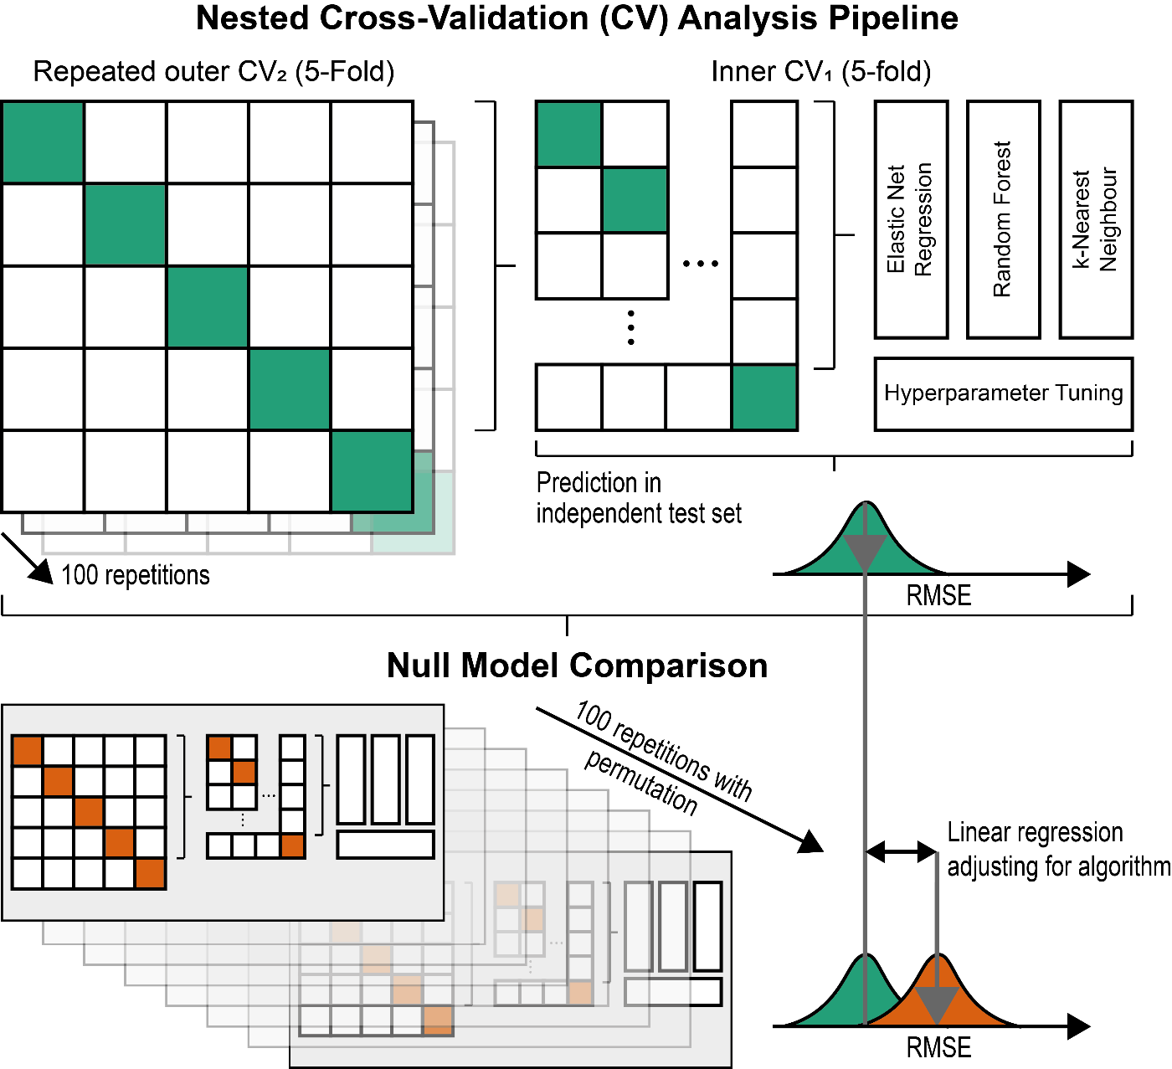

Model Training
Model training in the inner CV cycle was performed using elastic net regression, random forest and k-nearest neighbour with the goal of minimising the Root Mean Squared Error (RMSE) between predicted and observed values. These algorithms were chosen as they differ quite substantially in underlying computations (see details below), which provides a means of testing generalisability of findings across individual algorithms. Relevant hyperparameters for these algorithms were fine-tuned in the inner CV cycle using a grid search and the best hyperparameters were taken forward for independent prediction in the held-out outer CV test set.
Elastic net regression was performed using the glmnet package (version 4.1; Engebretsen and Bohlin, 2019). Elastic net regression is an extension of least squares regression including two hyperparameters, a penalisation parameter λ and a tuning parameter α. The tuning parameter α can take values between 0-1 and determines the type of penalisation, where 0 equals ridge regression, 1 equals LASSO regression, and values in between 0-1 indicate the relative balance of ridge vs. LASSO penalisation. The penalisation parameter λ can also take values between 0-1 with higher values reflecting a greater amount of penalisation.
Random forest was performed using the randomForest package (version 4.6-14; Liaw and Wiener, 2002). Random forests are an ensemble learning methods that construct multiple decision trees and average across tree-based predictions in a regression setting. There is one tuning parameter mtry which specifies the number of available variables at nodes for splitting.
K-nearest neighbour (KNN) is implemented in caret. KNN calculates the distance between individuals in the feature space. Based on the distance to the k individuals that are closest to the to-be-predicted individual, a prediction is made that constitutes the average value of these nearest neighbours. The tuning parameter k thus defines the number of nearest neighbours used for prediction.
Variable Importance
Variable importance was estimated using the caret package, which provides normalised values between 0-100, with higher values reflecting greater variable importance (Kuhn, 2008). Estimation of variable importance depends on the model algorithm, so differs for selected algorithms of elastic net regression, random forest, and k-nearest neighbour. For elastic net regression, variable importance is based on t-statistics from elastic net regression models. For random forest, variable importance is estimated by comparing mean squared error (MSE) of out-of-bag predictions with out-of-bag predictions with the variable permuted. For k-nearest neighbour, no specific variable importance calculation exists, so variable importance is based on linear regression t-statistics of variables on the outcome.

Permutation-based Null Model Comparison
To statistically test the advantage of the prediction models against chance predictions, the complete nested CV analysis pipeline was repeated with random permutations of the 7-week depressive symptom outcome in each outer CV repetition (see Figure 1). This created a permutation-based RMSE distribution that allowed comparisons with actual model predictions. To minimise the multiple testing burden, we used linear regression of RMSE values across nested CV repetitions and outer folds on a dummy variable coding model- vs permutation-based prediction and a variable coding for the algorithm used. Significance of model- vs permutation-based prediction could then be interpreted to reflect significant predictive value of the model averaged across the three prediction algorithms.

Assessment of Generalisability
As

Availability of Data and Materials
All scripts for statistical analyses are openly available under XY. Data from the OPTIMA study are sensitive and cannot be freely shared with researchers under the ethics agreement.

RESULTS

Baseline characteristics
Baseline characteristics of participants of the OPTIMA study are highlighted in Table 1.

Table 1
Baseline Characteristics
 | Inflammation Status
Variable | Non-Inflamed | Inflamed | Pª | Total
N | 74 (64.9%) | 40 (35.1%) |  | 114 (100%)
Sex
Female | 35 (47.3%) | 25 (62.5%) |  | 60 (52.63%)
Male | 39 (52.7%) | 15 (37.5%) | 0.175 | 54 (47.37%)
Missing (%) | 0 (0%) | 0 (0%) |  | 0 (0%)
Age
Mean (SD) | 41.3 (13.92) | 45.4 (12.77) |  | 42.74 (13.62)
Median (IQR) | 42.5 (29-52) | 48.5 (35.25-55) | 0.125 | 44 (30-53)
Missing (%) | 0 (0%) | 0 (0%) |  | 0 (0%)
Social class
lower-class | 11 (14.86%) | 7 (17.5%) |  | 5 (4.39%)
lower middle-class | 21 (28.38%) | 13 (32.5%) |  | 21 (18.42%)
middle middle-class | 40 (54.05%) | 27 (67.5%) |  | 54 (47.37%)
upper middle-class | 26 (35.14%) | 8 (20%) | 0.179 | 21 (18.42%)
Missing (%) | 8 (10.81%) | 5 (12.5%) |  | 13 (11.4%)
Country of Origin
Germany | 69 (93.24%) | 35 (87.5%) |  | 92 (80.7%)
Other | 13 (17.57%) | 9 (22.5%) | 0.499 | 10 (8.77%)
Missing (%) | 8 (10.81%) | 4 (10%) |  | 12 (10.53%)
Ethnicity
German | 67 (90.54%) | 36 (90%) |  | 91 (79.82%)
Other | 15 (20.27%) | 8 (20%) | 1 | 11 (9.65%)
Missing (%) | 8 (10.81%) | 4 (10%) |  | 12 (10.53%)
Employment status
Employed | 49 (66.22%) | 26 (65%) |  | 58 (50.88%)
Retired | 13 (17.57%) | 8 (20%) |  | 4 (3.51%)
Unemployed | 32 (43.24%) | 20 (50%) | 0.844 | 35 (30.7%)
Missing (%) | 10 (13.51%) | 7 (17.5%) |  | 17 (14.91%)
BDI
Mean (SD) | 32.15 (7.87) | 32.8 (7.83) |  | 32.38 (7.82)
Median (IQR) | 32 (27-37.75) | 32.5 (27-38.25) | 0.673 | 32 (27-38)
Missing (%) | 0 (0%) | 0 (0%) |  | 0 (0%)
MADRS
Mean (SD) | 26.85 (5.01) | 24.92 (6.09) |  | 26.21 (5.44)
Median (IQR) | 27 (23-30) | 24 (22-27) | 0.078 | 26 (22.5-30)
Missing (%) | 0 (0%) | 3 (7.5%) |  | 3 (2.63%)
BSI: Depression
Mean (SD) | 2.68 (0.91) | 2.89 (0.8) |  | 2.76 (0.88)
Median (IQR) | 2.75 (1.83-3.33) | 3 (2.29-3.38) | 0.23 | 2.83 (2.04-3.33)
Missing (%) | 0 (0%) | 0 (0%) |  | 0 (0%)
Hospitalisation in
Day-clinic | 15 (20.27%) | 14 (35%) |  | 29 (25.44%)
Ward | 59 (79.73%) | 26 (65%) | 0.134 | 85 (74.56%)
Missing (%) | 0 (0%) | 0 (0%) |  | 0 (0%)
Number of psychiatric diagnoses
Mean (SD) | 5.21 (3.12) | 5.11 (2.46) |  | 5.17 (2.9)
Median (IQR) | 5 (3-8) | 5 (3-7) | 0.864 | 5 (3-7)
Missing (%) | 1 (1.35%) | 2 (5%) |  | 3 (2.63%)
Note: ªP-values are based on T-tests and χ²-tests for continuous and categorical variables, respectively.

Treatment Prediction
Tbc

Figure 2: Model Prediction Performance
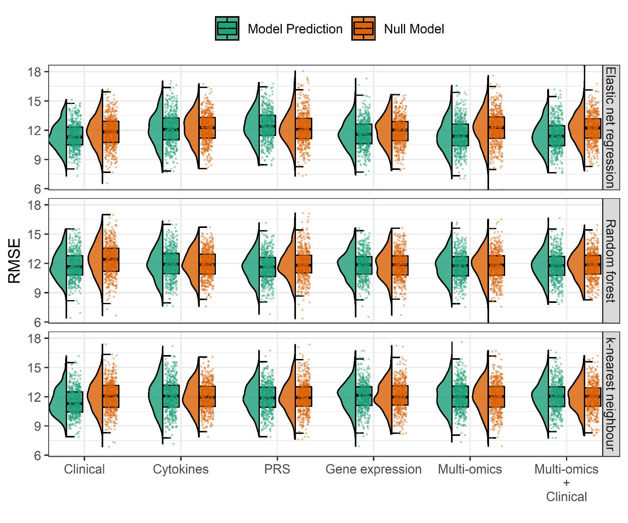

Table 2: Treatment Prediction Results
 |  |  | Permutation test
Feature set | RMSE  (Mean, SD) | R²  (Median, IQR) | ∆RMSEª  (Mean, SD) | P-value^{b}
Clinical
Elastic net regression
Random forest
k-nearest neighbour
Cytokines
Elastic net regression
Random forest
k-nearest neighbour
Transcriptomics
Elastic net regression
Random forest
k-nearest neighbour
Genomics
Elastic net regression
Random forest
k-nearest neighbour
Multi-omics
Elastic net regression
Random forest
k-nearest neighbour
Multi-omics & clinical
Elastic net regression
Random forest
k-nearest neighbour
Note: ªDifference in RMSE between actual predictions and predictions with permuted outcome variable. ^{b}P-value obtained from paired t-tests comparing the distribution actual predictions and predictions with permuted outcome variable.

Figure 3: Variable Importance for Top 20 Predictors
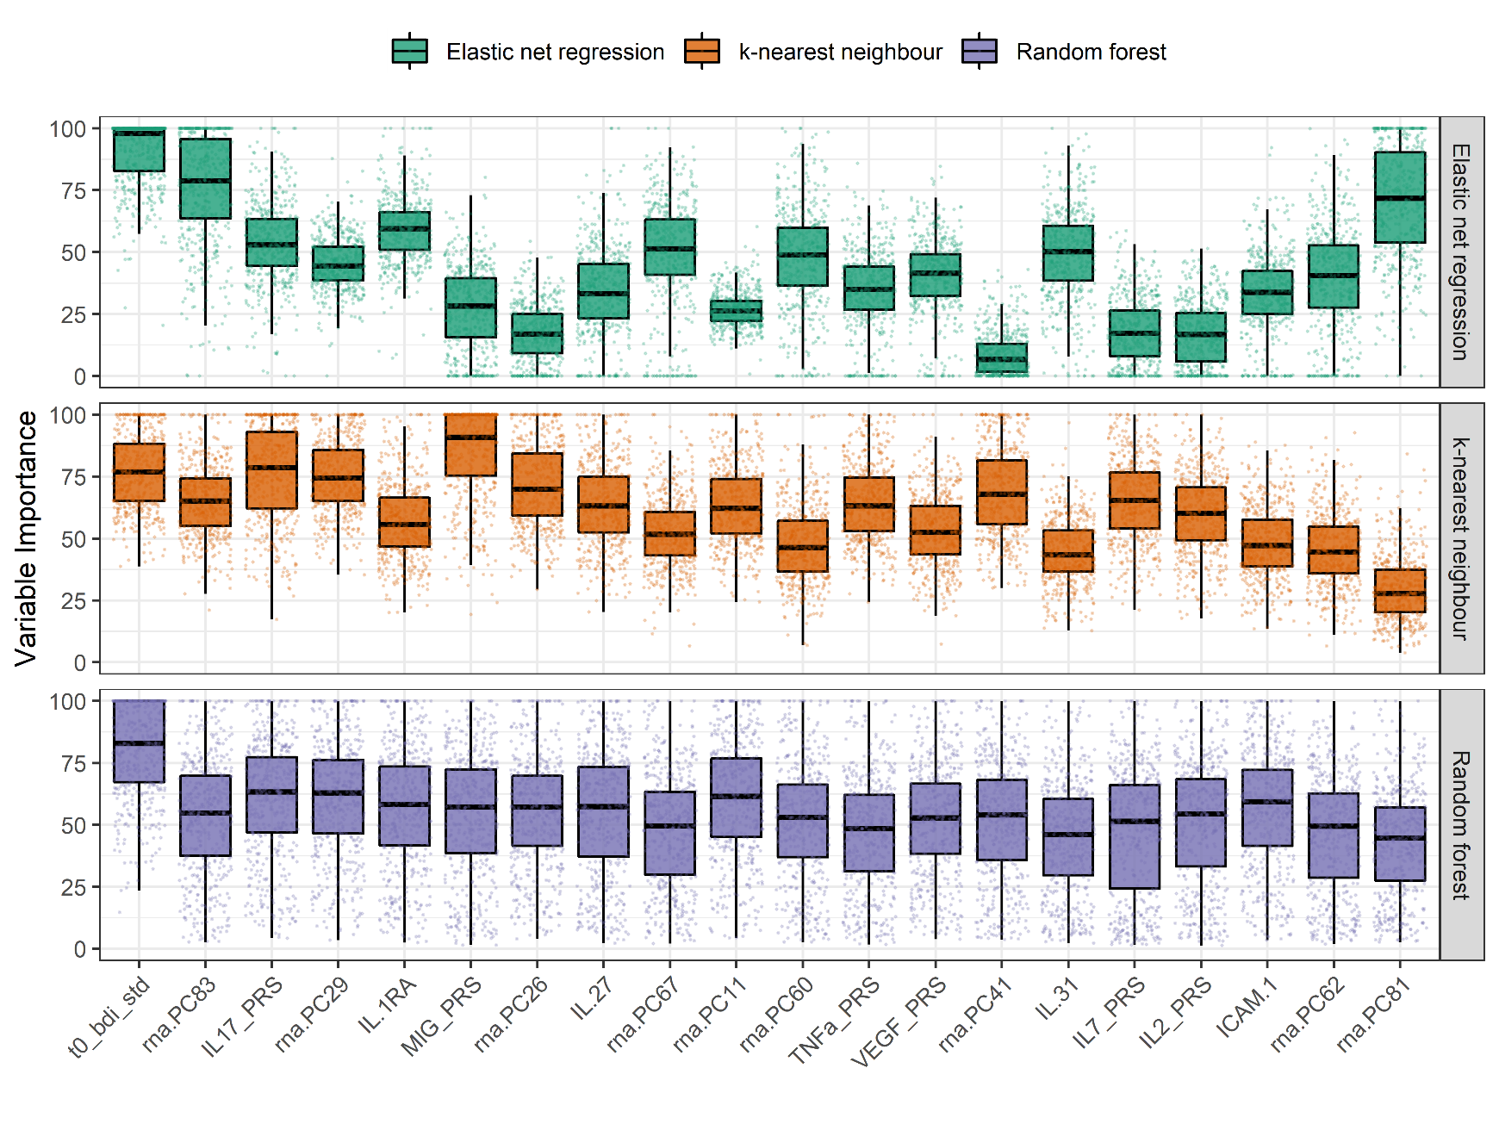

Content Validity Analyses
as

DISCUSSION
Tbc

Conclusion
Tbc

COMPETING INTERESTS
The authors do not have any competing interests.

FUNDING
This study is funded by the Max Planck Institute of Psychiatry. NK is supported by the International Max Planck Research School of Translational Psychiatry (IMPRS-TP).

AUTHOR CONTRIBUTIONS
tbc

ACKNOWLEDGMENTS
tbc

REFERENCES
Ahola-Olli, A. V, Würtz, P., Havulinna, A.S., Aalto, K., Pitkänen, N., Lehtimäki, T., Kähönen, M., Lyytikäinen, L.-P., Raitoharju, E., Seppälä, I., Sarin, A.-P., Ripatti, S., Jalkanen, S., Maksimow, M., Salomaa, V., Salmi, M., Kettunen, J., Raitakari, O.T., 2017. Genome-wide Association Study Identifies 27 Loci Influencing Concentrations of Circulating Cytokines and Growth Factors. Am. J. Hum. Genet. 100, 40–50. https://doi.org/10.1016/j.ajhg.2016.11.007
Beck, A.T., Steer, R.A., Brown, G., 1996. Beck depression inventory–II. Psychol. Assess. https://doi.org/10.1037/t00742-000
Brückl, T.M., Spoormaker, V.I., Sämann, P.G., Brem, A., Henco, L., Czamara, D., Elbau, I., Grandi, N.C., Jollans, L., Kühnel, A., Leuchs, L., Pöhlchen, D., Schneider, M., Tontsch, A., Keck, M.E., Schilbach, L., Czisch, M., Lucae, S., Erhardt, A., Binder, E.B., 2020. The biological classification of mental disorders (BeCOME) study: a protocol for an observational deep-phenotyping study for the identification of biological subtypes. BMC Psychiatry 1–25. https://doi.org/10.1186/s12888-020-02541-z
Carvalho, L.A., Torre, J.P., Papadopoulos, A.S., Poon, L., Juruena, M.F., Markopoulou, K., Cleare, A.J., Pariante, C.M., 2013. Lack of clinical therapeutic benefit of antidepressants is associated overall activation of the inflammatory system. J. Affect. Disord. 148, 136–140. https://doi.org/10.1016/j.jad.2012.10.036
Cattaneo, A., Ferrari, C., Turner, L., Mariani, N., Enache, D., Hastings, C., Kose, M., Lombardo, G., McLaughlin, A.P., Nettis, M.A., Nikkheslat, N., Sforzini, L., Worrell, C., Zajkowska, Z., Cattane, N., Lopizzo, N., Mazzelli, M., Pointon, L., Cowen, P.J., Cavanagh, J., Harrison, N.A., de Boer, P., Jones, D., Drevets, W.C., Mondelli, V., Bullmore, E.T., Pariante, C.M., 2020. Whole-blood expression of inflammasome- and glucocorticoid-related mRNAs correctly separates treatment-resistant depressed patients from drug-free and responsive patients in the BIODEP study. Transl. Psychiatry 10, 232. https://doi.org/10.1038/s41398-020-00874-7
Dantzer, R., O’Connor, J.C., Freund, G.G., Johnson, R.W., Kelley, K.W., 2008. From inflammation to sickness and depression: when the immune system subjugates the brain. Nat. Rev. Neurosci. 9, 46–56. https://doi.org/10.1038/nrn2297
Dwyer, D.B., Falkai, P., Koutsouleris, N., 2018. Machine Learning Approaches for Clinical Psychology and Psychiatry. Annu. Rev. Clin. Psychol. 14, 91–118. https://doi.org/10.1146/annurev-clinpsy-032816-045037
Engebretsen, S., Bohlin, J., 2019. Statistical predictions with glmnet. Clin. Epigenetics 11, 123. https://doi.org/10.1186/s13148-019-0730-1
Gadad, B.S., Jha, M.K., Grannemann, B.D., Mayes, T.L., Trivedi, M.H., 2017. Proteomics profiling reveals inflammatory biomarkers of antidepressant treatment response: Findings from the CO-MED trial. J. Psychiatr. Res. 94, 1–6. https://doi.org/10.1016/j.jpsychires.2017.05.012
Ge, T., Chen, C.-Y., Ni, Y., Feng, Y.-C.A., Smoller, J.W., 2019. Polygenic prediction via Bayesian regression and continuous shrinkage priors. Nat. Commun. 10, 1776. https://doi.org/10.1038/s41467-019-09718-5
Goldsmith, D.R., Rapaport, M.H., Miller, B.J., 2016. A meta-analysis of blood cytokine network alterations in psychiatric patients: comparisons between schizophrenia, bipolar disorder and depression. Mol. Psychiatry 21, 1696–1709. https://doi.org/10.1038/mp.2016.3
Grosse, L., Hoogenboezem, T., Ambrée, O., Bellingrath, S., Jörgens, S., de Wit, H.J., Wijkhuijs, A.M., Arolt, V., Drexhage, H.A., 2016. Deficiencies of the T and natural killer cell system in major depressive disorder. Brain. Behav. Immun. 54, 38–44. https://doi.org/10.1016/j.bbi.2015.12.003
Haapakoski, R., Ebmeier, K.P., Alenius, H., Kivimäki, M., 2016. Innate and adaptive immunity in the development of depression: An update on current knowledge and technological advances. Prog. Neuro-Psychopharmacology Biol. Psychiatry 66, 63–72. https://doi.org/10.1016/j.pnpbp.2015.11.012
Haroon, E., Daguanno, A.W., Woolwine, B.J., Goldsmith, D.R., Baer, W.M., Wommack, E.C., Felger, J.C., Miller, A.H., 2018. Antidepressant Treatment Resistance is Associated with Increased Inflammatory Markers in Patients with Major Depressive Disorder. Psychoneuroendocrinology 95, 43–49. https://doi.org/10.1016/j.psyneuen.2018.05.026
Himmerich, H., Patsalos, O., Lichtblau, N., Ibrahim, M.A.A., Dalton, B., 2019. Cytokine Research in Depression: Principles, Challenges, and Open Questions. Front. Psychiatry 10, 30. https://doi.org/10.3389/fpsyt.2019.00030
Jakobsen, J.C., Gluud, C., Wetterslev, J., Winkel, P., 2017. When and how should multiple imputation be used for handling missing data in randomised clinical trials – a practical guide with flowcharts. BMC Med. Res. Methodol. 17, 162. https://doi.org/10.1186/s12874-017-0442-1
Khandaker, G.M., Oltean, B.P., Kaser, M., Dibben, C.R.M., Ramana, R., Jadon, D.R., Dantzer, R., Coles, A.J., Lewis, G., Jones, P.B., 2018. Protocol for the insight study: a randomised controlled trial of single-dose tocilizumab in patients with depression and low-grade inflammation. BMJ Open 8, e025333. https://doi.org/10.1136/bmjopen-2018-025333
Khandaker, G.M., Pearson, R.M., Zammit, S., Lewis, G., Jones, P.B., 2014. Association of serum interleukin 6 and C-reactive protein in childhood with depression and psychosis in young adult life: a population-based longitudinal study. JAMA Psychiatry 71, 1121–1128. https://doi.org/10.1001/jamapsychiatry.2014.1332
Köhler, C.A., Freitas, T.H., Maes, M., de Andrade, N.Q., Liu, C.S., Fernandes, B.S., Stubbs, B., Solmi, M., Veronese, N., Herrmann, N., Raison, C.L., Miller, B.J., Lanctôt, K.L., Carvalho, A.F., 2017. Peripheral cytokine and chemokine alterations in depression: a meta-analysis of 82 studies. Acta Psychiatr. Scand. 135, 373–387. https://doi.org/10.1111/acps.12698
Kopf-Beck, J., Zimmermann, P., Egli, S., Rein, M., Kappelmann, N., Fietz, J., Tamm, J., Rek, K., Lucae, S., Brem, A., Sämann, P., Schilbach, L., Keck, M.E., 2020. Schema therapy versus cognitive behavioral therapy versus individual supportive therapy for depression in an inpatient and day clinic setting: study protocol of the OPTIMA-RCT. BMC Psychiatry 20, 506. https://doi.org/10.1186/s12888-020-02880-x
Kuhn, M., 2008. Building Predictive Models in R Using the caret Package. J. Stat. Softw. 28. https://doi.org/10.18637/jss.v028.i05
Kühner, C., Bürger, C., Keller, F., Hautzinger, M., 2007. Reliabilität und Validität des revidierten Beck-Depressionsinventars (BDI-II). Nervenarzt 78, 651–656. https://doi.org/10.1007/s00115-006-2098-7
Lanquillon, S., Krieg, J.-C., Bening-Abu-Shach, U., Vedder, H., 2000. Cytokine Production and Treatment Response in Major Depressive Disorder. Neuropsychopharmacology 22, 370–379. https://doi.org/10.1016/S0893-133X(99)00134-7
Liaw, A., Wiener, M., 2002. Classification and Regression by randomForest. R News 2, 18–22.
Ligthart, S., Vaez, A., Võsa, U., Stathopoulou, M.G., de Vries, P.S., Prins, B.P., Van der Most, P.J., Tanaka, T., Naderi, E., Rose, L.M., Wu, Y., Karlsson, R., Barbalic, M., Lin, H., Pool, R., Zhu, G., Macé, A., Sidore, C., Trompet, S., Mangino, M., Sabater-Lleal, M., Kemp, J.P., Abbasi, A., Kacprowski, T., Verweij, N., Smith, A. V, Huang, T., Marzi, C., Feitosa, M.F., Lohman, K.K., Kleber, M.E., Milaneschi, Y., Mueller, C., Huq, M., Vlachopoulou, E., Lyytikäinen, L.-P., Oldmeadow, C., Deelen, J., Perola, M., Zhao, J.H., Feenstra, B., Amini, M., Lahti, J., Schraut, K.E., Fornage, M., Suktitipat, B., Chen, W.-M., Li, X., Nutile, T., Malerba, G., Luan, J., Bak, T., Schork, N., Del Greco M., F., Thiering, E., Mahajan, A., Marioni, R.E., Mihailov, E., Eriksson, Joel, Ozel, A.B., Zhang, W., Nethander, M., Cheng, Y.-C., Aslibekyan, S., Ang, W., Gandin, I., Yengo, L., Portas, L., Kooperberg, C., Hofer, E., Rajan, K.B., Schurmann, C., den Hollander, W., Ahluwalia, Tarunveer S., Zhao, J., Draisma, H.H.M., Ford, I., Timpson, N., Teumer, A., Huang, H., Wahl, S., Liu, Y., Huang, J., Uh, H.-W., Geller, F., Joshi, P.K., Yanek, L.R., Trabetti, E., Lehne, B., Vozzi, D., Verbanck, M., Biino, G., Saba, Y., Meulenbelt, I., O’Connell, J.R., Laakso, M., Giulianini, F., Magnusson, P.K.E., Ballantyne, C.M., Hottenga, J.J., Montgomery, G.W., Rivadineira, F., Rueedi, R., Steri, M., Herzig, K.-H., Stott, D.J., Menni, C., Frånberg, M., St. Pourcain, B., Felix, S.B., Pers, T.H., Bakker, S.J.L., Kraft, P., Peters, A., Vaidya, D., Delgado, G., Smit, J.H., Großmann, V., Sinisalo, J., Seppälä, I., Williams, S.R., Holliday, E.G., Moed, M., Langenberg, C., Räikkönen, K., Ding, J., Campbell, H., Sale, M.M., Chen, Y.-D.I., James, A.L., Ruggiero, D., Soranzo, N., Hartman, C.A., Smith, E.N., Berenson, G.S., Fuchsberger, C., Hernandez, D., Tiesler, C.M.T., Giedraitis, V., Liewald, D., Fischer, K., Mellström, D., Larsson, A., Wang, Y., Scott, W.R., Lorentzon, M., Beilby, J., Ryan, K.A., Pennell, C.E., Vuckovic, D., Balkau, B., Concas, M.P., Schmidt, R., Mendes de Leon, C.F., Bottinger, E.P., Kloppenburg, M., Paternoster, L., Boehnke, M., Musk, A.W., Willemsen, G., Evans, D.M., Madden, P.A.F., Kähönen, M., Kutalik, Z., Zoledziewska, M., Karhunen, V., Kritchevsky, S.B., Sattar, N., Lachance, G., Clarke, R., Harris, T.B., Raitakari, O.T., Attia, J.R., van Heemst, D., Kajantie, E., Sorice, R., Gambaro, G., Scott, R.A., Hicks, A.A., Ferrucci, L., Standl, M., Lindgren, C.M., Starr, J.M., Karlsson, M., Lind, L., Li, J.Z., Chambers, J.C., Mori, T.A., de Geus, E.J.C.N., Heath, A.C., Martin, N.G., Auvinen, J., Buckley, B.M., de Craen, A.J.M., Waldenberger, M., Strauch, K., Meitinger, T., Scott, R.J., McEvoy, M., Beekman, M., Bombieri, C., Ridker, P.M., Mohlke, K.L., Pedersen, N.L., Morrison, A.C., Boomsma, D.I., Whitfield, J.B., Strachan, D.P., Hofman, A., Vollenweider, P., Cucca, F., Jarvelin, M.-R., Jukema, J.W., Spector, T.D., Hamsten, A., Zeller, T., Uitterlinden, André G., Nauck, M., Gudnason, V., Qi, L., Grallert, H., Borecki, I.B., Rotter, J.I., März, W., Wild, P.S., Lokki, M.-L., Boyle, M., Salomaa, V., Melbye, M., Eriksson, J.G., Wilson, J.F., Penninx, B.W.J.H., Becker, D.M., Worrall, B.B., Gibson, G., Krauss, R.M., Ciullo, M., Zaza, G., Wareham, N.J., Oldehinkel, A.J., Palmer, L.J., Murray, S.S., Pramstaller, P.P., Bandinelli, S., Heinrich, J., Ingelsson, E., Deary, I.J., Mägi, R., Vandenput, L., van der Harst, P., Desch, K.C., Kooner, J.S., Ohlsson, C., Hayward, C., Lehtimäki, T., Shuldiner, A.R., Arnett, D.K., Beilin, L.J., Robino, A., Froguel, P., Pirastu, M., Jess, T., Koenig, W., Loos, R.J.F., Evans, D.A., Schmidt, H., Davey Smith, G., Slagboom, P.E., Eiriksdottir, G., Morris, A.P., Psaty, B.M., Tracy, R.P., Nolte, I.M., Boerwinkle, E., Visvikis-Siest, S., Reiner, A.P., Gross, M., Bis, J.C., Franke, L., Franco, O.H., Benjamin, E.J., Chasman, D.I., Dupuis, Josée, Snieder, H., Dehghan, A., Alizadeh, B.Z., Alizadeh, B.Z., Boezen, H.M., Franke, L., van der Harst, P., Navis, G., Rots, M., Snieder, H., Swertz, M., Wolffenbuttel, B.H.R., Wijmenga, C., Benjamin, E., Chasman, D.I., Dehghan, A., Ahluwalia, Tarunveer Singh, Meigs, J., Tracy, R., Alizadeh, B.Z., Ligthart, S., Bis, J., Eiriksdottir, G., Pankratz, N., Gross, M., Rainer, A., Snieder, H., Wilson, J.G., Psaty, B.M., Dupuis, Josee, Prins, B., Vaso, U., Stathopoulou, M., Franke, L., Lehtimaki, T., Koenig, W., Jamshidi, Y., Siest, S., Abbasi, A., Uitterlinden, Andre G., Abdollahi, M., Schnabel, R., Schick, U.M., Nolte, I.M., Kraja, A., Hsu, Y.-H., Tylee, D.S., Zwicker, A., Uher, R., Davey Smith, G., Morrison, A.C., Hicks, A., van Duijn, C.M., Ward-Caviness, C., Boerwinkle, E., Rotter, J., Rice, K., Lange, L., Perola, M., de Geus, E., Morris, A.P., Makela, K.M., Stacey, D., Eriksson, Johan, Frayling, T.M., Slagboom, E.P., 2018. Genome Analyses of >200,000 Individuals Identify 58 Loci for Chronic Inflammation and Highlight Pathways that Link Inflammation and Complex Disorders. Am. J. Hum. Genet. 103, 691–706. https://doi.org/10.1016/j.ajhg.2018.09.009
Liu, J.J., Wei, Y. Bin, Strawbridge, R., Bao, Y., Chang, S., Shi, L., Que, J., Gadad, B.S., Trivedi, M.H., Kelsoe, J.R., Lu, L., 2020. Peripheral cytokine levels and response to antidepressant treatment in depression: a systematic review and meta-analysis. Mol. Psychiatry 25, 339–350. https://doi.org/10.1038/s41380-019-0474-5
Lopresti, A.L., Schmidt, F.M., 2018. Cognitive behaviour therapy and inflammation: A systematic review of its relationship and the potential implications for the treatment of depression. Aust. New Zeal. J. Psychiatry 51, 385–386. https://doi.org/10.1177/0004867418757919
Lynall, M.-E., Turner, L., Bhatti, J., Cavanagh, J., de Boer, P., Mondelli, V., Jones, D., Drevets, W.C., Cowen, P., Harrison, N.A., Pariante, C.M., Pointon, L., Clatworthy, M.R., Bullmore, E., 2020. Peripheral Blood Cell–Stratified Subgroups of Inflamed Depression. Biol. Psychiatry 88, 185–196. https://doi.org/10.1016/j.biopsych.2019.11.017
Mac Giollabhui, N., Ng, T.H., Ellman, L.M., Alloy, L.B., 2020. The longitudinal associations of inflammatory biomarkers and depression revisited: systematic review, meta-analysis, and meta-regression. Mol. Psychiatry. https://doi.org/10.1038/s41380-020-00867-4
Marx, W., McGuinness, A.J., Rocks, T., Ruusunen, A., Cleminson, J., Walker, A.J., Gomes-da-Costa, S., Lane, M., Sanches, M., Diaz, A.P., Tseng, P.-T., Lin, P.-Y., Berk, M., Clarke, G., O’Neil, A., Jacka, F., Stubbs, B., Carvalho, A.F., Quevedo, J., Soares, J.C., Fernandes, B.S., 2020. The kynurenine pathway in major depressive disorder, bipolar disorder, and schizophrenia: a meta-analysis of 101 studies. Mol. Psychiatry. https://doi.org/10.1038/s41380-020-00951-9
Milaneschi, Y., Kappelmann, N., Ye, Z., Lamers, F., Moser, S., Jones, P.B., Burgess, S., Penninx, B.W.J.H., Khandaker, G.M., 2021. Association of inflammation with depression and anxiety: evidence for symptom-specificity and potential causality from UK Biobank and NESDA cohorts. Mol. Psychiatry. https://doi.org/10.1038/s41380-021-01188-w
Milaneschi, Y., Lamers, F., Berk, M., Penninx, B.W.J.H., 2020. Depression Heterogeneity and Its Biological Underpinnings: Toward Immunometabolic Depression. Biol. Psychiatry 88, 369–380. https://doi.org/10.1016/j.biopsych.2020.01.014
Orlovska-Waast, S., Köhler-Forsberg, O., Brix, S.W., Nordentoft, M., Kondziella, D., Krogh, J., Benros, M.E., 2019. Cerebrospinal fluid markers of inflammation and infections in schizophrenia and affective disorders: a systematic review and meta-analysis. Mol. Psychiatry 24, 869–887. https://doi.org/10.1038/s41380-018-0220-4
Osimo, E.F., Baxter, L.J., Lewis, G., Jones, P.B., Khandaker, G.M., 2019. Prevalence of low-grade inflammation in depression: a systematic review and meta-analysis of CRP levels. Psychol. Med. 49, 1958–1970. https://doi.org/10.1017/S0033291719001454
Ozaki, K., Leonard, W.J., 2002. Cytokine and Cytokine Receptor Pleiotropy and Redundancy. J. Biol. Chem. 277, 29355–29358. https://doi.org/10.1074/jbc.R200003200
R Core Team, 2017. R: A language and environment for statistical computing.
Reininghaus, B., Riedrich, K., Dalkner, N., Bengesser, S.A., Birner, A., Platzer, M., Hamm, C., Gostner, J.M., Fuchs, D., Reininghaus, E.Z., 2018. Changes in the tryptophan-kynurenine axis in association to therapeutic response in clinically depressed patients undergoing psychiatric rehabilitation. Psychoneuroendocrinology 94, 25–30. https://doi.org/10.1016/j.psyneuen.2018.04.029
Subramanian, N., Torabi-Parizi, P., Gottschalk, R.A., Germain, R.N., Dutta, B., 2015. Network representations of immune system complexity. Wiley Interdiscip. Rev. Syst. Biol. Med. 7, 13–38. https://doi.org/10.1002/wsbm.1288

TABLES AND FIGURES

