Project Documentation

**Project Title:** SAP to Azure Cloud Data Lake Migration for OLAP Analysis
**Author:** Karan Naidu
**Date:** August 03, 2024
**Tech Stack:** Azure Data Factory, Azure Databricks, PySpark, SSMS, Power BI

1. Executive Summary
This project involved migrating approximately 500 TB of SAP-generated data stored in HDFS to an Azure-based data architecture for the purpose of analytical (OLAP) reporting. Using ExpressRoute and Azure Data Factory with a Self-hosted Integration Runtime, data was ingested into Azure Data Lake. Transformation logic was handled using Azure Databricks and PySpark on a 24-core cluster, with optimized processing techniques such as lazy evaluation and salting. Processed data was stored in a Snowflake-schema data warehouse in SSMS, which was ultimately connected to Power BI dashboards for consumption.
Medallion Architecture overview -
🥉 Bronze Layer – Raw Ingestion
- Storage: Azure Data Lake Storage Gen2
- Data Source: SAP data stored in HDFS (Parquet, JSON, CSV)
- Process:
  - Pulled via Azure Data Factory using Integration Runtime and ExpressRoute, stored as-is with minimal processing
- Purpose: Raw, unprocessed data landing zone for auditability and traceability
🥈 Silver Layer – Cleaned and Enriched
- Storage: Delta Tables in Azure Data Lake (via Azure Databricks)
- Transformation Tool: PySpark in Azure Databricks
- Optimizations:
  - Salting, Lazy Evaluation, Column Pruning
  - Partitioning by region or transaction date
- Data Format: Delta Lake
- Purpose: Cleaned, deduplicated, and enriched data ready for reporting or analytics
🥇 Gold Layer – Curated Analytics
- Storage: SQL Server (SSMS)
- Model: Snowflake Schema (Fact + Dimension tables)
- Sink: Final write done via Azure Data Factory
- Usage: Consumed by Power BI dashboards and analytical models
- Purpose: High-performance analytical layer for business intelligence

2. Architecture Overview
The overall architecture follows a hybrid cloud pattern, leveraging a secure connection from on-premise HDFS to Azure Cloud using ExpressRoute and Self-hosted Integration Runtime. Azure Data Factory is used for orchestration, routing different file types through Azure Data Flow or Azure Databricks based on size and format.
The high-level flow is as follows:
1. On-premise HDFS hosts SAP-exported data in Parquet, JSON, and CSV formats.
2. ExpressRoute provides a secure channel to Azure.
3. Azure Data Factory orchestrates extraction and load operations.
4. Files ≤ 2GB or in CSV format are processed via ADF Data Flow.
5. Larger Parquet/JSON files are processed using Azure Databricks (24-core cluster) using PySpark.
6. Transformed data is written to a Snowflake-schema modeled SSMS data warehouse.
7. Final tables are exposed to Power BI for dashboarding and analysis.

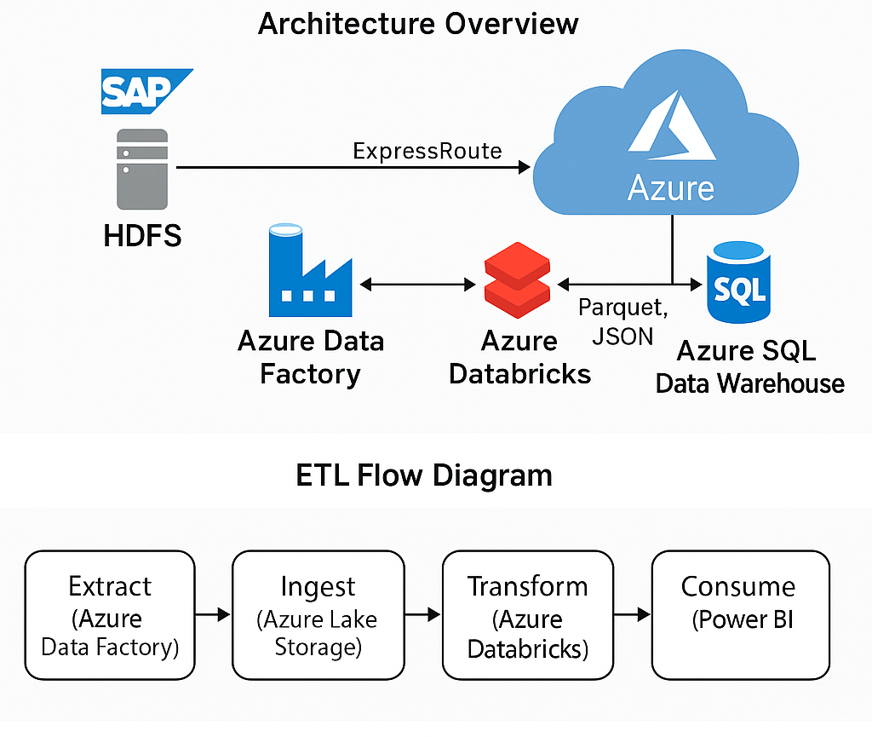

3. Tools & Technologies

Component | Technology Used | Description
Ingestion | Azure Data Factory | Orchestration of data ingestion from HDFS using Self-hosted IR.
Secure Connectivity | Azure ExpressRoute | Private network connection from on-premise to Azure.
Data Storage | Azure Data Lake Gen2 | Stores raw and intermediate transformed data.
Processing Engine | Azure Databricks (24-core) | Handles large file processing using PySpark.
Transformation Logic | PySpark | Used for ETL with optimization techniques like salting and lazy eval.
Lightweight Processing | ADF Data Flow | Used for files ≤ 2GB and CSV format.
Data Modeling | Snowflake Schema in SSMS | Stores final fact/dimension tables for OLAP access.
Reporting | Power BI | Used for dashboarding and data visualization.

4. Implementation Details
The project was implemented using a modular ETL pipeline pattern in Azure. Each stage of data movement and processing was broken into reusable ADF pipelines and Databricks notebooks. ADF handled all orchestrations with conditional branching to select between Data Flows or Databricks processing based on file metadata.
In Azure Databricks, PySpark scripts were written with modular functions and configuration-driven design. Data was read from ADLS Gen2, transformed using PySpark operations with lazy evaluation to minimize shuffling, and written into curated zones which were ultimately loaded into SSMS using ADF Copy Activity.

5. Data Modeling (Snowflake Schema)
The data warehouse design follows a Snowflake Schema to support analytical querying. Fact tables were designed to hold transactional data with foreign keys linked to multiple dimension tables.
Dimension tables held descriptive attributes, and in some cases, further sub-dimensions were created to normalize hierarchies such as geography, product categories, and departments.
Fact Table Example: `Sales_Fact`
Dimension Tables: `Customer_Dim`, `Product_Dim`, `Time_Dim`, `Location_Dim`
Sub-Dimensions: `City_SubDim`, `Region_SubDim`, `Product_Category_SubDim`
*Note – (Due to Confidentiality agreement can’t disclose the Table names this is an example structure)

6. Optimization Techniques Used
To ensure scalability and efficiency during transformation, the following optimization techniques were implemented:
- **Lazy Evaluation:** Utilized PySpark's inherent laziness to defer transformations until actions were triggered.
- **Salting:** Applied salting on skewed join keys to evenly distribute data during shuffles.
- **Partitioning:** Partitioned input and output datasets on relevant columns such as date and region.
- **Broadcast Joins:** Used small dimension tables for broadcast joins to speed up joins.
- **Caching:** Persisted intermediate DataFrames for reuse when applicable.

7. Learnings & Challenges
Several learnings and challenges emerged during the project lifecycle:
- Managing schema evolution in Parquet files required robust schema inference and validation.
- Dealing with data skew during joins was resolved by salting techniques.
- Optimizing costs and cluster auto-scaling in Databricks required monitoring and tuning.
- Ensuring ADF pipeline reliability under heavy loads involved retry policies and dependency chains.
- Integration testing for Power BI dashboards required mock data and refresh testing mechanisms.

