Digital Harware Systems at low logic level I
Nikolaos Karapatsias 10661

Part 1

1) Arithmetic Logical Unit Module (alu.v)
- Verilog:

- Starting by implementing our module’s input output ports as requested:
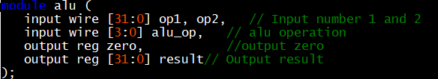

- Then we are decoding each of 9 functions we want to execute with our module using “parameter” :

- From there, we are creating a 9 to 1 MUX using ”case” loop which is expecting as an input the 4bit operation code, and sets the output as the result of the desired function. Note that all the reg updates of “Zero” and “Result” are done synchronously whenever an input signal changes. 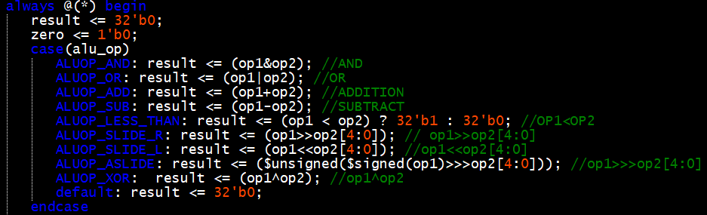
- Last but not least we are setting the “Zero” register either to 0 or 1 following the current result:

- Results:

As we can see, our module produces the expected values:
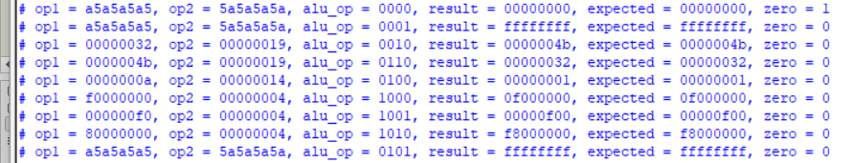
2) Calc_enc Module (calc_enc.v):

- Verilog:
- In this module we are implementing the creation of the operation code used to control alu module using structural verilog. We are doing that by creating 4 different gate logic circuit’s for each of the 4 bits of alu_op. To achieve that, we are using 3 buttons named btnc, btnl and btnr as declared below:
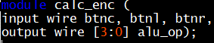

- Then we are making the required declarations and assignments of wires in order for our project to work properly.
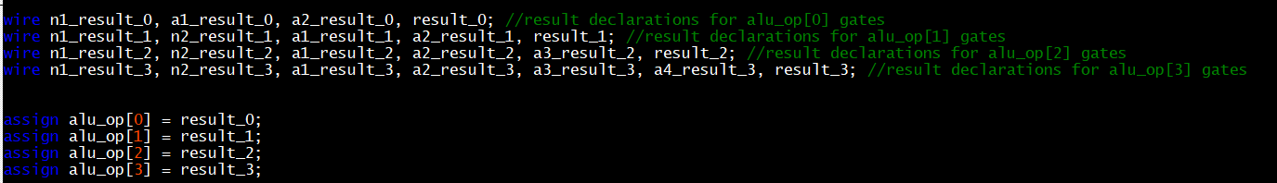

- From there, we are ready to implement logic for each of the 4 bits:
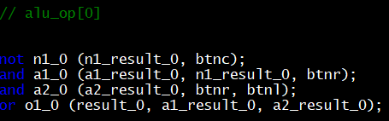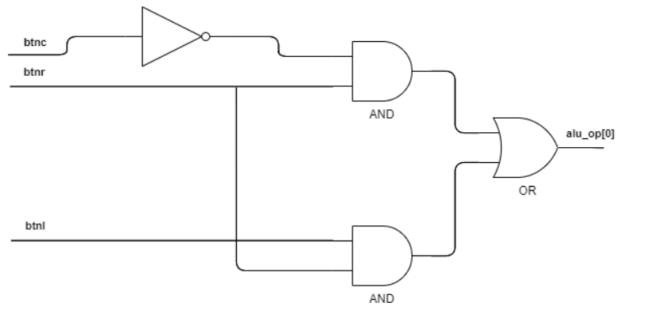
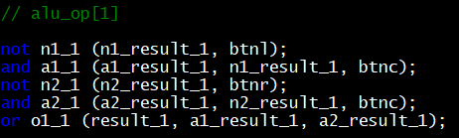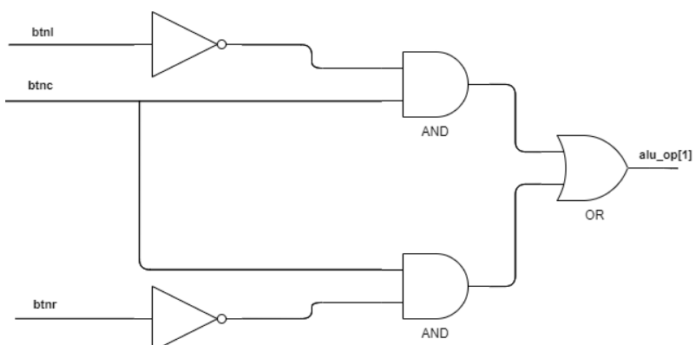
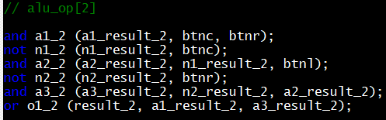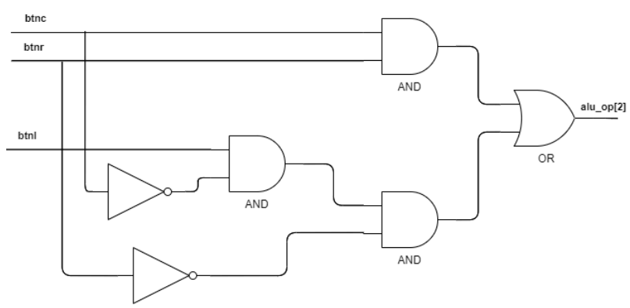
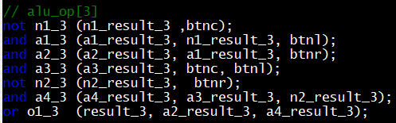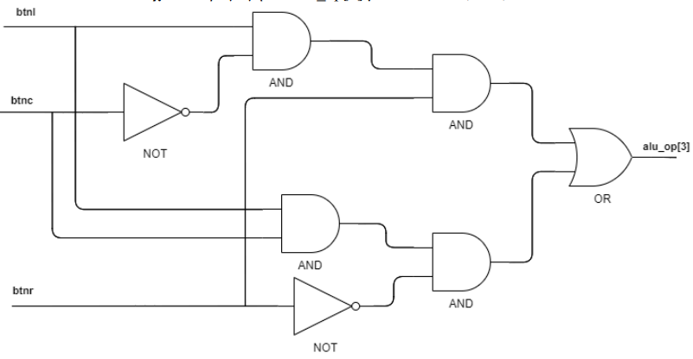

- Result table:
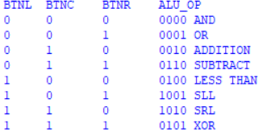

3) Calc Module (calc.v):
- Verilog:
- Firstly, we are declaring our input/output ports that are requested.
- From there, we are setting some registers and wires that will help us to implement this module. Note that result, zero, op1 and op2 are the wires that connects the alu to our current module. The accumulator register is used as described in the pdf file.
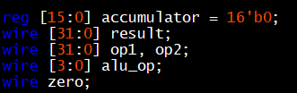

- Then, we are making some assignments as described. Op1 gets the value stored in the accumulator using a sign extension to transpose it from 16bits to 32bits. The same tactic is used for Op2 which gets the value of switch using sign extension again.
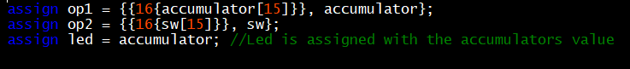

- In the next step, we are installing the submodules alu and calc_enc (described later)

- Last but not least, we are updating our accumulator value synchronously with a positive edge of the clock, either with 0 when btnu button is pressed or the result of alu when btnd one is pressed.
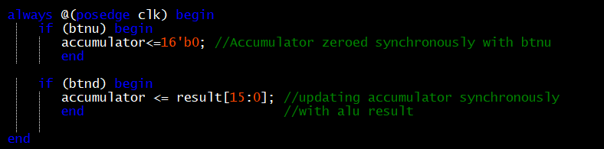

- Result table and waveform:

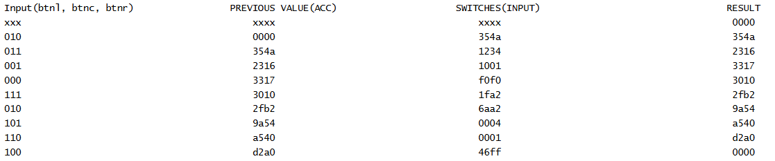
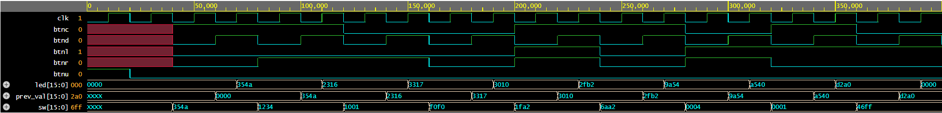
4)Regfile Module (regfile.v):
- Verilog:
- Fristly we are initializing our input/output ports of our module as described in the instructions

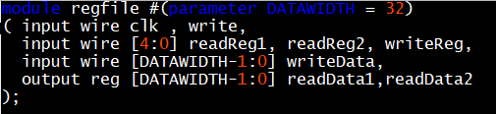
- Then we are creating a system of 32 registers where each can store 32 bits using a for loop inside an initial begin block
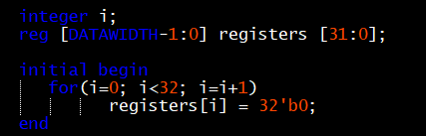

- And finally we are implementing the logic of our registers file. Firstly, we are always reading synchronously the two values of the given “readRegisters” 1 and 2 if the write signal is 1 we are also allowing our module to write “writeData” to the location specified by “writeReg”. Note that if there is a conflict between the read and write registers, we are prioritizing the writing function by setting it asynchronously (=) and not synchronous (<=) as the other registers. In that case, the output of the requested read data will be the input of “writeData” port of the same clock cycle. 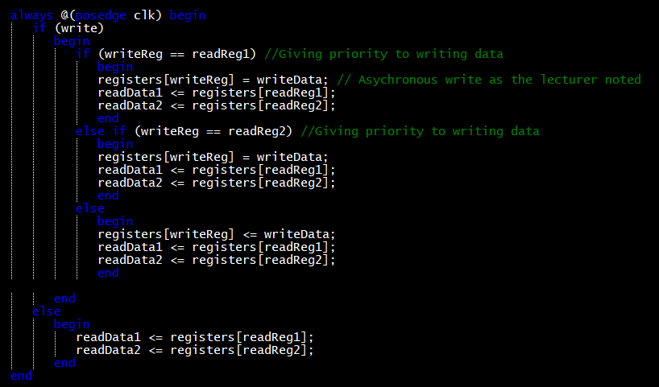

- Results:

The output waveform is shown in the below image. Firstly, we enable write signal and setting the first 4 registers of the regfile module as 32’b0, 32’b1, 32’b10, and 32’b11 respectively. This is done in the first 4 cycles (60 ns). Afterwards, we disable the write data signal and read the values stored in the first 4 registers. As you can see, the values match the ones we loaded in the previous step. Finally, on the 7th cycle (120 ns) we are enabling again writing, and on the same cycle we try to read from the same register. The value of the register we read is the same as the value of “writeData” we loaded on the same cycle, 01ff_ffff as expected.
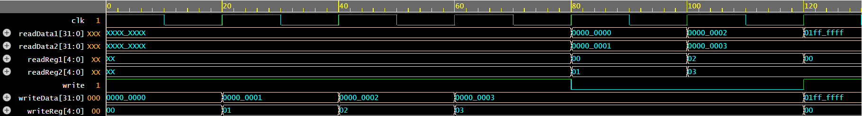

Part2
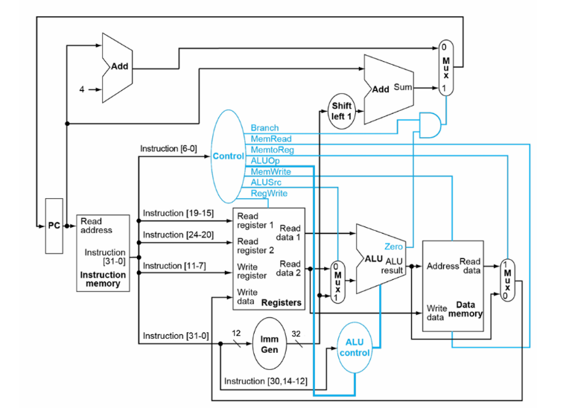
1)Datapath Module (datapath.v):
- Verilog:
- Firstly we are declaring our modules input/output ports and also some registers an wires to help us implement the datapath logic.
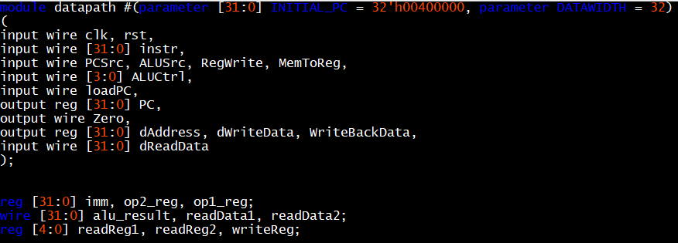

- After that, we are installing the required submodules Alu and Regfile analyzed previously.
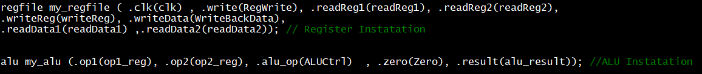
- Also we are initializing the Program counter to 0x00400000.
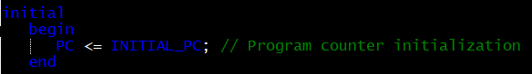

- Now we are ready to start implementing the datapath logic. Firstly, we are setting a restet parameter to restart our system whenever we want to. We are also loading the Programm counter with the next address of Rom whenever is asked from the signal “loadPC”. “PCSrc” signal defines the step by which we will update the value of Programm Counter. That signal is high “1” only on BEQ type of instructions and sets the step equal to the immediate value specified by the instruction. In all the other instructions that signal remains low.
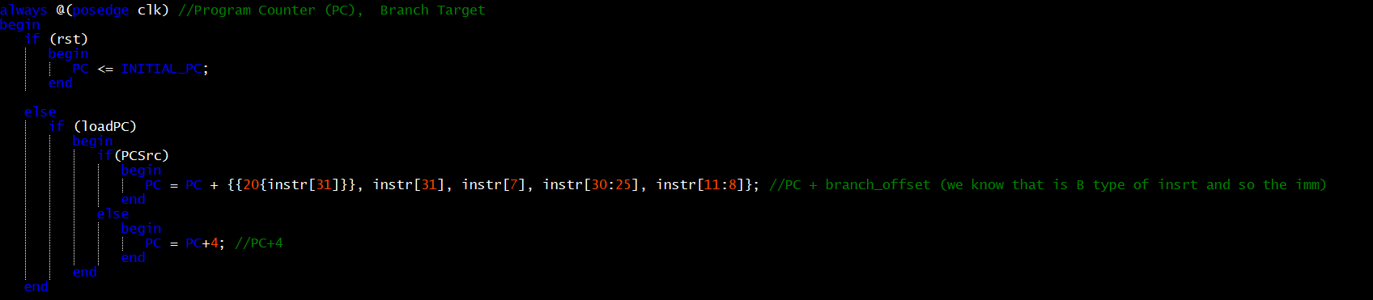
- In that step we are calculating the immediate value of the given instruction. Note that there are four basic types of instructions in RiscV architecture: R, I, B and S and each format is shown below:
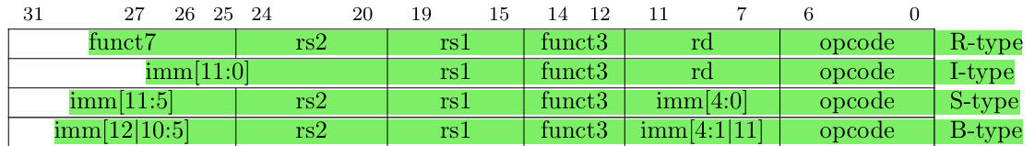

Following that, we are calculating the immediate value of the current instruction each time using sign extension:
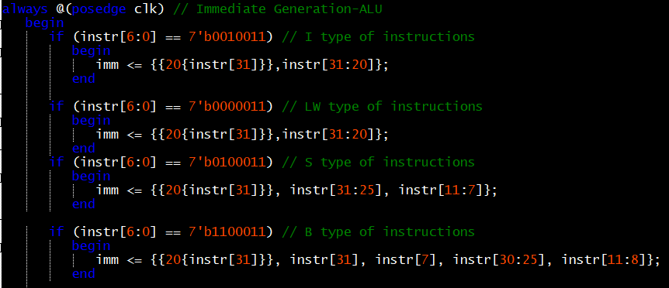

- Then, we are updating the Operators of the ALU following the main graph in the beginning of Part 2. We are assigning the output of readData1 of registers to the first operator (Op1) of ALU. Also we are using a 2 to 1 MUX to define which signal to load on the second operator (Op2). This is decided by the value of signal ALUSrc. Whenever this signal is low we are loading the second output of registers (readData2) while on a high value we are loading the immediate value calculated in the previous step. Also in order to complete this section, we are connecting the result received from ALU, to the dAddress register which later will be assigned as the address of the RAM memory

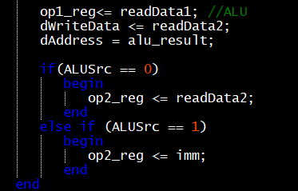

- In the next step, we need to feed some parts of the instruction register to the 3 inputs of the registers file.

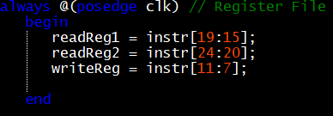

- Finally, we need to create the logic that writes the generated data back to the registers file. These data can be transferred from two different sources: Result of alu or output data of RAM. This is decided by the signal MemtoReg which controls a 2 to 1 MUX and sets the operation of MUX either to 0 for Alu_result passthrough or 1 for RAM data feed (dReadData)

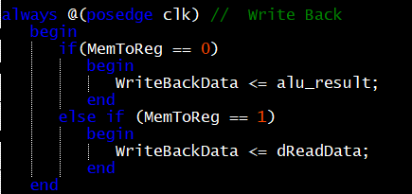

Note: As the reader may already realized, all registers are updated synchronously. An exception is made for dAddress, readReg1, readReg2 and writeReg. This is done cause all of these registers are working as a connection between the datapath module and the future module they are gonna be used in. But bearing in mind that all modules are working synchronously with clock positive edge signal, setting these registers to synchronous update will result to +1 clock cycle delay until these signals reach their destination, which leads to system instabilities as we tested. An exception is also made for alu where we set all of its input registers to synchronous update since the ALU module doesn’t contain any clock activation system on its own, since its output ports are updated automatically whenever the input signals are changed. Of course, another way of implementing this logic is by using wires instead of registers, to work in exactly the same way.

2)Top processor Module (top_proc.v):
- Verilog:

- Firstly we are defining our module’s inputs and outputs and also declaring some required registers and wires.
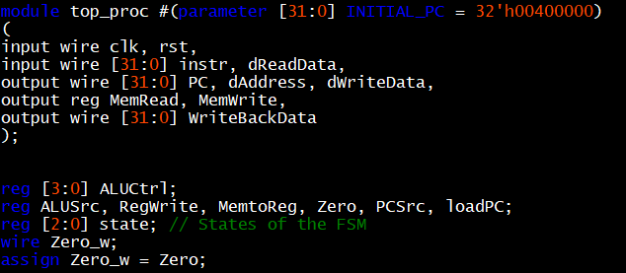
- Also we are decoding the Finite State Machine’s states in order to use them later in the project
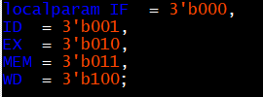
- Now we are ready to start implementing the systems logic. We will start by generating the “AluCtrl” signal which would be passed to the ALU operation code. This can be separated in 3 different sections based on the Op code of the current instruction:

- Sw or Lw instructions trigger the alu opcode 0010 which corresponds to addition.
- BEQ instruction triggers the alu opcode 0110 which corresponds to subtract
- R and I type of instructions trigger the alu opcode corresponding to the current action needed. For example, ADD and ADDI will both trigger 0010 while SLL and SLLI will trigger 100.

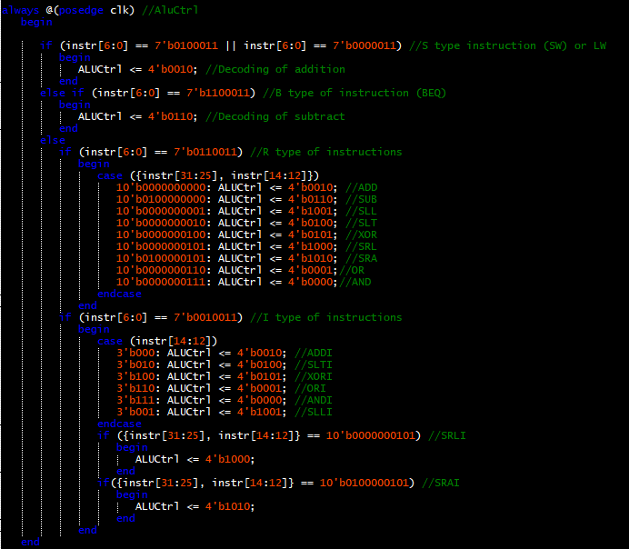

- Next, we define the value of “ALUSrc” signals which as we said selects the input of the second operator (Op2) of ALU. Only LW, SW and I type of instructions need the immediate value as an operator so that’s the only case where the “ALUSrc” is set to High.
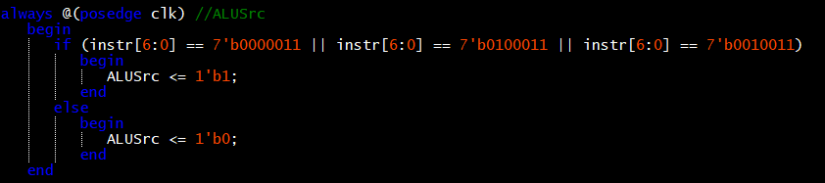

- Finally, we are implementing the Finite State Machine which has 5 consecutive states: Instruction Fetch (IF), Instruction Decode (ID), Execute (EX), Memory (MEM) and Write Back(WB) as shown below. Of course, Reset button press and default case, which both lead to IF state, are not represented for simplicity reasons.

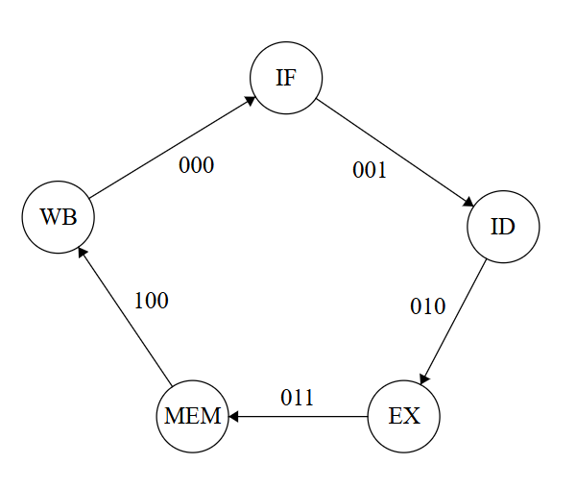

- To implement this FSM we used a case loop with 5 different states changing one after the other with a positive edge clock signal and a “state” register which stores the decoding of the current state. To proceed in the next state, each time before a state is finished we are assigning synchronously to “state” register the value of the next state. For example before the IF state ends we got to store the value of the next state. In this way our system loops again and again in these 5 states endlessly to form an FSM. The required parts needed to be executed on each state are shown in the below picture.

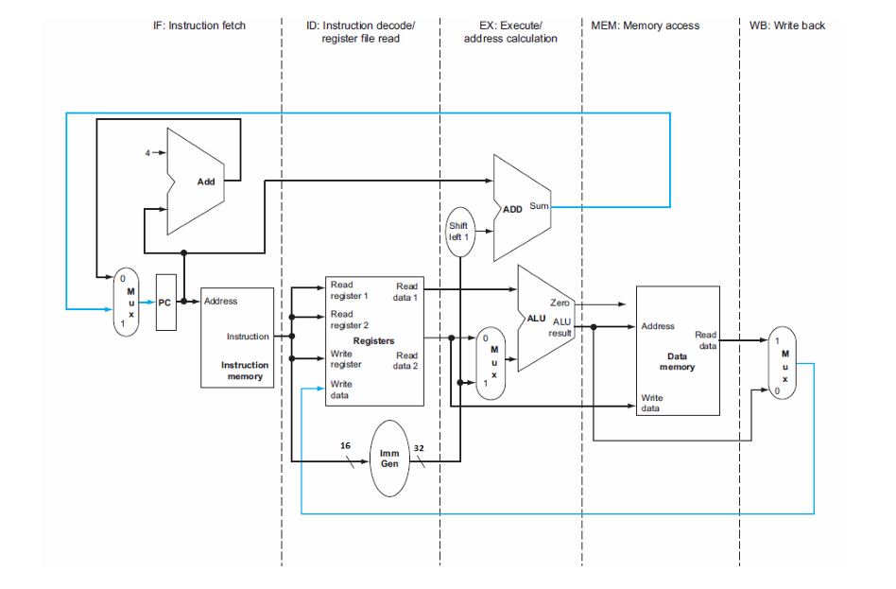

- IF state: In this state, the Program counter has already been loaded with the address of the next instruction so in this step we are feeding its value to the rom module address input. In that way loadPC signal needs to be set to low as we are already on our way to receive the new instruction. The same applies to RegWrite and MemWrite, remain 0. Note that in all states the FSM is checking the current instruction and if it receives a LW instruction it sets MemtoReg to “1” to choose the source of WriteBackData. Also, it is constantly checking if the instruction is BEQ and the alu result is O, in order to feed the immediate value to op2 by setting PCSrc to 1. Otherwise, this signal remains 0. Finally, changes the state to ID to proceed in the next FSM state in the incoming clock cycle

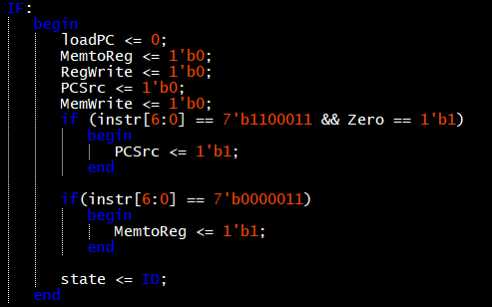

- 2) ID state: In this state the FSM is decoding the currenet instruction and feeds the required data to the Registers inputs. The same as previous applies for RegWrite, MemWrite, MemtoReg and PCSrc signals. Finally, changes the state to EX to proceed in the next FSM state in the incoming clock cycle

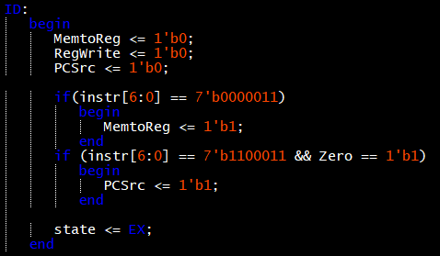

- EX state: In that state, the FSM executes the calculation of the alu result based on the inputs we forwarded on the previous states. The same as previous applies for RegWrite, MemWrite, MemtoReg and PCSrc signals. Finally, changes the state to MEM to proceed in the next FSM state in the incoming clock cycle.
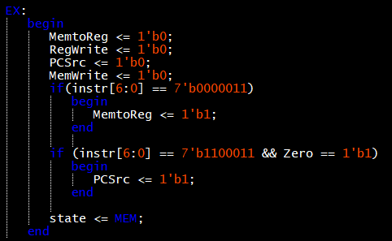

- MEM state: In this state, the goal is to enable write and read signals of RAM module considering the instruction. If the current instruction is SW then the system needs to set MemWrite to “1” in order to store the data outputted from ReadData2 in the address specified by the result of the ALU. Note that this specific RAM module doesn’t use read enable signal so as long as the MemWrite signal is low we can read data from it at any time. The same as previous applies for RegWrite, MemtoReg and PCSrc signals. Finally, changes the state to WB to proceed in the next and final FSM state in the incoming clock cycle.

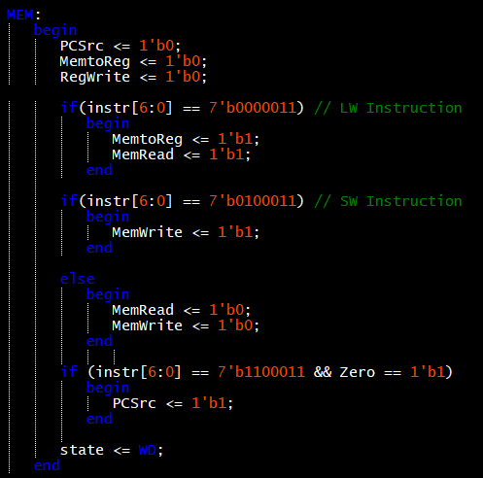
- WB state: This final state , is responsible for writing back the data produced either from ram (read) or from ALU calculation which is specified by the signal MemtoReg. So as we did in all states, MemtoReg’s value is updated to “1” only if we got a LW instruction. This is the only state of the FSM that MemtoReg signal matter. After all of these, the loadPC signal is turned on allowing the program counter to point (asynchronously for system synchronization purposes) to the next instruction from ROM module, in order for the instruction register to be ready in the IF state. Last but not least, the state register receives the code of IF state.

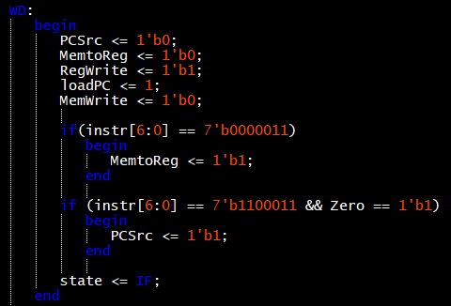
Note that for safety reasons we are adding a default value which corresponds to ID state.

- Instruction list included in rom_bytes.data

N/N | Bit Code (32 bits) | Instruction
1 | 0000000001110000000000001 0010011 | ADDI
2 | 0000000101010000000000010 0010011 | ADDI
3 | 0000000000100000100000011 0110011 | ADD
4 | 1111111101110000000000100 0010011 | ADDI
5 | 1111111011110001000000101 0010011 | ADDI
6 | 0000000001000010100000110 0110011 | ADD
7 | 0100000000100001100000111 0110011 | SUB
8 | 0000000001010011100101000 0110011 | SLL
9 | 0000000010000010001001001 0110011 | SLT
10 | 0000000000100100010001010 0110011 | XOR
11 | 0000000010000101011101011 0110011 | AND
12 | 0000000010010101110101100 0110011 | SRL
13 | 0000000000110110011001101 0110011 | OR
14 | 0100000010010010010101110 0110011 | SRA
15 | 0000000010110010101000000 0100011 | SW
16 | 0000000000000010101001111 0000011 | LW
17 | 1111110100110100011110000 0010011 | ANDI
18 | 0000000101101000011010001 0010011 | ORI
19 | 0000000000010110110110010 0010011 | SRLI
20 | 0000000010110111100010000 1100011 | BEQ
21 | 0000000000000000000000000 0000000 | -
22 | 0000000000000000000000000 0000000 | -
23 | 0000000000000000000000000 0000000 | -
24 | 0000000000000000000000000 0000000 | -
25 | 0000000011111001001001001 0010011 | SLTI
26 | 0000001110100100010010011 0010011 | XORI
27 | 0000000000011000100110100 0010011 | SLLI
28 | 0100000000100111110100101 0010011 | SRAI
29 | 0000000000000000000000000 0000000 | -
- Final waveforms for each component:
Note: Hex scale used for clearer visualization.

- RAM
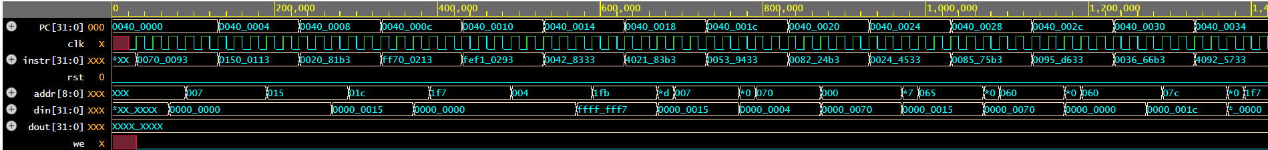

- ROM

- ALU
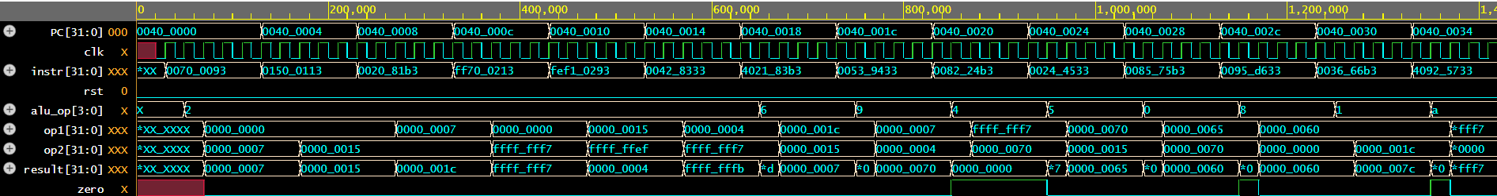

- DATAPATH
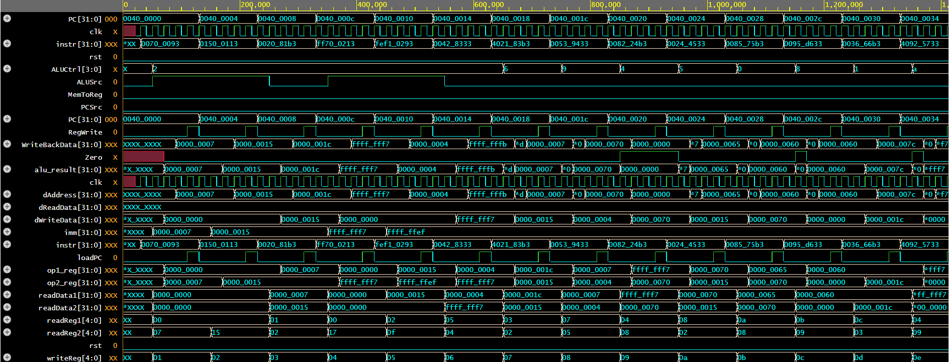

- TOP_PROC
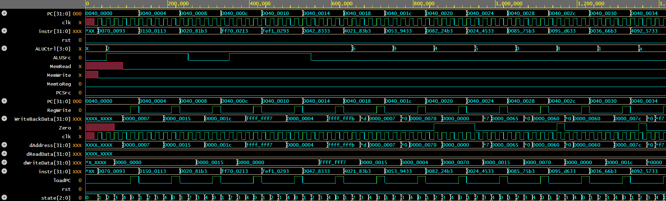

- TESTBENCH
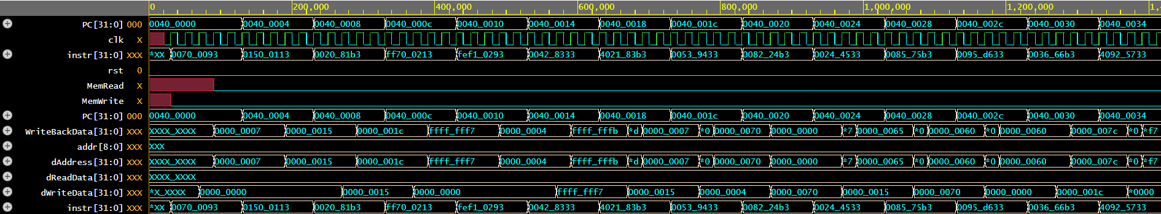

Waveforms for example instructions:
- ADDI:
The first instruction we are gonna analyze is 1st in the row:
00000000011100000000000010010011
Lets break it down step by step:

- Op code: 001 0011(It’s an I type of instruction)
- r_source: 10010
- r_destination: 01001
- Imm: 0000 0000 1111
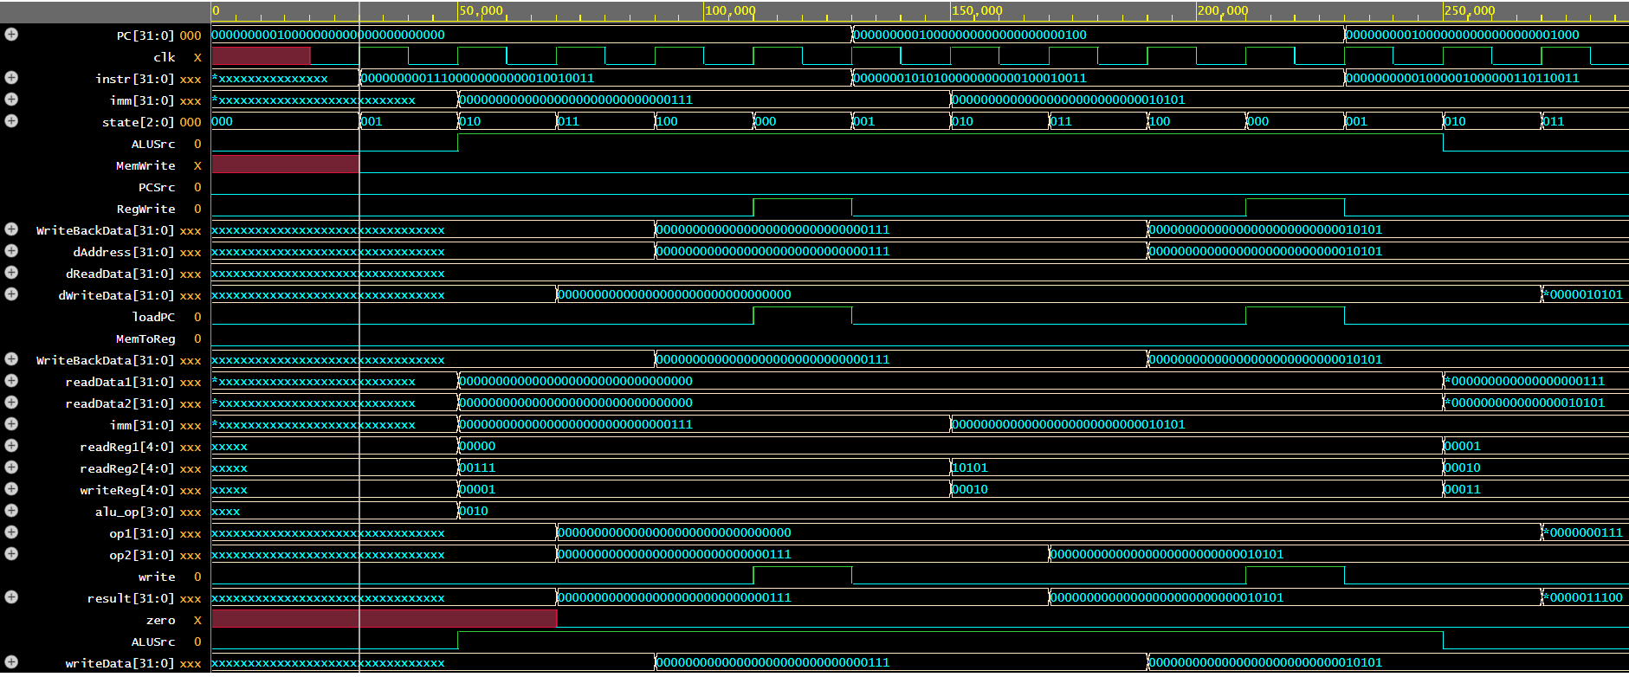

In the picture above we can see that by the end of IF state (000) the instruction register is already loaded. Also by the end of the ID state (001) the imm register containing the immediate value of the instruction: 00000000000000000000000000000111 with sign extension. Also we can see that in the same time the Read register 1 is having the [19-15] and [24-20] bits of the instruction as shown in the part 2 main picture. Note also that the op2 is chosen from imm as the system recognized its an I instruction and updated ALUSrc to 1 (Note that ALUop is set to addition 0010). By the end of the state EX (010) we see that the op1 and 2 are loaded and the alu calculated the addition between the contents of ReadReg1 (which is 32’b0 as expected) and the imm register’s value. In the MEM state nothing happens as the instruction is not LW or SW so the Memwrite signal remains 0. Finally, in the end of the WB state (100) we can see that MemtoReg signal remains 0 as we don’t have any LW instruction.Also the loadPC is enable and the PC gets the second address on the next cycle. The RegWrite signal is enabled, writeReg is equal to [11,7] bits of the instruction and. The result of these two is that Writebackdata is loaded with the result of alu and through WriteData (which has the same value) the data are stored in the registers file. The same operation applies for the second instruction which is also an ADDI.

- SUB:
The second instruction we are going to analyze is 7th in the row:
01000000001000011000001110110011
Lets break it down step by step:

- Op code: 0110011 (It’s an R type of instruction)
- r_source: 00111
- rs1: 00011
- rs2: 0 0010
- Sub = rs1-rs2

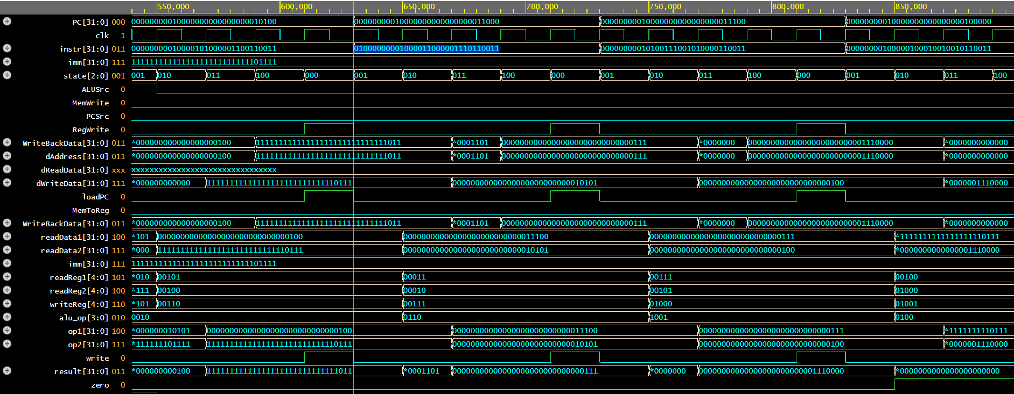
Note: Sub instruction is the highlighted one

As we can see IF (000) works perfectly and the instruction is loaded in the end of it. Also readReg1 and readReg2 have the address of the two operants we decoded above (rs, rs2) by the end of ID (001). From there in EX(010), their contents loaded into the Op1 and Op2 as the ALUSrc remains 0 as long as we don’t have any LW, SW or I instruction. From there, again the MEM(011) state is not used as we don’t have any SW or LW. MemWrite remains 0 and the writeback data register gets the value of alu result (where aluop is 0110 equal to subtract) which is directly transferred to writeData in the beginning of the WB cycle. Finally, in the end of the WB the data are stored in the address 00111 shown by the rd register decoded from the instruction. Note also that the PCSrc (as zero is also 1) is enabled which means the next value of PC is the current plus the imm

- SW:
The third instruction we are going to analyze is 15th in the row:
00000000101100101010000000100011
Lets break it down step by step:

- Op code: 0100011 (S type of instruction)
- r_source (rss2): 01011
- r_address(rs1): 00101
- imm: 000000000000 (offset)
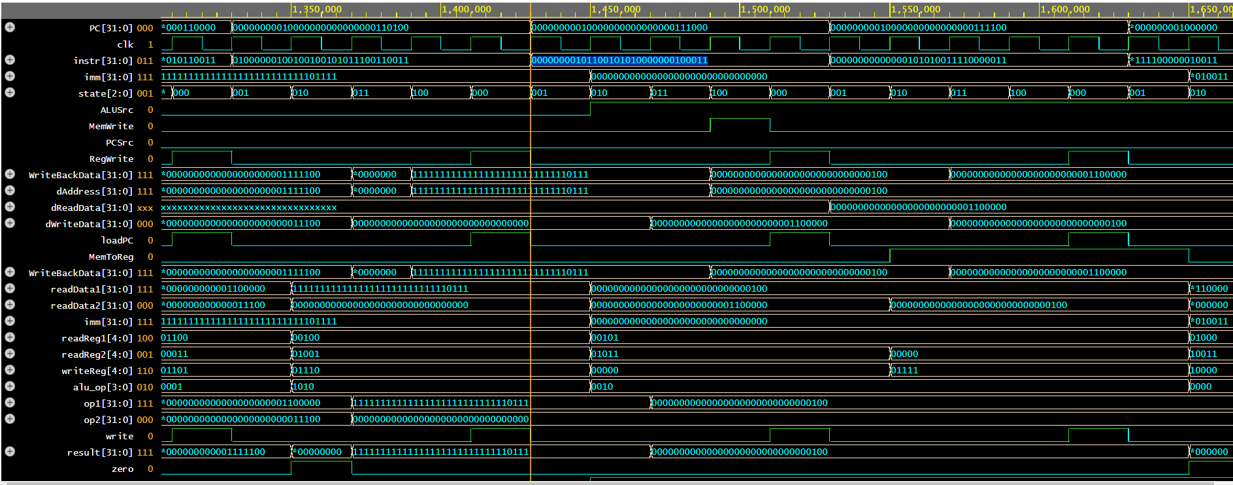
Note: SW instruction is the highlighted one

Again IF (000) works perfectly so we move to the next state. We can see that by the end of the ID (001) the readReg1 is equal to rs1: 00101 (address register) and the readReg2 is equal to rs2: 00101 (source register). Note also that by the end of ID the alu_op is showing addition 0010 as expected. As we have a SW instruction the ALUSrc is equal to 1 giving the op2 operant the value of imm (0). Then in the EX (010) state the system calculates the result and passes the value to the address of the RAM module (addr). The MemWrite and so the we (in ram) is 1, and the din gets the value of dreadData2 to store it in the specified address.

- LW:
The fifth instruction we are going to analyze is 19th in the row:
00000000101100101010000000100011
Lets break it down step by step:

- Op code: 100011 (S type of Instruction)
- rd: 01111
- rs1: 00101
- imm: 000000000000
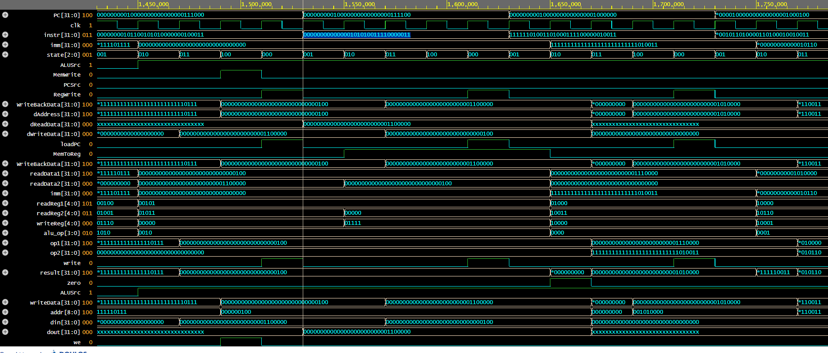
Note: LW instruction is the highlighted one

In exactly the same way as before we can see that all signals working perfectly, the addresses and the operants of alu are correctly set, the same with aluop and in dout we get the value we stored before in the same address which is: 32’b1100000

- BEQ:
The fourth and final instruction we are going to analyze is 15th in the row:
00000000101101111000100001100011
Lets break it down step by step:

- Op code: 1100011 (B type of instruction)
- rs2: 01011
- rs1: 01111
- imm: 000000001000

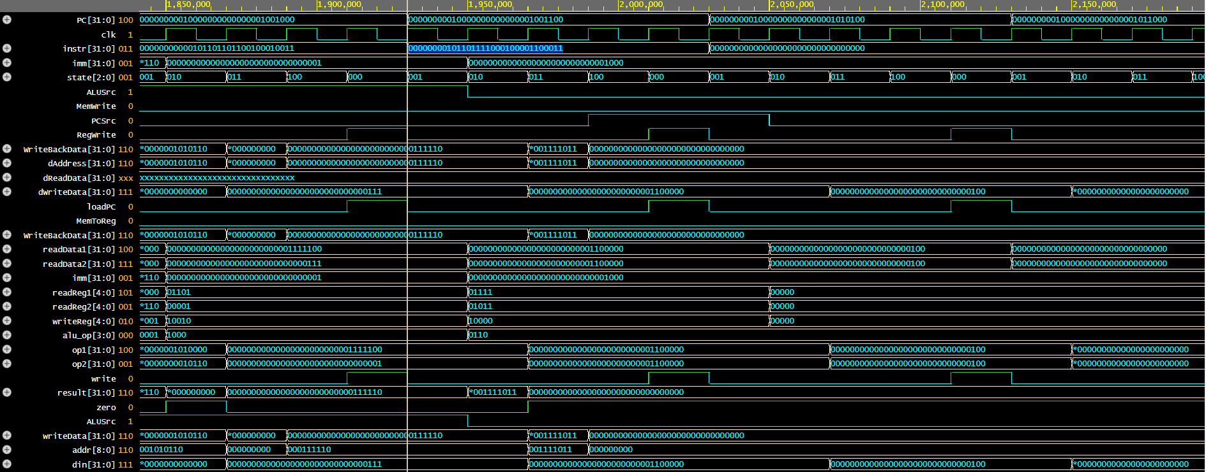
Note: BEQ instruction is the highlighted one

We can also see that the FSM is working properly. The aluop is equal to subtract 0110. The imm is also calculated correctly. Also readreag2 is equal to rs2 (01011) and readreg1 is equal to rs1 (01111). And finally the address of the next program counter is calculated by PC+imm=PC+8.

FINAL WAVEFORM
