User Manual

* **Homepage**
  + **Descriptions**: This is the website homepage where user get the detail about the website.
  + **Steps**: Run the project first page of the website.

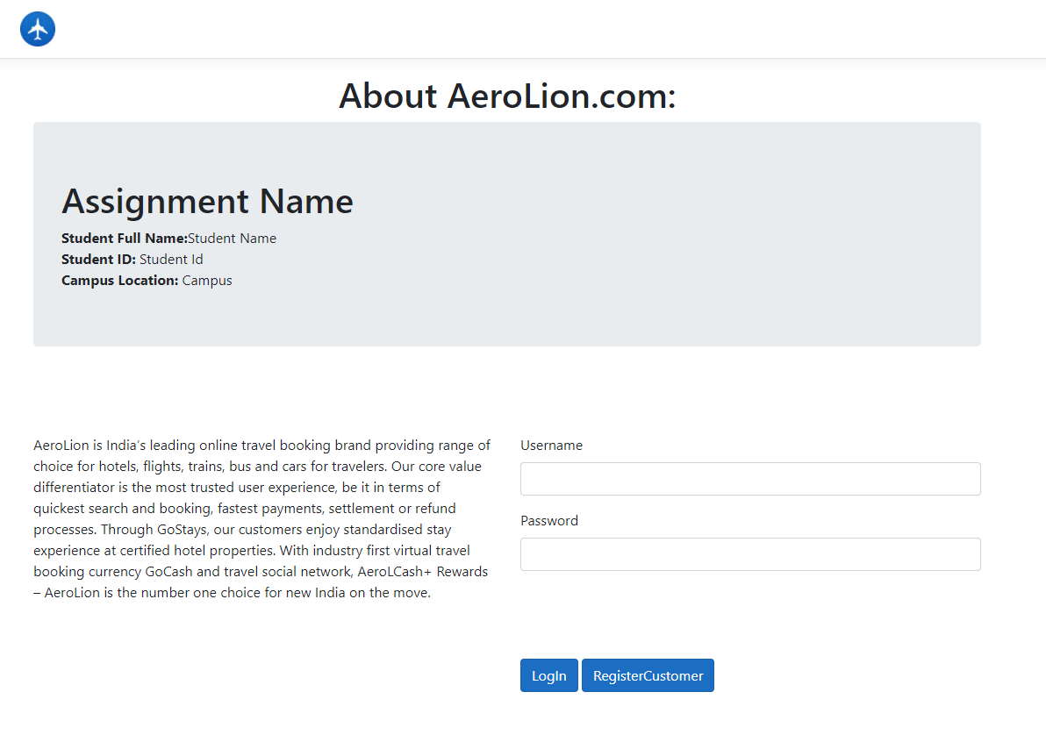

* **Create Client**
  + **Descriptions**: We can create client from here who can register from this page and can flight booking after login. Currently login functionality is not provided for client in this project.
  + **Steps**:
    - Click on the Register Client button from homepage.
    - It will redirect to create login page.

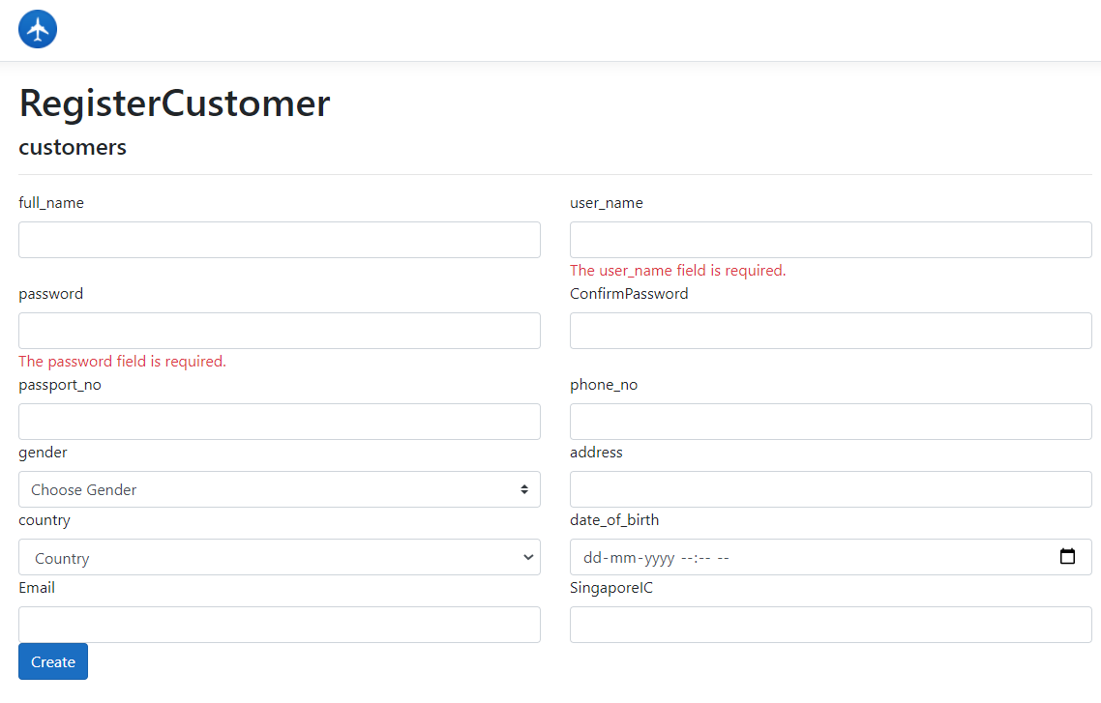

* **List of Flight**
  + **Descriptions**: We can see all the flight detail from this page. We have options here on this page for create new flight.
    - We can also edit a flight detail from this page
  + **Steps**:
    - Login with the admin credential
      * Username : mikeJ
      * Password : 1234
    - It will redirect to the user list of all flight page.

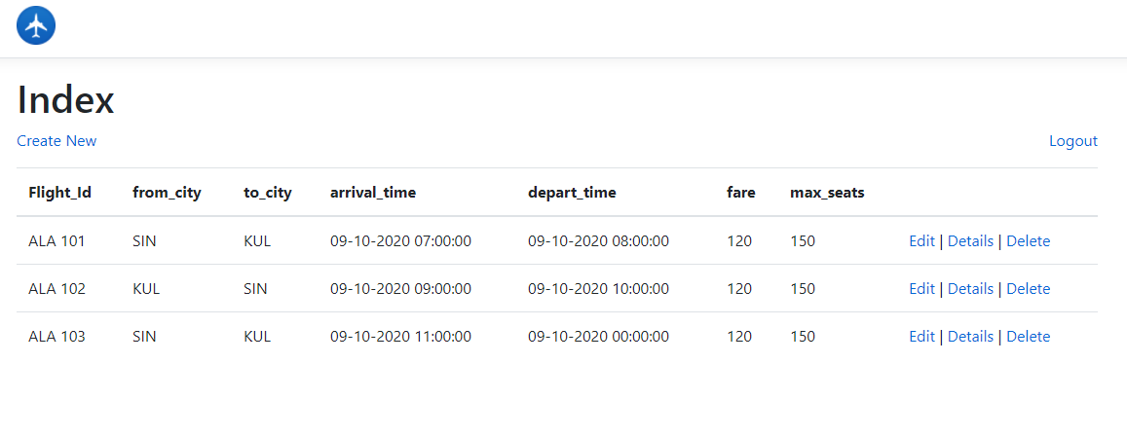

* **Create New Flight**
  + **Descriptions**: We can add new flight from this page that will show on flight list page.
  + **Steps**:
    - Click on create new button from the list of flight page.
    - It will redirect to create new flight page.
    - We can add new flight from this page.

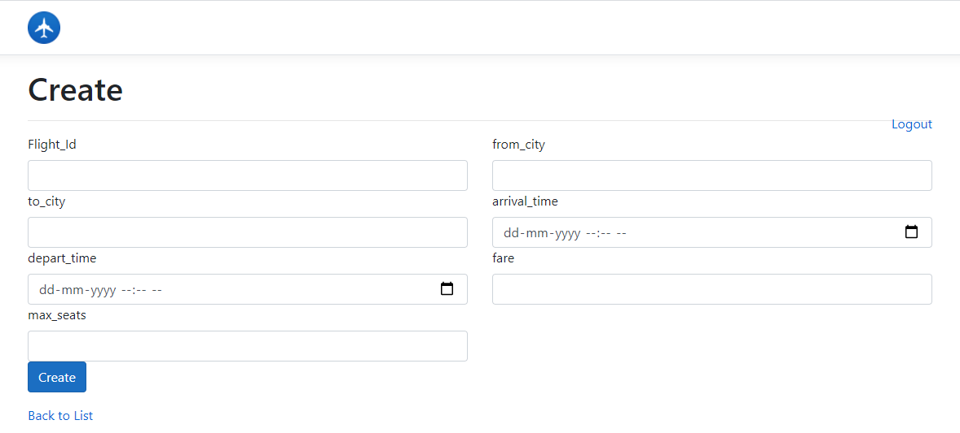

* **Edit Flight Details**
  + **Descriptions**: We can edit new flight from this page that will show on flight list page.
  + **Steps**:
    - Click on edit link from the list of flight page grid.
    - It will redirect to edit flight page.
    - We can edit flight from this page.

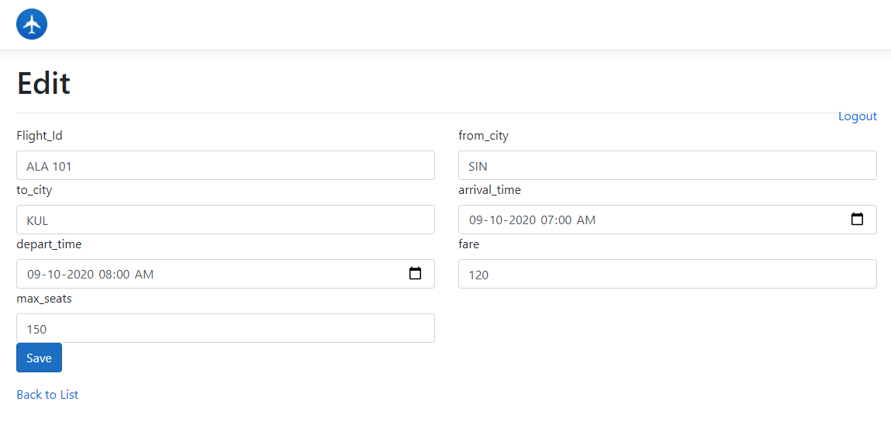

* **Flight Detail**
  + **Descriptions**: We can view flight detail from this page that will show on flight list page.
  + **Steps**:
    - Click on view link from the list of flight page grid.
    - It will redirect to view flight page.
    - We can view flight from this page.

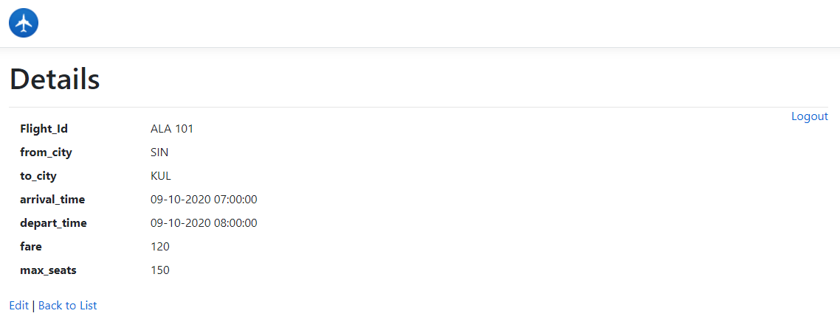

* **Delete Flight**
  + **Descriptions**: We can delete flight from this page that will show on flight list page.
  + **Steps**:
    - Click on delete link from the list of flight page grid.
    - It will redirect to delete flight page.
    - We can delete flight from this page.

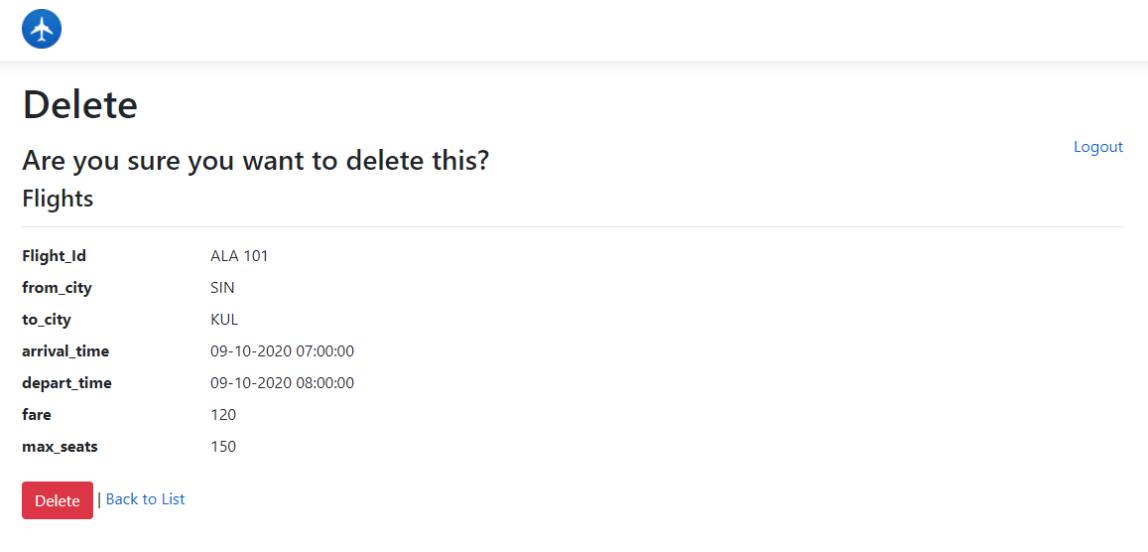

TestCases

* **Create Client Test Case 1**
  + Go to create client page.
  + Click on submit button.
  + Show validation for required field

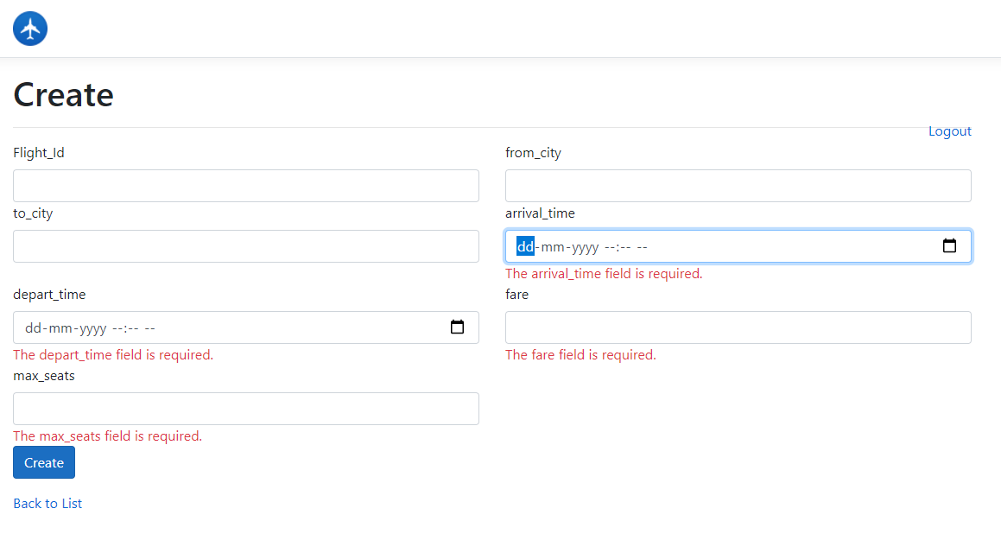

* **Create Client Test Case 2**
  + Go to create client page.
  + Enter the client information.
  + Click on create button
  + Successfully save the information of client.

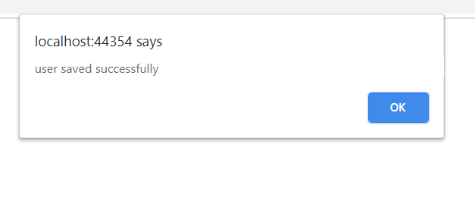

* **Login Test Case 1**
  + Go to Home Page.
  + Click on login button.
  + Show validation for enter the username and password.

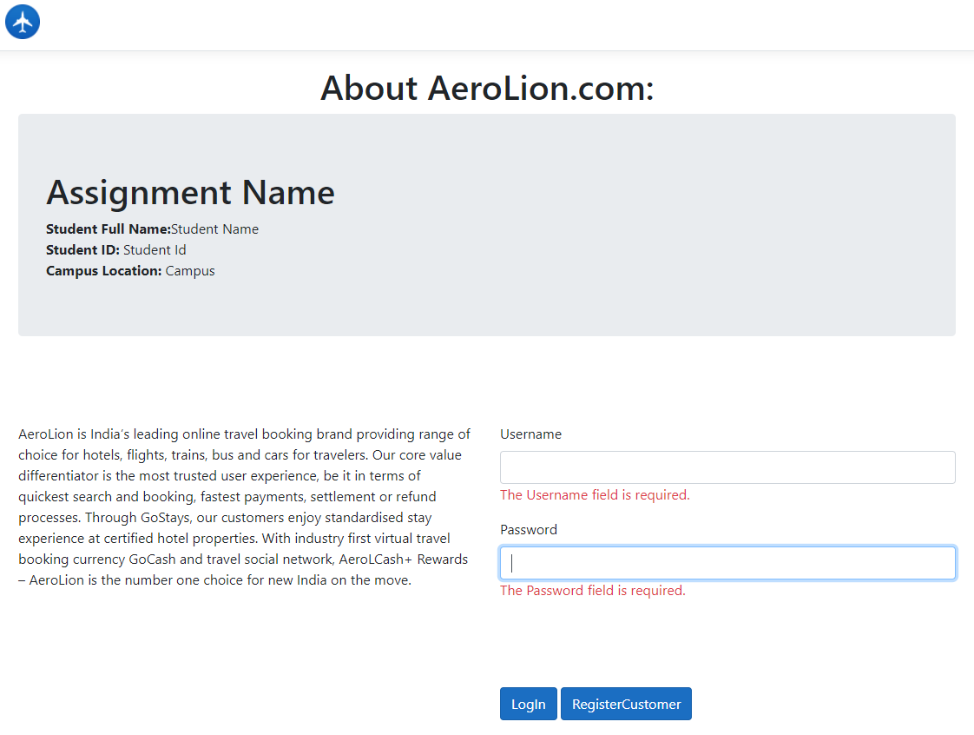

* **Create flight Test Case 1**
  + Go to list of flight page.
  + Click on create new button.
  + Redirect to create new flight page.



* **Create flight Test Case 2**
  + Go to create new flight page.
  + Click on create new button.
  + Show validation for required field

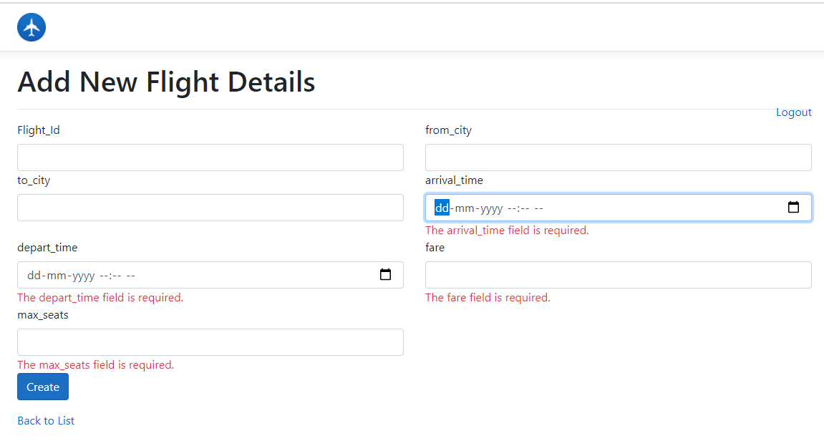

* **Edit flight Test Case 1**
  + Go to list of flight page.
  + Click on edit link from the grid.
  + Redirect to edit flight page.
  + Click on save button.
  + Show validation for required field

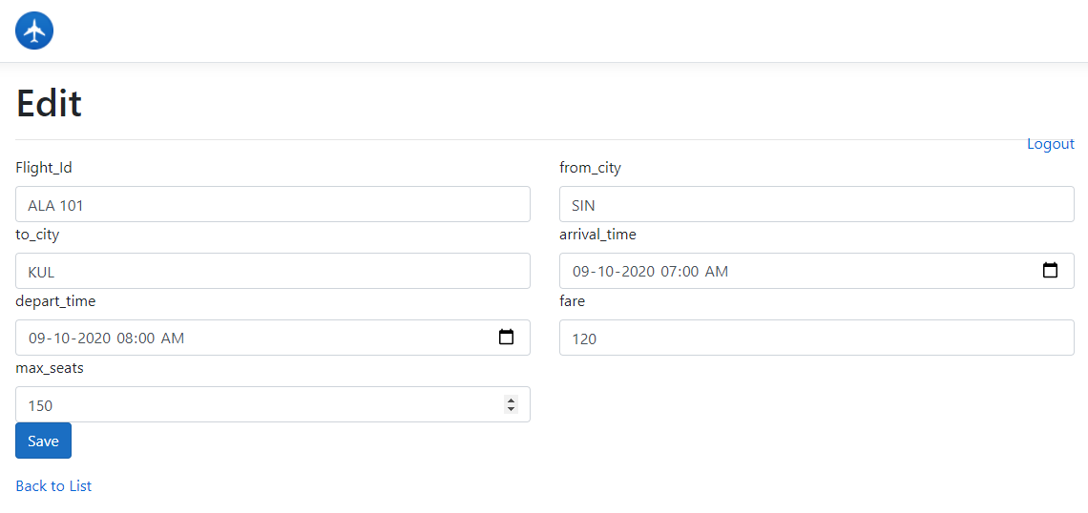

* **View flight Test Case 1**
  + Go to list of flight page.
  + Click on view link from the grid.
  + Redirect to view flight page.
  + Flight information should visible.

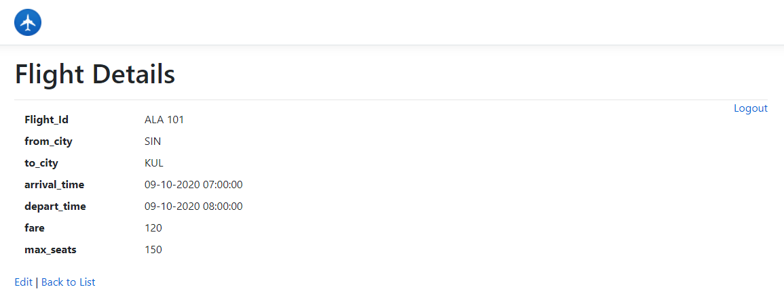

* **Delete flight Test Case 1**
  + Go to list of flight page.
  + Click on delete link from the grid.
  + Redirect to delete flight page.
  + Click on delete button
  + Delete the flight information successfully.

