**Section - 1**

**Project Title**

Recommendation program for a Food & Beverage Outlet in a New York Park

**Project Description**

One of my friend who is running a chain of restaurants in several parts of United States is intend to open a Restaurant in any of a Landmarks in New York and especially a Park in New York.

**Business Problem**

The client has an established restaurant chain in U.S. successfully running in several parts and the client would like to venture into any of the Parks area in New York city.

The following details are requested by the Client:-

* Pickup any park for an example whichever park is in a central area
* What are the Nearby attractions
* What are the Food & beverage outlets near the location around 1000 meters radius
* What type of Outlets (Fast food, Coffee shop, etc)
* What type of Cuisines are served in the Outlets

**Section – 2**

**Description of the Data**

I have downloaded the data from the website <https://geo.nyu.edu/catalog>

It contains NY University Spatial Data Repositories

The data I have downloaded was the Landmarks of New York City. I have downloaded as a JSON file

nyu-2451-34514-geojson.json and loaded into my Notebook labs folder and read it through the function Json.loads()

Sample of Data Screenshot

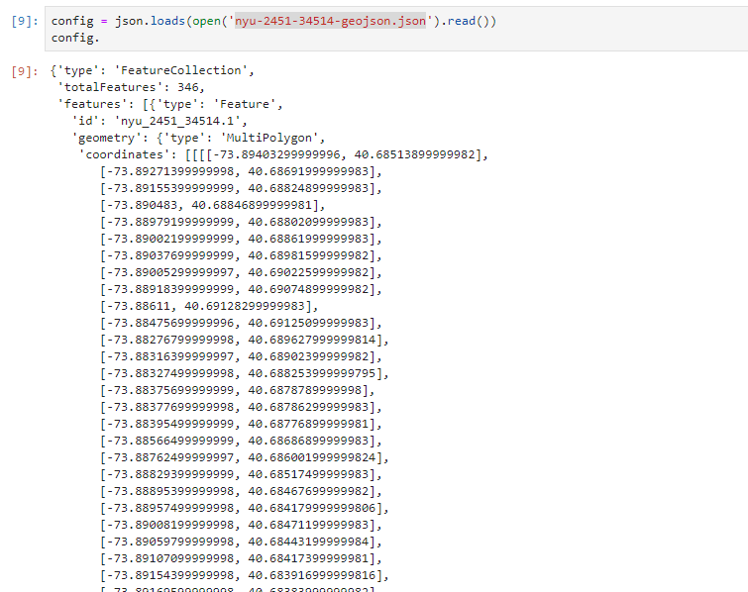

**Data Arrangement**

The Raw Data has been imported into a Data Frame as the following columns

* Statefp
* Areaid
* Fullname
* Longitude
* Latitude

Now I have my sample data imported into the Data Frame as **landmarks**

