**Section - 1**

**Project Title**

Recommendation program for a Food & Beverage Outlet in a New York Park

**Project Description**

One of my friend who is running a chain of restaurants in several parts of United States is intend to open a Restaurant in any of a Landmarks in New York and especially a Park in New York.

**Business Problem**

The client has an established restaurant chain in U.S. successfully running in several parts and the client would like to venture into any of the Parks area in New York city.

The following details are requested by the Client:-

* Pickup any park for an example whichever park is in a central area
* What are the Nearby attractions
* What are the Food & beverage outlets near the location around 1000 meters radius
* What type of Outlets (Fast food, Coffee shop, etc)
* What type of Cuisines are served in the Outlets

**Section – 2**

**Description of the Data**

I have downloaded the data from the website <https://geo.nyu.edu/catalog>

It contains NY University Spatial Data Repositories

The data I have downloaded was the Landmarks of New York City. I have downloaded as a JSON file

nyu-2451-34514-geojson.json and loaded into my Notebook labs folder and read it through the function Json.loads()

Sample of Data Screenshot

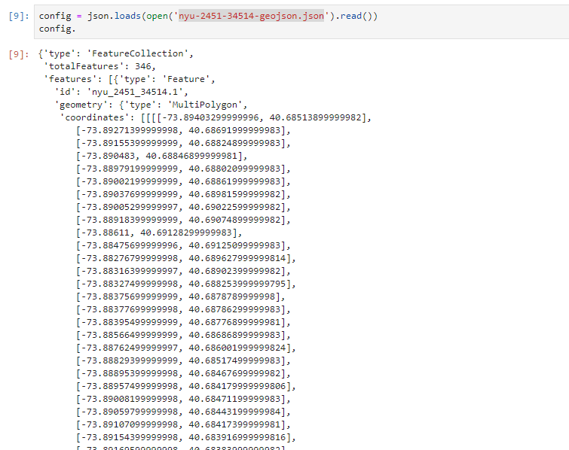

**Data Arrangement**

The Raw Data has been imported into a Data Frame as the following columns

* Statefp
* Areaid
* Fullname
* Longitude
* Latitude

Now I have my sample data imported into the Data Frame as **landmarks**

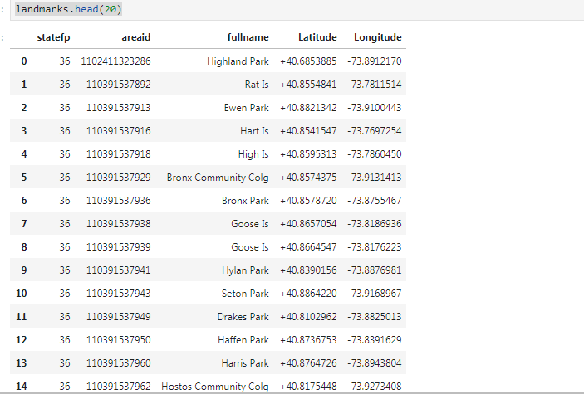

**Section – 3**

**Methodology**

Once the Landmarks data are cleaned and arranged for processing, now we need to connect to the Foursquare platform to get the API connected and collect the information.

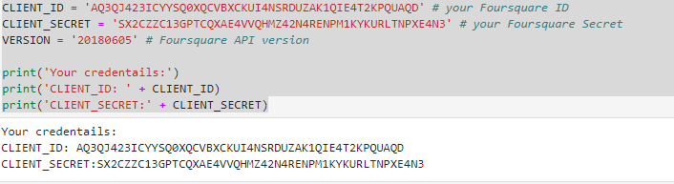

**Data Selection**

Since the Customer has requested randomly any Park in the New York Landmarks data, we have chosen the first row ‘ Highland Park ‘ to process the data.

I have set the radius as 1000 meters and set the maximum search result as 100 rows

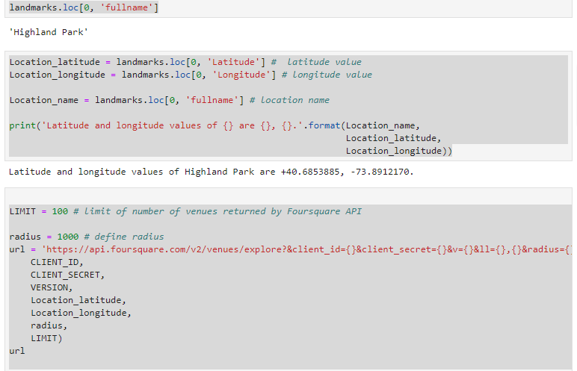

**Section – 4**

**Results**

The Raw data has been processed as below

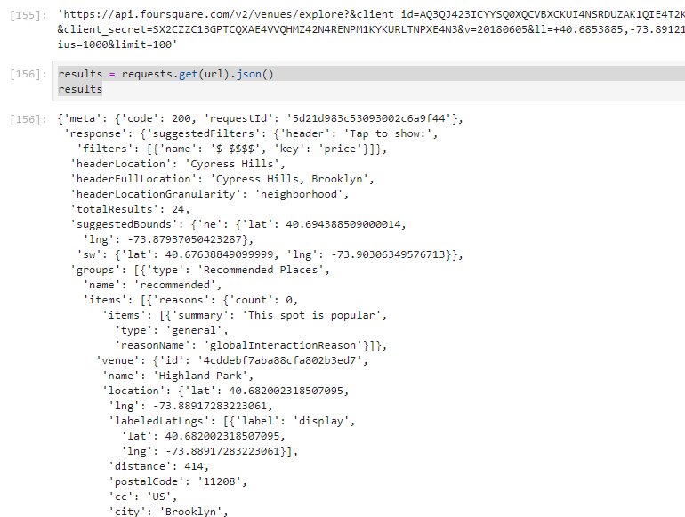

And we extracted the data into the Dataframe as below

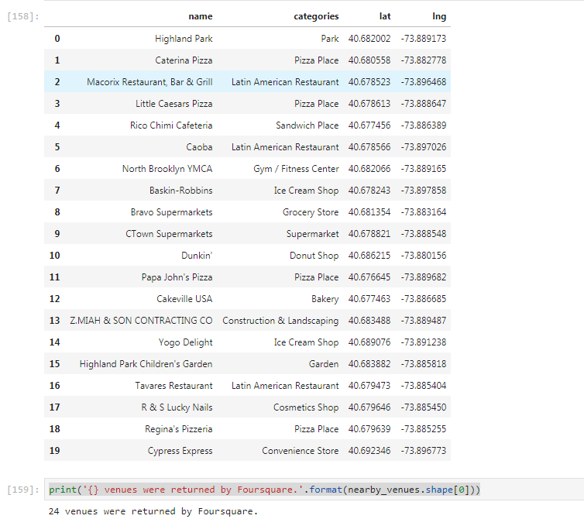

We could get the details as above where in the details are very specific as we can make out what kind of restaurants, food & beverage outlets are located.

**Section – 4**

**Discussion**

We can discuss from the above result, There are **Ice Cream Shops, Pizza Outlets, Sandwich Stores, Donut Shops and there are Latin American Restaurants.**

**Section – 5**

**Conclusion**

From the Above analysis, we can conclude that the selected area “ Highland Park” has food and beverage outlets of

* Ice Cream Shops - 2
* Pizza Outlets – 4
* Sandwich Shops – 1
* Bakery – 1
* Latin American Restaurants – 3
* Donut Shop – 1

The Client can make a decision as already there are 4 outlets of Pizza shops and the client may introduce new cuisines in the area.

The client can use the test data as any other Park in the above test data to check for any other location or Park.