Automatic Pipeline Tag Prediction from Model Card Text
RoBERTa and ModernBERT Classification of HuggingFace Model Cards

Novejot Kaur Bal
School of Information
University of California, Berkeley
nkbal@berkeley.edu
Noshen Nooren Habib
School of Information
University of California, Berkeley
noshen@berkeley.edu

Abstract
The purpose of the research was to perform fine-tuned multi-class text classification on model card text to improve reliable automated prediction of a model’s primary intended task, mainly referenced as its pipeline tag in this study. We compared multi-class classification methods between a baseline TF-IDF and logistic regression model, and fine-tuned RoBERTa and ModernBERT. The tasks were performed on a HuggingFace maintained snapshot of approximately 667,424 model cards in parquet format. Experiments were conducted on model performance between a data-scaling ablation to understand how performance varies with training set size, and model performance on unlabeled model cards to evaluate model generalizability. The main evaluation metrics used were accuracy and macro-F1. The results showed performance improvement from the baseline, to RoBERTa, and to ModernBERT, as well as improvement over the primary literature that motivated this research. The experiments on training set size also showed improvement in the evaluation metrics as set size increased. When applied to a held-out pool of 115,620 previously untagged model cards, the fine-tuned transformer models produced substantially more confident predictions than the baseline (mean confidence 89.4% for RoBERTa and 90.9% for ModernBERT, versus 63.6% for the baseline) and agreed with each other on 87.0% of cards, a proxy signal that these gains generalize beyond the labeled test set.

Introduction
  - Motivation:
The Hugging Face Hub hosts over 1.4 million open-weight models spanning many modalities and tasks, from language to vision, audio, and robotics, making it the largest repository of pre-trained, open-source machine learning models in the world. Central to navigating this ecosystem is the pipeline_tag, a metadata field declaring a model's primary task (e.g., text-classification, summarization, question-answering). However, pipeline tags are entirely self-reported by model authors, and coverage is deeply inconsistent: in a July 2026 crawl of 667,424 model repositories that we used for this project, 49.4% (329,733 rows) had no pipeline_tag at all, well above the roughly 40% figure originally estimated when this project was proposed. At this scale, manual remediation is not feasible. Most models do have some natural language documentation in the form of a model card, a README describing the model's purpose, training data, and intended use. This text carries a rich task-relevant signal. In this research, we asked:
Can we fine-tune transformer models to predict a model's pipeline_tag from its model card text alone, and use this to automatically recover missing metadata at scale?
  - Objectives
Di Sipio et al. [1] conducted a case study on a HuggingFace dataset and demonstrated model card text was sufficiently informative to classify models into software engineering (SE) task types using traditional classifiers, Complement Naive Bayes (CNB) and the C-Support Vector classifier (SVC). They demonstrated that model card text was informative for classification: their models achieved a 0.885 F1 score for CNB and 0.935 for SVC. Our work extended this in two key directions: (1) we used fine-tuned transformer models rather than traditional classifiers, and (2) we targeted the full space of general NLP pipeline tags rather than a narrower SE-specific taxonomy. Beyond the core model comparison, we ran a data-scaling ablation to understand how performance varied with training set size. All three models were evaluated at 25%, 50%, 75%, and 100% of training data to understand future data collection requirements to build reliable model recommendation systems.

Background
Before turning to the academic literature, it is worth situating this work against the mechanisms already deployed on the Hub itself to fill in a missing pipeline_tag, none of which solve the problem generally. Config-based inference is free and automatic: for models built on the transformers library, the Hub can derive a pipeline_tag directly from the model's config.json architecture field. This only works, however, for transformers-library models with an intact, populated config, and does nothing for diffusion models, custom architectures, or any repository whose config has been stripped or omitted. Model Atlas [8] takes a different approach, building a large-scale directed graph over the Hub's model lineage and imputing missing attributes, including pipeline_tag, library_name, and license, by propagating information across models connected through base_model relationships such as fine-tuning and quantization. This works well for models with discoverable lineage, but an orphan fine-tune with no declared base_model, or a model whose parent is itself untagged, is invisible to the graph. The remaining, and still dominant, mechanism is manual community pull requests: accurate when they happen, but bottlenecked entirely by human attention, which is a large part of why roughly half of the Hub's models remain untagged today [9]. Our approach sits apart from all three: rather than depending on a populated config, a declared lineage, or a maintainer's attention, it needs only the one artifact that is the lowest common denominator across the Hub, a written model card, present regardless of library, architecture, or whether anyone has ever noticed the model exists.
Prior work has approached model card and text classification from several angles that informed our design choices. Di Sipio et al. [1] showed that Hugging Face model card text alone was informative enough to classify models into software engineering task types using traditional classifiers (Complement Naive Bayes and C-Support Vector Classifier), reaching macro-F1 scores of 0.885 and 0.935 respectively, but did not fine-tune or otherwise train the transformer families they discussed as candidates for the same task. We built directly on this result by using a full general-purpose pipeline_tag taxonomy rather than a narrower SE-specific one, and by actually fine-tuning RoBERTa and ModernBERT rather than only proposing them as a mapping target.
Kostina et al. [3] benchmarked large language models and fine-tuned transformer encoders on multi-class and binary text classification tasks (employee location prediction from job reviews, and fake-versus-real news detection), and found that fine-tuned encoder models remained competitive with, and often outperformed, larger generative LLMs on these tasks. We adopted their fine-tuning framework (tokenization, batch construction, and evaluation protocol) as the basis for our own RoBERTa and ModernBERT fine-tuning, applying it to a new dataset, domain, and label space.
Warner et al. [4] introduced ModernBERT as a modernized bidirectional encoder trained on 2 trillion tokens of English text, code, and scientific documents, with an extended 8,192-token context window designed to remove the truncation limitations of older encoders such as RoBERTa. This motivated our inclusion of ModernBERT beyond RoBERTa: long, technical model cards are common on the Hugging Face Hub, and ModernBERT's training corpus and context length made it a natural candidate for this domain, even in the 512-token configuration we ultimately used for a fair, compute-constrained comparison against RoBERTa.
Finally, Liu et al. [7] introduced RoBERTa as a robustly optimized pretraining recipe over BERT, trained on 160GB of English text from BookCorpus, Wikipedia, CommonCrawl, and open-source web text, and demonstrated consistent improvements over BERT across a range of downstream classification benchmarks. RoBERTa's status as a widely used, well-understood encoder baseline made it a natural point of comparison against the newer, longer-context ModernBERT in our own experiments, letting us isolate the effect of pretraining corpus and architecture updates from the effect of context length alone, since both models were fine-tuned under the same 512-token truncation.

Dataset
The data source used in this study was an official HuggingFace maintained snapshot of 667,424 model cards in parquet format. Each row included the full model card text alongside structured metadata fields including pipeline_tag, library_name, tags, and download/like counts. Rows without model card text and without pipeline tags were removed as empty model cards indicated no information to train on, and a missing pipeline tag did not provide a ground-truth dataset to evaluate model performance on. About 74% of the remaining data also included a YAML metadata block that explicitly indicated the pipeline tag for the card; this block was removed to prevent pattern-matching and inflated accuracy scores. Additional data cleaning involved the removal of duplicate cards, template and boilerplate format cards, a custom quality ratio threshold (unique words : total length) applied to ensure text quality, and selected the top ten most frequent pipeline tags to manage class imbalance. The pipeline tag labels were encoded to use in training steps. After data cleaning, the total dataset had 145,003 examples. We used an 80/10/10 split for training, validation, and test datasets.
- To build a pool for the downstream unlabeled-inference experiment, we applied the same cleaning pipeline described above to the subset of model cards missing a pipeline_tag. Starting from roughly 341,471 untagged candidate rows, we stripped YAML frontmatter for cards that retained other metadata fields without a pipeline_tag, removed duplicate and template cards using the same normalized-text hashing approach, and applied the identical character-length (100-100,000) and unique-word-ratio (at least 0.15) quality thresholds used on the labeled data. This produced a final untagged pool of 115,620 model cards with no ground-truth label, used exclusively for the unlabeled inference experiment described below.

Methodology
  - Baseline Model:
The baseline model used TF-IDF vectors from cleaned model card text with logistic regression to create a benchmark for the primary metrics of accuracy and macro F1 score to be compared to more complex improvement methods. This sparse bag-of-words representation captured word frequency and overlap patterns. It tested whether lexical features alone were sufficient for pipeline tag detection. Shanto, Dip, et al. conducted a study and compared logistic regression, SVC, Naive Bayes (NB), and RoBERTa for sentiment classification on the IMDb movie review dataset. The results showed logistic regression outperformed NB on accuracy and F1-score, but only outperformed SVC on ROC AUC by 6.15% [5]. Although logistic regression did not outperform SVC on accuracy and F1-score, the difference in scores were minimal, only lower by 0.7% on accuracy and 0.6 on F1-score. Also, given the small difference in performance, we considered the significant performance improvement for the ROC AUC metric justified the choice to continue using logistic regression for the baseline. Our model card dataset had large class imbalances that we hypothesized would be better dealt with in logistic regression and based on the existing literature, ROC AUC evaluated imbalanced datasets with more nuance through true positive and true negative rates than simple accuracy alone [6]. All model card text was cleaned before fitting the data: removed punctuation and numbers, lowercased all letters, and whitespace was collapsed [Appendix 1]. The TF-IDF vectorizer was tuned to allow a 20,000 maximum vocabulary, bigrams and unigrams, sublinear scaling to reduce performance metrics skewing to only the most frequent words, and dropped any words that appeared less than 5 times as a baseline. Each class or pipeline tag labels’ weights were balanced in the logistic regression model function to account for the existing class imbalance [Appendix 2]. This baseline applied a traditional classification method to complement the work of Di Sipio et al., where similar shallow machine learning models were evaluated, rather than deep transformer based models like the proposed BERT evolutions in this study, to set a baseline similar to or better than the cited work.
  - Transformer Models:
In Di Sipio’s case study, mapping between pipeline tags and software engineering task types used BERT, RoBERTa, and T5 as representative model families. The study furthered their research into a recommendation framework between model families and engineering tasks, but did not train, fine-tune, or feed any data into the three models [1].
  - Data-Scaling Ablation
We run a data-scaling ablation to understand how performance would vary with training set size. All three models were evaluated at 25%, 50%, 75%, and 100% of training data. They generated learning curves that revealed the data efficiency of each architecture. This was the methodological contribution that extended the study beyond only a fine-tuning comparison. The evaluation of training size on test performance also provided insight into Di Sipio’s cited limitations of “missingness” of model cards to build a recommendation system that could have impacted our model’s performance on a new set of cards if we did not train on enough data [1].
  - Unlabeled Model Cards
None of the 145,003 labeled examples let us validate performance on the much larger population of Hugging Face models that are missing a pipeline_tag entirely, which is the population this project ultimately aims to help. To evaluate this, we used the three trained classifiers, the TF-IDF logistic regression baseline, fine-tuned RoBERTa, and fine-tuned ModernBERT, to independently predict a pipeline_tag for each of the 115,620 cleaned, untagged model cards. Because no ground-truth label exists for this population, we could not compute accuracy or macro-F1 directly. Instead we used two proxy signals for reliability: each model's own prediction confidence (the softmax probability of the predicted class for the transformers, and the predicted-class probability from the logistic regression decision function for the baseline), and pairwise agreement between the three models. A model card that all three independently trained classifiers agree on with high confidence is a reasonable candidate for automatic tagging without human review, while a card with low confidence or model disagreement is a better candidate for manual labeling. We also compared confidence by predicted tag against the class-level weaknesses identified during labeled-set error analysis, to check whether the same classes that were hardest to classify on held-out labeled data remained the hardest on a genuinely unseen population of cards.

Results
  - Baseline v. Transformers
    - Baseline
The baseline logistic regression model with TF-IDF resulted in a test accuracy of 94.68% and a macro-F1 score of 0.9523. This was already an improvement over Di Sipio’s case study where the highest macro-F1 score was 0.935 for SVC. The results per pipeline tag class as shown in Figure 1 indicated a model card’s true and predicted label per class required further analysis on the most incorrectly predicted pipeline tags. For example, `text-generation` cards were predicted as `image-text-to-text` cards 390 times and `image-text-to-text` labeled cards were predicted as `text-generation` 88 times. We found that both misclassified pairs shared vocabulary overlaps between their true and mislabeled predicted tags on these text strings: ['qwen', 'sft']. We focused on text-generation vs image-text-to-text as both tasks were fundamentally different, yet could have had almost identical training procedures explained in their model cards since Qwen itself is a family of LLMs that can perform a variety of tasks [2].
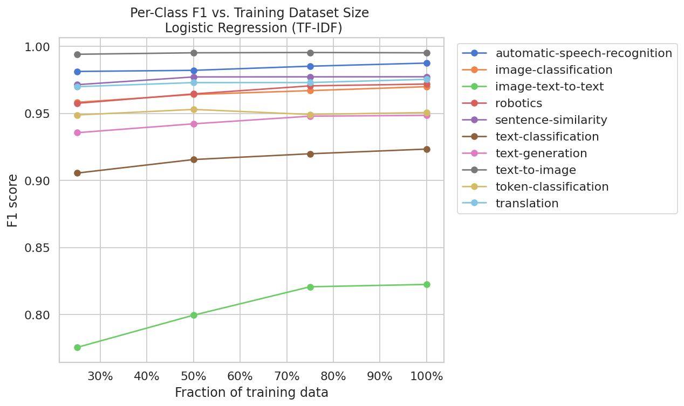
Figure 1: Per Pipeline Tag Class F1 Score From Logistic Regression (TF-IDF) Model
For further error analysis, we manually read through misclassified model cards and performed an analysis of all the model cards confused as image-text-to-text that also mentioned family names but no vision-specific language. We found 37% (152 out of 407) of those misclassified cards had no language that pointed to the predicted label aside from overarching family names (i.e., gemma, qwen, and llama. This motivated the use of the improvement models of RoBERTa and ModernBERT that we hypothesized would reduce the mislabeled cards with the use of context-based embeddings instead of only lexical signals. We did not find significant evidence that model card text length was a strong indicator of performance as both correct and incorrectly predicted tags shared similar text length distributions with large overlap; correct predictions even showed a longer maximum text length than mislabeled cards.

    - RoBERTa-base
The RoBERTa model resulted in a test accuracy of 95.58% and a macro-F1 score of 0.9538. This was an overall improvement from the baseline. Two metrics that stood out based on the previous error analysis were the class specific F1 scores for pipeline tags image-text-to-text and text-generation. In the test dataset, text-generation and image-text-to-text had the first and third largest support set sizes respectively. The F1 score for image-text-to-text increased from 0.82 in the baseline to 0.84 after the RoBERTa-base model was trained on the same dataset. Likewise, the F1 score for text-generation increased from 0.95 to 0.96 [Figure 2]. This finding supported the initial hypothesis that the baseline’s inability to distinguish context behind frequently shared terms like “qwen" and "sft” would be improved with RoBERTa where surrounding context was weighed on top of term frequencies.

    - ModernBERT-base
In the same realm of contextual embeddings improving classification of pipeline tags, we trained ModernBERT-base on the same test set. Since we did not evaluate ModernBERT using its longer context window due to the dataset size and computational limitations, we still expected higher accuracy and F1 scores due to the difference in data it was trained on compared to RoBERTa. ModernBERT-base was released in 2024 and trained on 2 trillion tokens of English text documents, scientific research data, and code [4], while RoBERTa-base was released in 2019 and trained on 160GB of English text that included BookCorpus, Wikipedia, CommonCrawl subsets, and open source WebText [7]. The recency of the training corpus and the focus on scientific and code data justified the use of ModernBERT even if we did not extend the context window.
The ModernBERT model resulted in a test accuracy of 96.54% and a macro-F1 score of 0.9637. This was another improvement over Di Sipio’s work, our baseline, and the fine-tuned RoBERTa model. For pipeline tag image-text-to-text, F1 increased to 0.87 (+0.05 from baseline, +0.03 from RoBERTa). For text-generation, F1 increased to 0.97 (+0.02 from baseline, +0.01 from RoBERTa) [Figure 2]. This supported the claim that classification on a pre-trained model with more task specific trained context (scientific and code training data) would improve overall and class specific performance.
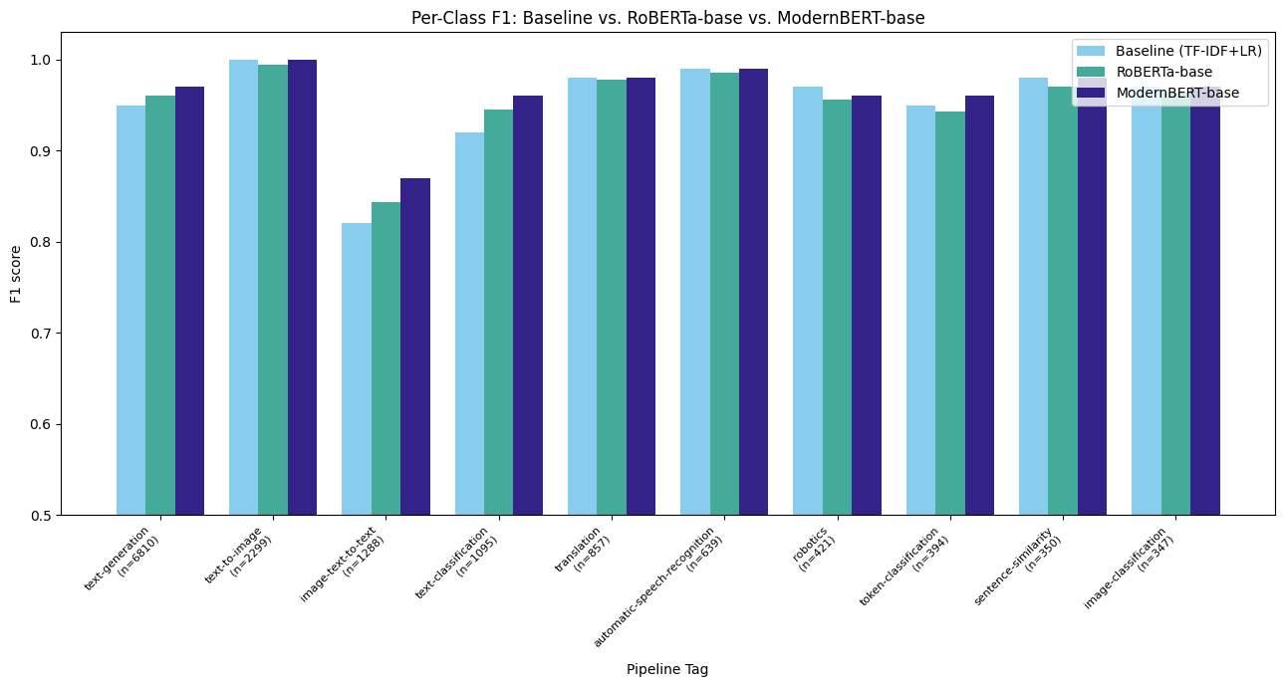
Figure 2: Per Pipeline Tag Class F1 Score for Baseline, RoBERTa, and ModernBERT

While overall performance improved in accuracy and macro-F1 scores across the three models, per-class metrics were more informative for our analysis and fine-tuning. We found RoBERTa to show the most improvement over the baseline for pipeline tags among larger support sizes, whereas ModernBERT outperformed both the TF-IDF LR and RoBERTa models across all tags [Table 1].
Table 1: Model Performance Results Across Reference Literature and Present Experiments
Models | Acc (%) | F1 | Macro-F1
 | Di Sipio et al. (2024)
CNB | - | 0.885 | -
SVC | - | 0.935 | -
 | Current Research
TF-IDF + LR | 94.68 | - | 0.952
RoBERTa | 95.58 | - | 0.954
ModernBERT | 96.54 | - | 0.964

  - Data-Scaling Ablation
Monitoring model performance across training set size demonstrated improvement across all three model architectures as training set size increased as shown in Figure 3. 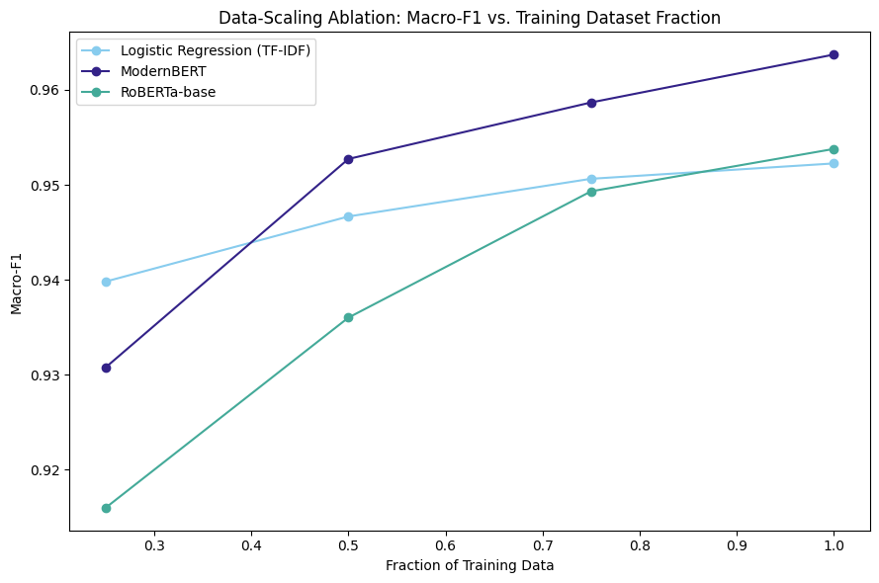
Figure 3: Macro-F1 Score per Model vs Training Set Size
The models were evaluated at 25%, 50%, 75%, and 100% of training data on the same test set per iteration. We observed the baseline outperformed both RoBERTa and ModernBERT at 25% of training data. It continued to outperform RoBERTa until we trained on 100% of the training set. ModernBERT had the highest macro-F1 score for the 50% - 100% training size experiments. The smaller training set size runs showed overfitting of the results when we analyzed the per class F1-scores per data scaling iteration. As shown in Figure 1 above, pipeline tag image-text-to-text showed consistently worse performance across the entire training set size and was below 0.8 at 25% of the training size. When we checked per-class F1 scores across the transformer models per training fraction, we see the individual pipeline tag performance increase and show improvement among the most confused pipeline tag labels.

  - Unlabeled Model Cards
We applied all three trained classifiers to the 115,620 cleaned, previously untagged model cards and compared their prediction confidence and pairwise agreement, our two proxy measures for reliability in the absence of ground-truth labels. Mean prediction confidence rose sharply from the baseline to the fine-tuned transformers: 63.6% for the TF-IDF logistic regression baseline, versus 89.4% for RoBERTa and 90.9% for ModernBERT. This mirrors the accuracy and macro-F1 ordering observed on the labeled test set, and suggests the transformer models are not only more accurate on held-out labeled data but also more decisive when applied to a genuinely novel population of cards.
Pairwise agreement between models followed the same pattern. RoBERTa and ModernBERT agreed with each other on 87.0% of predictions, while the baseline agreed with RoBERTa on 79.4% of predictions and with ModernBERT on 80.2%. All three models agreed on 74.9% of the 115,620 cards, a large subset where independently trained models converge on the same predicted pipeline_tag. This is a useful practical signal for deployment: cards where all three models agree with high confidence are reasonable candidates for automatic tagging without human review, while cards with low confidence or model disagreement are better routed to manual review.
Per-tag confidence on the untagged pool was broadly, though not perfectly, consistent with the class-level weaknesses identified in labeled-set error analysis [Appendix 3]. token-classification, one of the weaker classes on the labeled test set, remained comparatively low-confidence for the baseline (63.2% mean confidence). Notably, robotics and image-classification were the lowest-confidence tags for both transformer models on the untagged pool (robotics: 84.0% for RoBERTa, 80.4% for ModernBERT), even though these classes were not flagged as the weakest during labeled-set error analysis, suggesting the untagged population may contain model cards that are harder to classify than the cleaned, labeled training distribution, or that these categories are simply rarer in practice than the training distribution implies: robotics predictions dropped from 4,682 under the baseline to 2,684-2,794 under the two transformer models. text-generation, by far the largest class, was predicted most often by all three models, and with rising frequency and confidence moving from baseline (70,027 cards, 64.6% mean confidence) to RoBERTa (76,206 cards, 91.6%) to ModernBERT (77,114 cards, 93.6%), consistent with text-generation's dominance in both the labeled training distribution and the broader Hugging Face Hub.

Discussion
Across both evaluation settings, the labeled test set and the unlabeled inference experiment, we observed the same consistent ordering: ModernBERT outperformed RoBERTa, which outperformed the TF-IDF logistic regression baseline, in accuracy and macro-F1 on held-out labeled data, and in prediction confidence and cross-model agreement on genuinely unlabeled data. This convergence across two very different evaluation conditions gives us more confidence that the improvement from fine-tuning reflects real signal rather than overfitting to a single test split. Because 49.4% of models in our July 2026 Hugging Face Hub crawl had no pipeline_tag at all, a classifier of this quality could meaningfully improve search, filtering, and downstream model-recommendation systems, including LLM-based ones, that rely on this metadata field, without requiring model authors to manually backfill missing tags.
Several limitations temper how far these results generalize. First, our ground-truth labels are themselves self-reported by model authors, so some of the errors the baseline and transformer models made, such as confusing text-generation and image-text-to-text cards that both mention a model family name like Qwen without vision-specific language, may reflect genuinely ambiguous or under-specified model cards rather than a model failure. Second, compute constraints limited us to a single epoch of fine-tuning on a T4 GPU with 512-token truncation for both RoBERTa and ModernBERT; we tested sliding-window inputs to capture more of ModernBERT's 8,192-token context but did not see gains that justified the added compute, so it remains an open question whether ModernBERT's full context window would meaningfully improve performance on the small share of unusually long model cards. Third, the unlabeled-inference experiment has no ground truth by definition, so confidence and agreement are proxies for reliability, not proof of correctness: it is possible for all three models to agree confidently and still be wrong, particularly for classes such as robotics and image-classification, where confidence dropped even for the transformer models. Finally, restricting the label space to the ten most frequent pipeline tags means the classifiers cannot recover the correct tag for a genuinely rare pipeline tag; those cards are misclassified into one of the ten trained categories by construction, and the untagged pool almost certainly contains some of them.

Conclusion
We set out to test whether model card text alone is sufficient to automatically recover a missing pipeline_tag on the Hugging Face Hub, and found that it is: a TF-IDF logistic regression baseline already reached a macro-F1 of 0.9523, and fine-tuning RoBERTa and ModernBERT improved on it further, to 0.9538 and 0.9637 respectively, both ahead of the strongest comparable result in the literature that motivated this work. Applied to 115,620 previously untagged model cards with no ground truth available, the fine-tuned transformer models produced consistently higher-confidence, higher-agreement predictions than the baseline, an encouraging sign that these gains hold up on real, unlabeled data and not only on a held-out test split drawn from the same distribution. Data-scaling results showed macro-F1 improving for all three architectures as training data increased, with ModernBERT most consistently the strongest performer from 50% of training data onward. Future work should validate the fine-tuned models against a small, manually labeled sample of the untagged pool to move beyond confidence and agreement as reliability proxies, explore whether ModernBERT's full 8,192-token context window helps on the subset of unusually long model cards, and extend training beyond a single epoch and beyond the ten most frequent pipeline tags to test how the approach scales to the full label space.

Contributions
[Author contributions to be added.]

References
- Claudio, Di Sipio, et al. “Automated Categorization of Pre-Trained Models for Software Engineering: A Case Study with a Hugging Face Dataset.” ArXiv.org, 2024, arxiv.org/abs/2405.13185.
- Tongyi Qianwen (Qwen) - Alibaba Cloud. (2024). In AlibabaCloud. https://www.alibabacloud.com/en/solutions/generative-ai/qwen?_p_lc=1
- Kostina, Arina, et al. “Large Language Models for Text Classification: Case Study and Comprehensive Review.” ArXiv.org, 2025, https://arxiv.org/pdf/2501.08457
- Warner, Benjamin, et al. “Smarter, Better, Faster, Longer: A Modern Bidirectional Encoder for Fast, Memory Efficient, and Long Context Finetuning and Inference.” Proceedings of the 63Rd Annual Meeting of the Association for Computational Linguistics, vol. 1, 1 Aug. 2025, pp. 2526–2547. Association for Computational Linguistics, https://aclanthology.org/2025.acl-long.127.pdf
- Shanto, Dip, et al. From TF-IDF to Transformers: A Comparative and Ensemble Approach to Sentiment Classification. 21 May 2026, ArXiv.org, https://arxiv.org/pdf/2605.22003v1
- Richardson, Eve, et al. “The Receiver Operating Characteristic Curve Accurately Assesses Imbalanced Datasets.” Patterns, vol. 5, no. 6, 1 May 2024, pp. 100994–100994, 10.1016/j.patter.2024.100994.
- Liu, Yinhan, et al. RoBERTa: A Robustly Optimized BERT Pretraining Approach. 26 July 2019, https://arxiv.org/pdf/1907.11692.
- Horwitz, Eliahu, et al. “Charting and Navigating Hugging Face's Model Atlas.” ArXiv.org, 13 Mar. 2025, arxiv.org/abs/2503.10633.
- Hugging Face. “Model Cards.” Hugging Face Hub Documentation, huggingface.co/docs/hub/en/model-cards.

Appendix
[1] Raw Text (truncated example):
“"---
license: apache-2.0
language:
- en
tags:
- azure
- cloud-architecture
- qwen3.5
- grpo
- gspo
- reinforcement-learning
- vision-language-model
base_model: unsloth/Qwen3.5-0.8B
datasets:
- thegovind/azure-architecture-grpo-benchmark
- thegovind/azure-architecture-vqa
---

# Azure Cloud Solution Architect - Qwen 3.5 0.8B (GRPO Merged)

A **fully merged** Qwen 3.5 0.8B model trained with GRPO (Group Relative Policy Optimization) to be an Azure Cloud Solution Architect with structured reasoning capabilities. This is the LoRA adapters merged into the base weights — ready for deployment with no adapter loading needed.

## What This Model Does

- Answers multi-choice Azure architecture questions with structured reasoning
- Produces output in `<REASONING>...</REASONING>` and `<SOLUTION>...</SOLUTION>` format
- References specific Azure services in its reasoning
- Trained with 4 reward signals: format compliance, answer correctness, Azure relevance, reasoning quality
”

Cleaned Text for TF-IDF LR Baseline (truncated example):
“license apache language en tags azure cloud architecture qwen grpo gspo reinforcement learning vision language model base model unsloth qwen b datasets thegovind azure architecture grpo benchmark thegovind azure architecture vqa pipeline tag text generation azure cloud solution architect qwen b grpo merged a fully merged qwen b model trained with grpo group relative policy optimization to be an azure cloud solution architect with structured reasoning capabilities this is the lora adapters merged into the base weights ready for deployment with no adapter loading needed what this model does answers multi choice azure architecture questions with structured reasoning produces output in reasoning reasoning and solution solution format references specific azure services in its reasoning trained with reward signals format compliance answer correctness azure relevance reasoning quality”

[2] Class Imbalances in Training Dataset:
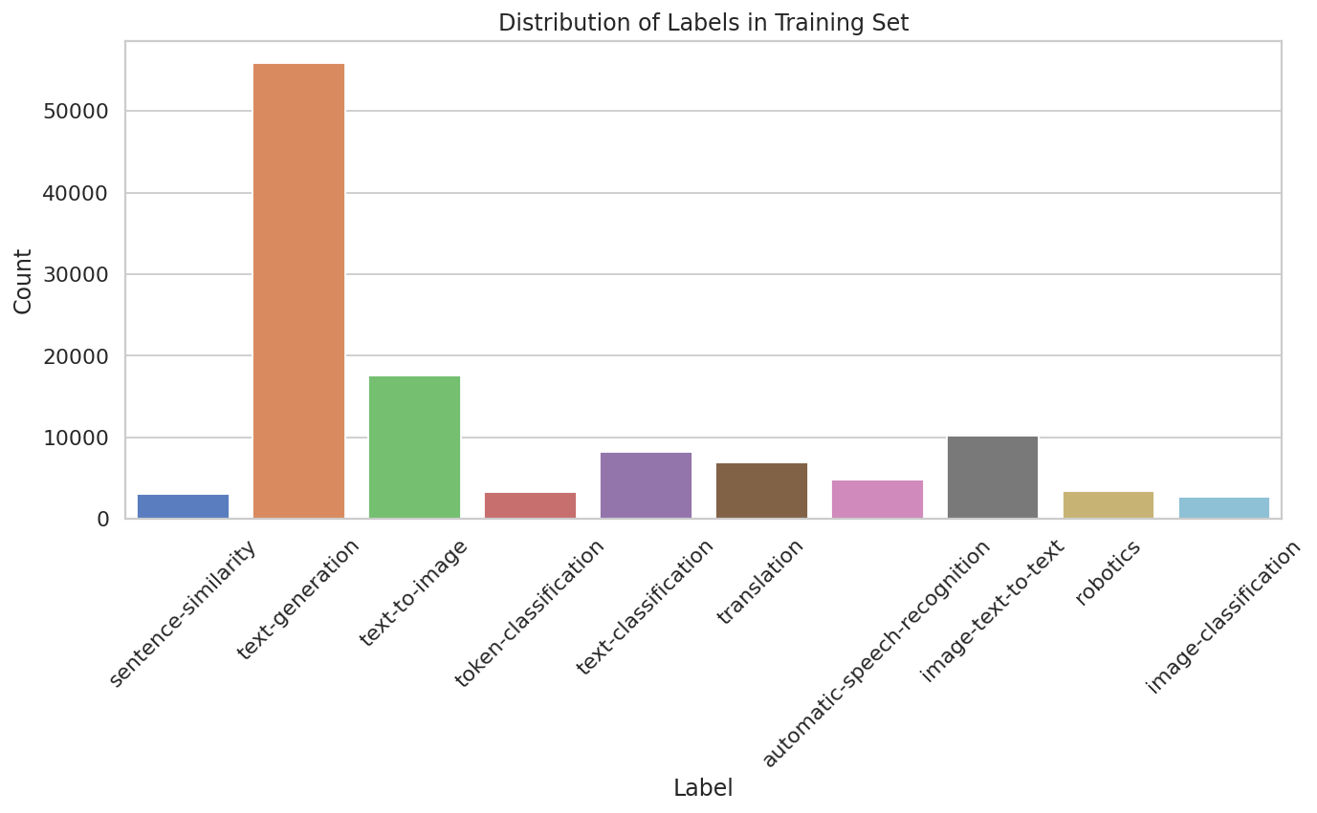
[3]
[3] Model Confidence and Predicted Volume on the Untagged Model Card Pool (n = 115,620):
Pipeline Tag | Baseline n | Baseline conf. | RoBERTa n | RoBERTa conf. | ModernBERT n | ModernBERT conf.
text-generation | 70,027 | 64.6% | 76,206 | 91.6% | 77,114 | 93.6%
text-to-image | 5,160 | 73.1% | 5,657 | 92.1% | 5,832 | 91.5%
image-text-to-text | 12,758 | 66.1% | 10,899 | 82.4% | 10,549 | 84.1%
image-classification | 8,163 | 54.4% | 4,878 | 85.6% | 4,900 | 85.7%
text-classification | 7,710 | 59.9% | 6,630 | 84.8% | 6,395 | 85.1%
automatic-speech-recognition | 3,809 | 64.2% | 4,451 | 90.8% | 3,051 | 89.8%
robotics | 4,682 | 53.0% | 2,684 | 84.0% | 2,794 | 80.4%
translation | 1,016 | 62.6% | 824 | 87.2% | 1,261 | 83.2%
token-classification | 1,097 | 63.2% | 2,092 | 67.7% | 2,548 | 82.6%
sentence-similarity | 1,198 | 66.1% | 1,299 | 86.8% | 1,176 | 85.3%

