Artifactory (Jfrog)

Jenkins –Artifactory

Ref: introduction-to-jfrog-artifactory

https://jfrog.com/webinar/introduction-to-jfrog-artifactory/

Artifactory:

Step1: Download https://jfrog.com/download-artifactory-pro/

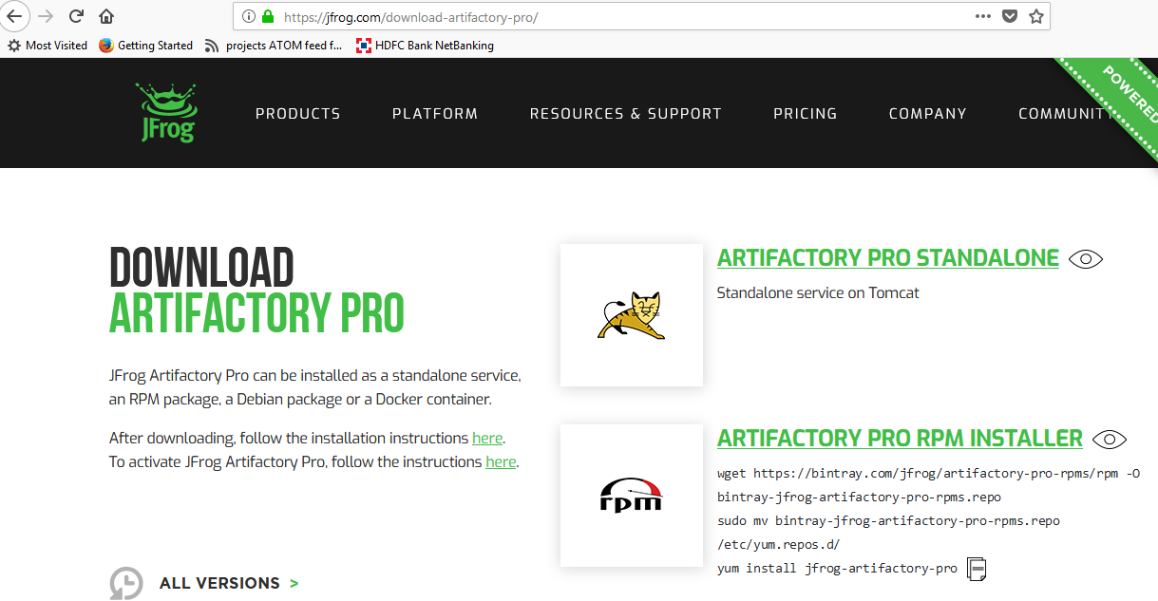

Step2:

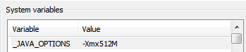

Step3: Change the Default port

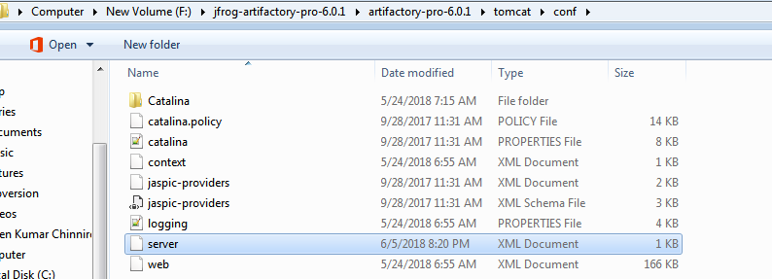

Initial Value is 8081 and changes to 9081

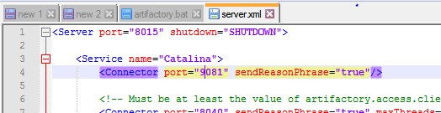

Step3: Service Installation

Artifactory makes use of the  [Apache Commons Procrun](http://commons.apache.org/proper/commons-daemon/procrun.html" \t "_blank) components allowing you to install the application as a Windows Service.

To run Artifactory as a Windows service, browse to %ARTIFACTORY\_HOME%\bin, and execute the file *InstallService.bat*.

By editing *InstallService.bat,*you can modify default properties such as *JOPTS* and the log directory.

For your changes to take effect you need to stop the currently running Artifactory service and run *InstallService.bat* again once you have completed your modifications.

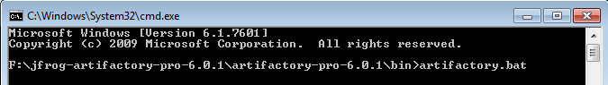

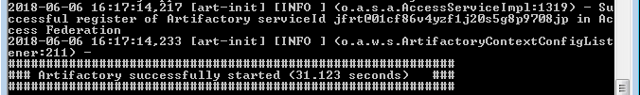

Step4:Accesing Accessing Artifactory

Artifactory can be accessed using the following URL:

<http://SERVER_DOMAIN:9081/artifactory>.

License Free Trail Version:

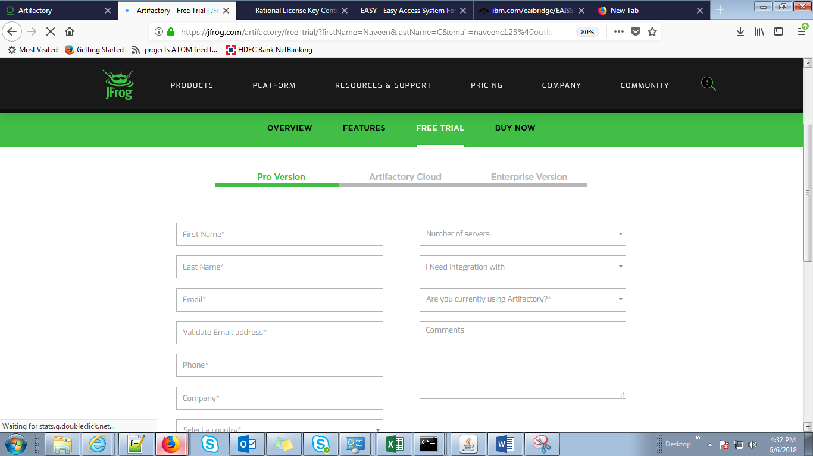

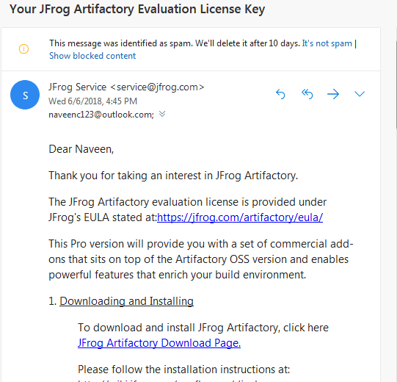

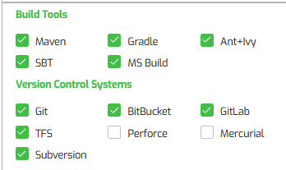

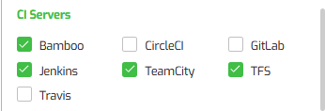

CI Sever: Jenkins,team city

